Housing Market vs Stock Markets

Martin Gascon

11/01/2015

# Introduction

### Motivation and Goals

My idea was to compare the housing market with the stock market. If there is a correlation between them, I would like to know which index predicts better the Housing price and which cities are more correlated to those indexes.

Some of the various questions that I would like to answer include:

* Does the Stock Market Affect the Housing Market?
* If there is an effect effect, is this the same for different cities?
* Which index is more connected to the Housing Market?

### About the Data

For this project, I’ve downloaded data from Zillow (www.zillow.com) which provides the monthly mean value per square feet of all homes in U.S from April 1996 to April 2015. This data includes values per month organized by zipcodes for every major city in the country. I’ve also downloaded data about the stock market index (NASDAQ and DOW JONES INDUSTRIAL AVERAGE) for the same time range from the yahoo finances site.

* <http://finance.yahoo.com/q/hp?a=03&b=1&c=2006&d=03&e=1&f=2015&g=m&s=NYA%2C+&ql=1>

# Analysis

### Exploratory analysis

The exploratory analysis using R language reveals that we have around 3672 cities and 229 variables which correspond to monthly prices. I averaged the prices for each city (all zipcodes) and selected only complete cases. I also selected the close value for the market index.

### Data Processing/Results

After loading the data for Housing values and the Dow Jones Industrial Average (DJIA), I chose two main cities (New York and San Francisco) to study the correlation between these two datasets.

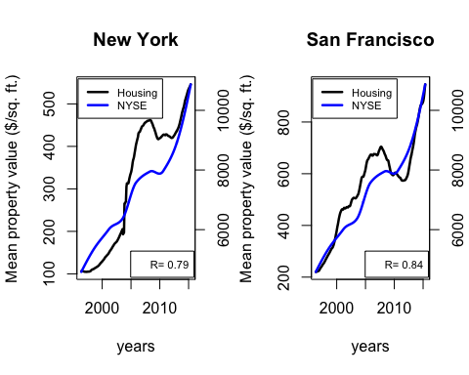

We observe that the housing and stock markets are clearly interconnected but not exactly in the same way for different cities. The Correlation for SF is higher than the one from NY (0.84 vs 0.79) even though Wall Street is in NY.

Let's do the same comparison with the Nasdaq index.

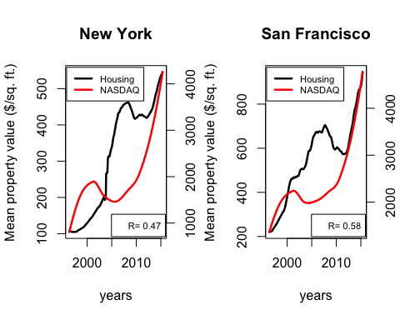

It was also surprising that NASDAQ, which has more companies from the technology sector, has a lower correlation to the housing market compared to the Dow Jones, despite the fact that the most important companies are close to San Francisco. However, we can see a relative higher correlation for San Francisco than New York.

If we consider all the cities now, we can answer a few questions:

1. which cities are the 10 most expensive in the U.S.

## [1] "Palo Alto" "Los Altos" "Menlo Park"   
## [4] "Malibu" "Stanford" "Burlingame"   
## [7] "San Francisco" "Manhattan Beach" "Saratoga"   
## [10] "Cupertino"

All in California. 8 of them in Silicon Valley.

1. which cities are the 5 least expensive in the U.S.

## [1] "Shenandoah" "Town of Salamanca" "Cahokia"   
## [4] "East Saint Louis" "Youngstown"

1. which cities are more correlated to Dow Jones?

## Mountain View Eagle Pass Cupertino San Carlos Sunnyvale   
## 0.8840694 0.8834987 0.8795367 0.8784956 0.8770255

Curiously, 3 of them have the headquarters of Google, Apple and Yahoo.

1. which cities are more correlated to NASDAQ?

## Palo Alto Hohenwald Purcell Mountain View Cupertino   
## 0.7236257 0.7134041 0.7011296 0.6991091 0.6922888

In this case, we have Palo Alto which is very close to Facebook headquarters.

1. which cities are less correlated to Dow Jones?

## Detroit Town of Beloit Center Line Redford   
## -0.4113483 -0.3460930 -0.3104341 -0.2955093

1. which cities are less correlated to NASDAQ?

## Detroit Town of Beloit Center Line Redford   
## -0.4113483 -0.3460930 -0.3104341 -0.2955093

It is surprising the anticorrelation of Detroit with the Stock Markets.

### Conclusions

Surprisingly the NASDAQ index, which has more companies from the technology sector, has a lower correlation to the housing market when compared to the Dow Jones index. There are clear differences between major cities like New York and the San Francisco where the most important companies of the NASDAQ index have their headquarters.