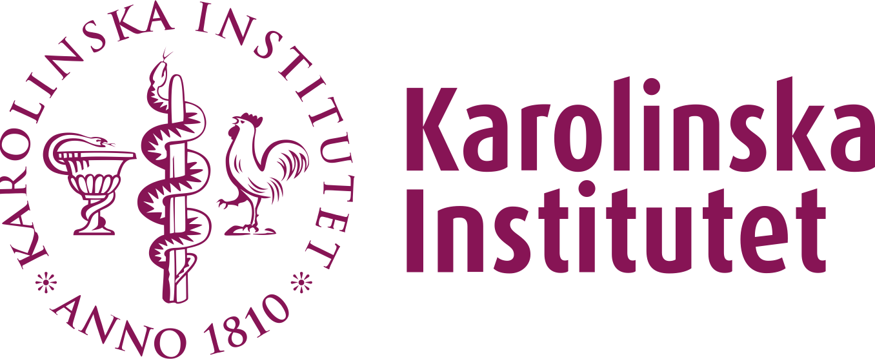Collaboration confirmation

**Mailing address:** Karolinska Institutet, 171 77 Stockholm, Sweden|

**Visiting address:** Tomtebodavägen 18A, 171 65 Solna  
**Telephone:** +46 708 53 95 98, direct |   
**E‑mail:**martin.gerdin@ki.se | **Web**: [ki.se](https://ki.se) | Org. no 202100 2973

2025-02-04

Department of Global Public Health

Martin Gerdin Wärnberg,

Principal Researcher

To whom it may concern

Collaboration between Karolinska Institutet and the George Institute for Global Health in India

This letter confirms that Karolinska Institutet and the George Institute for Global Health in India have entered into a research collaboration agreement (contract number 4-298/2025) for conducting the research project “Effects of Advanced Trauma Life Support® Training Compared to Standard Care on Adult Trauma Patient Outcomes (ADVANCE TRAUMA): A Cluster Randomised Trial”.

Best regards,

Martin Gerdin Wärnberg

Associate Professor, Principal Researcher

ADVANCE TRAUMA Principal Investigator