ADVANCE TRAUMA

Statistical Analysis Plan
Effects of Advanced Trauma Life Support® Training Compared to Standard Care on Adult Trauma Patient Outcomes: A Stepped-Wedge Cluster Randomised Trial

Table of contents
1. Administrative information
1.1 Study identifiers
1.2 Changelog
1.3 Contributors
1.4 Use of generative artificial intelligence
2. Introduction
2.1 Visual abstract
2.2 Trial synopsis
2.3 Special considerations
2.4 Funding
3. Aim and objectives
3.1 Aim
3.2 Objectives
3.3 Framework
4. Study design
4.1 Trial design
4.2 Intervention and control treatment
4.3 Randomisation and inclusion
4.4 Sample size calculations
4.4.1 Main stepped-wedge design and primary outcome
4.4.2 Nested staircase design and secondary outcomes
4.5 Interim analysis
4.6 Final analysis
5. Statistical principles
5.1 Statistical hypotheses
5.2 Levels of statistical significance and confidence
5.3 Type I error control
5.4 Descriptive summaries
5.5 Adherence and protocol deviations
5.5.1 Adherence to the intervention
5.5.2 Protocol deviations
6. Trial sample
6.1 Eligibility criteria
6.1.1 Cluster eligibility criteria
6.1.1.1 Inclusion criteria
6.1.1.2 Exclusion criteria
6.1.2 Patient participant eligibility criteria
6.1.2.1 Inclusion criteria
6.1.2.2 Exclusion criteria
6.2 Participant flow
6.3 Baseline characteristics
6.3.1 Cluster characteristics
6.3.2 Patient characteristics
7. Outcomes
7.1 Outcomes
7.1.1 Primary outcome
7.1.2 Secondary outcomes
7.1.2.1 Collected using the main stepped-wedge design
7.1.2.2 Collected using the nested staircase design
8. Intercurrent events, populations and summary measures
8.1 Intercurrent events
8.1.1 Strategies for handling intercurrent events
8.2 Population
8.3 Analysis sets
8.4 Effect measures
9. Analysis methods
9.1 Analysis of the primary outcome
9.2 Analysis of secondary outcomes
9.2.1 All-cause mortality within 24 hours, 30 days and three months of arrival at the emergency department
9.2.2 Quality of life within seven days of discharge, and at 30 days and three months of arrival at the emergency department, among survivors
9.2.3 Disability within seven days of discharge, and at 30 days and three months of arrival at the emergency department, among survivors
9.2.4 Return to work at 30 days and three months after arrival at the emergency department, among survivors
9.2.5 Length of emergency department stay
9.2.6 Length of hospital stay
9.2.7 Intensive care unit admission
9.2.8 Length of intensive care unit stay
9.2.9 Adherence to ATLS® principles during initial patient resuscitation
9.3 Correlations
9.4 Missing data
9.5 Sensitivity analyses
9.5.1 Exposure defined by the actual date of transition
9.5.2 Models with autoregressive within-cluster correlation
9.5.3 Models with random cluster by intervention effects
9.5.4 Models with time modelled with a spline function
9.5.5 Models exploring lag and weaning effects
9.6 Adjusted analyses
9.7 Subgroup analyses
9.8 Safety events
9.9 Statistical software
9.10 Presentation of analysis results
10. Shell figures and tables
10.1 Trial roll-out
10.2 CONSORT diagrams
10.3 Shell tables and figures for analysis results
11. References

1. Administrative information

1.1 Study identifiers
- Protocol version 1.5.0 dated 2025-06-12
- ClinicalTrials.gov identifier: NCT06321419
- Clinical Trials Registry - India identifier: CTRI/2024/07/071336

1.2 Changelog
We will add a changelog here once we finalise version 1.0.0.

1.3 Contributors
Name and ORCID | Affiliation | Role
Martin Gerdin Wärnberg (MGW) | Karolinska Institutet | Principal Investigator
Anna Olofsson (AO) | Karolinska Institutet | Statistician, TMG member
Karla Hemming (KH) | University of Birmingham, Birmingham, UK | Statistician, TMG member
James Martin (JM) | University of Birmingham, Birmingham, UK | Statistician
Jessica Kasza (JK) | Monash University, Melbourne, Australia | Statistician
Arpita Ghosh (AG) | The George Institute for Global Health, New Delhi, India | Statistician

1.4 Use of generative artificial intelligence
We used generative artificial intelligence tools, including large language models accessed via Cursor, to help draft, revise, and format this statistical analysis plan. We reviewed and approved all content, and we take full responsibility for the final document.

2. Introduction

2.1 Visual abstract
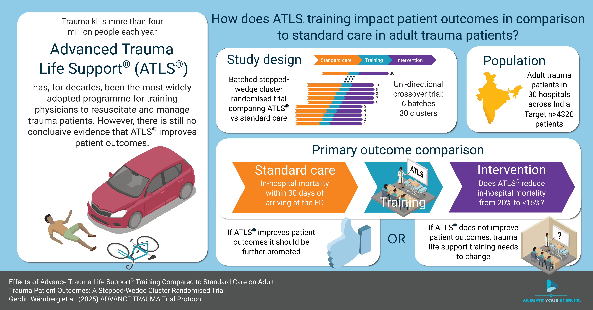
Figure 1: ADVANCE TRAUMA visual abstract.

2.2 Trial synopsis
Title Effects of Advanced Trauma Life Support® Training Compared to Standard Care on Adult Trauma Patient Outcomes: A Stepped-Wedge Cluster Randomised Trial
Rationale Trauma is a massive global health issue. Many training programmes have been developed to help physicians in the initial management of trauma patients. Among these programmes, Advanced Trauma Life Support® (ATLS®) is the most popular, having trained over one million physicians worldwide. Despite its widespread use, there are no controlled trials showing that ATLS® improves patient outcomes. Multiple systematic reviews emphasise the need for such trials.
Aim To compare the effects of ATLS® training with standard care on outcomes in adult trauma patients.
Primary Outcome In-hospital mortality within 30 days of arrival at the emergency department.
Trial Design Batched stepped-wedge cluster randomised trial in India.
Trial Population Adult trauma patients presenting to the emergency department of a participating hospital.
Sample Size 30 clusters and at least 4320 patients.
Eligibility Criteria
Clusters are secondary or tertiary hospitals providing trauma care in India that admit or refer/transfer for admission at least 400 patients with trauma per year. Within each cluster, one or more units of physicians providing initial trauma care in the emergency department will be trained.
Participants are adult trauma patients who present to the emergency department of participating hospitals and are admitted or transferred for admission.
Intervention The intervention will be ATLS® training, a proprietary 2.5 day course teaching a standardised approach to trauma patient care using the concepts of a primary and secondary survey. Physicians will be trained in an accredited ATLS® training facility in India.
Ethical Considerations We will use an opt-out consent approach for collection of routinely recorded data. We will obtain informed consent for collection of non-routinely recorded data, such as quality of life and disability outcomes. Patients who are unconscious or lack a legally authorized representative will be included under a waiver of informed consent. Note that consent here refers to consent to data collection.
Trial Period February 2025 to October 2029

2.3 Special considerations

2.4 Funding
This trial is not yet fully funded. The Trial Management Group has decided to proceed with the trial with the expectation that additional funding will be secured. The Trial Steering Committee will be informed of the funding status at each meeting. If funding is not secured, the trial will be stopped. This will likely result in an underpowered trial. The justification for this decision is that the intervention is considered standard of care in many countries and the data collection is considered minimal risk. There is therefore a very small risk of harm to patient participants, but a potential direct benefit to those patient participants who receive the intervention. The benefit-risk ratio is therefore considered to be favourable, even in the case of an underpowered trial.

3. Aim and objectives

3.1 Aim
To compare the effects of ATLS® training with standard care on outcomes in adult trauma patients.

3.2 Objectives
- To estimate the effects of ATLS® training on 30-day in-hospital mortality compared with standard care.
- To assess, through sensitivity analyses, how robust the primary analysis results are to different model specifications, exposure definitions, and missing-data assumptions.
- To estimate the effects of ATLS® training on secondary outcomes compared with standard care.
- To explore the effects of ATLS® training on subgroups of patients compared with standard care.

3.3 Framework
We have designed and will analyse the trial within a superiority framework, with ATLS® training compared with standard care for the primary and secondary outcomes. We target a cluster-specific (conditional) intervention effect among eligible patient participants, not a marginal (population-averaged) effect and not an equal-weight average across clusters.

4. Study design

4.1 Trial design
This is a batched stepped-wedge cluster randomised trial with 30 clusters (see Figure 2). Each cluster is one hospital, and we randomise hospitals, even when we train more than one unit of physicians in the same hospital. There are two intervention conditions: ATLS® training and standard care.
The trial comprises 6 batches of identical 13-period 5-sequence designs, with one cluster allocated to each sequence of each batch (equal allocation across sequences)¹. Each period is one month, and each cluster will be in the trial for a total of 13 months. We measure clusters repeatedly across periods. We will implement the intervention during a one-month transition period, which we exclude from the analysis. There will be an anticipated overlap of 6 months between successive batches.
Clusters will be sequentially allocated to batches based on when they enter the study, and within each batch clusters will then be randomised to an intervention implementation sequence. We include individual patients cross-sectionally for the primary outcome, although we assess some secondary outcomes at multiple follow-up time points. The anticipated trial period is from February 2025 to October 2029.
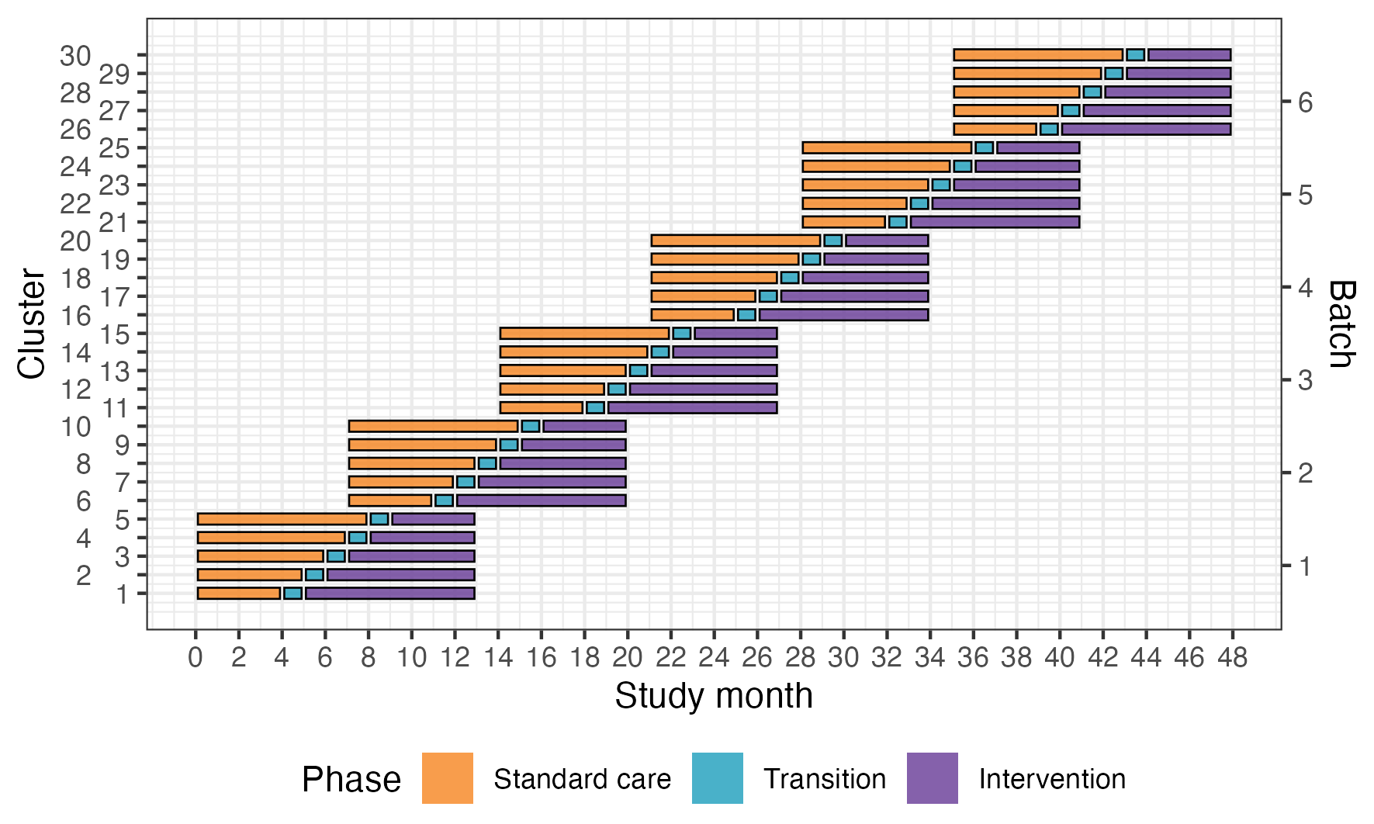
Figure 2: Trial design. Each line shows how long we include patients in a cluster, by batch and sequence. Clusters will be sequentially allocated to a batch based on when they enter the study. Within each batch clusters will then be randomised to an intervention implementation sequence.
Because certain secondary outcomes will be more burdensome to collect and because we anticipate larger effects on these outcomes, we will nest a staircase design within the main stepped-wedge design to measure these outcomes (see Figure 3)². The staircase design will include a random subset of patients presenting in the three months before and the three months after each cluster’s scheduled transition period.
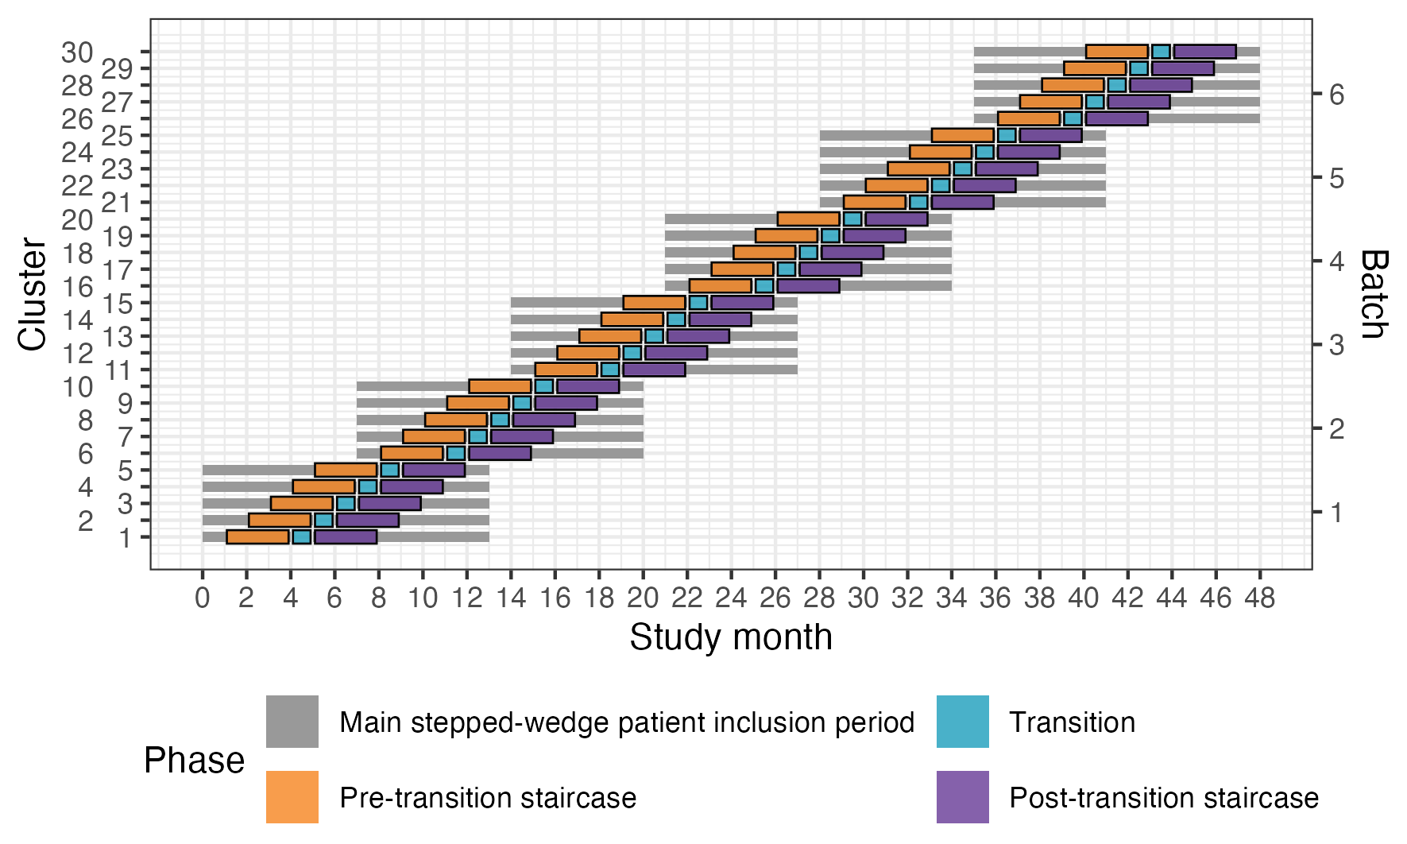
Figure 3: Nested staircase design. We include a random subset of patients presenting in the three months before and the three months after each cluster’s scheduled transition period.
We will report the actual roll-out of the trial in the supplementary material (Figure 5). For each cluster, the figure will show the planned periods of patient inclusion, the observed standard-care, transition, and intervention periods, and the dates of each ATLS® training course.

4.2 Intervention and control treatment
The intervention will be ATLS® training. The control will be standard care, meaning no formal trauma life support training. We will train the physicians that initially resuscitate and provide trauma care during the first hour after patient arrival at the emergency department. These physicians can be casualty medical officers, surgical residents, or emergency medicine residents, depending on the setup at each participating centre. The training will occur during the transition phase in each cluster. Our experience from our pilot study is that study sites adhere to the training slot alloted to them through the trial, so we judge the risk of clusters implementing ATLS® before their randomised implementation sequence as very low.
We will train the number units of physicians needed to reach the required patient sample size, but estimate that this will require training an average of ten physicians per hospital, which on average should be mean that we can train one to two units per hospital. This is possible because many hospitals in India organise physicians staffing their emergency departments in units, and the physicians in the same unit work together in the emergency department on the same days of the week. We will therefore collect data only on the days when these units work. The units selected to constitute a cluster from each hospital will be a convenience sample out of all eligible units in those hospitals.
Advanced Trauma Life Support® (ATLS®)³ is a proprietary 2.5 day course teaching a standardised approach to trauma patient care using the concepts of a primary and secondary survey. The programme was developed by the Committee of Trauma of the American College of Surgeons. The course includes intial treatment and resuscitation, triage and interfacility transfers. Leaning is based on practical scenario-driven skill stations, lectures and includes a final performance proficiency evaluation. Physicians will be trained in an accredited ATLS® training facility in India. We will assess adherence to ATLS principles before and after implementing ATLS training.
Standard care varies across hospitals in India, but trauma patients are initially managed by casualty medical officers, surgical residents, or emergency medicine residents. They are mainly first- or second-year residents who resuscitate patients, perform interventions and refer patients for imaging or other investigations. Compared with other settings where a trauma team approach is adopted, nurses and other healthcare professionals are only involved to a limited extent during the initial management.

4.3 Randomisation and inclusion
We will enrol and assign clusters to batches once eligibility is confirmed and ethical approval is obtained. Each batch will include hospitals from different regions to optimise trial logistics and training delivery.
We randomise clusters to sequences within each batch. Within each batch we balance allocation on cluster size, defined as the monthly volume of eligible patients, using covariate-constrained randomisation (CCR). We chose CCR to improve balance between intervention conditions on this key design variable.
In Batch 1, we randomised five clusters to five sequences using CCR. JM wrote an R program that listed all 120 possible allocations. For each allocation, the program calculated the squared difference in anticipated cluster size between the two intervention conditions. Because there was only one covariate, this squared difference was the balance score.
We excluded the 10% of allocations with the greatest imbalance and drew the final allocation at random from the remaining allocations. Because of limitations in the program, we calculated the balance score as if the design had no transition periods. We will repeat this CCR procedure independently for each remaining batch.
JM generates the random allocation sequence for each batch and sends it to the Trial Team so they can begin logistical arrangements, including securing places on upcoming ATLS® training courses. We will conceal the allocation order from participating clusters for as long as is logistically feasible, because releasing physicians for training requires advance planning.
We select patients for the nested staircase outcomes by random sampling stratified by shift, separately from cluster randomisation, see Nested staircase design and secondary outcomes (Section 4.4.2).

4.4 Sample size calculations
When we designed the trial, we calculated the sample size using the Shiny CRT Calculator⁴.

4.4.1 Main stepped-wedge design and primary outcome
With 30 clusters across 6 batches and a total sample size of 4320 our study has ~90% power across different combinations of cluster autocorrelations (CAC) and intra-cluster correlations (ICC) to detect a reduction in the primary outcome of in-hospital mortality within 30 days from 20% under standard care to 15% after ATLS® training (see Figure 4 A)⁴. This 5% absolute reduction in mortality is a clinically meaningful and conservative estimate based on our updated systematic review and pilot study^{5,6}. We allowed for the clustered design, incorporated the one month transition period, and assumed: a discrete time decay correlation structure, an ICC of 0.02 (but considered sensitivity across the range 0.01-0.05), and a CAC of 0.9 (but considered sensitivity across the range 0.8-1.0), based on our pilot study and current guidance^{7–10}. We included the CAC to allow for variation in clustering over time. We assume that each cluster will contribute approximately 12 observations per month to the analysis, but allowed for substantial variation in cluster sizes, based on our previous work. We also estimated the sample size required to detect a reduction in the primary outcome from 10% to 7.5%, which would require at least 30 observations per period and cluster (see Figure 4 B).
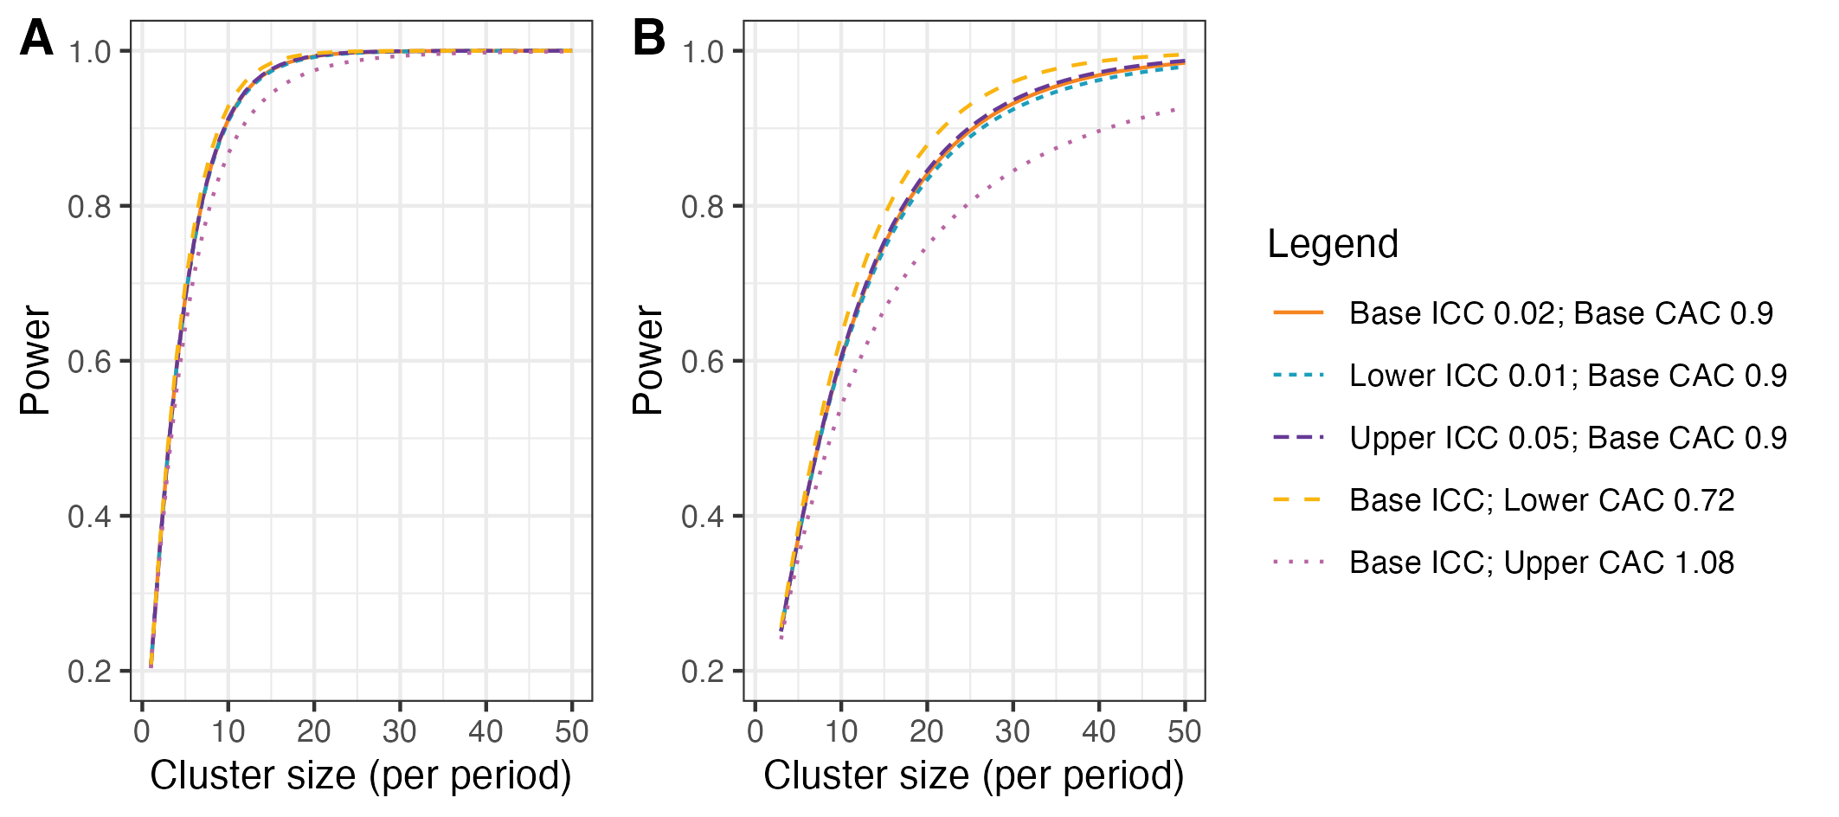
Figure 4: Power curves for different combinations of cluster autocorrelations (CAC) and intra-cluster correlations (ICC). A) Shows power curves assuming a reduction in the primary outcome of in-hospital mortality within 30 days from 20% under standard care to 15% after ATLS® training. B) Shows power curves assuming a reduction in the primary outcome from 10% under standard care to 7.5% after ATLS® training. Under this scenario, we would need to increase the sample size per month to around 30 observations to achieve 90% power under most combinations of CAC and ICC.

4.4.2 Nested staircase design and secondary outcomes
The secondary outcomes measured using the nested staircase design are adherence to ATLS® principles during initial patient resuscitation, quality of life, and disability. The power calculations presented here are intended only to inform the sample size required for their data collection within the nested staircase design. The expected effects of the intervention on these outcomes are an improvement in adherence from 50% during standard care to 70% after training¹¹, an increase in EQ-5D-5L health status from 70 during care to 75 after training¹², and finally a decrease in disability from a baseline value of 25 during standard care to 22.5 after training¹³. For quality of life and disability, these effects correspond to standardised effect sizes, expressed as Cohen’s d, of 0.5. With 30 clusters in total, six per sequence, for a discrete time decay correlation structure, with ICCs of 0.01 to 0.15 and a CAC of 0.8, there is >80% power to detect these effects by including four patients in each cluster in each period. Accounting for loss to follow-up, we will include at least six patients per cluster per month. These patients will be a random subset of patients included in the primary outcome data collection during the staircase months. The random subset will be selected using stratified random sampling by shift, meaning that the timing of the clinical research coordinator’s shift will be randomised to cover approximately eight hours during the morning, afternoon, or night shift. Adherence to ATLS® principles, quality of life, and disability will be measured in all patients included during these shifts. In each hospital, the number of shifts that will be randomised will be determined by the volume of patients included during the months preceding the staircase months.

4.5 Interim analysis
There will be one interim analysis after half of the batches have completed the trial. The interim analysis will be assessed by the joint Trial Steering and Data Monitoring Committee. The purposes of this interim analysis will be to assess the trial’s feasibility and recommend that the trial be stopped if it is not feasible (e.g. if hospitals fail to adhere to the randomisation schedule or if there are substantial missing data in outcomes), and to compare characteristics across intervention conditions to monitor for differential recruitment/ascertainment between the intervention and control groups. No efficacy stopping is planned because any estimates obtained at the time point of the interim analysis will be associated with major statistical uncertainties.
The joint Trial Steering and Data Monitoring Committee (SDMC) will meet after each batch has completed the trial. For each meeting, the Trial Team will prepare a report, and the Trial Management Group will approve it before circulation. The report prepared after half of the batches have completed the trial is the interim analysis report. Each report will include:
- trial progress, overall, by batch and by intervention condition: the number of clusters included and dropping out, and the number of potentially eligible patients screened, patients included, patients who did not consent to out-of-hospital follow-up, and patients lost to follow-up
- adherence to the randomisation schedule and reasons for non-adherence
- summary statistics of included clusters and patient participants by intervention condition
- completeness of primary and secondary outcome data, overall and by intervention condition
- summary statistics of primary and secondary outcomes, pooled across intervention conditions and periods
- ATLS® training delivery, including the number of physicians trained in each hospital
- protocol deviations and proposed protocol amendments
- safety events, as defined for SDMC monitoring
- relevant external evidence
We will not present or compare outcome values by intervention condition in these reports, to avoid biasing the SDMC or Trial Management Group. The SDMC will use each report to advise whether the trial remains feasible and should continue as planned.

4.6 Final analysis
We will analyse the primary and secondary outcomes together in a single final analysis once all trial data are available.

5. Statistical principles

5.1 Statistical hypotheses
We will estimate the effect of ATLS® training on 30-day in-hospital mortality compared with standard care, as an odds ratio (OR) and as an absolute risk difference (ARD). An OR < 1 or ARD < 0 indicates lower mortality among patients treated in hospitals after ATLS® implementation than under standard care. Based on our pilot study and systematic review of the literature, we expect the intervention to reduce mortality.

5.2 Levels of statistical significance and confidence
We will use a two-sided significance level of 0.05 for all analyses, and we will report 95% confidence intervals (CI) for all estimates.

5.3 Type I error control
We will not adjust for multiple testing because we do not regard any secondary outcome as singularly more important. We will interpret the secondary outcomes together and not over-emphasise a single statistically significant result when the others appear unchanged.

5.4 Descriptive summaries
In every descriptive table we summarise discrete variables as frequencies and percentages, and continuous and count variables as medians and interquartile ranges (Q1–Q3). We report missing values for each variable, and we do not adjust any of these summaries for clustering. Where a table has a key version and a version with all variables, for example for patient characteristics, we present the key version in the main text and the full version in the supplementary material.

5.5 Adherence and protocol deviations

5.5.1 Adherence to the intervention
Adherence to the intervention is defined at the cluster and individual levels. It is distinct from the secondary outcome adherence to ATLS® principles during initial patient resuscitation, see Adherence to ATLS® principles during initial patient resuscitation (Section 9.2.9). That outcome is not used to exclude patients from the primary analysis.
At the cluster level, adherence means that the cluster receives ATLS® training during the transition period scheduled for its randomised sequence and does not implement ATLS® training earlier. We will assess cluster-level adherence using the training log kept by the Trial Team. We will report the number and proportion of clusters that completed training as scheduled and the reasons for any non-adherence to the randomisation schedule. We also review adherence to the randomisation schedule in each report to the SDMC, see Interim analysis (Section 4.5).
At the individual level, exposure to the intervention is defined by the cluster’s scheduled transition date, and patients are classified by the period in which they arrived at the emergency department, see Analysis sets (Section 8.3). The primary analysis includes eligible patients irrespective of whether care was delivered by a trained physician.

5.5.2 Protocol deviations
A protocol deviation is any departure from the approved trial protocol, ICH-GCP, or applicable regulations. As stated in the protocol, we will report any serious breach or deviation to the sponsor without delay for assessment. A deviation is serious if it significantly affects, or is likely to affect, participant safety or integrity or the reliability of trial data. Minor deviations do not affect participant safety or integrity and do not materially affect the scientific value of the trial. We will document them in the trial records of the principal investigator and the sponsor.
We will summarise protocol deviations in each report to the SDMC and at the final analysis, overall and by intervention condition where informative. We will give counts by type, cluster-level or individual-level and serious or minor where classified, together with the reasons. We will not exclude clusters or patients from the primary analysis because of a deviation. Exposure is still defined by the scheduled transition date, see Analysis sets (Section 8.3).

6. Trial sample

6.1 Eligibility criteria
Our trial has eligibility criteria at the cluster and patient participant levels. We summarise them below, and the protocol gives full details.

6.1.1 Cluster eligibility criteria

6.1.1.1 Inclusion criteria
Clusters must meet the following criteria:
- admit or refer/transfer for admission at least 400 patients with trauma per year or 35 patients with trauma per month for at least the last six months;
- provide surgical and orthopaedic emergency services around the clock; and
- have at most 25% of physicians providing initial trauma care trained in a formalised trauma life support training programme, like ATLS® or Primary Trauma Care (PTC).
Additionally, the units to be trained within the cluster must meet the following criteria:
- admits or refers/transfers for admission at least 12 patients with trauma per month for at least the last six months; and
- no more than 25% of physicians providing initial trauma care trained in a formalised trauma life support training programme.

6.1.1.2 Exclusion criteria
Hospitals are excluded if they meet any of the following criteria:
- implement a formalised trauma life support training programme during the trial period; or
- plan to implement or implement other major interventions that affects trauma care during the trial period.

6.1.2 Patient participant eligibility criteria

6.1.2.1 Inclusion criteria
Patients participants must meet the following criteria:
- age of at least 15 years;
- trauma occurred less than 48 hours before arrival at the hospital;
- present to the emergency department of participating hospitals, with a history of trauma defined as having any of the reasons listed in the International Classification of Diseases chapter XX as the reason for presenting;
- admitted, or died between arrival at the hospital and admission, or referred/transferred from the emergency department of a participating hospital to another hospital for admission; and
- managed by a participating unit in the emergency department.

6.1.2.2 Exclusion criteria
Patients participants are excluded if they meet the following criteria:
- present with isolated closed extremity fracture; or
- are directly admitted to a ward without being seen by a physician in the emergency department.

6.2 Participant flow
We will use CONSORT diagrams to show the flow of clusters and patients through the main batched stepped-wedge trial. In line with recent batched stepped-wedge practice¹⁴, we will present two figures in the main text: a cluster-level diagram (Figure 6) and a patient-level diagram (Figure 7). For each sequence, the diagrams will report the numbers randomised or included, losses and exclusions after randomisation with reasons, and the numbers analysed for the primary outcome. The patient diagram will also show flow before and after ATLS® training.
A separate figure in the supplementary material will show flow for the nested-staircase outcomes, which are adherence to ATLS® principles, EQ-5D-5L, and WHODAS 2.0 (Figure 8). It will show patients in the staircase periods, losses and exclusions, and the numbers analysed, by sequence, before and after ATLS® training, and overall.
We will report the trial according to the CONSORT extension for stepped-wedge cluster randomised trials¹⁵.

6.3 Baseline characteristics

6.3.1 Cluster characteristics
We will describe cluster characteristics, including state and size, as specified under Descriptive summaries (Section 5.4). The state categories depend on the final set of participating clusters. We will present these characteristics in the main text (Table 2).

6.3.2 Patient characteristics
We will describe the characteristics of all eligible patients over the entire trial period, before and after ATLS® training and overall, as specified under Descriptive summaries (Section 5.4). Baseline characteristics do not include outcome variables. We will present key characteristics in the main text (Table 3) and all characteristics in the supplementary material (Table 4).

7. Outcomes

7.1 Outcomes
Table 1 summarises all outcomes with their populations, effect measures, and handling of intercurrent events. The strategies named in the last column of that table are defined under Strategies for handling intercurrent events (Section 8.1.1).

7.1.1 Primary outcome
The primary outcome will be in-hospital mortality within 30 days of arrival at the emergency department. We define this outcome as any death occurring in the hospital during the initial admission, up to 30 days post arrival at the emergency department. Clinical research coordinators will extract information on death from patient hospital records. If the patient has been transferred to another hospital, the clinical research coordinators will collect data on this outcome by calling the patient or a patient representative, or by contacting the hospital to which the patient was transferred. Data on this outcome will be collected continuously during the trial.

7.1.2 Secondary outcomes

7.1.2.1 Collected using the main stepped-wedge design
- All cause mortality within 24 hours, 30 days and three months of arrival at the emergency department. In contrast to the primary outcome, all-cause mortality includes all deaths regardless of setting. Data on this outcome will be collected in the same way as for the primary outcome.
- Length of emergency department stay. Data on this outcome will be collected from patient hospital records.
- Length of hospital stay. Data on this outcome will be collected from patient hospital records.
- Intensive care unit admission. Data on this outcome will be collected from patient hospital records.
- Length of intensive care unit stay. Data on this outcome will be collected from patient hospital records.
- Return to work at 30 days and three months after arrival at the emergency department. Data on this outcome will be collected in person if the patient is still in hospital, or by phone if the patient has been discharged.

7.1.2.2 Collected using the nested staircase design
- Adherence to ATLS® principles during initial patient resuscitation, up to one hour after the physician has first seen the patient. This assessment will be done using a 14 item checklist covering the key steps of the ATLS® primary survey, which was modelled based on previous work on ATLS® adherence¹⁶. We will consider completion of all 14 steps as 100% adherence. The clinical research coordinators collecting the data will be trained by the trial team to do this, prior to the start of the trial. We will collect this data by observing the care of a random sample of patients. The sampling will be designed as a nested staircase design.
- Quality of life within seven days of discharge, and at 30 days and three months of arrival at the emergency department, measured by the official and validated translations of the EQ5D5L. This outcome is only relevant to alive patients. Data on this outcome will be collected in person if the patient is still in hospital, or by phone if the patient has been discharged. We will collect this data using a nested staircase design.
- Disability within seven days of discharge, and at 30 days and three months of arrival at the emergency department, assessed using the WHO Disability Assessment Schedule 2.0 (WHODAS 2.0). This outcome is only relevant to alive patients. Data on this outcome will be collected in person if the patient is still in hospital, or by phone if the patient has been discharged. This data will also be collected using a nested staircase design.

Table 1: Summary of outcomes, populations, effect measures, and handling of intercurrent events. The strategies named in the last column are defined in the section Strategies for handling intercurrent events.
Outcome | Design component | Data type | Population | Main analysis model | Effect measure | Potential intercurrent events | Strategy for handling intercurrent events
Primary outcome: In-hospital mortality within 30 days of arrival at the emergency department | Main stepped-wedge | Dichotomous | Trauma patients | Mixed-effects binomial (logit, identity) | OR; ARD | Loss to follow-up | Missing data
All-cause mortality within 24 hours of arrival at the emergency department | Main stepped-wedge | Dichotomous | Trauma patients | Mixed-effects binomial (logit, identity) | OR; ARD | Loss to follow-up; withdrawal | Missing data
All-cause mortality within 30 days of arrival at the emergency department | Main stepped-wedge | Dichotomous | Trauma patients | Mixed-effects binomial (logit, identity) | OR; ARD | Loss to follow-up; withdrawal | Missing data
All-cause mortality within three months of arrival at the emergency department | Main stepped-wedge | Dichotomous | Trauma patients | Mixed-effects binomial (logit, identity) | OR; ARD | Loss to follow-up; withdrawal | Missing data
Length of emergency department stay | Main stepped-wedge | Count (hours) | Trauma patients | Mixed-effects negative binomial (log) | Rate ratio | Death; transfer | Observed stay truncated by death or transfer
Length of hospital stay | Main stepped-wedge | Count (days) | Trauma patients | Mixed-effects negative binomial (log) | Rate ratio | Death; transfer | Observed stay truncated by death or transfer
Intensive care unit (ICU) admission | Main stepped-wedge | Dichotomous | Trauma patients | Mixed-effects binomial (logit, identity) | OR; ARD | Death; transfer | Classified by whether ICU admission occurred first
Length of intensive care unit stay | Main stepped-wedge | Count (days) | Trauma patients admitted to ICU | Mixed-effects negative binomial (log) | Rate ratio | Death; transfer | Observed stay truncated by death or transfer
Return to work at 30 days after arrival at the emergency department | Main stepped-wedge | Dichotomous | Trauma patients alive at follow-up and working at inclusion | Mixed-effects binomial (logit, identity) | OR; ARD | Death; loss to follow-up; withdrawal | While-alive; missing data otherwise
Return to work at three months after arrival at the emergency department | Main stepped-wedge | Dichotomous | Trauma patients alive at follow-up and working at inclusion | Mixed-effects binomial (logit, identity) | OR; ARD | Death; loss to follow-up; withdrawal | While-alive; missing data otherwise
Adherence to ATLS® principles during initial patient resuscitation | Nested staircase | Proportion | Trauma patients | Mixed-effects beta (logit) | Logit-scale difference | Incomplete observation | Available-case in the observed nested sample
Quality of life within seven days of discharge | Nested staircase | Ordinal EQ-5D-5L; VAS | Trauma patients alive at follow-up | Cumulative logit; linear mixed | COR; mean difference | Death; loss to follow-up; withdrawal | While-alive; missing data otherwise
Quality of life at 30 days after arrival at the emergency department | Nested staircase | Ordinal EQ-5D-5L; VAS | Trauma patients alive at follow-up | Cumulative logit; linear mixed | COR; mean difference | Death; loss to follow-up; withdrawal | While-alive; missing data otherwise
Quality of life at three months after arrival at the emergency department | Nested staircase | Ordinal EQ-5D-5L; VAS | Trauma patients alive at follow-up | Cumulative logit; linear mixed | COR; mean difference | Death; loss to follow-up; withdrawal | While-alive; missing data otherwise
Disability within seven days of discharge | Nested staircase | Continuous (WHODAS 2.0 summary score) | Trauma patients alive at follow-up | Linear mixed | Mean difference | Death; loss to follow-up; withdrawal | While-alive; missing data otherwise
Disability at 30 days after arrival at the emergency department | Nested staircase | Continuous (WHODAS 2.0 summary score) | Trauma patients alive at follow-up | Linear mixed | Mean difference | Death; loss to follow-up; withdrawal | While-alive; missing data otherwise
Disability at three months after arrival at the emergency department | Nested staircase | Continuous (WHODAS 2.0 summary score) | Trauma patients alive at follow-up | Linear mixed | Mean difference | Death; loss to follow-up; withdrawal | While-alive; missing data otherwise

8. Intercurrent events, populations and summary measures

8.1 Intercurrent events
Intercurrent events are patient-level events after intervention exposure that affect the occurrence or interpretation of an outcome. Table 1 lists the anticipated events and the handling strategy for each outcome.
We will report each event as the count and percentage of patients with the event before the outcome was assessed, before and after ATLS® training and overall, see Descriptive summaries (Section 5.4). Denominators are the primary analysis set or the nested sample before any outcome-specific restriction, so that events that remove a patient from an analysis set are still counted. We will present these summaries in the supplementary material (Table 5).
At the cluster level, we treat early or late transition, incomplete delivery of ATLS® training, and cluster dropout as adherence or protocol issues rather than intercurrent events, see Adherence and protocol deviations (Section 5.5). They do not change how exposure is defined, see Analysis sets (Section 8.3).
At the individual level, the intervention is training of hospital staff, so patients cannot discontinue or withdraw from it. The anticipated patient-level intercurrent events are:
- Transfer to another hospital. Relevant to length of emergency department, hospital, and intensive care unit (ICU) stay and to ICU admission. Transfer is not an intercurrent event for mortality outcomes, because the primary outcome includes in-hospital deaths after transfer and all-cause mortality counts deaths in any setting.
- Death. Death is an intercurrent event only for outcomes assessed after it. For length of stay and ICU admission it is handled in the same way as transfer, see Strategies for handling intercurrent events (Section 8.1.1). Quality of life, disability, and return to work are defined only among patients alive at the relevant follow-up.
- Withdrawal of consent for non-routine data collection. Relevant to outcomes that need opt-in follow-up, namely return to work, quality of life, disability, and all-cause mortality when not available from records. It is not relevant to the primary outcome, length of stay, ICU admission, or adherence, which are collected under opt-out consent. Patients who withdraw contribute outcomes observed before withdrawal unless they also ask for their data to be removed. Missing values are handled under Missing data (Section 9.4).
- Loss to follow-up. Relevant to the same outcomes as withdrawal, and to the primary outcome for patients transferred to another hospital. Missing values are handled under Missing data (Section 9.4).
- Incomplete observation of resuscitation. Relevant only to ATLS® adherence. We score the checklist by observing the initial resuscitation until it ends or until one hour after the physician first sees the patient, whichever comes first. Items not completed by then count as not adhered to, including when the patient leaves the emergency department or dies before one hour. Observation is incomplete only when the observer could not follow the resuscitation to that point, for example because the observer arrived late or was interrupted. We exclude unobserved and incompletely observed resuscitations from the adherence analysis.

8.1.1 Strategies for handling intercurrent events
We define the strategies below in the order in which they first appear in Table 1. Where the table lists two strategies for an outcome, the second applies to any event not covered by the first.
- Missing data. The outcome is not observed. Under the available-case approach we exclude these observations from the analysis of that outcome, and under multiple imputation we impute them, see Missing data (Section 9.4).
- Observed stay truncated by death or transfer. The length of stay is the completed duration until the patient leaves the unit, including when the patient leaves by dying or being transferred. These stays enter the analysis at their observed value and are not censored.
- Classified by whether ICU admission occurred first. Patients who die or are transferred count as admitted to intensive care only if the admission occurred before that event. The outcome is therefore defined for every patient in the analysis set.
- While-alive. The outcome is defined only among patients alive at the assessment time point. The estimated effect applies to survivors at that time point, and mortality is analysed separately.
- Available-case in the observed nested sample. The outcome is analysed among completely observed resuscitations, see Intercurrent events (Section 8.1). Unobserved and incompletely observed resuscitations are excluded.
Where we use a while-alive strategy, we assume that death before the outcome assessment does not cause selection bias beyond what the separate analysis of mortality addresses. We will interpret the results for survivor outcomes together with the results for mortality. We will consider the assumptions behind each strategy when we interpret the results and check model assumptions, see 9. Analysis methods (Section 9).

8.2 Population
A population is the group of patients to which an estimated effect applies. An analysis set is the set of observations that enter a given analysis, as defined under Analysis sets (Section 8.3). Table 1 names the population for each outcome.
- Trauma patients. Patients aged 15 years or older who present to the emergency department with trauma requiring admission. This is the population for the primary outcome, all-cause mortality, length of emergency department and hospital stay, ICU admission, and adherence to ATLS® principles.
- Trauma patients admitted to ICU. The population for length of ICU stay.
- Trauma patients alive at follow-up. Trauma patients who were alive when the outcome was assessed, within seven days of discharge, at 30 days, or at three months after arrival at the emergency department. These are the populations for quality of life and disability.
- Trauma patients alive at follow-up and working at inclusion. Trauma patients who were alive at 30 days or at three months after arrival at the emergency department and who were working at the time of inclusion. Working means paid or unpaid work, studying or keeping house. These are the populations for return to work.

8.3 Analysis sets
An observation is one presentation by an eligible patient to the emergency department of a participating cluster. It belongs to the cluster the patient presented to and to the period in which the patient arrived. An observation is exposed to the intervention if the patient arrived after the period in which the cluster was scheduled to transition, and to standard care otherwise, irrespective of when the cluster was in fact trained or who delivered the care, see Adherence and protocol deviations (Section 5.5) and Exposure defined by the actual date of transition (Section 9.5.1).
- Primary analysis set. All randomised clusters and all eligible patients, that is all observations within clusters with available data, irrespective of the receipt of the intervention, with the exception of the transition periods. A cluster that leaves the trial early, or is still in the trial when the trial stops, contributes the periods it completed. Used for the outcomes collected in the main stepped-wedge design.
- Nested sample. The observations for the patients randomly selected for nested staircase data collection, see Nested staircase design and secondary outcomes (Section 4.4.2). Used for quality of life and disability.
- Observed nested sample. The observations in the nested sample with a completely observed resuscitation, see Intercurrent events (Section 8.1). Used for adherence to ATLS® principles.
Each analysis includes the observations in its analysis set that belong to the population of the outcome and have an observed outcome value. Under multiple imputation, observations with a missing outcome are retained and imputed, see Missing data (Section 9.4). Adjusted available-case analyses include only observations with complete adjustment covariates.

8.4 Effect measures
Outcomes are measured on individual patients. We will summarise the primary and secondary outcomes before and after ATLS® training and overall, as specified under Descriptive summaries (Section 5.4). We will present key outcomes in the main text (Table 6) and all outcomes in the supplementary material (Table 7).
Table 1 lists the comparative effect measure for each outcome. We estimate them from the mixed-effects models described under 9. Analysis methods (Section 9). These models give cluster-specific (conditional) estimates of the intervention effect, not marginal (population-averaged) estimates. The target is an average over patients rather than over clusters, see Framework (Section 3.3). The effect measures by outcome type are:
- Dichotomous outcomes: odds ratio from a binomial model with a logit link, and absolute risk difference from a binomial model with an identity link.
- Count (length-of-stay) outcomes: rate ratio from a negative binomial model with a log link.
- Ordinal outcomes (EQ-5D-5L domains): cumulative odds ratio from a cumulative logit model.
- Continuous outcomes (EQ-5D-5L VAS and WHODAS 2.0 summary score): mean difference from a linear mixed model.
- Adherence proportion: difference on the logit scale from a beta regression model.

9. Analysis methods
We will analyse the primary and secondary outcomes with mixed-effects regression models that account for clustering at the hospital level. The link function and outcome distribution depend on the data type of each outcome, and the subsections below specify the model for each outcome.
Randomisation is at the hospital level, and all participating units within a hospital belong to the same cluster. The models therefore include a random effect at the hospital level and no separate random effect for unit within hospital.
Unless stated otherwise, the following specifications apply to all analyses in this section. We will estimate the models by maximum likelihood, using a Laplace approximation to integrate over the random effects. Linear mixed models are the exception, and we will estimate them by restricted maximum likelihood (REML), which the Kenward–Roger correction requires. We do not prespecify the R package or numerical implementation, see Statistical software (Section 9.9).
Standard errors will be model-based, and confidence intervals will be Wald-type. Because the trial has few clusters, we will apply a small-sample correction to avoid inflating the type I error rate. For linear mixed models, we plan to use the Kenward–Roger correction¹⁷. Small-sample corrections for binomial and other non-linear mixed models are an area of active research, so we will choose the correction for these models closer to the end of patient inclusion, based on the best available evidence at that time. The correction may also differ between outcomes collected in the complete stepped-wedge design and in the incomplete nested staircase design.
We will use model diagnostics to check distributional assumptions and model convergence.

9.1 Analysis of the primary outcome
The primary outcome is in-hospital mortality within 30 days of arrival at the emergency department, which we will analyse as a dichotomous variable. We will estimate the OR and the ARD of death under ATLS® compared with standard care.
We will use a mixed-effects binomial regression model with a logit link to estimate the OR and with an identity link to estimate the ARD. Our primary estimand is a single intervention effect that is assumed constant across all periods of ATLS® exposure, rather than separate effects for each period after transition. We will fit a prespecified sequence of models of decreasing complexity and report the most complex model that converges. We move to a simpler model only if we meet convergence or numerical stability problems. If the model with the logit link converges but the model with the identity link does not, we will report only an OR.
All models in the sequence include a fixed effect for intervention exposure and adjust for time. Later models simplify the parametrisation of time, the random effects structure, or both.
The model sequence is defined as follows:
- Primary model: a model with categorical fixed effects for period, estimated separately for each batch, and a fixed effect for intervention exposure. The model accounts for clustering with a random intercept for cluster and a random cluster-by-period effect, both normally distributed (Equation 1).
$$g\{Pr\left(Y_{bkti}=1\right)\}=μ+β_{bt}+θX_{bkt}+α_{bk}+γ_{bkt} \left(1\right)$$
- Simplified random effects structure: the primary model without the random cluster-by-period effect, so that clustering is modelled by a random intercept for cluster only (Equation 2).
$$g\{Pr\left(Y_{bkti}=1\right)\}=μ+β_{bt}+θX_{bkt}+α_{bk} \left(2\right)$$
- Model with shared period effects: the primary model with categorical fixed effects for calendar month instead of separate period effects for each batch. Batches share the effects of the months in which they overlap. Alternatively, calendar time may be modelled directly, for example as a continuous covariate or with splines. The model keeps the random intercept for cluster and the random cluster-by-period effect, and clusters remain indexed by batch (Equation 3).
$$g\{Pr\left(Y_{bkti}=1\right)\}=μ+β_{c\left(b,t\right)}+θX_{bkt}+α_{bk}+γ_{bkt} \left(3\right)$$
- Combined simplified model: a model with shared period effects and a random intercept for cluster only. This is the simplest model we consider acceptable for the primary analysis (Equation 4).
$$g\{Pr\left(Y_{bkti}=1\right)\}=μ+β_{c\left(b,t\right)}+θX_{bkt}+α_{bk} \left(4\right)$$
Where:
- $g\left(⋅\right)$: the link function, specified as either the logit link, $g\left(p\right)=log\{p/\left(1−p\right)\}$, or the identity link, $g\left(p\right)=p$, depending on the estimand of interest.
- $Pr\left(Y_{bkti}=1\right)$: the probability of death for patient $i=1,…,m_{bkt}$ in cluster $k$ during period $t=1,…,13$ in batch $b$. The planned design has 6 batches of 5 clusters, giving 30 clusters in total. A cluster that completes the trial contributes 12 periods, because its transition period is excluded.
- $m_{bkt}$: the number of patients in cluster $k$ during period $t$ in batch $b$.
- $μ$: the intercept, representing the value of the linear predictor for the reference levels of all fixed effects, with random effects equal to zero.
- $β_{bt}$: the fixed effect of period $t$ in batch $b$, with one effect for each period of each batch. The planned design has 6 $×$ 13 = 78 period effects.
- $β_{c\left(b,t\right)}$: the fixed effect of calendar month $c\left(b,t\right)$, the month of the trial in which period $t$ of batch $b$ falls. Batches share the effects of the months in which they overlap, so there is one effect for each calendar month of the trial. The number of calendar months depends on when each batch starts and is 48 in the planned design.
- $θ$: the intervention effect, the fixed effect of intervention exposure and the primary estimand. Under the logit link, $θ$ is the log odds ratio for death under ATLS® compared with standard care. Under the identity link, it is the absolute risk difference.
- $X_{bkt}$: the intervention exposure indicator for cluster $k$ during period $t$ in batch $b$, with $X_{bkt}=1$ for ATLS® and $X_{bkt}=0$ for standard care.
- $α_{bk}$: a normally distributed random effect for cluster $k$ in batch $b$, representing between-cluster (hospital-level) variability in the outcome.
- $γ_{bkt}$: a normally distributed random effect for cluster $k$ in period $t$ in batch $b$, representing within-cluster variation over time and capturing cluster-specific deviations from the average period effect.
The distributional assumptions for the random effects are specified in Equation 5.
$$\begin{matrix}α_{bk} & \overset{\text{iid}}{∼}N\left(0,σ_{α}^{2}\right), \\ γ_{bkt} & \overset{\text{iid}}{∼}N\left(0,σ_{γ}^{2}\right), \\ α_{bk} & ⟂γ_{bkt}.\end{matrix} \left(5\right)$$

9.2 Analysis of secondary outcomes
Unless stated otherwise, we will analyse each secondary outcome with the period parametrisation and random effects structure of the model selected for the primary analysis under Analysis of the primary outcome (Section 9.1). The link function and outcome distribution are chosen to suit each outcome, with the effect measures listed under Effect measures (Section 8.4). We will not repeat the model sequence for each secondary outcome. If the selected model does not converge for a secondary outcome, we will continue down the same sequence for that outcome. We will report which model we used for each outcome. For outcomes collected in the nested staircase design, period effects are calendar-month effects shared across batches, as in the model with shared period effects, rather than separate effects for each batch. The random effects structure still follows the primary analysis.
For cumulative logit models, we will also check the proportional odds assumption.

9.2.1 All-cause mortality within 24 hours, 30 days and three months of arrival at the emergency department
We will analyse these outcomes as dichotomous variables with the binomial model selected for the primary analysis, with the logit and identity links, to estimate ORs and ARDs.

9.2.2 Quality of life within seven days of discharge, and at 30 days and three months of arrival at the emergency department, among survivors
We measure quality of life within the nested staircase design, using the official and validated translations of the EQ-5D-5L. The EQ-5D-5L gives two outcome types: five ordinal domain scores (mobility, self-care, usual activities, pain/discomfort, and anxiety/depression), each rated on a Likert scale from 1 to 5, and a visual analogue scale (VAS) ranging from 0 to 100.
For each of the five ordinal domains, we will use a mixed-effects cumulative logit (proportional odds) model:
$$\text{logit}\{Pr\left(Y_{bkti}≤j\right)\}=μ_{j}+β_{c\left(b,t\right)}+θX_{bkt}+α_{bk}+γ_{bkt} \left(6\right)$$
Where $μ_{j}$ is the intercept for category $j$, and all other terms are defined as in the primary analysis model.
The VAS will be analysed as a continuous outcome using a linear mixed-effects model:
$${\text{VAS}}_{bkti}=μ+β_{c\left(b,t\right)}+θX_{bkt}+α_{bk}+γ_{bkt}+ϵ_{bkti}, ϵ_{bkti}∼N\left(0,σ^{2}\right) \left(7\right)$$

9.2.3 Disability within seven days of discharge, and at 30 days and three months of arrival at the emergency department, among survivors
We measure disability within the nested staircase design using the 12-item version of the WHO Disability Assessment Schedule 2.0 (WHODAS 2.0)¹⁸. It covers six domains of functioning: cognition, mobility, self-care, getting along, life activities, and participation. Each item is rated from 1 (no difficulty) to 5 (extreme difficulty or cannot do). We will calculate a summary score from 0 to 100 using the WHODAS 2.0 “complex scoring” method, and we will not calculate domain scores. We will analyse the summary score with a linear mixed-effects model (Equation 7).

9.2.4 Return to work at 30 days and three months after arrival at the emergency department, among survivors
We will analyse return to work as a dichotomous outcome with the binomial model selected for the primary analysis, with the logit and identity links, to estimate ORs and ARDs.

9.2.5 Length of emergency department stay
We will analyse length of emergency department stay as a count outcome: the number of hours from arrival at the emergency department (ED) until ED exit. Exit may occur via ward admission, ICU admission, transfer to another hospital, death, or discharge home. All of these routes contribute the observed ED duration. We will estimate the effect of ATLS® training on mean ED length of stay. We analyse mortality separately as a primary and secondary outcome rather than as a competing event.
The model is a mixed-effects negative binomial regression with a log link and a fixed effect for intervention exposure. Equation 8 shows the model with the structure of the primary model. If a simpler structure was selected for the primary analysis, we use that structure instead. The intervention effect $θ$ is the log rate ratio for ED length of stay under ATLS® compared with standard care, and we will report the rate ratio $exp\left(θ\right)$.
$$log\{E\left(Y_{bkti}\right)\}=μ+β_{bt}+θX_{bkt}+α_{bk}+γ_{bkt} \left(8\right)$$
Where $Y_{bkti}$ is the length-of-stay count for patient $i$ in cluster $k$ during period $t$ in batch $b$, and all other terms are defined as in the primary analysis model. The negative binomial model also estimates a dispersion parameter.

9.2.6 Length of hospital stay
We will analyse length of hospital stay as a count outcome: the number of days from arrival at the emergency department until the patient leaves the hospital by discharge, transfer, or death. The analysis uses the same negative binomial model as for ED length of stay (Equation 8).

9.2.7 Intensive care unit admission
We will analyse ICU admission as a dichotomous outcome with the binomial model selected for the primary analysis, with the logit and identity links, to estimate ORs and ARDs. Patients who die or are transferred count as admitted only if ICU admission occurred before that event.

9.2.8 Length of intensive care unit stay
We will analyse length of ICU stay as a count outcome among patients admitted to ICU: the number of days from ICU admission until the patient leaves the ICU by discharge, transfer, or death. The analysis uses the same negative binomial model as for ED length of stay (Equation 8).

9.2.9 Adherence to ATLS® principles during initial patient resuscitation
We assess adherence to ATLS® principles within the nested staircase design, in both the standard care and the ATLS® periods. Adherence is the percentage of completed items on a 14-item checklist that covers the key steps of the ATLS® primary survey, so completing all 14 items is 100% adherence. We will convert the percentage to a proportion between 0 and 1 and analyse it with a mixed-effects beta regression model with a logit link:
$$\text{logit}\{E\left(Y_{bkti}\right)\}=μ+β_{c\left(b,t\right)}+θX_{bkt}+α_{bk}+γ_{bkt} \left(9\right)$$
Where $E\left(Y_{bkti}\right)$ is the expected adherence proportion, and $θ$ is the difference in expected adherence proportion on the logit scale. The beta distribution excludes 0 and 1, so we will transform observed proportions to lie in the open interval $\left(0,1\right)$ before fitting the model. The model also estimates a precision (dispersion) parameter.

9.3 Correlations
We will report time-adjusted within-cluster correlations for all outcomes with 95% CIs, including the intra-cluster correlation (ICC) and within- and between-period correlations implied by the assumed correlation structures, together with all estimated variance components. For binary and ordinal outcomes we will also report these correlations on the latent scale. For continuous outcomes the latent and observed scales are the same.
We will derive the correlations from the estimated variance components of the fitted models. For models with an AR(1) within-cluster structure, we will estimate the correlation parameter directly from that structure. We will present these parameters in the supplementary material (Table 11).

9.4 Missing data
We will present the frequency and percentage of missing data for all variables. How we handle missing data in the primary analysis will depend on the percentage of missing primary outcome data.
If less than 10% of patients have a missing primary outcome, we will use an available-case approach. The unadjusted primary analysis will include all patients with an observed primary outcome. The adjusted analysis will include only patients with complete data on the adjustment covariates. We will repeat the unadjusted analysis in these patients so that the unadjusted and adjusted results can be compared directly. We will not impute secondary outcomes under the available-case approach.
If 10% or more of patients have a missing primary outcome, we will use multiple imputation by chained equations (MICE) under a missing-at-random assumption, with at least 20 imputations. We will impute the primary outcome, the secondary outcomes as required for analysis, and the covariates in the fully adjusted model. The imputation model will reflect the hierarchical data structure, including clustering at the hospital level and design variables such as period and intervention exposure. We will run the unadjusted and adjusted analyses on the imputed datasets and present the corresponding complete-case analyses for comparison.
If there is evidence that data are missing not at random, we will explore this in a sensitivity analysis.

9.5 Sensitivity analyses
The sensitivity analyses assess how robust the estimated intervention effect $θ$ in the primary analysis is to the modelling assumptions, the definition of intervention exposure, and the missing-data assumption. Unless stated otherwise, each sensitivity analysis fits one model with the logit link and one with the identity link. If a sensitivity model does not converge, we will report this and, where feasible, fit a simpler random effects structure or period parametrisation, following the model sequence of the primary analysis.
We will also explore whether models with more complex correlation structures fit the data better. We do not use these models for the primary analysis because it is not well understood when they converge or how to choose between plausible correlation structures.

9.5.1 Exposure defined by the actual date of transition
Where a cluster’s actual transition date differs from its scheduled date by more than four weeks, we will refit the primary analysis model with the intervention exposure indicator $X_{bkt}$ defined by the actual rather than the scheduled transition date. We exclude observations in the month of the actual transition, as we do for the scheduled transition, and leave all other model terms unchanged. We will report the number of clusters for which we redefine exposure.

9.5.2 Models with autoregressive within-cluster correlation
We will explore whether allowing the correlation between outcomes within a cluster to decay over time changes our inference about the intervention effect. We will specify a discrete time-decay correlation structure, with a random cluster effect that follows a first-order autoregressive (AR(1)) process (Equation 10). Under this parametrisation, the correlation between the cluster random effects in two periods decreases geometrically with the time between them.
The AR(1) process replaces the random intercept $α_{bk}$ of the primary analysis model. All other terms, including the cluster-by-period random effect $γ_{bkt}$, are unchanged.
$$α_{bk,t}=ρα_{bk,t−1}+η_{bkt}, η_{bkt}∼N\left(0,σ_{η}^{2}\right) \left(10\right)$$
Where:
- $α_{bk,t}$: the random effect for cluster $k$ in period $t$ in batch $b$.
- $ρ$: the correlation between adjacent periods within the same cluster.
- $η_{bkt}$: a normally distributed innovation with variance $σ_{η}^{2}$, which is distinct from the marginal cluster variance $σ_{α}^{2}$ in Equation 5.
Other parametrisations specify the decaying correlation through a joint covariance matrix. Their parameters are not directly equivalent to $ρ$ and should not be interpreted in the same way.

9.5.3 Models with random cluster by intervention effects
To assess sensitivity to the assumption that the intervention effect is the same in all clusters, we will add a random cluster-level slope for intervention exposure to the primary analysis model. As specified in the protocol, the slope may be correlated with the cluster random intercept. The cluster-by-period random effect remains independent of both (Equation 11).
$$g\{Pr\left(Y_{bkti}=1\right)\}=μ+β_{bt}+θX_{bkt}+α_{bk}+γ_{bkt}+u_{bk}X_{bkt} \left(11\right)$$
Where:
- $u_{bk}$: a random effect representing cluster-specific deviations from the average intervention effect.
- The cluster intercept and intervention slope are jointly normally distributed,
$$\left(\begin{matrix}α_{bk} \\ u_{bk}\end{matrix}\right)∼N​\left(\left(\begin{matrix}0 \\ 0\end{matrix}\right),\left(\begin{matrix}σ_{α}^{2} & σ_{αu} \\ σ_{αu} & σ_{u}^{2}\end{matrix}\right)\right),$$
- with $σ_{αu}≠0$ allowed.
- $γ_{bkt}∼N\left(0,σ_{γ}^{2}\right)$ is independent of $\left(α_{bk},u_{bk}\right)$.

9.5.4 Models with time modelled with a spline function
To explore whether the categorical period effects are both parsimonious and adequate to represent any underlying secular trend, we will replace them with a natural cubic spline of calendar month shared across all batches. The spline has interior knots every 12 months from the first calendar month of the trial, excluding any knot within six months of the last calendar month, and boundary knots at the first and last calendar months. A natural cubic spline is linear beyond its boundary knots, so $K$ interior knots give $K+1$ basis functions in addition to the intercept. With the planned 48 calendar months, the interior knots fall at months 12, 24 and 36, giving four basis functions. The model is specified in Equation 12.
$$g\{Pr\left(Y_{bkti}=1\right)\}=μ+\sum_{j=1}^{K+1}{β_{j}}S_{j}\{c\left(b,t\right)\}+θX_{bkt}+α_{bk}+γ_{bkt} \left(12\right)$$
Where:
- $c\left(b,t\right)$: the calendar month in which period $t$ of batch $b$ falls, as defined for the primary analysis model.
- $K$: the number of interior knots.
- $S_{j}\{c\left(b,t\right)\}$: the $j$th natural cubic spline basis function of calendar month, shared across batches.
- $β_{j}$: the coefficient for the $j$th spline basis function.

9.5.5 Models exploring lag and weaning effects
We will also extend the primary analysis model with an interaction between intervention exposure and the number of periods since the cluster was first exposed, to examine whether longer exposure to the intervention changes outcomes¹⁹. This lets us model lag effects, where the intervention takes time to become embedded in the culture before it has an effect, and weaning effects, where its effect fades. The analysis uses the fact that some clusters are exposed to the intervention for much longer than others (Equation 13).
$$g\{Pr\left(Y_{bkti}=1\right)\}=μ+β_{bt}+θX_{bkt}+θ_{\text{int}}X_{bkt}×T_{bkt}+α_{bk}+γ_{bkt} \left(13\right)$$
Where $θ_{\text{int}}$ is the interaction between intervention exposure and time since first exposure, and $T_{bkt}$ is the number of periods since first exposure.

9.6 Adjusted analyses
In the fully adjusted analysis we will also adjust for the following covariates, with the expected percentage of missing data in parentheses:
- Age (<5%)
- Sex (<5%)
- Systolic blood pressure (25%)
- Glasgow Coma Scale (25%)
- Injury Severity Score (10%)
- Mechanism of injury (10%)
These covariates are known individual-level prognostic factors for the primary outcome. We will add them as fixed effects to the model selected for the primary analysis and assume linear effects for the continuous covariates.

9.7 Subgroup analyses
We will perform the following subgroup analyses of the primary outcome:
- geographical region, defined by the state in which the participating hospital is located, with each state as a separate category. The number of states depends on the final set of participating clusters and cannot be prespecified.
- age groups, defined as older adolescents (15–19 years), young adults (20–24 years), adults (25–59 years), and older adults (60 years and older)²⁰
- sex, using the levels male and female
- clinical cohorts, defined as blunt multisystem trauma, penetrating trauma, and severe isolated traumatic brain injury, modified to avoid overlap between the cohorts²¹. This subgroup analysis will include only patients classified into one of these three cohorts.
- major trauma, defined as an Injury Severity Score (ISS) of 16 or higher, versus ISS below 16
- cluster size, defined as the monthly volume of eligible patients, as used for covariate-constrained randomisation, and categorised as small (fewer than 12 patients per month), medium (12–20), or large (more than 20)
As in the protocol, we treat geographical region as our primary subgroup and the rest as exploratory.
Each subgroup analysis will use the binomial model selected for the primary analysis, with the logit and identity links. We will add the subgroup variable and its interaction with intervention exposure as fixed effects. We will estimate the intervention effect in each subgroup level, as an OR and an ARD with a 95% CI, by combining the main intervention effect with the corresponding interaction term. We will report the p-value for the interaction as a test of heterogeneity across subgroup levels. We assume no interaction between subgroups and secular trends. Such interactions may be evaluated in future analyses if indicated.

9.8 Safety events
We will summarise safety events, as defined in the protocol, as the number and percentage of patients with at least one recorded event, before and after ATLS® training and overall, see Descriptive summaries (Section 5.4). We will present these summaries in the main text (Table 12).

9.9 Statistical software
We will use the R Statistical Software for all analyses²². We will select the packages for mixed-effects modelling, small-sample corrections, multiple imputation, and reporting tables closer to the time of analysis, based on convergence behaviour and available methodology, and document them in the analysis code and final report. We will archive the analysis code used for the final analysis with the trial materials.

9.10 Presentation of analysis results
We will report intervention effect estimates for the primary and secondary outcomes with 95% CIs and p-values, using the effect measures specified for each outcome. We will present key outcome analyses in the main text (Table 8) and all outcome analyses in the supplementary material (Table 9).
We will report the sensitivity, fully adjusted, and subgroup analyses of the primary outcome in the same way in the supplementary material (Table 10). We will also show the subgroup-specific intervention effects in the main text as a forest plot of ORs and ARDs with 95% CIs (Figure 9).

10. Shell figures and tables
The captions in this section state whether each table or figure is intended for the main text or the supplementary material of the trial report. Values in the shells are simulated so the layout can be reviewed before data collection is complete.

10.1 Trial roll-out
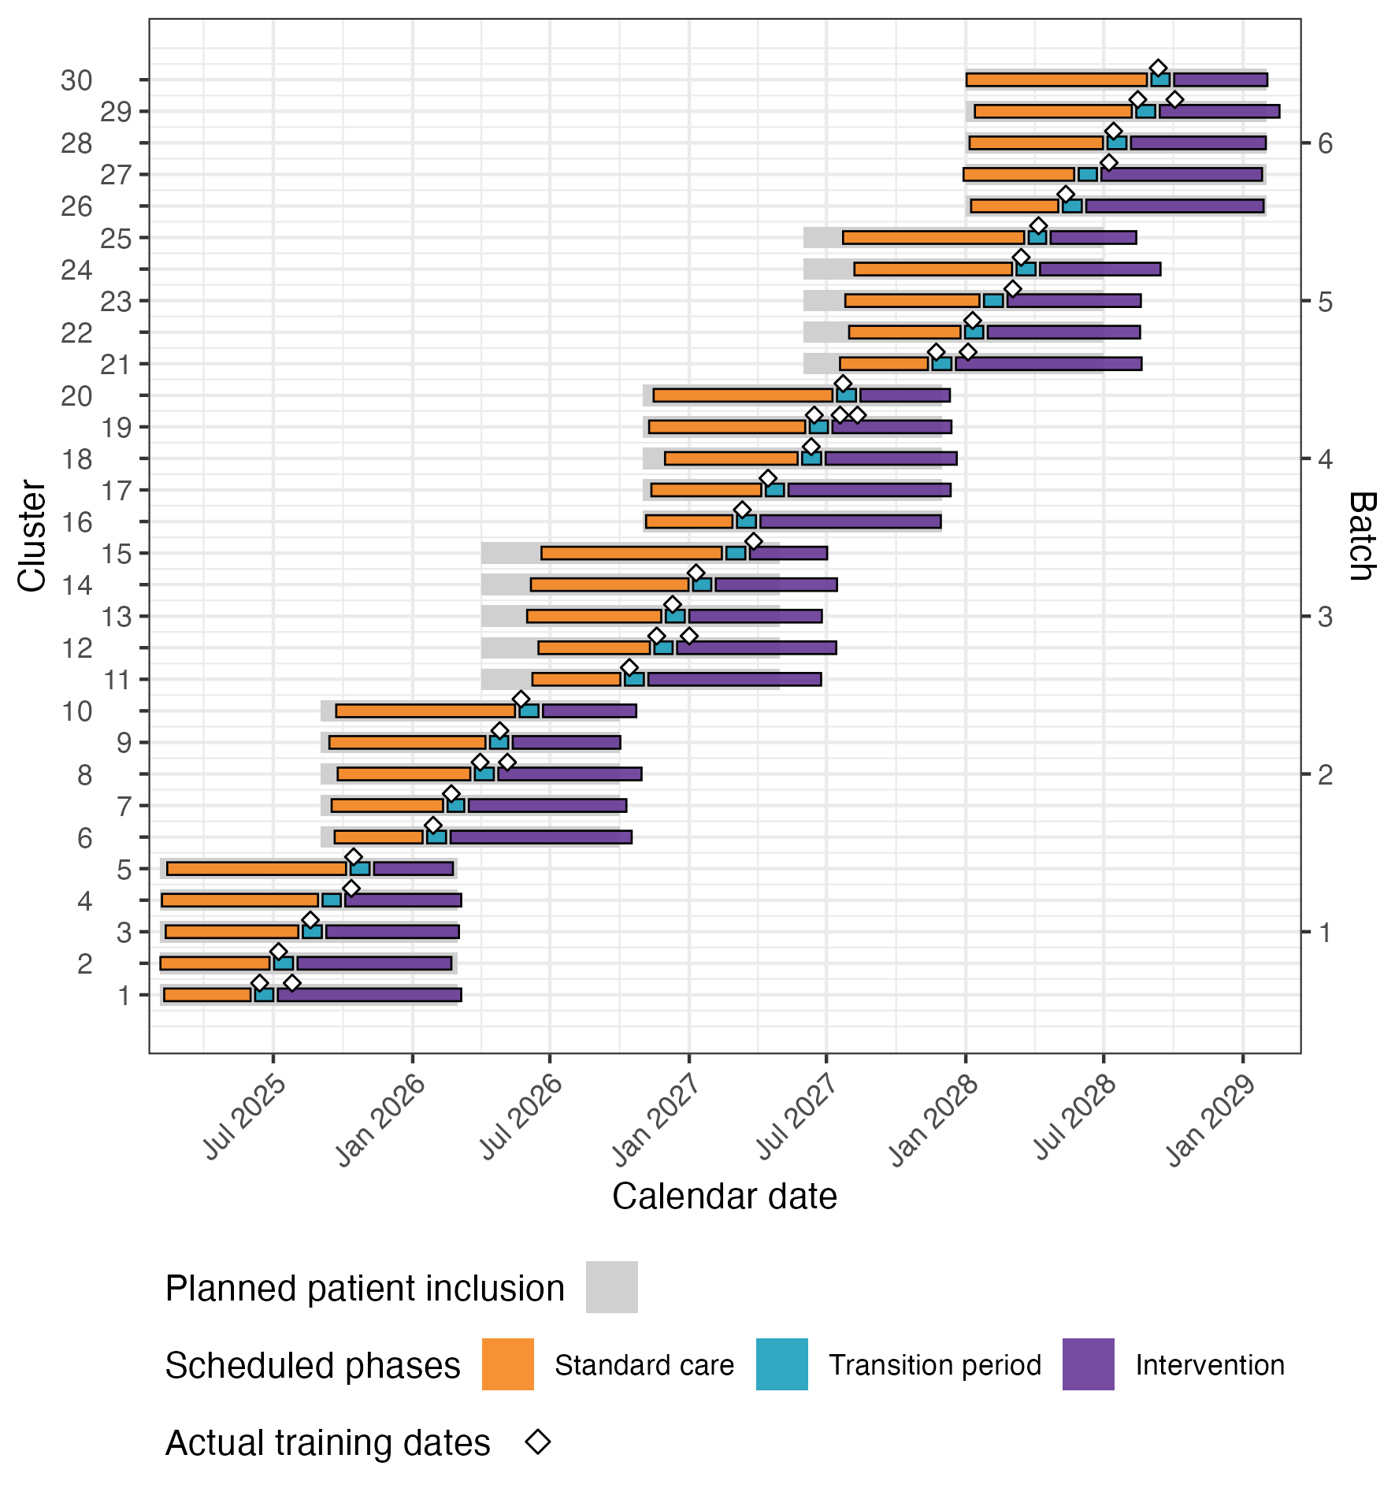
Figure 5: Shell figure of the actual trial roll-out. Light grey bars show the planned patient-inclusion periods. Coloured bars show the observed standard-care, transition, and intervention periods. A diamond on a cluster’s bar marks each ATLS® training course, and a cluster may have more than one course. Placeholder dates will be replaced with observed dates. Intended for the supplementary material.

10.2 CONSORT diagrams
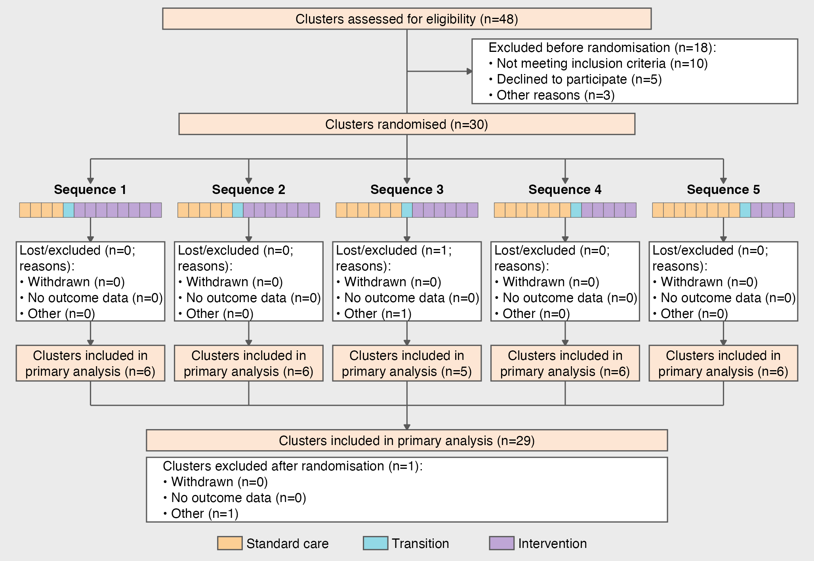
Figure 6: Cluster-level CONSORT diagram shell with simulated counts. Boxes cover clusters assessed and randomised, losses and exclusions after randomisation with reasons, and clusters included in the primary analysis, by sequence and overall. The flowchart summarises data across all batches. Intended for the main text.

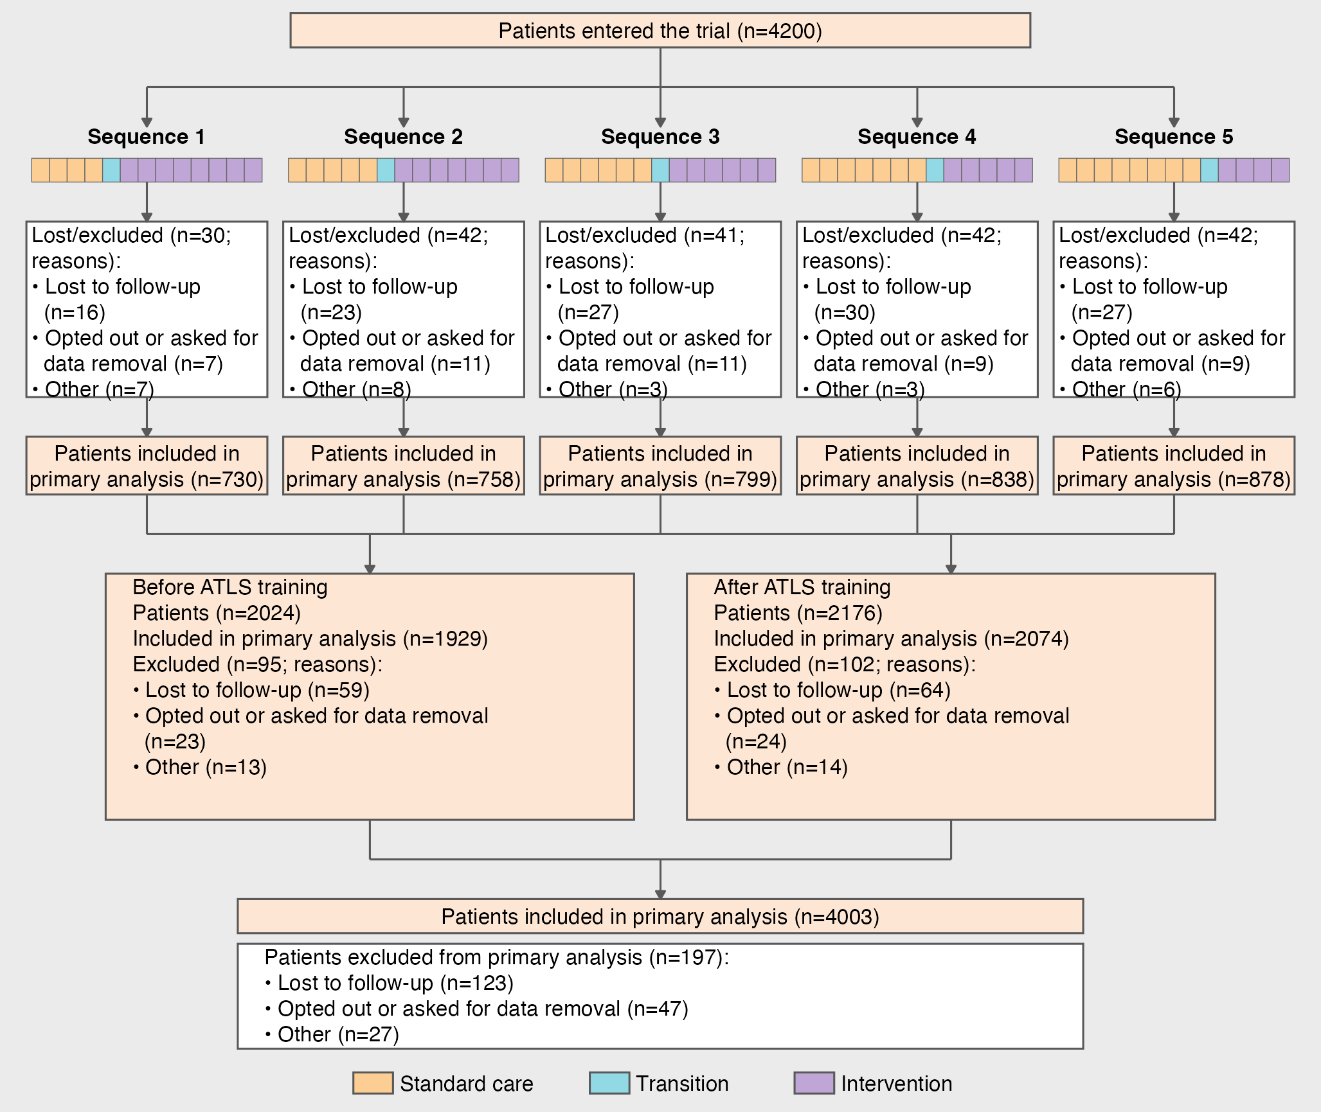
Figure 7: Patient-level CONSORT diagram shell with simulated counts. Boxes cover patients entered, losses and exclusions from the primary analysis with reasons, and patients analysed, by sequence, before and after ATLS® training, and overall. The flowchart summarises data across all batches. Intended for the main text.

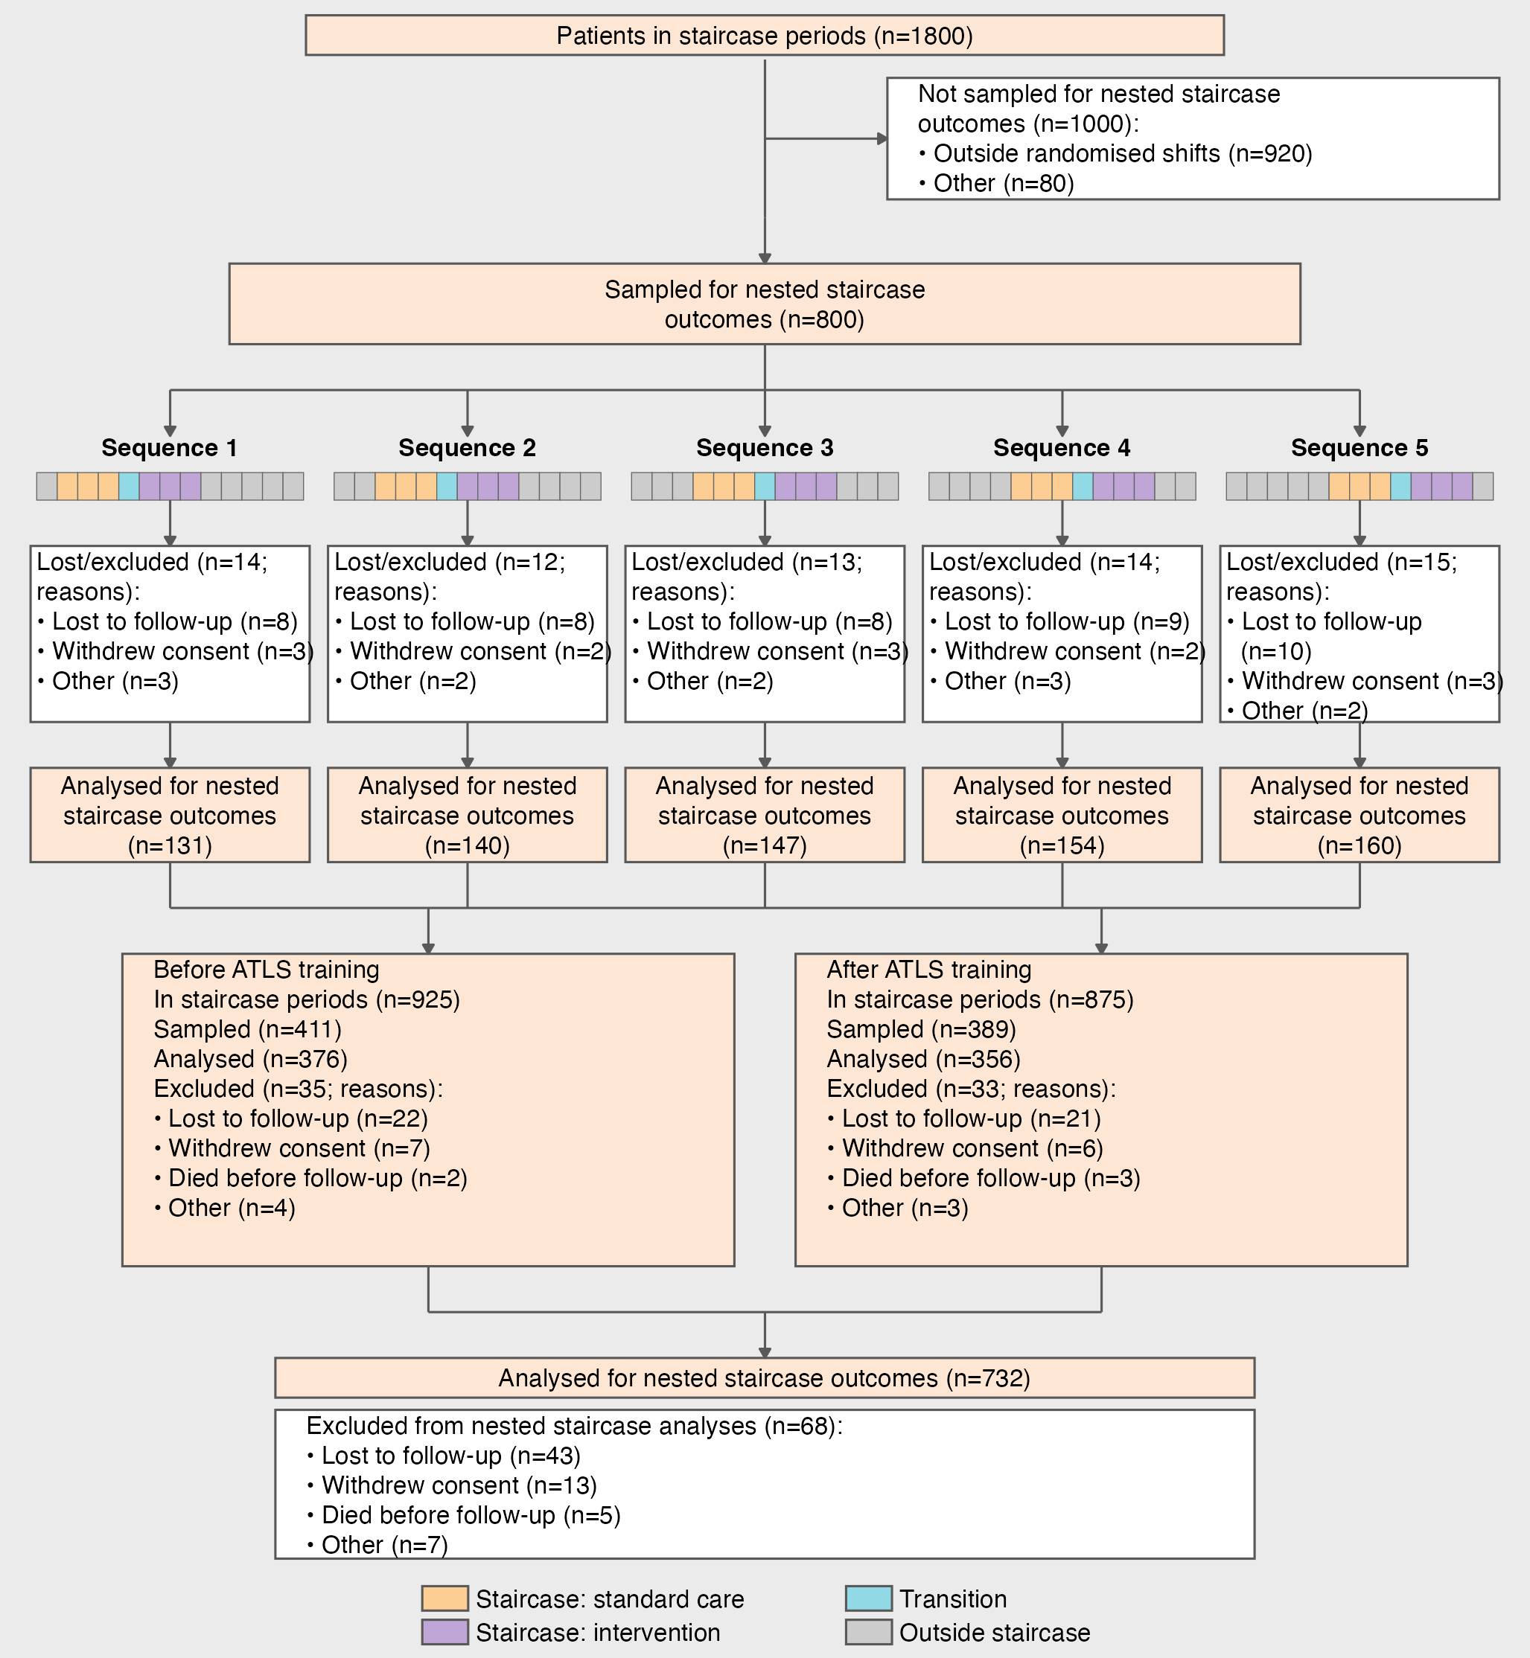
Figure 8: Nested-staircase CONSORT diagram shell with simulated counts. Boxes cover patients in staircase periods, the shift-stratified nested sample, losses and exclusions with reasons, and patients analysed for nested-staircase secondary outcomes, by sequence, before and after ATLS® training, and overall. Coloured strip cells mark staircase months, and grey cells are outside nested data collection. The flowchart summarises data across all batches. Intended for the supplementary material.

10.3 Shell tables and figures for analysis results
Table 2: Cluster characteristics. Intended for the main text.
 | Implementation sequence
Characteristic | Sequence 1 | Sequence 2 | Sequence 3 | Sequence 4 | Sequence 5 | Overall
State, n (%)
States depend on participating clusters | 6 (100%) | 6 (100%) | 6 (100%) | 6 (100%) | 6 (100%) | 30 (100%)
Monthly trauma patient volume, Median (Q1, Q3) | 85 (56, 89) | 98 (92, 140) | 129 (96, 143) | 94 (60, 143) | 81 (54, 94) | 93 (77, 135)
Hospital beds, Median (Q1, Q3) | 96 (72, 145) | 89 (75, 125) | 129 (81, 133) | 90 (51, 119) | 93 (60, 137) | 96 (72, 133)
Intensive care unit beds, Median (Q1, Q3) | 59 (41, 74) | 96 (79, 107) | 57 (48, 72) | 88 (82, 131) | 72 (52, 103) | 77 (50, 101)
Dedicated trauma beds, Median (Q1, Q3) | 134 (89, 162) | 87 (43, 179) | 95 (84, 141) | 106 (46, 175) | 121 (66, 136) | 111 (66, 154)
Specialities available around the clock, n (%)
General surgery | 1 (17%) | 0 (0%) | 2 (33%) | 3 (50%) | 1 (17%) | 7 (23%)
Orthopaedics | 1 (17%) | 1 (17%) | 2 (33%) | 1 (17%) | 3 (50%) | 8 (27%)
Neurosurgery | 2 (33%) | 3 (50%) | 1 (17%) | 0 (0%) | 1 (17%) | 7 (23%)
Vascular surgery | 1 (17%) | 2 (33%) | 1 (17%) | 2 (33%) | 1 (17%) | 7 (23%)
Interventional radiology | 1 (17%) | 0 (0%) | 0 (0%) | 0 (0%) | 0 (0%) | 1 (3.3%)
Emergency medicine | 0 (0%) | 0 (0%) | 0 (0%) | 0 (0%) | 0 (0%) | 0 (0%)
Facilities available around the clock, n (%)
X-ray | 2 (33%) | 1 (17%) | 1 (17%) | 2 (33%) | 0 (0%) | 6 (20%)
Ultrasound/FAST | 2 (33%) | 2 (33%) | 2 (33%) | 2 (33%) | 0 (0%) | 8 (27%)
CT | 1 (17%) | 1 (17%) | 1 (17%) | 1 (17%) | 1 (17%) | 5 (17%)
MRI | 1 (17%) | 2 (33%) | 0 (0%) | 0 (0%) | 3 (50%) | 6 (20%)
Blood bank | 0 (0%) | 0 (0%) | 2 (33%) | 1 (17%) | 2 (33%) | 5 (17%)
Initial resuscitation provider, n (%)
Casualty medical officers | 5 (83%) | 3 (50%) | 4 (67%) | 5 (83%) | 4 (67%) | 21 (70%)
Emergency medicine residents | 1 (17%) | 3 (50%) | 2 (33%) | 1 (17%) | 2 (33%) | 9 (30%)
Surgical residents | 0 (0%) | 0 (0%) | 0 (0%) | 0 (0%) | 0 (0%) | 0 (0%)

Table 3: Key patient characteristics. Intended for the main text.
 | ATLS training
Characteristic | Before ATLS | After ATLS | Overall
Age (years), Median (Q1, Q3) | 38 (29, 48) | 40 (28, 49) | 38 (29, 48)
Missing | 6 | 4 | 10
Sex, n (%)
Female | 48 (42%) | 57 (49%) | 105 (46%)
Male | 46 (41%) | 39 (33%) | 85 (37%)
Other | 19 (17%) | 21 (18%) | 40 (17%)
Missing | 7 | 3 | 10
Transferred in, n (%) | 43 (37%) | 34 (30%) | 77 (33%)
Missing | 5 | 5 | 10
Mechanism of injury, n (%)
Road traffic injury | 49 (43%) | 45 (39%) | 94 (41%)
Fall | 26 (23%) | 31 (27%) | 57 (25%)
Assault | 32 (28%) | 27 (23%) | 59 (26%)
Other | 7 (6.1%) | 13 (11%) | 20 (8.7%)
Missing | 6 | 4 | 10
Injury Severity Score, Median (Q1, Q3) | 9 (5, 17) | 10 (6, 15) | 10 (6, 16)
Missing | 4 | 6 | 10
Glasgow Coma Scale score, Median (Q1, Q3) | 14.00 (12.00, 15.00) | 13.00 (12.00, 15.00) | 13.00 (12.00, 15.00)
Missing | 6 | 4 | 10
Systolic blood pressure (mmHg), Median (Q1, Q3) | 118 (102, 134) | 122 (108, 134) | 120 (105, 134)
Missing | 5 | 5 | 10
Respiratory rate (breaths/min), Median (Q1, Q3) | 20.1 (16.7, 22.2) | 20.7 (16.9, 24.0) | 20.2 (16.8, 23.0)
Missing | 5 | 5 | 10
Oxygen saturation (%), Median (Q1, Q3) | 95.1 (92.3, 98.7) | 96.2 (93.7, 98.6) | 95.7 (92.7, 98.7)
Missing | 5 | 5 | 10
Surgery, n (%) | 39 (34%) | 34 (30%) | 73 (32%)
Missing | 4 | 6 | 10
Transfusion, n (%) | 38 (33%) | 38 (33%) | 76 (33%)
Missing | 6 | 4 | 10
Imaging, n (%)
Ultrasound | 59 (52%) | 62 (53%) | 121 (53%)
X-ray | 37 (33%) | 30 (26%) | 67 (29%)
CT | 17 (15%) | 25 (21%) | 42 (18%)
Missing | 7 | 3 | 10

Table 4: All patient characteristics. Intended for the supplementary material.
 | ATLS training
Characteristic | Before ATLS | After ATLS | Overall
Age (years), Median (Q1, Q3) | 38 (29, 48) | 40 (28, 49) | 38 (29, 48)
Missing | 6 | 4 | 10
Sex, n (%)
Female | 48 (42%) | 57 (49%) | 105 (46%)
Male | 46 (41%) | 39 (33%) | 85 (37%)
Other | 19 (17%) | 21 (18%) | 40 (17%)
Missing | 7 | 3 | 10
Marital status, n (%)
Never married | 25 (22%) | 27 (23%) | 52 (23%)
Currently married | 29 (25%) | 37 (32%) | 66 (29%)
Separated | 18 (16%) | 18 (16%) | 36 (16%)
Divorced | 23 (20%) | 24 (21%) | 47 (20%)
Widowed | 12 (10%) | 7 (6.1%) | 19 (8.3%)
Cohabiting | 8 (7.0%) | 2 (1.7%) | 10 (4.3%)
Missing | 5 | 5 | 10
Education level, n (%)
Not attended school | 26 (23%) | 33 (28%) | 59 (26%)
Primary school | 31 (27%) | 18 (16%) | 49 (21%)
Secondary school | 14 (12%) | 16 (14%) | 30 (13%)
Higher secondary school | 20 (18%) | 20 (17%) | 40 (17%)
Graduate | 15 (13%) | 16 (14%) | 31 (13%)
Post graduate and above | 6 (5.3%) | 9 (7.8%) | 15 (6.5%)
Other | 2 (1.8%) | 4 (3.4%) | 6 (2.6%)
Missing | 6 | 4 | 10
Main work status, n (%)
Paid work, such as daily wage earner, teacher, factory worker and government employee | 28 (24%) | 28 (24%) | 56 (24%)
Self-employed, such as own your business or farming | 21 (18%) | 18 (16%) | 39 (17%)
Non-paid work, such as volunteer or charity | 9 (7.8%) | 15 (13%) | 24 (10%)
Student | 12 (10%) | 9 (7.8%) | 21 (9.1%)
Keeping house/homemaker | 13 (11%) | 11 (9.6%) | 24 (10%)
Retired | 10 (8.7%) | 10 (8.7%) | 20 (8.7%)
Unemployed (health reasons) | 12 (10%) | 8 (7.0%) | 20 (8.7%)
Unemployed (other reasons) | 8 (7.0%) | 7 (6.1%) | 15 (6.5%)
Other | 2 (1.7%) | 7 (6.1%) | 9 (3.9%)
No income | 0 (0%) | 2 (1.7%) | 2 (0.9%)
Missing | 5 | 5 | 10
Income level (INR per month), n (%)
Below 10,000 | 20 (17%) | 22 (19%) | 42 (18%)
10,001-20,000 | 28 (24%) | 16 (14%) | 44 (19%)
20,001-30,000 | 19 (16%) | 18 (16%) | 37 (16%)
30,001-50,000 | 17 (15%) | 17 (15%) | 34 (15%)
50,001-80,000 | 14 (12%) | 16 (14%) | 30 (13%)
80,001-1,00,000 | 9 (7.7%) | 13 (12%) | 22 (9.6%)
Above 1,00,000 | 9 (7.7%) | 9 (8.0%) | 18 (7.8%)
No income | 1 (0.9%) | 2 (1.8%) | 3 (1.3%)
Missing | 3 | 7 | 10
Comorbidities (Charlson Comorbidity Index), n (%)
Myocardial infarction | 14 (12%) | 13 (12%) | 27 (12%)
Congestive heart failure | 7 (5.9%) | 10 (9.0%) | 17 (7.4%)
Peripheral vascular disease | 9 (7.6%) | 8 (7.2%) | 17 (7.4%)
Cerebrovascular disease | 15 (13%) | 9 (8.1%) | 24 (10%)
Dementia | 12 (10%) | 8 (7.2%) | 20 (8.7%)
Chronic pulmonary disease | 11 (9.2%) | 7 (6.3%) | 18 (7.8%)
Rheumatologic disease | 15 (13%) | 7 (6.3%) | 22 (9.6%)
Peptic ulcer disease | 6 (5.0%) | 10 (9.0%) | 16 (7.0%)
Liver disease | 5 (4.2%) | 6 (5.4%) | 11 (4.8%)
Diabetes | 5 (4.2%) | 5 (4.5%) | 10 (4.3%)
Hemiplegia or paraplegia | 4 (3.4%) | 8 (7.2%) | 12 (5.2%)
Renal disease | 1 (0.8%) | 7 (6.3%) | 8 (3.5%)
Malignancy | 2 (1.7%) | 1 (0.9%) | 3 (1.3%)
Leukemia | 1 (0.8%) | 4 (3.6%) | 5 (2.2%)
Lymphoma | 4 (3.4%) | 4 (3.6%) | 8 (3.5%)
AIDS | 4 (3.4%) | 1 (0.9%) | 5 (2.2%)
None | 3 (2.5%) | 3 (2.7%) | 6 (2.6%)
Other | 1 (0.8%) | 0 (0%) | 1 (0.4%)
Missing | 1 | 9 | 10
Severity of liver disease, n (%)
None | 64 (56%) | 61 (53%) | 125 (54%)
Mild | 26 (23%) | 36 (31%) | 62 (27%)
Moderate or severe | 24 (21%) | 19 (16%) | 43 (19%)
Missing | 6 | 4 | 10
Severity of diabetes, n (%)
None | 58 (51%) | 65 (56%) | 123 (53%)
Controlled | 38 (33%) | 31 (27%) | 69 (30%)
Uncontrolled | 18 (16%) | 20 (17%) | 38 (17%)
Missing | 6 | 4 | 10
Severity of malignancy, n (%)
None | 51 (44%) | 45 (39%) | 96 (42%)
Localized | 43 (37%) | 45 (39%) | 88 (38%)
Metastatic tumor | 21 (18%) | 25 (22%) | 46 (20%)
Missing | 5 | 5 | 10
Clinical Frailty Scale, n (%)
1. Very Fit | 23 (20%) | 24 (21%) | 47 (20%)
2. Fit | 19 (16%) | 20 (18%) | 39 (17%)
3. Managing well | 20 (17%) | 18 (16%) | 38 (17%)
4. Living with very mild frailty | 24 (21%) | 15 (13%) | 39 (17%)
5. Living with mild frailty | 6 (5.1%) | 11 (9.7%) | 17 (7.4%)
6. Living with moderate frailty | 12 (10%) | 7 (6.2%) | 19 (8.3%)
7. Living with severe frailty | 6 (5.1%) | 10 (8.8%) | 16 (7.0%)
8. Living with very severe frailty | 4 (3.4%) | 4 (3.5%) | 8 (3.5%)
9. Terminally ill | 3 (2.6%) | 4 (3.5%) | 7 (3.0%)
Missing | 3 | 7 | 10
Mode of transport, n (%)
Ambulance | 37 (32%) | 47 (41%) | 84 (37%)
Police | 26 (23%) | 23 (20%) | 49 (21%)
Private vehicle | 24 (21%) | 24 (21%) | 48 (21%)
Walking | 21 (18%) | 12 (10%) | 33 (14%)
Others | 6 (5.3%) | 10 (8.6%) | 16 (7.0%)
Missing | 6 | 4 | 10
Transferred in, n (%) | 36 (32%) | 33 (28%) | 69 (30%)
Missing | 7 | 3 | 10
Mechanism of injury, n (%)
Road traffic injury | 47 (41%) | 50 (43%) | 97 (42%)
Fall | 30 (26%) | 29 (25%) | 59 (26%)
Assault | 23 (20%) | 23 (20%) | 46 (20%)
Other | 14 (12%) | 14 (12%) | 28 (12%)
Missing | 6 | 4 | 10
Injury Severity Score, Median (Q1, Q3) | 9 (6, 15) | 9 (6, 17) | 9 (6, 15)
Missing | 6 | 4 | 10
Injury source data, n (%)
Medical record | 50 (43%) | 45 (39%) | 95 (41%)
X-ray report | 31 (27%) | 32 (28%) | 63 (27%)
CT-report | 23 (20%) | 22 (19%) | 45 (20%)
Surgical notes | 11 (9.6%) | 16 (14%) | 27 (12%)
Missing | 5 | 5 | 10
Glasgow Coma Scale score, Median (Q1, Q3) | 14.00 (12.00, 15.00) | 14.00 (12.00, 15.00) | 14.00 (12.00, 15.00)
Missing | 5 | 5 | 10
Systolic blood pressure (mmHg), Median (Q1, Q3) | 123 (109, 135) | 114 (102, 134) | 120 (105, 135)
Missing | 2 | 8 | 10
Diastolic blood pressure (mmHg), Median (Q1, Q3) | 72 (64, 81) | 74 (65, 83) | 73 (65, 82)
Missing | 7 | 3 | 10
Heart rate (beats/min), Median (Q1, Q3) | 91 (80, 103) | 89 (80, 100) | 90 (80, 102)
Missing | 5 | 5 | 10
Respiratory rate (breaths/min), Median (Q1, Q3) | 20.6 (16.3, 23.5) | 19.4 (16.3, 22.7) | 20.4 (16.3, 23.0)
Missing | 5 | 5 | 10
Oxygen saturation (%), Median (Q1, Q3) | 95.5 (93.5, 98.1) | 96.4 (93.7, 98.6) | 95.9 (93.6, 98.5)
Missing | 7 | 3 | 10
Body temperature (°F), Median (Q1, Q3) | 98.45 (97.71, 99.16) | 98.40 (97.63, 99.33) | 98.43 (97.70, 99.28)
Missing | 4 | 6 | 10
Emergency department disposition, n (%)
Admitted | 40 (35%) | 41 (36%) | 81 (35%)
Referred or transferred for admission | 38 (33%) | 45 (39%) | 83 (36%)
Dead | 24 (21%) | 20 (17%) | 44 (19%)
Others | 13 (11%) | 9 (7.8%) | 22 (9.6%)
Missing | 5 | 5 | 10
Type of admitting ward, n (%)
General surgery | 26 (23%) | 38 (32%) | 64 (28%)
Orthopaedics | 22 (19%) | 22 (19%) | 44 (19%)
Neurosurgery | 22 (19%) | 18 (15%) | 40 (17%)
Intensive care unit | 12 (11%) | 16 (14%) | 28 (12%)
High dependency unit | 16 (14%) | 10 (8.5%) | 26 (11%)
Medicine | 10 (8.8%) | 7 (6.0%) | 17 (7.4%)
Trauma ward | 5 (4.4%) | 6 (5.1%) | 11 (4.8%)
Missing | 7 | 3 | 10
Hospital disposition, n (%)
Alive | 51 (44%) | 59 (51%) | 110 (48%)
Dead | 43 (37%) | 40 (35%) | 83 (36%)
Transferred for admission | 21 (18%) | 16 (14%) | 37 (16%)
Missing | 5 | 5 | 10
Transferred to another hospital, n (%) | 34 (29%) | 40 (35%) | 74 (32%)
Missing | 4 | 6 | 10
Surgery, n (%) | 47 (41%) | 34 (29%) | 81 (35%)
Missing | 6 | 4 | 10
Preoperative ASA score, n (%)
1. A normal healthy patient | 39 (35%) | 37 (32%) | 76 (33%)
2. A patient with mild systemic disease | 24 (21%) | 30 (26%) | 54 (23%)
3. A patient with severe systemic disease | 21 (19%) | 19 (16%) | 40 (17%)
4. A patient with severe systemic disease that is a constant threat to life | 10 (8.8%) | 15 (13%) | 25 (11%)
5. A moribund patient who is not expected to survive without the operation | 14 (12%) | 10 (8.5%) | 24 (10%)
6. A declared brain-dead patient whose organs are being removed for donor purposes | 5 (4.4%) | 6 (5.1%) | 11 (4.8%)
Missing | 7 | 3 | 10
Transfusion, n (%) | 37 (32%) | 35 (30%) | 72 (31%)
Missing | 6 | 4 | 10
Type of blood product, n (%)
Packed red blood cells | 40 (34%) | 37 (32%) | 77 (33%)
Platelets | 36 (31%) | 32 (28%) | 68 (30%)
Fresh frozen plasma | 19 (16%) | 25 (22%) | 44 (19%)
Whole blood | 13 (11%) | 9 (7.9%) | 22 (9.6%)
Other | 8 (6.9%) | 11 (9.6%) | 19 (8.3%)
Missing | 4 | 6 | 10
Number of units transfused, Median (Q1, Q3) | 2.00 (1.00, 4.00) | 2.00 (1.00, 3.00) | 2.00 (1.00, 3.00)
Missing | 4 | 6 | 10
Imaging, n (%)
Ultrasound | 56 (48%) | 60 (53%) | 116 (50%)
X-ray | 43 (37%) | 37 (32%) | 80 (35%)
CT | 17 (15%) | 17 (15%) | 34 (15%)
Missing | 4 | 6 | 10

Table 5: Intercurrent events by outcome. Intended for the supplementary material.
 | ATLS training
Intercurrent event | Before ATLS | After ATLS | Overall
Primary outcome
In-hospital mortality within 30 days
Loss to follow-up, n (%) | 42 (35%) | 36 (30%) | 78 (33%)
Secondary outcomes (main stepped-wedge design)
All-cause mortality within 24 hours
Withdrawal of consent for non-routine data collection, n (%) | 42 (35%) | 39 (33%) | 81 (34%)
Loss to follow-up, n (%) | 37 (31%) | 45 (38%) | 82 (34%)
All-cause mortality within 30 days
Withdrawal of consent for non-routine data collection, n (%) | 42 (35%) | 34 (28%) | 76 (32%)
Loss to follow-up, n (%) | 40 (33%) | 46 (38%) | 86 (36%)
All-cause mortality within three months
Withdrawal of consent for non-routine data collection, n (%) | 43 (36%) | 39 (33%) | 82 (34%)
Loss to follow-up, n (%) | 39 (33%) | 39 (33%) | 78 (33%)
Length of emergency department stay
Death, n (%) | 38 (32%) | 32 (27%) | 70 (29%)
Transfer to another hospital, n (%) | 43 (36%) | 39 (33%) | 82 (34%)
Length of hospital stay
Death, n (%) | 38 (32%) | 39 (33%) | 77 (32%)
Transfer to another hospital, n (%) | 35 (29%) | 41 (34%) | 76 (32%)
Intensive care unit (ICU) admission
Death, n (%) | 42 (35%) | 31 (26%) | 73 (30%)
Transfer to another hospital, n (%) | 38 (32%) | 37 (31%) | 75 (31%)
Length of intensive care unit stay
Death, n (%) | 37 (31%) | 37 (31%) | 74 (31%)
Transfer to another hospital, n (%) | 36 (30%) | 38 (32%) | 74 (31%)
Return to work at 30 days
Death before 30 days, n (%) | 39 (33%) | 38 (32%) | 77 (32%)
Withdrawal of consent for non-routine data collection, n (%) | 36 (30%) | 41 (34%) | 77 (32%)
Loss to follow-up, n (%) | 39 (33%) | 40 (33%) | 79 (33%)
Return to work at three months
Death before three months, n (%) | 40 (33%) | 47 (39%) | 87 (36%)
Withdrawal of consent for non-routine data collection, n (%) | 35 (29%) | 53 (44%) | 88 (37%)
Loss to follow-up, n (%) | 41 (34%) | 47 (39%) | 88 (37%)
Secondary outcomes during initial resuscitation (nested staircase design)
Adherence to ATLS® principles
Incomplete observation of resuscitation, n (%) | 42 (35%) | 42 (35%) | 84 (35%)
Secondary outcomes within seven days of discharge (nested staircase design)
Quality of life
Death before assessment, n (%) | 33 (28%) | 38 (32%) | 71 (30%)
Withdrawal of consent for non-routine data collection, n (%) | 36 (30%) | 38 (32%) | 74 (31%)
Loss to follow-up, n (%) | 45 (38%) | 37 (31%) | 82 (34%)
Disability
Death before assessment, n (%) | 43 (36%) | 44 (37%) | 87 (36%)
Withdrawal of consent for non-routine data collection, n (%) | 30 (25%) | 39 (33%) | 69 (29%)
Loss to follow-up, n (%) | 41 (34%) | 43 (36%) | 84 (35%)
Secondary outcomes at 30 days after arrival at the emergency department (nested staircase design)
Quality of life
Death before 30 days, n (%) | 39 (33%) | 36 (30%) | 75 (31%)
Withdrawal of consent for non-routine data collection, n (%) | 44 (37%) | 30 (25%) | 74 (31%)
Loss to follow-up, n (%) | 38 (32%) | 33 (28%) | 71 (30%)
Disability
Death before 30 days, n (%) | 36 (30%) | 43 (36%) | 79 (33%)
Withdrawal of consent for non-routine data collection, n (%) | 45 (38%) | 42 (35%) | 87 (36%)
Loss to follow-up, n (%) | 38 (32%) | 34 (28%) | 72 (30%)
Secondary outcomes at three months after arrival at the emergency department (nested staircase design)
Quality of life
Death before three months, n (%) | 42 (35%) | 40 (33%) | 82 (34%)
Withdrawal of consent for non-routine data collection, n (%) | 43 (36%) | 35 (29%) | 78 (33%)
Loss to follow-up, n (%) | 32 (27%) | 40 (33%) | 72 (30%)
Disability
Death before three months, n (%) | 45 (38%) | 44 (37%) | 89 (37%)
Withdrawal of consent for non-routine data collection, n (%) | 27 (23%) | 38 (32%) | 65 (27%)
Loss to follow-up, n (%) | 42 (35%) | 36 (30%) | 78 (33%)

Table 6: Descriptive summaries of key outcomes. Intended for the main text.
 | ATLS training
Outcome | Before ATLS | After ATLS | Overall
Primary outcome
In-hospital mortality within 30 days, n (%) | 39 (34%) | 35 (30%) | 74 (32%)
Missing | 6 | 4 | 10
Secondary outcomes (main stepped-wedge design)
All-cause mortality within 24 hours, n (%) | 42 (37%) | 34 (29%) | 76 (33%)
Missing | 6 | 4 | 10
All-cause mortality within 30 days, n (%) | 41 (36%) | 42 (36%) | 83 (36%)
Missing | 6 | 4 | 10
All-cause mortality within three months, n (%) | 40 (35%) | 40 (34%) | 80 (35%)
Missing | 7 | 3 | 10
Length of emergency department stay (hours), Median (Q1, Q3) | 49 (41, 59) | 48 (38, 59) | 49 (39, 59)
Missing | 6 | 4 | 10
Length of hospital stay (days), Median (Q1, Q3) | 51 (42, 63) | 51 (42, 59) | 51 (42, 61)
Missing | 6 | 4 | 10
Intensive care unit admission, n (%) | 43 (37%) | 35 (31%) | 78 (34%)
Missing | 3 | 7 | 10
Length of intensive care unit stay (days), Median (Q1, Q3) | 50 (43, 59) | 53 (40, 62) | 51 (41, 60)
Missing | 6 | 4 | 10
Return to work at 30 days, n (%) | 33 (29%) | 30 (26%) | 63 (27%)
Missing | 7 | 3 | 10
Return to work at three months, n (%) | 39 (35%) | 35 (30%) | 74 (32%)
Missing | 7 | 3 | 10
Secondary outcomes during initial resuscitation (nested staircase design)
Adherence to ATLS principles (%), Median (Q1, Q3) | 49 (38, 58) | 49 (38, 62) | 49 (38, 59)
Missing | 7 | 3 | 10
Secondary outcomes within seven days of discharge (nested staircase design)
EQ-5D-5L VAS, Median (Q1, Q3) | 61 (50, 73) | 64 (52, 77) | 63 (51, 76)
Missing | 3 | 7 | 10
WHODAS 2.0 summary score, Median (Q1, Q3) | 27 (16, 38) | 25 (18, 37) | 26 (17, 38)
Missing | 4 | 6 | 10
Secondary outcomes at 30 days after arrival at the emergency department (nested staircase design)
EQ-5D-5L VAS, Median (Q1, Q3) | 63 (50, 76) | 64 (53, 77) | 64 (53, 77)
Missing | 5 | 5 | 10
WHODAS 2.0 summary score, Median (Q1, Q3) | 26 (17, 35) | 28 (18, 38) | 27 (18, 37)
Missing | 6 | 4 | 10
Secondary outcomes at three months after arrival at the emergency department (nested staircase design)
EQ-5D-5L VAS, Median (Q1, Q3) | 60 (48, 72) | 62 (52, 74) | 61 (50, 73)
Missing | 5 | 5 | 10
WHODAS 2.0 summary score, Median (Q1, Q3) | 25 (17, 35) | 31 (19, 39) | 27 (18, 37)
Missing | 3 | 7 | 10

Table 7: Descriptive summaries of all outcomes. Intended for the supplementary material.
 | ATLS training
Outcome | Before ATLS | After ATLS | Overall
Primary outcome
In-hospital mortality within 30 days, n (%) | 39 (34%) | 35 (30%) | 74 (32%)
Missing | 6 | 4 | 10
Secondary outcomes (main stepped-wedge design)
All-cause mortality within 24 hours, n (%) | 42 (37%) | 34 (29%) | 76 (33%)
Missing | 6 | 4 | 10
All-cause mortality within 30 days, n (%) | 41 (36%) | 42 (36%) | 83 (36%)
Missing | 6 | 4 | 10
All-cause mortality within three months, n (%) | 40 (35%) | 40 (34%) | 80 (35%)
Missing | 7 | 3 | 10
Length of emergency department stay (hours), Median (Q1, Q3) | 49 (41, 59) | 48 (38, 59) | 49 (39, 59)
Missing | 6 | 4 | 10
Length of hospital stay (days), Median (Q1, Q3) | 51 (42, 63) | 51 (42, 59) | 51 (42, 61)
Missing | 6 | 4 | 10
Intensive care unit admission, n (%) | 43 (37%) | 35 (31%) | 78 (34%)
Missing | 3 | 7 | 10
Length of intensive care unit stay (days), Median (Q1, Q3) | 50 (43, 59) | 53 (40, 62) | 51 (41, 60)
Missing | 6 | 4 | 10
Return to work at 30 days, n (%) | 33 (29%) | 30 (26%) | 63 (27%)
Missing | 7 | 3 | 10
Return to work at three months, n (%) | 39 (35%) | 35 (30%) | 74 (32%)
Missing | 7 | 3 | 10
Secondary outcomes during initial resuscitation (nested staircase design)
Adherence to ATLS principles (%), Median (Q1, Q3) | 49 (38, 58) | 49 (38, 62) | 49 (38, 59)
Missing | 7 | 3 | 10
Secondary outcomes within seven days of discharge (nested staircase design)
EQ-5D-5L VAS, Median (Q1, Q3) | 61 (50, 73) | 64 (52, 77) | 63 (51, 76)
Missing | 3 | 7 | 10
WHODAS 2.0 summary score, Median (Q1, Q3) | 27 (16, 38) | 25 (18, 37) | 26 (17, 38)
Missing | 4 | 6 | 10
EQ-5D-5L mobility, n (%)
1. I have no problems in walking about | 33 (29%) | 40 (34%) | 73 (32%)
2. I have slight problems in walking about | 28 (25%) | 30 (26%) | 58 (25%)
3. I have moderate problems in walking about | 22 (19%) | 22 (19%) | 44 (19%)
4. I have severe problems in walking about | 23 (20%) | 15 (13%) | 38 (17%)
5. I am unable to walk about | 8 (7.0%) | 9 (7.8%) | 17 (7.4%)
Missing | 6 | 4 | 10
EQ-5D-5L self-care, n (%)
1. I have no problems washing or dressing myself | 23 (20%) | 37 (32%) | 60 (26%)
2. I have slight problems washing or dressing myself | 32 (28%) | 33 (29%) | 65 (28%)
3. I have moderate problems washing or dressing myself | 31 (27%) | 15 (13%) | 46 (20%)
4. I have severe problems washing or dressing myself | 19 (17%) | 23 (20%) | 42 (18%)
5. I am unable to wash or dress myself | 10 (8.7%) | 7 (6.1%) | 17 (7.4%)
Missing | 5 | 5 | 10
EQ-5D-5L usual activities, n (%)
1. I have no problems doing my usual activities | 44 (39%) | 38 (33%) | 82 (36%)
2. I have slight problems doing my usual activities | 32 (28%) | 34 (29%) | 66 (29%)
3. I have moderate problems doing my usual activities | 24 (21%) | 22 (19%) | 46 (20%)
4. I have severe problems doing my usual activities | 11 (9.6%) | 14 (12%) | 25 (11%)
5. I am unable to do my usual activities | 3 (2.6%) | 8 (6.9%) | 11 (4.8%)
Missing | 6 | 4 | 10
EQ-5D-5L pain/discomfort, n (%)
1. I have no pain or discomfort | 36 (31%) | 45 (39%) | 81 (35%)
2. I have slight pain or discomfort | 30 (26%) | 28 (25%) | 58 (25%)
3. I have moderate pain or discomfort | 20 (17%) | 18 (16%) | 38 (17%)
4. I have severe pain or discomfort | 18 (16%) | 17 (15%) | 35 (15%)
5. I have extreme pain or discomfort | 12 (10%) | 6 (5.3%) | 18 (7.8%)
Missing | 4 | 6 | 10
EQ-5D-5L anxiety/depression, n (%)
1. I am not anxious or depressed | 46 (40%) | 43 (37%) | 89 (39%)
2. I am slightly anxious or depressed | 21 (18%) | 27 (23%) | 48 (21%)
3. I am moderately anxious or depressed | 24 (21%) | 26 (23%) | 50 (22%)
4. I am severely anxious or depressed | 16 (14%) | 10 (8.7%) | 26 (11%)
5. I am extremely anxious or depressed | 8 (7.0%) | 9 (7.8%) | 17 (7.4%)
Missing | 5 | 5 | 10
Secondary outcomes at 30 days after arrival at the emergency department (nested staircase design)
EQ-5D-5L VAS, Median (Q1, Q3) | 63 (51, 73) | 59 (50, 69) | 60 (50, 72)
Missing | 2 | 8 | 10
WHODAS 2.0 summary score, Median (Q1, Q3) | 31 (18, 39) | 28 (16, 37) | 29 (17, 38)
Missing | 7 | 3 | 10
EQ-5D-5L mobility, n (%)
1. I have no problems in walking about | 26 (22%) | 49 (43%) | 75 (33%)
2. I have slight problems in walking about | 36 (31%) | 22 (19%) | 58 (25%)
3. I have moderate problems in walking about | 26 (22%) | 23 (20%) | 49 (21%)
4. I have severe problems in walking about | 24 (21%) | 12 (11%) | 36 (16%)
5. I am unable to walk about | 5 (4.3%) | 7 (6.2%) | 12 (5.2%)
Missing | 3 | 7 | 10
EQ-5D-5L self-care, n (%)
1. I have no problems washing or dressing myself | 36 (32%) | 39 (33%) | 75 (33%)
2. I have slight problems washing or dressing myself | 32 (28%) | 30 (26%) | 62 (27%)
3. I have moderate problems washing or dressing myself | 22 (19%) | 24 (21%) | 46 (20%)
4. I have severe problems washing or dressing myself | 17 (15%) | 17 (15%) | 34 (15%)
5. I am unable to wash or dress myself | 6 (5.3%) | 7 (6.0%) | 13 (5.7%)
Missing | 7 | 3 | 10
EQ-5D-5L usual activities, n (%)
1. I have no problems doing my usual activities | 32 (28%) | 35 (30%) | 67 (29%)
2. I have slight problems doing my usual activities | 37 (32%) | 25 (22%) | 62 (27%)
3. I have moderate problems doing my usual activities | 27 (23%) | 32 (28%) | 59 (26%)
4. I have severe problems doing my usual activities | 10 (8.7%) | 12 (10%) | 22 (9.6%)
5. I am unable to do my usual activities | 9 (7.8%) | 11 (9.6%) | 20 (8.7%)
Missing | 5 | 5 | 10
EQ-5D-5L pain/discomfort, n (%)
1. I have no pain or discomfort | 42 (36%) | 42 (38%) | 84 (37%)
2. I have slight pain or discomfort | 29 (25%) | 29 (26%) | 58 (25%)
3. I have moderate pain or discomfort | 22 (19%) | 18 (16%) | 40 (17%)
4. I have severe pain or discomfort | 16 (14%) | 13 (12%) | 29 (13%)
5. I have extreme pain or discomfort | 9 (7.6%) | 10 (8.9%) | 19 (8.3%)
Missing | 2 | 8 | 10
EQ-5D-5L anxiety/depression, n (%)
1. I am not anxious or depressed | 39 (33%) | 33 (29%) | 72 (31%)
2. I am slightly anxious or depressed | 30 (25%) | 33 (29%) | 63 (27%)
3. I am moderately anxious or depressed | 22 (19%) | 26 (23%) | 48 (21%)
4. I am severely anxious or depressed | 21 (18%) | 13 (12%) | 34 (15%)
5. I am extremely anxious or depressed | 6 (5.1%) | 7 (6.3%) | 13 (5.7%)
Missing | 2 | 8 | 10
Secondary outcomes at three months after arrival at the emergency department (nested staircase design)
EQ-5D-5L VAS, Median (Q1, Q3) | 64 (47, 78) | 60 (48, 72) | 62 (47, 74)
Missing | 4 | 6 | 10
WHODAS 2.0 summary score, Median (Q1, Q3) | 31 (20, 39) | 31 (15, 39) | 31 (19, 39)
Missing | 4 | 6 | 10
EQ-5D-5L mobility, n (%)
1. I have no problems in walking about | 51 (44%) | 39 (35%) | 90 (39%)
2. I have slight problems in walking about | 30 (26%) | 29 (26%) | 59 (26%)
3. I have moderate problems in walking about | 13 (11%) | 21 (19%) | 34 (15%)
4. I have severe problems in walking about | 16 (14%) | 15 (13%) | 31 (13%)
5. I am unable to walk about | 7 (6.0%) | 9 (8.0%) | 16 (7.0%)
Missing | 3 | 7 | 10
EQ-5D-5L self-care, n (%)
1. I have no problems washing or dressing myself | 40 (35%) | 41 (36%) | 81 (35%)
2. I have slight problems washing or dressing myself | 30 (26%) | 38 (33%) | 68 (30%)
3. I have moderate problems washing or dressing myself | 22 (19%) | 14 (12%) | 36 (16%)
4. I have severe problems washing or dressing myself | 15 (13%) | 14 (12%) | 29 (13%)
5. I am unable to wash or dress myself | 8 (7.0%) | 8 (7.0%) | 16 (7.0%)
Missing | 5 | 5 | 10
EQ-5D-5L usual activities, n (%)
1. I have no problems doing my usual activities | 39 (34%) | 40 (35%) | 79 (34%)
2. I have slight problems doing my usual activities | 35 (30%) | 36 (31%) | 71 (31%)
3. I have moderate problems doing my usual activities | 19 (17%) | 22 (19%) | 41 (18%)
4. I have severe problems doing my usual activities | 14 (12%) | 8 (7.0%) | 22 (9.6%)
5. I am unable to do my usual activities | 8 (7.0%) | 9 (7.8%) | 17 (7.4%)
Missing | 5 | 5 | 10
EQ-5D-5L pain/discomfort, n (%)
1. I have no pain or discomfort | 35 (30%) | 37 (32%) | 72 (31%)
2. I have slight pain or discomfort | 29 (25%) | 37 (32%) | 66 (29%)
3. I have moderate pain or discomfort | 24 (21%) | 26 (23%) | 50 (22%)
4. I have severe pain or discomfort | 19 (17%) | 11 (9.6%) | 30 (13%)
5. I have extreme pain or discomfort | 8 (7.0%) | 4 (3.5%) | 12 (5.2%)
Missing | 5 | 5 | 10
EQ-5D-5L anxiety/depression, n (%)
1. I am not anxious or depressed | 40 (35%) | 41 (36%) | 81 (35%)
2. I am slightly anxious or depressed | 32 (28%) | 28 (24%) | 60 (26%)
3. I am moderately anxious or depressed | 23 (20%) | 23 (20%) | 46 (20%)
4. I am severely anxious or depressed | 12 (10%) | 16 (14%) | 28 (12%)
5. I am extremely anxious or depressed | 8 (7.0%) | 7 (6.1%) | 15 (6.5%)
Missing | 5 | 5 | 10

Table 8: Shell table of key primary and secondary outcome analysis results. Intended for the main text.
Outcome | Estimate | 95% CI | p-value
Primary outcome
In-hospital mortality within 30 days
Odds ratio | 0.77 | 0.55, 1.07 | 0.12
Absolute risk difference | -0.04 | -0.08, 0.00 | 0.043
Secondary outcomes (main stepped-wedge design)
All-cause mortality within 24 hours
Odds ratio | 0.72 | 0.54, 0.97 | 0.029
Absolute risk difference | -0.01 | -0.05, 0.02 | 0.4
All-cause mortality within 30 days
Odds ratio | 0.74 | 0.49, 1.13 | 0.2
Absolute risk difference | -0.01 | -0.05, 0.02 | 0.4
All-cause mortality within three months
Odds ratio | 1.30 | 1.04, 1.62 | 0.020
Absolute risk difference | -0.02 | -0.07, 0.03 | 0.4
Length of emergency department stay
Rate ratio | 0.84 | 0.68, 1.04 | 0.10
Length of hospital stay
Rate ratio | 0.93 | 0.72, 1.18 | 0.5
Intensive care unit (ICU) admission
Odds ratio | 0.77 | 0.56, 1.06 | 0.11
Absolute risk difference | -0.06 | -0.11, 0.00 | 0.041
Length of intensive care unit stay
Rate ratio | 0.99 | 0.78, 1.25 | >0.9
Return to work at 30 days
Odds ratio | 0.76 | 0.49, 1.20 | 0.2
Absolute risk difference | -0.01 | -0.07, 0.04 | 0.6
Return to work at three months
Odds ratio | 0.94 | 0.69, 1.27 | 0.7
Absolute risk difference | -0.05 | -0.08, -0.01 | 0.021
Secondary outcomes during initial resuscitation (nested staircase design)
Adherence to ATLS® principles
Logit-scale difference | 0.00 | -0.05, 0.06 | >0.9
Secondary outcomes within seven days of discharge (nested staircase design)
Quality of life
Cumulative odds ratio | 0.69 | 0.49, 0.98 | 0.038
Mean difference | 0.01 | -0.02, 0.04 | 0.6
Disability
Mean difference | 0.00 | -0.04, 0.04 | >0.9
Secondary outcomes at 30 days after arrival at the emergency department (nested staircase design)
Quality of life
Cumulative odds ratio | 0.78 | 0.47, 1.31 | 0.4
Mean difference | -0.02 | -0.05, 0.02 | 0.4
Disability
Mean difference | -0.03 | -0.08, 0.01 | 0.14
Secondary outcomes at three months after arrival at the emergency department (nested staircase design)
Quality of life
Cumulative odds ratio | 0.83 | 0.66, 1.04 | 0.11
Mean difference | -0.07 | -0.12, -0.02 | 0.004
Disability
Mean difference | 0.03 | -0.02, 0.08 | 0.3
Abbreviations: CI = Confidence Interval, IRR = Incidence Rate Ratio, OR = Odds Ratio

Table 9: Shell table of all primary and secondary outcome analysis results. Intended for the supplementary material.
Outcome | Estimate | 95% CI | p-value
Primary outcome
In-hospital mortality within 30 days
Odds ratio | 0.77 | 0.55, 1.07 | 0.12
Absolute risk difference | -0.04 | -0.08, 0.00 | 0.043
Secondary outcomes (main stepped-wedge design)
All-cause mortality within 24 hours
Odds ratio | 0.72 | 0.54, 0.97 | 0.029
Absolute risk difference | -0.01 | -0.05, 0.02 | 0.4
All-cause mortality within 30 days
Odds ratio | 0.74 | 0.49, 1.13 | 0.2
Absolute risk difference | -0.01 | -0.05, 0.02 | 0.4
All-cause mortality within three months
Odds ratio | 1.30 | 1.04, 1.62 | 0.020
Absolute risk difference | -0.02 | -0.07, 0.03 | 0.4
Length of emergency department stay
Rate ratio | 0.84 | 0.68, 1.04 | 0.10
Length of hospital stay
Rate ratio | 0.93 | 0.72, 1.18 | 0.5
Intensive care unit (ICU) admission
Odds ratio | 0.77 | 0.56, 1.06 | 0.11
Absolute risk difference | -0.06 | -0.11, 0.00 | 0.041
Length of intensive care unit stay
Rate ratio | 0.99 | 0.78, 1.25 | >0.9
Return to work at 30 days
Odds ratio | 0.76 | 0.49, 1.20 | 0.2
Absolute risk difference | -0.01 | -0.07, 0.04 | 0.6
Return to work at three months
Odds ratio | 0.94 | 0.69, 1.27 | 0.7
Absolute risk difference | -0.05 | -0.08, -0.01 | 0.021
Secondary outcomes during initial resuscitation (nested staircase design)
Adherence to ATLS® principles
Logit-scale difference | 0.00 | -0.05, 0.06 | >0.9
Secondary outcomes within seven days of discharge (nested staircase design)
EQ-5D-5L mobility
Cumulative odds ratio | 0.69 | 0.49, 0.98 | 0.038
EQ-5D-5L self-care
Cumulative odds ratio | 1.06 | 0.81, 1.39 | 0.7
EQ-5D-5L usual activities
Cumulative odds ratio | 0.99 | 0.70, 1.42 | >0.9
EQ-5D-5L pain/discomfort
Cumulative odds ratio | 0.78 | 0.47, 1.31 | 0.4
EQ-5D-5L anxiety/depression
Cumulative odds ratio | 0.89 | 0.67, 1.18 | 0.4
EQ-5D-5L VAS
Mean difference | -0.03 | -0.08, 0.01 | 0.14
Disability
Mean difference | -0.03 | -0.05, 0.00 | 0.087
Secondary outcomes at 30 days after arrival at the emergency department (nested staircase design)
EQ-5D-5L mobility
Cumulative odds ratio | 0.59 | 0.39, 0.88 | 0.010
EQ-5D-5L self-care
Cumulative odds ratio | 1.21 | 0.81, 1.82 | 0.3
EQ-5D-5L usual activities
Cumulative odds ratio | 0.61 | 0.45, 0.83 | 0.002
EQ-5D-5L pain/discomfort
Cumulative odds ratio | 0.68 | 0.55, 0.85 | <0.001
EQ-5D-5L anxiety/depression
Cumulative odds ratio | 0.68 | 0.51, 0.91 | 0.009
EQ-5D-5L VAS
Mean difference | -0.02 | -0.06, 0.02 | 0.3
Disability
Mean difference | -0.02 | -0.07, 0.03 | 0.4
Secondary outcomes at three months after arrival at the emergency department (nested staircase design)
EQ-5D-5L mobility
Cumulative odds ratio | 0.84 | 0.62, 1.15 | 0.3
EQ-5D-5L self-care
Cumulative odds ratio | 0.84 | 0.56, 1.26 | 0.4
EQ-5D-5L usual activities
Cumulative odds ratio | 1.04 | 0.75, 1.44 | 0.8
EQ-5D-5L pain/discomfort
Cumulative odds ratio | 0.91 | 0.62, 1.33 | 0.6
EQ-5D-5L anxiety/depression
Cumulative odds ratio | 0.88 | 0.62, 1.24 | 0.5
EQ-5D-5L VAS
Mean difference | -0.03 | -0.06, 0.00 | 0.074
Disability
Mean difference | -0.02 | -0.05, 0.00 | 0.075
Abbreviations: CI = Confidence Interval, IRR = Incidence Rate Ratio, OR = Odds Ratio

Table 10: Shell table of sensitivity, fully adjusted, and subgroup analysis results for the primary outcome. Intended for the supplementary material.
Analysis | Estimate | 95% CI | p-value
Sensitivity analyses
Autoregressive within-cluster correlation (AR(1))
Odds ratio | 0.77 | 0.55, 1.07 | 0.12
Absolute risk difference | -0.04 | -0.08, 0.00 | 0.043
Random cluster-by-intervention effects
Odds ratio | 0.72 | 0.54, 0.97 | 0.029
Absolute risk difference | -0.01 | -0.05, 0.02 | 0.4
Time modelled with a spline function
Odds ratio | 0.74 | 0.49, 1.13 | 0.2
Absolute risk difference | -0.01 | -0.05, 0.02 | 0.4
Lag and weaning effects (intervention)
Odds ratio | 1.30 | 1.04, 1.62 | 0.020
Absolute risk difference | -0.02 | -0.07, 0.03 | 0.4
Lag and weaning effects (periods since first exposure)
Odds ratio | 0.75 | 0.58, 0.96 | 0.024
Absolute risk difference | -0.02 | -0.06, 0.02 | 0.3
Actual date of transition for intervention exposure
Odds ratio | 0.77 | 0.56, 1.06 | 0.11
Absolute risk difference | -0.06 | -0.11, 0.00 | 0.041
Fully adjusted analysis
Odds ratio | 0.95 | 0.71, 1.27 | 0.7
Absolute risk difference | -0.04 | -0.09, 0.02 | 0.2
Subgroup analyses
Geographical region (state-specific estimates; states depend on participating clusters)
Odds ratio | 0.90 | 0.57, 1.42 | 0.7
Absolute risk difference | -0.01 | -0.05, 0.03 | 0.7
Age group: Older adolescents (15-19 years)
Odds ratio | 0.72 | 0.53, 0.97 | 0.034
Absolute risk difference | 0.00 | -0.05, 0.06 | >0.9
Age group: Young adults (20-24 years)
Odds ratio | 0.69 | 0.49, 0.98 | 0.038
Absolute risk difference | 0.01 | -0.02, 0.04 | 0.6
Age group: Adults (25-59 years)
Odds ratio | 0.99 | 0.70, 1.42 | >0.9
Absolute risk difference | -0.03 | -0.10, 0.03 | 0.3
Age group: Older adults (60 years and older)
Odds ratio | 0.89 | 0.67, 1.18 | 0.4
Absolute risk difference | -0.03 | -0.08, 0.01 | 0.14
Sex: Male
Odds ratio | 0.83 | 0.66, 1.04 | 0.11
Absolute risk difference | -0.07 | -0.12, -0.02 | 0.004
Sex: Female
Odds ratio | 1.21 | 0.81, 1.82 | 0.3
Absolute risk difference | -0.07 | -0.11, -0.03 | <0.001
Clinical cohort: Blunt multisystem trauma
Odds ratio | 0.68 | 0.55, 0.85 | <0.001
Absolute risk difference | -0.05 | -0.09, -0.02 | 0.004
Clinical cohort: Penetrating trauma
Odds ratio | 0.87 | 0.64, 1.17 | 0.4
Absolute risk difference | -0.02 | -0.07, 0.03 | 0.4
Clinical cohort: Severe isolated traumatic brain injury
Odds ratio | 0.84 | 0.62, 1.15 | 0.3
Absolute risk difference | -0.02 | -0.07, 0.03 | 0.4
Major trauma: ISS >=16
Odds ratio | 1.04 | 0.75, 1.44 | 0.8
Absolute risk difference | -0.01 | -0.06, 0.04 | 0.6
Major trauma: ISS <16
Odds ratio | 0.88 | 0.62, 1.24 | 0.5
Absolute risk difference | -0.03 | -0.06, 0.00 | 0.074
Cluster size: Small (<12 patients/month)
Odds ratio | 0.83 | 0.67, 1.03 | 0.10
Absolute risk difference | -0.01 | -0.05, 0.04 | 0.7
Cluster size: Medium (12-20 patients/month)
Odds ratio | 0.75 | 0.54, 1.04 | 0.081
Absolute risk difference | 0.01 | -0.02, 0.05 | 0.4
Cluster size: Large (>20 patients/month)
Odds ratio | 0.85 | 0.71, 1.03 | 0.11
Absolute risk difference | 0.00 | -0.04, 0.04 | 0.9
Abbreviations: CI = Confidence Interval, OR = Odds Ratio

Table 11: Shell table of within-cluster correlation parameters for all outcomes. Intended for the supplementary material.
Parameter | Estimate | 95% CI
In-hospital mortality within 30 days
Cluster variance | 0.32 | 0.12, 0.53
Cluster-by-period variance | 0.29 | 0.09, 0.50
Intra-cluster correlation (ICC) | 0.03 | 0.00, 0.09
Within-period correlation | 0.07 | 0.06, 0.09
Between-period correlation | 0.03 | 0.00, 0.09
Latent-scale ICC | 0.08 | 0.00, 0.15
Latent-scale within-period correlation | 0.12 | 0.07, 0.16
Latent-scale between-period correlation | 0.06 | 0.03, 0.10
AR(1) within-period correlation | 0.03 | 0.02, 0.05
AR(1) correlation decay parameter (rho) | 0.74 | 0.61, 0.86
All-cause mortality within 24 hours
Cluster variance | 0.33 | 0.13, 0.53
Cluster-by-period variance | 0.22 | 0.00, 0.48
Intra-cluster correlation (ICC) | 0.09 | 0.05, 0.13
Within-period correlation | 0.04 | 0.00, 0.09
Between-period correlation | 0.08 | 0.04, 0.11
Latent-scale ICC | 0.09 | 0.05, 0.12
Latent-scale within-period correlation | 0.03 | 0.00, 0.11
Latent-scale between-period correlation | 0.10 | 0.04, 0.16
AR(1) within-period correlation | 0.02 | 0.00, 0.07
AR(1) correlation decay parameter (rho) | 0.87 | 0.70, 1.1
All-cause mortality within 30 days
Cluster variance | 0.50 | 0.28, 0.71
Cluster-by-period variance | 0.34 | 0.05, 0.63
Intra-cluster correlation (ICC) | 0.07 | 0.04, 0.11
Within-period correlation | 0.04 | 0.01, 0.08
Between-period correlation | 0.06 | 0.00, 0.11
Latent-scale ICC | 0.01 | 0.00, 0.05
Latent-scale within-period correlation | 0.12 | 0.09, 0.14
Latent-scale between-period correlation | 0.01 | 0.00, 0.04
AR(1) within-period correlation | 0.02 | 0.00, 0.06
AR(1) correlation decay parameter (rho) | 0.59 | 0.44, 0.73
All-cause mortality within three months
Cluster variance | 0.41 | 0.22, 0.60
Cluster-by-period variance | 0.40 | 0.17, 0.63
Intra-cluster correlation (ICC) | 0.06 | 0.01, 0.10
Within-period correlation | 0.06 | 0.00, 0.15
Between-period correlation | 0.10 | 0.09, 0.12
Latent-scale ICC | 0.08 | 0.02, 0.13
Latent-scale within-period correlation | 0.07 | 0.04, 0.10
Latent-scale between-period correlation | 0.05 | 0.04, 0.07
AR(1) within-period correlation | 0.06 | 0.02, 0.09
AR(1) correlation decay parameter (rho) | 0.80 | 0.61, 1.0
Length of emergency department stay
Cluster variance | 0.30 | 0.10, 0.51
Cluster-by-period variance | 0.56 | 0.39, 0.74
Intra-cluster correlation (ICC) | 0.06 | 0.00, 0.13
Within-period correlation | 0.09 | 0.05, 0.13
Between-period correlation | 0.08 | 0.04, 0.12
AR(1) within-period correlation | 0.03 | 0.00, 0.07
AR(1) correlation decay parameter (rho) | 0.91 | 0.78, 1.0
Length of hospital stay
Cluster variance | 0.42 | 0.34, 0.51
Cluster-by-period variance | 0.36 | 0.19, 0.53
Intra-cluster correlation (ICC) | 0.09 | 0.04, 0.13
Within-period correlation | 0.10 | 0.06, 0.13
Between-period correlation | 0.03 | 0.00, 0.11
AR(1) within-period correlation | 0.07 | 0.04, 0.10
AR(1) correlation decay parameter (rho) | 0.91 | 0.75, 1.1
Intensive care unit (ICU) admission
Cluster variance | 0.41 | 0.29, 0.54
Cluster-by-period variance | 0.37 | 0.19, 0.55
Intra-cluster correlation (ICC) | 0.04 | 0.00, 0.09
Within-period correlation | 0.05 | 0.01, 0.08
Between-period correlation | 0.01 | 0.00, 0.06
Latent-scale ICC | 0.09 | 0.05, 0.14
Latent-scale within-period correlation | 0.05 | 0.00, 0.12
Latent-scale between-period correlation | 0.10 | 0.05, 0.14
AR(1) within-period correlation | 0.11 | 0.07, 0.15
AR(1) correlation decay parameter (rho) | 0.57 | 0.38, 0.75
Length of intensive care unit stay
Cluster variance | 0.26 | 0.10, 0.42
Cluster-by-period variance | 0.68 | 0.47, 0.88
Intra-cluster correlation (ICC) | 0.11 | 0.07, 0.14
Within-period correlation | 0.11 | 0.06, 0.17
Between-period correlation | 0.07 | 0.01, 0.13
AR(1) within-period correlation | 0.02 | 0.00, 0.09
AR(1) correlation decay parameter (rho) | 0.67 | 0.52, 0.83
Return to work at 30 days
Cluster variance | 0.56 | 0.32, 0.81
Cluster-by-period variance | 0.38 | 0.18, 0.59
Intra-cluster correlation (ICC) | 0.09 | 0.04, 0.14
Within-period correlation | 0.03 | 0.02, 0.05
Between-period correlation | 0.08 | 0.02, 0.14
Latent-scale ICC | 0.04 | 0.00, 0.10
Latent-scale within-period correlation | 0.09 | 0.03, 0.16
Latent-scale between-period correlation | 0.11 | 0.06, 0.15
AR(1) within-period correlation | 0.06 | 0.01, 0.11
AR(1) correlation decay parameter (rho) | 0.61 | 0.41, 0.81
Return to work at three months
Cluster variance | 0.25 | 0.05, 0.46
Cluster-by-period variance | 0.12 | 0.00, 0.31
Intra-cluster correlation (ICC) | 0.09 | 0.05, 0.14
Within-period correlation | 0.06 | 0.04, 0.09
Between-period correlation | 0.09 | 0.05, 0.14
Latent-scale ICC | 0.01 | 0.00, 0.05
Latent-scale within-period correlation | 0.06 | 0.03, 0.08
Latent-scale between-period correlation | 0.02 | 0.00, 0.09
AR(1) within-period correlation | 0.07 | 0.00, 0.14
AR(1) correlation decay parameter (rho) | 0.74 | 0.60, 0.88
Adherence to ATLS® principles
Cluster variance | 0.22 | 0.05, 0.40
Cluster-by-period variance | 0.36 | 0.19, 0.53
Intra-cluster correlation (ICC) | 0.11 | 0.06, 0.16
Within-period correlation | 0.03 | 0.00, 0.08
Between-period correlation | 0.07 | 0.00, 0.15
AR(1) within-period correlation | 0.01 | 0.00, 0.07
AR(1) correlation decay parameter (rho) | 0.72 | 0.59, 0.85
Quality of life within seven days of discharge
Cluster variance | 0.43 | 0.21, 0.64
Cluster-by-period variance | 0.34 | 0.14, 0.54
Intra-cluster correlation (ICC) | 0.05 | 0.03, 0.07
Within-period correlation | 0.07 | 0.02, 0.12
Between-period correlation | 0.03 | 0.01, 0.06
Latent-scale ICC | 0.05 | 0.00, 0.11
Latent-scale within-period correlation | 0.02 | 0.00, 0.11
Latent-scale between-period correlation | 0.03 | 0.00, 0.10
AR(1) within-period correlation | 0.07 | 0.05, 0.08
AR(1) correlation decay parameter (rho) | 0.72 | 0.58, 0.86
Quality of life at 30 days
Cluster variance | 0.16 | 0.00, 0.41
Cluster-by-period variance | 0.43 | 0.18, 0.69
Intra-cluster correlation (ICC) | 0.08 | 0.02, 0.13
Within-period correlation | 0.05 | 0.00, 0.12
Between-period correlation | 0.07 | 0.02, 0.13
Latent-scale ICC | 0.07 | 0.04, 0.10
Latent-scale within-period correlation | 0.09 | 0.06, 0.12
Latent-scale between-period correlation | 0.09 | 0.05, 0.13
AR(1) within-period correlation | 0.09 | 0.07, 0.11
AR(1) correlation decay parameter (rho) | 0.57 | 0.35, 0.78
Quality of life at three months
Cluster variance | 0.14 | 0.00, 0.35
Cluster-by-period variance | 0.37 | 0.19, 0.55
Intra-cluster correlation (ICC) | 0.05 | 0.00, 0.13
Within-period correlation | 0.11 | 0.04, 0.18
Between-period correlation | 0.04 | 0.00, 0.10
Latent-scale ICC | 0.02 | 0.00, 0.06
Latent-scale within-period correlation | 0.10 | 0.07, 0.13
Latent-scale between-period correlation | 0.08 | 0.03, 0.13
AR(1) within-period correlation | 0.04 | 0.02, 0.07
AR(1) correlation decay parameter (rho) | 0.82 | 0.61, 1.0
Disability within seven days of discharge
Cluster variance | 0.27 | 0.11, 0.42
Cluster-by-period variance | 0.60 | 0.42, 0.77
Intra-cluster correlation (ICC) | 0.03 | 0.00, 0.06
Within-period correlation | 0.09 | 0.01, 0.16
Between-period correlation | 0.07 | 0.00, 0.13
AR(1) within-period correlation | 0.03 | 0.00, 0.09
AR(1) correlation decay parameter (rho) | 0.67 | 0.60, 0.75
Disability at 30 days
Cluster variance | 0.34 | 0.16, 0.53
Cluster-by-period variance | 0.45 | 0.20, 0.70
Intra-cluster correlation (ICC) | 0.07 | 0.05, 0.10
Within-period correlation | 0.07 | 0.03, 0.11
Between-period correlation | 0.12 | 0.04, 0.19
AR(1) within-period correlation | 0.09 | 0.06, 0.12
AR(1) correlation decay parameter (rho) | 0.88 | 0.71, 1.0
Disability at three months
Cluster variance | 0.59 | 0.37, 0.81
Cluster-by-period variance | 0.20 | 0.00, 0.42
Intra-cluster correlation (ICC) | 0.09 | 0.04, 0.14
Within-period correlation | 0.03 | 0.00, 0.09
Between-period correlation | 0.08 | 0.02, 0.13
AR(1) within-period correlation | 0.02 | 0.00, 0.06
AR(1) correlation decay parameter (rho) | 0.84 | 0.73, 0.95
Abbreviation: CI = Confidence Interval

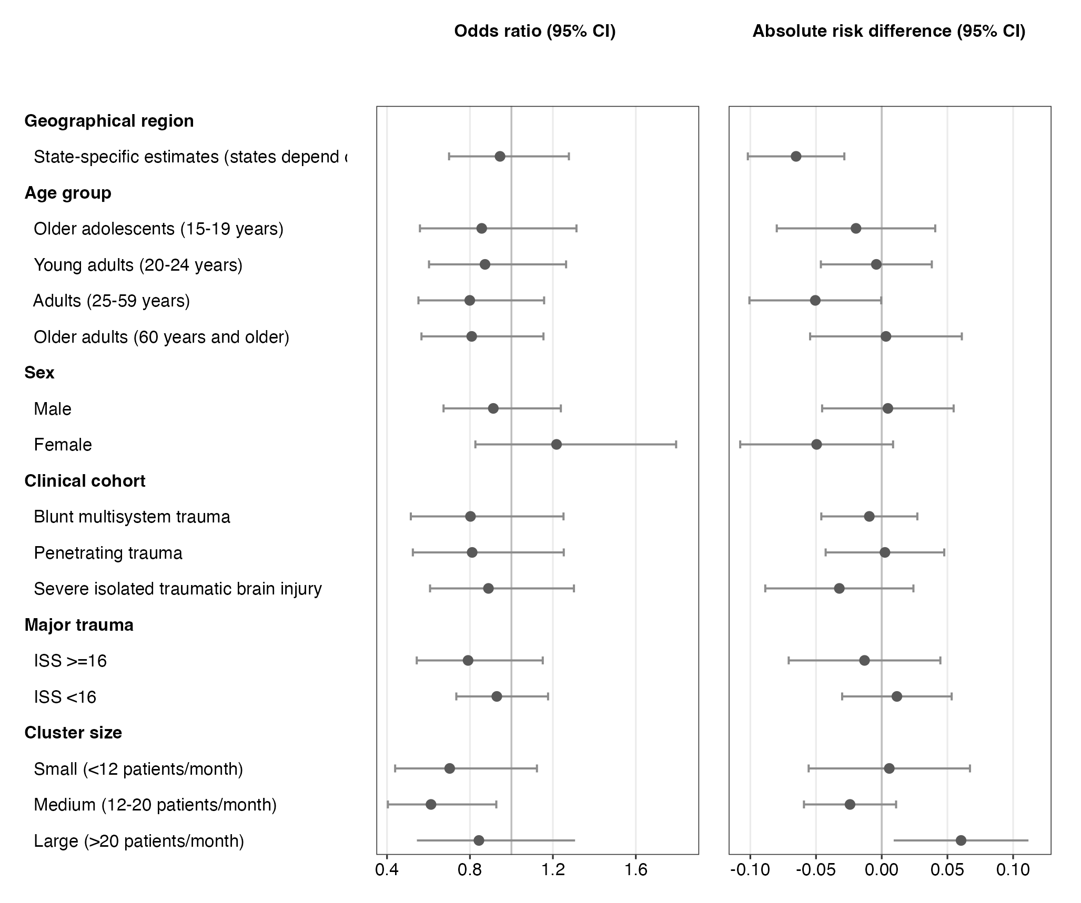
Figure 9: Forest plot of subgroup-specific intervention effects on in-hospital mortality within 30 days. Intended for the main text.

Table 12: Safety events. Intended for the main text.
 | ATLS training
Safety event | Before ATLS | After ATLS | Overall
Prolonged mechanical ventilation (>7 days), n (%) | 42 (35%) | 36 (30%) | 78 (33%)
Initiation of renal replacement therapy, n (%) | 42 (35%) | 39 (33%) | 81 (34%)
Prolonged (>2 days) or renewed use of vasopressors such as norepinephrine or vasopressin, n (%) | 37 (31%) | 45 (38%) | 82 (34%)
Other reported safety events, n (%) | 42 (35%) | 34 (28%) | 76 (32%)
Events assessed as probably related to the trial or intervention, n (%) | 40 (33%) | 46 (38%) | 86 (36%)

11. References
1. Kasza, J. et al. The batched stepped wedge design: A design robust to delays in cluster recruitment. Stat Med 41, 3627–3641 (2022).
2. Grantham, K. L. et al. The staircase cluster randomised trial design: A pragmatic alternative to the stepped wedge. Statistical Methods in Medical Research 33, 24–41 (2024).
3. Committee on Trauma. Advanced trauma life support® student course manual. (American College of Surgeons, 2018).
4. Hemming, K. et al. A tutorial on sample size calculation for multiple-period cluster randomized parallel, cross-over and stepped-wedge trials using the shiny CRT calculator. Int J Epidemiol 49, 979–995 (2020).
5. Nakhid, Z. et al. Effect of trauma life support training on patient outcomes: A systematic review and meta-analysis. Scandinavian Journal of Trauma, Resuscitation and Emergency Medicine (2026).
6. Gerdin Wärnberg, M. et al. Feasibility of a cluster randomised trial on the effect of trauma life support training: A pilot study in India. BMJ Open 15, e099020 (2025).
7. Campbell, M. K. et al. Determinants of the intracluster correlation coefficient in cluster randomized trials: The case of implementation research. Clinical Trials 2, 99–107 (2005).
8. Eldridge, S. M. et al. How big should the pilot study for my cluster randomised trial be? Stat Methods Med Res 25, 1039–1056 (2015).
9. Martin, J. et al. Intra-cluster and inter-period correlation coefficients for cross-sectional cluster randomised controlled trials for type-2 diabetes in UK primary care. Trials 17, (2016).
10. Korevaar, E. et al. Intra-cluster correlations from the CLustered OUtcome dataset bank to inform the design of longitudinal cluster trials. Clinical Trials 18, 529–540 (2021).
11. Lashoher, A. et al. Implementation of the World Health Organization Trauma Care Checklist Program in 11 Centers Across Multiple Economic Strata: Effect on Care Process Measures. World Journal of Surgery 41, 954–962 (2017).
12. Kapitan, E. et al. The effect of trauma quality improvement programme implementation on quality of life among trauma patients in urban India. medRxiv 2024.09.28.24314529 (2024).
13. Higgins, A. M. et al. The psychometric properties and minimal clinically important difference for disability assessment using WHODAS 2.0 in critically ill patients. Critical Care and Resuscitation 23, 103–112 (2021).
14. ESCP EAGLE Safe Anastomosis Collaborative and NIHR Global Health Research Unit in Surgery et al. Evaluation of a quality improvement intervention to reduce anastomotic leak following right colectomy (EAGLE): Pragmatic, batched stepped-wedge, cluster-randomized trial in 64 countries. British Journal of Surgery 111, znad370 (2024).
15. Hemming, K. et al. Reporting of stepped wedge cluster randomised trials: Extension of the CONSORT 2010 statement with explanation and elaboration. BMJ k1614 (2018).
16. Aukstakalnis, V. et al. Impact of video recordings review with structured debriefings on trauma team performance: A prospective observational cohort study. European Journal of Trauma and Emergency Surgery: Official Publication of the European Trauma Society (2024).
17. Grantham, K. L. et al. Evaluating the performance of Bayesian and restricted maximum likelihood estimation for stepped wedge cluster randomized trials with a small number of clusters. BMC Medical Research Methodology 22, 112 (2022).
18. Ustun, T. B. et al. Measuring Health and Disability: Manual for WHO Disability Assessment Schedule (WHODAS 2.0). (World Health Organization, 2010).
19. Kenny, A. et al. Analysis of stepped wedge cluster randomized trials in the presence of a time-varying treatment effect. Statistics in medicine 10.1002/sim.9511 (2022).
20. Diaz, T. et al. A call for standardised age-disaggregated health data. The Lancet Healthy Longevity 2, e436–e443 (2021).
21. Hornor, M. A. et al. Quality Benchmarking in Trauma: From the NTDB to TQIP. Current Trauma Reports 4, 160–169 (2018).
22. R Core Team. R: A language and environment for statistical computing. (R Foundation for Statistical Computing, 2023).

These include but are not limited to the National Emergency Life Support (NELS) programme, the Basic Trauma Life Support (BTLS) programme, the Pre-Hospital Trauma Life Support (PHTLS) programme, the Trauma Nursing Core Course (TNCC) and the Advanced Trauma Care for Nurses (ATCN) programme.
These include but are not limited to implementing of a trauma team approach, opening a trauma centre and implementing a trauma quality improvement programme.

