Statistical Analysis Plan
Version 0.5.0, 2025-10-14
Table of contents

1. Administrative information

1.1 Study identifiers
- Protocol version 1.5.0 dated 2025-06-12
- ClinicalTrials.gov identifier: NCT06321419
- Clinical Trials Registry - India identifier: CTRI/2024/07/071336

1.2 Changelog
Once version 1.0.0 is finalised, this section will be updated with a changelog.

1.3 Contributors
Name and ORCID | Affiliation | Role
Martin Gerdin Wärnberg (MGW) | Karolinska Institutet | Principal Investigator
Anna Olofsson (AO) | Karolinska Institutet | Statistician, TMG member
Karla Hemming (KH) | University of Birmingham, Birmingham, UK | Statistician, TMG member
James Martin (JM) | University of Birmingham, Birmingham, UK | Statistician
Jessica Kasza | Monash University, Melbourne, Australia | Statistician

2. Trial synopsis
Title Effects of Advanced Trauma Life Support® Training Compared to Standard Care on Adult Trauma Patient Outcomes: A Cluster Randomised Trial
Rationale Trauma is a massive global health issue. Many training programmes have been developed to help physicians in the initial management of trauma patients. Among these programmes, Advanced Trauma Life Support® (ATLS®) is the most popular, having trained over one million physicians worldwide. Despite its widespread use, there are no controlled trials showing that ATLS® improves patient outcomes. Multiple systematic reviews emphasise the need for such trials.
Aim To compare the effects of ATLS® training with standard care on outcomes in adult trauma patients.
Primary Outcome In-hospital mortality within 30 days of arrival at the emergency department.
Trial Design Batched stepped-wedge cluster randomised trial in India.
Trial Population Adult trauma patients presenting to the emergency department of a participating hospital.
Sample Size 30 clusters and at least 4320 patients.
Eligibility Criteria
Hospitals are secondary or tertiary hospitals in India that admit or refer/transfer for admission at least 400 patients with trauma per year.
Clusters are one or more units of physicians providing initial trauma care in the emergency department of tertiary hospitals in India.
Patients participants are adult trauma patients who present to the emergency department of participating hospitals and are admitted or transferred for admission.
Intervention The intervention will be ATLS® training, a proprietary 2.5 day course teaching a standardised approach to trauma patient care using the concepts of a primary and secondary survey. Physicians will be trained in an accredited ATLS® training facility in India.
Ethical Considerations We will use an opt-out consent approach for collection of routinely recorded data. We will obtain informed consent for collection of non-routinely recorded data, such as quality of life and disability outcomes. Patients who are unconscious or lack a legally authorized representative will be included under a waiver of informed consent. Note that consent here refers to consent to data collection.
Trial Period February 2025, to October 2029

3. Special considerations

3.1 Funding
This trial is not yet fully funded. The Trial Management Group has decided to proceed with the trial with the expectation that additional funding will be secured. The Trial Steering Committee will be informed of the funding status at each meeting. If funding is not secured, the trial will be stopped. This will likely result in an underpowered trial. The justification for this decision is that the intervention is considered standard of care in many countries and the data collection is considered minimal risk. There is therefore a very small risk of harm to patient participants, but a potential direct benefit to those patient participants who receive the intervention. The benefit-risk ratio is therefore considered to be favourable, even in the case of an underpowered trial.

3.2 Potential amendments
There are ongoing discussions about re-framing the trial as a hybrid effectiveness-implementation trial and include a cost-effectiveness analysis. This would involve adding additional data collection to assess the implementation and costs of the intervention. This would involve additional funding and amended ethical approvals.

4. Statistical analysis

5. Aim and objectives

5.1 Aim
To compare the effects of ATLS® training with standard care on outcomes in adult trauma patients.

5.2 Objectives
- To estimate the effects of ATLS® training on 30-day in-hospital mortality compared to standard care.
- To assess the robustness of the main analysis results to different model specifications through sensitivity analyses.
- To estimate the effects of ATLS® training on secondary outcomes compared to standard care.
- To explore the effects of ATLS® training on subgroups of patients compared to standard care.

5.3 Design
This is a batched stepped-wedge cluster randomised trial, including a total of 30 (see Figure 1). The trial will be composed of 6 batches of identical 12-period 5-sequence design, with one cluster being assigned to each sequence of each batch¹. Each period is one month, and each cluster will be in the trial for a total of 13 months. The intervention will be implemented during a one-month transition period, which will be excluded from the analysis. There will be an overlap of 6 months between successive batches.
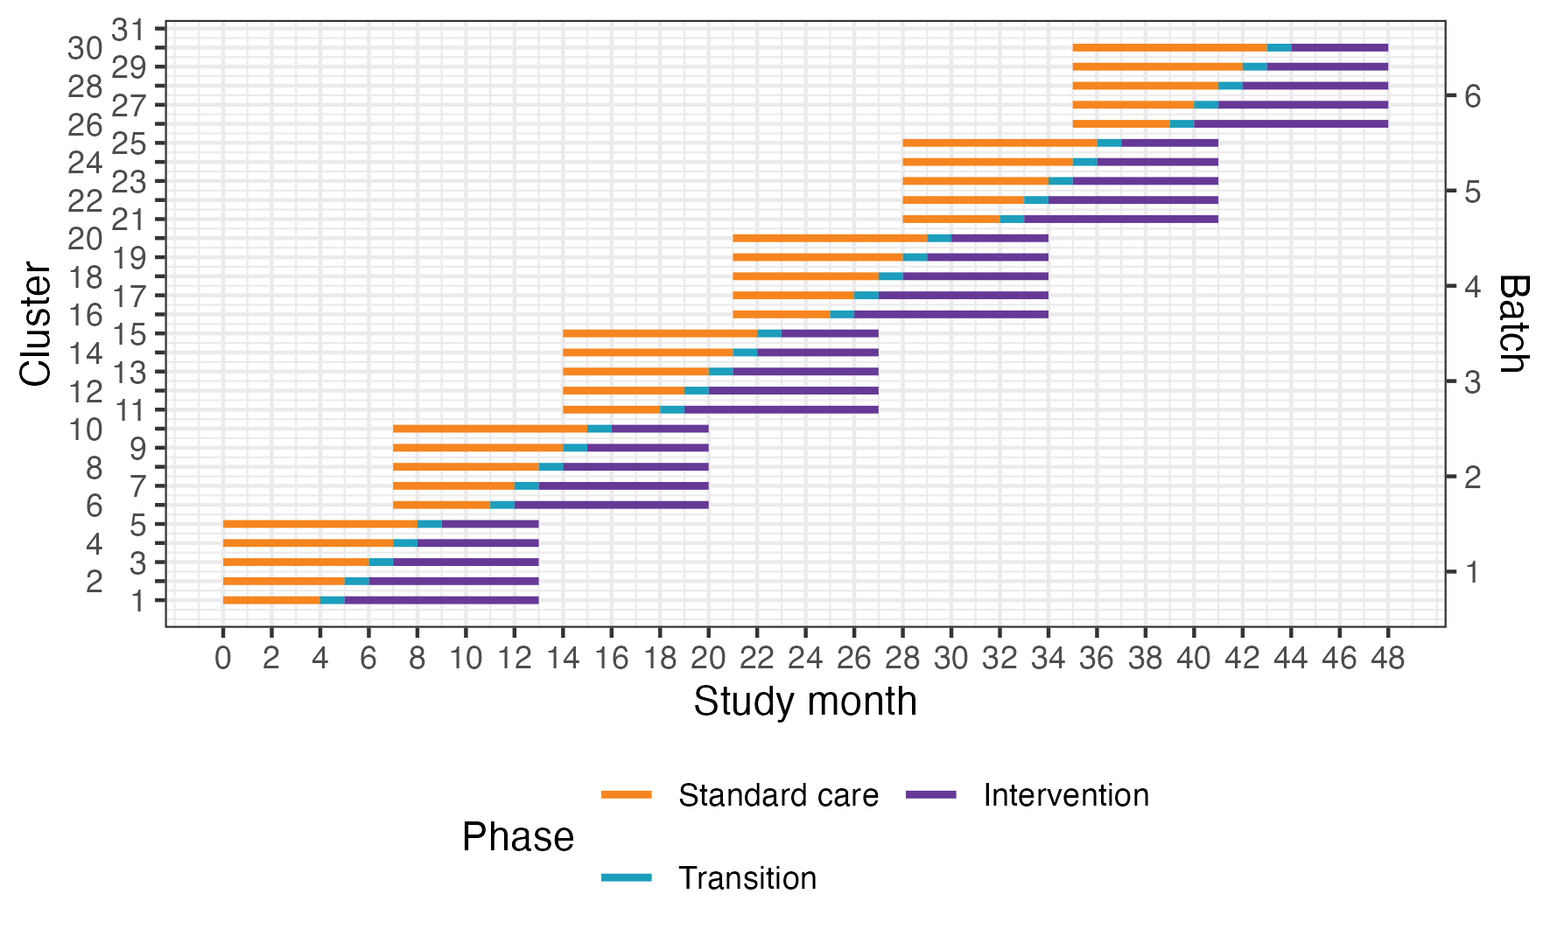
Figure 1: Trial design. Lines represent the duration of patient enrolment across clusters and phases. Clusters will be sequentially allocated to a batch based on when they enter the study. Within each batch clusters will then be randomised to an intervention implementation sequence.
Within the main stepped-wedge design, we will nest a staircase design to measure a range of secondary outcomes (see Figure 2)². The staircase design will include a random subset of patients presenting during the three months preceding the transition phase, and the three months following the transition phase.
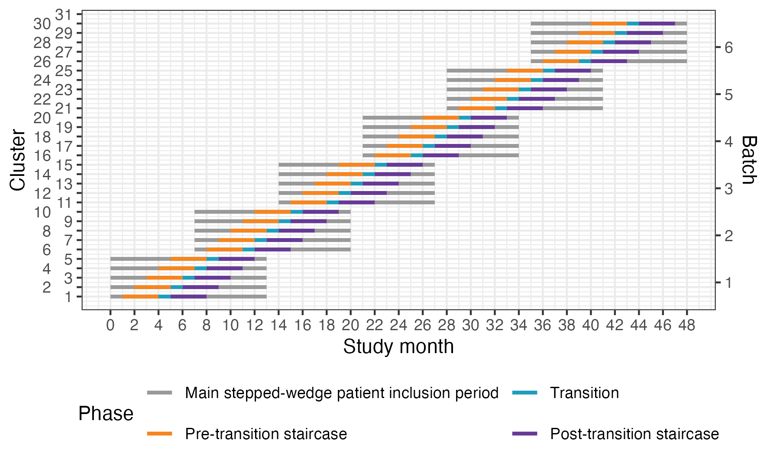
Figure 2: Nested staircase design. The design includes a random subset of patients presenting during the three months preceding the transition phase, and the three months following the transition phase.

5.4 Randomisation of clusters
We will assign clusters to batches as they are found to be eligible and receive ethical approval. Batches will include clusters from hospitals in different regions to optimize trial logistics. We will randomise the clusters alloted to each batch to the different intervention implementation sequences within that batch. We will balance the randomisation within each batch on cluster size, defined as monthly volume of eligible patient participants, using covariate constrained randomisation. The random allocation sequence will be generated by JM who will send the results to the trial team, to allow the logistics of securing seats in upcoming courses to be initiated. We will conceal the randomisation order to the sites for as long as it is logistically possible, considering that arrangements at the site level for sending physicians to ATLS® training need to be made in advance.

5.5 Outcomes

5.5.1 Primary outcome
The primary outcome will be in-hospital mortality within 30 days of arrival at the emergency department. Clinical research coordinators will extract information on death from patient hospital records. If the patient has been transferred to another hospital, the clinical research coordinators will collect data on this outcome by calling the patient or a patient representative, or by contacting the hospital to which the patient was transferred. Data on this outcome will be collected continuously during the trial.

5.5.2 Secondary outcomes

Collected using the main stepped-wedge design
- All cause mortality within 24 hours, 30 days and three months of arrival at the emergency department. Data on this outcome will be collected in the same way as for the primary outcome.
- Length of emergency department stay. Data on this outcome will be collected from patient hospital records.
- Length of hospital stay. Data on this outcome will be collected from patient hospital records.
- Intensive care unit admission. Data on this outcome will be collected from patient hospital records.
- Length of intensive care unit stay. Data on this outcome will be collected from patient hospital records.
- Return to work at 30 days and three months after arrival at the emergency department. Data on this outcome will be collected in person if the patient is still in hospital, or by phone if the patient has been discharged.

Collected using the nested staircase design
- Adherence to ATLS® principles during initial patient resuscitation, up to one hour after the physician has first seen the patient. This assessment will be done using a 14 item checklist covering the key steps of the ATLS® primary survey, which was modelled based on previous work on ATLS® adherence³. We will consider completion of all 14 steps as 100% adherence. The clinical research coordinators collecting the data will be trained by the trial team to do this, prior to the start of the trial. We will collect this data by observing the care of a random sample of patients. The sampling will be designed as a nested staircase design.
- Quality of life within seven days of discharge, and at 30 days and three months of arrival at the emergency department, measured by the official and validated translations of the EQ5D3L. Data on this outcome will be collected in person if the patient is still in hospital, or by phone if the patient has been discharged. We will collect this data using a nested staircase design.
- Disability within seven days of discharge, and at 30 days and three months of arrival at the emergency department, assessed using the WHO Disability Assessment Schedule 2.0 (WHODAS 2.0). Data on this outcome will be collected in person if the patient is still in hospital, or by phone if the patient has been discharged. This data will also be collected using a nested staircase design.

5.6 Statistical hypotheses
Our primary statistical hypotheses are:
- Null hypothesis: There is no difference in the primary outcome of 30-day in-hospital mortality between those randomised to ATLS® and standard care, meaning that the odds ratio (OR) for ATLS® vs standard care would be 1.
- Alternative hypothesis: There is an absolute difference in the primary outcome of 30-day in-hospital mortality between those randomised to ATLS® and standard care of at least 5% units, meaning that the OR for ATLS® vs standard care would be different from 1. Our expectation, based on our pilot study and review of the literature, is that the OR will be less than 1, indicating lower odds of 30-day in-hospital mortality among those randomised to ATLS® group compared to those randomised to the standard care group.

5.7 Sample size calculations

Main stepped wedge design and primary outcome
With 30 clusters across 6 batches and a total sample size of 4320 our study has ~90% power across different combinations of cluster autocorrelations (CAC) and intra-cluster correlations (ICC) to detect a reduction in the primary outcome of in-hospital mortality within 30 days from 20% under standard care to 15% after ATLS® training (see Figure 3)^{@ 4}. This effect is a conservative estimate and the reduction equals a risk ratio of 0.75, which would be clinically important while also being consistent with our pilot study and updated systematic review. We allowed for the clustered design, incorporated the one month transition period, and assumed: a discrete time decay correlation structure, an ICC of 0.02 (but considered sensitivity across the range 0.01-0.05), and a CAC of 0.9 (but considered sensitivity across the range 0.8-1.0), based on our pilot study and current guidance^{5–8}. We included the CAC to allow for variation in clustering over time. We assume that each cluster will contribute approximately 12 observations per month to the analysis, but allowed for substantial variation in cluster sizes, based on our previous work.
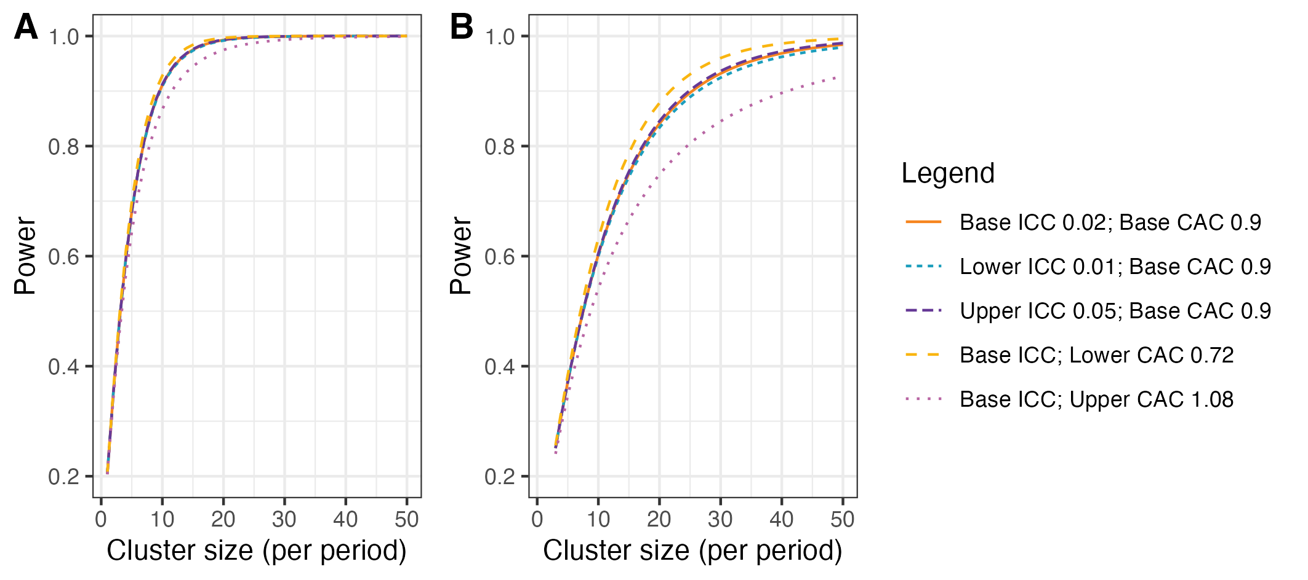
Figure 3: Power curves for different combinations of cluster autocorrelations (CAC) and intra-cluster correlations (ICC). A) Shows power curves assuming a reduction in the primary outcome of in-hospital mortality within 30 days from 20% under standard care to 15% after ATLS® training. B) Shows power curves assuming a reduction in the primary outcome from 10% under standard care to 7.5% after ATLS® training. Under this scenario, we would need to increase the sample size per month to around 30 observations to achieve 90% powere under most combinations of CAC and ICC.

Nested staircase design and secondary outcomes
The secondary outcomes that will be measured using the nested staircase design are adherence to ATLS® principles during initial patient resuscitation, quality of life, and disability. The expected effect of the intervention on each of these outcomes are an improvement in adherence from 50% during standard care to 70% after training⁹, an increase in EQ5D5L health status from 70 during care to 75 after training¹⁰, and finally a decrease in disability from a baseline value of 25 during standard care to 22.5 after training¹¹. For quality of life and disability, these effects correspond to standardised effect sizes, expressed as Cohen’s d, of 0.5. With 30 clusters in total, six per sequence, for a discrete time decay correlation structure, with ICCs of 0.01 to 0.15 and a CAC of 0.8, there is >80% power to detect an these effects by including four patients in each cluster in each period. Accounting for loss to follow-up, we will include at least six patients per cluster per month. These patients will be a random subset of patients included during the staircase months. The random subset will be selected using simple random sampling on the shift level, meaning that the timing of the clinical research coordinator’s shift will be randomised to cover approximately eight hours during the morning, afternoon, or night shift. Adherence to ATLS® principles, quality of life, and disability will be measured in all patients included during these shifts. In each hospital, the number of shifts that will be randomised will be determined by the volume of patients included during the months preceding the staircase months.

5.8 Statistical principles

5.8.1 Statistical software
We will use the R Statistical Software for all analyses¹².

5.8.2 Levels of statistical significance and confidence
We will use a two-sided significance level of 0.05 for all analyses, and we will report 95% confidence intervals (CI) for all estimates. We will not adjust for multiple testing because no secondary outcome is regarded as singularly more important.

5.9 Analysis populations
The unit of randomisation is the hospital, because all units trained in the same hospital will be treated as one cluster, but the unit of analysis is the individual patient. The group allocation for a patient depends on the period in which the patient was admitted to the hospital, and patients will be considered exposed to the intervention if they were admitted to the hospital at any time point following the transition period. We will use an intention-to-treat approach for all analyses, according to the planned date of transition from standard care. We might consider a per protocol analysis if cluster deviate considerably from the planned date of transition, using the actual date of transition as the cut-off point. We will report the results of the per protocol analysis as a sensitivity analysis. We will use a CONSORT diagram to display the flow of hospitals, clusters and patients through the trial. We will present cluster level summaries of the intervention effect. We will report the study according to the CONSORT guidelines for stepped-wedge randomised trials¹³.

5.10 Baseline analyses

5.10.1 Cluster characteristics
We will describe cluster characteristics including location and size using frequencies and percentages for discrete variables and means, standard deviations, medians and interquartile ranges (Q1-Q3) for continuous variables.

5.10.2 Patient characteristics
We will describe patient characteristics at baseline, meaning all pre-training periods, per treatment group and overall using frequencies and percentages for discrete variables and means, standard deviations, medians and interquartile ranges (Q1-Q3) for continuous variables. We will not adjust for clustering when presenting baseline characteristics.

5.11 Interim analysis
There will be one interim analyses after half of the batches have completed the trial. The interim analyses will be assessed by the joint Trial Steering and Data Monitoring Committee. The interim analysis will include the baseline analyses including the frequencies and proportions of the primary outcome in the intervention and control arms. We will not perform any formal hypothesis testing as part of our planned interim analyses.

5.12 Analysis of the primary outcome
The primary outcomes is in-hospital mortality within 30 days of arrival at the emergency department and will be analysed as a dichotomous variable. We will estimate the primary intervention effect as the OR of death between the ATLS® and standard care arms, with an OR < 1 indicating lower odds of death in the ATLS® arm compared to the standard care arm and vice versa.

5.12.1 Main analyses

Mixed effects binomial model with logit link
We will use a mixed effects binomial model with a logit link to estimate the OR. We will include fixed effects for period as a categorical variable and a fixed effect for intervention exposure. The primary analysis will allow for clustering as a random cluster and random cluster by period effect, both assumed to follow a normal distribution. The full model is specified in Equation 1. To correct the potential inflation of the type I error rate due to small number of clusters, a correction for a small number of clusters will be applied, but the correction that will be selected will be based on the best available evidence available closer to the time, and it may differ for the outcomes collected via the complete and incomplete designs. This model will be fitted using residual pseudo-likelihood estimation based on linearization with subject-specific expansion (RSPL).
$$\text{logit}\left(\text{Pr}\left(Y_{bkti}=1\right)\right)=μ+β_{bt}+θX_{bkt}+α_{bk}+γ_{bkt} \left(1\right)$$
Where:
- $\text{Pr}\left(Y_{bkti}=1\right)$: the probability of death for patient $i=1,…,m$ in cluster $k=1,…,30$ during period $t=1,…,12$ in batch $b=1,…,6$.
- $μ$: the intercept, representing the baseline log-odds of the outcome when all predictors are set to 1.
- $β_{bt}$: the fixed effect of period $t$ in batch $b$, accounting for a separate period effect for each batch, so that there is a total of 72 period effects.
- $θ$: the fixed effect of intervention exposure, representing the effect of ATLS® exposure on the probability of death.
- $X_{bkt}$: the treatment arm indicator for patient $i$ in cluster $k$ during period $t$ in batch $b$, with $X_{bkt}=1$ for ATLS® and $X_{bkt}=0$ for standard care.
- $α_{bk}$: the random effect of cluster $k$ in batch $b$, representing the variability in outcomes between different clusters (hospitals) across batches.
- $γ_{bkt}$: the random effect of cluster $k$ in period $t$ in batch $b$, accounting for the random variation within clusters across periods and batches, including potential interaction effects between clusters and time.
We will present the effect of ATLS® exposure as an odds ratio (OR) for mortality with an associated 95% CI, using the standard care arm as the reference. Additionally, we will present the risk difference with a 95% CI. The randomization within each batch will be balanced based on cluster size, defined as the expected monthly volume of eligible patient participants. Therefore, no further adjustment for cluster size will be made in the main analysis.

Model with identify link
We will use an identity link used to estimate the risk difference, meaning that the coefficient will be interpreted as the difference in the probability of death between the ATLS® and standard care arms, as an alternative to the OR. We will present the risk difference with a 95% CI. This model is specified in Equation 2 and will also be fitted using RSPL. If the binomial model with the identity link does not converge then only a odds ratio will be reported.
$$\text{Pr}\left(Y_{bkti}=1\right)=μ+β_{bt}+θX_{bkt}+α_{bk}+γ_{bkt} \left(2\right)$$
Where:
- $μ$: the intercept, representing the baseline probability of the outcome when all predictors are zero.

5.12.2 Sensitivity analyses
The sensitivity analyses will be conducted to assess the robustness of the main analysis results to different model specifications. We will first model the primary outcome using an identity link function to estimate the risk difference instead of the OR. Henceforth, each additional sensitivity analyses will be operationalised using two separate models, one with the logit link and one with the identity link. We will first explore more complex correlation structures. We will then model time using a spline function. Finally, we will conduct a fully adjusted covariate analysis.

Models with different correlation structure
We will explore if models with more complicated correlation structures are a better fit to the data. These models are not being used as our primary analysis models as there is limited understanding as to when such models will converge and how to choose between the various different correlation structures which might be plausible. First, we will include a discrete time decay correlation structure including a random cluster effect with auto-regressive structure (AR(1)), described in Equation 3.
$$α_{bk,t}=ρα_{bk,t−1}+ϵ_{t}, ϵ_{t}∼N\left(0,σ_{α}^{2}\right) \left(3\right)$$
Where:
- $ρ$: the correlation between the random effects of two consecutive periods, the period $t$ and the period $t−1$, reflecting how outcomes in one period are correlated with outcomes in the previous period within the same cluster.
- $α_{bk,t}$: the random effect of cluster $k$ in period $t$ in batch $b$. This represents the variation in the outcome that is specific to each cluster and period, accounting for time-related effects.
- $ϵ_{t}$ is the error term for period $t$, which is assumed to be normally distributed with mean 0 and variance $σ_{α}^{2}$.
To allow for the randomisation by batches, we will also include a different secular trend for each batch as a random effect interaction term between batch and period. The full model is specified in Equation 4.
$$g\left(\text{Pr}\left(Y_{bkti}=1\right)\right)=μ+β_{bt}+θX_{bkt}+α_{bk,t}+γ_{bkt}+δ_{bt} \left(4\right)$$
Where:
- $g\left(⋅\right)$: the link function.
- $α_{bk,t}$: the updated random effect of cluster $k$ in batch $b$ during period $t$ with the AR(1) correlation structure. This accounts for correlation between adjacent periods in the same cluster.
- $δ_{bt}$: the random effect of batch $b$ during period $t$, which captures any variability across different batches over time.

Models with random cluster by intervention effects
Models will also be extended to include random cluster by intervention effects (with a non-zero covariance term) to examine if results are sensitive to the assumption of no intervention by cluster interaction. The model is specified in Equation 5.
$$g\left(\text{Pr}\left(Y_{bkti}=1\right)\right)=μ+β_{bt}+θX_{bkt}+α_{bk}+γ_{bkt}+u_{bk}×X_{bkt} \left(5\right)$$
Where:
- $u_{bk}$: the random effect of cluster $k$ by intervention interaction.
- $X_{bkt}$: the treatment arm indicator for patient $i$ in cluster $k$ during period $t$.
- $u_{bk} \times X_{bkt} $: the random interaction effect between the intervention and cluster $k$.

Models with time modelled with a spline function
We will further explore the potential for a time-varying treatment effect¹⁴. To explore if the fixed period effect is both parsimonious and adequate to represent the extent of any underlying secular trend, we will model the time effect using natural cubic splines with knots at the equally spaced time points 3, 6 and 9. This will result in five spline basis functions, because the natural cubic splines are modelled with three degrees of freedom but are constrained to be linear before the first and after the last knot. The model is specified in Equation 6.
$$g\left(\text{Pr}\left(Y_{bkti}=1\right)\right)=μ+\sum_{j=1}^{5}{β_{j}}S_{j}\left(t,\{3,6,9\}\right)+θX_{bkt}+α_{bk}+γ_{bkt} \left(6\right)$$
Where:
- $S_{j}\left(t,\{3,6,9\}\right)$: the natural cubic spline basis functions with knots placed at times 3, 6 and 9.
- $β_{j}$: the coefficient for the $j$-th spline basis function.

Models exploring lag and weaning effects
Models will also be extended to include an interaction between treatment and number of periods since first treated, to examine if there is any indication of a relationship between duration of exposure to the intervention and outcomes. This will allow us to model different lag effects (whereby it takes time for the intervention to become embedded within the culture before its impact can properly start to be realised); as well as weaning effects (whereby the effect of the intervention starts to decrease – or fade). This type of analysis attempts to disentangle how some clusters end up having a long exposure to the intervention and others have a much shorter exposure time. The model is specified in Equation 7.
$$g\left(\text{Pr}\left(Y_{bkti}=1\right)\right)=μ+β_{bt}+θX_{bkt}+θ_{\text{int}}X_{bkt}×T_{bkt}+α_{bk}+γ_{bkt} \left(7\right)$$
Where:
- $θ_{\text{int}}$ is the coefficient for the interaction between treatment and time since first treated.
- $T_{bkt}$ is the number of periods since first treated.

5.12.3 Adjusted analyses
Fully adjusted covariate analysis will additionally adjust for (expected % missing data in parentheses):
- Age (<5%)
- Sex (<5%)
- Systolic blood pressure (25%)
- Glasgow Coma Scale (25%)
- Injury Severity Score (10%)
- Mechanism of injury (10%)
These are known individual-level prognostic factors for the primary outcome. These covariates will be included in the models specified in Equation 1 and Equation 2 as fixed effects. We will model the continuous covariates assuming linear effects.

5.12.4 Subgroup analyses
We will perform the following subgroup analyses:
- geographical region, defined using the state in which the participating hospital is located. Demonstrating the consistency of any effect across multiple regions will enhance the generalisibility of the results;
- age groups, defined as older adolescents (15-19 years), young adults (20-24 years), adults (25-59 years), and older adults (60 years and older) [¹⁵;
- sex, using the levels male and female;
- clinical cohorts, defined as blunt multisystem trauma, penetrating trauma, and severe isolated traumatic brain injury, with modification to avoid overlap between the cohorts; and
- cluster size (number of patients per hospital)
These subgroup analyses will be conducted by adding the subgroup variable and the interaction between the subgroup variable and the intervention exposure variable as fixed effects to the models specified in Equation 1 and Equation 2.

5.12.5 Treatment of missing data
We will present the frequency and percentage of missing data for all variables. If the percentage of missing data for the primary outcome is less than 10%, we will perform a complete case analysis. If the percentage of missing data for the primary outcome is 10% or more, we will handle missing data depending on the missing data mechanism. If the data are missing at random (MAR), we will perform multiple imputation using multiple imputation by chained equations (MICE), imputing data for the primary outcome as well as all covariates included in the fully adjusted model. The number of imputations will be determined by the percentage of missing data, with a minimum of 20 imputations. If there is evidence that the data are missing not at random (MNAR), we will explore the impact of this assumption using a sensitivity analysis (e.g., pattern mixture models or selection models) to assess how robust our findings are to different assumptions about the missing data mechanism. Additionally, we will perform diagnostic checks after multiple imputation to ensure the quality of the imputation process, including comparing distributions of observed and imputed data and checking convergence.

5.13 Analysis of secondary outcomes

5.13.1 All cause mortality within 24 hours, 30 days and three months of arrival at the emergency department
We will use the model with the logit link specified in Equation 1 and the model with the identity link specified in Equation 2 to estimate the OR and risk difference for these mortality outcomes.

5.13.2 Quality of life within seven days of discharge, and at 30 days and three months of arrival at the emergency department
Quality of life will be measured by the official and validated translations of the EQ5D5L. This tool assesses five dimensions of health-related quality of life: mobility, self-care, usual activities, pain/discomfort, and anxiety/depression. Each dimension is rated on a likert scale from 1 to 5. There is also a visual analogue scale (VAS) for self-rated quality of life, ranging from 0 to 100. For each of the five dimensions we will use a mixed effects ordinal model as specified in Equation 8.
$$\text{logit}\left(\text{Pr}\left(Y_{bkti}≤j\right)\right)=μ_{j}+β_{bt}+θX_{bkt}+α_{bk}+γ_{bkt} \left(8\right)$$
Where:
- $μ_{j}$: the intercept for the $j$-th category of the EQ5D dimension ($j$ = 1, 2, 3, 4, 5).
The VAS will be analysed using a linear mixed effects model as specified in Equation 9.
$${\text{VAS}}_{bkti}=μ+β_{bt}+θX_{bkt}+α_{bk}+γ_{bkt}+ϵ_{bkti}, ϵ_{bkti}∼N\left(0,σ^{2}\right) \left(9\right)$$
Where:
- $ϵ_{bkti}$: the error term for patient $i$ in cluster $k$ in period $t$ in batch $b$, assumed to be normally distributed with mean 0 and variance $σ^{2}$.

5.13.3 Disability within seven days of discharge, and at 30 days and three months of arrival at the emergency department
We will measure disability using the WHO Disability Assessment Schedule 2.0 (WHODAS 2.0)¹⁶. This tool assesses six domains of functioning: cognition, mobility, self-care, getting along, life activities, and participation. Each domain is rated on a likert scale from 1 to 5, with 1 indicating no difficulties and 5 indicating extreme difficulties. We will analyse each domain separately using a mixed effects ordinal model as specified in Equation 8. We will also calculate a WHODAS 2.0 summary score using the method referred to as the “complex scoring” method. This method involves summing the item scores within each of the six domains, then summing the scores of all domains, and finally transforming the total score to a 0-100 scale. We will analyse the summary score using a linear mixed effects model as specified in Equation 9.

5.13.4 Return to work at 30 days and three months after arrival at the emergency department
We will analyse return to work as a dichotomous variable using a mixed effects binomial model with a logit link as specified in Equation 1.

5.13.5 Length of emergency department stay
We will analyse length of emergency department stay as a continuous variable using a linear mixed effects model as specified in Equation 9.

5.13.6 Length of hospital stay
We will analyse length of hospital stay as a continuous variable using a linear mixed effects model as specified in Equation 9.

5.13.7 Intensive care unit admission
We will analyse intensive care unit admission as a dichotomous variable using a mixed effects binomial model with a logit link as specified in Equation 1.

5.13.8 Length of intensive care unit stay
We will analyse length of intensive care unit stay as a continuous variable using a linear mixed effects model as specified in Equation 9.

5.13.9 Adherence to ATLS® principles during initial patient resuscitation
We will assess adherence to ATLS® principles using a 14-item checklist that covers the key steps of the ATLS® primary survey. Adherence will be measured as the proportion of steps completed, with 100% adherence defined as completing all 14 steps. We will analyse adherence using a mixed-effects beta regression model with a logit link as specified in Equation 10.
$$\text{logit}\left(\text{E}\left(Y_{bkti}\right)\right)=μ+β_{bt}+θX_{bkt}+α_{bk}+γ_{bkt} \left(10\right)$$
Where:
- $\text{E}\left(Y_{bkti}\right)$: The expected proportion of completed ATLS steps for patient $i$ in cluster $k$ during period $t$ in batch $b$.
- $μ$: The intercept, representing the baseline log-odds of completing ATLS steps when all predictors are set to 1.
- $β_{bt}$: The fixed effect of period $t$ in batch $b$, allowing for different period effects for each batch.
- $θ$: The fixed effect of ATLS exposure, representing the effect of the intervention on adherence to ATLS principles.
- $X_{bkt}$: The treatment arm indicator for patient $i$ in cluster $k$ during period $t$ in batch $b$ (1 for ATLS, 0 for standard care).
- $α_{bk}$: The random effect of cluster $k$ in batch $b$, capturing variability in adherence across clusters (hospitals).
- $γ_{bkt}$: The random effect of cluster $k$ in period $t$ within batch $b$, accounting for within-cluster variability across time periods and batches.

6. References
1. Kasza, J. et al. The batched stepped wedge design: A design robust to delays in cluster recruitment. Stat Med 41, 3627–3641 (2022).
2. Grantham, K. L. et al. The staircase cluster randomised trial design: A pragmatic alternative to the stepped wedge. Statistical Methods in Medical Research 33, 24–41 (2024).
3. Aukstakalnis, V. et al. Impact of video recordings review with structured debriefings on trauma team performance: A prospective observational cohort study. European Journal of Trauma and Emergency Surgery: Official Publication of the European Trauma Society (2024).
4. Hemming, K. et al. A tutorial on sample size calculation for multiple-period cluster randomized parallel, cross-over and stepped-wedge trials using the shiny CRT calculator. Int J Epidemiol 49, 979–995 (2020).
5. Campbell, M. K. et al. Determinants of the intracluster correlation coefficient in cluster randomized trials: The case of implementation research. Clinical Trials 2, 99–107 (2005).
6. Eldridge, S. M. et al. How big should the pilot study for my cluster randomised trial be? Stat Methods Med Res 25, 1039–1056 (2015).
7. Martin, J. et al. Intra-cluster and inter-period correlation coefficients for cross-sectional cluster randomised controlled trials for type-2 diabetes in UK primary care. Trials 17, (2016).
8. Korevaar, E. et al. Intra-cluster correlations from the CLustered OUtcome dataset bank to inform the design of longitudinal cluster trials. Clinical Trials 18, 529–540 (2021).
9. Lashoher, A. et al. Implementation of the World Health Organization Trauma Care Checklist Program in 11 Centers Across Multiple Economic Strata: Effect on Care Process Measures. World Journal of Surgery 41, 954–962 (2017).
10. Kapitan, E. et al. The effect of trauma quality improvement programme implementation on quality of life among trauma patients in urban India. medRxiv 2024.09.28.24314529 (2024).
11. Higgins, A. M. et al. The psychometric properties and minimal clinically important difference for disability assessment using WHODAS 2.0 in critically ill patients. Critical Care and Resuscitation 23, 103–112 (2021).
12. R Core Team. R: A language and environment for statistical computing. (R Foundation for Statistical Computing, 2023).
13. Hemming, K. et al. Reporting of stepped wedge cluster randomised trials: Extension of the CONSORT 2010 statement with explanation and elaboration. BMJ k1614 (2018).
14. Kenny, A. et al. Analysis of stepped wedge cluster randomized trials in the presence of a time-varying treatment effect. Statistics in medicine 10.1002/sim.9511 (2022).
15. Diaz, T. et al. A call for standardised age-disaggregated health data. The Lancet Healthy Longevity 2, e436–e443 (2021).
16. Ustun, T. B. et al. Measuring Health and Disability: Manual for WHO Disability Assessment Schedule (WHODAS 2.0). (World Health Organization, 2010).

TODO: James gets back with a short snippet with more details on how the randomisation will be done.
Question: Should we adjust for calendar time because the last batch will be two years later than the first batch?
Question: Just a thought: keep in mind the complexity of the random effects structure; if it leads to convergence problems or overfitting, should we consider simplifying the random effects?
Question: The model will estimate some 78 parameters. Is this a problem considering the low number of participants per period?
Questions: 1. Should we adjust for calendar time because the last batch will be two years later than the first batch? 2. Should we add it as covariate in the list above? 3. Should it be continuous (e.g., months since the study started) or categorical calendar time (if you expect non-linear trends or stepwise changes over years)? 4. Should we analyse Time Since Admission? Depending on the nature of the trauma, the time since patient admission might also influence outcomes, especially if the timing of interventions or care decisions plays a critical role. Eg. time from admission to surgery.
Question: Are we exploring too many subgroups?

