APPENDIX 3

MRC CTU TEMPLATE TRIAL MANAGEMENT GROUP CHARTER (version 3.01)

Extension of DAMOCLES IDMC template Charter (version 1)
This document provides a template for Trial Management Group members for MRC CTU-involved trials. A copy of this template should form the basis for each individual trial’s charter.
- The Charter should be completed before (or early into) the trial and the content should be agreed with the TMG members. The membership of the Trial Management Group membership may be decided by the Trial Development Group.
- For consistency and cross-trial comparability the tabular structure of the template is strongly recommended.
- All highlighted sections should be updated and replaced where relevant or deleted otherwise (eg guidance notes); revisions are, of course, permitted to the standard non-highlighted text where appropriate but please bring these changes to the special attention of the SOP Committee as such changes may be incorporated into the next updated of this template Charter. All embedded comments should be removed.
- The abbreviations/glossary in the Appendix should be updated and a one-page diagram summarising the trial inserted as Figure 1
- In instances where the Data Monitoring Committee is not independent of the trial, the “Independent” should be dropped from the title and the acronym changed from IDMC to DMC throughout. This will be rare at MRC CTU. Independence is defined by the potential competing interests in the Annexe 1. Note that, by nature, the Sponsor/Funder are not independent of the trial.
Disclaimer: If this document is being used outside of a MRC CTU-led trial, please explicitly acknowledge the source as MRC Clinical Trials Unit. MRC CTU should be notified by sending an email to the SOP Committee


[ACRONYM]: [Short title of trial]

[Long title of trial]

ISRCTN…..
NCT
EUDRACT……
CTA……

Trial Management Group Charter
Version xxx, Date…
(developed using MRC Clinical Trials Unit template TMG Charter version 3.01, 13-Mar-2006)

Authorised by:
Name: | [name] |  |  | Role: | [Programme Leader]
Signature: |  |  |  | Date: | dd-mmm-yyyy
Prepared by
Name: | [name] |  |  | Role: | [role]
Signature: |  |  |  | Date: | dd-mmm-yyyy

CHARTER FOR TRIAL MANAGEMENT GROUP

Content | details of TMg

1. Introduction
Name (& Sponsor’s ID) of trial  Insert name (and Sponsor’s ID) of trial and registration number (e.g. ISRCTN and/or EUDRACT number) on front cover | [To be completed]
Objectives of trial, including interventions being investigated Insert objectives of trial, including interventions being investigated from protocol. | [To be completed]  A study summary diagram is included in Figure 1
Outline of scope of Charter | The purpose of this document is to describe the membership, terms of reference, roles, responsibilities, authority, decision-making and relationships of the Trial Management Group (TMG) for the this trial, including the timing of meetings, frequency and format of meetings and relationships with other trial committees.

2. Roles and responsibilities
A broad statement of the aims of the TMG | To manage the trial, including the clinical and practical aspects.
Specific roles of TMG members  Some or all of the following roles will be selected | The specific roles of the TMG will be to:  - attend TMG meetings and advise on availability for future TMG meetings  - input into and comment on the protocol and case report forms  - allow contact details to be included in the protocol  - promote the trial  - develop strategies to encourage recruitment and address any issues with recruitment at each trial centre  - be involved in the day-to-day running of the trial by supporting the Chief Investigator and MRC CTU  - provide clinical or other expert guidance to MRC CTU and participating sites on trial-based matters such as clinical and practical queries and interpretation of information recorded on CRFs  - maintain confidentiality of any trial information that is not in the public domain  - respond to trial correspondence and any questions in a timely fashion  - encourage completion of case report forms (CRFs) and monitor reported CRF completion rates  - input into the monitoring and classification of serious adverse events (SAEs)  - input into the meetings of the Trial Steering Committee (TSC), if appropriate  - input into the meetings of the Independent Data Monitoring Committee (IDMC), when appropriate (open sections only)  - provide responses to any issues or concerns raised by TSC  - consider the implications of any recommendations made by the IDMC and accepted by the TSC  - be aware of accumulating external evidence and assess its impact and relevance  - input into the development of the statistical analysis plan  - input into the interpretation and writing up of the trial results  - comment to TSC on external applications to use trial data including stored samples  Note that the CI has roles to perform in addition to those of being a member of the TMG. These are not detailed in this document.

3. Before or early in the trial
Whether the TMG will have input into the protocol | The core of the TMG will have developed from the Trial Development Group. The TMG will be responsible for finalising the protocol for review by TSC.
Any specific regulatory issues  The TMG should be aware of any regulatory issues associated with the trial, for example licensing trials or where there are issues obtaining informed consent. | [To be completed]
Any other issues specific to the treatment under study  Issues specific to the treatments under study should be described. | [To be completed]
Whether members of the TMG will have a contract | TMG members will not formally sign a contract. They should formally register their agreement to join the group by confirming (1) that they agree to be on the TMG and (2) that they agree with the contents of this Charter. Members should complete and return the form in Annexe 1.

4. Composition
Membership and size of the TMG  Membership should provide broad expertise appropriate to the trial, including at least two clinicians experienced in the clinical area and staff from MRC CTU (trial manager, data manager, statistician, senior scientists).  Depending on the trial it may be appropriate to include clinical oncologists, medical oncologists, surgeons, research nurses, pharmacists, QL experts, health economists, radiographers, molecular geneticists, sociologists, psychologists, representatives from other participating trials groups such as NCIC, etc.  In some models, there should be consumer representation on the TMG (eg this is common in Cancer Group trials); in other models, consumer representation may be better on the TSC (eg this is common in MDP trials)  Members of TMG will be invited by MRC CTU or Chief Investigator, and may be suggested by NRCI disease-specific Clinical Studies Group. | The members of the TMG for this trial are:  - [---give name and expertise---]  - [---give name and expertise ---]  - [---give name and expertise ---]  - [---give name and expertise ---]  - [---give name and expertise ---]  - [---give name and expertise ---]  - [---give name and expertise ---]  - [---give name and expertise ---]  - [---give name and expertise ---]  - [---give name and expertise ---]  - [---give name and expertise ---]  Members of the TMG should disclose potential competing interests (see Section 5).
The Chair, how they are chosen and the Chair’s role (Likewise, if relevant, the vice-Chairman)  The Chair will usually be the CI of the trial. In the case of large TMGs a vice-Chair will be formally appointed. | The Chair of the TMG will be the Chief Investigator of the trial. They should also have experience of Chairing meetings and should be able to facilitate and summarise discussions. (See Organisation of TMG Meetings)  The CI will be a member of the TSC and must attend all TSC meetings. The CI should be available to attend IDMC meetings. The other TMG members will not usually be expected to routinely attend TSC or IDMC meetings but may attend sessions when necessary and appropriate.  The vice-Chair will assume the responsibilities of the Chair when the Chair is not available.
The responsibilities of the trials unit team | The trials unit team (e.g. Trial Manager, etc) will be responsible for running the trial on a day-to-day basis, maintaining trial databases, randomising patients, ensuring complete and correct data, preparing short reports for meetings (including those of the TMG) and dealing with research governance and, if appropriate, regulatory matters.

5. Relationships
Relationships with the other trial committees (e.g. Trial Steering Committee, TSC), Sponsor and regulatory bodies  This should be spelled out. A diagram can help to clarify relationships when there are several inter-related committees. A short statement of the responsibilities of the other committees should be given if these are not provided in the protocol. | The responsibilities of each trial committee are detailed in the protocol. The relationships between these groups are displayed in Figure 2.
Advisory and executive bodies | The TSC is the oversight body and is delegated this role by the Sponsor. All substantial issues regarding the trial must be referred to the TSC for consideration. The IDMC is advisory to the TSC.
Payments to TMG members  Members will be reimbursed for reasonable travel costs and other expenses incurred. In some instances this may be only for UK travel. | [Describe any arrangements for covering travel]  No other payments or rewards would be given to professional members. Honoraria will be paid to lay members.
The need for TMG members to disclose information about any potential competing interests | Members of the TMG should disclose potential competing interests (other than an intellectual involvement in the trial) which may be perceived by some as preventing them from making decisions to the benefit of the trial. Potential competing interests are not restricted to financial matters – involvement in other trials or involvement with pharma could be relevant, for example they have an ongoing advisory role to a company providing drugs to the trial. Although members may well be able to act objectively despite such connections, complete disclosure enhances credibility (see Annexe 1). This should be confirmed before accepting the invitation to join the TMG and MRC CTU must be informed immediately if this changes during the trial period.  TMG members should not use any trial data to inform trading in pharmaceutical shares, and careful consideration should be given to trading in stock of companies with competing products.

6. Organisation of meetings
Expected frequency of TMG meetings  The exact frequency of meetings will depend upon the demands of the particular trial with regards recruitment rate, development stage, outcome measure and other factors. The wishes of the TMG and needs of the trials unit will be considered when planning each meeting. It is recommended that the TMG meet at least twice yearly, more often at the start and end of the trial. Face-to-face meetings will usually be held at MRC CTU; some meetings may be held at suitable and convenient locations such as at conferences that many TMG members would be attending. During the early stages of the trial, monthly teleconferences are helpful and recommended. | [To be completed]
Whether meetings will be face-to-face or by teleconference  Meetings should ideally be face-to-face to facilitate full discussion and allow members to get to know each other. It is recommended that some meetings could be undertaken as teleconferences especially if held regularly but communication in this fashion can be difficult when there are many members. | Face-to-face meetings will normally be held, depending on the needs of the trial. Teleconferences will be held on other occasions. Meetings will be organised by MRC CTU staff.
When the TMG is quorate | (See Section 8)
Can TMG members who cannot attend the meeting input | The TMG report and agenda will be circulated before the meeting; TMG members who will not be able to attend the meeting may pass comments to the TMG Chair and MRC CTU for consideration during the discussions.
What happens to members who do not attend meetings | Members will be expected to send apologies in advance of any meeting they cannot attend. If a member neither attends nor sends apologies for a meeting, every effort will be made to ensure their availability for the next meeting. If a member does not attend nor send apologies for the following meeting, they will be asked if they wish to remain part of the TMG. If a member does not attend a third meeting in a row, they should be replaced, unless there are particular extenuating circumstances.

7. Trial reporting documentation
Content of trial reports  Data key to the management of the trial; state any areas that will not be broken down by arm. | The TMG will be provided with reports of accrual, baseline characteristics, follow-up rates, toxicity, CRF return rates, etc. The TMG members will not be privy to accumulating outcome measure data by trial arm – this will be reviewed by the IDMC only.
The people who will see accumulating trial data and interim analysis | The accumulating trial data and interim analyses will be confidential. TMG members will not be privy to these interim reports; these will be viewed only by the IDMC.
Responsibility for identifying and circulating external evidence (e.g. from other trials/ systematic reviews) | Accumulating data may be considered by the IDMC in the context of external evidence (e.g. from other trials/ systematic reviews). The TMG, notably the CI and/or the MRC CTU team, should be responsible for identifying and collating the external information.
What will happen to the reports and papers  Only one copy needs to be kept; a copy will be kept by the trials unit. State how long they would be expected to keep them. | TMG members would be expected to store securely copies of the reports to TMG, agendas and minutes, as well as copies of communications between meetings. All documentation should be considered confidential. The trials unit will keep a central record of all minutes, reports and correspondence by the TSC.

8. Decision making
What decisions and recommendations will be open to the TMG  Decisions should be selected from the list | The TMG is responsible for the day-to-day running of the trial and can make decisions appropriate to this role. However, the TSC is the oversight body for the trial.  TMG to TSC  The TMG should refer to the TSC in some instances. The following are examples:  - Request for additional interim analyses owing to concerns raised by external evidence  - Stopping recruitment due to slow recruitment  - Modifying target recruitment, or pre-analysis follow-up, based on any change to the assumptions underlying the original trial sample size calculation (but not on any emerging differences)  - Proposing substantial changes to the protocol, patient information sheet, eligibility criteria and other trial documentation  - Request for endorsement for the early presentation of results  - Request for endorsement for external data requests after the trial has closed  - Request for sharing of trial samples  TMG to IDMC  The TMG can make recommendations to the IDMC. Possible recommendations from the TMG to the IDMC could include:-  - Proposal of extra analyses for review by IDMC  - Addition of new trial sites  TMG alone  Without referral to other committees, the TMG can:-  - Propose strategies for dealing with poor recruitment rates, data quality or compliance with CRFs and/or follow-up schedules according to consistency checks or site monitoring reports  - Censure trial sites
How decisions will be reached within the TMG | On all issues, every effort should be made to achieve consensus. The role of the Chair is to summarise discussions and encourage consensus; it is therefore best for the Chair to give their own opinion last.
When the TMG is quorate  There should be a minimum number of attendees and represented specialities before the TMG is quorate; this should be specified eg at least 2 clinical members and a representative from CTU. | [To be completed]
Any specific issues relating to the trial design that might influence the proceedings, e.g. cluster trials, equivalence trials, multi-arm trials | [To be completed]

9. Reporting
To whom will the TMG report their recommendations/concerns, and in what form  The TMG will report to the TSC with a letter or email sent via the TSC Facilitator although the TMG should be represented at TSC meetings. A template report is used for Cancer Group trials. | A standard report template will be used to provide information to the TSC. Additional information may be sent from the TMG to the TSC by writing via the TSC Facilitator.
Whether minutes of the meeting be made and, if so, by whom and where they will be kept | A short summary of each meeting with any action points clearly marked will be made. Initial drafts will be made by the MRC CTU team before comments from the TMG members who were present. The TMG Chair will sign off these notes and a copy will be kept in a central file at the MRC CTU.
What will be done if there is disagreement between the TMG and TSC | The TSC is the oversight body for the trial. If the TMG has serious problems or concerns with a TSC decision a meeting of these groups will be held. The information to be shown would depend upon the action proposed and the TSC’s or TMG’s concerns. Depending on the reason for the disagreement particularly sensitive trial data may have to be revealed to all or some of those attending such a meeting. The meeting would be Chaired by a senior member of the MRC CTU staff, IDMC Chair or an external expert who is not directly involved with the trial. It is noted that the CI and member(s) of the trials unit are represented on both the TMG and TSC.

10. After the trial
Publication of results | At the end of the trial there will be meetings of the TMG to discuss the final data. The core of the Writing Committee will be drawn from the TMG. TMG members will promptly return comments on any circulated drafts. The IDMC and TSC members may be invited to give advice about data presentation and interpretation.
The information about the TMG that will be included in published trial reports | Regardless of the authorship policy of the trial, TMG members will be named and their affiliations listed in the main report, unless they explicitly request otherwise.
Any constraints on TMG members divulging information about their trial experiences  It should be specified when the TMG may discuss issues from their involvement in the trial or trade in stock of a company making a trial drug involved e.g. 12 months after the primary trial results have been published, or when permission is agreed with the TSC. | TMG members should not divulge sensitive information about the ongoing trial unless specifically authorised by the TMG and, if appropriate, by the TSC, depending on the nature of the information.

Abbreviations and glossary (add and remove items as necessary)
AE | Adverse event
AR | Adverse reaction
CF | Consent form
CI | Chief Investigator
CRF | Case Report Form
CTA | Clinical Trials Authorisation
MRC CTU | Clinical Trials Unit
DMC | Data Monitoring Committee
ERC | Endpoint Review Committee
EUDRACT | European Union Drug Regulatory Agency Clinical Trial
HE | Health Economics
IB | Investigator’s Brochure
IDMC | Independent Data Monitoring Committee
ISRCTN | International standard randomised controlled trial number
MHRA | Medicines and Healthcare products Regulatory Authority
MRC | Medical Research Council
NHS | National Health Service
PI | Principal Investigator
PIS | Patient information Sheet
QL | Quality of life
SAE | Serious adverse event
SAR | Serious adverse reaction
SOP | Standard operating procedures
SPC | Summary of product characteristics
SSA | Site specific assessment
SUSAR | Suspected unexpected serious adverse reaction
TMG | Trial Management Group
TSC | Trial Steering Committee
UAR | Unexpected adverse reaction

Figure 1: Diagram summarising trial

Use simple diagram, probably lifted from protocol

Figure 2: Relationship of trial committees

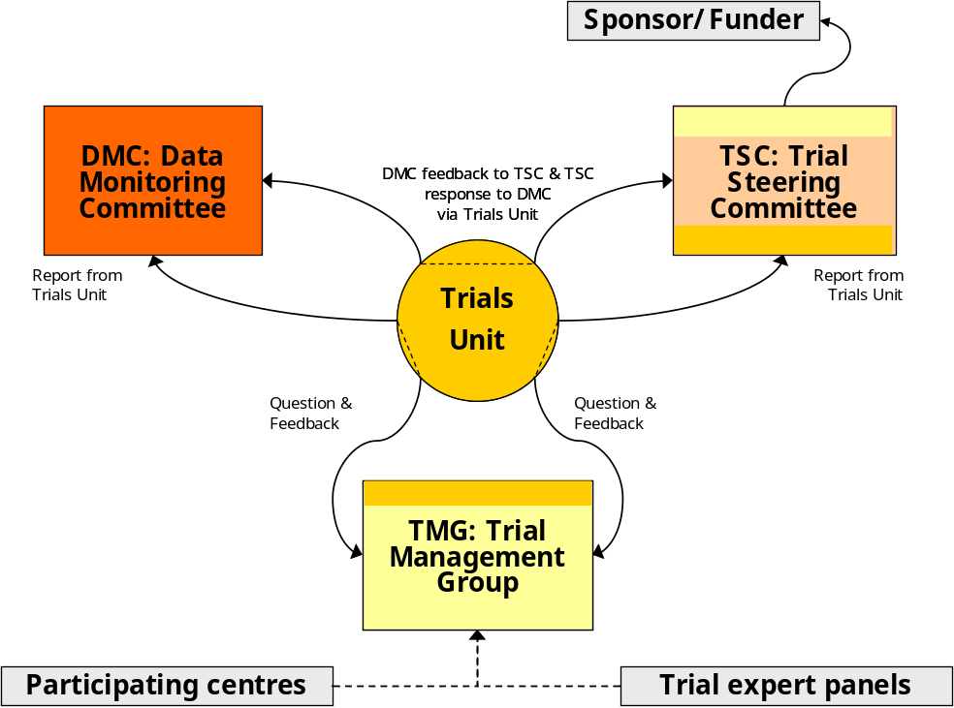

Annexe 1: Agreement and potential competing interests form

Trial name (Trial ID): Agreement to join the Trial Management Group and disclosure of potential competing interests

Please complete the following document and return to the Trial Manager.

(please initial box to agree)
I have read and understood the TMG Charter version xx.x, dated __/___/____

I agree to join the Trial Management Group for this trial

I agree to treat all sensitive trial data and discussions confidentially

The avoidance of any perception that members of a TMG may be biased in some fashion is important for the credibility of the decisions made by the TMG and for the integrity of the trial.

Potential competing interests should be disclosed via the MRC CTU. In many cases simple disclosure up front should be sufficient. Otherwise, the (potential) TMG member should remove the conflict or stop participating in the TMG. Table 1 lists potential competing interests.

No, I have no potential competing interests to declare
Yes, I have potential competing interests to declare (please detail below)

Please provide details of any potential competing interests:

Name: ___________________________

Signed: __________________________ Date: ______________

Table 1: Potential competing interests
- Stock ownership in any commercial companies involved
- Stock transaction in any commercial company involved (if previously holding stock)
- Consulting arrangements with the Sponsor/Funder (including CI for other MRC trials)
- Ongoing advisory role to a company providing drugs to the trial
- Frequent speaking engagements on behalf of the intervention
- Intellectual conflict e.g. strong prior belief in the trial’s experimental arm
- Involvement in regulatory issues relevant to the trial procedures
- Investment (financial or intellectual) or career tied up in competing products

Note: This TMG charter was developed using MRC CTU template TMG Charter version 3.01, 13-Mar-2006

Annexe 2: Summary of changes from previous version

Version 3.0
This is version 3.0 of the TMG charter for this trial and is numbered this way for historical reasons. There are no changes to be reported from previous versions.

