This is a title

This is a subtitle

Firstname Surname

2023-01-30

# Heading 1

Normal body text.

*Italic text*

**Bold text**

## Heading 2

### Heading 3

|  |  |
| --- | --- |
| speed | dist |
| 4 | 2 |
| 4 | 10 |
| 7 | 4 |
| 7 | 22 |
| 8 | 16 |
| 9 | 10 |
| 10 | 18 |
| 10 | 26 |
| 10 | 34 |
| 11 | 17 |
| 11 | 28 |
| 12 | 14 |
| 12 | 20 |
| 12 | 24 |
| 12 | 28 |
| 13 | 26 |
| 13 | 34 |
| 13 | 34 |
| 13 | 46 |
| 14 | 26 |
| 14 | 36 |
| 14 | 60 |
| 14 | 80 |
| 15 | 20 |
| 15 | 26 |
| 15 | 54 |
| 16 | 32 |
| 16 | 40 |
| 17 | 32 |
| 17 | 40 |
| 17 | 50 |
| 18 | 42 |
| 18 | 56 |
| 18 | 76 |
| 18 | 84 |
| 19 | 36 |
| 19 | 46 |
| 19 | 68 |
| 20 | 32 |
| 20 | 48 |
| 20 | 52 |
| 20 | 56 |
| 20 | 64 |
| 22 | 66 |
| 23 | 54 |
| 24 | 70 |
| 24 | 92 |
| 24 | 93 |
| 24 | 120 |
| 25 | 85 |

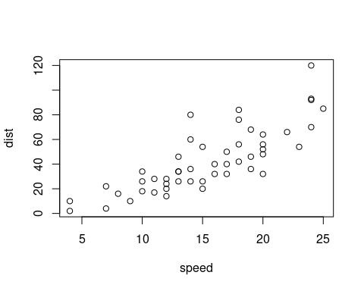

Figure 1.1: This is a figure caption