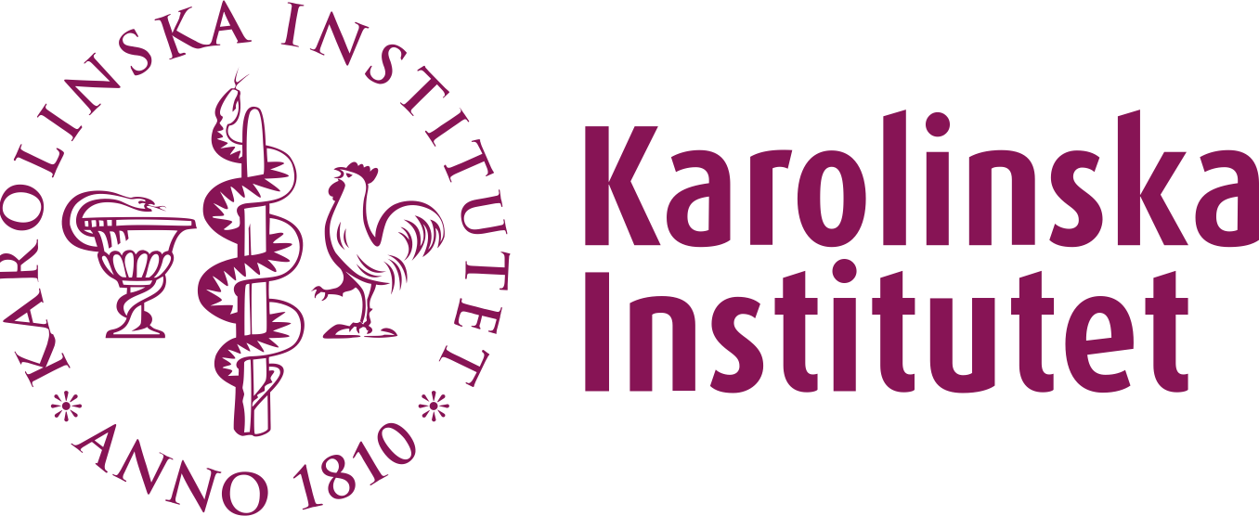Certification of business travel

**Mailing address:** Karolinska Institutet, 171 77 Stockholm| **Visiting address:** Tomtebodavägen 18, 171 65 Solna  
**Telephone:**+46 8 524 800 00, switchboard, +46 8 524 833 74, direct |  
**E‑mail:**marie.hasselberg@ki.se | **Web**: [ki.se](https://ki.se) | Org. no 202100 2973

2024-10-01

Department of Global Public Health

Head of Department

Marie Hasselberg, Professor

Embassy of India, Sweden & Latvia

Kornhamnstorg 4

111 27 Stockholm

Certification of business travel

To Whom It May Concern,

This letter is to certify that Martin Gerdin Wärnberg is employed by Karolinska Institutet in Stockholm, Sweden, and will be traveling to India for a business visit to the George Institute for Global Health. The visit will take place from October 14 to October 26, 2024.

Best regards,

Marie Hasselberg  
Professor and Head of Department  
Department of Global Public Health  
Karolinska Institutet