Medusa Software


C-Sharp (C#) Coding Guidelines

1.0.0 Gabriel Cerutti

© COPYRIGHT 2009
Medusa Software
ALL RIGHTS RESERVED
Revision History

Version | Date | Summary of Change | Author
1.0.0 | 12/02/2009 | Conversion a Medusa… jeje | Gabriel Cerutti

Table of Contents

1 Introduction 1
1.1 Scope 1
1.2 Document Conventions 1
1.3 Terminology & Definitions 2
1.4 Quick Summary 3
1.4.1 Capitalization Styles 3
1.4.2 Case Sensitivity 4
1.4.3 Abbreviations 5
1.4.4 Word Choice 5
1.4.5 Avoiding Type Name Confusion 6
1.4.6 Namespace Naming Guidelines 8
1.4.7 Class Naming GuidelinesAbbreviations 9
1.4.8 Interface Naming Guidelines 9
1.4.9 Attribute Naming Guidelines 10
1.4.10 Enumeration Type Naming Guidelines 10
1.4.11 Static Field Naming Guidelines 11
1.4.12 Parameter Naming Guidelines 11
1.4.13 Method Naming Guidelines 11
1.4.14 Property Naming Guidelines 12
1.4.15 Event Naming Guidelines 13
1.4.16 Language Usage 14
1.4.17 Coding Style 15
2 Naming Conventions 16
2.1 General Guidelines 16
2.2 Name Usage & Syntax 17
3 Coding Style 20
3.1 Formatting 20
3.2 Code Commenting 21
4 Language Usage 23
4.1 General 23
4.2 Variables & Types 23
4.3 Flow Control 25
4.4 Exception Handling 26
4.5 Events, Delegates, & Threading 27
4.6 Object Composition 28
5 References 31

This page is intentionally left blank

Introduction

This document describes rules and recommendations for developing applications and class libraries using the C# Language. The goal is to define guidelines to enforce consistent style and formatting and help developers avoid common pitfalls and mistakes.
Specifically, this document covers Naming Conventions, Coding Style and Language Usage.

Scope

This document only applies to the C# Language and the .NET Framework Common Type System (CTS) it implements. Although the C# language is implemented alongside the .NET Framework, this document does not address usage of .NET Framework class libraries. However, common patterns and problems related to C#’s usage of the .NET Framework are addressed in a limited fashion.
Even though standards for curly-braces ({ or }) and white space (tabs vs. spaces) are always controversial, these topics are addressed here to ensure greater consistency and maintainability of source code.

Document Conventions

Much like the ensuing coding standards, this document requires standards in order to ensure clarity when stating the rules and guidelines. Certain conventions are used throughout this document to add emphasis.

Below are some of the common conventions used throughout this document.

Coloring & Emphasis:

Blue Text colored blue indicates a C# keyword or .NET type.

Bold Text with additional emphasis to make it stand-out.

Keywords:

Always Emphasizes this rule must be enforced.

Never Emphasizes this action must not happen.

Do Not Emphasizes this action must not happen.

Avoid Emphasizes that the action should be prevented, but some exceptions may exist.

Try Emphasizes that the rule should be attempted whenever possible and appropriate.

Example Precedes text used to illustrate a rule or recommendation.

Reason Explains the thoughts and purpose behind a rule or recommendation.

Terminology & Definitions

The following terminology is referenced throughout this document:

Access Modifier
C# keywords public, protected, internal, and private declare the allowed code-accessibility of types and their members. Although default access modifiers vary, classes and most other members use the default of private. Notable exceptions are interfaces and enums which both default to public.

Pascal case
The first letter in the identifier and the first letter of each subsequent concatenated word are capitalized. You can use Pascal case for identifiers of three or more characters. For example:
BackColor

Camel case
The first letter of an identifier is lowercase and the first letter of each subsequent concatenated word is capitalized. For example:
backColor

Uppercase
All letters in the identifier are capitalized. Use this convention only for identifiers that consist of two or fewer letters. For example:
System.IO
System.Web.UI

Common Type System
The .NET Framework common type system (CTS) defines how types are declared, used, and managed. All native C# types are based upon the CTS to ensure support for cross-language integration.

Identifier
A developer defined token used to uniquely name a declared object or object instance. For example:

public class MyClassNameIdentifier {……..}

Magic Number
Any numeric literal used within an expression (or to initialize a variable) that does not have an obvious or well-known meaning. This usually excludes the integers 0 or 1 and any other numeric equivalent precision that evaluates as zero.

Premature Generalization
As it applies to object model design; this is the act of creating abstractions within an object model not based upon concrete requirements or a known future need for the abstraction. In simplest terms: “Abstraction for the sake of Abstraction.”

Quick Summary

This section contains tables describing a high-level summary of the major standards covered in this document.
These tables are not comprehensive, but give a quick glance at commonly referenced elements.

Capitalization Styles

You might also have to capitalize identifiers to maintain compatibility with existing, unmanaged symbol schemes, where all uppercase characters are often used for enumerations and constant values. In general, these symbols should not be visible outside of the assembly that uses them.

The following table summarizes the capitalization rules and provides examples for the different types of identifiers.

Identifier | Case | Example
Class | Pascal | AppDomain
Enum type | Pascal | ErrorLevel
Enum values | Pascal | FatalError
Event | Pascal | ValueChange
Exception class | Pascal | WebException  Note Always ends with the suffix Exception.
Read-only Static field | Pascal | RedValue
Interface | Pascal | IDisposable  Note Always begins with the prefix I.
Method | Pascal | ToString
Namespace | Pascal | System.Drawing
Parameter | Camel | typeName
Property | Pascal | BackColor
Protected instance field | Camel | redValue  Note Rarely used. A property is preferable to using a protected instance field.
Public instance field | Pascal | RedValue  Note Rarely used. A property is preferable to using a public instance field.

Case Sensitivity

- To avoid confusion and guarantee cross-language interoperation, follow these rules regarding the use of case sensitivity:
- Do not use names that require case sensitivity. Components must be fully usable from both case-sensitive and case-insensitive languages. Case-insensitive languages cannot distinguish between two names within the same context that differ only by case. Therefore, you must avoid this situation in the components or classes that you create.
- Do not create two namespaces with names that differ only by case. For example, a case insensitive language cannot distinguish between the following two namespace declarations.

namespace ee.cummings;
namespace Ee.Cummings;

- Do not create a function with parameter names that differ only by case. The following example is incorrect.

void MyFunction(string a, string A)

- Do not create a namespace with type names that differ only by case. In the following example, Point p and POINT p are inappropriate type names because they differ only by case.

System.Windows.Forms.Point p
System.Windows.Forms.POINT p

- Do not create a type with property names that differ only by case. In the following example, int Color and int COLOR are inappropriate property names because they differ only by case.

int Color {get, set}
int COLOR {get, set}

- Do not create a type with method names that differ only by case. In the following example, calculate and Calculate are inappropriate method names because they differ only by case.

void calculate()
void Calculate()

Abbreviations

To avoid confusion and guarantee cross-language interoperation, follow these rules regarding the use of abbreviations:

- Do not use abbreviations or contractions as parts of identifier names. For example, use GetWindow instead of GetWin.
- Do not use acronyms that are not generally accepted in the computing field.
- Where appropriate, use well-known acronyms to replace lengthy phrase names. For example, use UI for User Interface and OLAP for On-line Analytical Processing.
- When using acronyms, use Pascal case or camel case for acronyms more than two characters long. For example, use HtmlButton or htmlButton. However, you should capitalize acronyms that consist of only two characters, such as System.IO instead of System.Io.
- Do not use abbreviations in identifiers or parameter names. If you must use abbreviations, use camel case for abbreviations that consist of more than two characters, even if this contradicts the standard abbreviation of the word.

Word Choice

Avoid using class names that duplicate commonly used .NET Framework namespaces. For example, do not use any of the following names as a class name: System, Collections, Forms, or UI. See the Class Library for a list of .NET Framework namespaces.
In addition, avoid using identifiers that conflict with the following keywords.

AddHandler | AddressOf | Alias | And | Ansi
As | Assembly | Auto | Base | Boolean
ByRef | Byte | ByVal | Call | Case
Catch | CBool | CByte | CChar | CDate
CDec | CDbl | Char | CInt | Class
CLng | CObj | Const | CShort | CSng
CStr | CType | Date | Decimal | Declare
Default | Delegate | Dim | Do | Double
Each | Else | ElseIf | End | Enum
Erase | Error | Event | Exit | ExternalSource
False | Finalize | Finally | Float | For
Friend | Function | Get | GetType | Goto
Handles | If | Implements | Imports | In
Inherits | Integer | Interface | Is | Let
Lib | Like | Long | Loop | Me
Mod | Module | MustInherit | MustOverride | MyBase
MyClass | Namespace | New | Next | Not
Nothing | NotInheritable | NotOverridable | Object | On
Option | Optional | Or | Overloads | Overridable
Overrides | ParamArray | Preserve | Private | Property
Protected | Public | RaiseEvent | ReadOnly | ReDim
Region | REM | RemoveHandler | Resume | Return
Select | Set | Shadows | Shared | Short
Single | Static | Step | Stop | String
Structure | Sub | SyncLock | Then | Throw
To | True | Try | TypeOf | Unicode
Until | volatile | When | While | With
WithEvents | WriteOnly | Xor | eval | extends
instanceof | package | var

Avoiding Type Name Confusion

Different programming languages use different terms to identify the fundamental managed types. Class library designers must avoid using language-specific terminology. Follow the rules described in this section to avoid type name confusion.

Use names that describe a type's meaning rather than names that describe the type. In the rare case that a parameter has no semantic meaning beyond its type, use a generic name. For example, a class that supports writing a variety of data types into a stream might have the following methods.
Do not create language-specific method names, as in the following example.

void Write(double doubleValue);
void Write(float floatValue);
void Write(long longValue);
void Write(int intValue);
void Write(short shortValue);

In the extremely rare case that it is necessary to create a uniquely named method for each fundamental data type, use a universal type name. The following table lists fundamental data type names and their universal substitutions.

C# type name | Universal type name
sbyte | SByte
byte | Byte
short | Int16
ushort | UInt16
int | Int32
uint | UInt32
long | Int64
ulong | UInt64
float | Single
double | Double
bool | Boolean
char | Char
string | String
object | Object

For example, a class that supports reading a variety of data types from a stream might have the following methods.

double ReadDouble();
float ReadSingle();
long ReadInt64();
int ReadInt32();
short ReadInt16();

The preceding example is preferable to the following language-specific alternative.

double ReadDouble();
float ReadFloat();
long ReadLong();
int ReadInt();
short ReadShort();

Namespace Naming Guidelines

The general rule for naming namespaces is to use the company name followed by the technology name and optionally the feature and design as follows.

CompanyName.TechnologyName[.Feature][.Design]

For example:
Microsoft.Media
Microsoft.Media.Design

Prefixing namespace names with a company name or other well-established brand avoids the possibility of two published namespaces having the same name. For example, Microsoft.Office is an appropriate prefix for the Office Automation Classes provided by Microsoft.

Use a stable, recognized technology name at the second level of a hierarchical name. Use organizational hierarchies as the basis for namespace hierarchies. Name a namespace that contains types that provide design-time functionality for a base namespace with the .Design suffix. For example, the System.Windows.Forms.Design Namespace contains designers and related classes used to design System.Windows.Forms based applications.
A nested namespace should have a dependency on types in the containing namespace. For example, the classes in the System.Web.UI.Design depend on the classes in System.Web.UI. However, the classes in System.Web.UI do not depend on the classes in System.Web.UI.Design.

You should use Pascal case for namespaces, and separate logical components with periods, as in Microsoft.Office.PowerPoint. If your brand employs nontraditional casing, follow the casing defined by your brand, even if it deviates from the prescribed Pascal case. For example, the namespaces NeXT.WebObjects and ee.cummings illustrate appropriate deviations from the Pascal case rule.
Use plural namespace names if it is semantically appropriate. For example, use System.Collections rather than System.Collection. Exceptions to this rule are brand names and abbreviations. For example, use System.IO rather than System.IOs.

Do not use the same name for a namespace and a class. For example, do not provide both a Debug namespace and a Debug class.

Finally, note that a namespace name does not have to parallel an assembly name. For example, if you name an assembly MyCompany.MyTechnology.dll, it does not have to contain a MyCompany.MyTechnology namespace.

Class Naming GuidelinesAbbreviations

The following rules outline the guidelines for naming classes:

Use a noun or noun phrase to name a class.

- Use Pascal case.
- Use abbreviations sparingly.
- Do not use a type prefix, such as C for class, on a class name. For example, use the class name FileStream rather than CFileStream.
- Do not use the underscore character (_).
- Occasionally, it is necessary to provide a class name that begins with the letter I, even though the class is not an interface. This is appropriate as long as I is the first letter of an entire word that is a part of the class name. For example, the class name IdentityStore is appropriate.
- Where appropriate, use a compound word to name a derived class. The second part of the derived class's name should be the name of the base class. For example, ApplicationException is an appropriate name for a class derived from a class named Exception, because ApplicationException is a kind of Exception. Use reasonable judgment in applying this rule. For example, Button is an appropriate name for a class derived from Control. Although a button is a kind of control, making Control a part of the class name would lengthen the name unnecessarily.

The following are examples of correctly named classes.

public class FileStream
public class Button
public class String

Interface Naming Guidelines

The following rules outline the naming guidelines for interfaces:
- Name interfaces with nouns or noun phrases, or adjectives that describe behavior. For example, the interface name IComponent uses a descriptive noun. The interface name ICustomAttributeProvider uses a noun phrase. The name IPersistable uses an adjective.
- Use Pascal case.
- Use abbreviations sparingly.
- Prefix interface names with the letter I, to indicate that the type is an interface.
- Use similar names when you define a class/interface pair where the class is a standard implementation of the interface. The names should differ only by the letter I prefix on the interface name.
- Do not use the underscore character (_).

The following are examples of correctly named interfaces.

public interface IServiceProvider
public interface IFormatable

The following code example illustrates how to define the interface IComponent and its standard implementation, the class Component.

public interface IComponent
{
// Implementation code goes here.
}
public class Component: IComponent
{
// Implementation code goes here.
}

Attribute Naming Guidelines

You should always add the suffix Attribute to custom attribute classes. The following is an example of a correctly named attribute class.

public class ObsoleteAttribute{}

Enumeration Type Naming Guidelines

The enumeration (Enum) value type inherits from the Enum Class. The following rules outline the naming guidelines for enumerations:

- Use Pascal case for Enum types and value names.
- Use abbreviations sparingly.
- Do not use an Enum suffix on Enum type names.
- Use a singular name for most Enum types, but use a plural name for Enum types that are bit fields.
- Always add the FlagsAttribute to a bit field Enum type.

Static Field Naming Guidelines

The following rules outline the naming guidelines for static fields:

- Use nouns, noun phrases, or abbreviations of nouns to name static fields.
- Use Pascal case.
- Do not use a Hungarian notation prefix on static field names.
- It is recommended that you use static properties instead of public static fields whenever possible.

Parameter Naming Guidelines

It is important to carefully follow these parameter naming guidelines because visual design tools that provide context sensitive help and class browsing functionality display method parameter names to users in the designer. The following rules outline the naming guidelines for parameters:

- Use camel case for parameter names.
- Use descriptive parameter names. Parameter names should be descriptive enough that the name of the parameter and its type can be used to determine its meaning in most scenarios. For example, visual design tools that provide context sensitive help display method parameters to the developer as they type. The parameter names should be descriptive enough in this scenario to allow the developer to supply the correct parameters.
- Use names that describe a parameter's meaning rather than names that describe a parameter's type. Development tools should provide meaningful information about a parameter's type. Therefore, a parameter's name can be put to better use by describing meaning. Use type-based parameter names sparingly and only where it is appropriate.
- Do not use reserved parameters. Reserved parameters are private parameters that might be exposed in a future version if they are needed. Instead, if more data is needed in a future version of your class library, add a new overload for a method.
- Do not prefix parameter names with Hungarian type notation.

The following are examples of correctly named parameters.

Type GetType(string typeName)
string Format(string format, object[] args)

Method Naming Guidelines

The following rules outline the naming guidelines for methods:

- Use verbs or verb phrases to name methods.
- Use Pascal case.

The following are examples of correctly named methods.

RemoveAll()
GetCharArray()
Invoke()

Property Naming Guidelines

The following rules outline the naming guidelines for properties:

- Use a noun or noun phrase to name properties.
- Use Pascal case.
- Do not use Hungarian notation.
- Consider creating a property with the same name as its underlying type. For example, if you declare a property named Color, the type of the property should likewise be Color. See the example later in this topic.

The following code example illustrates correct property naming.

public class SampleClass
{
public Color BackColor
{
// Code for Get and Set accessors goes here.
}
}

The following code example illustrates providing a property with the same name as a type.

public enum Color
{
// Insert code for Enum here.
}
public class Control
{
public Color Color
{
get {// Insert code here.}
set {// Insert code here.}
}
}

The following code example is incorrect because the property Color is of type Integer.

public enum Color {// Insert code for Enum here.}
public class Control
{
public int Color
{
get {// Insert code here.}
set {// Insert code here.}
}
}

In the incorrect example, it is not possible to refer to the members of the Color enumeration. Color.Xxx will be interpreted as accessing a member that first gets the value of the Color property (type Integer in Visual Basic or type int in C#) and then accesses a member of that value (which would have to be an instance member of System.Int32).

Event Naming Guidelines

The following rules outline the naming guidelines for events:

- Use Pascal case.
- Do not use Hungarian notation.
- Use an EventHandler suffix on event handler names.
- Specify two parameters named sender and e. The sender parameter represents the object that raised the event. The sender parameter is always of type object, even if it is possible to use a more specific type. The state associated with the event is encapsulated in an instance of an event class named e. Use an appropriate and specific event class for the e parameter type.
- Name an event argument class with the EventArgs suffix.
- Consider naming events with a verb. For example, correctly named event names include Clicked, Painting, and DroppedDown.
- Use a gerund (the "ing" form of a verb) to create an event name that expresses the concept of pre-event, and a past-tense verb to represent post-event. For example, a Close event that can be canceled should have a Closing event and a Closed event. Do not use the BeforeXxx/AfterXxx naming pattern.
- Do not use a prefix or suffix on the event declaration on the type. For example, use Close instead of OnClose.
- In general, you should provide a protected method called OnXxx on types with events that can be overridden in a derived class. This method should only have the event parameter e, because the sender is always the instance of the type.

The following example illustrates an event handler with an appropriate name and parameters.

public delegate void MouseEventHandler(object sender, MouseEventArgs e);

The following example illustrates a correctly named event argument class.

public class MouseEventArgs : EventArgs
{
int x;
int y;
public MouseEventArgs(int x, int y)
{ this.x = x; this.y = y; }
public int X { get { return x; } }
public int Y { get { return y; } }
}

Language Usage

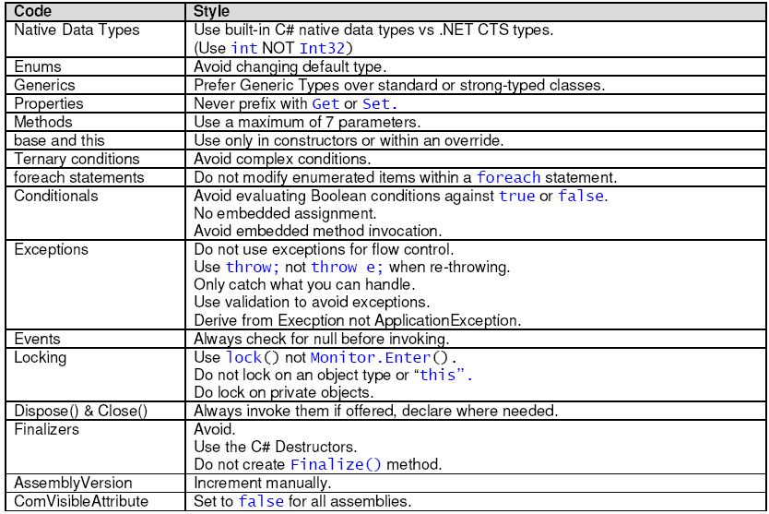

Coding Style

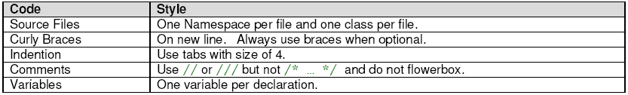

Naming Conventions

Consistency is the key to maintainable code. This statement is most true for naming your projects, source files, and identifiers including Fields, Variables, Properties, Methods, Parameters, Classes, Interfaces, and Namespaces.

General Guidelines
- Always use Camel Case or Pascal Case names.
- Avoid ALL CAPS and all lowercase names. Single lowercase words or letters are acceptable.
- Do not create namespaces, classes, methods, properties, fields, or parameters that vary only by capitalization.
- Do not use names that begin with a numeric character.
- Always choose meaningful and specific names.
- Always try to be verbose at the time of naming identifiers or writing comments.
- Variables and Properties should describe an entity not the type or size.
- Do not use Hungarian Notation!
Example: strName or iCount
- Avoid using abbreviations unless the full name is excessive.
- Avoid abbreviations longer than 5 characters.
- Any Abbreviations must be widely known and accepted.
- Use uppercase for two-letter abbreviations, and Pascal Case for longer abbreviations.
- Do not use C# reserved words as names.
- Avoid naming conflicts with existing .NET Framework namespaces, or types.
- Avoid adding redundant or meaningless prefixes and suffixes to identifiers
Example:
//Bad
public enum ColorsEnum { …. }
public class CVehicle { …. }
public struct RectangleStruct { …. }

- Do not include the parent class name within a property name.
Example: Customer.Name NOT Customer.CustomerName
- Try to prefix Boolean variables and properties with “Can”, “Is” or “Has”.
- Append computational qualifiers to variable names like Average, Count, Sum, Min and Max where appropriate.
- When defining a root namespace, use a Product, Company, or Developer Name as the root.
Example: LanceHunt.StringUtilities

Name Usage & Syntax

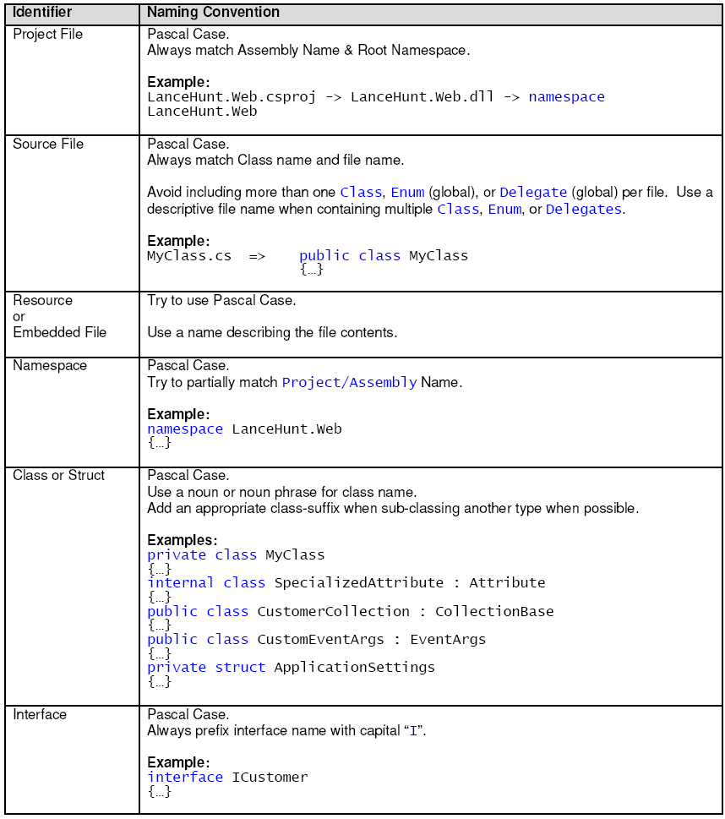

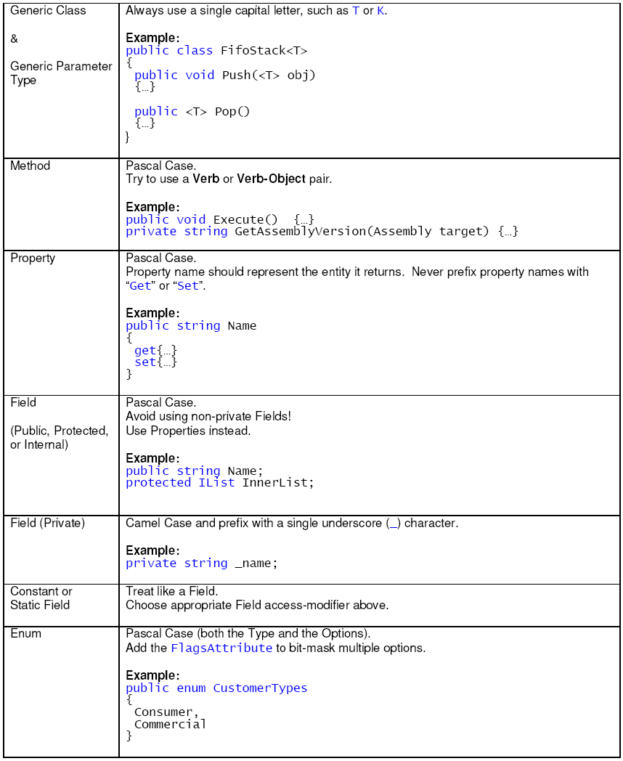

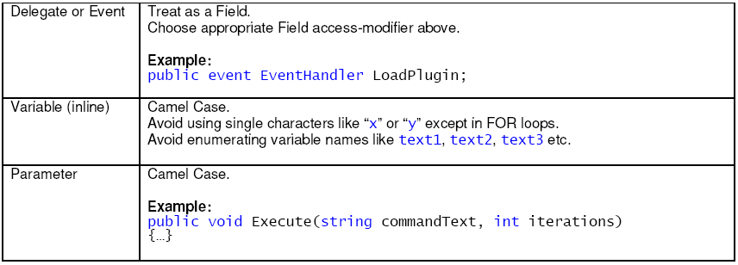

Coding Style

Coding style causes the most inconsistency and controversy between developers. Each developer has a preference, and rarely are two the same. However, consistent layout, format, and organization are key to creating maintainable code. The following sections describe the preferred way to implement C# source code in order to create readable, clear, and consistent code that is easy to understand and maintain.

Formatting

- Never declare more than 1 namespace per file.
- Avoid putting multiple classes in a single file.
- Always place curly braces ({ and }) on a new line.
- Always use curly braces ({ and }) in conditional statements.
- Always use a Tab & Indention size of 4.
- Declare each variable independently – not in the same statement.
- Place namespace “using” statements together at the top of file. Group .NET namespaces above custom namespaces.
- Group internal class implementation by type in the following order:
  - Member variables.
  - Constructors & Finalizers.
  - Nested Enums, Structs, and Classes.
  - Properties
  - Methods
- Sequence declarations within type groups based upon access modifier and visibility:
  - Public
  - Protected
  - Internal
  - Private
- Segregate interface Implementation by using #region statements.
- Append folder-name to namespace for source files within sub-folders.
- Recursively indent all code blocks contained within braces.
- Use white space (CR/LF, Tabs, etc) liberally to separate and organize code.
- Avoid declaring multiple attribute declarations within a single line. Instead stack each attribute as a separate declaration.
Example:

// Bad !
[Attribute1, Attribute2, Attribute3]
public class MyClass
{ …… }

// Good !
[Attribute1]
[Attribute2]
[Attribute3]
public class MyClass
{ …… }

- Place Assembly scope attribute declarations on a separate line.
- Place Type scope attribute declarations on a separate line.
- Place Method scope attribute declarations on a separate line.

- Place Member scope attribute declarations on a separate line.
- Place Parameter attribute declarations inline with the parameter.
- If in doubt, always err on the side of clarity and consistency.

Code Commenting

- All comments should be written in U.S. English.
2 Use // or /// but never /* …….. */
3 Do not “flowerbox” comment blocks.
Example:

// ****************************************************
// Comment block
// ****************************************************

4 Use inline-comments to explain assumptions, known issues, and algorithm insights.
5 Do not use inline-comments to explain obvious code. Well written code is self documenting.
6 Only insert inline-comments for Bad Code to say “fix this code” – otherwise, rewrite it!
7 Include Task-List keyword flags to enable comment-filtering.
Example:

// TODO: Place Database code here
// UNDONE: Removed P/Invoke Call due to errors
// HACK: Temporary fix until able to refactor

8 Always apply C# comment-blocks (///) to public, protected, and internal declarations.
9 Only use C# comment-blocks for documenting the API.
10 Always include <summary> comments. Include <param>, <return>, and <exception> comment sections where applicable.
11 Include <see cref=””/> and <seeAlso cref+””/> where possible.
12 Always add CDATA tags to comments containing code and other embedded markup in order to avoid encoding issues.
Example:

/// <example>
/// Add the following key to the “appSettings” section of your config:
/// <code><! [CDATA[
/// <configuration>
/// <appSettings>
/// <add key=”mySetting” value=”myvalue”/>
/// </appSettings>
/// </configuration>
/// ]]></code>
/// </example>

Language Usage

General
- Do not omit access modifiers. Explicitly declare all identifiers with the appropriate access modifier instead of allowing the default.
Example:

// Bad !
Void WriteEvent(string message)
{ … }

// Good !
private Void WriteEvents(string Message)
{ … }

- Do not use the default (“1.0.*”) versioning scheme. Increment the AssemblyVersionAttribute value manually.
- Set the ComVisibleAttribute to false for all assemblies. Afterwards, selectively enable the ComVisibleAttribute for individual classes as needed.
Example:

[assembly: ComVisible(false)]
[ComVisible(true)]
public MyClass
{ … }

- Consider factoring classes with unsafe code blocks into a separate assembly.
- Avoid mutual references between assemblies.

Variables & Types

- Try to initialize variables where you declare them.
2. Use the simplest data type, list, or object required. For example, use int over. Long unless you know you need to store 64bit values.
3. Always use the built-in C# data type aliases, not the .NET common type system (CTS).
Example:

short NOT System.Int16
int NOT System.Int32
long NOT System.Int64
string NOT System.String

4. Only declare member variables as private. Use properties to provide access to them with public, protected, or internal access modifiers.
5. Avoid specifying a type for an enum - use default of int unless you have an explicit need for long.
- Avoid using inline numeric literals (magic numbers). Instead, use a Constant or Enum.
- Avoid declaring inline string literals. Instead use Constants, Resources, Registry or other data sources.
- Only declare constants for simple types.
- Declare readonly or static readonly variables instead of constants for complex types.
- Avoid direct casts. Instead, use the “as” operator and check for null.
Example:

object dataObject = LoadData();
DataSet ds = dataObject as DataSet;

if (ds != null)
{ … }

- Always prefer C# Generic collection types over standard or strong-typed collections.
- Always explicitly initialize arrays of reference types using a for loop.
- Avoid boxing and unboxing value types.
Example:

int count = 1;
object refCount = count; // Implicity boxed.
int newCount = (int)refCount; // Explicity unboxed.

- Floating point values should include at least one digit before the decimal place and one after.
Example: totalPercent = 0.05;

- Try to use the “@” prefix for string literals instead of escaped strings.
- Prefer String.Format() or StringBuilder over string concatenation.
- Never concatenate strings inside a loop.
- Do not compare strings to String.Empty or “ ” to check for empty strings. Instead, compare by using String.Length == 0.

- Avoid hidden string allocations within a loop. Use String.Compare() instead.
Example: (ToLower() creates a temp string)

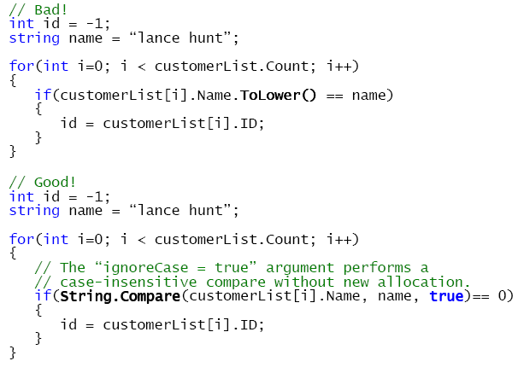

Flow Control

1. Avoid invoking methods within a conditional expression.
2. Avoid creating recursive methods. Use loops or nested loops instead.
3. Avoid using foreach to iterate over immutable value-type collections. E.g. String arrays.
4. Do not modify enumerated items within a foreach statement.
5. Use the ternary conditional operator only for trivial conditions. Avoid complex or compound ternary operations.
Example: int result = isValid ? 9 : 4;

6. Avoid evaluating Boolean conditions against true or false.
Example:

// Bad !
if (isValid == true)
{ … }

// Good !
if (isValid)
{ … }

7. Avoid assignment within conditional statements.
Example: if ((i=2)==2) { … }

8. Avoid compound conditional expressions – use Boolean variables to split parts into multiple manageable expressions.
Example:

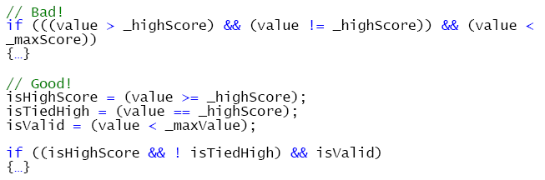

9. Avoid explicit Boolean tests in conditionals.
Example:

// Bad !
if (IsValid == true)
{ … }

// Good !
if (IsValid)
{ … }

10. Only use switch/case statements for simple operations with parallel conditional logic.
11. Prefer nested if/else over switch/case for short conditional sequences and complex conditions.
12. Prefer polymorphism over switch/case to encapsulate and delegate complex operations.

Exception Handling

1. Do not use try/catch blocks for flow-control.
- Only catch exceptions that you can handle.
- Never declare an empty catch block.
- Avoid nesting a try/catch within a catch block.
- Use exception filters where possible.
- Order exception filters from most to least derived exception type.
- Avoid re-throwing an exception. Allow it to bubble-up instead.
- If re-throwing an exception, omit the exception argument from the _% & statement so the original call stack is preserved.
Example:

// Bad !
catch (Exception ex)
{
Log(ex);
throw ex;
}

// Good !
catch (Exception ex)
{
Log(ex);
throw;
}

9. Only use the finally block to release resources from a try statement.
10. Always use validation to avoid exceptions.
Example:

// Bad !
try
{
conn.Close();
}
catch (Exception ex)
{
// handle exception if already closed!
}

// Good !
if (conn.State != ConnectionState.Closed)
{
conn.Close();
}

11. Avoid defining custom exception classes. Use existing exception classes instead.
12 When a custom exception is required;
  - Always derive from Exception not ApplicationException.
  - Always override the ToString method and String implicit operator to provide serialization.
  - Always implement the Exception Constructor Pattern:
public MyCustomException ();
public MyCustomException (string message);
public MyCustomException (string message, Exception innerException);

13. When throwing a new Exception always pass the innerException in order to maintain the exception tree & inner call stack.

Events, Delegates, & Threading

- Always check Event & Delegate instances for null before invoking.
- Use the default EventHandler and EventArgs for most simple events.
- Always derive a custom EventArgs class to provide additional data.
- Use the existing CancelEventArgs class to allow the event subscriber to control events.
- Always use the “lock” keyword instead of the Monitor type.
- Only lock on a private or private static object.
- Example: lock(myVariable);
- Avoid locking on a Type.
- Example: lock(typeof(MyClass));
- Avoid locking on the current object instance.
- Example: lock(this);

Object Composition
- Always declare types explicitly within a namespace. Do not use the default “{global}” namespace.
- Avoid declaring methods with more than 7 parameters. Refactor or consider passing a struct or class instead.
- Do not use the “new” keyword to hide members of a derived type.
- Only use the “base” keyword when invoking a base class constructor or base implementation within an override.
- Do not use the protected access modifier in sealed classes.
- Consider using method overloading instead of the params attribute.
- Always validate an enumeration variable or parameter value before consuming it. They may contain any value that the underlying Enum type (default int) supports.
Example:
public void Test(BookCategory cat)
{
if (Enum.IsDefined(typeof(BookCategory), cat))
}

8. Consider overriding Equals() on a struct.
9. Always override the Equality Operator (==) when overriding the Equals() method.
10. Always override the String Implicit Operator when overriding the ToString() method.
11. Always call Close() or Dispose() on classes that offer it.
12. Wrap instantiation of IDisposable objects with a “using” statement to ensure that Dispose() is automatically called.
Example:

using (SqlConnection cn = new SqlConnection(_connectionString))
{ … }

13. Always implement the IDisposable interface & pattern on classes referencing external resources.
Example: (shown with optional Finalizer)

public void Dispose()
{
Dispose(true);
GC.SuppressFinaliza(this);
}

protected virtual void Dispose(bool disposing)
{
if (disposing)
{
// Free other state (managed objects).
}
// Free your own state (unmanaged objects).
// Set large fields to null.
}

// C# finalizer. (optional)
~Base()
{
// Simply call Dispose(false).
Dispose (false);
}

14. Avoid implementing a Finalizer.
15. Never define a Finalize() method as a finalizer. Instead use the C# destructor syntax.
Example

// Bad !
void Finalize() { … }

// Good !
~MyClass { … }

References

“MSDN: Naming Guidelines, Microsoft Corporation, 2004,
http://msdn.microsoft.com/library/default.asp?url=/library/en-us/cpgenref/html/cpconnamingguidelines.asp

“MSDN: C# Language Specification v1.5”, Scott Wiltamuth & Anders Hejlsberg, Microsoft Corporation, 2003,
http://msdn.microsoft.com/library/default.asp?url=/library/en-us/csspec/html/vclrfcsharpspec_15.asp

“MSDN: Design Guidelines for Class Library Developers”, Microsoft Corporation, 2004,
http://msdn.microsoft.com/library/default.asp?url=/library/en-us/cpgenref/html/cpconNETFrameworkDesignGuidelines.asp

“Applied Microsoft .NET Framework Programming”, Jeffrey Richter, January 23, 2002, 1st ed., Microsoft Press, ISBN: 0735614229

