PRACTICAL TECHNIQUES FOR DESIGNING MICROSTRIP TAPPED HAIRPIN RESONATOR FILTERS ON FR4 LAMINATES
Nikholas G. Toledo
Communications Engineering Division
Advanced Science and Technology Institute
C.P. Garcia Ave., UP Technopark, Diliman
Quezon City, Philippines 1101

ABSTRACT
Practical design techniques are presented for tapped hairpin resonator filters on FR4 laminates. The hairpin filter is one of the most popular low microwave frequency filters because of it is compact and does not require grounding. Its design on FR4 laminates is very difficult to do because of the relatively poor performance of the laminate at the microwave region. The laminate properties of the FR4 become nonlinear unlike more expensive microwave laminates. The motivation to use FR4 in the low microwave frequencies is its cost. Methods and techniques were developed to address these problems of the FR4 and are discussed in this paper.

I. Introduction
The most popular microstrip filter in low microwave frequencies is the hairpin resonator filter. It does not require a large real estate as the edge-coupled filter. It also does not require critical grounding thus making manufacturing easier. There is however, very little literature that discusses the design of this filter. Electronic Design Automation (EDA) software is normally employed to synthesize and optimize the design for the desired specifications and yield. A very important requirement for the EDA simulation results to be close to actual results is correct modeling of the filter structure and precise characterization of the substrate or laminate used.

The FR4 laminate is the most common electronic carrier for circuits operating below the microwave frequency. Beyond 1 GHz, the laminate properties (like ε_{r}, tan δ, roughness, etc…) of the FR4 become nonlinear. It becomes difficult to precisely characterize the FR4 at the desired microwave frequency. Beyond 3 GHz, the use of the FR4 is not anymore recommended because of unacceptable attenuation. (There are however some amateur designs [1] that employ FR4 up to 5.7 GHz but these modules are very lossy for industry standards.) Choosing values close to the data sheet values and values derived from analyzing quarter and half wavelength microstrip lines normally result in EDA simulation results that are off the actual response by several hundred megahertz. The FR4 however is cheaper than most stable microwave laminates that methods were developed so that filters can be designed without the aid of simulation and synthesis software.

II. Initial Hairpin Filter Design
The hairpin filter is a variant of the edge-coupled band pass filter. A sliding factor is introduced to allow for bending thus making the design more compact (see Fig. 1) [2], [3]. The details of designing an edge-coupled filter are described in [4].

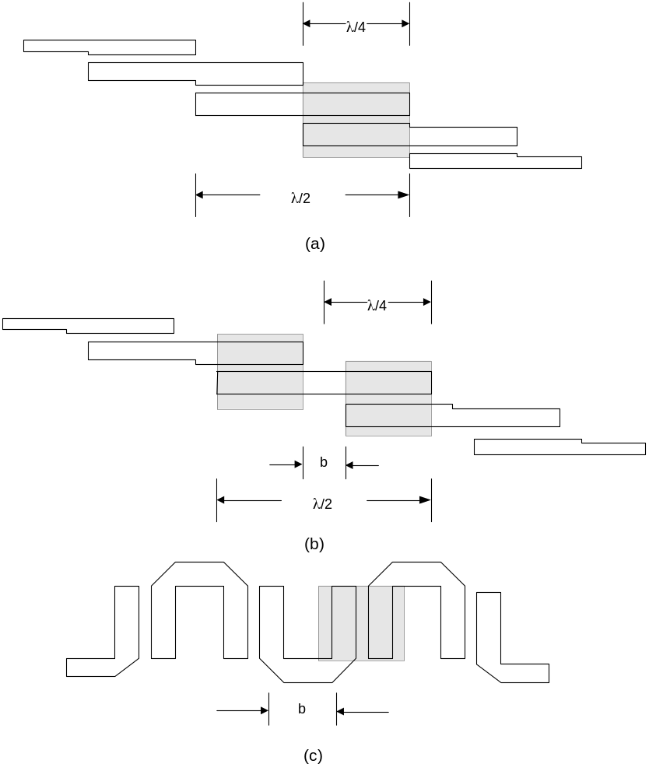
Figure 1. (a) Edge-coupled filter – notice that the coupling resonators are λ/4 long (depicted by gray area); (b) The resonators are moved to provide for a slide factor, b (depicted by gray area where length < λ/4); (c) The λ/2 resonators are bent at the slide factor area to produce the hairpin resonator structure.

The structure depicted in Fig. 1c however, was observed to introduce a large insertion loss and an unacceptable return loss in FR4 laminates. A tapped hairpin resonator filter has a smaller insertion loss and better return loss. This is a variant of an edge-coupled filter that contains a matching stub (see Fig. 2). Varying the length of this stub and the tapping distance varies the return loss and consequently the insertion loss.

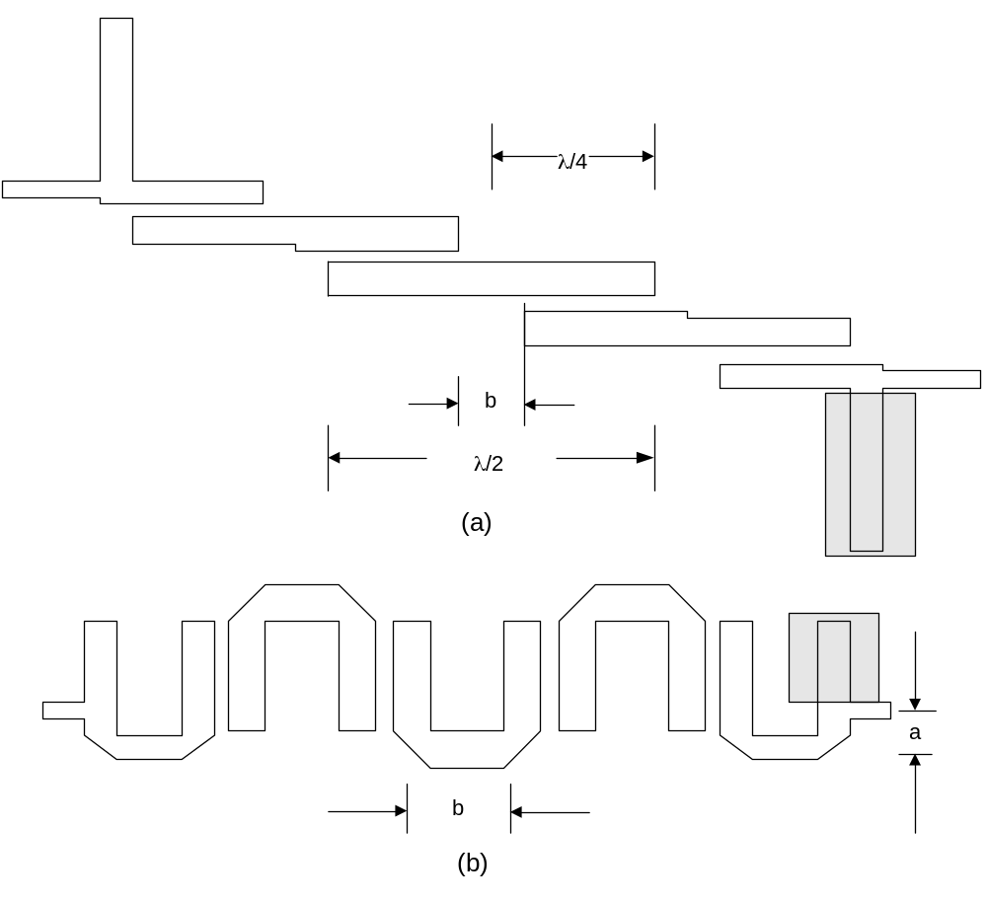

Figure 2. (a) Edge-coupled filter with matching stub (depicted by the gray area); (b) The matching stub is incorporated into the resonator thereby forming the tapped hairpin resonator filter. The tapping distance, a, is adjusted for optimal return loss.

Optimizing the design using EDA software where the substrate parameters are:
dielectric constant, ε_{r} = 4.77
laminate height, H = 59 mil
metal thickness, T = 0.7 mil
loss Tangent, Tan δ = 0.008
roughness = 0.075 mil
relative permeability, Mur = 1
conductor conductivity, Cond = 5.88E+07
cover height = 3.9E+34 mil

often lead to results that are several hundreds of megahertz away from the actual results. These values were based on the data sheets of Isola Laminate Systems (P.N. DURAVER E-CU#104), the analysis of quarter and half wavelength microstrip line structures and [5].

Patterns on the behavior of the filter were observed during the characterization and testing of different filter samples. Each sample has a specific structural dimension altered to test the effect on the filter response. These patterns are presented in the next section.

III. DESIGN PATTERNS
The following design patterns were observed while a filter is being designed experimentally for the Digital Microwave Radio project of the Advanced Science and Technology Institute. The filter must be able to operate between 2.32-2.36 GHz. The filter response at 2.45 GHz should be about 15 dB below the average insertion loss between 2.32-2.36 GHz thereby providing an additional 15 dB LO rejection to the mixer. The insertion loss at 2.54-2.58 GHz should be as low as possible. A second channel requires a filter with a passband at 2.54-2.58 GHz but rejects the 2.32-2.36 GHz frequencies.
The filters made throughout the experiment are 5th order filter. Fewer orders would provide poor selectivity and more orders would make the design too large.

3.1 Initial Design
An edge-coupled filter is first designed using the steps enumerated in [4]. The Z_{oo}, Z_{oe} values and the laminate parameters are then sent to the LineCalc transmission line calculator [6] to determine the length of the resonator, the spacing and the width. A slide factor is then introduced to provide for the bending of the resonator into a hairpin structure. The basic structure is shown in Fig. 3 including the dimensions varied to determine the specific response of the filter.
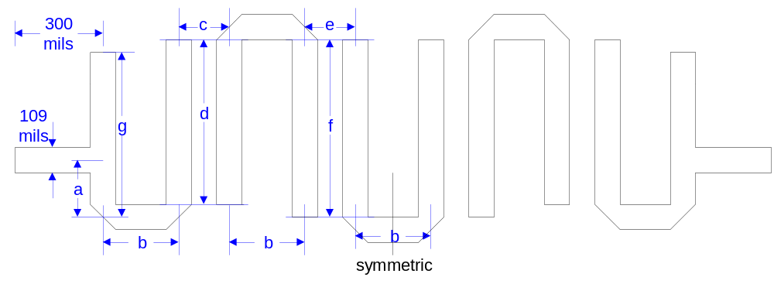
Figure 3. Tapped hairpin resonator filter dimensions. The structure is assumed to be symmetric so that S₁₁=S₂₂ and S₂₁=S₂₂ and that fewer variables could be used.

The dimensions used in most of the experiments were:
a = 263 mils
b = 525 mils
c = 131 mils
d = 416 mils
e = 171 mils
f = 416 mils
g = 430 mils

The width of the 1st resonator according to the steps given in [4] should be 91 mils while the 2nd and 3rd resonators should have widths of 107.6 and 108 mils. For simplicity of design, the width of the structure within the filter was set at 108 mils while the tapping line is 109 mils (50 Ω).

3.2 Coupling Resonator Length, d
Holding every variable in Fig. 3 constant except for d, designs were made for a = 263 mils, a + 2 mm, a + 4 mm, a – 2 mm and a – 4 mm. The center frequencies were noted and plotted in Fig. 4. This curve can be a useful reference when designing for the center frequency of the hairpin filter. Note however that this curve is relative to the initial values of parameters a to g. This means that if we want frequency x and this corresponds to coupling resonator length y and when the results of the actual test is off the target frequency x by Δx (because the parameters a to g are not the same), all we have to do is estimate from the curve the Δy needed to arrive at the desired frequency. Naturally, if the resonator length has been set to the desired frequency and other variables were changed, the center frequency may again change but this is not as severe as the effect of the resonator lengths on the center frequency. These changes can easily be compensated in succeeding design iterations.
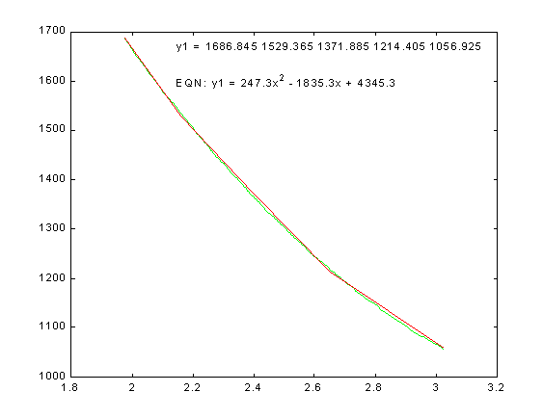
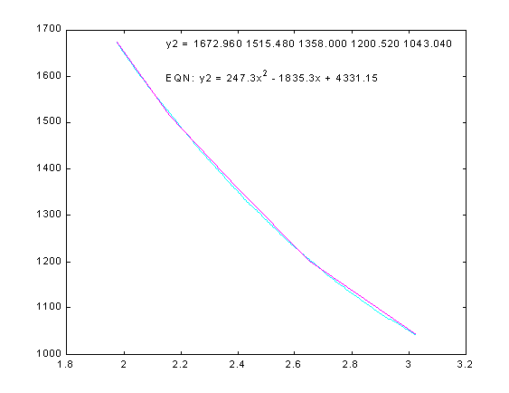
Figure 4. (a) Curve for the 1st resonator length. The y-axis gives the total length (i.e. g + b + d). (b) Curve for the 2st and 3rd resonator lengths. The y-axis gives the total length (i.e. d + b + f or 2f + b).

The equations of the of the curves in Fig. 4 are:
1st resonator length y = 247.3 f_{c}² – 1835.3 f_{c} + 4345.3 (1)
2nd,3rd resonator length y = 247.3 f_{c}² – 1835.3 f_{c} + 4331.15 (2)

3.3 Resonator Spacing, c and e
The rule of thumb used in this design is e = c + 1 mm since more coupling is required in the input matching/resonating element. This assumption allows the manipulation of just one variable instead of two thereby making analysis easier. A more involved experiment can be done to determine the actual response of varying c and e.

Smaller resonator spacing provide more coupling between adjacent resonators. More signal power is transferred and the resulting filter response is a wider bandwidth as seen in Fig. 5. Ripples are also present of the bandwidth is too wide.

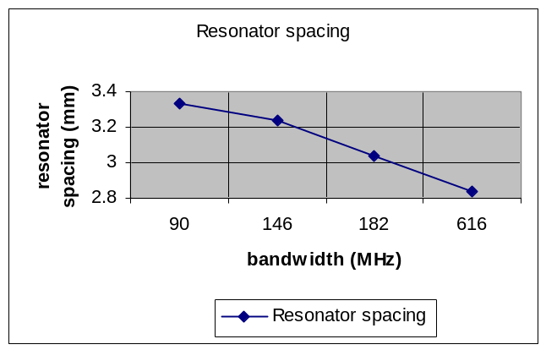
Figure 5. Resonator spacing vs. bandwidth. The desired bandwidth can be initially estimated from this curve.

3.4 Sliding Factor, b
The sliding factor b affects the insertion loss, the center frequency and the possibility of reentrant frequencies.

Decreasing b lowers the insertion loss, as more signal power is concentrated on the coupling structures instead of being attenuated along a transmission line path. However, if b is decreased without holding the total resonator length (given in Fig. 4) constant, then a frequency shift occurs. Also, decreasing b drastically may introduce resonator self-coupling, which produces reentrant frequencies [3].

Experiments on decreasing b while keeping all other variables constant were done and the results are frequency shift and varying S₁₁ response.

Experiments on decreasing b while keeping the total resonator length constant were also done and the results are slight changes in bandwidth and varying S11 response. This draws a conclusion that by keeping the total resonator length constant, the S₁₁ can be controlled. The effect of the sliding factor on the S₁₁ is more significantly observed when the 1st set of sliding factor experiments was performed. It is therefore recommended to vary only the sliding factor b to scan for the best S₁₁ response. Adjustments in resonator length can later be done to obtain again the desired center frequency.

3.5 Tap Distance, a
The tap distance a controls the return loss. Since the tapped hairpin resonator filter is actually a modified edge-coupled filter with matching stubs (see Fig. 2), adjusting a is just like adjusting the tuning stub’s length to obtain an impedance match. Like most variables, there is an optimal value below and beyond which the response deteriorates. It was observed that other properties of the filter like bandwidth and center frequency are almost not affected when a is varied. It was also observed that the insertion loss of the filter decreases as the return loss is increased. The tap distance is therefore the last variable being varied for optimal design.

IV. PRACTICAL TECHNIQUES
To design a hairpin filter, first follow the steps outlined in Section 3.1 of this paper to obtain the initial values of the variables. A prototype filter is then done and tested. The center frequency and bandwidth are then noted.

The center frequency results are compared with the curves of Fig. 4. The total resonator lengths are then adjusted following the explanation given in Sec. 3.2. Using the same technique, the resonator spacing is deduced from the curve of Fig. 5 for the desired bandwidth. Create the next prototype and then test to verify. The resulting center frequency and bandwidth may not be exactly as planned but they should be close the desired values.

In choosing the right sliding factor, the practical technique is to first use an arbitrary sliding factor (b = 525 mils in the case of the experiment). Choose the total resonator length for a particular frequency based on Fig. 4. Vary b by a constant amount (b = 525 mils – 2n mm where n = 1, 2, 3, … in the case of the experiment) while holding d, f and g constant. The center frequency will surely shift. Choose the response with the best return loss and the least insertion loss. (This part of the design iteration may take 3 prototype boards) This is approximately the correct sliding factor for the filter. Readjust d, f and g using Fig. 4 as basis to obtain the desired center frequency. The change in the insertion loss and return loss will just be slight.

Once the optimal resonator lengths, resonator spacing and sliding factor have been chosen, design a few more boards with varying tap distance to get the optimal design. Do not go beyond half of the resonator length g as the response would have been terrible by then. By rule of thumb, the bandwidth should have a return loss of 10 dB at least.

The total number of boards to be used in this design should be about 8-10 boards. This is a lot less than the 32 boards used in this research to produce an optimal 2.32-2.36 GHz band pass filter.

The final optimal filter produced is shown in Fig. 6 and its results in Fig. 7. The final filter has a 6 dB insertion loss, a very good result considering the fact that small and steep bandwidths generally suffer from high insertion loss and that above 2 GHz, the FR4 laminate is very lossy.

V. CONCLUSION
Practical techniques based on design patterns of a tapped hairpin resonator filter on FR4 laminates have been presented in this paper. This motivation is due to the difficulty of designing such filters on FR4 laminates using EDAs. Several patterns have been observed. The resonator length was shown to have a significant effect on the center frequency. The resonator spacing generally controls the bandwidth. Choosing the right slide factor increases the potential of the filter for a good match and low loss. The tap distance ultimately matches the filter to the rest of the circuitry. A step-by-step method is then presented in order to aid in the filter design.

REFERENCES
- ARRL, Ed. The ARRL UHF/Microwave Projects Manual. CT: ARRL, 1994.
- E. Cristal and S. Frankel, “Hairpin-Line and Hybrid Hairpin-Line/Half-Wave Parallel-Coupled-Line Filters,” IEEE Trans. on MTT, vol. 20, no. 11, pp. 719-728, November 1972.

- R. Rhea, HF Filter Design and Computer Simulation. Atlanta, GA: Noble Publishing, 1994.
- G. Matthaei, L. Young, and E. M. T. Jones, Microwave Filters, Impedance-Matching Networks, and Coupling Structures. Boston, MA: Artech House, 1980.

- T. Laverghetta, Microwave Materials and Fabrication Techniques, 3rd Ed., Norwood, MA: Artech House, 2000.

- Agilent Technologies, “Line Calc Program,” Advanced Design System ver. 1.3, Palo Alto, CA, November 1999.

