DEsign of a Narrowband Hairpin Filter on PTFE laminate

Carlota D. Salamat, Maria Abigail D. Lorenzo and Eusebio Jaybee B. Roxas Jr.
Communications Engineering Division, Advanced Science and Technology Institute
C.P. Garcia Ave., UP Technopark, Diliman, Quezon City Philippines 1101
Email: dmr@asti.dost.gov.ph

ABSTRACT

This paper presents a practical design procedure for hairpin resonator filters using a PTFE-based laminate. The design process starts with the theoretical design of the filter. Optimization of the design is achieved using the software Genesys of EagleWare. Finally, the results of the implementation of the design are presented. Some of the advantages of using PTFE-based laminates are also highlighted.

INTRODUCTION

The hairpin resonator filter is one of the most popular microstrip filter configurations used in the lower microwave frequencies. It is easy to manufacture because it has open-circuited ends that require no grounding. Its form is derived from the edge-coupled resonator filter by folding back the ends of the resonators into a “U” shape. This reduces the length and improves the aspect ratio of the microstrip significantly as compared to that of the edge-coupled configuration.

There are many substrates with various dielectric constants that are used in wireless applications. Those with high dielectric constants are more suitable for lower frequency applications in order to help minimize the size. Polytetrafluoroethylene

(PTFE)-based laminates are some of the most widely used materials in the implementation of microwave circuits. The PTFE laminate used in the design presented in this paper is the ceramic-filled type, which is a high dielectric laminate.

The ceramic-filled PTFE laminate has several advantages over the less expensive FR4 substrate. While the FR4 becomes very unstable at frequencies above 1 GHz, the ceramic-filled PTFE-based laminate has very stable characteristics even beyond 10 GHz. Furthermore, the high dielectric constant of the ceramic-filled PTFE laminate reduces the size of the microstrip circuit significantly compared to one that is designed using FR4.

Aside from the relatively higher price of the material itself, one major drawback of using PTFE-based laminates is the cost of fabrication. This may be attributed to the need for special surface processing associated with plate through manufacturing, which employs highly reactive sodium naphthalene etchants that are very expensive. However, in this design, the ceramic-filled PTFE-based laminate still proves to be the practical choice for a substrate since hairpin filters do not require grounding. Therefore, there will be no need for plate through manufacturing.

basic theory

Hairpin filter

In order to appreciate the concepts behind the hairpin filter, it would be helpful to have a background about the edge-coupled filter. A detailed procedure of the design of the edge-coupled filter can be found in [1].

The hairpin filter configuration is derived from the edge-coupled filter. To improve the aspect ratio, the resonators are folded into a “U” shape (see Figure 1). Each resonator of the hairpin filter is 180 degrees so that the length from the center to either end of the resonator is 90 degrees. From 90 degrees, θ degrees are “slid” out of the coupled section into the uncoupled segment of the resonator (fold of the resonator). This reduces the coupled line lengths and, in effect reduces the coupling between resonators.

2θ
90°- θ
S_{j, j+1}

Figure 1. 5th order hairpin filter where θ is the slide factor and S_{j, j+1} is the spacing between resonators.

One guide in choosing the slide factor of the filter is the correlation of the resonator self-spacing and the mutual spacing of the resonators. Studies of few examples suggest that resonator self-spacings 2 to 2.5 times larger than the mutual spacings are sufficient. As the slide factor is reduced the arms of the hairpin resonators become more closely spaced. This introduces resonator self-coupling that narrows the bandwidth and increases the insertion loss of the hairpin filter [3].

Substrate

The size of a filter can be further reduced by using a high-dielectric thin substrate. The length of the resonator is inversely proportional to the square root of the dielectric constant. The dielectric thickness determines the width of the microstrip line for various impedance values. It is important to note that the relationship of the width of the microstrip and the dielectric height h is not linear as shown by equation 1. Therefore, a decrease in the dielectric height will mean a greater decrease in the width w of microstrip lines.
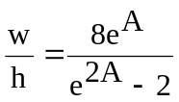
(1)

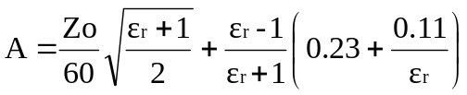where,

Zo = characteristic impedance
ε_{r} = dielectric constant

Figure 2 shows an example to illustrate this relationship. This is a plot of strip width in inches versus impedance for various height of the dielectric material. It shows that a 50 Ω line for a common 1/16-inch Teflon® fiberglass board is 0.160 inch wide. When the thickness of the board was cut into half (or 1/32 inch), the width of the 50 Ω line did not decrease to 0.08 inch, which is half of its original value. Instead, it decreased to 0.06 inch. Hence the width of a microstrip line is indeed not a linear function of the height of the dielectric material [2].

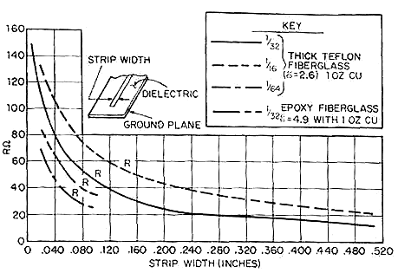
Figure 2. Line impedance versus strip width for various dielectric heights.

Even though the use of very thin substrates may mean smaller dimensions, this practice is still not advisable because it introduces very high losses for the circuit, not to mention very poor mechanical stability.

3. Design Methodology

For this filter, RO3006 from Rogers Corporation was used. These boards are ceramic-filled PTFE composites intended for high frequency applications. Its main advantage over the FR4 is its stable dielectric constant (see Figure 3) over a wider range of frequencies.

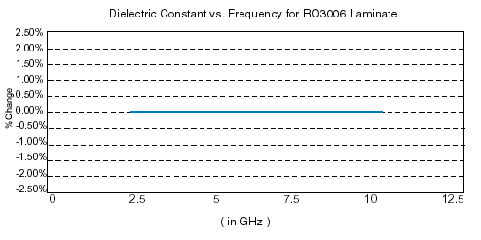Figure 3. Dielectric Constant over Frequency of Rogers RO3006

RO3006 has the following characteristics:

Dielectric constant, ε_{r} = 6.15
Tangent Loss, tan D = 0.0025
Dielectric Height, h = 25 mils
Resistivity compared to copper, ρ = 1
Metal Thickness, M = 1.42 mils
Roughness, S_{r} = 0.095

Initial Design

The filter should have a center frequency of 2.56 GHz. A bandwidth of 80 MHz and 60-dB attenuation are desired at 2.34 GHz. A slide factor of 10° was selected for this filter. A fifth-order filter satisfies these requirements. Using Table 4.05-2 of [1], the prototype parameters for n=5 can be obtained. For this design the prototype parameters are as follows:

w₁’ = 1
g₀ = g6 = 1
g₁ = g5 = 0.7563
g₂ = g4 = 1.3049
g₃ = 1.5773

After obtaining the prototype parameters, the values of the even and odd mode impedances were computed using equations (1) and (2).

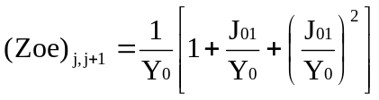 (1)
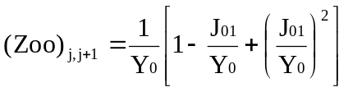

(2)

where,

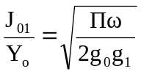

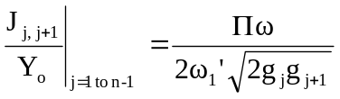

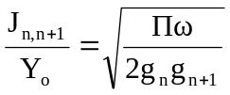

The obtained values for this design are shown in Table 1:

j | Even – mode impedance (Zoe)_{j , j+1} | Odd – mode impedance (Zoo)_{j , j+1} | Characteristic Impedance Zo  Zo² ≈ (Zoe)(Zoo)
0 | 65.9834 | 40.50703 | 51.69906
1 | 52.5969 | 47.65147 | 50.06115
2 | 51.7693 | 48.34775 | 50.02928

Table 1. Odd and Even Impedances values obtained from the admittance inverter parameters

Using TLine of Eagleware Genesys [6], the values for the resonator spacing s and the width of the traces can be obtained (see Table 2).

j | Spacing between resonators S_{j, j+1} | Width  (in mils) | λ/2 (180°)
0 | 12.659 | 29.7409 | 1120.41
1 | 60.1172 | 34.9132 | 1096.95
2 | 77.6057 | 34.9887 | 1095.64

Table 2. The width and spacing between resonators obtained using Tline software

In order to compensate for the reduced coupling between resonators due to the introduction of slide factor, the spacing between resonators must be decreased and the resonator line widths must be adjusted. Although the optimized values are very near the computed values, optimizing it using Electronic Design Automation (EDA) software like Advanced Design System and Genesys from Eagleware spare the designer from the trouble of implementing several iterations of the filter. These softwares use an iteration algorithm which adjusts the width and spacing of a shortened coupling section cascaded with two adjacent lines to match the characteristics of the original quarter-wave section [3].

4. RESULTS AND ANALYSES

Figure 4 shows the 2.56 GHz hairpin filter implemented on Rogers RO3006. This is almost 50% smaller than the one implemented on an epoxy-glass substrate (FR4), which is also shown in the figure.

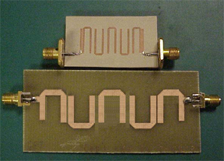
Figure 4. 5th order hairpin filters implemented on RO3006 (top) and FR4 (bottom). The filter implemented in RO3006 is 50% smaller than the one implemented on FR4.

The significant decrease in the final size of the filter was due to the high dielectric constant and thinness of the dielectric.

It was tested using a network analyzer and Figure 5 shows the response of the filter. Its center frequency is at 2.56 GHz and it has a bandwidth of 82MHz, both very near to the specifications that were set earlier. At 2.34 GHz the filter has an insertion loss of 69 dB, which is better than the initial target. This rejection is much higher (by around 25 dB) than the insertion loss obtained when this design was implemented on an FR4 substrate. The return loss (S11) can be further improved by implementing a tapped hairpin filter.

5. CONCLUSION

A step-by-step procedure in designing hairpin filter was presented in this paper. This is aimed to guide designers who are new in implementing hairpin filters. After obtaining the appropriate order of the filter, the values of the odd and even impedances were computed

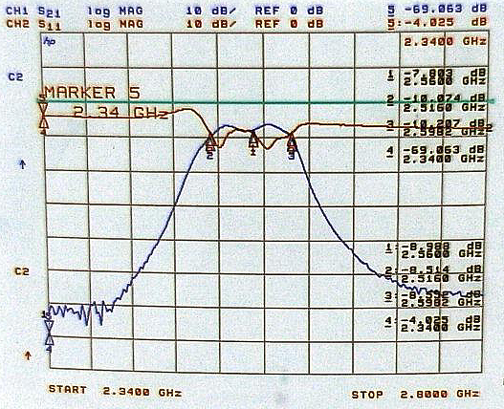
Figure 5. Response of the 5th order hairpin filter implemented on RO3006. It has good sideband rejection and minimal insertion loss.

using the admittance inverter parameters. Using a transmission line calculator software, the values of the line width and spacing between resonators were also obtained. It was then optimized using an EDA to compensate for the reduced coupling between resonators due to the introduction of slide factor. Although the optimized values were very near the computed values, optimizing it spares the designer from the trouble of implementing several iterations of the filter since there is no exact formula in compensating for the reduced coupling.

Using a ceramic-filled substrate significantly decreased the final size of the filter due to its high dielectric constant. Another important factor that contributed to the decrease in size was the thinness of the dielectric. For applications that require small size and stable dielectric constant, it is recommended to use high dielectric constant and thin dielectric ceramic-filled PTFE laminates.

References

[1] Matthaei, L. Young, and E. M. T. Jones, Microwave Filters, Impedance-Matching Networks, and Coupling Structures. Boston, MA: Artech House, 1980.

[2] T. Laverghetta, Microwave Materials and Fabrication Techniques, 3rd edition, Norwood, MA: Artech House, 2000.

[3] R. Rhea, HF Filter Design and Computer Simulation. Atlanta, GA: Noble Publishing, 1994.

[4] T. Edwards, Foundations for Microstrip Circuit Design, 2nd edition, England: John Wiley & Sons Ltd.,1981.

[5] N. Toledo, “Practical Techniques for designing Microstrip tapped hairpin resonator filters on FR4 laminates” 2nd National ECE Conference, Manila, Philippines, November 2001.

[6] Eagleware Corporation, “ TLine Program,” Genesys version 8.1, Norcross, GA, May 2002.

