1. Exercise Three(3) TOE chart and Psuedocode:

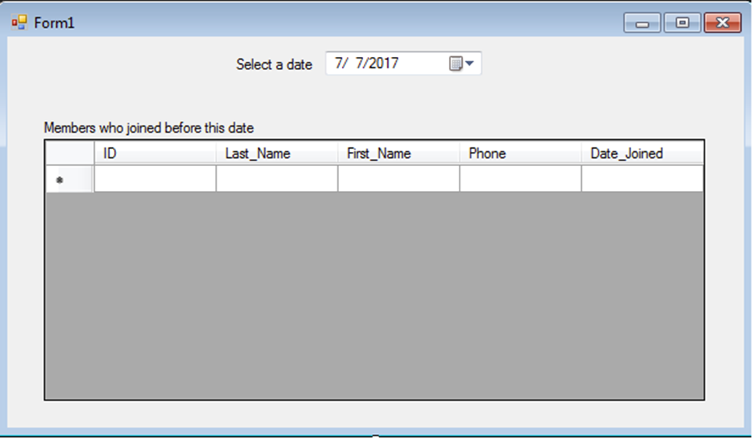

**Object Tasks Event**

DateTimePicker(Date_Selector) Filter table to show members Date_Selector.ValueChanged

who joined before a date

DataGridView(DataGridView1) Shows values from memebers None

table of karate database

Label(Label1) Display the instruction “Select a None

Date”

Label(Label2) Display the table that members joined

Before the user’s date input None

Pseudocode:

Code for the event handler

//Query was created to filter the data in the date table and present the information in DataGridView

Date_Selector.ValueChanged(the desired database and its table, user input)//