**The ECSS SpaceWire Communications Protocol implemented into IEEE 802.3 Power over Ethernet**

# Background

The operational capability and sustainability of current spacecraft is constrained by their inherent physical system architecture, highly customised monolithic design and the limited or no availability of servicing and maintenance. The research of cost effective, high performing, scalable and flexible solutions is essential to the future of the European Space Agency to spearhead the commercial space industry strategy.

Project MOSAR is an EU funded initiative made of an international consortium of 9 partners that will aim to raise the degree of modularity of space systems by an order of magnitude with respect to current space industry standards. Thales Alenia Space UK is a world leader in space systems design, integration and manufacturing with advanced space engineering facilities acting as the leader on the design of satellite propulsions system, satellite sub-systems and system design studies. An area of opportunity identified by Thales Alenia UK was the research into a common architecture that could provide two capabilities; these being mission systems and sub-systems inter-communications and the distribution of power. If viable, this would result in the production of spacecraft requiring less materials for their construction and operation, more re-usable due to the ability to reconfigure mission system architectures and less debris being ejected into space. All of these factors would contribute towards a more efficient and sustainable approach to the environmental challenges faced within the space industry.

Current spacecraft mission systems adopt bespoke and/or proprietary methods of deploying communication networks such as MIL-STD 1553B and CAN 2.0 which both present their own issues when considering interoperability with interfacing sub-systems. It is desirable that an existing commercially available communications protocol could provide the underpinning inter-communications between future spacecraft sub-systems, as well as provide a common architecture to also distribute power; a solution to support the project MOSAR objective of modularising spacecraft sub-systems with adaptive architectures.

# Aims and Objectives

The aim of the project is to conduct a feasibility study of the given topic; “The SpaceWire Communications Protocol implemented into IEEE 802.3 Power over Ethernet (PoE)”, theoretically, analytically and through functional testing defined by qualitative criteria.

From the described aim, objectives for this project were identified as below;

1. Conduct an initial feasibility study of the project aim through Literature and Documentation Review.
2. Demonstrate the feasibility study through the means of developing an Embedded System and conducting Functional Testing.
3. Identify the outcome of the feasibility study and recommendation of further on the project subject matter.
4. Demonstrate evidence against all Project Module Specification Learning Outcomes.
5. Identify all applicable hazards and mitigate risk accordingly to tolerable and As Low as Reasonably Practicable (ALARP) levels.

# Scope

The scope of the project meets the Learning Outcomes of the module. The technical scope of the project has been refined to qualitative criteria as defined below, to meet the projects time and resources constraints;

1. The implementation of the SpaceWire Network Layer onto the Ethernet Protocol Stack onto an embedded system.
2. Functional Testing shall prove the capability only through qualitative criteria of incorporating the SpaceWire Network Layer into the Ethernet PoE protocol.
3. Functional Testing shall be conducted with commercially available COTS hardware.
4. The SpaceWire and Ethernet network shall only consist of an end-to-end link.

# Research Questions

Based upon the aims and objectives of the project, the following research questions have been defined;

1. What are the requirements of the SpaceWire and IEEE 802.3 Ethernet Protocols?
2. Can the SpaceWire protocol be implemented into the IEEE 802.3 Ethernet Protocol to create a full stack?
3. What are the difficulties and advantages of implementing SpaceWire into the Ethernet Protocol Stack?
4. What use-cases would benefit from a combined power and communications architecture?

# Project Management and Artefacts

It was the responsibility of the student (document author) to ensure that the project was and shall continue to be managed appropriately, ensuring that the following information listed below is captured and regularly updated throughout the project;

1. Baselined Project Schedule
2. Project Resources Form
3. Risk Assessment and ALARP Justification
4. Ethics On-Line Checklist
5. Security Awareness Form.

A Baselined Project Schedule was generated at Project Initiation to ensure the key activities, milestones and deadlines were identified to plan the project accordingly with the given time constraints and resources. The project schedule shall be updated regularly to reflect changes in the project. A Safety Risk Assessment was conducted at the initiation of the project and will be regularly updated as appropriate; the hazard/accident combinations that were identified have been sentenced and tolerable and ALARP to acceptable levels between myself and the supervisor. Meeting Minutes and a Record of Decisions were and will continue to be captured with outstanding actions captured in a separate Action Tracker.

Configuration management is essential to the project for the control of source-code that is to be written during the Embedded Systems Development phase. To provide source-code control the chosen tool to be used throughout the project was GitHub; a Github Repository can be created within a Project File Folder that tracks the changes and provides version control.

The Ethics On-Line Checklist was completed at project initiation with the supervisor and it was determined that there were no ethical issues that could arise from the area of research and activities associated with the project.

Only one dependency was identified for the project, which was for the resources (hardware) to enable functional testing aspects of the project to be supplied by UWE. This has been since addressed and the hardware has been acquired.

# Literature Review

To achieve the project aim, the system requirements of the implemented system were to be derived and understood fully, to inform the design and implementation phases of the project. It was identified that the ECSS SpaceWire, IEEE 802.3 Ethernet and IEEE 802.3bt engineering standards were required to be reviewed and analysed with supporting research papers from the scientific community; to design, implement and evaluate a communications system able to distribute power on a common architecture.

## OSI Concept Model

To understand how to design and implement a communications system, it was required to research the theoretical concept of how communication systems are designed, optimally in reference to professional engineering standards. A commonly used topology to describe a communications system is the full protocol stack. The Open Systems interconnection (OSI) Protocol Stack is defined within Reference (OSI, 1994), which sections the theoretical full protocol stack in seven abstract layers, each one stacked up upon the last showing how data is compartmentalised and handled at each stage. The seven layers of a communications protocol as defined by the International Organisation of Standardisation are shown below in Figure 1.

Using the OSI Concept Model allowed the ability to conduct research and comparison analysis on the IEEE 802.3 Ethernet and SpaceWire Protocols, to distinctly identify how data is handled at each layer. Subsequently this informs the feasibility study of what is achievable when implementing the SpaceWire Protocol into the IEEE 802.3 and deriving the requirements of the implemented system.

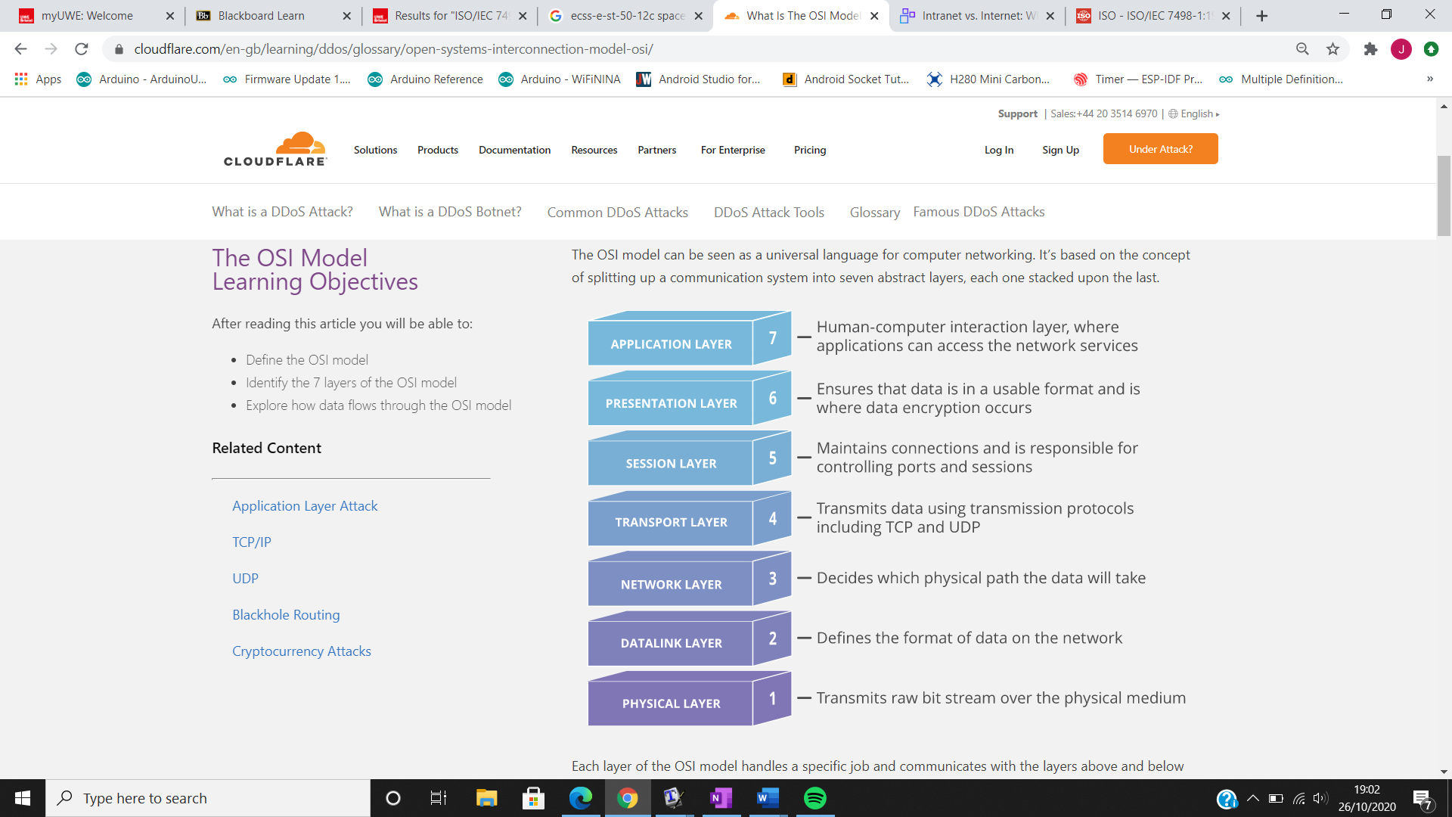

**Figure 1** - OSI Concept Model

## ECSS SpaceWire

The European Cooperation for Space Standardization (ECSS) SpaceWire is defined within the ECSS-E-ST-50-12C Rev.1 standard (European Cooperation for Space Standardisation - ESA Requirements and Standards Division, 2019). The rationale behind SpaceWire was to standardise the proprietary and ad-hoc approach adopted by space equipment manufacturers for interunit communications. This led to several different types of communication links being used on spacecraft, which subsequently increased the cost and time required for spacecraft integration and testing.

The use of the SpaceWire standard ensures that all equipment used on spacecraft is compatible at both the component and sub-system levels, allowing greater re-usability and reliability whilst also reducing development costs. SpaceWire provides a 2 – 200 Mbps, bi-directional, full-duplex data link that connects together SpaceWire enabled equipment. The SpaceWire implementation can either be a point to point link or the use of a network routing switch.

The SpaceWire Protocol Stack is based upon the OSI Concept Model to establish the architecture for the network communications between sub-systems and components within a spacecraft mission system. SpaceWire mandates the use of four layers of the OSI concept model, notably being the Physical, Data Link, Network and Application Layer. SpaceWire also specifies the use of a Management Information Base that configures and determines the status of the SpaceWire network.

The Physical Layer utilises the use of a 4 pair twisted-pairs to provide the physical medium for Low Voltage Differential Signalling (LVDS), allowing bi-directional data transmission. The data-link layer specifies how communication is established across a link and how information is flowed; it also specifies the encoding/decoding of characters into symbols to be transmitted over the physical medium as a bitstream. The network layer specifies how SpaceWire packets, time-codes and distributed interrupts are transferred over a SpaceWire network, in addition to addressing the packets to the destination address between nodes and routers.

## IEEE 802.3 Ethernet

The Institute of Electrical and Electronic Engineers (IEEE) 802.3 Standard (IEEE Computer Society, 2018) is an international commercially available standard for Local and Metropolitan Area Networks, employing Carrier Sense Multiple Access/Collision Detection (CSMA/CD) and the Ethernet Protocol (IEEE 802.3) for data communication. In reference to the OSI Concept model (Figure 1) the Ethernet Protocol implements the Physical and Data-Link Layer for data communications. The sub-layers Media Access Control (MAC) and Logical Link Controller (LLC) make up the Data-Link Layer of the OSI Model.

The physical layer consists of the use of 4 pair twisted-pairs to allow the use of LVDS to allow bi-directional data transmission. The data-link layer consists of two sub-layers that format the data into frames and ethernet packets, handles the addressing and error checking.

## IEEE 802.3 PoE

The IEEE 802.3 Ethernet standard defines the specifications to include the distribution of power over an Ethernet based network, in addition to data communications within a network. The Power over Ethernet (PoE) capability is stipulated through the IEEE 802.3bt (Man, Committee and Computer, 2019) standard utilising the 4-pair twisted pair cabling that has been qualified to be used within the standard. A PoE system comprises of three separated specified major elements, these are the; power supply defined as the Power Sourcing Equipment (PSE), the powered load defined as the Powered Device (PD) and twisted pair cabling connecting the two devices.

There have been progressive iterations of the IEEE 802.3 PoE Standard defining the PoE capability since its initial release in 2003 with the 802.3af standard. A summary of the current PoE capabilities are given in Figure 2 (Microchip Technology Inc, 2019), the key parameter being the total amount of output power that can be provided to a powered-device.

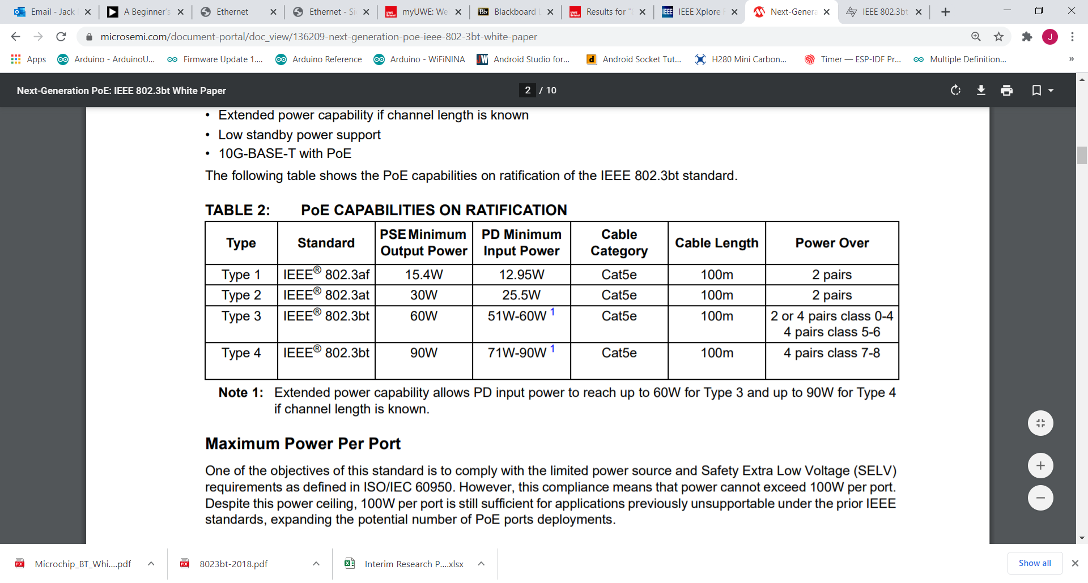

**Figure 2** - IEEE 802.3 PoE Summary

## SpaceWire and Ethernet Protocol Implementation

The overarching issue of the implementation of SpaceWire into Ethernet has been researched within the aerospace and space community (Rozanov and Yablokov, 2014), detailing the limitation of the format of the ethernet frame containing fixed sized header, payload and error checking sections that in some scenarios are inefficient to transmit. SpaceWire packets in principle can have infinitely long payload sizes whereas Ethernet can only transmit a fixed length of between 46 – 1500 bytes, therefore it is able to be recognised that for SpaceWire payloads larger than 1500 bytes that further processing within the network layer of the full protocol stack is required to re-build segmented payloads. The constraint of Ethernet Frames also requires further processing to determine the SpaceWire Headers of broadcast codes which include time-codes and interrupt codes which are sent within the payload. The requirement of further SpaceWire headers to be inserted within the Ethernet Frame resultantly has a detrimental impact on the efficiency of the communications link. Figure 3 shows the relationship between the number of bytes sent with respect to the payload for both the Ethernet and SpaceWire protocols. It shows that the viability of the Ethernet Protocol is only applicable where payloads of more than 30-40 Bytes are transmitted per packet, therefore for the implementation of the combined SpaceWire and Ethernet protocol this characteristic has to be considered for the intended use-case of the spacecraft mission system.

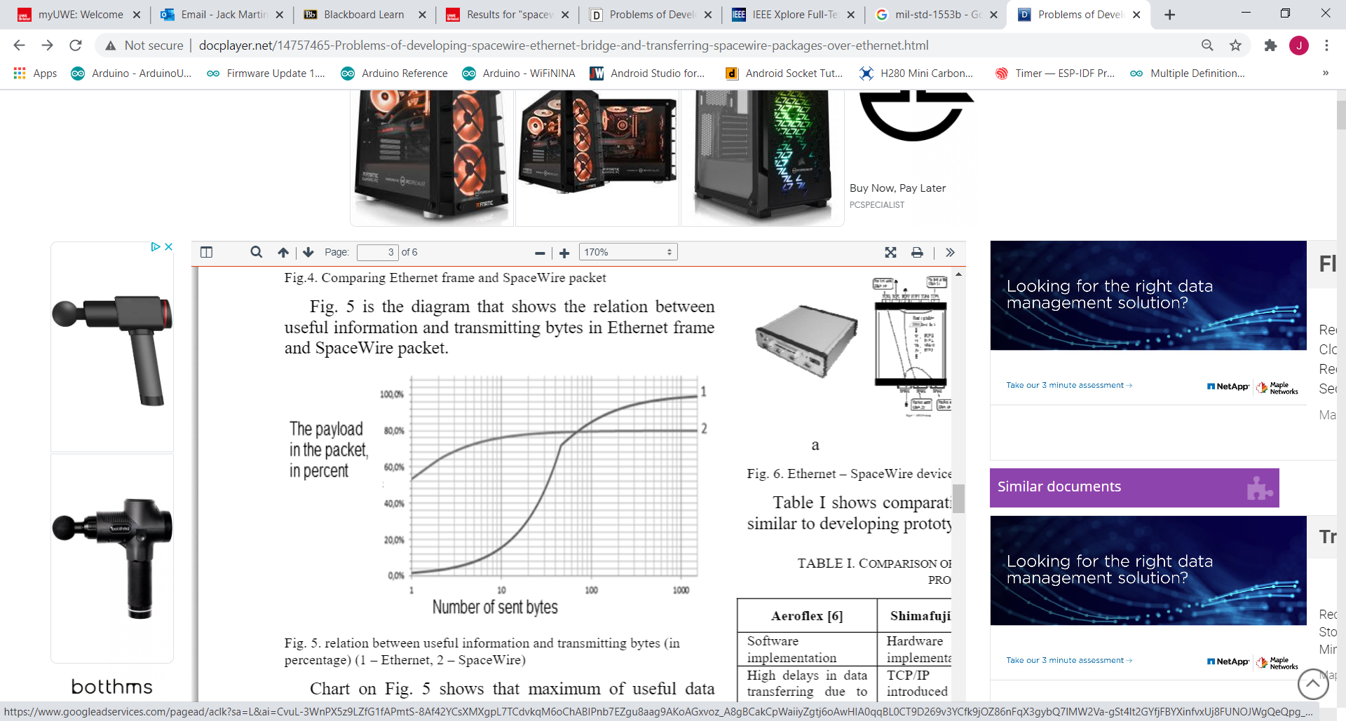

**Figure 3 -** Ethernet (1) and SpaceWire (2) Packet vs Payload Analysis

# Project Methodology (V-Model)

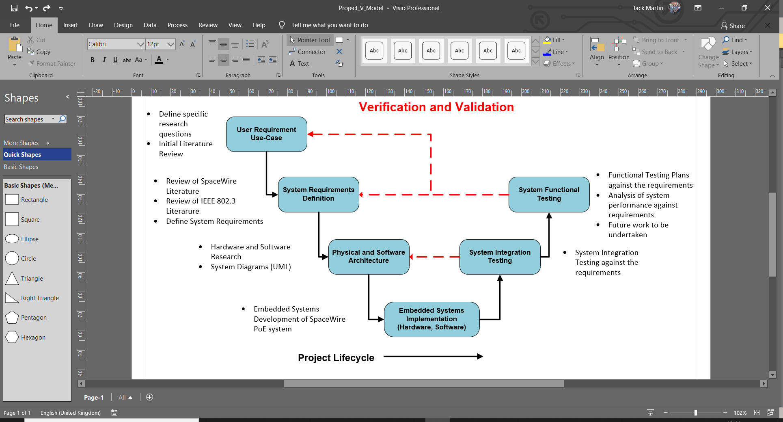

**Figure 4** - Project Methodology

The project methodology is based upon the Systems Engineering V-Model which is endorsed by the International Council on Systems Engineering (INCOSE) (INCOSE, 2007). It stipulates a linear approach to systems engineering in relation to the project life-cycle stages and processes, ensuring that the initial system requirements identified for the project are verified and validated.

# Progress to Date

The following outcomes and decisions have been identified with regards to the project to date;

1. Literature/Documentation review has been completed to determine the specifications from both the SpaceWire and IEEE 802.3 Ethernet Protocols.
2. Determined the full protocol stack of the implementation of SpaceWire into IEEE 802.3 Ethernet.
3. Use-Case for the testing of the implemented system shall resemble the SpaceWire example application so outcomes of the project offer most relevancy.
4. System Requirements Document generated in reference to the decided Use-case for the project.

The Project Gantt Chart shows that I have made appropriate progress against the identified tasks to date. The literature/documentation review can be deemed complete, and has been used to inform the project/system definition which corresponds to the left hand side of the V-model (Figure 4). The hardware for the implemented system has been identified and acquired from the Project Room, allowing for the commencement of the Embedded Systems Development phase of the project.

Initial software development work has been started, identifying key documentation for the development boards and framework and libraries that can be utilised throughout the software development cycle. A Unified Modelling Language Diagram will be created with the opportunity to develop a sysML diagram for the systems engineering aspects of the project.

# Bibliography

European Cooperation for Space Standardisation - ESA Requirements and Standards Division (2019) *ECSS-E-ST-50-12C Rev.1, SpaceWire - Links, Nodes, Routers and Networks*.

IEEE Computer Society (2018) *IEEE Standard for Ethernet 802.3-2018*.

INCOSE (2007) *Systems Engineering Handbook: A Guide for System Life Cycle Processes and Activities*.

Man, L.A.N., Committee, S. and Computer, I. (2019) *IEEE Standard for Ethernet Amendment 2: Physical Layer and Management Parameters for Power over Ethernet over 4 pairs*.

Microchip Technology Inc (2019) *Next-Generation PoE: IEEE 802.3bt White Paper*.

OSI (1994) *ISO/IEC 7498-1:1994 - Information technology -- Open Systems Interconnection -- Basic Reference Model: The Basic Model*.

Rozanov, V. and Yablokov, E. (2014) *Problems of Developing SpaceWire - Ethernet Bridge and Transferring SpaceWire Packages over Ethernet*.

**UK Engineering Council Guidance on Security**

Security is an important consideration for any project and in any workplace. UK SPEC provides guidance on security and outlines how it expects professional engineers to conduct themselves with respect to security. This guidance is split into six key principles. Your task is to visit the UK SPEC security page and read through the tips provided for each principle.

Using the tips on the webpage provide at least one example for each of the six principles that you can directly link to your project or that should be considered in the role of Professional Engineer. Then summarise your findings in the comments box below.

The link is <https://www.engc.org.uk/security>

1. How would you adopt a security-minded approach to your project?

The project originates from Industry that is currently leading the research of compartmentalisation of spacecraft modules, otherwise known as Project MOSAR. The information that is detailed within this project may be commercially sensitive and require the use of an NDA. Therefore I will approach the project with the upmost professionalism and consider the security aspects of the project at the forefront of decision making. With an NDA it provides assurance that potential sensitive information is not distributed to parties or organisations that have no access to the information.

1. What should you consider in order to apply responsible judgement and take a leadership role?

The project may entail communications and the exchange of information between Industry Partners of UWE and myself. Therefore to maintain a good relationship that emphasises on the importance of withholding a good standard of security awareness, the appropriate means of communication will be used depending on the sensitivity of the information. Such as if restricted infrastructure/networks shall be utilised or the exchange of information in a Secure Communications Information Facility (SCIF).

1. How will you ensure that your project complies with legislation and codes, while understanding intent and prepared to seek further improvements?

Legislation and Codes of Conduct will be identified at the initiation of the project and regularly reviewed throughout the duration of the project. An example of such legislation would be the Official Secrets Act 1989 which would restrict the distribution of information, ensuring professionalism and integrity from the outset.

1. How do you ensure good security-minded communications?

The governance for security for a project can be stipulated through the use of a Security Aspects Letter. The Security Aspects Letter details the different elements of a project and states the classification of the information which directs how that information should be treated i.e stored, transmitted, disseminated etc. The letter encourages a security minded approach to the information contained within the project and makes stakeholders aware of the sensitivity of the project.

1. How would you go about understanding, complying with and seeking to improve lasting systems for security governance?

The security aspects of a Product, System or Service should be considered at the earliest convenience to appropriately manage and mitigate any security risks that are identified. Governance can be provided by implementing a Security Management Plan which identifies the Roles and Responsibilities for a project and programme of work to achieve a desired outcome, and to also regularly review the security status. With tis governance in place, it provide assurance that a lasting system can be introduced and continue to be considering security awareness throughout its lifecycle.

1. What do you need to consider when contributing to public and professional awareness of security?

The UK SPEC identifies the ability of recognising the social, political and economic implications are important to identify the security risks. An example of where you might need to consider the awareness of security for the public may be when using Personal Data that can aggregated into identifying an individual or organisation.

Summarise how you will address security in your project *(max 200 words)*

Security awareness will be a key overarching principle throughout the project, to identify and mitigate accordingly any security related risks that may arise. If deemed appropriate a Security Risk Register will be generated and monitored throughout the project and reported using the appropriate reporting tools via the Project Supervisor.

Information will primarily be open-source although the aggregation of data and commercial strategy may potentially be commercially-sensitive. Information will be collated and confidential where necessary to avoid the risk of disseminating confidential information.





**GENERAL RISK ASSESSMENT FORM**

|  |  |  |
| --- | --- | --- |
| **Describe the activity being assessed:** Functional Testing of an Embedded System Communications Protocol in a home environment | **Assessed by: Jack Martin** | **Endorsed by:** |
| **Who might be harmed: Jack Martin (Student)**  1  **How many exposed to risk:** | **Date of Assessment: 12/10/2020** | **Review date(s): 10/11/2020** |

|  |  |  |  |  |  |  |  |  |  |  |
| --- | --- | --- | --- | --- | --- | --- | --- | --- | --- | --- |
| **Hazards Identified**  ***(state the potential harm)*** | **Existing Control Measures** | **S** | **L** | **Risk**  **Level** | **Additional Control Measures** | **S** | **L** | **Risk Level** | **By whom and by when** | **Date completed** |
| Non-Ionising Radiation (RADHAZ including Medical Devices and Personnel) | CE Marked (SAR Testing)  CEMFAW Compliance through SAR Testing | 2 | 1 | 2 | None Required. **ALARP** | 2 | 1 | 2 | N/A | 12/10/20 |
| Hazardous Materials (Batteries and Manufacturing Materials) | CE Marked Development Boards/Equipment  RoHS Compliance achieved compliance demonstrated through CE Marking | 3 | 1 | 3 | None Required. **ALARP** | 3 | 1 | 3 | N/A | 12/10/20 |
| Electrical Sources (Mains 240V AC) | CE Marked Equipment (EU/UK Legislation Compliance)  Electrical Sources enclosed by Design and hazard only present if damaged.  IEEE 802.3 Compliant Equipment | N/A | N/A | N/A | Hazard/Accident scenario deemed in-credible. **Delete and Retain** | N/A | N/A |  | N/A | 12/10/20 |
| Electrical Sources (<50VDC) | No voltages are exposed by design.  CE Marked Products.  Circuit Protection by design.  OEM Manuals, Warnings and Cautions | 2 | 1 | 1 | None Required. **ALARP** | 2 | 1 | 2 | N/A | 12/10/20 |
| Cables causing Trips and Falls | None.  Not anticipated that the use of the cables will cause an accident. | N/A | N/A | N/A | Hazard/Accident scenario deemed in-credible. **Delete and Retain** | N/A | N/A |  | N/A | 12/10/20 |
| Incorrect Operation of Equipment (Lack of EMC Compliance) – Smoke, Fumes, Electrical Failure etc. | CE Marked Development Boards for Radiating Element (ESP32 Module)  Development Board FCC Certified  Interfacing equipment suitable for use-case | 2 | 1 | 2 | The Hazard Accident is very unlikely due to the current control measures in place (Design and Certification). Although lack of assurance via EU EMC compliance pertains the hazard to remain Open. **ALARP.** | 2 | 1 | 2 | N/A | 10/11/20 |

**RISK MATRIX: (To generate the risk level).**

|  |  |  |  |  |  |
| --- | --- | --- | --- | --- | --- |
| **Very likely**  **5** |  |  |  |  |  |
| **Likely**  **4** |  |  |  |  |  |
| **Possible**  **3** |  |  |  |  |  |
| **Unlikely**  **2** |  |  |  |  |  |
| **Extremely unlikely**  **1** |  | **(3)** | **(1)** |  |  |
| **Likelihood (L)**  **Severity (S)** | **Minor injury – No first aid treatment required**  **1** | **Minor injury – Requires First Aid Treatment**  **2** | **Injury - requires GP treatment or Hospital attendance**  **3** | **Major Injury**  **4** | **Fatality**  **5** |

**ACTION LEVEL: (To identify what action needs to be taken).**

|  |  |  |
| --- | --- | --- |
| **POINTS:** | **RISK LEVEL:** | **ACTION:** |
| 1 – 2 | NEGLIGIBLE | No further action is necessary. |
| 3 – 5 | TOLERABLE | Where possible, reduce the risk further |
| 6 - 12 | MODERATE | Additional control measures are required |
| 15 – 16 | HIGH | Immediate action is necessary |
| 20 - 25 | INTOLERABLE | Stop the activity/ do not start the activity |



|  |  |  |  |  |
| --- | --- | --- | --- | --- |
| **Action S/N** | **Description** | **Action Owner** | **Target Date** | **Comments/Updates** |
| 20201001/01 | ~~JM to research and summarise the initial feasibility of demonstrating the functional proofing of implementing SpaceWire protocol into Po~~E | JM | 13/10/20 | JM completed initial research and produced draft project schedule. **Complete** |
| 20201001/02 | ~~YZ to determine if Thales facilities and/or SME guidance is available for use to assist project~~ | YZ | 30/10/20 | 03/11/20. Ongoing due to restrictions and lockdown.  **Closed/Rejected.** |
| 20201001/03 | ~~JM to send all required Project Initiation Documentation to YZ prior to submitting to the Engineering Database~~ | JM | 13/10/20 | **Complete** |
| 20201013/01 | ~~JM to define initial system architecture for functional testing and complete Student Resources Request Forms to acquire required hardware and software~~ | JM | 23/10/20 | Project Request Forms endorsed by YZ and sent  On 20/10/20  **Complete** |
| 20201103/01 | ~~JM to send Project Artefacts to YZ via e-mail.~~ | JM | 09/11/20 | E-mail sent 10th November. **Complete.** |

|  |  |  |  |
| --- | --- | --- | --- |
| **Contact Register** | | | |
| **Meeting** | **Date** | **Attendees** | **Actions** |
| Initial Project Meeting | 01/10/2020 | Jack Martin  Yaseen Zaidi | 20201001/01  20201001/02  20201001/03 |
| Project Proposal And Ethics Checklist | 13/10/2020 | Jack Martin  Yaseen Zaidi | 20201013/01 |
| Project Resources and Progress | 03/11/2020 | Jack Martin  Yaseen Zaidi | 20201103/01 |
| Project Progress and Resources | 10/11/2020 | Jack Martin  Yaseen Zaidi |  |
| Interim Proposal Report and Progress Meeting | 01/12/2020 | Jack Martin  Yaseen Zaidi | 20201201/01 |
| PoE Use-Case | 02/12/2020 | Yaseen Zaidi  Matthew Rowlings  Michael Walshe |  |