Martin Jaime-Viveros

CPE301 – SPRING 2016

Design Assignment 0

**DO NOT REMOVE THIS PAGE DURING SUBMISSION:**

The student understands that all required components should be submitted in complete for grading of this assignment.

|  |  |  |  |
| --- | --- | --- | --- |
| **NO** | **SUBMISSION ITEM** | **COMPLETED (Y/N)** | **MARKS**  **(/MAX)** |
| 0. | COMPONENTS LIST AND CONNECTION BLOCK DIAGRAM w/ PINS |  |  |
| 1. | INITIAL CODE OF TASK 1/A |  |  |
| 2. | INCREMENTAL / DIFFERENTIAL CODE OF TASK 2/B |  |  |
| 3. | INCREMENTAL / DIFFERENTIAL CODE OF TASK 3/C |  |  |
| 4. | INCREMENTAL / DIFFERENTIAL CODE OF TASK 4/D |  |  |
| 5. | INCREMENTAL / DIFFERENTIAL CODE OF TASK 5/E |  |  |
| 6. | SCHEMATICS |  |  |
| 7. | SCREENSHOTS OF EACH TASK OUTPUT |  |  |
| 8. | SCREENSHOT OF EACH DEMO |  |  |
| 9. | VIDEO LINKS OF EACH DEMO |  |  |
| 10. | GOOGLECODE LINK OF THE DA |  |  |
|  |  |  |  |
|  |  |  |  |

|  |  |  |  |
| --- | --- | --- | --- |
| 0. | COMPONENTS LIST AND CONNECTION BLOCK DIAGRAM w/ PINS |  |  |

* Atmel Studio 7

|  |  |  |  |
| --- | --- | --- | --- |
| 1. | INITIAL CODE OF TASK A |  |  |

Task A: Write an assembly code to add five random numbers >30 and <60. If the sum

produces an overflow set PORTB.2 pin = HIGH else PORTB.2 pin = LOW.

; DA0T1.asm

;

; Created: 2/11/2016 19:06:27

; Author : Martin Jaime-Viveros

;

.cseg

start**:**

;; Load arbitrary immediates into registers 16:20

ldi r16**,** 59

ldi r17**,** 59

ldi r18**,** 59

ldi r19**,** 59

ldi r20**,** 59

sbi DDRB**,** 2 ;; Set port B pin 2 as output

**out** PORTB**,** r0 ;; Set all outputs to 0

;; Add the integers

**add** r16**,** r17

**add** r16**,** r18

**add** r16**,** r19

**add** r16**,** r20

brcc End ;; Check if carry flag set

ldi r17**,** 4

**out** PORTB**,** r17 ;; Set output high at pin2 on port B

End**:**

rjmp End

|  |  |  |  |
| --- | --- | --- | --- |
| 2. | TASK B |  |  |

Determine the execution time/#cycles of your algorithm using the simulation, set CLOCK speed = 8 MHz.

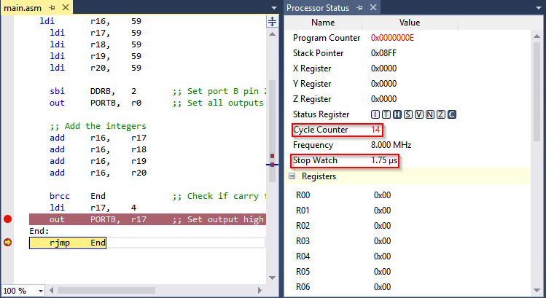

The worst case of the algorithm is when the sum is produces a carry as in the case of 59 + 59 + 59 + 59 + 59 = 295 = 0x127 since that would cause the code to execute all lines.

With execution time of **1.75 µs with 14 cycles, the average cycle lasted 125 ns**. Which agrees with a **clock period of 125 ns**.

|  |  |  |  |
| --- | --- | --- | --- |
| 6. | SCHEMATICS |  |  |

The project was run on the Atmel Studio 7 simulator.

|  |  |  |  |
| --- | --- | --- | --- |
| 7. | SCREENSHOTS OF EACH TASK OUTPUT |  |  |

TASK 1a: Write an assembly code to add five random numbers >30 and <60. If the sum

produces an overflow set PORTB.2 pin = HIGH else PORTB.2 pin = LOW. screenshots of

the AVRStudio6 during debugging at the beginning and end of Task a.

**Before with no overflow**

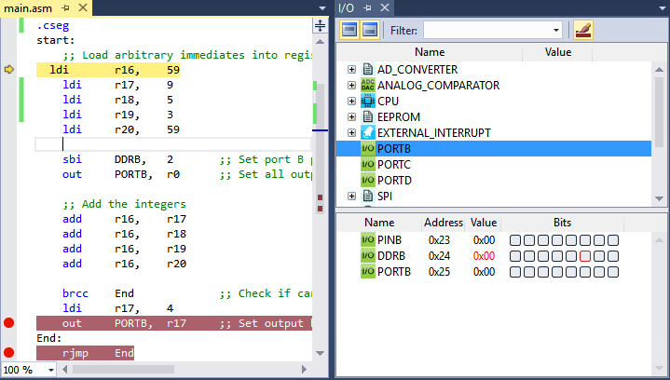

**After with no overflow**

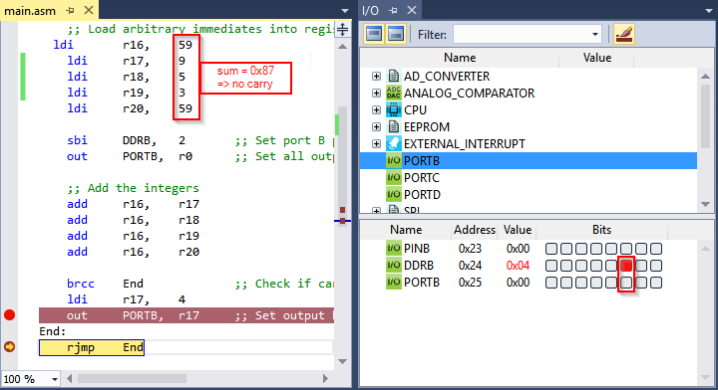

**Before with overflow**

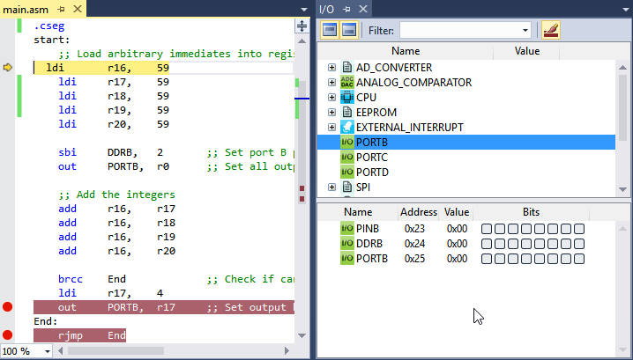

**After with overflow**

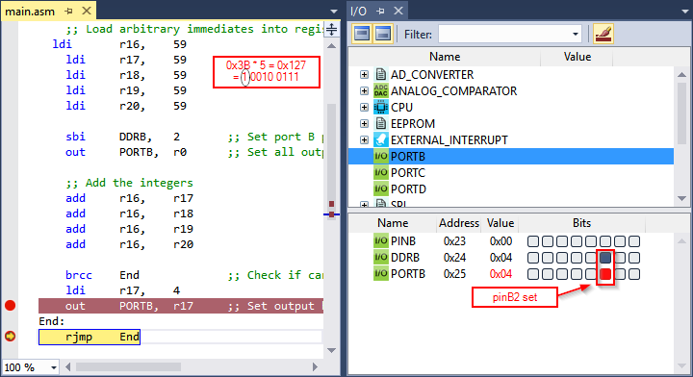

|  |  |  |  |
| --- | --- | --- | --- |
| 8. | SCREENSHOT OF EACH DEMO |  |  |

See simulation output on previous section.

|  |  |  |  |
| --- | --- | --- | --- |
| 9. | VIDEO LINKS OF EACH DEMO |  |  |
| Videos were not requested | | | |
| 10. | Github repository |  |  |
|  | | | |

**Student Academic Misconduct Policy**

<http://studentconduct.unlv.edu/misconduct/policy.html>

“This assignment submission is my own, original work”.

Martin Jaime-Viveros