Martin Jaime-Viveros

CPE301 – SPRING 2016

Design Assignment 5

**DO NOT REMOVE THIS PAGE DURING SUBMISSION:**

The student understands that all required components should be submitted in complete for grading of this assignment.

|  |  |  |  |
| --- | --- | --- | --- |
| **NO** | **SUBMISSION ITEM** | **COMPLETED (Y/N)** | **MARKS**  **(/MAX)** |
| 0. | COMPONENTS LIST AND CONNECTION BLOCK DIAGRAM w/ PINS |  |  |
| 1. | INITIAL CODE OF TASK 1/A |  |  |
| 2. | INCREMENTAL / DIFFERENTIAL CODE OF TASK 2/B |  |  |
| 3. | INCREMENTAL / DIFFERENTIAL CODE OF TASK 3/C |  |  |
| 4. | INCREMENTAL / DIFFERENTIAL CODE OF TASK 4/D |  |  |
| 5. | INCREMENTAL / DIFFERENTIAL CODE OF TASK 5/E |  |  |
| 6. | SCHEMATICS |  |  |
| 7. | SCREENSHOTS OF EACH TASK OUTPUT |  |  |
| 8. | SCREENSHOT OF EACH DEMO |  |  |
| 9. | VIDEO LINKS OF EACH DEMO |  |  |
| 10. | GOOGLECODE LINK OF THE DA |  |  |
|  |  |  |  |
|  |  |  |  |

|  |  |  |  |
| --- | --- | --- | --- |
| 0. | COMPONENTS LIST AND CONNECTION BLOCK DIAGRAM w/ PINS |  |  |

* Atmega328P
* DC motor
* Servo motor
* Stepper motor
* ULN2003
* PC
* 5V power supply

See schematics for block diagrams

|  |  |  |  |
| --- | --- | --- | --- |
| 1. | INITIAL CODE OF TASK 1 |  |  |

Write an AVR C program to control the speed of the DC Motor using a potentiometer connected to any of the analog-in port.

The speed of a DC motor can be modulated by mapping the value of a potentiometer output voltage to a PWM output to the DC motor.

## Flow chart of Task 1

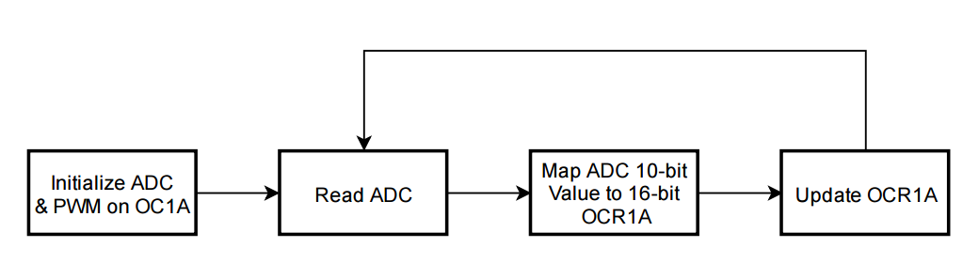

## Code

#define *F_CPU* 8000000UL // XTAL = 8MHZ

#include <stdio.h>

#include <avr/io.h>

#include <util/delay.h>

#define BAUDRATE 9600 // Define baudrate

#define ASYNCH_NORM_PRESCALER (*F_CPU*/16/BAUDRATE - 1) // Calculate prescaler for USART0

void ADC0init(); // Initialize ADC0 input

void PWM_OC1A_init(); // Initialize PWM on OC1A at 50Hz

unsigned short readADC(); // read ADC0 analog input and return it

void updateDC_OC1A(unsigned char); // Change duty cycle on OC1A

int USART0_sendChar(char, *FILE*\*); // Send character on USART0

void usart0_init (void); // Initialize USART0

// reset stream pointer

// http://www.gnu.org/savannah-checkouts/non-gnu/avr-libc/user-manual/group__avr__stdio.html

*FILE* USART0_stream = *FDEV_SETUP_STREAM*(USART0_sendChar, *NULL*, *_FDEV_SETUP_WRITE*);

int main()

{

unsigned short adcVal; // Variable to store input ADC Value

unsigned char dc; // Store calculated DC value based on adcVal

*stdout* = &USART0_stream;// change standard output to point to a USART stream

PWM_OC1A_init(); // initialize pwm on OC1A

ADC0init(); // Initialize ADC0 input

usart0_init(); // Initialize USART0 for debugging and monitoring

while (1)

{

adcVal = readADC(); // read ADC0;

dc = (unsigned short)(100.0*adcVal / 1023); // get percentage of input voltage from Vcc.

updateDC_OC1A(dc); // Update OCR1A to update duty cycle of OC1A

*printf*("ADC Value = %u\n", adcVal); // Monitoring output

*printf*("\tDuty cycle = %u%%\n", dc); // Monitoring output

*_delay_ms*(100); // Have an imperceivable delay

}

}

void usart0_init (void)

/*

* Procedure to initialize USART0 asynchronous with enabled RX/TX, 8 bit data,

* no parity, and 1 stop bit.

*/

{

UCSR0B = (1<<TXEN0) | (1<<RXEN0); // enable transmit/receive

UCSR0C = (1<<UCSZ01) | (1<<UCSZ00); // asynchronous, 8N1

UBRR0L = ASYNCH_NORM_PRESCALER; // Set prescaler based on desired baudrate

}

int USART0_sendChar(char data, *FILE* *stream)

/*

* Procedure to send a single character over USART0. If character is linefeed, reset

* line.

* Assumes ASCII code.

*/

{

if(data == '\n') // If character is linefeed,

{ // First send return.

while(! (UCSR0A & (1<<UDRE0)) );

UDR0 = '\r';

}

while(! (UCSR0A & (1<<UDRE0)) ); // Wait for last data to be transmitted.

UDR0 = data; // send data.

return 0;

}

void updateDC_OC1A(unsigned char DC)

// Procedure to update PWM duty cycle on OC1A. Given an unsigned character DC, this

// procedure will calculate the appropriate OCR1A value based on the top value of

// Timer1.

{

OCR1A = (unsigned short)(DC * 2499.0 / 100);

}

unsigned short readADC()

// readADC will read the adcValue after it has been calculated.

{

ADCSRA |= (1<<ADSC); // Begin conversion

while((ADCSRA & (1<<ADIF)) == 0 ); // Wait for conversion to finish.

return ADC;

}

void PWM_OC1A_init()

{

//Set PORTB1 pin as output

DDRB |= (1<<DDB1); // make OC1A as output.

// Output compare mode on OC1A. Fast PWM with top = ICR1.

// Clear OC1A on Compare match and set at bottom.

TCCR1A |= (1<<COM1A1)|(0<<COM1A0)|(0<<COM1B1)|(0<<COM1B0)|(0<<FOC1A)|(0<<FOC1B)|(1<<WGM11)|(0<<WGM10);

// Start timer with prescaler 64

TCCR1B |= (0<<ICNC1)|(0<<ICES1)|(1<<WGM13)|(1<<WGM12)|(0<<CS12)|(1<<CS11)|(1<<CS10);

ICR1 = 2499; // F_CPU / (N * F_pwm) - 1, where N is the prescaler = 64, and F_pwm is the desired 50Hz frequency.

}

void ADC0init()

// ADC0init will initialize analog input on ADC0, set voltage reference to Vcc, with

// data right justified on data register.

{

DDRC &= ~(0<<DDC0);

ADCSRA = 0x87; // Make ADC enable and select ck/128

ADMUX = (1<<REFS0); // VCC reference, ADC0 single ended input

// data will be right-justified

}

|  |  |  |  |
| --- | --- | --- | --- |
| 2. | INITIAL CODE OF TASK 2 |  |  |

Write an AVR C program to control the speed of the Stepper Motor using a potentiometer connected to any of the analog-in port.

Similarly, to task 1, the value read from the potentiometer can be simply used as the delay between steps of the stepper motor.

## Flow chart of task 2

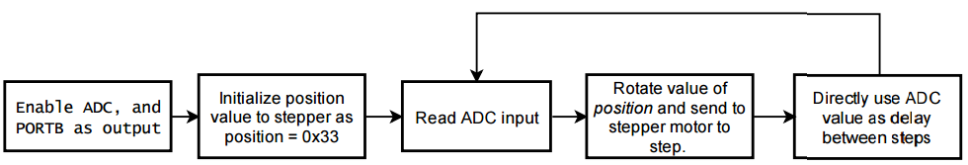

## Code

#define *F_CPU* 8000000UL // XTAL = 8MHZ

#include <stdio.h>

#include <avr/io.h>

#include <util/delay.h>

#define BAUDRATE 9600

#define ASYNCH_NORM_PRESCALER (*F_CPU*/16/BAUDRATE - 1)

void ADC0init(); // Initialize ADC0 input

unsigned short readADC(); // read ADC0 analog input and return it

void delay_ms(unsigned int); // shell procedule to call _delay_ms on variable input

void step_clockwise(unsigned int, unsigned int); // step stepper motor desired number of times with delay

unsigned char rotateLeft(unsigned char); // rotate bits of input to the left.

int USART0_sendChar(char, *FILE*\*); // Write character to USART0

void usart0_init (void); // Initialize USART0

// reset stream pointer

// http://www.gnu.org/savannah-checkouts/non-gnu/avr-libc/user-manual/group__avr__stdio.html

*FILE* USART0_stream = *FDEV_SETUP_STREAM*(USART0_sendChar, *NULL*, *_FDEV_SETUP_WRITE*);

// Current position signal of stepper motor

unsigned char positionSig = 0x33;

int main()

{

unsigned short adcVal;

DDRB = 0xFF; // make portB output pins.

*stdout* = &USART0_stream; // change standard output to point to a USART stream

usart0_init(); // Initialize USART0 for debugging and monitoring

ADC0init(); // Initialize ADC0 input

while (1)

{

adcVal = readADC(); // read ADC0;

step_clockwise(1, adcVal); // Step stepper motor 1 step with an adcVal delay

// print monitoring message

*printf*("ADC Value: %u | Position signal: 0x%X\n", adcVal, positionSig);

}

}

void usart0_init (void)

/*

* Procedure to initialize USART0 asynchronous with enabled RX/TX, 8 bit data,

* no parity, and 1 stop bit.

*/

{

UCSR0B = (1<<TXEN0) | (1<<RXEN0); // enable transmit/receive

UCSR0C = (1<<UCSZ01) | (1<<UCSZ00); // asynchronous, 8N1

UBRR0L = ASYNCH_NORM_PRESCALER; // Set prescaler based on desired baudrate

}

int USART0_sendChar(char data, *FILE* *stream)

/*

* Procedure to send a single character over USART0. If character is linefeed, reset

* line.

* Assumes ASCII code.

*/

{

if(data == '\n') // If character is linefeed,

{ // First send return.

while(! (UCSR0A & (1<<UDRE0)) );

UDR0 = '\r';

}

while(! (UCSR0A & (1<<UDRE0)) ); // Wait for last data to be transmitted.

UDR0 = data; // send data

return 0;

}

unsigned char rotateLeft(unsigned char x)

/*

* Given an unsigned character x, rotateLeft will do a logic rotatation of

* the bits of x to the right.

*/

{

unsigned char shiftIn = 0;

if ((x & 0x80) == 0x80)

shiftIn = 0x01;

return ((x<<1) | shiftIn);

}

void step_clockwise(unsigned int steps, unsigned int delay)

/*

* Given the unsigned integers steps, and delay, step_clockwise will send the appropriate

* signal to PORTB[7:0] to step a stepper motor in the clockwise direction.

* A global variable positionSig must be initialized to 0x33.

*/

{

for (; steps > 0; steps--) // loop steps times.

{

positionSig = rotateLeft(positionSig); // Rotate value of positionSig

PORTB = positionSig; // send data to PORTB

delay_ms(delay); // Delay a given value of milliseconds.

}

}

unsigned short readADC()

// readADC will read the adcValue after it has been calculated.

{

ADCSRA |= (1<<ADSC); // Begin conversion

while((ADCSRA & (1<<ADIF)) == 0 ); // Wait for conversion to finish.

return ADC;

}

void ADC0init()

// ADC0init will initialize analog input on ADC0, set voltage reference to Vcc, with

// data right justified on data register.

{

DDRC &= ~(0<<DDC0);

ADCSRA = 0x87; // Make ADC enable and select ck/128

ADMUX = (1<<REFS0); // VCC reference, ADC0 single ended input

// data will be right-justified

}

void delay_ms(unsigned int count)

/*

* Procedure to perform a delay based on an unsigned short

* since the _delay_ms macro will not accept parameters

* other than constant values.

*/

{

int i;

for(i = 0; i < count; i++)

*_delay_ms*(1);

}

|  |  |  |  |
| --- | --- | --- | --- |
| 3. | INITIAL CODE OF TASK 3 |  |  |

Write an AVR C program to control the position of the Servo Motor using a potentiometer connected to any of the analog-in port. When pot value is 0 the servo is at position 0 deg. and when pot value is max (approx. 5V) the servo is at position 180 deg.

Similarly to task 1, the 10 bit value read from the potentiometer can be mapped to the 16 bit value on OCR1A to control the duty cycle of the PWM signal fed to the servo motor. Since the servo motor’s positions between 0 degrees and 180 degrees were between OCR1A values of 65 to 285, the potentiometer value was mapped to a value from 0 to 285. However, OCR1A was set to 65 if value after mapping was lower than 65.

## Flow chart of task 3

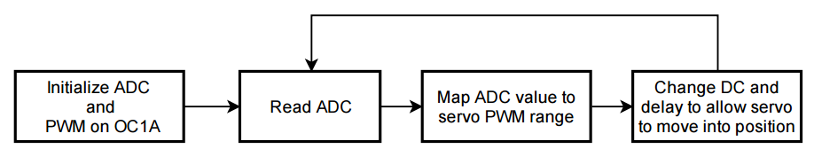

## Code

#define *F_CPU* 8000000UL // XTAL = 8MHZ

#include <stdio.h>

#include <avr/io.h>

#include <util/delay.h>

#define SERVO_MIN 65

#define SERVO_MAX 285

#define BAUDRATE 9600

#define ASYNCH_NORM_PRESCALER (*F_CPU*/16/BAUDRATE - 1)

void ADC0init(); // Initialize ADC0 input

unsigned short readADC(); // read ADC0 analog input and return it

void delay_ms(unsigned int); // shell procedule to call _delay_ms on variable input

void PWM_OC1A_init(); // Initialize PWM on OC1A at 50Hz

int USART0_sendChar(char, *FILE*\*); // Send character on USART0

void usart0_init (void); // Initialize USART0

// reset stream pointer

// http://www.gnu.org/savannah-checkouts/non-gnu/avr-libc/user-manual/group__avr__stdio.html

*FILE* USART0_stream = *FDEV_SETUP_STREAM*(USART0_sendChar, *NULL*, *_FDEV_SETUP_WRITE*);

int main()

{

unsigned short adcVal; // Variable to store input ADC Value

unsigned short newVal; // new value calculated based on a range for servo

DDRB = 0xFF; // make portB output pins.

ADC0init(); // Initialize ADC0 input

PWM_OC1A_init(); // initialize pwm on OC1A

usart0_init(); // Initialize USART0 for debugging and monitoring

*stdout* = & USART0_stream;// change standard output to point to a USART stream

while (1)

{

adcVal = readADC(); // read ADC0;

// Map ADC value to a range from 0 to SERVO_MAX

newVal = (unsigned short)((float)adcVal / ((1UL<<10) - 1) * SERVO_MAX);

*printf*("adcVal = %u\n", adcVal); // Print monitoring data

*printf*("\tnewVal = %u\n", newVal);

if (newVal <= SERVO_MIN) // If newVal is less than minimum servo value (0 degrees)

OCR1A = SERVO_MIN; // then set OCR1A to minimum value.

else

{

OCR1A = newVal; // else, update OCR1A to change duty cycle.

}

*_delay_ms*(50); // Delay to allow servo to move

}

}

int USART0_sendChar(char data, *FILE* *stream)

/*

* Procedure to send a single character over USART0. If character is linefeed, reset

* line.

* Assumes ASCII code.

*/

{

if(data == '\n')

{

while(! (UCSR0A & (1<<UDRE0)) );

UDR0 = '\r';

}

while(! (UCSR0A & (1<<UDRE0)) );

UDR0 = data;

return 0;

}

void usart0_init (void)

/*

* Procedure to initialize USART0 asynchronous with enabled RX/TX, 8 bit data,

* no parity, and 1 stop bit.

*/

{

UCSR0B = (1<<TXEN0) | (1<<RXEN0); // enable transmit/receive

UCSR0C = (1<<UCSZ01) | (1<<UCSZ00); // asynchronous, 8N1

UBRR0L = ASYNCH_NORM_PRESCALER; // To set 9600 baud rate with 8MHz clock

}

unsigned short readADC()

/*

* Procedure to send a single character over USART0. If character is linefeed, reset

* line.

* Assumes ASCII code.

*/

{

ADCSRA |= (1<<ADSC); // Begin conversion

while((ADCSRA & (1<<ADIF)) == 0 ); // Wait for conversion to finish.

return ADC;

}

void ADC0init()

// ADC0init will initialize analog input on ADC0, set voltage reference to Vcc, with

// data right justified on data register.

{

DDRC &= ~(0<<DDC0);

ADCSRA = 0x87; // Make ADC enable and select ck/128

ADMUX = (1<<REFS0); // VCC reference, ADC0 single ended input

// data will be right-justified

}

void delay_ms(unsigned int count)

/*

* Procedure to perform a delay based on an unsigned short

* since the _delay_ms macro will not accept parameters

* other than constant values.

*/

{

int i;

for(i = 0; i < count; i++)

*_delay_ms*(1);

}

void PWM_OC1A_init()

{

//Set PORTB1 pin as output

DDRB |= (1<<DDB1); // make OC1A as output.

// Output compare mode on OC1A. Fast PWM with top = ICR1.

// Clear OC1A on Compare match and set at bottom.

TCCR1A |= (1<<COM1A1)|(0<<COM1A0)|(0<<COM1B1)|(0<<COM1B0)|(0<<FOC1A)|(0<<FOC1B)|(1<<WGM11)|(0<<WGM10);

// Start timer with prescaler 64

TCCR1B |= (0<<ICNC1)|(0<<ICES1)|(1<<WGM13)|(1<<WGM12)|(0<<CS12)|(1<<CS11)|(1<<CS10);

ICR1 = 2499; // F_CPU / (N * F_pwm) - 1, where N is the prescaler = 64, and F_pwm is the desired 50Hz frequency.

}

|  |  |  |  |
| --- | --- | --- | --- |
| 6. | SCHEMATICS |  |  |

## Task 1

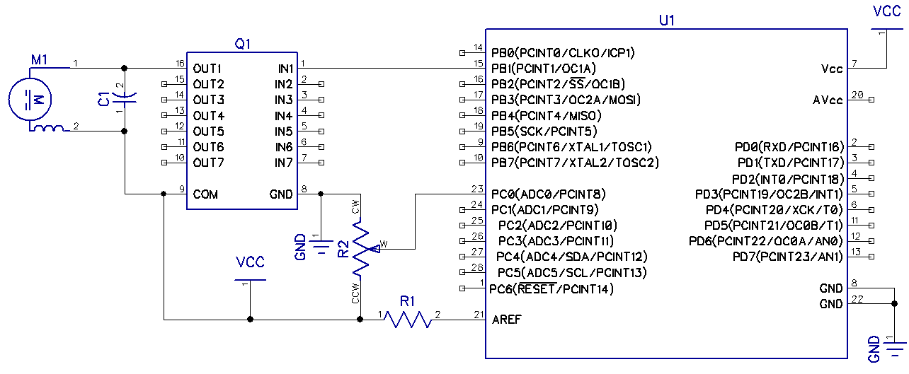

## Task 2

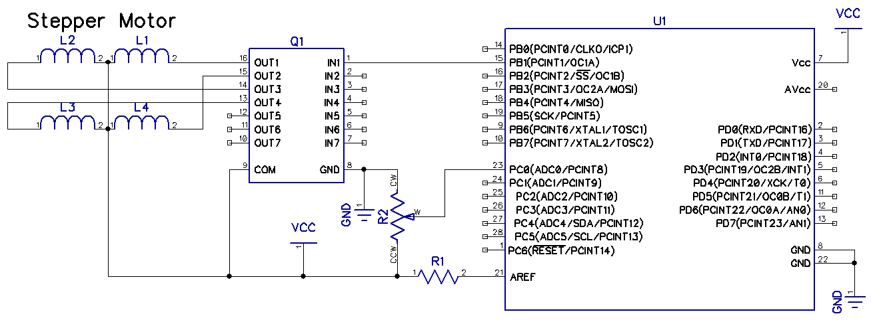

## Task 3

## 

|  |  |  |  |
| --- | --- | --- | --- |
| 7. | SCREENSHOTS OF EACH TASK OUTPUT |  |  |

## TASK 1:

The figure below illustrates where the potentiometer was at a 90% position. Output duty cycle is displayed with the Pololu monitoring software for Pololu USB AVR Programmer.

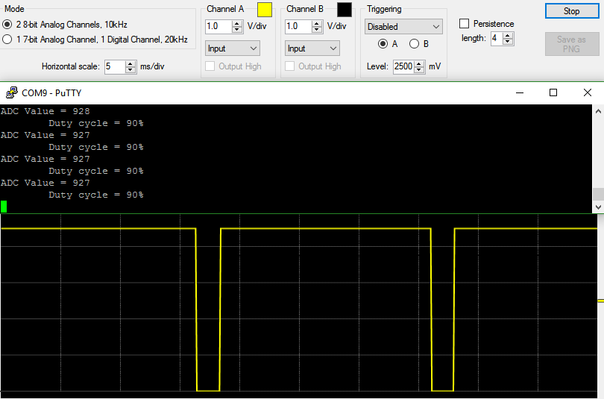

And then with 10% duty cycle

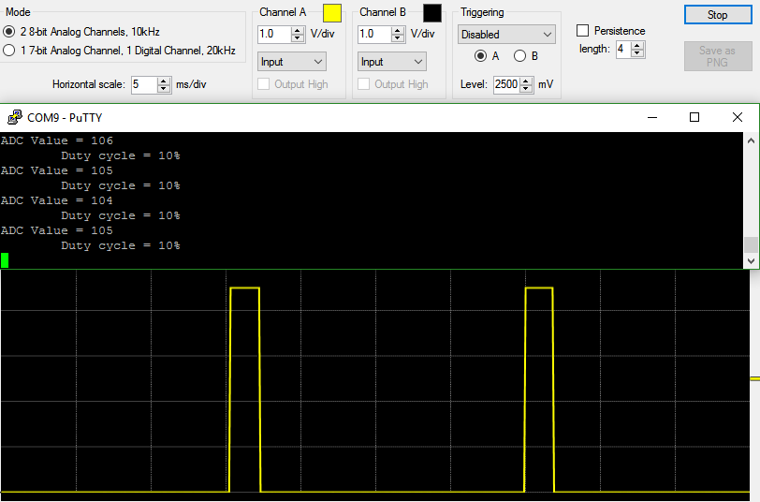

## Task 2:

The following screenshot simply ullustrates the monitoring of the potentiometer value as it is rotated and the position signal being sent to the stepper motor. Each line represents one step. Notice that the position signal is being rotated at each iteration.

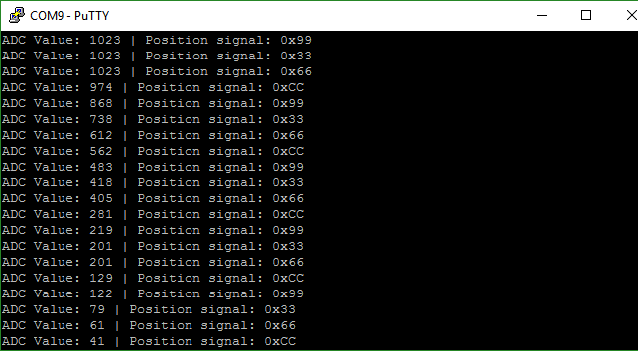

## Task 3:

The following image illustrates the monitoring of the PWM signal and the mapping of values from potentiometer to OCR1A.

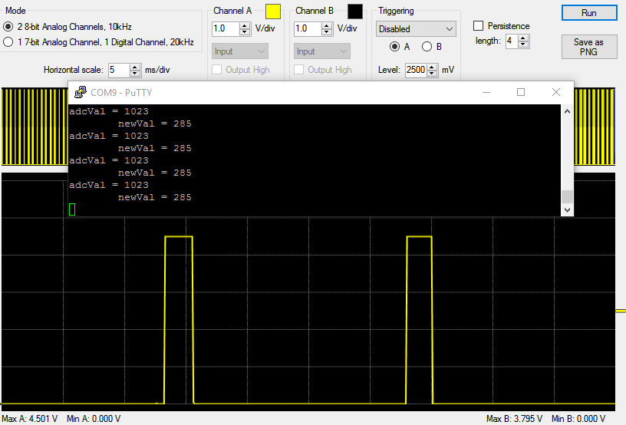

|  |  |  |  |
| --- | --- | --- | --- |
| 8. | SCREENSHOT OF EACH DEMO |  |  |

## TASK 1:

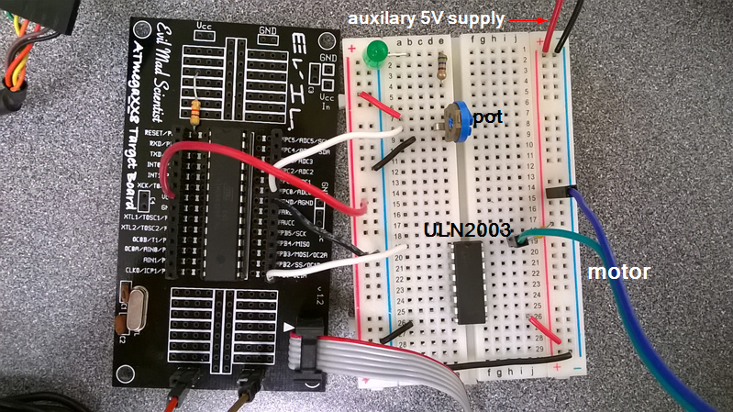

## Task 2:

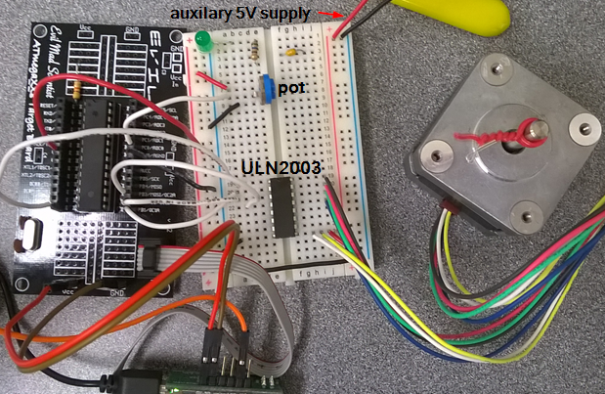

## Task 3:

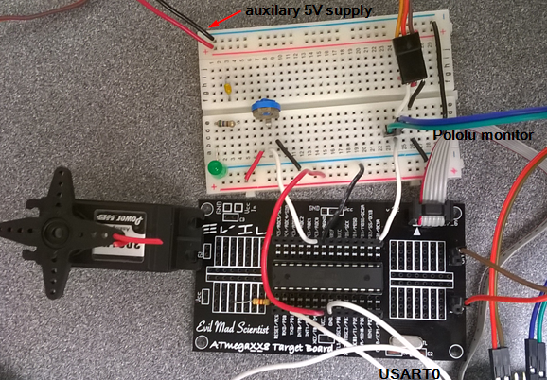

|  |  |  |  |
| --- | --- | --- | --- |
| 9. | VIDEO LINKS OF EACH DEMO |  |  |
| http:// @youtube | | | |
| 10. | GOOGLECODE LINK OF THE DA |  |  |
| http:// @svn or github repository link | | | |

**Student Academic Misconduct Policy**

<http://studentconduct.unlv.edu/misconduct/policy.html>

“This assignment submission is my own, original work”.

Martin Jaime-Viveros