Name: Martin Jaime
NSHID#: 1013512824
Project Title: Compass Read and Publish

Problem Statement: Read compass data with the Atmega328P and publish its data to a webserver to display it on a webpage.

Objectives: Develop familiarization with I²C interface, connecting a microcontroller to a network, and interfacing a wi-fi module with a microcontroller.

Design Steps:

The design for this project will consist of the Atmega328P connected over I²C to the compass. The compass continuously refreshes the data stored on its registers. The MCU will read the data and pass it on to the Wi-Fi module over UART. The Wi-Fi module will then publish this data on a web server.

The data will consist of the magnitude of the magnetic fileld acting on the sensor on three axis.

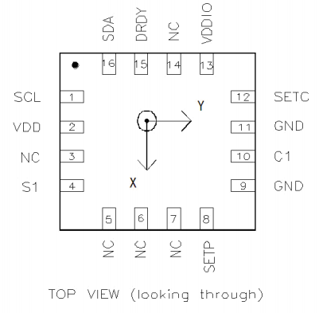
As seen on the image, the three axis are labeled x, y, and z is pointing towards the reader. With these three values, the direction of the magnetic field can be determined with pythagorean theorem.

Timeline:
April 17th: Gain familiarization with HMC8553L. Begin integrating Wi-Fi module.
April 23rd: Finish integrating Wi-Fi module. Connect MCU to a network.
April 24th: Sign up for web service to publish the data.
April 27th: Read data from compass.
April 30th: Prefinal Report
May 3rd: Debugging.
May 4th: Complete Final Report.
May 5th: Final Report due, demonstration, and submission

Hardware Components:
- Atmega328P
- HMC8553L
- HUZZA ESP8266

Initial Schematics:
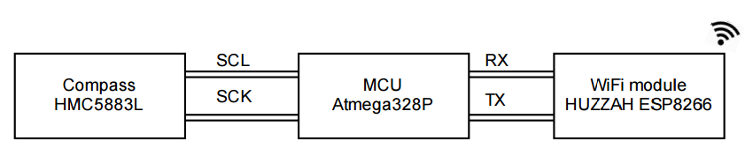

Reference:

http://www.soc-robotics.com/pdfs/HMC5883L.pdf

https://learn.adafruit.com/downloads/pdf/adafruit-huzzah-esp8266-breakout.pdf

http://www.atmel.com/images/atmel-8271-8-bit-avr-microcontroller-atmega48a-48pa-88a-88pa-168a-168pa-328-328p_datasheet_complete.pdf

