**University of Nevada Las Vegas. Department of Electrical and Computer Engineering Laboratories.**

|  |  |  |  |  |  |
| --- | --- | --- | --- | --- | --- |
| Class: | **CpE 301: Embedded System Design** | | | Semester: | **Spring 2016** |
|  | | | | | |
| Points |  | Document author: | **Martin Jaime** | | |
|  | Author's email: | **jaimem5@unlv.nevada.edu** | | |
|  | | | |
| Document topic: | **Postlab 2: Atmel Studio Tutorial Part 1** | | |
| Instructor's comments: | | | | | |

**1. Introduction / Theory of Operation**

The goal of this lab was to install Atmel Studio 7 and WinAVR. Also build and simulate a project in Atmel Studio 7

**2. Description of Experiments**

**Experiment 1**

Download and install Atmel Studio 7, and WinAVR. Atmel Studio 7 had already been installed previously.

**Experiment 2**

Download the datasheet for the Atmega328P

**Experiment 3**

Use installed software to create and build a project. I built blinky project demonstrated in lecture.

Code:

#define *F_CPU* 10000000UL

#include <util/delay.h>

#include <avr/io.h>

int main() {

// Set the pin 5 at port B as output

DDRB |= (1<<PB5);

while(1) {

// Turn led on by setting corresponding bit high in the PORTB register.

PORTB |= (1<<PB5);

*_delay_ms*(500);

// Turn led off by setting corresponding bit low in the PORTB register.

PORTB &= ~(1<<PB5);

*_delay_ms*(3000);

}

}

**3. Encountered Problems**

The only problem is that the link to download WinAVR did not respond.

**4. Summary**

We downloaded and installed necessary software to work with the Atmega328P and demonstrated use of the IDE to program the microcontroller, and debug it.

**5. Conclusions**

The IDE eases the use of the microcontroller.

**6. Questions**

1. Go to the Atmel website and find the Atmega328P datasheet. List some of the various functions that can be performed using the chip.

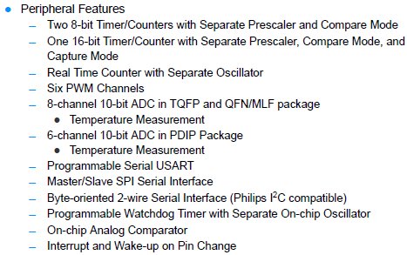

1. Go to Atmel's website and find another microcontroller that is similar enough to replace the Atmega328P. Explain why it would be a suitable replacement and list some of the differences from the 328P.  
     
   A potential replacement for the Atmega328P is the **Atmega325P**. It is the only difference, is that the pin count on the 325P is twice as large, but with 7 fewer external interrupts, and the maximum operating frequency is 4 MHz lower.

**7. PCB and Schematic**

There was no schematic used.