# Dátova kocka Príjem

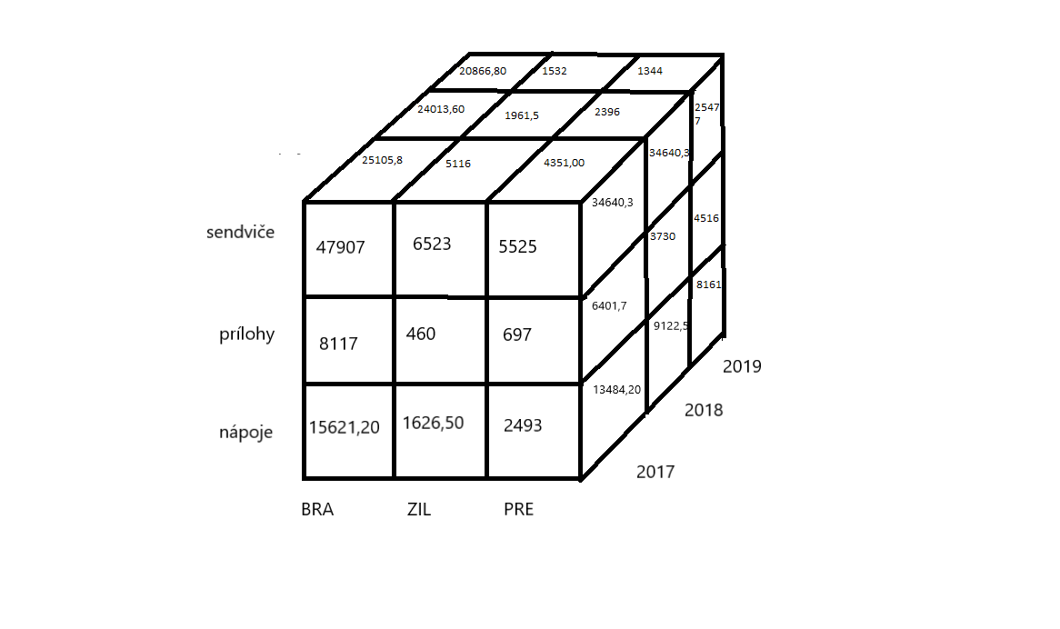**Nákres**

# Ukážka príkazov

**Predná strana**

**BRA**

[SELECT](https://pma2.webzdarma.cz/url.php?url=https://dev.mysql.com/doc/refman/5.5/en/select.html) t.kraj,[SUM](https://pma2.webzdarma.cz/url.php?url=https://dev.mysql.com/doc/refman/5.5/en/group-by-functions.html#function_sum)(t.prijem)prijem FROM tabulka_faktov2 t WHERE t.id_skup_vyr='1' [and](https://pma2.webzdarma.cz/url.php?url=https://dev.mysql.com/doc/refman/5.5/en/logical-operators.html#operator_and) t.kraj='BRA' group BY kraj (15621,20)

[SELECT](https://pma2.webzdarma.cz/url.php?url=https://dev.mysql.com/doc/refman/5.5/en/select.html) t.kraj,[SUM](https://pma2.webzdarma.cz/url.php?url=https://dev.mysql.com/doc/refman/5.5/en/group-by-functions.html#function_sum)(t.prijem)prijem FROM tabulka_faktov2 t WHERE t.id_skup_vyr='2' [and](https://pma2.webzdarma.cz/url.php?url=https://dev.mysql.com/doc/refman/5.5/en/logical-operators.html#operator_and) t.kraj='BRA' group BY kraj (8117)

[SELECT](https://pma2.webzdarma.cz/url.php?url=https://dev.mysql.com/doc/refman/5.5/en/select.html) t.kraj,[SUM](https://pma2.webzdarma.cz/url.php?url=https://dev.mysql.com/doc/refman/5.5/en/group-by-functions.html#function_sum)(t.prijem)prijem FROM tabulka_faktov2 t WHERE t.id_skup_vyr='3' [and](https://pma2.webzdarma.cz/url.php?url=https://dev.mysql.com/doc/refman/5.5/en/logical-operators.html#operator_and) t.kraj='BRA' group BY kraj (47907)

**ZIL**

[SELECT](https://pma2.webzdarma.cz/url.php?url=https://dev.mysql.com/doc/refman/5.5/en/select.html) t.kraj,[SUM](https://pma2.webzdarma.cz/url.php?url=https://dev.mysql.com/doc/refman/5.5/en/group-by-functions.html#function_sum)(t.prijem)prijem FROM tabulka_faktov2 t WHERE t.id_skup_vyr='1' [and](https://pma2.webzdarma.cz/url.php?url=https://dev.mysql.com/doc/refman/5.5/en/logical-operators.html#operator_and) t.kraj='ZIL' group BY kraj (1626,50)

[SELECT](https://pma2.webzdarma.cz/url.php?url=https://dev.mysql.com/doc/refman/5.5/en/select.html) t.kraj,[SUM](https://pma2.webzdarma.cz/url.php?url=https://dev.mysql.com/doc/refman/5.5/en/group-by-functions.html#function_sum)(t.prijem)prijem FROM tabulka_faktov2 t WHERE t.id_skup_vyr='2' [and](https://pma2.webzdarma.cz/url.php?url=https://dev.mysql.com/doc/refman/5.5/en/logical-operators.html#operator_and) t.kraj='ZIL' group BY kraj (460)

[SELECT](https://pma2.webzdarma.cz/url.php?url=https://dev.mysql.com/doc/refman/5.5/en/select.html) t.kraj,[SUM](https://pma2.webzdarma.cz/url.php?url=https://dev.mysql.com/doc/refman/5.5/en/group-by-functions.html#function_sum)(t.prijem)prijem FROM tabulka_faktov2 t WHERE t.id_skup_vyr='3' [and](https://pma2.webzdarma.cz/url.php?url=https://dev.mysql.com/doc/refman/5.5/en/logical-operators.html#operator_and) t.kraj='ZIL' group BY kraj (6523)

**PRE**

[SELECT](https://pma2.webzdarma.cz/url.php?url=https://dev.mysql.com/doc/refman/5.5/en/select.html) t.kraj,[SUM](https://pma2.webzdarma.cz/url.php?url=https://dev.mysql.com/doc/refman/5.5/en/group-by-functions.html#function_sum)(t.prijem)prijem FROM tabulka_faktov2 t WHERE t.id_skup_vyr='1' [and](https://pma2.webzdarma.cz/url.php?url=https://dev.mysql.com/doc/refman/5.5/en/logical-operators.html#operator_and) t.kraj='PRE' group BY kraj (2493)

[SELECT](https://pma2.webzdarma.cz/url.php?url=https://dev.mysql.com/doc/refman/5.5/en/select.html) t.kraj,[SUM](https://pma2.webzdarma.cz/url.php?url=https://dev.mysql.com/doc/refman/5.5/en/group-by-functions.html#function_sum)(t.prijem)prijem FROM tabulka_faktov2 t WHERE t.id_skup_vyr='2' [and](https://pma2.webzdarma.cz/url.php?url=https://dev.mysql.com/doc/refman/5.5/en/logical-operators.html#operator_and) t.kraj='PRE' group BY kraj (697)

[SELECT](https://pma2.webzdarma.cz/url.php?url=https://dev.mysql.com/doc/refman/5.5/en/select.html) t.kraj,[SUM](https://pma2.webzdarma.cz/url.php?url=https://dev.mysql.com/doc/refman/5.5/en/group-by-functions.html#function_sum)(t.prijem)prijem FROM tabulka_faktov2 t WHERE t.id_skup_vyr='3' [and](https://pma2.webzdarma.cz/url.php?url=https://dev.mysql.com/doc/refman/5.5/en/logical-operators.html#operator_and) t.kraj='PRE' group BY kraj (5525)

**Bočná strana**

**2017**

[SELECT](https://pma2.webzdarma.cz/url.php?url=https://dev.mysql.com/doc/refman/5.5/en/select.html) t.id_skup_vyr,[SUM](https://pma2.webzdarma.cz/url.php?url=https://dev.mysql.com/doc/refman/5.5/en/group-by-functions.html#function_sum)(t.prijem)prijem FROM tabulka_faktov2 t WHERE t.rok='17' [and](https://pma2.webzdarma.cz/url.php?url=https://dev.mysql.com/doc/refman/5.5/en/logical-operators.html#operator_and) t.id_skup_vyr='1' group BY t.id_skup_vyr (13484,20)

[SELECT](https://pma2.webzdarma.cz/url.php?url=https://dev.mysql.com/doc/refman/5.5/en/select.html) t.id_skup_vyr,[SUM](https://pma2.webzdarma.cz/url.php?url=https://dev.mysql.com/doc/refman/5.5/en/group-by-functions.html#function_sum)(t.prijem)prijem FROM tabulka_faktov2 t WHERE t.rok='17' [and](https://pma2.webzdarma.cz/url.php?url=https://dev.mysql.com/doc/refman/5.5/en/logical-operators.html#operator_and) t.id_skup_vyr='2' group BY t.id_skup_vyr (6401,70)

[SELECT](https://pma2.webzdarma.cz/url.php?url=https://dev.mysql.com/doc/refman/5.5/en/select.html) t.id_skup_vyr,[SUM](https://pma2.webzdarma.cz/url.php?url=https://dev.mysql.com/doc/refman/5.5/en/group-by-functions.html#function_sum)(t.prijem)prijem FROM tabulka_faktov2 t WHERE t.rok='17' [and](https://pma2.webzdarma.cz/url.php?url=https://dev.mysql.com/doc/refman/5.5/en/logical-operators.html#operator_and) t.id_skup_vyr='3' group BY t.id_skup_vyr (34640,30)

**2018**

[SELECT](https://pma2.webzdarma.cz/url.php?url=https://dev.mysql.com/doc/refman/5.5/en/select.html) t.id_skup_vyr,[SUM](https://pma2.webzdarma.cz/url.php?url=https://dev.mysql.com/doc/refman/5.5/en/group-by-functions.html#function_sum)(t.prijem)prijem FROM tabulka_faktov2 t WHERE t.rok='18' [and](https://pma2.webzdarma.cz/url.php?url=https://dev.mysql.com/doc/refman/5.5/en/logical-operators.html#operator_and) t.id_skup_vyr='1' group BY t.id_skup_vyr (9122.5)

[SELECT](https://pma2.webzdarma.cz/url.php?url=https://dev.mysql.com/doc/refman/5.5/en/select.html) t.id_skup_vyr,[SUM](https://pma2.webzdarma.cz/url.php?url=https://dev.mysql.com/doc/refman/5.5/en/group-by-functions.html#function_sum)(t.prijem)prijem FROM tabulka_faktov2 t WHERE t.rok='18' [and](https://pma2.webzdarma.cz/url.php?url=https://dev.mysql.com/doc/refman/5.5/en/logical-operators.html#operator_and) t.id_skup_vyr='2' group BY t.id_skup_vyr (3730,00)

[SELECT](https://pma2.webzdarma.cz/url.php?url=https://dev.mysql.com/doc/refman/5.5/en/select.html) t.id_skup_vyr,[SUM](https://pma2.webzdarma.cz/url.php?url=https://dev.mysql.com/doc/refman/5.5/en/group-by-functions.html#function_sum)(t.prijem)prijem FROM tabulka_faktov2 t WHERE t.rok='18' [and](https://pma2.webzdarma.cz/url.php?url=https://dev.mysql.com/doc/refman/5.5/en/logical-operators.html#operator_and) t.id_skup_vyr='3' group BY t.id_skup_vyr (31061,30)

**2019**

[SELECT](https://pma2.webzdarma.cz/url.php?url=https://dev.mysql.com/doc/refman/5.5/en/select.html) t.id_skup_vyr,[SUM](https://pma2.webzdarma.cz/url.php?url=https://dev.mysql.com/doc/refman/5.5/en/group-by-functions.html#function_sum)(t.prijem)prijem FROM tabulka_faktov2 t WHERE t.rok='19' [and](https://pma2.webzdarma.cz/url.php?url=https://dev.mysql.com/doc/refman/5.5/en/logical-operators.html#operator_and) t.id_skup_vyr='1' group BY t.id_skup_vyr (8161)

[SELECT](https://pma2.webzdarma.cz/url.php?url=https://dev.mysql.com/doc/refman/5.5/en/select.html) t.id_skup_vyr,[SUM](https://pma2.webzdarma.cz/url.php?url=https://dev.mysql.com/doc/refman/5.5/en/group-by-functions.html#function_sum)(t.prijem)prijem FROM tabulka_faktov2 t WHERE t.rok='19' [and](https://pma2.webzdarma.cz/url.php?url=https://dev.mysql.com/doc/refman/5.5/en/logical-operators.html#operator_and) t.id_skup_vyr='2' group BY t.id_skup_vyr (4516)

[SELECT](https://pma2.webzdarma.cz/url.php?url=https://dev.mysql.com/doc/refman/5.5/en/select.html) t.id_skup_vyr,[SUM](https://pma2.webzdarma.cz/url.php?url=https://dev.mysql.com/doc/refman/5.5/en/group-by-functions.html#function_sum)(t.prijem)prijem FROM tabulka_faktov2 t WHERE t.rok='19' [and](https://pma2.webzdarma.cz/url.php?url=https://dev.mysql.com/doc/refman/5.5/en/logical-operators.html#operator_and) t.id_skup_vyr='3' group BY t.id_skup_vyr (25477)

**Horná strana**

**BRA**

[SELECT](https://pma2.webzdarma.cz/url.php?url=https://dev.mysql.com/doc/refman/5.5/en/select.html) t.kraj , [sum](https://pma2.webzdarma.cz/url.php?url=https://dev.mysql.com/doc/refman/5.5/en/group-by-functions.html#function_sum)(t.prijem) prijem FROM tabulka_faktov2 t where t.kraj='BRA' [and](https://pma2.webzdarma.cz/url.php?url=https://dev.mysql.com/doc/refman/5.5/en/logical-operators.html#operator_and) t.rok='17' group by kraj (25105,80)

[SELECT](https://pma2.webzdarma.cz/url.php?url=https://dev.mysql.com/doc/refman/5.5/en/select.html) t.kraj , [sum](https://pma2.webzdarma.cz/url.php?url=https://dev.mysql.com/doc/refman/5.5/en/group-by-functions.html#function_sum)(t.prijem) prijem FROM tabulka_faktov2 t where t.kraj='BRA' [and](https://pma2.webzdarma.cz/url.php?url=https://dev.mysql.com/doc/refman/5.5/en/logical-operators.html#operator_and) t.rok='18' group by kraj(24013,60)

[SELECT](https://pma2.webzdarma.cz/url.php?url=https://dev.mysql.com/doc/refman/5.5/en/select.html) t.kraj , [sum](https://pma2.webzdarma.cz/url.php?url=https://dev.mysql.com/doc/refman/5.5/en/group-by-functions.html#function_sum)(t.prijem) prijem FROM tabulka_faktov2 t where t.kraj='BRA' [and](https://pma2.webzdarma.cz/url.php?url=https://dev.mysql.com/doc/refman/5.5/en/logical-operators.html#operator_and) t.rok='19' group by kraj(20866,80)

**ZIL**

[SELECT](https://pma2.webzdarma.cz/url.php?url=https://dev.mysql.com/doc/refman/5.5/en/select.html) t.kraj , [sum](https://pma2.webzdarma.cz/url.php?url=https://dev.mysql.com/doc/refman/5.5/en/group-by-functions.html#function_sum)(t.prijem) prijem FROM tabulka_faktov2 t where t.kraj='ZIL' [and](https://pma2.webzdarma.cz/url.php?url=https://dev.mysql.com/doc/refman/5.5/en/logical-operators.html#operator_and) t.rok='17' group by kraj(5116,00)

[SELECT](https://pma2.webzdarma.cz/url.php?url=https://dev.mysql.com/doc/refman/5.5/en/select.html) t.kraj , [sum](https://pma2.webzdarma.cz/url.php?url=https://dev.mysql.com/doc/refman/5.5/en/group-by-functions.html#function_sum)(t.prijem) prijem FROM tabulka_faktov2 t where t.kraj='ZIL' [and](https://pma2.webzdarma.cz/url.php?url=https://dev.mysql.com/doc/refman/5.5/en/logical-operators.html#operator_and) t.rok='18' group by kraj(1961,5)

[SELECT](https://pma2.webzdarma.cz/url.php?url=https://dev.mysql.com/doc/refman/5.5/en/select.html) t.kraj , [sum](https://pma2.webzdarma.cz/url.php?url=https://dev.mysql.com/doc/refman/5.5/en/group-by-functions.html#function_sum)(t.prijem) prijem FROM tabulka_faktov2 t where t.kraj='ZIL' [and](https://pma2.webzdarma.cz/url.php?url=https://dev.mysql.com/doc/refman/5.5/en/logical-operators.html#operator_and) t.rok='19' group by kraj(1532)

**PRE**

[SELECT](https://pma2.webzdarma.cz/url.php?url=https://dev.mysql.com/doc/refman/5.5/en/select.html) t.kraj , [sum](https://pma2.webzdarma.cz/url.php?url=https://dev.mysql.com/doc/refman/5.5/en/group-by-functions.html#function_sum)(t.prijem) prijem FROM tabulka_faktov2 t where t.kraj='PRE' [and](https://pma2.webzdarma.cz/url.php?url=https://dev.mysql.com/doc/refman/5.5/en/logical-operators.html#operator_and) t.rok='17' group by kraj(4351,00)

[SELECT](https://pma2.webzdarma.cz/url.php?url=https://dev.mysql.com/doc/refman/5.5/en/select.html) t.kraj , [sum](https://pma2.webzdarma.cz/url.php?url=https://dev.mysql.com/doc/refman/5.5/en/group-by-functions.html#function_sum)(t.prijem) prijem FROM tabulka_faktov2 t where t.kraj='PRE' [and](https://pma2.webzdarma.cz/url.php?url=https://dev.mysql.com/doc/refman/5.5/en/logical-operators.html#operator_and) t.rok='18' group by kraj(2396,00)

[SELECT](https://pma2.webzdarma.cz/url.php?url=https://dev.mysql.com/doc/refman/5.5/en/select.html) t.kraj , [sum](https://pma2.webzdarma.cz/url.php?url=https://dev.mysql.com/doc/refman/5.5/en/group-by-functions.html#function_sum)(t.prijem) prijem FROM tabulka_faktov2 t where t.kraj='PRE' [and](https://pma2.webzdarma.cz/url.php?url=https://dev.mysql.com/doc/refman/5.5/en/logical-operators.html#operator_and) t.rok='19' group by kraj(1344.00)

# Dátová kocka- Náklad

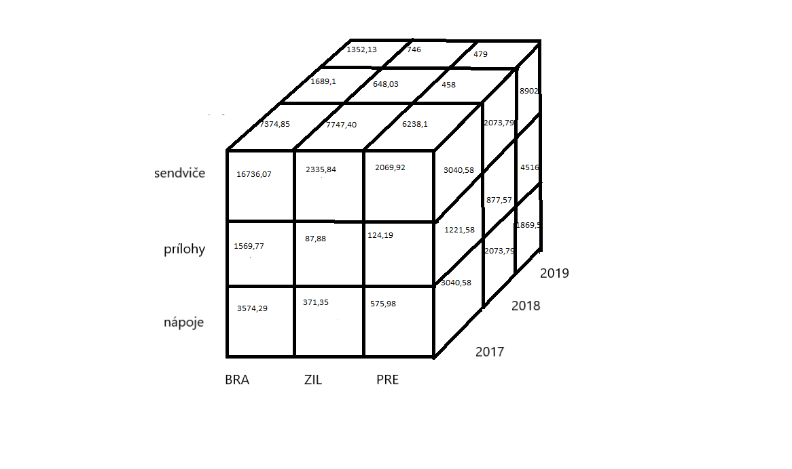Nákres

[SELECT](https://pma2.webzdarma.cz/url.php?url=https://dev.mysql.com/doc/refman/5.5/en/select.html) t.kraj,[SUM](https://pma2.webzdarma.cz/url.php?url=https://dev.mysql.com/doc/refman/5.5/en/group-by-functions.html#function_sum)(t.naklad)naklad FROM tabulka_faktov2 t WHERE t.id_skup_vyr='1' [and](https://pma2.webzdarma.cz/url.php?url=https://dev.mysql.com/doc/refman/5.5/en/logical-operators.html#operator_and) t.kraj='BRA' group BY kraj (3574,29)

[SELECT](https://pma2.webzdarma.cz/url.php?url=https://dev.mysql.com/doc/refman/5.5/en/select.html) t.kraj,[SUM](https://pma2.webzdarma.cz/url.php?url=https://dev.mysql.com/doc/refman/5.5/en/group-by-functions.html#function_sum)(t.naklad)naklad FROM tabulka_faktov2 t WHERE t.id_skup_vyr='2' [and](https://pma2.webzdarma.cz/url.php?url=https://dev.mysql.com/doc/refman/5.5/en/logical-operators.html#operator_and) t.kraj='BRA' group BY kraj (1569,77)

[SELECT](https://pma2.webzdarma.cz/url.php?url=https://dev.mysql.com/doc/refman/5.5/en/select.html) t.kraj,[SUM](https://pma2.webzdarma.cz/url.php?url=https://dev.mysql.com/doc/refman/5.5/en/group-by-functions.html#function_sum)(t.naklad)naklad FROM tabulka_faktov2 t WHERE t.id_skup_vyr='3' [and](https://pma2.webzdarma.cz/url.php?url=https://dev.mysql.com/doc/refman/5.5/en/logical-operators.html#operator_and) t.kraj='BRA' group BY kraj (16736,07)

**ZIL**

[SELECT](https://pma2.webzdarma.cz/url.php?url=https://dev.mysql.com/doc/refman/5.5/en/select.html) t.kraj,[SUM](https://pma2.webzdarma.cz/url.php?url=https://dev.mysql.com/doc/refman/5.5/en/group-by-functions.html#function_sum)(t.naklad)naklad FROM tabulka_faktov2 t WHERE t.id_skup_vyr='1' [and](https://pma2.webzdarma.cz/url.php?url=https://dev.mysql.com/doc/refman/5.5/en/logical-operators.html#operator_and) t.kraj='ZIL' group BY kraj (371,35)

[SELECT](https://pma2.webzdarma.cz/url.php?url=https://dev.mysql.com/doc/refman/5.5/en/select.html) t.kraj,[SUM](https://pma2.webzdarma.cz/url.php?url=https://dev.mysql.com/doc/refman/5.5/en/group-by-functions.html#function_sum)(t.naklad) naklad FROM tabulka_faktov2 t WHERE t.id_skup_vyr='2' [and](https://pma2.webzdarma.cz/url.php?url=https://dev.mysql.com/doc/refman/5.5/en/logical-operators.html#operator_and) t.kraj='ZIL' group BY kraj (87,88)

[SELECT](https://pma2.webzdarma.cz/url.php?url=https://dev.mysql.com/doc/refman/5.5/en/select.html) t.kraj,[SUM](https://pma2.webzdarma.cz/url.php?url=https://dev.mysql.com/doc/refman/5.5/en/group-by-functions.html#function_sum)(t.naklad)naklad FROM tabulka_faktov2 t WHERE t.id_skup_vyr='3' [and](https://pma2.webzdarma.cz/url.php?url=https://dev.mysql.com/doc/refman/5.5/en/logical-operators.html#operator_and) t.kraj='ZIL' group BY kraj (2335,84)

**PRE**

[SELECT](https://pma2.webzdarma.cz/url.php?url=https://dev.mysql.com/doc/refman/5.5/en/select.html) t.kraj,[SUM](https://pma2.webzdarma.cz/url.php?url=https://dev.mysql.com/doc/refman/5.5/en/group-by-functions.html#function_sum)(t.naklad)naklad FROM tabulka_faktov2 t WHERE t.id_skup_vyr='1' [and](https://pma2.webzdarma.cz/url.php?url=https://dev.mysql.com/doc/refman/5.5/en/logical-operators.html#operator_and) t.kraj='PRE' group BY kraj (575,98)

[SELECT](https://pma2.webzdarma.cz/url.php?url=https://dev.mysql.com/doc/refman/5.5/en/select.html) t.kraj,[SUM](https://pma2.webzdarma.cz/url.php?url=https://dev.mysql.com/doc/refman/5.5/en/group-by-functions.html#function_sum)(t.naklad)naklad FROM tabulka_faktov2 t WHERE t.id_skup_vyr='2' [and](https://pma2.webzdarma.cz/url.php?url=https://dev.mysql.com/doc/refman/5.5/en/logical-operators.html#operator_and) t.kraj='PRE' group BY kraj (124,19)

[SELECT](https://pma2.webzdarma.cz/url.php?url=https://dev.mysql.com/doc/refman/5.5/en/select.html) t.kraj,[SUM](https://pma2.webzdarma.cz/url.php?url=https://dev.mysql.com/doc/refman/5.5/en/group-by-functions.html#function_sum)(t.naklad)naklad FROM tabulka_faktov2 t WHERE t.id_skup_vyr='3' [and](https://pma2.webzdarma.cz/url.php?url=https://dev.mysql.com/doc/refman/5.5/en/logical-operators.html#operator_and) t.kraj='PRE' group BY kraj (2069,92)

**Bočná strana**

**2017**

[SELECT](https://pma2.webzdarma.cz/url.php?url=https://dev.mysql.com/doc/refman/5.5/en/select.html) t.id_skup_vyr,[SUM](https://pma2.webzdarma.cz/url.php?url=https://dev.mysql.com/doc/refman/5.5/en/group-by-functions.html#function_sum)(t.naklad)naklad FROM tabulka_faktov2 t WHERE t.rok='17' [and](https://pma2.webzdarma.cz/url.php?url=https://dev.mysql.com/doc/refman/5.5/en/logical-operators.html#operator_and) t.id_skup_vyr='1' group BY t.id_skup_vyr (3040,58)

[SELECT](https://pma2.webzdarma.cz/url.php?url=https://dev.mysql.com/doc/refman/5.5/en/select.html) t.id_skup_vyr,[SUM](https://pma2.webzdarma.cz/url.php?url=https://dev.mysql.com/doc/refman/5.5/en/group-by-functions.html#function_sum)(t.naklad) naklad FROM tabulka_faktov2 t WHERE t.rok='17' [and](https://pma2.webzdarma.cz/url.php?url=https://dev.mysql.com/doc/refman/5.5/en/logical-operators.html#operator_and) t.id_skup_vyr='2' group BY t.id_skup_vyr (1221,58)

[SELECT](https://pma2.webzdarma.cz/url.php?url=https://dev.mysql.com/doc/refman/5.5/en/select.html) t.id_skup_vyr,[SUM](https://pma2.webzdarma.cz/url.php?url=https://dev.mysql.com/doc/refman/5.5/en/group-by-functions.html#function_sum)(t.naklad)naklad FROM tabulka_faktov2 t WHERE t.rok='17' [and](https://pma2.webzdarma.cz/url.php?url=https://dev.mysql.com/doc/refman/5.5/en/logical-operators.html#operator_and) t.id_skup_vyr='3' group BY t.id_skup_vyr (12172,59)

**2018**

[SELECT](https://pma2.webzdarma.cz/url.php?url=https://dev.mysql.com/doc/refman/5.5/en/select.html) t.id_skup_vyr,[SUM](https://pma2.webzdarma.cz/url.php?url=https://dev.mysql.com/doc/refman/5.5/en/group-by-functions.html#function_sum)(t.naklad)naklad FROM tabulka_faktov2 t WHERE t.rok='18' [and](https://pma2.webzdarma.cz/url.php?url=https://dev.mysql.com/doc/refman/5.5/en/logical-operators.html#operator_and) t.id_skup_vyr='1' group BY t.id_skup_vyr (2073,79)

[SELECT](https://pma2.webzdarma.cz/url.php?url=https://dev.mysql.com/doc/refman/5.5/en/select.html) t.id_skup_vyr,[SUM](https://pma2.webzdarma.cz/url.php?url=https://dev.mysql.com/doc/refman/5.5/en/group-by-functions.html#function_sum)(t.naklad)naklad FROM tabulka_faktov2 t WHERE t.rok='18' [and](https://pma2.webzdarma.cz/url.php?url=https://dev.mysql.com/doc/refman/5.5/en/logical-operators.html#operator_and) t.id_skup_vyr='2' group BY t.id_skup_vyr (877,57)

[SELECT](https://pma2.webzdarma.cz/url.php?url=https://dev.mysql.com/doc/refman/5.5/en/select.html) t.id_skup_vyr,[SUM](https://pma2.webzdarma.cz/url.php?url=https://dev.mysql.com/doc/refman/5.5/en/group-by-functions.html#function_sum)(t.naklad)naklad FROM tabulka_faktov2 t WHERE t.rok='18' [and](https://pma2.webzdarma.cz/url.php?url=https://dev.mysql.com/doc/refman/5.5/en/logical-operators.html#operator_and) t.id_skup_vyr='3' group BY t.id_skup_vyr (11143,79)

**2019**

[SELECT](https://pma2.webzdarma.cz/url.php?url=https://dev.mysql.com/doc/refman/5.5/en/select.html) t.id_skup_vyr,[SUM](https://pma2.webzdarma.cz/url.php?url=https://dev.mysql.com/doc/refman/5.5/en/group-by-functions.html#function_sum)(t.naklad)naklad FROM tabulka_faktov2 t WHERE t.rok='19' [and](https://pma2.webzdarma.cz/url.php?url=https://dev.mysql.com/doc/refman/5.5/en/logical-operators.html#operator_and) t.id_skup_vyr='1' group BY t.id_skup_vyr (1869,5)

[SELECT](https://pma2.webzdarma.cz/url.php?url=https://dev.mysql.com/doc/refman/5.5/en/select.html) t.id_skup_vyr,[SUM](https://pma2.webzdarma.cz/url.php?url=https://dev.mysql.com/doc/refman/5.5/en/group-by-functions.html#function_sum)(t.naklad)naklad FROM tabulka_faktov2 t WHERE t.rok='19' [and](https://pma2.webzdarma.cz/url.php?url=https://dev.mysql.com/doc/refman/5.5/en/logical-operators.html#operator_and) t.id_skup_vyr='2' group BY t.id_skup_vyr (4516)

[SELECT](https://pma2.webzdarma.cz/url.php?url=https://dev.mysql.com/doc/refman/5.5/en/select.html) t.id_skup_vyr,[SUM](https://pma2.webzdarma.cz/url.php?url=https://dev.mysql.com/doc/refman/5.5/en/group-by-functions.html#function_sum)(t.naklad)naklad FROM tabulka_faktov2 t WHERE t.rok='19' [and](https://pma2.webzdarma.cz/url.php?url=https://dev.mysql.com/doc/refman/5.5/en/logical-operators.html#operator_and) t.id_skup_vyr='3' group BY t.id_skup_vyr (8902,24)

**Horná strana**

**BRA**

[SELECT](https://pma2.webzdarma.cz/url.php?url=https://dev.mysql.com/doc/refman/5.5/en/select.html) t.kraj , [sum](https://pma2.webzdarma.cz/url.php?url=https://dev.mysql.com/doc/refman/5.5/en/group-by-functions.html#function_sum)(t.naklad) naklad FROM tabulka_faktov2 t where t.kraj='BRA' [and](https://pma2.webzdarma.cz/url.php?url=https://dev.mysql.com/doc/refman/5.5/en/logical-operators.html#operator_and) t.rok='17' group by kraj (7374,85)

[SELECT](https://pma2.webzdarma.cz/url.php?url=https://dev.mysql.com/doc/refman/5.5/en/select.html) t.kraj , [sum](https://pma2.webzdarma.cz/url.php?url=https://dev.mysql.com/doc/refman/5.5/en/group-by-functions.html#function_sum)(t.naklad) naklad FROM tabulka_faktov2 t where t.kraj='BRA' [and](https://pma2.webzdarma.cz/url.php?url=https://dev.mysql.com/doc/refman/5.5/en/logical-operators.html#operator_and) t.rok='18' group by kraj(7747,40)

[SELECT](https://pma2.webzdarma.cz/url.php?url=https://dev.mysql.com/doc/refman/5.5/en/select.html) t.kraj , [sum](https://pma2.webzdarma.cz/url.php?url=https://dev.mysql.com/doc/refman/5.5/en/group-by-functions.html#function_sum)(t.naklad) naklad FROM tabulka_faktov2 t where t.kraj='BRA' [and](https://pma2.webzdarma.cz/url.php?url=https://dev.mysql.com/doc/refman/5.5/en/logical-operators.html#operator_and) t.rok='19' group by kraj(6238,1)

**ZIL**

[SELECT](https://pma2.webzdarma.cz/url.php?url=https://dev.mysql.com/doc/refman/5.5/en/select.html) t.kraj , [sum](https://pma2.webzdarma.cz/url.php?url=https://dev.mysql.com/doc/refman/5.5/en/group-by-functions.html#function_sum)(t.naklad) naklad FROM tabulka_faktov2 t where t.kraj='ZIL' [and](https://pma2.webzdarma.cz/url.php?url=https://dev.mysql.com/doc/refman/5.5/en/logical-operators.html#operator_and) t.rok='17' group by kraj(1689,1)

[SELECT](https://pma2.webzdarma.cz/url.php?url=https://dev.mysql.com/doc/refman/5.5/en/select.html) t.kraj , [sum](https://pma2.webzdarma.cz/url.php?url=https://dev.mysql.com/doc/refman/5.5/en/group-by-functions.html#function_sum)(t.naklad)naklad  FROM tabulka_faktov2 t where t.kraj='ZIL' [and](https://pma2.webzdarma.cz/url.php?url=https://dev.mysql.com/doc/refman/5.5/en/logical-operators.html#operator_and) t.rok='18' group by kraj(648,03)

[SELECT](https://pma2.webzdarma.cz/url.php?url=https://dev.mysql.com/doc/refman/5.5/en/select.html) t.kraj , [sum](https://pma2.webzdarma.cz/url.php?url=https://dev.mysql.com/doc/refman/5.5/en/group-by-functions.html#function_sum)(t.naklad) naklad FROM tabulka_faktov2 t where t.kraj='ZIL' [and](https://pma2.webzdarma.cz/url.php?url=https://dev.mysql.com/doc/refman/5.5/en/logical-operators.html#operator_and) t.rok='19' group by kraj(458)

**PRE**

[SELECT](https://pma2.webzdarma.cz/url.php?url=https://dev.mysql.com/doc/refman/5.5/en/select.html) t.kraj , [sum](https://pma2.webzdarma.cz/url.php?url=https://dev.mysql.com/doc/refman/5.5/en/group-by-functions.html#function_sum)(t.naklad) naklad FROM tabulka_faktov2 t where t.kraj='PRE' [and](https://pma2.webzdarma.cz/url.php?url=https://dev.mysql.com/doc/refman/5.5/en/logical-operators.html#operator_and) t.rok='17' group by kraj(1352,13)

[SELECT](https://pma2.webzdarma.cz/url.php?url=https://dev.mysql.com/doc/refman/5.5/en/select.html) t.kraj , [sum](https://pma2.webzdarma.cz/url.php?url=https://dev.mysql.com/doc/refman/5.5/en/group-by-functions.html#function_sum)(t.naklad) naklad FROM tabulka_faktov2 t where t.kraj='PRE' [and](https://pma2.webzdarma.cz/url.php?url=https://dev.mysql.com/doc/refman/5.5/en/logical-operators.html#operator_and) t.rok='18' group by kraj(746)

[SELECT](https://pma2.webzdarma.cz/url.php?url=https://dev.mysql.com/doc/refman/5.5/en/select.html) t.kraj , [sum](https://pma2.webzdarma.cz/url.php?url=https://dev.mysql.com/doc/refman/5.5/en/group-by-functions.html#function_sum)(t.naklad) naklad FROM tabulka_faktov2 t where t.kraj='PRE' [and](https://pma2.webzdarma.cz/url.php?url=https://dev.mysql.com/doc/refman/5.5/en/logical-operators.html#operator_and) t.rok='19' group by kraj(479)