Main figures and legends
Manuscript microbiome-hybrid, version of 2026-10-06 (Article.docx, md5 77a1e1ef, commit 4612fae). Legends are copied verbatim from the manuscript; figure files from docs/manuscrit/figures/.

Figure 1
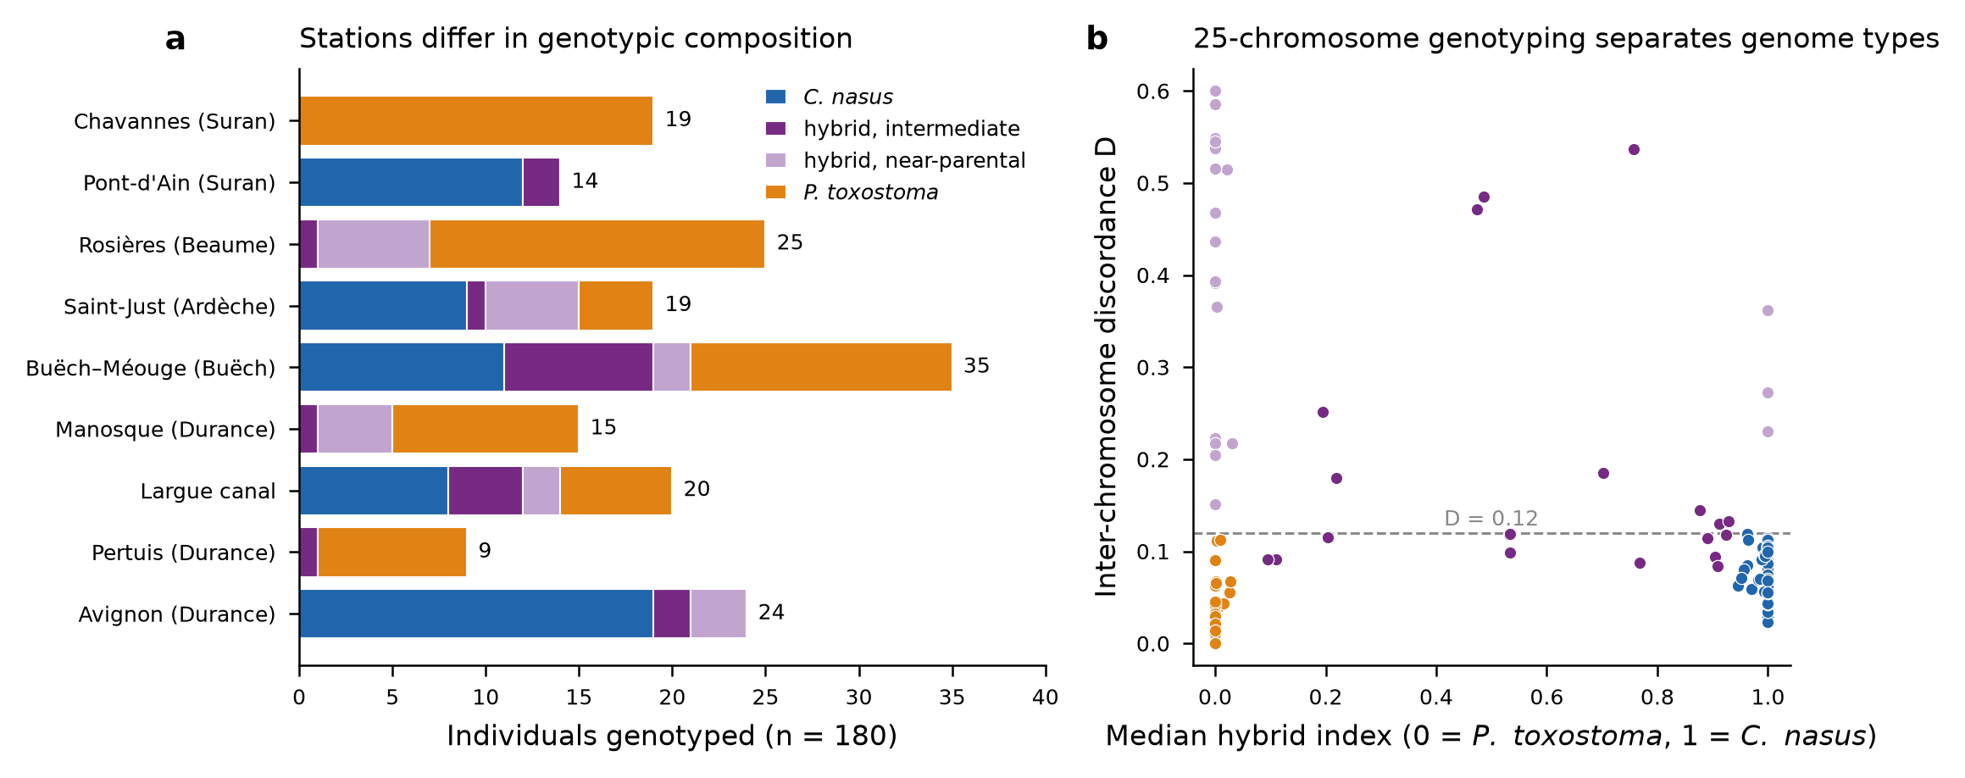
Figure 1. Genotypic composition of the nine stations and the two genome types of hybrids. a Individuals per station and genotypic category from 25-chromosome genotyping (n = 180), stations listed by river. Near-parental hybrids are introgressed on one to six of the 25 chromosomes. b Median hybrid index (0 = P. toxostoma, 1 = C. nasus) against the inter-chromosome discordance D for the 175 individuals genotyped from Q-scores on liver tissue; dashed line, D = 0.12. Categories were assigned from chromosome-level assignments, not by thresholding either axis; near-parental hybrids combine a parental median index with D ≥ 0.15.

Figure 2
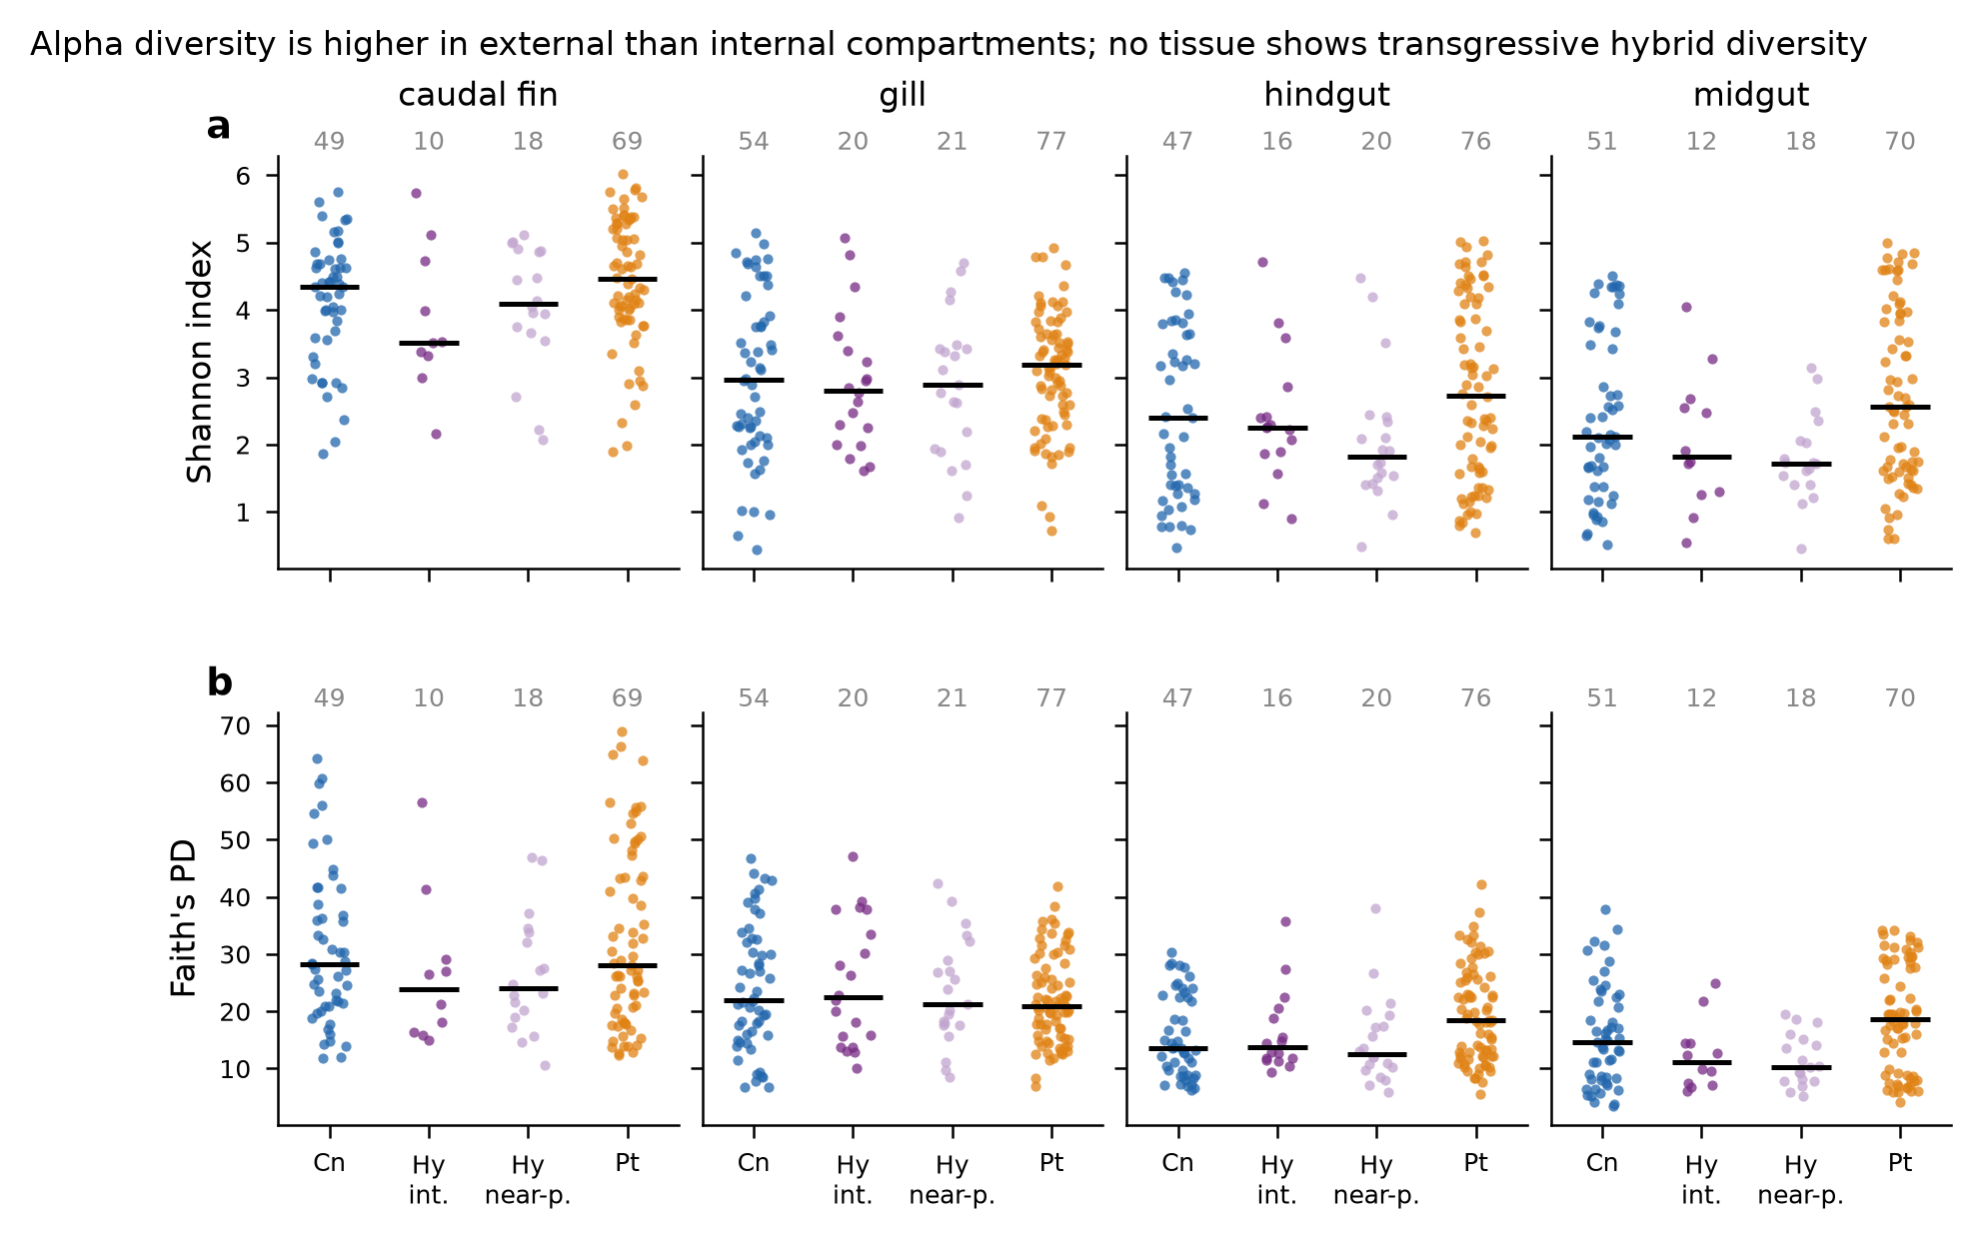
Figure 2. Alpha diversity by tissue and genotypic category. Shannon index (a) and Faith's phylogenetic diversity (b) per individual and tissue, as the mean over the three sequencing runs of values averaged over 400 rarefactions at 3,000 reads. Hybrids are shown separately as intermediate (Hy int.) and near-parental (Hy near-p.); pass 1 contrasts intermediate hybrids with the parental species and pass 2 pools both genome types. Numbers above each group: individuals; horizontal bars: medians. Tests are reported in the text; no combination of pass, tissue and index classified hybrids as transgressive.

Figure 3
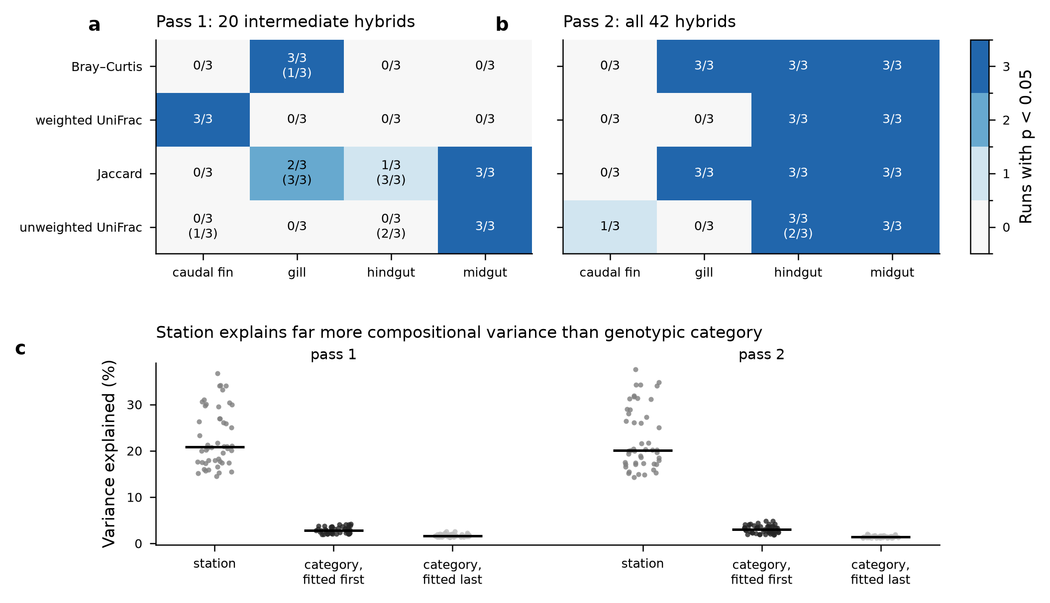
Figure 3. Detection of genotypic category in composition, and variance shares of station and category. a, b Number of sequencing runs (of three) in which genotypic category was significant (PERMANOVA, p < 0.05), per metric and tissue, in pass 1 (20 intermediate hybrids, 158 individuals) and pass 2 (all 42 hybrids, 180 individuals), in the principal model (category alone, permutations within station blocks, no plate position). In parentheses: the sensitivity model with plate position fitted first, where it differs. c Variance explained (R², %) in each of the 48 metric × tissue × run strata by station fitted first, and by category fitted first or last, in models without plate position; horizontal bars: medians.

Figure 4
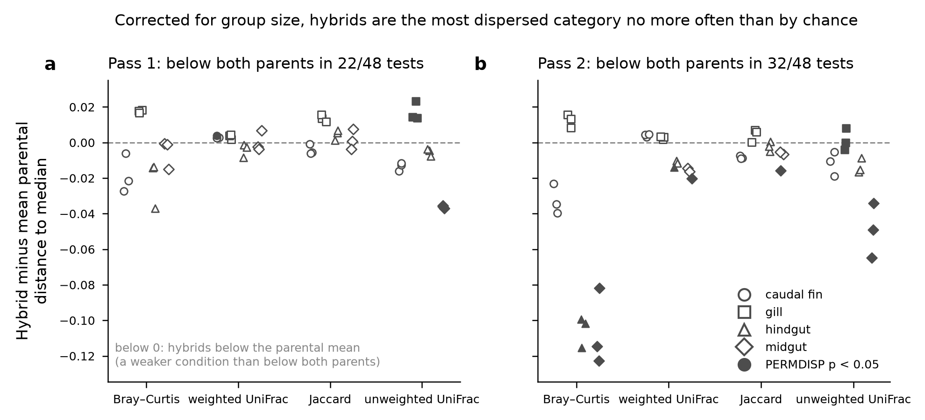
Figure 4. Dispersion of hybrids relative to the parental mean, corrected for group size. Difference between the median distance of hybrids to their group median and the mean of the two parental values, per metric, tissue (symbols) and sequencing run, with permutations constrained within station blocks and distances corrected for small-sample bias. Values below 0: hybrids less dispersed than the mean of the two parents; panel titles give the number of tests in which hybrids were less dispersed than both parents, a stricter condition. Filled symbols: PERMDISP test of category significant (p < 0.05). a Pass 1; b pass 2.

Figure 5
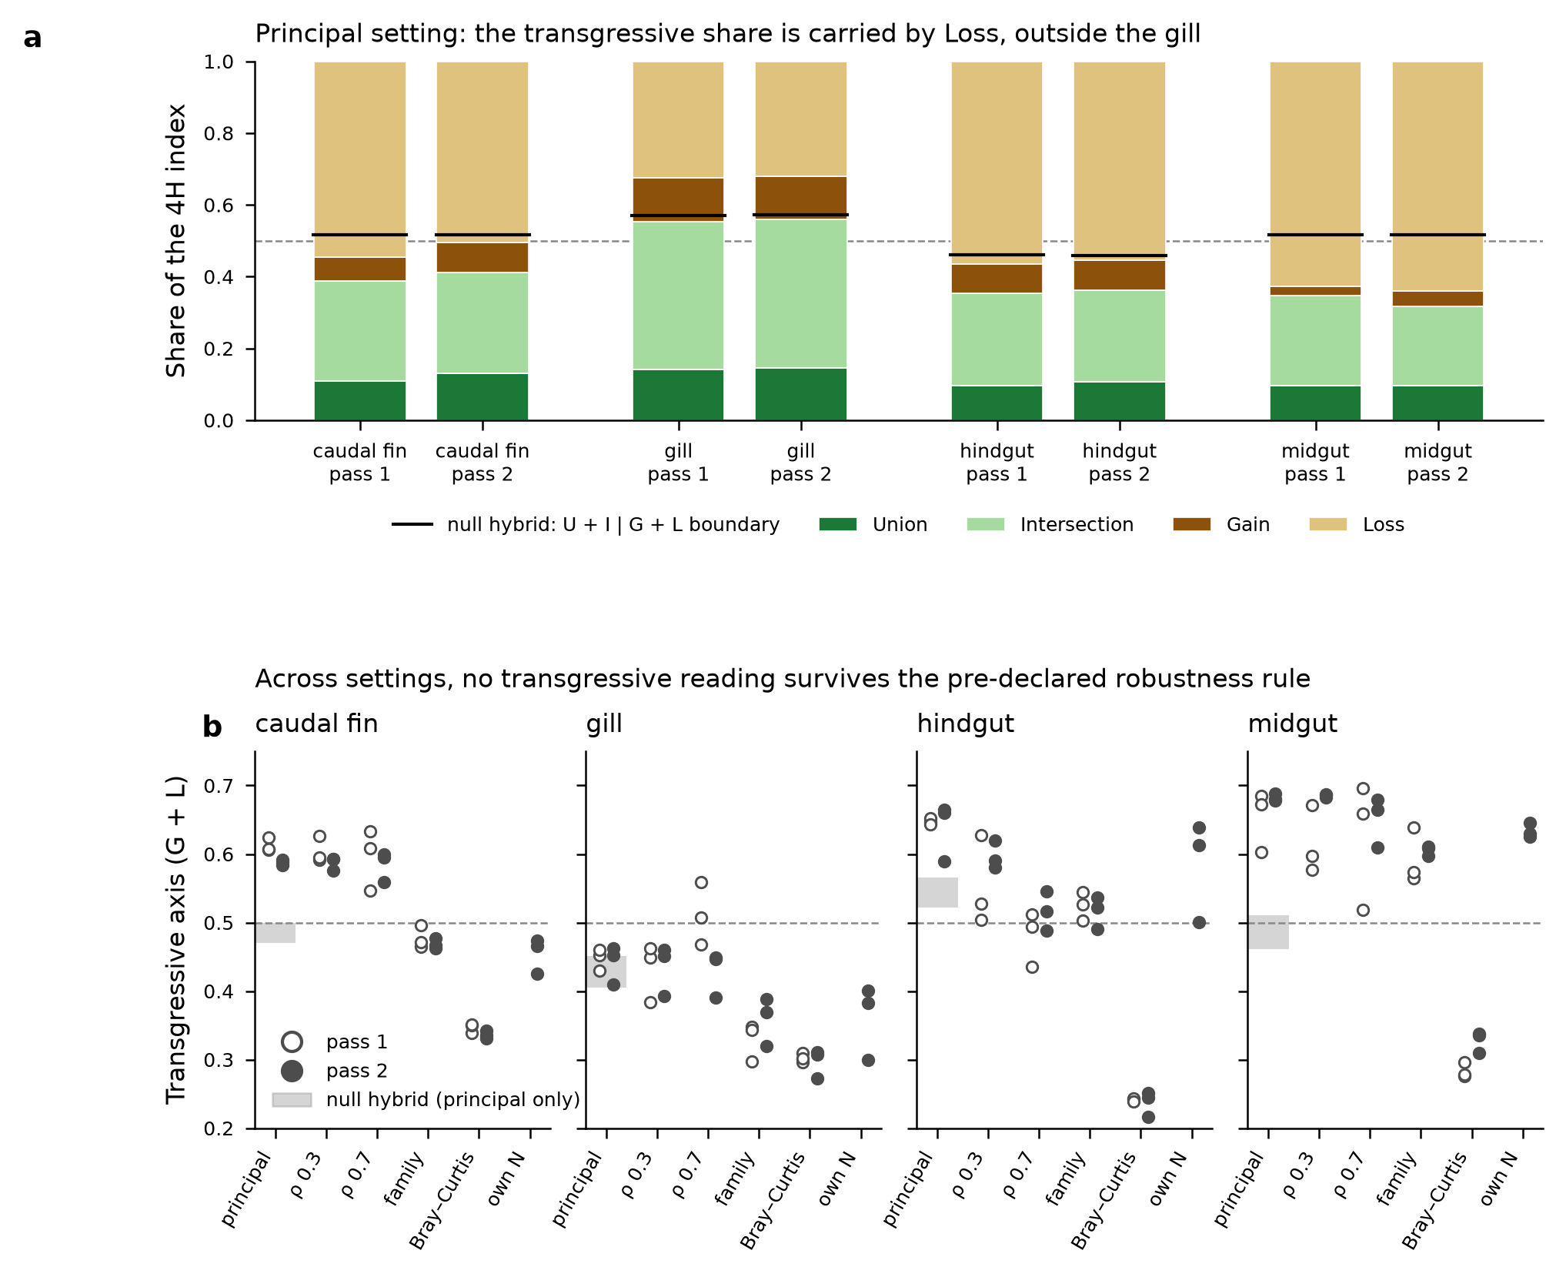
Figure 5. Four-dimensional (4H) index of hybrid microbiota and its sensitivity to settings. a Mean over the three runs of the four dimensions of the index — Union, Intersection, Gain and Loss — under the principal setting (incidence-based, genus rank, ρ = 0.5), per tissue and pass, at the common number of hosts per class (9–19); the parental axis is Union + Intersection and the transgressive axis Gain + Loss. Black bars: boundary between the two axes for the null hybrid (average of one randomly drawn individual of each parental species); dashed line, 0.5. b Transgressive axis per run under each setting: principal, ρ = 0.3, ρ = 0.7, family rank, abundance-based (Bray–Curtis) version, and pass 2 at its own number of hosts (26–40). Grey band: range of the null hybrid, computed under the principal setting only. Open symbols, pass 1; filled symbols, pass 2. 500 bootstraps per run, on the 1,749 samples with at least 1,000 genus-assigned reads.

