Computer Science Research Database

Release 2

Version 2.1

Revision History

|  |  |  |  |
| --- | --- | --- | --- |
| **Date** | **Version** | **Description** | **Author** |
| 1/25/2010 | 1.0 |  | Martin Brown |
| 2/3/2010 | 1.1 | Specification added for   * Conference search results * Viewing conference table of contents * Browse conference alphabetically   Added TOC Acronym in section 1.3  Updated References in 1.4 | Martin Brown |
| 2/3/2010 | 1.2 | Changed the way conference meetings are added to new conferences  Removed “Click here to find existing conferences” link when adding a conference meeting to a conference that has not yet been recorded  Removed some illustrative details in TOC. Specifically, removed the list of papers and authors from the corresponding figure. It is beyond the scope of this release. | Martin Brown |
| 2/4/2010 | 1.3 | Added ReCAPTCHA to forms for added security. | Martin Brown |
| 2/10/2010 | 1.4 | Specified what should happen when the user attempts to submit an existing conference – Figure 6  Moved the link to submit a new conference meeting for a specified conference from the TOC page to the View Conference page – Figures 9 and 10  Updated Figure 5 to show the name of the field that is required | Martin Brown |
| 2/22/2010 | 1.5 | Conference forms now require an email address in order to be submitted | Martin Brown |
|  | 1.6 | Results per page retrieved from the admin area  When browsing, the last letter clicked on has its link disabled  After searching, the search string now remains in the textbox | Martin Brown |
| 03/04/2010 | 1.7 | Publisher field is now an autocomplete field  Pages to add conferences and conference meetings now give more detailed instructions | Martin Brown |
| 03/05/2010 | 1.8 | Date format is removed from the date fields for Add Conference and Add Conference Meeting  Option to select date is removed from the date field in Add Conference and Add Conference Meeting  Changed how the conference search page should be handled. No results are shown until the user performs a search  Conference field is now autocomplete | Martin Brown |
| 03/05/2010 | 2.0 | Journals are a part of Release 2.0 | Martin Brown |
| 03/09/2010 | 2.1 | Updated details about the popup when adding a Conference or Conference Meeting | Martin Brown |

Table of Contents

1. Introduction 4

1.1 Purpose 4

1.2 Scope 4

1.3 Definitions, Acronyms, and Abbreviations 4

1.4 References 4

1.5 Overview 4

2. Overall Description 4

3. Specific Requirements 5

3.1 User Interfaces 5

3.1.1 Home Page 5

3.1.2 Conferences 6

3.1.3 Add a Conference 6

3.1.4 Add a Conference Meeting Confirmation Page 8

# Introduction

Computer Science Research Database is a system for managing computer science research papers in conferences and journals.

## Purpose

CSRD is being developed as part Florida A&M University’s Software Development and Maintenance Course at the computer science department for the spring of 2010. The purpose of CSRD is to facilitate the process of discovering academic computer science.

## Scope

## Definitions, Acronyms, and Abbreviations

* + SRS Software Requirements Specification
  + CSRD Computer Science Research Database
  + FAMU Florida Agricultural and Mechanical University
  + TOC Table of Contents

## References

* + Please see Dr. Prasad for more information.

## Overview

* + CSRD is a web application to be developed in PHP/MySQL. It is highly administrative, i.e. when users want to submit content to the website, the content must first be approved by the administrator. The main page will allow the user to browse conferences, journals, and authors. Conferences can be browsed by year. Journals can be browsed by volume.
  + Users will also be able to search for conferences, journals, authors and papers by entering keywords in the search field.
  + Finally, users may request to have papers submitted or to have conferences or journals added by filling out forms. Each submission is subject to review by the administrator.

# Overall Description

* Product perspective
  + CSRD should make it easy to collect information concerning computer science conferences, journals, authors, and papers.
* Product functions
  + The password field of the administrator should be secure
  + The administrator must be able to view several reports of CSRD
  + The administrator must be able to create, update, and delete records of conferences, journals, papers, and authors
  + Users must be able to request to add conferences, journals, papers, and authors
  + Users must be able to search conferences, journals, papers, and authors
* User characteristics
  + The administrator can login through the back-end of the system.
  + Front-end users do not login, but rather make their requests known by filling out forms on the front-end.
* Assumptions and dependencies
  + CSRD is only concerned with computer science research
  + CSRD is hosted locally on the developers’ personal computers
  + CSRD should function properly on modern web browsers

# Specific Requirements - Conferences

## User Interfaces

Each page will contain the title of the website (Computer Science Research Database) as well as the main menu, as seen in Figure 1. Clicking on the title of the website should always lead back to the home page. Each page will have a subtitle, such as the subtitle “Conferences” as seen in Figure 2. Fields with an asterisk (*) at the end of their respective labels are required fields and the form should not be accepted if the fields have not been entered (Figure 5).

### Home Page

The home page will contain the title of the website and links to conferences, journals, and authors as in Figure 1. For release 1, only the title and the Conferences links are active links. Clicking on the Conferences link will take the user to the Conferences page. Moreover, the title of the website is displayed on every page, and it should link back to the home page.



Figure - Home Page

### Conferences

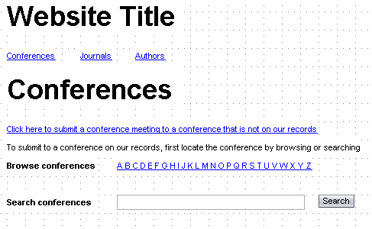

Figure - Conferences page

* No results are displayed in this page until the user browses or performs a search
* The conferences page will contain a link “Click here to submit a conference meeting to a conference that is not on our records” that links to the Add a Conference page.
* The users will be able to browse conferences alphabetically, by the conference acronym. So clicking on the letter A would match all conferences whose acronym begins with the letter A. Only conferences that have been approved should be displayed
* Whichever letter the user clicks on to browse, the link for that letter should be disabled so that the user can see which letter was last clicked on
* It will have a form that allows the user to search for conferences that have been approved by the administrator. The results of the search string should match any part of the conference name or the conference acronym
  + If there are no results to be displayed, then a message will appear notifying the user that “No results match your search”

### Add a New Conference

The Add a New Conference page contains a form which has several fields (Figure 3a)

* Conference – a text field allowing the user to enter the name of the conference. If the user enters the name of a conference that already exists, then the error message should be displayed, along with a link to the existing conference.
  + Moreover, the conference field should be autocomplete in order to assist the user in making sure that the conference doesn’t already exist.
  + If the user selects a conference from the autocomplete list, then a message should appear notifying the user that the conference already exists, as in Figure 3b
  + In the message, the word “here” should link to the Conference Meetings page (section 3.1.6)
  + If the user chooses to continue, then when the cursor loses focus on the Conference field, redirect the user to the Submit Conference Meeting page with the Conference already selected, as in Figure 3c. The message should still appear for clarity.
* Conference Acronym – The acronym or abbreviation for the conference, e.g. ACMSE
* Conference Meeting – a text field for the user to enter the title of the conference, i.e. ACM Southeast Conference 2009, 4th International conference on Software Engineering
* City – a text field for the user to enter the city where the conference took place
* Country – a drop down list containing a list of countries in the world
* State – a dynamic field
  + the field contains text letting the user know that the country field needs to be populated before a state can be selected, as in Figure 3a

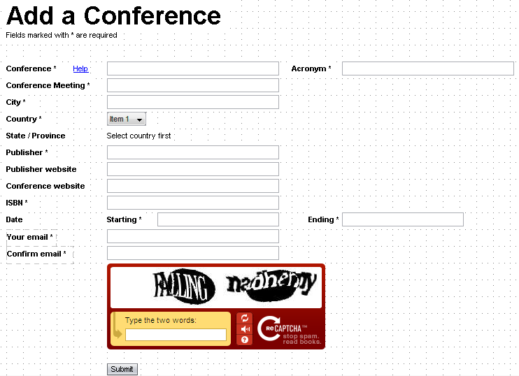

Figure a - Adding a Conference meeting



Figure 3b - Adding a Conference meeting

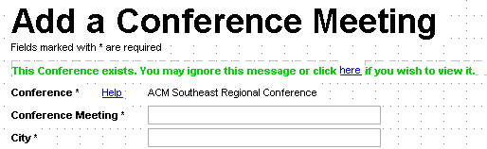

Figure c - Adding a Conference meeting

* + the field turns into a drop down list when the country field has been populated, as in Figure 4
* Publisher – a text field where the user can enter the name of the publisher
  + The publisher field should be autocomplete because the list can get really long.
* Publisher website – an optional link to the publisher’s web site
* Conference website – an optional link to the official web page for the conference meeting
* ISBN – a text field where the user can enter the International Standard Book Number
* Date – a date field that lets the user select the start- and end-date of the conference
* You email – email address of the person who is submitting the form,
* Confirm email – this email address must match the one in Your email in order for the form to be submitted
* reCAPTCHA – helps prevent automated abuse of the site
* The user submits the form by clicking on the Submit button or pressing the ENTER key in any of the text fields

The Help link next to the Conference label should create a popup as the one in Figure 3d, explaining the user what needs to be entered in Conference and Conference Meeting fields. The user should be able to close the popup by clicking on

Other details include:

* The date and time created should be recorded in both the conference and the conference_meeting table.
* The email address of the user should be recorded in both tables
* The conference and conference meeting should be set to unapproved

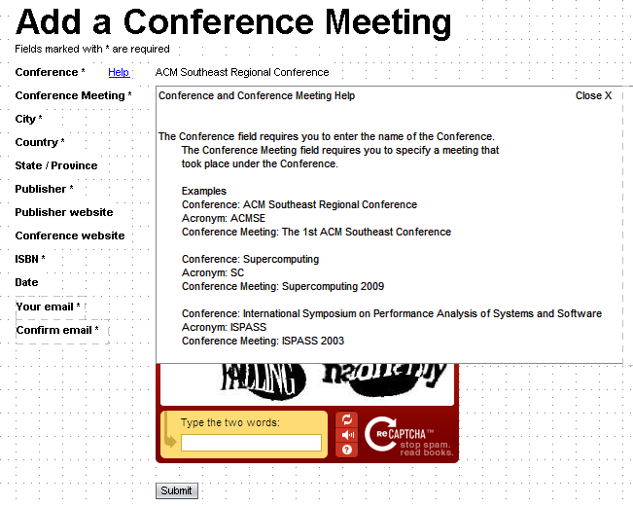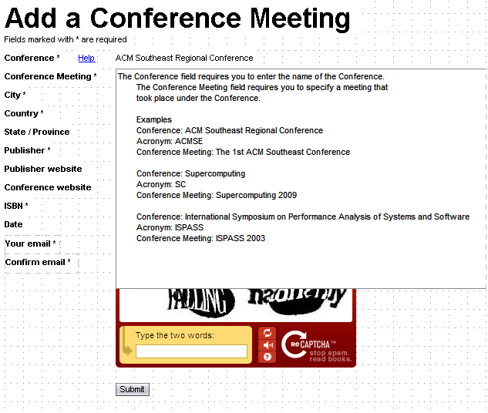

Figure 3d - Populating the country field activates the state field

Moreover, the section to add conference meeting details should also have a title, so that the user knows that they are entering details not a part of the conference itself.



Figure - Populating the country field activates the state field

If required fields are not entered (or if there is some other type of error specific to a field), then the user should get an error message as the one in Figure 5, above the form.

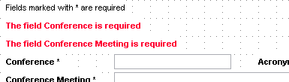

Figure - Error message if there are errors submitting the form

If the user enters the name of a conference that already exists, an error message should appear containing a link to the specific conference which the user is attempting to submit.



Figure - Attempting to add an existing conference

### Add a Conference Meeting Confirmation Page

After successfully submitting a conference meeting for review, the user will be directed to a confirmation page letting him or her know that the conference meeting is under review. See Figure 7. This page will contain a link that will take the user back to the home page.



Figure - Conference Meeting Confirmation Page

### Searching Conferences

When the user searches for matching conferences that have been approved, the results should be listed as in Figure

8a

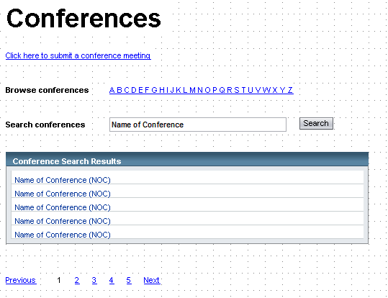

Figure a - Conference Search Results

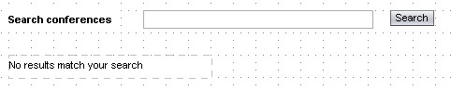

Figure b - Conference Search Results

* The search results contain only the name of the conference, not the conference meetings.
  + If there are no results, instead of the table containing search results, it should just say “No results found” as in Figure 8b
* Whatever the user searches for, the search field should be repopulated with that search string after the search form has been submitted
* The number of results shown per page should be retrieved from the administrator’s settings.
* Page navigation should be below the table, allowing the user to go to the Previous page, Next page, or click on a page number.
* If the user is currently on page n, then page n should not link to anything, as with page 1 in Figure 9.
* Moreover, if the user is currently on the very first page, then there should be no Previous link.
* Likewise, there should be no Next link if the user is on the last page of the search results.
* Clicking on the name of any of the conferences should take the user to the Conference Meetings page, described in the next section.

### Conference Meetings

The Conference Meetings page shows all conference meetings that took place under the name of a single conference. The conference meetings should be displayed as in Figure 9.

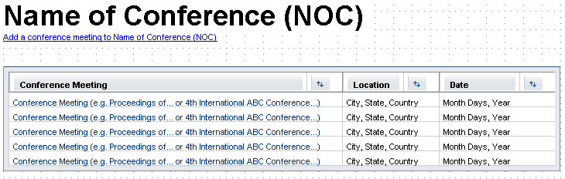

Figure - Conference meetings for a specified conference

* In the list of conference meetings, the location and date of the conference is also displayed.
* All conference meetings are linked. Clicking on one of the links takes the user to the Table of Contents (TOC) page for the selected conference meeting. TOC is described in the next section.
* Additionally, the user can request to have a conference meeting added to the conference that is currently being viewed by clicking on the “Add conference meeting to Name of Conference (NOC)” link, where Name of Conference (NOC) is replaced by the actual name of the conference.
* This takes the user to the Add a Conference Meeting page, which is described in the next section.

### Table of Contents

The TOC page contains the name of the conference, the name of the conference meeting, titles of papers presented at the conference and their attributes. Please see figure 10 for details.



Figure - Table of contents for a conference meeting

* Behind the title of the conference meeting comes the city, state, and country where it took place. It also has the date, i.e. Month, range of days, and year it took place. Finally, it shows the name of the publisher and the year of publication.
* The table of contents page will contain a list of papers that belong to the selected conference. Specification on papers and authors are beyond the scope of this release.

### Add a Conference Meeting

* The Add a Conference Meeting page is similar to the Add a Conference Page. The difference is that the conference already exists in the system, so the Conference field is replaced with static text, which is the name of the conference the user was viewing (name of the conference from the previous section, 3.1.7). See figure 11 for more details. The rest of the page will function in the same way as the Add a Conference page. Please refer to section 3.1.3.

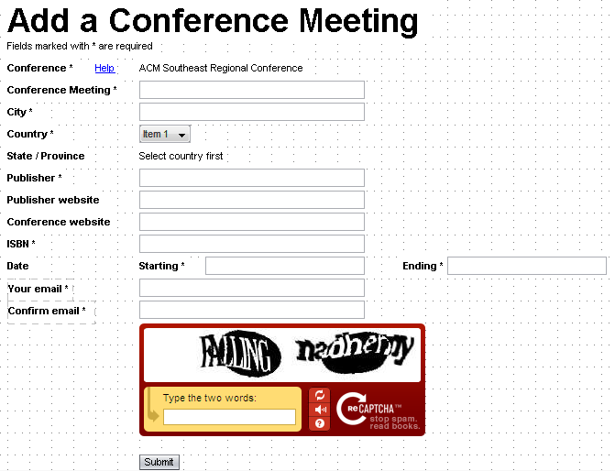

Figure - Add a conference meeting to an existing conference

# Specific Requirements - Journal

### Search Journals

Searching Journals is similar to searching Conferences, except that there is no Browse feature. Each result should link to the page detailed in section 4.1.2.

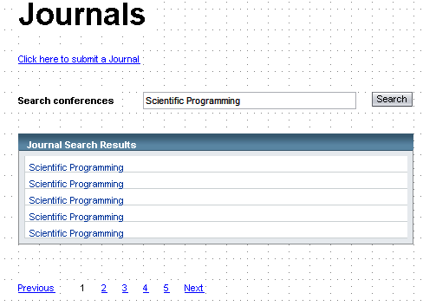

Figure - Searching for Journals

### Journal Volumes

The Journal Volumes page will contain a link for the user to add papers to the Journal. The link is currently not active.

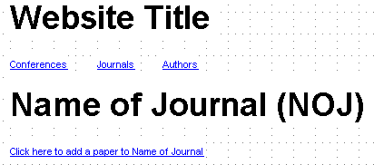

### Add a Journal

The Add a Journal page has several fields, as seen in Figure 15. Unapproved Journals should not appear in the search.

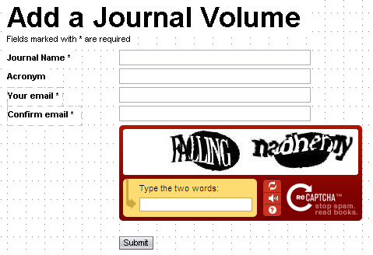

Figure - Adding a Journal

* Journal Name – This field is required.
  + The field is unique. The user may not enter the name of a Journal that already exists
* Acronym – This field is NOT required
* Your email – This field is required
* Confirm email – This field is required

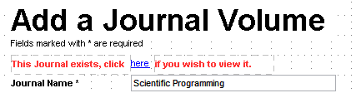

Figure - A Journal that already exists

Other details about this page:

* If the form is submitted without errors, then all fields should be saved to the Journal table.
* Moreover, the date and time of submission should be recorded to the journal table.
* The status should be set to unapproved (0) until the administrator approves it.

After the form has been submitted successfully, the user should be taken to a confirmation page, as in Figure 17



Figure - Add Journal Confirmation

ERD Diagram

