What is BugTracker.NET?
BugTracker.NET is simply a bug tracking system written using ASP.NET, C#, and Microsoft SQL Server. A bug tracking system is a software application that is designed to help quality assurance and programmers keep track of reported software bugs in their work. It may be regarded as a sort of issue tracking system.

Why Do We Use a Bug Tracker?
We use a bug tracker for various reasons. It provides a convenient way for us to see what bugs, tasks, enhancements, or questions currently need to be resolved for an application. It also allows us to track who reported a bug, who a bug has been reported to or how long a bug has been reported. We can also view the history of bugs that have been in the system, allowing us to compare bugs reported last month to bugs reported this month for example.

What Does a Bug Report Consist of?
The following table contains the different characteristics of a bug report
Description | A brief but explanatory title for the bug you are about to report
Project | Bugs can be reported for different projects, but in our case there’s only one project which is Alumni System
Organization | Similarly, bugs can be reported for different organizations, but there’s only one in our case, TeamGO
Category | Although it’s called a bug tracker, we also track tasks, questions, and enhancements  - Bugs are issues where the software fails to run according to the specification  - Tasks are reported when your supervisor has an additional assignment for you that may not have been in the original specification  - Questions are reported when the one reporting the bug is uncertain about a feature  - Enhancements are reported when the software runs according to the specification, but an improvement still needs to be made
Priority | There are three priority levels: high, medium, and low  - high - A bug should be reported as high when it causes complete failure of the system (i.e., an error shows up on the page)  - medium - Report a bug as medium when the system fails to run or produce output according to the specification, but doesn’t crash  - low - A bug with low priority is reported in cases when there is a problem with the layout of the page, when some text is misspelled, if a link leads to an incorrect page, or similar cases  All cases are not covered here but we expect you to use your best judgment when assigning priority to a bug
Assigned to | If you know who caused the bug, assign it to that person. If you find a bug, then assign the bug to yourself so that we have it on record. If you don’t know who caused the bug, then the quickest solution may be to ask. In cases where you can’t immediately decide who to assign a bug to, assign it to the project manager.
Status | There are five different bug statuses  - new - Report a bug as new when it is a new bug  - in progress - Change the status of a bug to in progress if you are currently working on resolving the issue  - re-opened - A bug’s status should be set to re-opened only when it previously had a status as closed or duplicate and the issue has not been resolved, or is not actually a duplicate  - closed - The closed status means that the issue has been resolved and that the error no longer exists  - duplicate - Report a bug as a duplicate if it describes the same issue as another bug
Comment | For new bugs, the comment should never be left blank. Provide as much detail as possible in this section so that the programmer can reproduce the bug

How to Report a Bug
First, make sure you are logged in to BugTracker.NET. Direct your browser to http://168.223.21.8/bugtracker/ and login using the username and password assigned to you. Please bookmark the page.
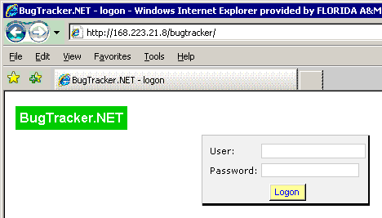
After logging in click on “add new bug” to add a new bug
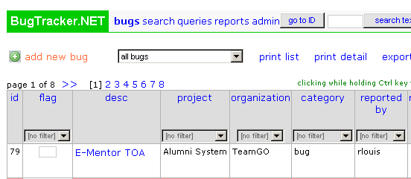
Now you can start entering detailed information about the bug.

Description
If you know the name of the page that the error occurs on, specify the name of the page first, followed by a colon. Then describe the reason that you are reporting a bug.

Example Description
StakeHolder.aspx: There is no button or link that would allow the user to continue requesting access after selecting their relationship with CIS

Project, Organization, Category, Priority, Assigned to, and Status
These fields should be filled out using the guidelines described in Table 1

Comment
It is imperative that comments be entered for new bugs. No matter how simple you may think it is to reproduce the bug, sometimes it can be difficult for the person reading your bug report to understand your train of thought. It is your duty to guide the programmer or anyone else reading the bug to be able to reproduce the issue. When adding a comment, use the following guidelines
- Let the programmer know exactly how you came across the bug by listing the steps he or she needs to take in order to reproduce the bug
- Give as much additional details as possible
- Tell them what button you pressed, and what order you pressed them in
- Give the programmer all the input you can think of so that they won’t have to ask you questions
- State what you saw, and if possible what you expected to see
- Give them the error message that you received
- Say what you mean and make sure it can’t be misinterpreted

Example Comment
To reproduce the error
- Click on the Request Access link on the home page
- Under the “What is your relationship to CIS” field, select “Current Student”
- Now try to continue with requesting access to the system. There is no button or link that would allow the user to go forward from here

How NOT to report a Bug
Maybe the best way to learn how to report a bug is by seeing examples of bad or non-descriptive bug reports. Take a look at the following descriptions and comments of bugs and ask yourself how the bug report can be improved.
Description: Search
Comment: The search is not working properly
The first thing that the programmer will see is the Description being Search. With such a non-descriptive bug title, the programmer will then click on the bug to view the bug details, expecting to see a more explanatory description in the comment. The programmer would ask, “What search? Basic search or advanced search?”
Description: Basic Search is not working properly
Comment: I tried searching for somebody but it gives an error
The problem with this description is that the programmer doesn’t know what your idea of “not working properly” is. Moreover, the programmer may receive a different error message than the one that you did if there are multiple errors on this page. The programmer may ask “What error did you get exactly?”
Description: Basic Search gives a Runtime Error when I try to search for someone
Comment: The error says that an application error occurred on the server
“The search works fine for me”, says the programmer. That may be because searching for Shaquille O’neal may give an error, but searching for John Doe would not. Give the programmer as much input as possible by letting them know who exactly you searched for.
Description: Basic Search gives a Runtime Error when I try to search for Shaquille O’neal
Comment: The error says that an application error occurred on the server
“The search still works fine for me”, says the programmer. Provide the exact details on how you performed the search. Searching by clicking the Submit button may work fine when searching by pressing ENTER on the keyboard may not.
Description: Basic Search gives a Runtime Error when I try to search for Shaquille O’neal
Comment: To reproduce the error
- Search for “Shaquille O’neal”
- Click on the Submit button
- You should then see a runtime error on the following page
“The search still works fine for me”, screams the programmer. It may be possible that, if the search feature is accessible from multiple pages, the search may work perfectly on one page, but give an error on another. Specify the page you were on before you saw the error.
Description: Search.aspx: Basic Search gives a Runtime Error when I search for Shaquille O’neal
Comment: To reproduce the error
- Go to the search page by clicking on the Search link on the home page
- In the search field, enter “Shaquille O’neal”
- Click on the Submit button

I don’t get this error when I search for John Doe, Rick James, or Dave Chappelle.
This is a much better bug report. From the description, the programmer can immediately see what page the error occurs on. By following the step-by-step instructions to reproduce the bug, it would be difficult for the programmer to be misled. He or she may then find that this error occurs only when a single quote is used in the search.

When reporting a bug
- DON’T include more than one bug in the same bug report. If you find multiple bugs at the same time or on the same page, create a separate bug report for each bug you find
- DON’T just tell the programmer that something needs to be fixed. Let them know what needs to be fixed and why

Screen Capture Utility
Using the BugTracker.NET Screen Capture tool, you can report your bugs and give a visual of what the page containing the bug looks like. You first need to download and run the tool. To download, login to the bug tracker and go to the bugs page. On the right side of the page, you should see the link to the screen capture tool. Click on the link and then follow the steps to download the tool.
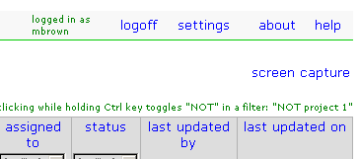
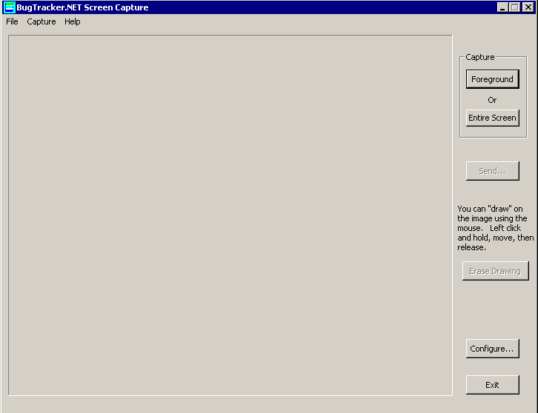
Run the tool and you should see a new window that looks like the image above. Click on the Configure button.

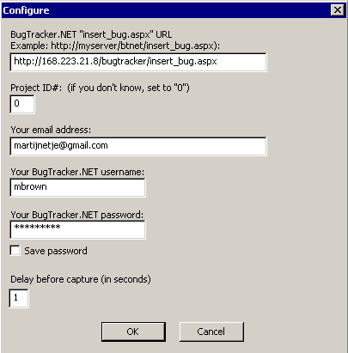
Use the figure above as a guide to complete the configuration. You should only have to do this once. Click OK.
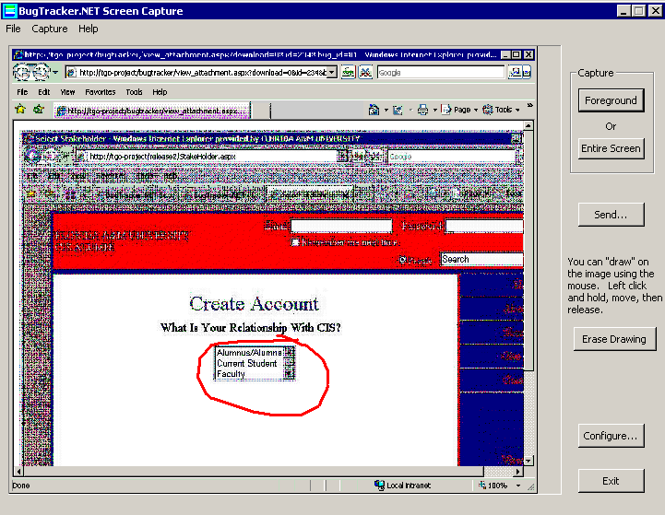
To capture the screen, use the Foreground button to capture the contents of the window in the foreground, or use the Entire Screen button to capture a screenshot of the whole screen. The result should be similar to the image above. After taking a screenshot, you can use your mouse to highlight areas on the screen that you think need to be brought to the developer’s attention. An example of this can also be seen in the screenshot above.
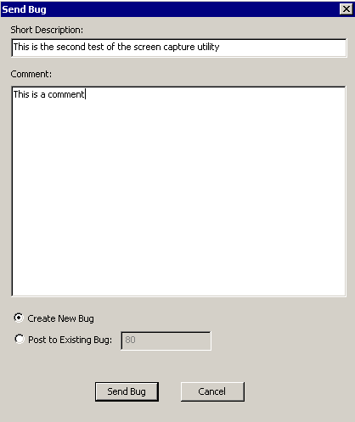
To send a screenshot, click on the Send button. A window pops up asking you to enter the Description and Comment as in the figure below. These fields are the same as the ones you see when creating a bug in your browser, so the same rules apply here as well. If you are creating a new bug, click on the Send Bug button. If you wish to add the screenshot to an existing bug, first find out the bug ID, click on Post to Existing Bug radio button, and then enter the Bug ID. Finally, click the Send Bug button to send the screenshot.
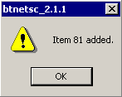
You should get a confirmation message letting you know that the bug has been added successfully. If you get a 404 error, please go through the Configuration steps again to make sure that you have entered the correct information.
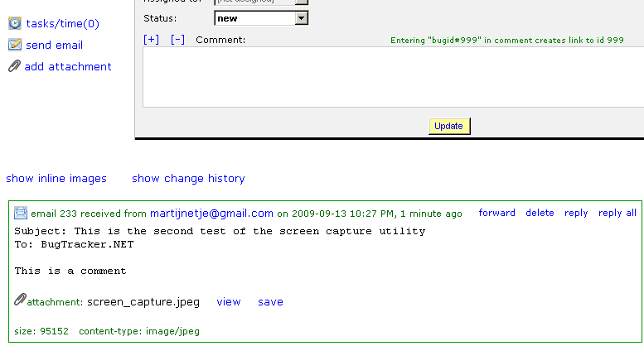
You should now see the bug in BugTracker.NET. Click on the bug to complete the bug report, certain fields still need to be specified that could not be specified using the screen capture utility, such as the priority and who the bug should be assigned to. You can view what the screenshot looks like by clicking on the view link next to the attachment in the bug comment.

Practice
Let’s practice using BugTracker.NET. In your browser, navigate to http://168.223.21.8/bugtracker/ and login to the bug tracker and then try to do the following
- Find all bugs that are assigned to wdavis
- Find all bugs that have been reported by mbrown and assigned to wdavis
- Find all bugs that have been reported by gwalls
- Find all bugs that have a high priority, assigned to wdavis, and reported by mbrown
- Find all bugs that have been reopened
- Go to the bug with bug ID 13
- Search for bugs where the bug description contains the word “email”
- Search for bugs reported between July 15 and July 29, 2009

