Computer Science Research Database
Release 1

Version 1.2

Revision History
Date | Version | Description | Author
1/25/2010 | 1.0 |  | Martin Brown
2/3/2010 | 1.1 | Specification added for  - Conference search results  - Viewing conference table of contents  - Browse conference alphabetically  Added TOC Acronym in section 1.3  Updated References in 1.4 | Martin Brown
2/3/2010 | 1.2 | Changed the way conference meetings are added to new conferences  Removed “Click here to find existing conferences” link when adding a conference meeting to a conference that has not yet been recorded  Removed some illustrative details in TOC. Specifically, removed the list of papers and authors from the corresponding figure. It is beyond the scope of this release. | Martin Brown

Table of Contents
1. Introduction 4
1.1 Purpose 4
1.2 Scope 4
1.3 Definitions, Acronyms, and Abbreviations 4
1.4 References 4
1.5 Overview 4
2. Overall Description 4
3. Specific Requirements 5
3.1 User Interfaces 5
3.1.1 Home Page 5
3.1.2 Conferences 6
3.1.3 Add a Conference 6
3.1.4 Add a Conference Meeting Confirmation Page 8

Introduction

Computer Science Research Database is a system for managing computer science research papers in conferences and journals.

Purpose

CSRD is being developed as part Florida A&M University’s Software Development and Maintenance Course at the computer science department for the spring of 2010. The purpose of CSRD is to facilitate the process of discovering academic computer science.

Scope

Definitions, Acronyms, and Abbreviations
  - SRS Software Requirements Specification
  - CSRD Computer Science Research Database
  - FAMU Florida Agricultural and Mechanical University
  - TOC Table of Contents

References
  - Please see Dr. Prasad for more information.

Overview
  - CSRD is a web application to be developed in PHP/MySQL. It is highly administrative, i.e. when users want to submit content to the website, the content must first be approved by the administrator. The main page will allow the user to browse conferences, journals, and authors. Conferences can be browsed by year. Journals can be browsed by volume.
  - Users will also be able to search for conferences, journals, authors and papers by entering keywords in the search field.
  - Finally, users may request to have papers submitted or to have conferences or journals added by filling out forms. Each submission is subject to review by the administrator.

Overall Description
- Product perspective
  - CSRD should make it easy to collect information concerning computer science conferences, journals, authors, and papers.

- Product functions
  - The password field of the administrator should be secure
  - The administrator must be able to view several reports of CSRD
  - The administrator must be able to create, update, and delete records of conferences, journals, papers, and authors
  - Users must be able to request to add conferences, journals, papers, and authors
  - Users must be able to search conferences, journals, papers, and authors

- User characteristics
  - The administrator can login through the back-end of the system.
  - Front-end users do not login, but rather make their requests known by filling out forms on the front-end.

- Assumptions and dependencies
  - CSRD is only concerned with computer science research
  - CSRD is hosted locally on the developers’ personal computers
  - CSRD should function properly on modern web browsers

Specific Requirements

User Interfaces
Each page will contain the title of the website (Computer Science Research Database) as well as the main menu, as seen in Figure 1. Clicking on the title of the website should always lead back to the home page. Each page will have a subtitle, such as the subtitle “Conferences” as seen in Figure 2. Fields with an asterisk (*) at the end of their respective labels are required fields and the form should not be accepted if the fields have not been entered (Figure 5).

Home Page
The home page will contain the title of the website and links to conferences, journals, and authors as in Figure 1. For release 1, only the title and the Conferences links are active links. Clicking on the Conferences link will take the user to the Conferences page.


Figure 1 - Home Page

Conferences
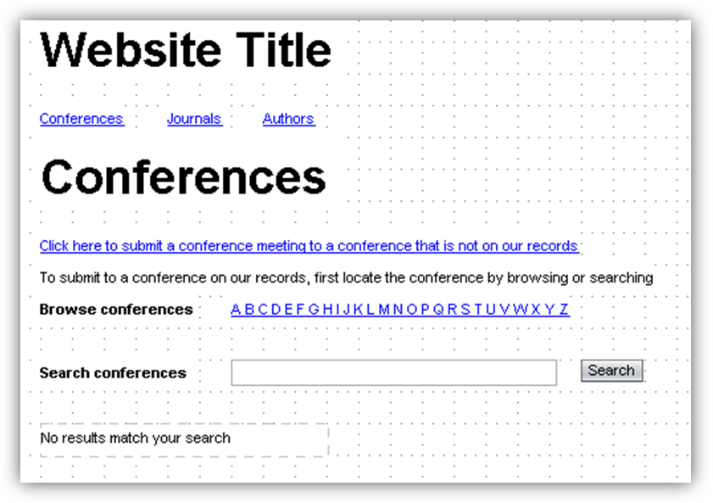
Figure 2 - Conferences page
- The conferences page will contain a link “Click here to submit a conference meeting to a conference that is not on our records” that links to the Add a Conference page.
- The users will be able to browse conferences alphabetically
- It will have a form that allows the user to search for conferences that have been approved by the administrator.
  - If there are no results to be displayed, then a message will appear notifying the user that “No results match your search”

Add a New Conference
The Add a New Conference page contains a form which has several fields (Figure 3)
- Conference – a text field allowing the user to enter the name of the conference
- Conference Acronym – The acronym or abbreviation for the conference, e.g. ACMSE
- Conference Meeting – a text field for the user to enter the title of the conference, i.e. ACM Southeast Conference 2009, 4th International conference on Software Engineering
- City – a text field for the user to enter the city where the conference took place
- Country – a drop down list containing a list of countries in the world
- State – a dynamic field
  - the field contains text letting the user know that the country field needs to be populated before a state can be selected, as in Figure 3
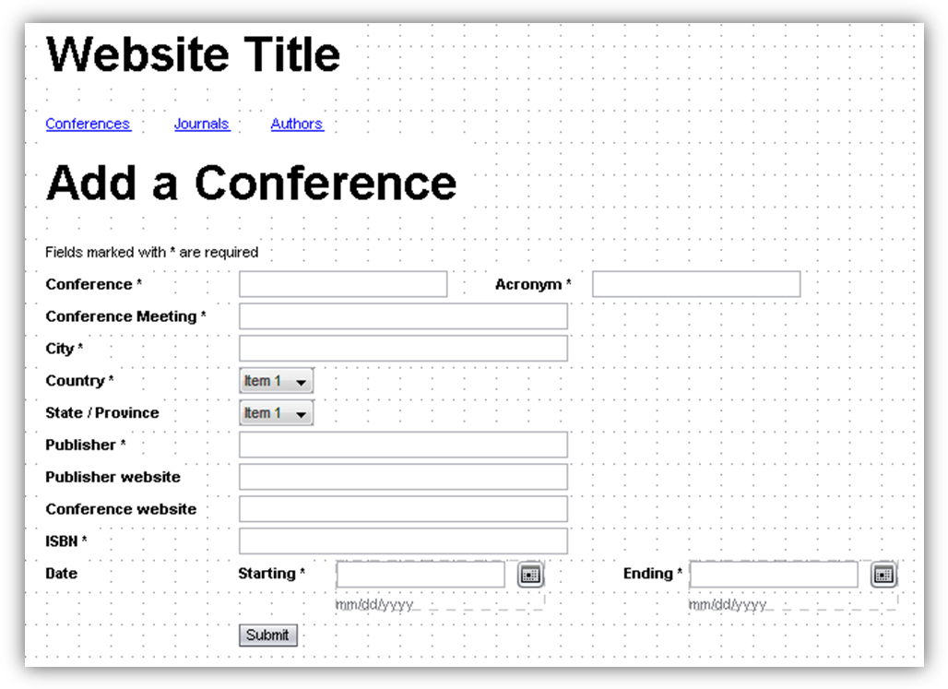
Figure 3 - Adding a Conference meeting
  - the field turns into a drop down list when the country field has been populated, as in Figure 4
- Publisher – a text field where the user can enter the name of the publisher
- Publisher website – an optional link to the publisher’s web site
- Conference website – an optional link to the official web page for the conference meeting
- ISBN – a text field where the user can enter the International Standard Book Number
- Date – a date field that lets the user select the start- and end-date of the conference
- The user submits the form by clicking on the Submit button or pressing the ENTER key in any of the text fields


Figure 4 - Populating the country field activates the state field
If required fields are not entered (or if there is some other type of error specific to a field), then the user should get an error message as the one in Figure 5, above the form.
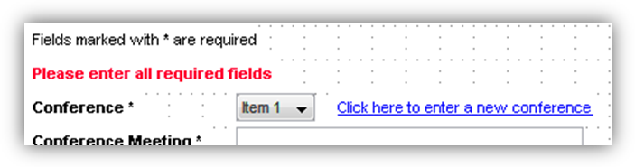
Figure 5 - Error message if there are errors submitting the form

Add a Conference Meeting Confirmation Page
After successfully submitting a conference meeting for review, the user will be directed to a confirmation page letting him or her know that the conference meeting is under review. See Figure 6. This page will contain a link that will take the user back to the home page.

Figure 6 - Conference Meeting Confirmation Page

Searching Conferences
When the user searches for matching conferences that have been approved, the results should be listed as in Figure 7
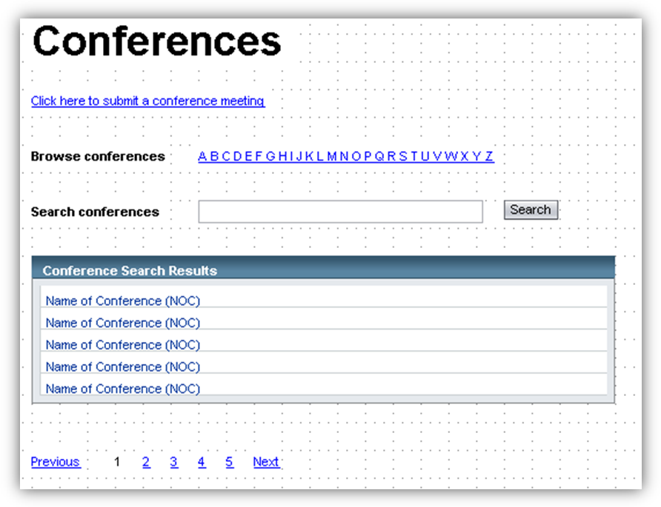
Figure 7 - Conference Search Results
The search results contain only the name of the conference, not the conference meetings. Search results are set at 25 results per page. Page navigation should be below the table, allowing the user to go to the Previous page, Next page, or click on a page number. If the user is currently on page n, then page n should not link to anything, as with page 1 in Figure 8. Moreover, if the user is currently on the very first page, then there should be no Previous link. Likewise, there should be no Next link if the user is on the last page of the search results. Clicking on the name of any of the conferences should take the user to the Conference Meetings page, described in the next section.

Conference Meetings
The Conference Meetings page shows all conference meetings that took place under the name of a single conference. The conference meetings should be displayed as in Figure 8.
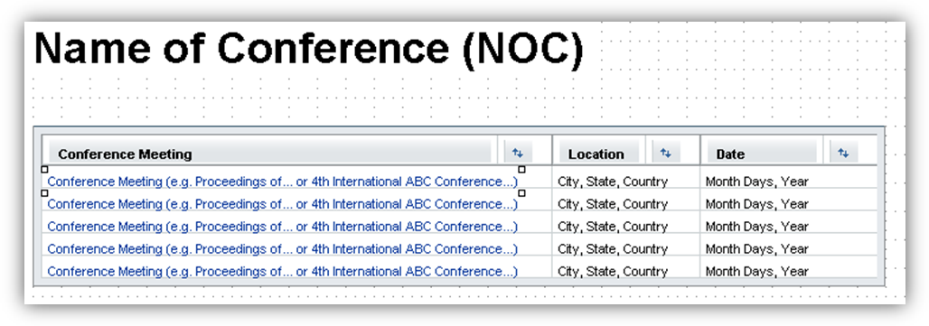
Figure 8 - Conference meetings for a specified conference
In the list of conference meetings, the location and date of the conference is also displayed. All conference meetings are linked. Clicking on one of the links takes the user to the Table of Contents (TOC) page for the selected conference meeting. TOC is described in the next section.

Table of Contents
The TOC page contains the name of the conference, the name of the conference meeting, titles of papers presented at the conference and their attributes. Please see figure 9 for details.

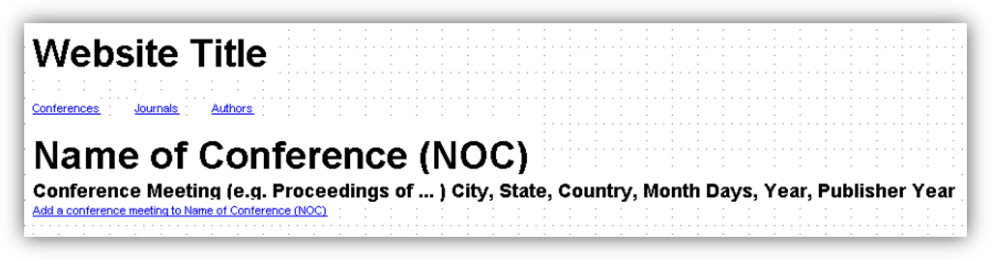
Figure 9 - Table of contents for a conference meeting
Behind the title of the conference meeting comes the city, state, and country where it took place. It also has the date, i.e. Month, range of days, and year it took place. Finally, it shows the name of the publisher and the year of publication.
Additionally, the user can request to have a conference meeting added to the conference that is currently being viewed by clicking on the “Add conference meeting to Name of Conference (NOC)” link, where Name of Conference (NOC) is replaced by the actual name of the conference. This takes the user to the Add a Conference Meeting page, which is described in the next section.
The table of contents page will contain a list of papers that belong to the selected conference. Specification on papers and authors are beyond the scope of this release.

Add a Conference Meeting
The Add a Conference Meeting page is similar to the Add a Conference Page. The difference is that the conference already exists in the system, so the Conference field is replaced with static text, which is the name of the conference the user was viewing (name of the conference from the previous section, 3.1.7). See figure 10 for more details. The rest of the page will function in the same way as the Add a Conference page. Please refer to section 3.1.3.
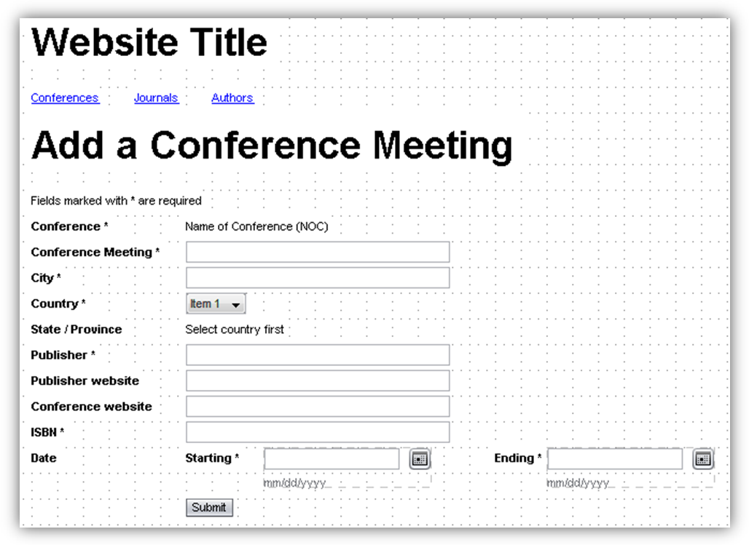
Figure 10 - Add a conference meeting to an existing conference

