Computer Science Research Database
Release 1

Version 1.0

Revision History
Date | Version | Description | Author
1/25/2010 | 1.0 |  | Martin Brown

Table of Contents
1. Introduction 4
1.1 Purpose 4
1.2 Scope 4
1.3 Definitions, Acronyms, and Abbreviations 4
1.4 References 4
1.5 Overview 4
2. Overall Description 4
3. Specific Requirements 5
3.1 User Interfaces 5
3.1.1 Home Page 5
3.1.2 Conferences 5
3.1.3 Add a Conference 6
3.1.4 Add a Conference Meeting Confirmation Page 7

Introduction

Computer Science Research Database is a system for managing computer science research papers in conferences and journals.

Purpose

CSRD is being developed as part Florida A&M University’s Software Development and Maintenance Course at the computer science department for the spring of 2010. The purpose of CSRD is to facilitate the process of discovering academic computer science.

Scope

Definitions, Acronyms, and Abbreviations
  - SRS Software Requirements Specification
  - CSRD Computer Science Research Database
  - FAMU Florida Agricultural and Mechanical University
  - DBLP Digital Bibliography and Library Project

References
  - The idea behind the purpose of CSRD is referenced from DBLP at http://www.informatik.uni-trier.de/~ley/db/. However, CSRD is not identical to DBLP.

Overview
  - CSRD is a web application to be developed in PHP/MySQL. It is highly administrative, i.e. when users want to submit content to the website, the content must first be approved by the administrator. The main page will allow the user to browse conferences, journals, and authors. Conferences can be browsed by year. Journals can be browsed by volume.
  - Users will also be able to search for conferences, journals, authors and papers by entering keywords in the search field.
  - Finally, users may request to have papers submitted or to have conferences or journals added by filling out forms. Each submission is subject to review by the administrator.

Overall Description
- Product perspective
  - CSRD should make it easy to collect information concerning computer science conferences, journals, authors, and papers.

- Product functions
  - The password field of the administrator should be secure
  - The administrator must be able to view several reports of CSRD
  - The administrator must be able to create, update, and delete records of conferences, journals, papers, and authors
  - Users must be able to request to add conferences, journals, papers, and authors
  - Users must be able to search conferences, journals, papers, and authors

- User characteristics
  - The administrator can login through the back-end of the system.
  - Front-end users do not login, but rather make their requests known by filling out forms on the front-end.

- Assumptions and dependencies
  - CSRD is only concerned with computer science research
  - CSRD is hosted locally on the developers’ personal computers
  - CSRD should function properly on modern web browsers

Specific Requirements

User Interfaces
Each page will contain the title of the website (Computer Science Research Database) as well as the main menu, as seen in Figure 1. Clicking on the title of the website should always lead back to the home page. Each page will have a subtitle, such as the subtitle “Conferences” as seen in Figure 2. Fields with an asterisk (*) at the end of their respective labels are required fields and the form should not be accepted if the fields have not been entered (Figure 5).

Home Page
The home page will contain the title of the website and links to conferences, journals, and authors as in Figure 1. For release 1, only the title and the Conferences links are active links. Clicking on the Conferences link will take the user to the Conferences page.


Figure 1 - Home Page

Conferences
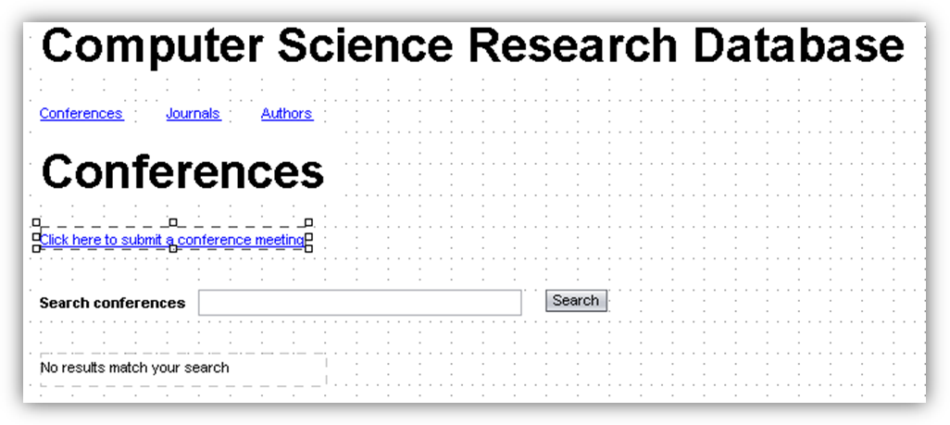
Figure 2 - Conferences page

- The conferences page will contain a link “Click here to submit a conference” that links to the Add a Conference page.
- It will have a form that allows the user to search for conferences that have been approved by the administrator.
  - If there are no results to be displayed, then a message will appear notifying the user that “No results match your search”

Add a Conference
The Add a Conference page contains a form which has several fields (Figure 3)
- Conference – a drop down list containing a list of conferences. The conferences show up in the list regardless of whether the administrator has approved the conference on the website or not.
- Conference Title – a text field for the user to enter the title of the conference, i.e. ACM Southeast Conference 2009
- City – a text field for the user to enter the city where the conference took place
- Country – a drop down list containing a list of countries in the world
- State – a dynamic field
  - the field contains text letting the user know that the country field needs to be populated before a state can be selected, as in Figure 3
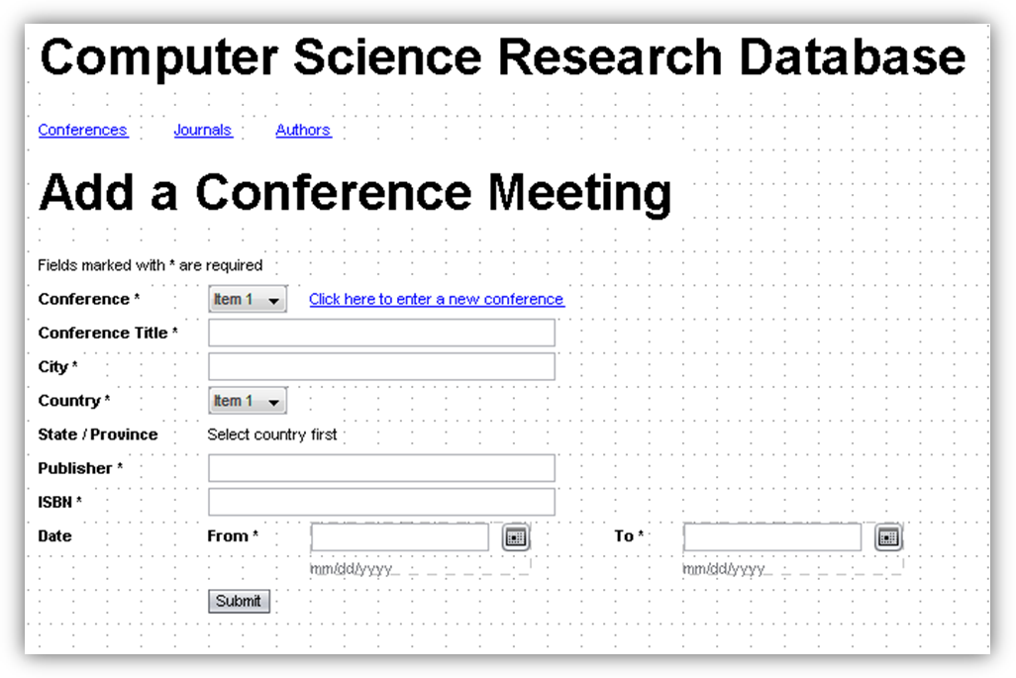
Figure 3 - Adding a Conference meeting
  - the field turns into a drop down list when the country field has been populated, as in Figure 4
- Publisher – a text field where the user can enter the name of the publisher
- ISBN – a text field where the user can enter the International Standard Book Number
- Date – a date field that lets the user select the start- and end-date of the conference
- The user submits the form by clicking on the Submit button or pressing the ENTER key in any of the text fields


Figure 4 - Populating the country field activates the state field
If required fields are not entered (or if there is some other type of error specific to a field), then the user should get an error message as the one in Figure 5, above the form.

Figure 5 - Error message if there are errors submitting the form

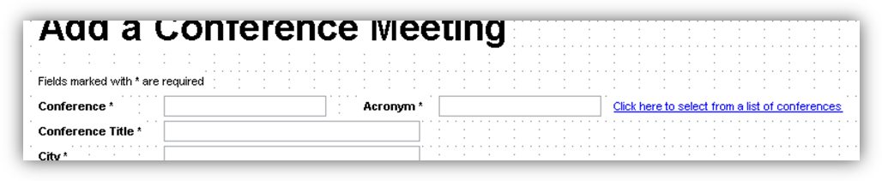
Figure 6 - Adding a conference meeting - adding a conference
If the conference meeting for which the conference is being added is not in the Conference drop down list, then the user may click on the “Click here to select from a list of conferences” link in order to add a conference, as seen in Figure 6.

Add a Conference Meeting Confirmation Page
After successfully submitting a conference meeting for review, the user will be directed to a confirmation page letting him or her know that the conference meeting is under review. See Figure 7. This page will contain a link that will take the user back to the home page.

Figure 7 - Conference Meeting Confirmation Page

