# Q3.1: Based on what you know, how would you rate the quality of investigations that COPA does?

|  |  |  |  |
| --- | --- | --- | --- |
| Code | Value | Count | Frequency |
| 1 | High | 13 | 61.9% |
| 2 | Medium | 5 | 23.8% |
| 3 | Low | 0 | 0.0% |
| 4 | I'm not sure | 3 | 14.3% |

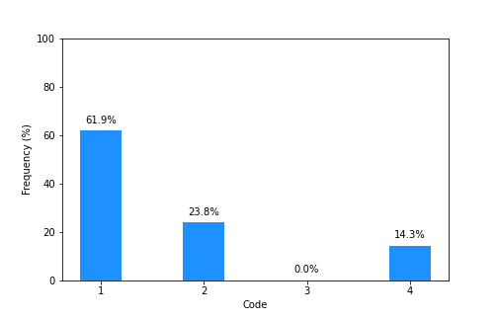

# Q3.2: How fair do you think COPA’s investigation process is?

|  |  |  |  |
| --- | --- | --- | --- |
| Code | Value | Count | Frequency |
| 1 | Very fair | 10 | 47.6% |
| 2 | Somewhat fair | 10 | 47.6% |
| 3 | Somewhat unfair | 0 | 0.0% |
| 4 | Very unfair | 0 | 0.0% |
| 5 | I'm not sure | 1 | 4.8% |

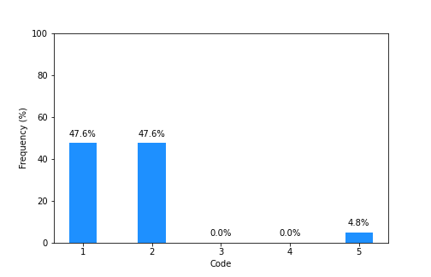

# Q3.3: How open (i.e. transparent) is COPA about the work it does?

|  |  |  |  |
| --- | --- | --- | --- |
| Code | Value | Count | Frequency |
| 1 | Very open | 17 | 81.0% |
| 2 | Somewhat open | 3 | 14.3% |
| 3 | Barely open | 0 | 0.0% |
| 4 | Not open at all | 0 | 0.0% |
| 5 | I'm not sure | 1 | 4.8% |

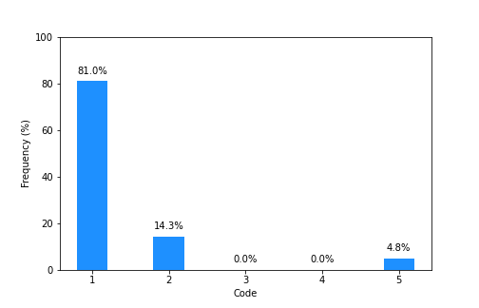

# Q3.4: How trustworthy is COPA’s investigation process?

|  |  |  |  |
| --- | --- | --- | --- |
| Code | Value | Count | Frequency |
| 1 | Very trustworthy | 12 | 57.1% |
| 2 | Somewhat trustworthy | 7 | 33.3% |
| 3 | Somewhat untrustworthy | 0 | 0.0% |
| 4 | Very untrustworthy | 0 | 0.0% |
| 5 | I'm not sure | 2 | 9.5% |

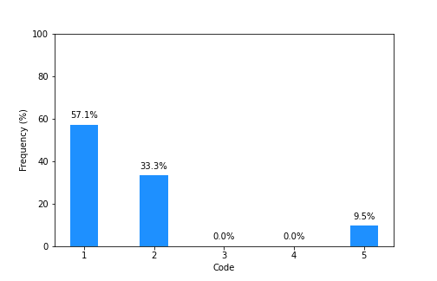

# Q3.5: How fast or slow do you think COPA’s investigations are?

|  |  |  |  |
| --- | --- | --- | --- |
| Code | Value | Count | Frequency |
| 1 | Very fast | 0 | 0.0% |
| 2 | Somewhat fast | 7 | 33.3% |
| 3 | Somewhat slow | 10 | 47.6% |
| 4 | Very slow | 1 | 4.8% |
| 5 | I'm not sure | 3 | 14.3% |

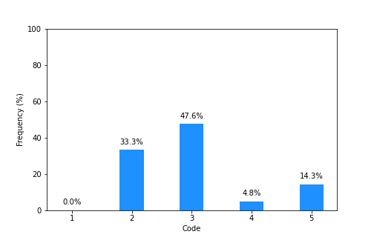

# Q4.2: If you had a complaint about a Chicago police officer tomorrow, how likely would you be to submit that complaint to COPA?

|  |  |  |  |
| --- | --- | --- | --- |
| Code | Value | Count | Frequency |
| 1 | Very likely | 15 | 71.4% |
| 2 | Somewhat likely | 4 | 19.0% |
| 3 | Somewhat unlikely | 1 | 4.8% |
| 4 | Very unlikely | 0 | 0.0% |
| NULL |  | 1 | 4.8% |

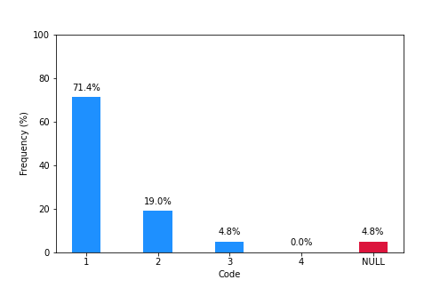

# Q2.1: How knowledgeable are you about the steps involved in a COPA investigation?

|  |  |  |  |
| --- | --- | --- | --- |
| Code | Value | Count | Frequency |
| 1 | Very knowledgeable | 10 | 47.6% |
| 2 | Somewhat knowledgeable | 8 | 38.1% |
| 3 | Somewhat unknowledgeable | 1 | 4.8% |
| 4 | Not knowledgeable at all | 2 | 9.5% |

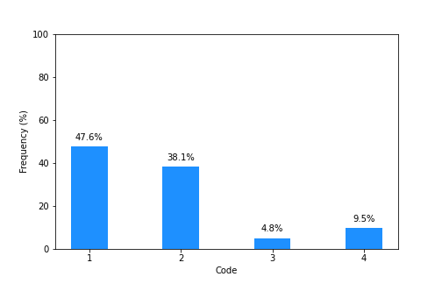

# Q4.1: Have you ever submitted a complaint against a Chicago police officer that COPA investigated?

|  |  |  |  |
| --- | --- | --- | --- |
| Code | Value | Count | Frequency |
| 1 | Yes | 5 | 23.8% |
| 2 | No | 15 | 71.4% |
| 3 | I'm not sure | 1 | 4.8% |

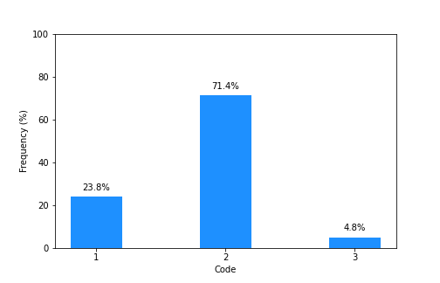

# Q5.1: How likely would you be to recommend COPA People’s Academy to other people?

|  |  |  |  |
| --- | --- | --- | --- |
| Code | Value | Count | Frequency |
| 1 | Very likely | 17 | 81.0% |
| 2 | Somewhat likely | 4 | 19.0% |
| 3 | Somewhat unlikely | 0 | 0.0% |
| 4 | Very unlikely | 0 | 0.0% |

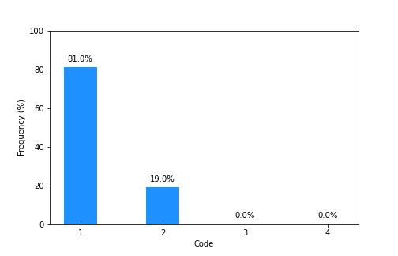

# Q2.2: How much new knowledge did you gain during COPA People’s Academy, if any?

|  |  |  |  |
| --- | --- | --- | --- |
| Code | Value | Count | Frequency |
| 1 | A lot of new knowledge | 12 | 57.1% |
| 2 | Some new knowledge | 7 | 33.3% |
| 3 | A little new knowledge | 1 | 4.8% |
| 4 | No new knowledge | 1 | 4.8% |

