Rule of Test 1:

*If "notepad.exe" created one file and later the file is executed as script, generate event "MaliciousScriptExec"*

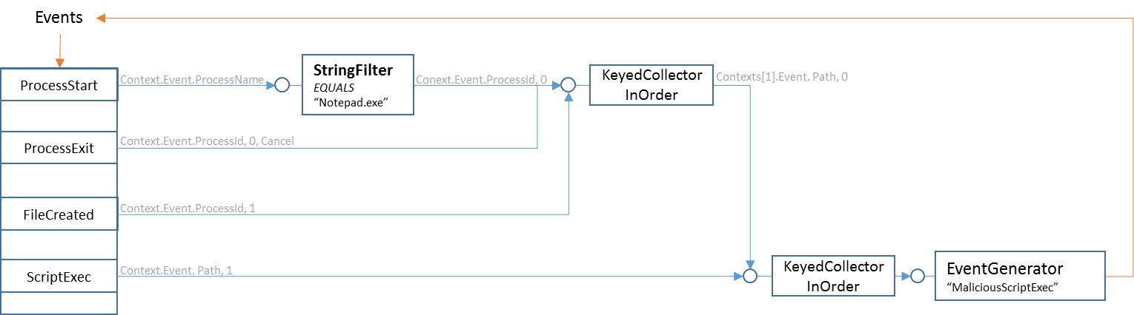

Rule of Test 2 (The "Real Example" in design document):

* *If there is new "FileBlocked" event and we did not report for 10 seconds, report right away.*
* *If we've already reported recently, hold new "FileBlocked" events for 10 seconds to aggregate them.*
* *Do not report if there is no new "FileBlocked"*

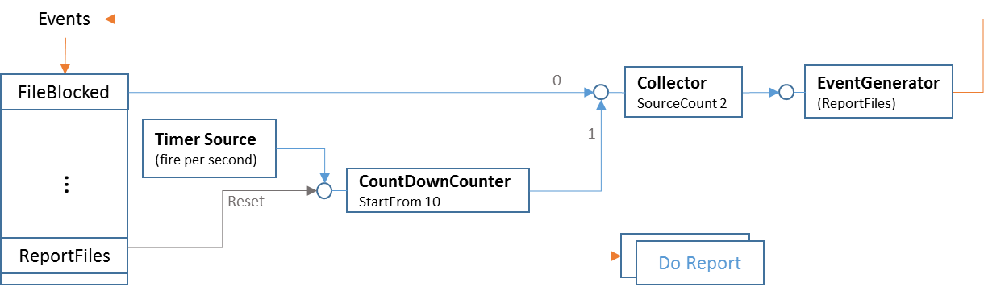

Rule of TestShare:

*A fake rule to test primitive share. This rule has same "StringFilter" and "KeyedCollectorInOrder" as Test1 rule, they should share these 2 primitives when added one by one.*

*Also test the "SignalOnNegative", which is the base to implement NOT and OR.*

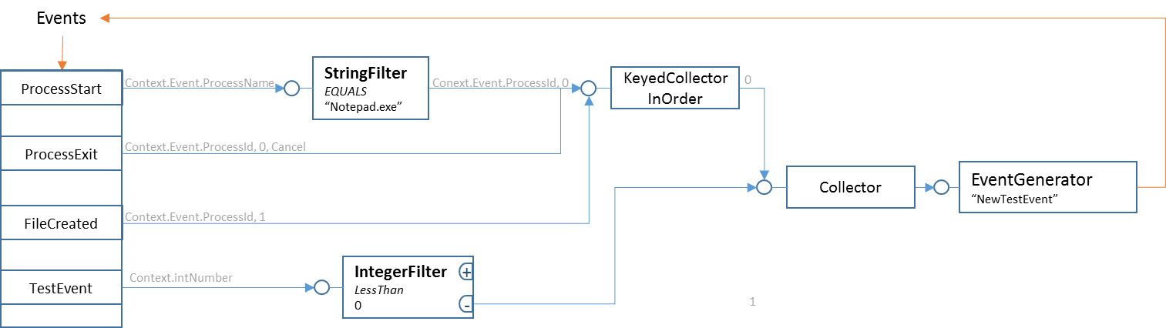

Rule of TestAccumulator:

*A fake rule to test primitive "Accumulator", also demo the OR logic.*

*On "RegistryWrite" event, if key path equals "path_1" and value name equals "name_1", give it score 20; if key path equals "path_2" and value equals 0 or 1, give it score 30. Generate event "RegistryAlert" when accumulated score exceed 60.*

