Martin Louie Carpio

2ECE-D

PROBLEM 1

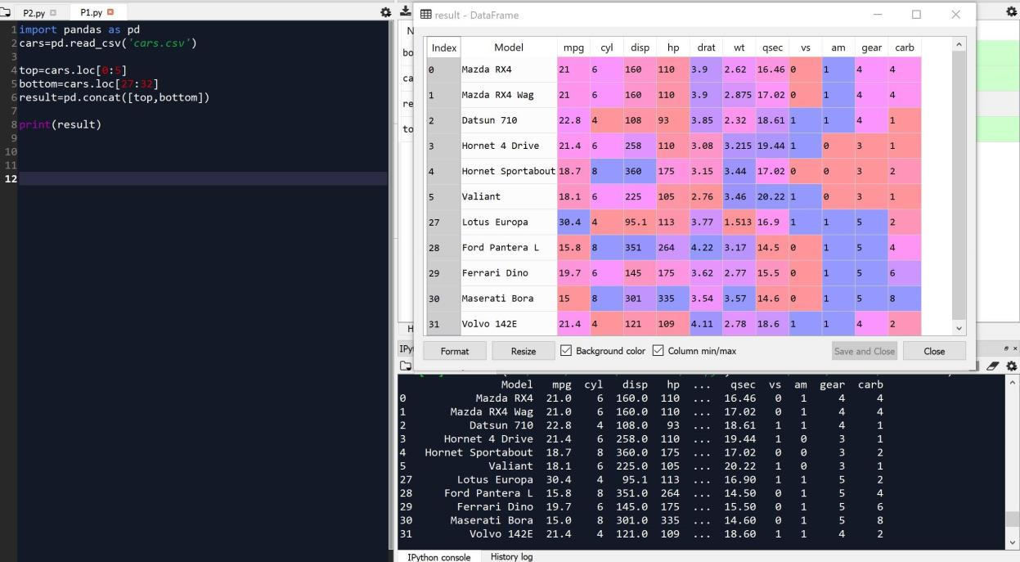

PROBLEM 2A

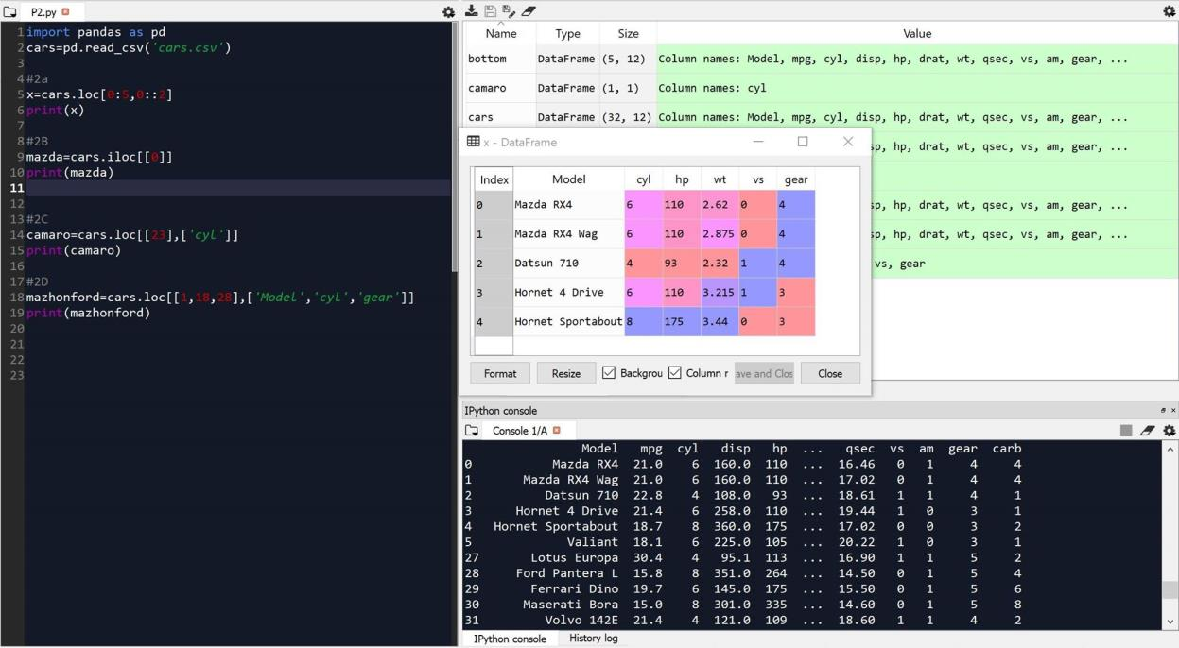

PROBLEM 2B

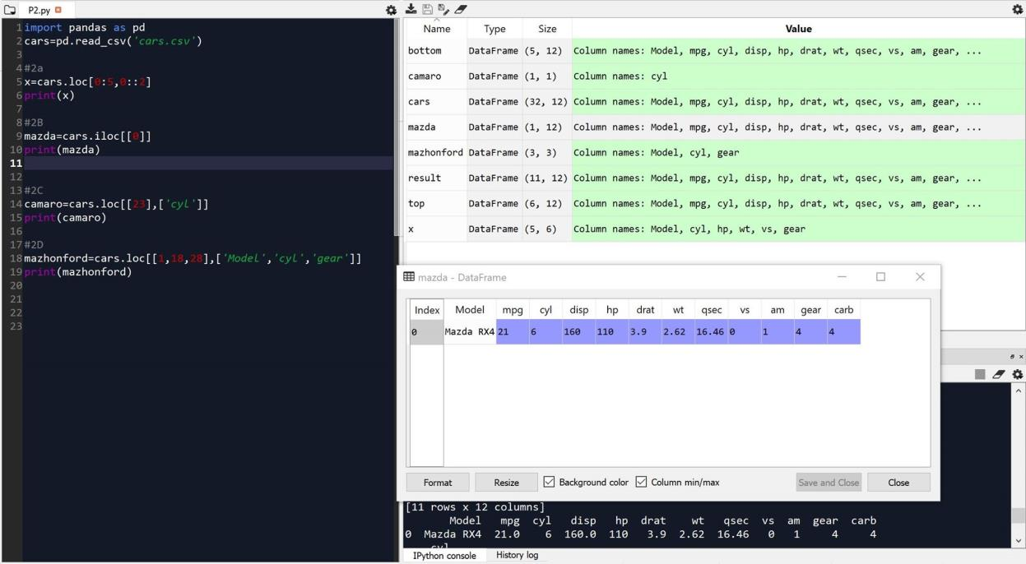

PROBLEM 2C

**Camaro Z28 has 8 cylinders**

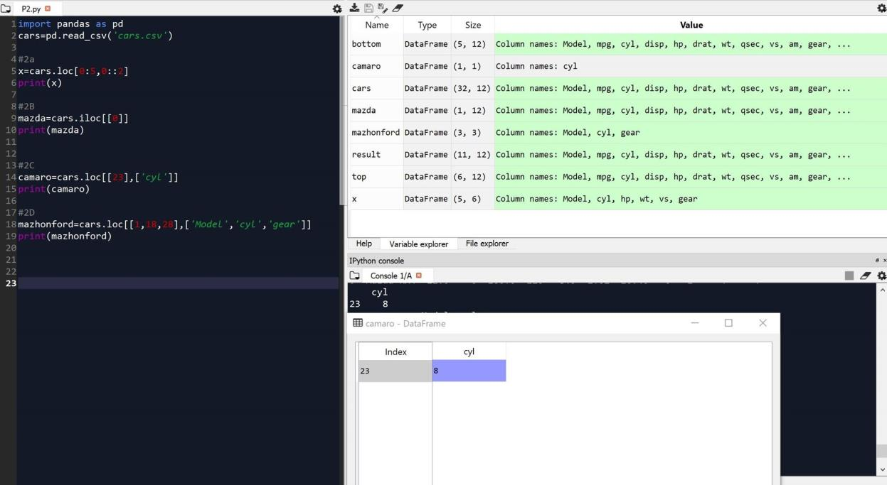

PROBLEM 2D

**Mazda RX4 Wag – 6 cylinders, gear: 4**

**Honda Civic – 4 cylinders, gear: 4**

**Ford Pantera L- 8 cylinders, gear:5**

