566-DAPHNE-CPLAN-0001

Commissioning Plan for the Data Acquisition Processing and Handling Environment (DAPHNE)

Original

**Effective Date: 19 August, 2016**

Commissioning Plan for the Data Acquisition Processing and Handling Environment (DAPHNE)

Date 8/19/2016

**Submitted by:**

|  |  |  |
| --- | --- | --- |
| *_________________________________* |  | *______________* |
| **Martin Perrine** |  | Date |
| NENG System Engineer |  |  |
| NASA Goddard Space Flight Center |  |  |

**Approved by:**

|  |  |  |
| --- | --- | --- |
| *_________________________________* |  | *______________* |
| **Salem El-Nimri** |  | Date |
| NENG Product Development Lead |  |  |
| NASA Goddard Space Flight Center |  |  |
| *_________________________________* |  | *______________* |
| **Alan T Schonbrunner** |  | Date |
| OPS/Testing/Network Engineer |  |  |
| NASA Wallops Flight Facility |  |  |

Preface

This document is under the configuration control of the Near Earth Network (NEN) Configuration Review Board (CRB). Changes to this document will be made by Documentation Change Notice (DCN) or by complete revision. Proposed changes to this document must be submitted along with supportive material justifying the proposed change. Comments or questions concerning this document and proposed changes will be addressed to:

Change Information Page

|  |  |  |  |  |  |
| --- | --- | --- | --- | --- | --- |
| **List of Effective Pages** | | | | | |
| **Page Number** | | **Issue** | | | |
|  | |  | |
|  | | Original based on similar document 566-NENG-CPLAN-0001 | |
|  | |  | |
|  | |  | |
|  | |  | |
|  | |  | |
|  | |  | |
|  | |  | |
|  | |  | |
|  | |  | |
|  | |  | |
|  | |  | |
|  | |  | |
|  | |  | |
|  | |  | |
|  | |  | |
| **Document History** | | | | | |
| **Document Number** | **Version - Change** | | **Date** | |
| 566-DAPHNE-CPLAN-0001 | Original | | 08/15/2016 | |
|  |  | |  | |
|  |  | |  | |
|  |  | |  | |
|  |  | |  | |
|  |  | |  | |
|  |  | |  | |
|  |  | |  | |

Contents

Preface iii

Section 1. Introduction 1-1

1.1 Purpose 1-1

1.2 Background 1-1

1.3 Reference Documents 1-1

Section 2. NEN System Description 2-3

2.1 What is DAPHNE 2-3

Section 3. Commissioning Plan 3-4

3.1 Preshipment 3-4

3.2 Post-shipment Activities 3-5

Abbreviations and Acronyms 1

# Introduction

## Purpose

The purpose of this document is to describe the plan to commission the Near Earth Network Gateway (NENG) for operations at a NASA Ground Station at the Alaska Satellite Facility (ASF).

## Background

DAPHNE long history of development and successful deployments at multiple NASA Ground Stations. The unit is intended as a store and forward system for return service satellite telemetry. The design has improved over the years migrating from the original MAC based system to a high performance LINUX server platform with increasing speeds and storage volume. Two units currently at ASF will be upgraded as a result of this commissioning action.

## Reference Documents

|  |  |
| --- | --- |
| **Document Number** | **Reference Document** |
| 453-NENUG | Near Earth Network Users’ Guide |
| SCNS-NEN-REQT-0008 | Requirement Specification for the Data Acquisition Processing and Handling Environment (DAPHNE) |
| SCNS-NEN-Plan-0001 | Test Plan for DAPHNE |
| 453-ICD-IRIS/NENGG | NEN ICD Between NENG and IRIS MOC |
| 566-DAPHNE-TPlan-001 | Test Plan for the Data Acquisition Processing and Handling Environment (DAPHNE) |
| NPR 2810.1A | Security of Information Technology. |
| 566-NENG-CPLAN-0001 | Commissioning Plan for the Near Earth Network Gateway (NENG) Phase 1 |

# The Data Acquisition Processing and Handling Environment (DAPHNE) System Description

## What is DAPHNE

DAPHNE implementation is a computer based store and forward telemetry data system. The system receives, processes, stores and delivers telemetry data for NASA satellite missions that utilize NASA’s Near Earth Network.

The mission telemetry data uses Consultative Committee for Space Data Standards (CCSDS) protocols including Advanced Orbiting Systems (AOS) framing and virtual channels. The data is input from a Ground Station intermediate frequency (IF) receiver. Each virtual channel in the AOS frame that is received by the system will be written into separate files. Files are limited in size e.g. one-minute lengths to simplify handling, for faster turn-around time, and smaller transmission cycles in case of any problems transferring the data to the mission.

DAPHNE uses the secure copy protocol (scp) to push the files to the customer in “near real-time” as soon as they are created. The files are queued and will be sent as fast as the data network supports. The files are also stored on the unit and are available for later access. The mission can use the self-service secure file transfer protocol (sftp) interface on the system to pull specific data files to their site.

Figure 2‑1 shows the general configuration of DAPHNE in the context the NEN.

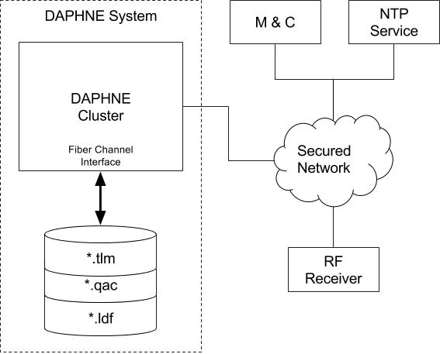

Figure ‑ DAPHNE Operations Configuration

# Commissioning Plan

## Preshipment

DAPHNE units are built by GSFC/566 at their Greenbelt office. The project team performs numerous verification activities prior to shipment of DAPHNE to a NASA Ground Station. These activities confirm functionality of the system, and verifies that it meets all formal requirements stated in the requirements specification. The activities include inspection, analysis, and testing methodologies. The focus of these activities are long term testing using a setup that simulates the data flow of hundreds of satellite overpass operations. The specific plan and procedures are given in The DAPHNE Test Plan, and The DAPHNE Test Procedures documents respectively. These documents will be referred to as “the Plan” and “the Procedure” in this document.

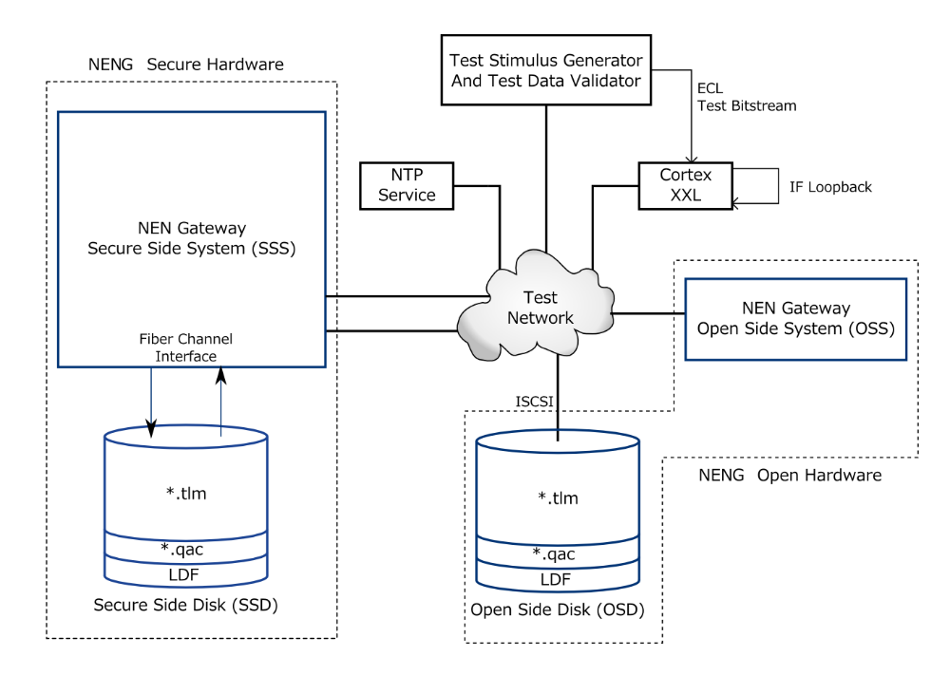The results of the pre-shipment activities will be included in the DAPHNE Acceptance Test Report and presented at a project Pre-ship Review. A successful conclusion of the Pre-ship review confirms that the unit is ready to ship to the NASA Ground Station where it will be commissioned into operation according to the plan given in this document. Figure 3‑1 depicts the configuration required for pre-shipment testing.

Figure ‑ DAPHNE in Lab Test Context.

Figure ‑ Pre-ship Test Bed Configuration

## Post-shipment Activities

At the NASA Ground Station DAPHNE will be setup in the operations area. After basic checkout by the project team the team will conduct a number of verification tests. These tests are described in the Plan and the Procedure. The operational team will be trained by the project how to setup and maintain the unit as part of these activities.

The operational team will then conduct rigorous “parallel” operational testing. The unit will be tested in parallel with the current operational units to assure correct operation prior to switch over. The MOC will receive both sets of data (old and new system) and will compare the two sets to confirm that the new system is fully functional. This general process for the parallel test is described below. The process was agreed to by NEN. The detailed procedures are described in The Near Earth Network Gateway Test Procedures. The length of each test can be determined by the operations team – but it is recommended to run it for seven days to verify the data retention requirement and the mission’s accessibility to earlier passes.

The major steps for the final commissioning are given below. The steps are identical to those used for the NENG delivery to Alaska Satellite Facility in September 2016. The terminology in the example is from that commissioning.

Step 1 See Figure 3‑3.

AS3 will shadow two IRIS X Band passes. The IRIS project will evaluate the data and if good step 2 will be performed.

AS3 existing NENG MAC will be taken off the network and kept in place for approximately 1 week in case there is an urgent need to switch back to.



Figure ‑ Step 1 configuration

Step II Figure 3‑4.

AS1 existing NENG MAC will be taken off the network and kept in place for approximately 1 week in case this is needed to go back to.

AS1 will track two IRIS X Band passes. The IRIS project will evaluate the data and if good the upgrade will be complete.



Figure 3‑4 Step II configuration

Final Step- See Figure 3‑5.

All new units are in place and operational



Figure ‑ Final configuration















































Abbreviations and Acronyms

| **Acronym** | **Definition** |
| --- | --- |
| AOS | Advanced Orbiting Systems |
| APID | Application ID |
| ASF | Alaska Satellite Facility, Fairbanks, AK |
| ASM | Attached Synch Marker |
| CADU | Channel Access Data Unit |
| CCSDS | Consultative Committee for Space Data Standards |
| CLK | Clock |
| CMD | Command |
| CRB | Configuration Review Board |
| CRC | Cyclic Redundancy Check |
| CSO | Communications Service Office (NISN) |
| DCN | Documentation Change Notice |
| DMD | Demodulator |
| ECL | Emitter Coupled Logic |
| ftp | file transfer protocol |
| ICD | Interface Control Document |
| IF | Intermediate Frequency |
| IP | Internet Protocol |
| IRIS | Interface Region Imaging Spectrograph |
| ISP | Internet service Provider |
| IT | Information Technology |
| LDF | Log Data File |
| LDPC | Low Density Parity Check |
| M&C | Monitor and Control |
| Mbps | Megabits per second |

|  |  |
| --- | --- |
| MOC | Mission Operations Center |
| MOD | Modulator |
| NASA | National Aeronautics and Space Administration |
| NEN | Near Earth Network |
| NENG | Near Earth Network Gateway |
| NIC | Network Interface Controllers / Network Interface Cards |
| NTP | Network Time Protocol |
| OSD | Open Side Disk |
| OSS | Open Side System |
| PN | Pseudorandom Noise |
| POP | Point-of-Presence |
| RAID | Redundant Array of Independent Disks |
| RF | Radio Frequency |
| RFICD | Interface Control Document |
| SCID | Space Craft Identification |
| SCNS | Space Communications Network Services |
| scp | secure copy protocol |
| SFEP | SoftFEP (software program) |
| sftp | secure file transfer protocol |
| sNTP | Secure Network Time Protocol |
| SSD | Secure Side Disk |
| SPEC | Specification |
| SSS | Secure Side System |
| STDN | Spaceflight Tracking and Data Network |
| TDR | Test Discrepancy Reports |
| USB | Universal Serial Bus |
| UTC | Universal Time Code |
| VCDU | Virtual Channel Data Unit |
| VCID | Virtual Channel Identifier |
| WGS | Wallops Ground Station, Wallops Island, VA |