Near Earth Network Data Acquisition Processing and Handling Environment Configuration Management Plan (CMP)

Rev 2

Add a reference document table.

Preface
This document is under the configuration control of the Data Acquisition Processing and Handling Environment (DAPHNE) Configuration Review Board (CRB). Changes to this document will be made by Documentation Change Notice (DCN) or by complete revision. Proposed changes to this document must be submitted along with supportive material justifying the proposed change. Comments or questions concerning this document and proposed changes will be addressed to Salem El-Nimri the Project Development Lead.

Change Information Page
List of Effective Pages
Page Number |  | Issue
Changes name to DAPHNE.
Changed reference to 566-DAPHNE-CMP-Rev2
Added description of internal versus external processes.
Document History
Document Number | Version - Change |  | Date
NEN-NEN-CMP-0001 | Original
566-DAPHNE-CMP-Rev2 | Updates from Original

Contents
Preface iii
Section 1. Introduction 1
1.1 Purpose 1
1.2 Scope 1
1.3 Definitions 1
1.3.1 Gitlab 1
1.3.2 Document Baseline 1
1.3.3 Wiki 1
Section 2. Gitlab 3
2.1 Introduction 3
2.2 Features 3
2.3 Access Control 3
2.3.1 Access Control 3
2.4 Issue Tracking 3
2.4.1 Overview 3
2.4.2 Issue Version Control 3
2.4.3 Issue Closure 4
2.5 Knowledge 4
2.5.1 Overview 4
2.5.2 Version Control 5
2.5.3 Release 6
Section 3. Configuration Management 1
3.1 Organization 1
3.2 DAPHNE Documents 1
3.2.1 Overview 1
3.2.2 Version Control 2
3.2.3 Naming and Numbering 2
3.2.4 Document Revising 2
3.2.5 Document Release 2
3.2.6 Document Signature Authority 2
3.3 DAPHNE Software 3
3.3.1 Overview 3
3.3.2 Version Control 3
3.3.3 Release 3
3.4 Configuration Control 3
3.4.1 Procedures for Changing Baselines 3
3.4.2 Change Control Boards (CCB) 3
3.5 Configuration Management Milestones 3
Abbreviations and Acronyms 1
List of Figures
Figure 2-1 Example of a Gitlab Issue 4
Figure 2-2 Issue Process 4
Figure 2-3 Gitlab Wiki 5
Figure 2-4 Gitlab Wiki History 5
Figure 3-1 NENG Documentation Location 2

List of Tables
No table of figures entries found.

Introduction

Purpose
The DAPHNE team manages software, documentation, and issues. This plan describes the how each configuration item will be managed throughout the duration of the project.

Scope

Definitions
The following are special definitions that apply in this document.
DAPHNE: Project name formally called NEN Gateway Phase II.
Gitlab:
configuration management (CM) tool is Gitlab.
Document Baseline: The Oofficial release of a document after internal review and signature approvals.
Wiki
table website containing documentation, meeting notes, and general information.

Gitlab

Introduction
Gitlab is a Project Management System (PMS) that is provided by Code 580. DAPHNE uses the system to manage its software development, track issues, and control key documents.

Features
The DAPHNE team utilizes the following Gitlab features to track project progress:
- Software version control
- Issue Tracking
- Documentation
- File storage
- Email notifications
- Milestones

Access Control
Gitlab roles consist of the following:
- Master: Owner of the project with complete control
- Developer: Software development capabilities
- Reporter: Issue reporting only
- Guest: View only access

Access Control
External stakeholders will be granted Reporter or Guest access as requested.

Issue Tracking

Overview
The DAPHNE team will track open project issues. Issues are assigned with due dates and can be tracked by any user. Issues can be created at anypoint in the project lifecycle including development, testing, reviews, and deployment.

Issue Control
Issues are tracked and archived after closure. Issues are either open or closed. An example is shown in Figure 2-1.
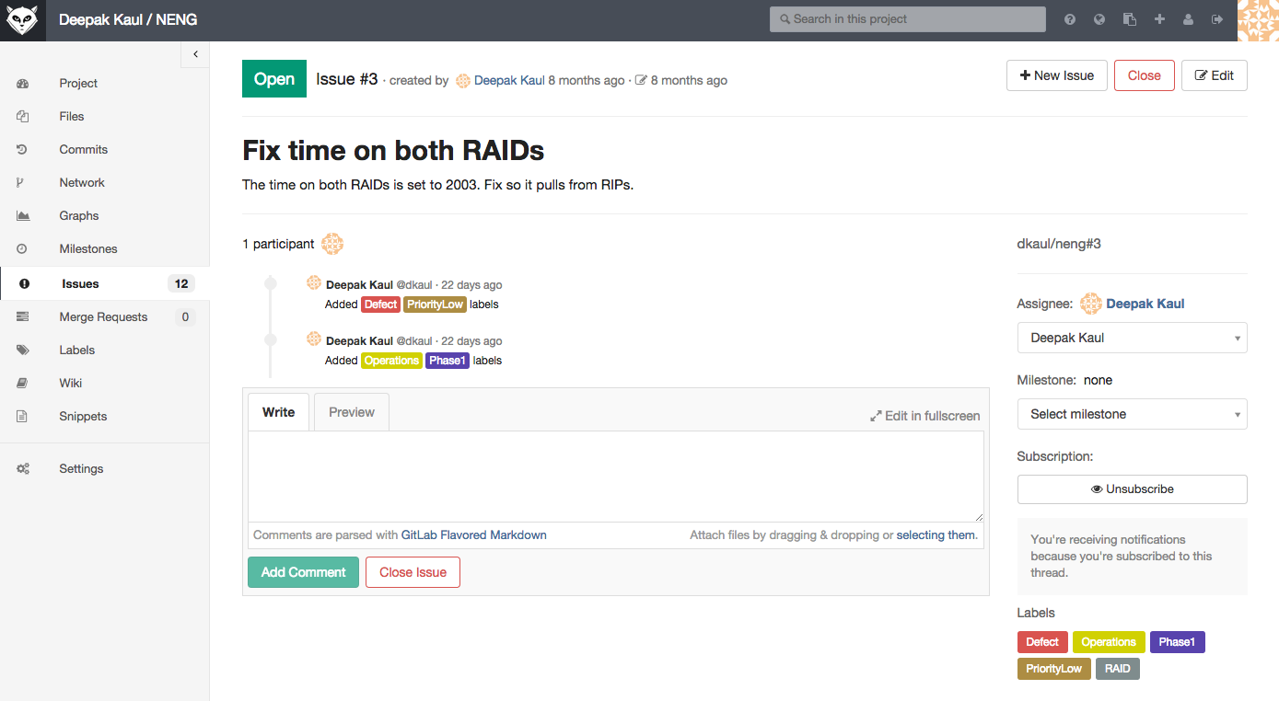
Figure 2-1 Example of a Gitlab Issue

Issue Closure
Issues are closed by the Master user after agreement from the team using the process in Figure 2-2.
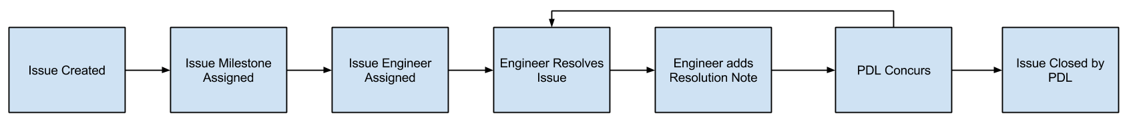
Figure 2-2 Issue Process

Knowledge: DAPHNES USE OF THE WIKI

Overview
The DAPHNE team uses the provided wiki to create reference and documentation. The GUI is shown in Figure 2-3.
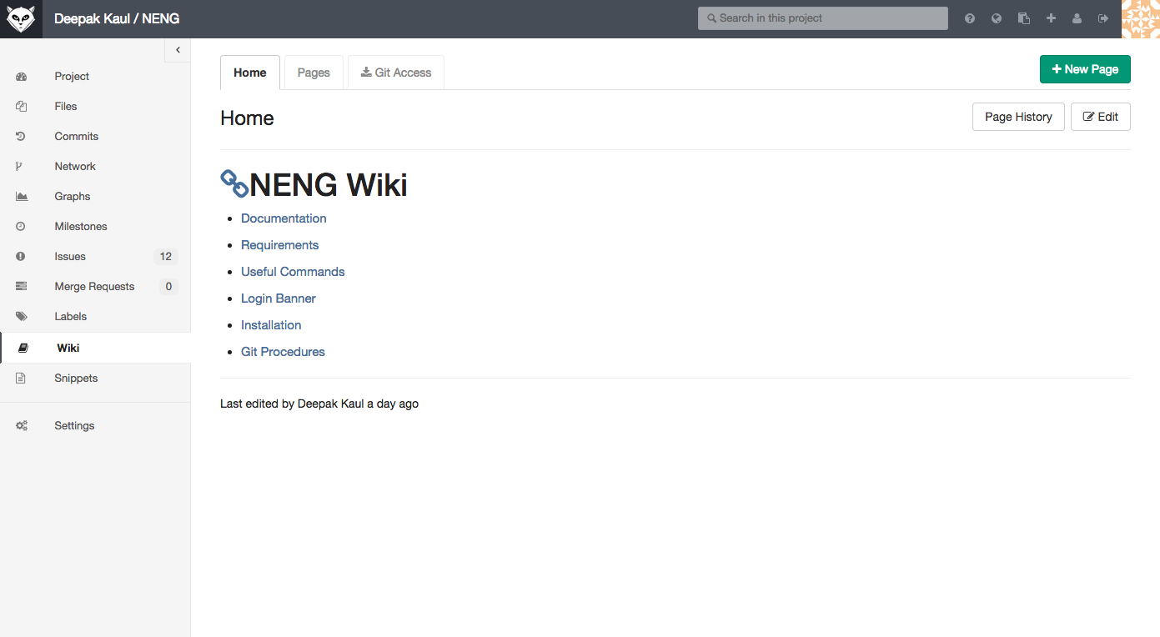
Figure 2-3 Gitlab Wiki

WIKI Version Control
The wiki has version control capabilities such as shown in Figure 2-4.
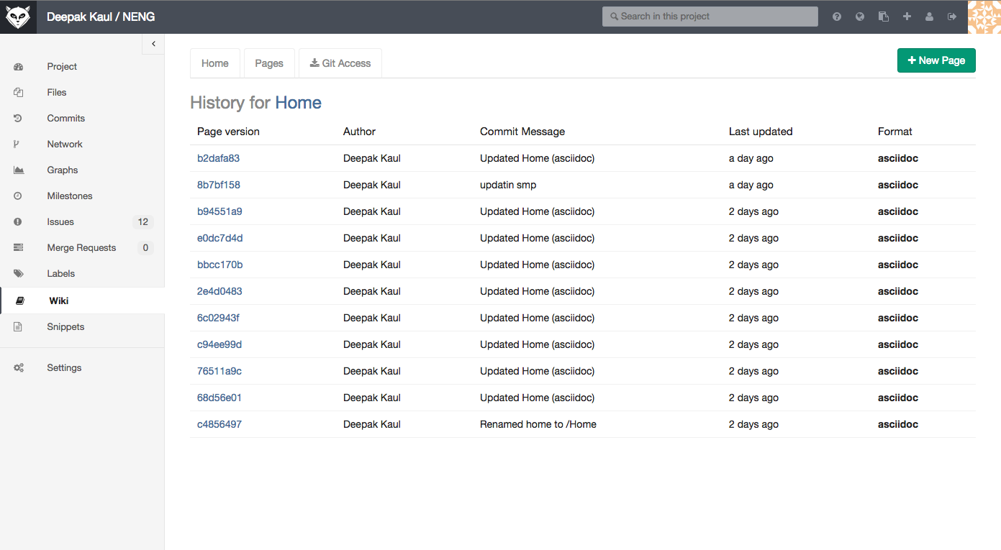
Figure 2-4 Gitlab Wiki History

Release FROM THE WIKI
Some documentation will be release to external entities after conversion to the appropriate format.

Configuration Management

Organization
The CM process includes processes for creating documentation and software.

DAPHNE Documents

Overview
DAPHNE documentation is maintained on Gitlab’s wiki pages and includes the categories below:
- Project Plans
- Systems Engineering
- Software Engineering
- Reference and Technical
- Subsystem Integration and Test
- System Testing
- User Documentation
- Operations Documentation
- Software Documentation
- Hardware Documentation

The WIKI page is shown in Figure 3-5.
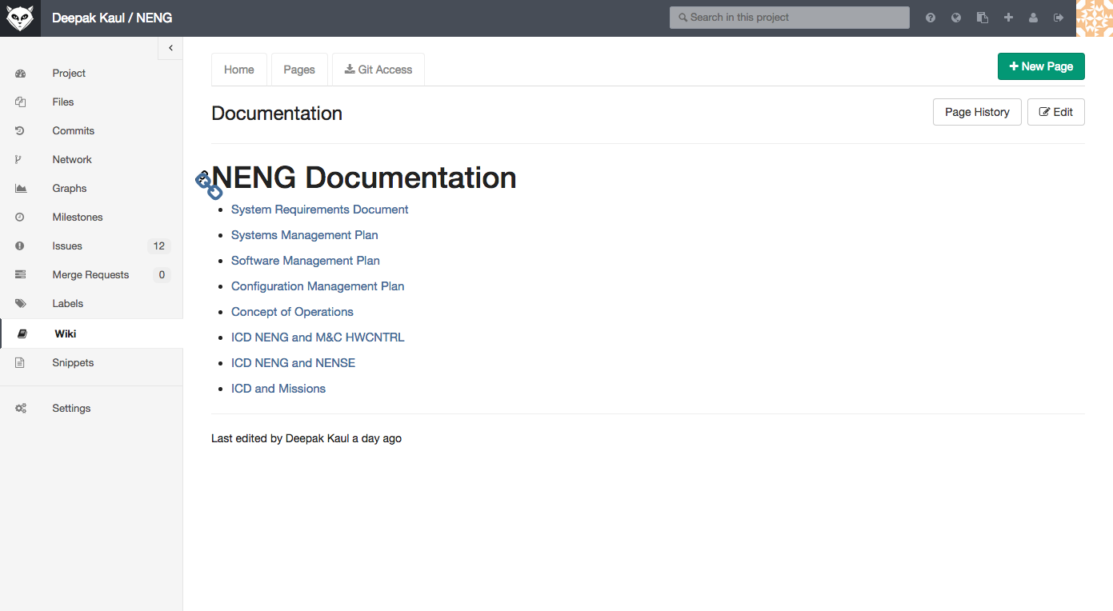
Figure 3-5 NENG Documentation Location

Version Control
Documents are version control leveraging Gitlab’s wiki version control capabilities.

Naming and Numbering
Documents will be converted from wiki into official word documents and will follow the following naming convention:
566-DAPHNE-[Document Acronym]-REV-XXX
Documents that are not ready for official release will be watermarked with draft.

Document Revising
Documents in draft form can be updated at any time. Documents that have been officially release must following the official revision procedure.

Document Release
Documents ready for release will follow the applicable DAPHNE or Code 450 release procedure which includes review by stakeholders and official signatures.

Document Signature Authority
DAPHNE documentation shall include signatures authorizing the document for release and distribution which include:
- Primary author of the document
- Project lead
- Code 566 Branch Head or representative
- NEN Project Manager or representative

Responsible Control Review Board

The following documents will be handled by the NEN CRB.
- The System Requirements Document.
- All Interface Control Documents (jointly with the controlling mission).
- The Commissioning Plan.

All other documents will be handled by the DAPHNE CRB and handled as internal documents.

DAPHNE Software

Overview
The DAPHNE team uses the Git version control system to manage software. Team members can download the repository, make changes, and upload them back to the repository. Software control includes not only all coding, subroutine, and drivers but also parameters to configure the system for operations to support each specific mission.

Version Control
The Git version control system handles all version control aspects of the DAPHNE software. This system will allow for multiple users to develop code simultaneously with conflicts and code merging being handled by the user and the Git repository. Using Git will allow for code releases and branches to be made after operational releases.

Release
Software will be released when it is deemed ready for a production environment by the DAPHNE team. A software release will follow a similar process to that of the document release. After the system is operational and has been tested, an “operational” release will occur and further development will be branched until it can be deemed operational after testing. After each new release a stable version is maintained until the latest release is fully testing and can be merged with the stable. Refer to the DAPHNE Software Management Plan (SMP) for more information about software releases.

Hardware
The commercial hardware purchased for DAPHNE and it’s interconnection will be controlled by the DAPHNE project.

Configuration Control

Procedures for Changing Document Baselines
DAPHNE will handle it’s documents in three ways. Firstly there are work level documents that are handled strictly internally to the project. Secondly, documents that require release from DAPHNE. Thirdly, documents that require CM control by an external entity such as the customer.

The first way uses internal control processes that can vary and are appropriate to the specific document.
The second way is using the DAPHNE control review board to realease a controlled version of the document.
The third way uses the NEN CRB to control the document once it has been released from DAPHNE using the first means above.

The process for changing baselines after it has been released to the NEN CM shall be handled by the NEN CM plan. Changes may be requested by the DAPHNE team and shall be approved by the NEN CM manager. Errors shall be corrected without need for review, however major changes or additions shall be reviewed by the DAPHNE team as well as the various stakeholders.

A list of controlled project documents is in the project document tree 566-DAPHNE-TREE-Rev2. The applicable CM process is noted in the document. All working level documents are not included in the document tree.

Change Control Boards (CCB)
The Change Control Board for DAPHNE is the DAPHNE team for the first way mentioned above. The second way would add the 566 and 560 management, and a NEN representative.
The third way is via the NEN CRB.

Abbreviations and Acronyms
Acronym | Definition
CCB | Configuration Control Board
CM  ICD | Configuration Management  Interface Control Document
NEN | Near Earth Network
NENG | Near Earth Network Gateway
PMS | Project Management System
TBD | To Be Determined

