**MASTER OF COMPUTER APPLICATIONS (MCA) APJ ABDUL KALAM TECHNOLOGICAL UNIVERSITY**

RLMCA234

Mobile Application Development Lab

*Lab Record Submitted by:*

Martin Michael

**Reg. No:** AJC19MCA-I038



**AMAL JYOTHI COLLEGE OF ENGINEERING KANJIRAPPALLY**

[Affiliated to APJ Abdul Kalam Technological University, Kerala. Approved by AICTE, Accredited by

NAAC with ‘A’ grade. Koovappally, Kanjirappally, Kottayam, Kerala - 686518]

**2019-2024**

**Course Outcomes**

CO1: Setup Android Platform and Android Studio IDE

CO2: Mange UIDesignWidget and Layouts, UIEvents, Event Listeners

CO3: Experiment Android Components, Activities, Intents, and Services

CO4: Debug Android Applications using different Tools. CO5: Develop application withSOLite DB.

CO6: Designand build functionalAndroid applications.

|  |  |  |
| --- | --- | --- |
| **SNO** | **AIM** | **PAGE NUMBER** |
| 1 | Create a mobile application for simple calculator | 4 |
| 2 | Create a mobile application for temperature conversion | 11 |
| 3 | Create a mobile application to navigate from one activity to another activity(Explicit Intent) | 15 |
| 4 | Create a mobile application to demonstrate Implicit Intent | 19 |
| 5 | Create a simple application to change the background color on button click | 24 |
| 6 | Create an application   1. to check the given number is Armstrong or not 2. to check the given number is Odd /Even 3. Print the factorial of a number | 27 |
| 7 | Create an application registration page and print the details on another page | 34 |
| 8 | Demonstrate Date Picker widget. | 42 |
| 9 | Develop an application to illustrate android lifecycle. | 46 |
| 10 | Develop an application to perform arithmetic operations with options Menu | 47 |
| 11 | Develop an application to show a list of fruits and vegetables in popup menu. | 51 |
| 12 | Develop an application to show phone contacts using context menu. | 54 |
| 13 | Develop an FM Radio with scan button to save the stations and select the saved stations using PREVIOUS and NEXT Buttons. | 59 |
| 14 | Develop an ordinary calculator with memory options. | 63 |
| 15 | Develop an alert dialog for confirmation on exit. | 70 |
| 16 | Develop a two tabbed window using Tabbed Activity and display proper messages when you switch between these tabs. | 72 |
| 17 | Create and apply style in your sample UI. | 75 |
| 18 | Apply a style as a theme (eg: dark theme) in your project | 77 |
| 19 | Develop an SQLite program for writing, reading, updating and deleting contacts details. | 79 |
| 20 | MICRO PROJECT | 85 |

# Program 1

**Aim: To develop android simple Calculator**

# Activity_main.xml

<?xml version="1.0" encoding="utf-8"?>

<androidx.constraintlayout.widget.ConstraintLayout xmlns:android="<http://schemas.android.com/apk/res/android>"

xmlns:app="<http://schemas.android.com/apk/res-auto>" xmlns:tools="[http://schemas.android.com/tools"](http://schemas.android.com/tools) android:layout_width="match_parent" android:layout_height="match_parent" tools:context=".MainActivity">

<TextView android:id="@+id/fno" android:layout_width="142dp" android:layout_height="30dp"

android:text="Enter First Number" app:layout_constraintBottom_toBottomOf="parent" app:layout_constraintEnd_toEndOf="parent" app:layout_constraintHorizontal_bias="0.059" app:layout_constraintStart_toStartOf="parent" app:layout_constraintTop_toTopOf="parent" app:layout_constraintVertical_bias="0.089" />

<EditText android:id="@+id/ed2" android:layout_width="193dp" android:layout_height="46dp" android:ems="10"

android:inputType="textPersonName" android:text=""

app:layout_constraintBottom_toBottomOf="parent" app:layout_constraintEnd_toEndOf="parent" app:layout_constraintHorizontal_bias="0.884" app:layout_constraintStart_toStartOf="parent" app:layout_constraintTop_toTopOf="parent" app:layout_constraintVertical_bias="0.167" />

<EditText android:id="@+id/result" android:layout_width="196dp" android:layout_height="56dp" android:ems="10"

android:inputType="textPersonName" android:text="" app:layout_constraintBottom_toBottomOf="parent" app:layout_constraintEnd_toEndOf="parent" app:layout_constraintHorizontal_bias="0.497" app:layout_constraintStart_toStartOf="parent" app:layout_constraintTop_toTopOf="parent" app:layout_constraintVertical_bias="0.827" />

<Button android:id="@+id/btnsubmit"

android:layout_width="wrap_content" android:layout_height="wrap_content" android:text="ADD" app:layout_constraintBottom_toBottomOf="parent" app:layout_constraintEnd_toEndOf="parent" app:layout_constraintHorizontal_bias="0.276" app:layout_constraintStart_toStartOf="parent" app:layout_constraintTop_toTopOf="parent"

app:layout_constraintVertical_bias="0.47" />

<Button android:id="@+id/b2"

android:layout_width="wrap_content" android:layout_height="wrap_content" android:text="SUB" app:layout_constraintBottom_toBottomOf="parent" app:layout_constraintEnd_toEndOf="parent" app:layout_constraintHorizontal_bias="0.696" app:layout_constraintStart_toStartOf="parent" app:layout_constraintTop_toTopOf="parent" app:layout_constraintVertical_bias="0.47" />

<Button android:id="@+id/b3"

android:layout_width="wrap_content" android:layout_height="wrap_content" android:text="MULT" app:layout_constraintBottom_toBottomOf="parent" app:layout_constraintEnd_toEndOf="parent" app:layout_constraintHorizontal_bias="0.276" app:layout_constraintStart_toStartOf="parent" app:layout_constraintTop_toTopOf="parent" app:layout_constraintVertical_bias="0.608" />

<Button android:id="@+id/b4"

android:layout_width="wrap_content" android:layout_height="wrap_content" android:text="DIV" app:layout_constraintBottom_toBottomOf="parent"

app:layout_constraintEnd_toEndOf="parent" app:layout_constraintHorizontal_bias="0.696" app:layout_constraintStart_toStartOf="parent" app:layout_constraintTop_toTopOf="parent" app:layout_constraintVertical_bias="0.608" />

<TextView android:id="@+id/sno" android:layout_width="142dp" android:layout_height="30dp"

android:text="Enter Second Number" app:layout_constraintBottom_toBottomOf="parent" app:layout_constraintEnd_toEndOf="parent" app:layout_constraintHorizontal_bias="0.059" app:layout_constraintStart_toStartOf="parent" app:layout_constraintTop_toTopOf="parent" app:layout_constraintVertical_bias="0.165" />

<EditText android:id="@+id/ed1" android:layout_width="191dp" android:layout_height="38dp" android:ems="10"

android:inputType="textPersonName" android:text="" app:layout_constraintBottom_toBottomOf="parent" app:layout_constraintEnd_toEndOf="parent" app:layout_constraintHorizontal_bias="0.878" app:layout_constraintStart_toStartOf="parent" app:layout_constraintTop_toTopOf="parent" app:layout_constraintVertical_bias="0.09" />

</androidx.constraintlayout.widget.ConstraintLayout>

# MainActivity.java

package com.example.myfirstapp;

import androidx.appcompat.app.AppCompatActivity; import android.os.Bundle;

import android.view.View; import android.widget.Button; import android.widget.EditText;

public class MainActivity extends AppCompatActivity { Button b1,b2,b3,b4;

EditText ed1,ed2,ed3; int a,b,c;

@Override

protected void onCreate(Bundle savedInstanceState) { super.onCreate(savedInstanceState); setContentView(R.layout.activity_main); b1=(Button)findViewById(R.id.btnsubmit); b2=(Button)findViewById(R.id.b2); b3=(Button)findViewById(R.id.b3); b4=(Button)findViewById(R.id.b4);

ed1=(EditText) findViewById(R.id.ed1); ed2=(EditText) findViewById(R.id.ed2); ed3=(EditText) findViewById(R.id.result); b1.setOnClickListener(new View.OnClickListener() {

@Override

public void onClick(View view) { a=Integer.parseInt(ed1.getText().toString());

b=Integer.parseInt(ed2.getText().toString()); c=a+b;

ed3.setText("Result is "+c);

}

});

b2.setOnClickListener(new View.OnClickListener() { @Override

public void onClick(View view) { a=Integer.parseInt(ed1.getText().toString()); b=Integer.parseInt(ed2.getText().toString()); c=a-b;

ed3.setText("Result is "+c);

}

});

b3.setOnClickListener(new View.OnClickListener() { @Override

public void onClick(View view) { a=Integer.parseInt(ed1.getText().toString()); b=Integer.parseInt(ed2.getText().toString()); c=a*b;

ed3.setText("Result is "+c);

}

});

b4.setOnClickListener(new View.OnClickListener() { @Override

public void onClick(View view) { a=Integer.parseInt(ed1.getText().toString()); b=Integer.parseInt(ed2.getText().toString()); c=a/b;

ed3.setText("Result is "+c);

}

});

}

}

# Output

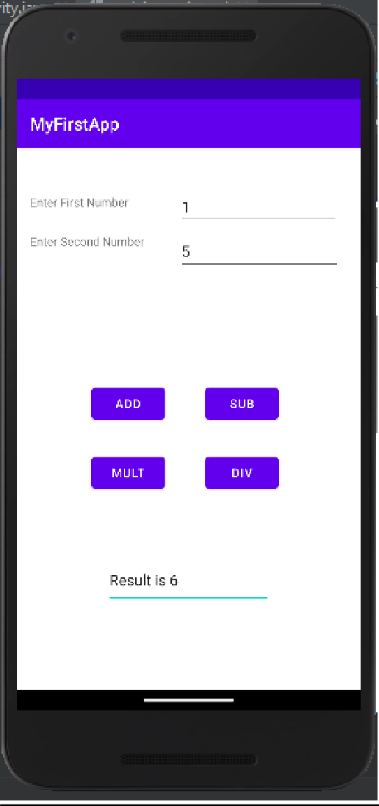

**Program 2**

**Aim: To create a temperature converter**

# Activity_main.xml

<?xml version="1.0" encoding="utf-8"?>

<androidx.constraintlayout.widget.ConstraintLayout xmlns:android="<http://schemas.android.com/apk/res/android>"

xmlns:app="<http://schemas.android.com/apk/res-auto>" xmlns:tools="[http://schemas.android.com/tools"](http://schemas.android.com/tools) android:layout_width="match_parent" android:layout_height="match_parent" tools:context=".MainActivity">

<TextView android:id="@+id/t1"

android:layout_width="149dp" android:layout_height="48dp" android:text="ENTER TEMP HERE"

app:layout_constraintBottom_toBottomOf="parent" app:layout_constraintEnd_toEndOf="parent" app:layout_constraintHorizontal_bias="0.045" app:layout_constraintStart_toStartOf="parent" app:layout_constraintTop_toTopOf="parent" app:layout_constraintVertical_bias="0.292" />

<EditText android:id="@+id/et1"

android:layout_width="wrap_content" android:layout_height="wrap_content" android:ems="10" android:inputType="textPersonName" app:layout_constraintBottom_toBottomOf="parent"

app:layout_constraintEnd_toEndOf="parent" app:layout_constraintHorizontal_bias="0.92" app:layout_constraintStart_toStartOf="parent" app:layout_constraintTop_toTopOf="parent" app:layout_constraintVertical_bias="0.291" />

<Button android:id="@+id/btn1"

android:layout_width="wrap_content" android:layout_height="wrap_content" android:text="TO FARENHEIT" app:layout_constraintBottom_toBottomOf="parent" app:layout_constraintEnd_toEndOf="parent" app:layout_constraintHorizontal_bias="0.498" app:layout_constraintStart_toStartOf="parent" app:layout_constraintTop_toTopOf="parent" app:layout_constraintVertical_bias="0.469" />

<Button android:id="@+id/btn2"

android:layout_width="wrap_content" android:layout_height="wrap_content" android:text="TO CELSIUS" app:layout_constraintBottom_toBottomOf="parent" app:layout_constraintEnd_toEndOf="parent" app:layout_constraintHorizontal_bias="0.507" app:layout_constraintStart_toStartOf="parent" app:layout_constraintTop_toTopOf="parent" app:layout_constraintVertical_bias="0.606" />

<TextView android:id="@+id/t2"

android:layout_width="117dp" android:layout_height="36dp" android:text="RESULT" app:layout_constraintBottom_toBottomOf="parent" app:layout_constraintEnd_toEndOf="parent" app:layout_constraintHorizontal_bias="0.057" app:layout_constraintStart_toStartOf="parent" app:layout_constraintTop_toTopOf="parent" app:layout_constraintVertical_bias="0.93" />

<EditText android:id="@+id/et2"

android:layout_width="wrap_content" android:layout_height="wrap_content" android:ems="10" android:inputType="textPersonName" app:layout_constraintBottom_toBottomOf="parent" app:layout_constraintEnd_toEndOf="parent" app:layout_constraintHorizontal_bias="0.92" app:layout_constraintStart_toStartOf="parent" app:layout_constraintTop_toTopOf="parent" app:layout_constraintVertical_bias="0.934" />

</androidx.constraintlayout.widget.ConstraintLayout>

# MainActivity.java

package com.example.temperatureconverter; import androidx.appcompat.app.AppCompatActivity; import android.os.Bundle;

import android.view.View;

import android.widget.Button; import android.widget.EditText;

public class MainActivity extends AppCompatActivity { Button b1,b2;

EditText et1,et2; Double a,b; @Override

protected void onCreate(Bundle savedInstanceState) { super.onCreate(savedInstanceState); setContentView(R.layout.activity_main); b1=(Button) findViewById(R.id.btn1);

b2=(Button) findViewById(R.id.btn2); et1=(EditText) findViewById(R.id.et1); et2=(EditText) findViewById(R.id.et2); b1.setOnClickListener(new View.OnClickListener() {

@Override

public void onClick(View view) { a=Double.parseDouble(String.valueOf(et1.getText())); b=a*(1.8)+32;

et2.setText("Result is "+b);

}

});

b2.setOnClickListener(new View.OnClickListener() { @Override

public void onClick(View view) { a=Double.parseDouble(String.valueOf(et1.getText())); b=(a-32)*(0.55555);

et2.setText("Result is "+b);

}

});

}

}

# Output

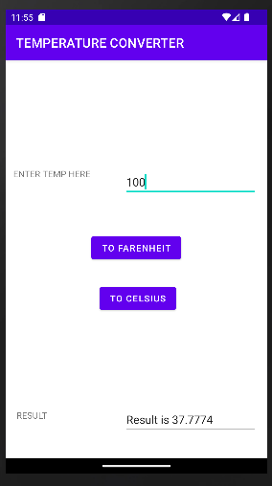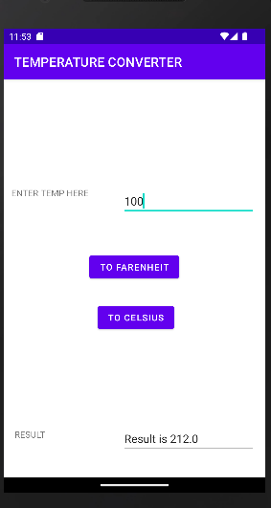

**Program 3**

**AIM: Create explicit intent android project which contain a button that moves to next page of an activity**

# Activity_main.xml

<?xml version="1.0" encoding="utf-8"?>

<androidx.constraintlayout.widget.ConstraintLayout xmlns:android="<http://schemas.android.com/apk/res/android>"

xmlns:app="<http://schemas.android.com/apk/res-auto>" xmlns:tools="[http://schemas.android.com/tools"](http://schemas.android.com/tools) android:layout_width="match_parent" android:layout_height="match_parent" tools:context=".MainActivity">

<Button android:id="@+id/btn1"

android:layout_width="232dp" android:layout_height="52dp" android:text="Go To Next Page"

app:layout_constraintBottom_toBottomOf="parent" app:layout_constraintEnd_toEndOf="parent" app:layout_constraintStart_toStartOf="parent" app:layout_constraintTop_toTopOf="parent" />

</androidx.constraintlayout.widget.ConstraintLayout>

# Actvity_second.xml

<?xml version="1.0" encoding="utf-8"?>

<androidx.constraintlayout.widget.ConstraintLayout xmlns:android="<http://schemas.android.com/apk/res/android>"

xmlns:app="<http://schemas.android.com/apk/res-auto>" xmlns:tools="[http://schemas.android.com/tools"](http://schemas.android.com/tools) android:layout_width="match_parent" android:layout_height="match_parent" tools:context=".SecondActivity">

<Button android:id="@+id/btn2"

android:layout_width="227dp" android:layout_height="60dp"

android:text="Go To Home Page" app:layout_constraintBottom_toBottomOf="parent" app:layout_constraintEnd_toEndOf="parent" app:layout_constraintStart_toStartOf="parent" app:layout_constraintTop_toTopOf="parent" />

</androidx.constraintlayout.widget.ConstraintLayout>

# MainActivity.java

package com.example.firstactivity;

import androidx.appcompat.app.AppCompatActivity; import android.content.Intent;

import android.os.Bundle; import android.view.View; import android.widget.Button;

public class MainActivity extends AppCompatActivity { Button bnext;

@Override

protected void onCreate(Bundle savedInstanceState) { super.onCreate(savedInstanceState); setContentView(R.layout.activity_main); bnext=(Button) findViewById(R.id.btn1); bnext.setOnClickListener(new View.OnClickListener() {

@Override

public void onClick(View v) {

Intent in=new Intent(MainActivity.this,SecondActivity.class); startActivity(in);

}

});

}

}

# SecondActivity.java

package com.example.firstactivity;

import androidx.appcompat.app.AppCompatActivity; import android.content.Intent;

import android.os.Bundle; import android.view.View; import android.widget.Button;

public class SecondActivity extends AppCompatActivity { Button bback;

@Override

protected void onCreate(Bundle savedInstanceState) { super.onCreate(savedInstanceState); setContentView(R.layout.activity_second);

bback=(Button)findViewById(R.id.btn2); bback.setOnClickListener(new View.OnClickListener() {

@Override

public void onClick(View view) {

Intent a=new Intent(SecondActivity.this,MainActivity.class); startActivity(a);

}

});

}

}

# Output

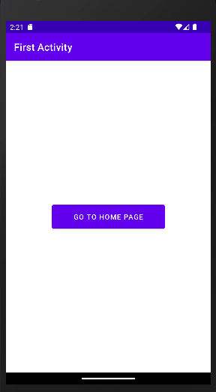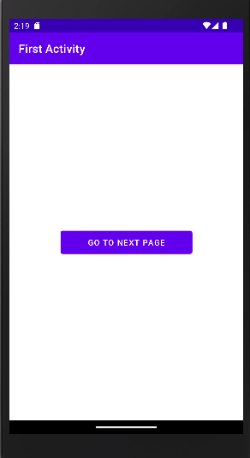

**Program 4**

**AIM: Create implicit intent android project which contain a button that moves to next page of an activity**

# Activity_main.xml

<?xml version="1.0" encoding="utf-8"?>

<androidx.constraintlayout.widget.ConstraintLayout xmlns:android="<http://schemas.android.com/apk/res/android>"

xmlns:app="<http://schemas.android.com/apk/res-auto>" xmlns:tools="[http://schemas.android.com/tools"](http://schemas.android.com/tools) android:layout_width="match_parent"

android:layout_height="match_parent" tools:context=".MainActivity">

<Button android:id="@+id/b3"

android:layout_width="wrap_content" android:layout_height="wrap_content" android:text="Message" app:layout_constraintBottom_toBottomOf="parent" app:layout_constraintEnd_toEndOf="parent" app:layout_constraintHorizontal_bias="0.492" app:layout_constraintStart_toStartOf="parent" app:layout_constraintTop_toTopOf="parent" app:layout_constraintVertical_bias="0.704" />

<Button android:id="@+id/b1"

android:layout_width="wrap_content" android:layout_height="wrap_content" android:text="Browser" app:layout_constraintBottom_toBottomOf="parent" app:layout_constraintEnd_toEndOf="parent" app:layout_constraintHorizontal_bias="0.492" app:layout_constraintStart_toStartOf="parent" app:layout_constraintTop_toTopOf="parent" app:layout_constraintVertical_bias="0.213" />

<Button android:id="@+id/b2"

android:layout_width="wrap_content" android:layout_height="wrap_content" android:text="Dial"

app:layout_constraintBottom_toBottomOf="parent" app:layout_constraintEnd_toEndOf="parent" app:layout_constraintHorizontal_bias="0.492" app:layout_constraintStart_toStartOf="parent" app:layout_constraintTop_toTopOf="parent" app:layout_constraintVertical_bias="0.461" />

</androidx.constraintlayout.widget.ConstraintLayout>

# MainActivity.java

package com.example.implicitindent;

import androidx.appcompat.app.AppCompatActivity; import android.content.Intent;

import android.net.Uri; import android.os.Bundle; import android.view.View; import android.widget.Button;

public class MainActivity extends AppCompatActivity { Button btn1;

Button btn2; Button btn3; @Override

protected void onCreate(Bundle savedInstanceState) { super.onCreate(savedInstanceState); setContentView(R.layout.activity_main); btn1=(Button) findViewById(R.id.b1);

btn2=(Button) findViewById(R.id.b2); btn3=(Button) findViewById(R.id.b3);

btn1.setOnClickListener(new View.OnClickListener(){ @Override

public void onClick(View v){

Intent in=new Intent(Intent.ACTION_VIEW, Uri.parse("https://login.aesajce.in/")); startActivity(in);

}

});

btn2.setOnClickListener(new View.OnClickListener(){ @Override

public void onClick(View v){

Intent in=new Intent(Intent.ACTION_DIAL, Uri.parse("tel:987654321")); startActivity(in);

}

});

btn3.setOnClickListener(new View.OnClickListener(){ @Override

public void onClick(View v){

Intent in=new Intent(Intent.ACTION_SEND); in.setType("text/plain"); in.putExtra(Intent.EXTRA_TEXT,"Hello..How Are You??"); startActivity(in);

}

});

}

}

# Output

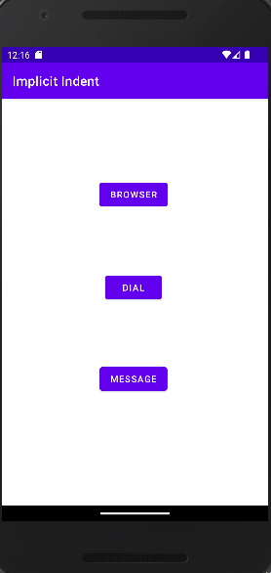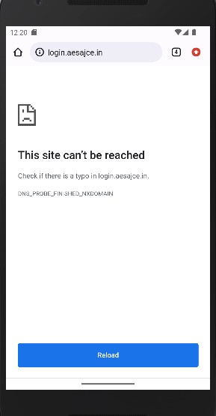

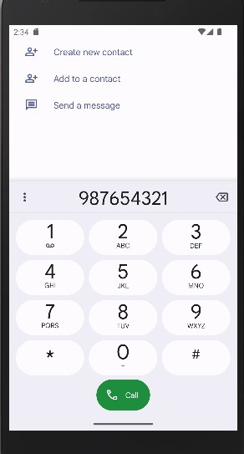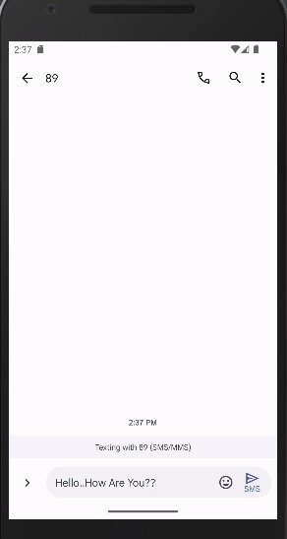

**Program 5**

**AIM: Change background color on button click**

# Activity_main.xml

<?xml version="1.0" encoding="utf-8"?>

<androidx.constraintlayout.widget.ConstraintLayout xmlns:android="<http://schemas.android.com/apk/res/android>"

xmlns:app="<http://schemas.android.com/apk/res-auto>" xmlns:tools="[http://schemas.android.com/tools"](http://schemas.android.com/tools) android:id="@+id/bg" android:layout_width="match_parent"

android:layout_height="match_parent" tools:context=".MainActivity">

<Button android:id="@+id/btnblue"

android:layout_width="wrap_content" android:layout_height="wrap_content" android:text="BLUE" app:layout_constraintBottom_toBottomOf="parent" app:layout_constraintEnd_toEndOf="parent" app:layout_constraintHorizontal_bias="0.498" app:layout_constraintStart_toStartOf="parent" app:layout_constraintTop_toTopOf="parent" app:layout_constraintVertical_bias="0.642" />

<Button android:id="@+id/btngreen"

android:layout_width="wrap_content" android:layout_height="wrap_content" android:text="GREEN" app:layout_constraintBottom_toBottomOf="parent"

app:layout_constraintEnd_toEndOf="parent" app:layout_constraintHorizontal_bias="0.498" app:layout_constraintStart_toStartOf="parent" app:layout_constraintTop_toTopOf="parent" app:layout_constraintVertical_bias="0.404" />

<Button android:id="@+id/btnred"

android:layout_width="wrap_content" android:layout_height="wrap_content" android:text="RED" app:layout_constraintBottom_toBottomOf="parent" app:layout_constraintEnd_toEndOf="parent" app:layout_constraintHorizontal_bias="0.498" app:layout_constraintStart_toStartOf="parent" app:layout_constraintTop_toTopOf="parent" app:layout_constraintVertical_bias="0.207" />

</androidx.constraintlayout.widget.ConstraintLayout>

# MainActivity.java

package com.example.colorchange;

import androidx.appcompat.app.AppCompatActivity; import androidx.constraintlayout.widget.ConstraintLayout; import android.content.Intent;

import android.graphics.Color; import android.net.Uri; import android.os.Bundle; import android.view.View; import android.widget.Button;

public class MainActivity extends AppCompatActivity { Button b1,b2,b3;

@Override

protected void onCreate(Bundle savedInstanceState) { super.onCreate(savedInstanceState); setContentView(R.layout.activity_main);

ConstraintLayout cl =(ConstraintLayout) findViewById(R.id.bg); b1 =(Button) findViewById(R.id.btnred);

b2 =(Button) findViewById(R.id.btngreen); b3 =(Button) findViewById(R.id.btnblue);

b1.setOnClickListener(new View.OnClickListener() { @Override

public void onClick(View v) { cl.setBackgroundColor(Color.RED);

}

});

b2.setOnClickListener(new View.OnClickListener() { @Override

public void onClick(View v) { cl.setBackgroundColor(Color.GREEN);

}

});

b3.setOnClickListener(new View.OnClickListener() { @Override

public void onClick(View v) { cl.setBackgroundColor(Color.BLUE);

}

});

}

}

# Output

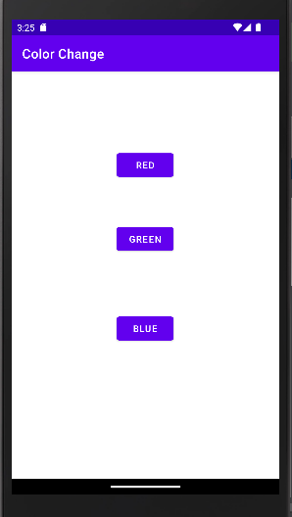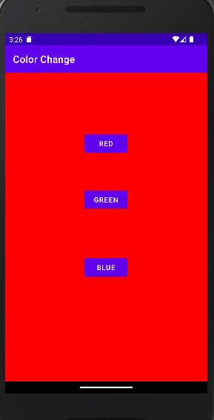

**Program 6**

**AIM: To check ARMSTRONG, FACTORIAL, ODD or EVEN**

# Activity_main.xml

<?xml version="1.0" encoding="utf-8"?>

<androidx.constraintlayout.widget.ConstraintLayout xmlns:android="<http://schemas.android.com/apk/res/android>"

xmlns:app="<http://schemas.android.com/apk/res-auto>" xmlns:tools="[http://schemas.android.com/tools"](http://schemas.android.com/tools) android:layout_width="match_parent" android:layout_height="match_parent" android:background="#FFFFFF" tools:context=".MainActivity">

<TextView android:id="@+id/textView"

android:layout_width="wrap_content"

android:layout_height="wrap_content" android:text="OPERATIONS" android:textColor="#F44336" android:textSize="24sp" app:layout_constraintBottom_toBottomOf="parent" app:layout_constraintEnd_toEndOf="parent" app:layout_constraintStart_toStartOf="parent" app:layout_constraintTop_toTopOf="parent" app:layout_constraintVertical_bias="0.038" />

<TextView android:id="@+id/textView2"

android:layout_width="wrap_content" android:layout_height="wrap_content" android:text="Enter Number" android:textColor="#673AB7" android:textSize="20sp" app:layout_constraintBottom_toBottomOf="parent" app:layout_constraintEnd_toEndOf="parent" app:layout_constraintHorizontal_bias="0.135" app:layout_constraintStart_toStartOf="parent" app:layout_constraintTop_toTopOf="parent" app:layout_constraintVertical_bias="0.193" />

<TextView android:id="@+id/result"

android:layout_width="wrap_content" android:layout_height="wrap_content" android:background="#FF5722" android:textColor="#FFFFFF" android:textSize="20sp"

app:layout_constraintBottom_toBottomOf="parent" app:layout_constraintEnd_toEndOf="parent" app:layout_constraintStart_toStartOf="parent" app:layout_constraintTop_toTopOf="parent" app:layout_constraintVertical_bias="0.359" />

<EditText android:id="@+id/number" android:layout_width="297dp" android:layout_height="47dp" android:ems="10" android:hint="Enter Number"

android:inputType="textPersonName" app:layout_constraintBottom_toBottomOf="parent" app:layout_constraintEnd_toEndOf="parent" app:layout_constraintHorizontal_bias="0.342" app:layout_constraintStart_toStartOf="parent" app:layout_constraintTop_toTopOf="parent" app:layout_constraintVertical_bias="0.274" />

<Button android:id="@+id/armstrong" android:layout_width="278dp" android:layout_height="59dp" android:backgroundTint="#4CAF50" android:text="Armstrong"

app:layout_constraintBottom_toBottomOf="parent" app:layout_constraintEnd_toEndOf="parent" app:layout_constraintHorizontal_bias="0.436" app:layout_constraintStart_toStartOf="parent" app:layout_constraintTop_toTopOf="@+id/textView"

app:layout_constraintVertical_bias="0.435" />

<Button android:id="@+id/factorial" android:layout_width="278dp" android:layout_height="59dp"

android:backgroundTint="#FF9800" android:text="FACTORIAL" app:layout_constraintBottom_toBottomOf="parent" app:layout_constraintEnd_toEndOf="parent" app:layout_constraintHorizontal_bias="0.436" app:layout_constraintStart_toStartOf="parent" app:layout_constraintTop_toTopOf="@+id/textView" app:layout_constraintVertical_bias="0.568" />

<Button

android:id="@+id/oddeven" android:layout_width="278dp" android:layout_height="59dp" android:backgroundTint="#03A9F4" android:text="ODD / EVEN" app:layout_constraintBottom_toBottomOf="parent" app:layout_constraintEnd_toEndOf="parent" app:layout_constraintHorizontal_bias="0.436" app:layout_constraintStart_toStartOf="parent" app:layout_constraintTop_toTopOf="@+id/textView" app:layout_constraintVertical_bias="0.708" />

</androidx.constraintlayout.widget.ConstraintLayout>

# MainActivity.java

package com.example.operations;

import androidx.appcompat.app.AppCompatActivity;

import android.annotation.SuppressLint; import android.os.Bundle;

import android.view.View; import android.widget.Button; import android.widget.EditText; import android.widget.TextView;

public class MainActivity extends AppCompatActivity { Button armstrong,factorial,oddeven;

EditText number;

TextView res;

@Override

protected void onCreate(Bundle savedInstanceState) { super.onCreate(savedInstanceState); setContentView(R.layout.activity_main); armstrong=(Button) findViewById(R.id.armstrong); factorial=(Button) findViewById(R.id.factorial); oddeven=(Button) findViewById(R.id.oddeven); res=(TextView) findViewById(R.id.result); number=(EditText) findViewById(R.id.number); armstrong.setOnClickListener(new View.OnClickListener() {

@Override

public void onClick(View v) {

int reminder=0,result=0,temp=0;

int num=Integer.parseInt(number.getText().toString()); temp = num;

while(temp!=0)

{

reminder=temp % 10;

result += (Math.pow(reminder,3));

temp/=10;

}

if(result==num)

{

res.setText(num+" is an armstong number");

}

else

{

res.setText(num+" is not an armstrong number");

}

}

});

factorial.setOnClickListener(new View.OnClickListener() { @Override

public void onClick(View v) { int fact=1;

int value=Integer.parseInt(number.getText().toString()); for (int i=1;i<value;i++){

fact*=i;

}

res.setText("Factorial is "+fact);

}

});

oddeven.setOnClickListener(new View.OnClickListener() { @Override

public void onClick(View v) {

int value=Integer.parseInt(number.getText().toString()); if(value%2==0){

res.setText(value+" is an even number");

}

else{

res.setText(value+" is an Odd number");

}

}

});

}

}

# Output

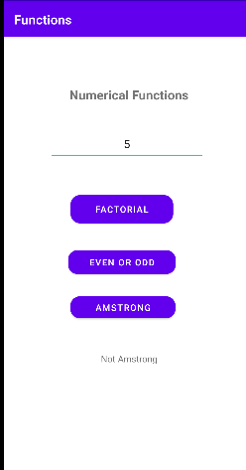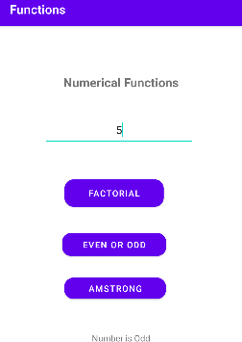

**Program 7**

**AIM: Create explicit intent android project which take input from a registration page and displays the output on another page**

# Activity_main.xml

<?xml version="1.0" encoding="utf-8"?>

<androidx.constraintlayout.widget.ConstraintLayout xmlns:android="<http://schemas.android.com/apk/res/android>"

xmlns:app="<http://schemas.android.com/apk/res-auto>" xmlns:tools="[http://schemas.android.com/tools"](http://schemas.android.com/tools) android:id="@+id/button" android:layout_width="match_parent" android:layout_height="match_parent" tools:context=".MainActivity">

<Button android:id="@+id/buttonmain" android:layout_width="130dp" android:layout_height="65dp" android:text="Next"

app:layout_constraintBottom_toBottomOf="parent" app:layout_constraintEnd_toEndOf="parent" app:layout_constraintHorizontal_bias="0.469" app:layout_constraintStart_toStartOf="parent" app:layout_constraintTop_toTopOf="parent" app:layout_constraintVertical_bias="0.81" />

<EditText android:id="@+id/editText" android:layout_width="234dp" android:layout_height="51dp" android:ems="10"

android:inputType="textPersonName" android:text="Name" app:layout_constraintBottom_toBottomOf="parent" app:layout_constraintEnd_toEndOf="parent" app:layout_constraintHorizontal_bias="0.497"

app:layout_constraintStart_toStartOf="parent" app:layout_constraintTop_toTopOf="parent" app:layout_constraintVertical_bias="0.185" />

<EditText android:id="@+id/editTextAge" android:layout_width="228dp" android:layout_height="55dp" android:ems="10" android:inputType="textPersonName" android:text="Age"

app:layout_constraintBottom_toBottomOf="parent" app:layout_constraintEnd_toEndOf="parent" app:layout_constraintHorizontal_bias="0.497" app:layout_constraintStart_toStartOf="parent" app:layout_constraintTop_toTopOf="parent" app:layout_constraintVertical_bias="0.327" />

<Spinner android:id="@+id/spinner" android:layout_width="319dp" android:layout_height="45dp"

app:layout_constraintBottom_toBottomOf="parent" app:layout_constraintEnd_toEndOf="parent" app:layout_constraintHorizontal_bias="0.63" app:layout_constraintStart_toStartOf="parent" app:layout_constraintTop_toTopOf="parent" app:layout_constraintVertical_bias="0.673" />

<RadioGroup android:layout_width="125dp" android:layout_height="121dp"

app:layout_constraintBottom_toBottomOf="parent" app:layout_constraintEnd_toEndOf="parent" app:layout_constraintHorizontal_bias="0.443" app:layout_constraintStart_toStartOf="parent" app:layout_constraintTop_toTopOf="parent" app:layout_constraintVertical_bias="0.48">

<RadioButton android:id="@+id/radioButton" android:layout_width="121dp" android:layout_height="50dp" android:text="Male" />

<RadioButton android:id="@+id/radioBtn" android:layout_width="118dp" android:layout_height="60dp" android:text="Female" />

</RadioGroup>

</androidx.constraintlayout.widget.ConstraintLayout>

# Activity_second.xml

<?xml version="1.0" encoding="utf-8"?>

<androidx.constraintlayout.widget.ConstraintLayout xmlns:android="<http://schemas.android.com/apk/res/android>"

xmlns:app="<http://schemas.android.com/apk/res-auto>" xmlns:tools="[http://schemas.android.com/tools"](http://schemas.android.com/tools) android:layout_width="match_parent" android:layout_height="match_parent" tools:context=".secondActivity">

<Button

android:id="@+id/button2" android:layout_width="137dp" android:layout_height="77dp" android:text="back Home"

app:layout_constraintBottom_toBottomOf="parent" app:layout_constraintEnd_toEndOf="parent" app:layout_constraintStart_toStartOf="parent" app:layout_constraintTop_toTopOf="parent" app:layout_constraintVertical_bias="0.547" />

<EditText android:id="@+id/editTextName" android:layout_width="wrap_content" android:layout_height="wrap_content" android:ems="10" android:inputType="textPersonName"

app:layout_constraintBottom_toBottomOf="parent" app:layout_constraintEnd_toEndOf="parent" app:layout_constraintHorizontal_bias="0.497" app:layout_constraintStart_toStartOf="parent" app:layout_constraintTop_toTopOf="parent" app:layout_constraintVertical_bias="0.217" />

<EditText android:id="@+id/editAge"

android:layout_width="wrap_content" android:layout_height="wrap_content" android:ems="10" android:inputType="textPersonName" app:layout_constraintBottom_toBottomOf="parent" app:layout_constraintEnd_toEndOf="parent"

app:layout_constraintHorizontal_bias="0.497" app:layout_constraintStart_toStartOf="parent" app:layout_constraintTop_toTopOf="parent" app:layout_constraintVertical_bias="0.311" />

<EditText android:id="@+id/editGender"

android:layout_width="wrap_content" android:layout_height="wrap_content" android:ems="10" android:inputType="textPersonName" app:layout_constraintBottom_toBottomOf="parent" app:layout_constraintEnd_toEndOf="parent" app:layout_constraintHorizontal_bias="0.497" app:layout_constraintStart_toStartOf="parent" app:layout_constraintTop_toTopOf="parent" app:layout_constraintVertical_bias="0.402" />

</androidx.constraintlayout.widget.ConstraintLayout>

# MainActivity.java

package com.example.mainintent;

import androidx.appcompat.app.AppCompatActivity; import android.content.Intent;

import android.os.Bundle; import android.view.View; import android.widget.Button; import android.widget.EditText;

import android.widget.RadioButton;

public class MainActivity extends AppCompatActivity {

Button btn; EditText nm,Age; RadioButton m,f; String Radioval; @Override

protected void onCreate(Bundle savedInstanceState) { super.onCreate(savedInstanceState); setContentView(R.layout.activity_main);

btn = (Button) findViewById(R.id.buttonmain); nm = (EditText) findViewById(R.id.editText);

Age = (EditText) findViewById(R.id.editTextAge); m = (RadioButton) findViewById(R.id.radioButton); f =(RadioButton) findViewById(R.id.radioBtn);

btn.setOnClickListener(new View.OnClickListener() { @Override

public void onClick(View view) { if(m.isChecked()){

Radioval=m.getText().toString();

}

else if(f.isChecked()){

Radioval = f.getText().toString();

}

String nameval = nm.getText().toString(); String age = Age.getText().toString();

Intent in = new Intent(MainActivity.this,secondActivity.class); in.putExtra("Name",nameval);

in.putExtra("Age", age); in.putExtra("Gender",Radioval); startActivity(in);

}

});

}

}

# ActivitySecond.java

package com.example.mainintent;

import androidx.appcompat.app.AppCompatActivity; import android.content.Intent;

import android.os.Bundle; import android.view.View; import android.widget.Button; import android.widget.EditText;

public class secondActivity extends AppCompatActivity { Button btn;

EditText nm,age,gender; @Override

protected void onCreate(Bundle savedInstanceState) { super.onCreate(savedInstanceState); setContentView(R.layout.activity_second);

Intent in =getIntent();

btn = (Button) findViewById(R.id.button2);

nm = (EditText) findViewById(R.id.editTextName); age = (EditText) findViewById(R.id.editAge); gender = (EditText) findViewById(R.id.editGender); String name = in.getStringExtra("Name");

String ageVal = in.getStringExtra("Age");

String genderVal = in.getStringExtra("Gender"); nm.setText(name);

age.setText(ageVal); gender.setText(genderVal);

btn.setOnClickListener(new View.OnClickListener() { @Override

public void onClick(View view) {

Intent in = new Intent(secondActivity.this,MainActivity.class); startActivity(in);

}

});

}

}

# Output

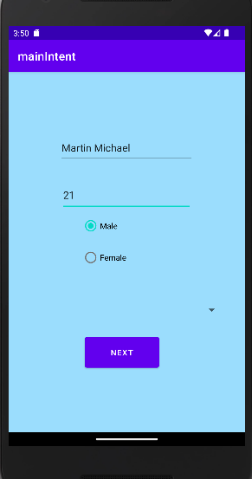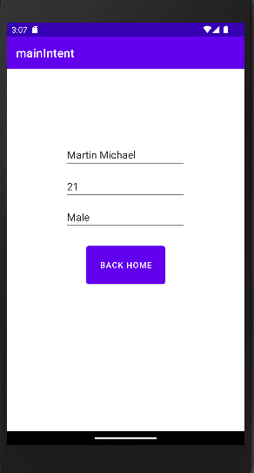

**Program 8**

**AIM: Date Picker**

# Activity_main.xml

<?xml version="1.0" encoding="utf-8"?>

<androidx.constraintlayout.widget.ConstraintLayout xmlns:android="<http://schemas.android.com/apk/res/android>"

xmlns:app="<http://schemas.android.com/apk/res-auto>" xmlns:tools="[http://schemas.android.com/tools"](http://schemas.android.com/tools) android:layout_width="match_parent" android:layout_height="match_parent" tools:context=".MainActivity" >

<DatePicker android:id="@+id/simpleDP" android:layout_width="wrap_content"

android:layout_height="wrap_content" app:layout_constraintBottom_toBottomOf="parent" app:layout_constraintEnd_toEndOf="parent" app:layout_constraintHorizontal_bias="0.491" app:layout_constraintStart_toStartOf="parent" app:layout_constraintTop_toTopOf="parent" app:layout_constraintVertical_bias="0.083"

/>

<TextView android:id="@+id/txtsimpledate" android:layout_width="104dp" android:layout_height="32dp"

app:layout_constraintBottom_toBottomOf="parent" app:layout_constraintEnd_toEndOf="parent" app:layout_constraintHorizontal_bias="0.563"

app:layout_constraintStart_toStartOf="parent" app:layout_constraintTop_toTopOf="parent" app:layout_constraintVertical_bias="0.871" />

<Button android:id="@+id/btnsubmit"

android:layout_width="wrap_content" android:layout_height="wrap_content" android:text="SUBMIT" app:layout_constraintBottom_toBottomOf="parent" app:layout_constraintEnd_toEndOf="parent" app:layout_constraintHorizontal_bias="0.509" app:layout_constraintStart_toStartOf="parent" app:layout_constraintTop_toTopOf="parent" app:layout_constraintVertical_bias="0.749" />

</androidx.constraintlayout.widget.ConstraintLayout>

# MainActivity.java

package com.example.datepicker;

import androidx.appcompat.app.AppCompatActivity; import android.graphics.Color;

import android.os.Bundle; import android.view.View; import android.widget.Button;

import android.widget.DatePicker; import android.widget.TextView; import android.widget.Toast;

public class MainActivity extends AppCompatActivity { DatePicker simpleDatePicker;

Button submit;

TextView txtdate; @Override

protected void onCreate(Bundle savedInstanceState) { super.onCreate(savedInstanceState); setContentView(R.layout.activity_main);

DatePicker ssimpleDatePicker=(DatePicker)findViewById(R.id.simpleDP); // initiate a date picker ssimpleDatePicker.setBackgroundColor(Color.YELLOW);

txtdate = (TextView) findViewById(R.id.txtsimpledate); simpleDatePicker = (DatePicker) findViewById(R.id.simpleDP); submit = (Button) findViewById(R.id.btnsubmit);

// perform click event on submit button submit.setOnClickListener(new View.OnClickListener() {

@Override

public void onClick(View v) {

// get the values for day of month , month and year from a date picker String day = "" + simpleDatePicker.getDayOfMonth();

String month = "/" + (simpleDatePicker.getMonth() + 1); String year = "/" + simpleDatePicker.getYear();

// display the values by using a toast

// Toast.makeText(getApplicationContext(), day + "\n" + month + "\n" + year, Toast.LENGTH_LONG).show();

Toast.makeText(getApplicationContext(), day + "" + month + "" + year, Toast.LENGTH_LONG).show();

txtdate.setText(day + "" + month + "" + year);

}

});

}

}

# Output

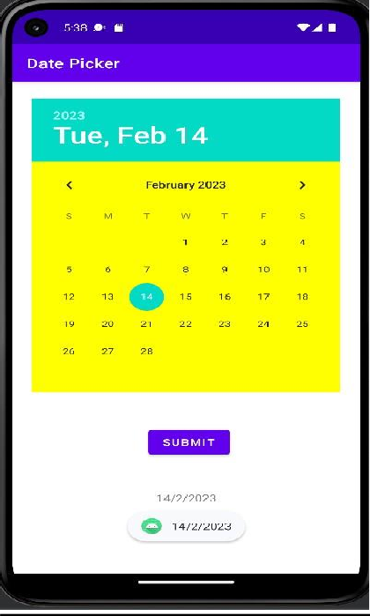

**Program 9**

**AIM: Develop an application to illustrate android lifecycle.**

# Activity_main.xml

package com.example.demo;

import androidx.appcompat.app.AppCompatActivity; import android.os.Bundle;

import android.util.Log;

public class MainActivity extends AppCompatActivity { @Override

protected void onCreate(Bundle savedInstanceState) { super.onCreate(savedInstanceState); setContentView(R.layout.activity_main); Log.d("lifecycle","onCreate invoked");

}

@Override

protected void onStart() { super.onStart();

Log.d("lifecycle","onStart invoked");

}

@Override

protected void onResume() { super.onResume();

Log.d("lifecycle","onResume invoked");

}

@Override

protected void onPause() { super.onPause();

Log.d("lifecycle","onPause invoked");

}

@Override

protected void onStop() { super.onStop();

Log.d("lifecycle","onStop invoked");

}

@Override

protected void onRestart() { super.onRestart();

Log.d("lifecycle","onRestart invoked");

}

@Override

protected void onDestroy() { super.onDestroy();

Log.d("lifecycle","onDestroy invoked");

}

}

# Output

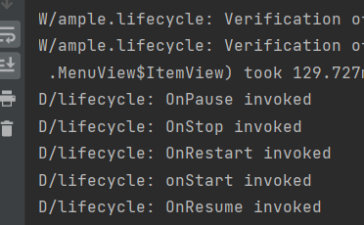

**Program 10**

**AIM: Develop an application to perform arithmetic operations with options Menu**

# Activity_main.xml

<?xml version="1.0" encoding="utf-8"?>

<androidx.constraintlayout.widget.ConstraintLayout xmlns:android="<http://schemas.android.com/apk/res/android>"

xmlns:app="<http://schemas.android.com/apk/res-auto>" xmlns:tools="[http://schemas.android.com/tools"](http://schemas.android.com/tools) android:layout_width="match_parent" android:layout_height="match_parent" tools:context=".MainActivity">

<EditText android:id="@+id/n2"

android:layout_width="wrap_content" android:layout_height="wrap_content" android:ems="10" android:inputType="textPersonName" app:layout_constraintBottom_toBottomOf="parent" app:layout_constraintEnd_toEndOf="parent" app:layout_constraintHorizontal_bias="0.92" app:layout_constraintStart_toStartOf="parent" app:layout_constraintTop_toTopOf="parent" app:layout_constraintVertical_bias="0.386" />

<EditText android:id="@+id/n3"

android:layout_width="wrap_content" android:layout_height="wrap_content" android:ems="10" android:inputType="textPersonName" app:layout_constraintBottom_toBottomOf="parent" app:layout_constraintEnd_toEndOf="parent" app:layout_constraintHorizontal_bias="0.855" app:layout_constraintStart_toStartOf="parent" app:layout_constraintTop_toTopOf="parent" app:layout_constraintVertical_bias="0.747" />

<TextView android:id="@+id/textView3"

android:layout_width="wrap_content" android:layout_height="wrap_content" android:text="Result" app:layout_constraintBottom_toBottomOf="parent" app:layout_constraintEnd_toEndOf="parent" app:layout_constraintHorizontal_bias="0.155" app:layout_constraintStart_toStartOf="parent" app:layout_constraintTop_toTopOf="parent" app:layout_constraintVertical_bias="0.757" />

<TextView android:id="@+id/textView2"

android:layout_width="wrap_content" android:layout_height="wrap_content" android:text="Second Number" app:layout_constraintBottom_toBottomOf="parent" app:layout_constraintEnd_toEndOf="parent" app:layout_constraintHorizontal_bias="0.188" app:layout_constraintStart_toStartOf="parent" app:layout_constraintTop_toTopOf="parent" app:layout_constraintVertical_bias="0.391" />

<TextView android:id="@+id/textView"

android:layout_width="wrap_content" android:layout_height="wrap_content" android:text="First Number" app:layout_constraintBottom_toBottomOf="parent" app:layout_constraintEnd_toEndOf="parent" app:layout_constraintHorizontal_bias="0.188" app:layout_constraintStart_toStartOf="parent" app:layout_constraintTop_toTopOf="parent" app:layout_constraintVertical_bias="0.28" />

<EditText android:id="@+id/n1"

android:layout_width="wrap_content" android:layout_height="wrap_content" android:ems="10" android:inputType="textPersonName" app:layout_constraintBottom_toBottomOf="parent" app:layout_constraintEnd_toEndOf="parent" app:layout_constraintHorizontal_bias="0.85" app:layout_constraintStart_toStartOf="parent" app:layout_constraintTop_toTopOf="parent" app:layout_constraintVertical_bias="0.263" />

</androidx.constraintlayout.widget.ConstraintLayout>

# MainActivity.java

package com.example.menucalculator;

import androidx.appcompat.app.AppCompatActivity; import android.content.ClipData;

import android.os.Bundle; import android.view.Menu; import android.view.MenuItem; import android.widget.EditText;

public class MainActivity extends AppCompatActivity { EditText t1,t2,t3; @Override

protected void onCreate(Bundle savedInstanceState) { super.onCreate(savedInstanceState); setContentView(R.layout.activity_main);

t1=(EditText) findViewById(R.id.n1); t2=(EditText) findViewById(R.id.n2); t3=(EditText) findViewById(R.id.n3);

}

@Override

public boolean onCreateOptionsMenu(Menu menu)

{

getMenuInflater().inflate(R.menu.functions,menu); return true;

}

@Override

public boolean onOptionsItemSelected(MenuItem item)

{

int a,b,c; a=Integer.parseInt(t1.getText().toString()); b=Integer.parseInt(t2.getText().toString()); switch(item.getItemId())

{

case R.id.add: c=a+b; t3.setText(c); case R.id.Subtract: c=a-b; t3.setText(c); case R.id.Multiply: c=a*b; t3.setText(c); case R.id.Divide: c=a/b; t3.setText(c); default: return false;

}

}

}

# Functions.xml

<?xml version="1.0" encoding="utf-8"?>

<menu xmlns:app="<http://schemas.android.com/apk/res-auto>" xmlns:android="<http://schemas.android.com/apk/res/android>">

<item android:id="@+id/add" android:title="ADD" />

<item android:id="@+id/Subtract" android:title="Subtract" />

<item android:id="@+id/Multiply" android:title="Multiply" />

<item android:id="@+id/Divide" android:title="Divide" />

</menu>

# Output

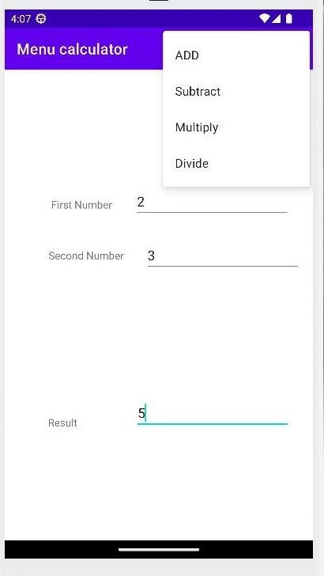

**Program 11**

**AIM: Develop an application to show a list of fruits and vegetables in popup menu.**

# Activity_main.xml

<?xml version="1.0" encoding="utf-8"?>

<androidx.constraintlayout.widget.ConstraintLayout xmlns:android="<http://schemas.android.com/apk/res/android>"

xmlns:app="<http://schemas.android.com/apk/res-auto>" xmlns:tools="[http://schemas.android.com/tools"](http://schemas.android.com/tools) android:layout_width="match_parent" android:layout_height="match_parent" tools:context=".MainActivity">

<Button android:id="@+id/button"

android:layout_width="wrap_content" android:layout_height="wrap_content" android:text="Button" tools:layout_editor_absoluteX="158dp" tools:layout_editor_absoluteY="341dp" />

</androidx.constraintlayout.widget.ConstraintLayout>

# MainActivity.java

package com.example.popupmenu;

import androidx.appcompat.app.AppCompatActivity; import android.os.Bundle;

import android.view.MenuItem; import android.view.View; import android.widget.Button; import android.widget.PopupMenu; import android.widget.Toast;

public class MainActivity extends AppCompatActivity { Button button; @Override

protected void onCreate(Bundle savedInstanceState) { super.onCreate(savedInstanceState); setContentView(R.layout.activity_main); button=(Button) findViewById((R.id.button)); button.setOnClickListener(new View.OnClickListener() {

@Override

public void onClick(View v) {

PopupMenu popup=new PopupMenu(MainActivity.this,button); popup.getMenuInflater().inflate(R.menu.popupmenu,popup.getMenu());

popup.setOnMenuItemClickListener(new PopupMenu.OnMenuItemClickListener() { @Override

public boolean onMenuItemClick(MenuItem item) { Toast.makeText(MainActivity.this, "You Clicked" + item.getTitle(),

Toast.LENGTH_SHORT).show(); return true;

}

});

});

}

}

popup.show();

}

# PopupMenu.xml

<?xml version="1.0" encoding="utf-8"?>

<menu xmlns:android="<http://schemas.android.com/apk/res/android>">

<item android:id="@+id/one" android:title="one" />

<item android:id="@+id/two" android:title="two" />

<item android:id="@+id/three" android:title="three" />

</menu>

# Output

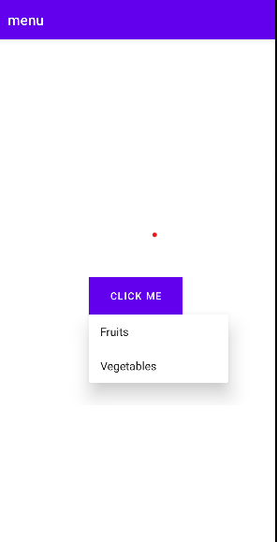

**Program 12**

**AIM:Develop an application to show phone contacts using context menu.**

# MainActivity.java

package com.test.app2;

import androidx.annotation.NonNull;

import androidx.appcompat.app.AppCompatActivity; import android.content.Context;

import android.os.Bundle;

import android.view.ContextMenu; import android.view.Menu;

import android.view.MenuInflater; import android.view.MenuItem; import android.view.View;

import android.widget.ArrayAdapter; import android.widget.Button; import android.widget.ListView; import android.widget.PopupMenu; import android.widget.Toast;

public class MainActivity extends AppCompatActivity { ListView lv;

Button b1;

String contacts[] = {"Anandhu", "Amal", "Anit", "Ananthalakshmi"};

@Override

protected void onCreate(Bundle savedInstanceState) { super.onCreate(savedInstanceState);

setContentView(R.layout.activity_main); b1 = (Button) findViewById(R.id.btn1);

b1.setOnClickListener(new View.OnClickListener() { @Override

public void onClick(View v) {

PopupMenu popup = new PopupMenu(MainActivity.this, b1); popup.getMenuInflater().inflate(R.menu.popupmenu, popup.getMenu()); popup.setOnMenuItemClickListener(new PopupMenu.OnMenuItemClickListener() {

@Override

public boolean onMenuItemClick(MenuItem item) { Toast.makeText(MainActivity.this, "You Clicked " + item.getTitle(),

Toast.LENGTH_LONG).show();

return true;

}

});

popup.show();

}

});

lv = (ListView) findViewById(R.id.lv);

ArrayAdapter<String> adapter = new ArrayAdapter<String>(this, android.R.layout.simple_list_item_1, contacts);

lv.setAdapter(adapter);

registerForContextMenu(lv);

}

@Override

public void onCreateContextMenu(ContextMenu menu, View v, ContextMenu.ContextMenuInfo menuinfo) {

super.onCreateContextMenu(menu, v, menuinfo); MenuInflater inflater = getMenuInflater(); inflater.inflate(R.menu.cmenu, menu); menu.setHeaderTitle("select the Action");

}

@Override

public boolean onContextItemSelected(MenuItem item) { if (item.getItemId() == R.id.cl) {

Toast.makeText(getApplicationContext(), "Calling", Toast.LENGTH_SHORT).show();

} else if (item.getItemId() == R.id.ms) {

Toast.makeText(getApplicationContext(), "Message Sent", Toast.LENGTH_SHORT).show();

} else { return false;

}

return true;

}

@Override

public boolean onCreateOptionsMenu(Menu menu)

{

getMenuInflater().inflate(R.menu.opt1menu,menu); return true;

}

@Override

public boolean onOptionsItemSelected(MenuItem item)

{

Toast.makeText(this,"Selected Item " + item.getTitle(),Toast.LENGTH_LONG).show(); switch (item.getItemId()){

case R.id.cp: return true;

case R.id.ps:

return true; case R.id.ct:

return true; case R.id.sh:

return true; default:

return super.onOptionsItemSelected(item);

}

}

}

}

# Activity_main.xml

<?xml version="1.0" encoding="utf-8"?>

<androidx.constraintlayout.widget.ConstraintLayout xmlns:android="<http://schemas.android.com/apk/res/android>"

xmlns:app="<http://schemas.android.com/apk/res-auto>" xmlns:tools="<http://schemas.android.com/tools>" android:layout_width="match_parent" android:layout_height="match_parent" tools:context=".MainActivity">

<ListView android:id="@+id/lv" android:layout_width="347dp"

android:layout_height="316dp" app:layout_constraintBottom_toBottomOf="parent" app:layout_constraintEnd_toEndOf="parent" app:layout_constraintStart_toStartOf="parent"

app:layout_constraintTop_toTopOf="parent" app:layout_constraintVertical_bias="0.151" />

<Button android:id="@+id/btn1"

android:layout_width="wrap_content" android:layout_height="wrap_content"

android:text="Click" app:layout_constraintBottom_toBottomOf="parent"

app:layout_constraintEnd_toEndOf="parent" app:layout_constraintHorizontal_bias="0.458" app:layout_constraintStart_toStartOf="parent" app:layout_constraintTop_toTopOf="parent"

app:layout_constraintVertical_bias="0.721" />

</androidx.constraintlayout.widget.ConstraintLayout>

# Cmenu.xml

<?xml version="1.0" encoding="utf-8"?>

<menu xmlns:app=["http:](http://schemas.android.com/apk/res-auto)/[/schemas.android.com/apk/res-auto](http://schemas.android.com/apk/res-auto)" xmlns:android=["http:](http://schemas.android.com/apk/res/android)/[/schemas.android.com/apk/res/android](http://schemas.android.com/apk/res/android)">

<item android:id="@+id/cl" android:title="Call" />

<item android:id="@+id/ms" android:title="Message" />

</menu>

# Opt1menu.xml

<?xml version="1.0" encoding="utf-8"?>

<menu xmlns:app=["http:](http://schemas.android.com/apk/res-auto)/[/schemas.android.com/apk/res-auto](http://schemas.android.com/apk/res-auto)" xmlns:android=["http:](http://schemas.android.com/apk/res/android)/[/schemas.android.com/apk/res/android](http://schemas.android.com/apk/res/android)">

<item android:id="@+id/cp" android:title="Copy" />

<item android:id="@+id/ps" android:title="Paste" />

<item android:id="@+id/ct" android:title="Cut" />

<item android:id="@+id/sh" android:title="Share" />

</menu>

# Mfile.xml

<?xml version="1.0" encoding="utf-8"?>

<menu xmlns:android="<http://schemas.android.com/apk/res/android>">

<item

android:id="@+id/one" android:title="Go Back" />

<item android:id="@+id/two"

android:title="Go back to home" />

</menu>

# Output

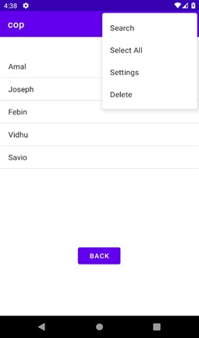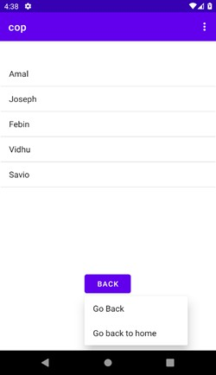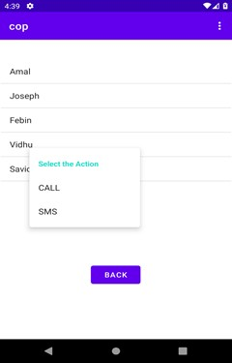

**Program 13**

**AIM: Develop an FM Radio with scan button to save the stations and select the saved stations using PREVIOUS and NEXT Buttons.**

# Activity_main.xml

<?xml version="1.0" encoding="utf-8"?>

<androidx.constraintlayout.widget.ConstraintLayout xmlns:android="<http://schemas.android.com/apk/res/android>"

xmlns:app="<http://schemas.android.com/apk/res-auto>" xmlns:tools="[http://schemas.android.com/tools"](http://schemas.android.com/tools) android:layout_width="match_parent" android:layout_height="match_parent" tools:context=".MainActivity">

<Button android:id="@+id/btn_pre" android:layout_width="90dp" android:layout_height="49dp" android:text="pre" android:textSize="16sp"

app:layout_constraintBottom_toBottomOf="parent" app:layout_constraintEnd_toEndOf="parent" app:layout_constraintHorizontal_bias="0.563" app:layout_constraintStart_toStartOf="parent" app:layout_constraintTop_toTopOf="parent" app:layout_constraintVertical_bias="0.307" />

<Button android:id="@+id/btn_nxt" android:layout_width="90dp" android:layout_height="49dp" android:text="nxt" android:textSize="16sp"

app:layout_constraintBottom_toBottomOf="parent" app:layout_constraintEnd_toEndOf="parent" app:layout_constraintHorizontal_bias="0.887" app:layout_constraintStart_toStartOf="parent" app:layout_constraintTop_toTopOf="parent" app:layout_constraintVertical_bias="0.307" />

<TextView android:id="@+id/head_txtv" android:layout_width="409dp" android:layout_height="80dp" android:background="#63F17B" android:gravity="center" android:text="FM Radio Frequency" android:textAlignment="gravity" android:textColor="#FFFFFF" android:textSize="24sp" android:textStyle="bold|italic"

app:layout_constraintBottom_toBottomOf="parent" app:layout_constraintEnd_toEndOf="parent" app:layout_constraintHorizontal_bias="0.011" app:layout_constraintStart_toStartOf="parent" app:layout_constraintTop_toTopOf="parent" app:layout_constraintVertical_bias="0.003" />

<EditText android:id="@+id/freq_edtxt" android:layout_width="253dp" android:layout_height="52dp" android:ems="10" android:gravity="center" android:hint="FM Frequency"

android:inputType="textPersonName" app:layout_constraintBottom_toBottomOf="parent" app:layout_constraintEnd_toEndOf="parent" app:layout_constraintHorizontal_bias="0.452" app:layout_constraintStart_toStartOf="parent" app:layout_constraintTop_toBottomOf="@+id/head_txtv" app:layout_constraintVertical_bias="0.072"

/>

<Button android:id="@+id/btn_scan" android:layout_width="135dp" android:layout_height="53dp" android:text="Scan"

app:layout_constraintBottom_toBottomOf="parent" app:layout_constraintEnd_toEndOf="parent" app:layout_constraintHorizontal_bias="0.101" app:layout_constraintStart_toStartOf="parent" app:layout_constraintTop_toTopOf="parent" app:layout_constraintVertical_bias="0.309" />

<TextView android:id="@+id/list_txt"

android:layout_width="149dp" android:layout_height="230dp" android:gravity="center|top" android:textSize="14sp" app:layout_constraintBottom_toBottomOf="parent" app:layout_constraintEnd_toEndOf="parent" app:layout_constraintHorizontal_bias="0.9"

app:layout_constraintStart_toStartOf="parent" app:layout_constraintTop_toTopOf="parent" app:layout_constraintVertical_bias="0.706" />

<TextView android:id="@+id/txt_channel" android:layout_width="149dp" android:layout_height="38dp" android:gravity="bottom|center" android:text="Channel List" android:textStyle="bold|italic"

app:layout_constraintBottom_toBottomOf="parent" app:layout_constraintEnd_toEndOf="parent" app:layout_constraintHorizontal_bias="0.9" app:layout_constraintStart_toStartOf="parent" app:layout_constraintTop_toTopOf="parent" app:layout_constraintVertical_bias="0.455" />

</androidx.constraintlayout.widget.ConstraintLayout>

**MainActivity.java**

package com.example.fm;

import androidx.appcompat.app.AppCompatActivity; import android.content.SharedPreferences;

import android.os.Bundle; import android.view.View; import android.widget.Button; import android.widget.EditText; import android.widget.TextView;

import java.util.ArrayList; import java.util.List; import java.util.HashSet; import java.util.Set; public class MainActivity extends AppCompatActivity { EditText e1;

Button b1,b2,b3; TextView t1; int counter = 0;

@Override

protected void onCreate(Bundle savedInstanceState) { super.onCreate(savedInstanceState); setContentView(R.layout.activity_main);

e1 = (EditText) findViewById(R.id.freq_edtxt); b1 = (Button) findViewById(R.id.btn_scan); b2 = (Button) findViewById(R.id.btn_pre);

b3 = (Button) findViewById(R.id.btn_nxt); t1 = (TextView) findViewById(R.id.list_txt);

SharedPreferences sp = getSharedPreferences("mychannel",MODE_PRIVATE); List<String> items = new ArrayList<String>();

items.add("89.15");

items.add("89.45");

items.add("90.00");

items.add("98.75");

items.add("99.15");

items.add("102.3");

Set<String> itemsSet = new HashSet<String>(items); SharedPreferences.Editor ed = sp.edit(); ed.putStringSet("items", itemsSet);

ed.apply();

b1.setOnClickListener(new View.OnClickListener() { @Override public void onClick(View view) {

SharedPreferences sp = getSharedPreferences("mychannel",MODE_PRIVATE); Set<String> itemsSet = sp.getStringSet("items", new HashSet<String>()); List<String> itemsList = new ArrayList<String>(itemsSet);

// Loop through the items and add them to the TextView StringBuilder stringBuilder = new StringBuilder();

for (String item : itemsList) { stringBuilder.append(item).append("\n");

}

t1.setText(stringBuilder.toString());

if (itemsList.size() > 0) { e1.setText(itemsList.get(counter));

}

}

});

b2.setOnClickListener(new View.OnClickListener() {

@Override

public void onClick(View view) {

SharedPreferences sp = getSharedPreferences("mychannel",MODE_PRIVATE); Set<String> itemsSet = sp.getStringSet("items", new HashSet<String>()); List<String> itemsList = new ArrayList<String>(itemsSet);

counter--;

if (counter < 0) {

counter = itemsList.size() - 1;

}

});

}

e1.setText(itemsList.get(counter)); b3.setOnClickListener(new View.OnClickListener() { @Override public void onClick(View view) {

SharedPreferences sp = getSharedPreferences("mychannel",MODE_PRIVATE); Set<String> itemsSet = sp.getStringSet("items", new HashSet<String>()); List<String> itemsList = new ArrayList<String>(itemsSet);

counter++;

if (counter >= itemsList.size()) { counter = 0;

}

});

}

}

# Output

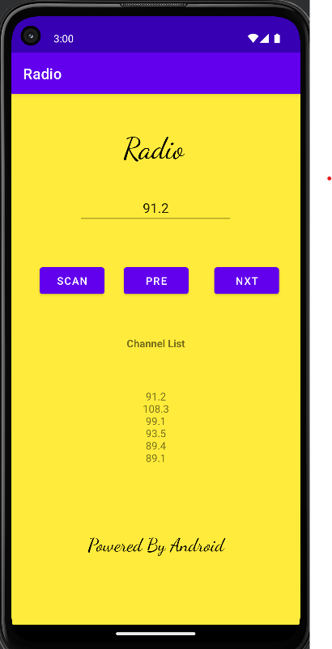

**Program 14**

**AIM: Develop an ordinary calculator with memory options.**

# Activity_main.xml

<?xml version="1.0" encoding="utf-8"?>

<androidx.constraintlayout.widget.ConstraintLayout xmlns:android="<http://schemas.android.com/apk/res/android>" xmlns:app="<http://schemas.android.com/apk/res-auto>" xmlns:tools="[http://schemas.android.com/tools"](http://schemas.android.com/tools) android:layout_width="match_parent" android:layout_height="match_parent" tools:context=".MainActivity">

<Button android:id="@+id/btnequal" android:layout_width="77dp" android:layout_height="54dp" android:onClick="equalEvent" android:text="="

app:layout_constraintBottom_toBottomOf="parent"

app:layout_constraintEnd_toEndOf="parent" app:layout_constraintHorizontal_bias="0.889" app:layout_constraintStart_toStartOf="parent" app:layout_constraintTop_toTopOf="parent" app:layout_constraintVertical_bias="0.822" />

<Button android:id="@+id/btndiv" android:layout_width="61dp" android:layout_height="50dp" android:text="/"

android:onClick="operatorEvent" app:layout_constraintBottom_toBottomOf="parent" app:layout_constraintEnd_toEndOf="parent" app:layout_constraintHorizontal_bias="0.894" app:layout_constraintStart_toStartOf="parent" app:layout_constraintTop_toTopOf="parent" app:layout_constraintVertical_bias="0.433" />

<Button android:id="@+id/btnmul" android:layout_width="61dp" android:layout_height="50dp" android:text="*" android:onClick="operatorEvent"

app:layout_constraintBottom_toBottomOf="parent" app:layout_constraintEnd_toEndOf="parent" app:layout_constraintHorizontal_bias="0.894" app:layout_constraintStart_toStartOf="parent" app:layout_constraintTop_toTopOf="parent" app:layout_constraintVertical_bias="0.533" />

<Button android:id="@+id/btnadd" android:layout_width="61dp" android:layout_height="50dp" android:text="+"

android:onClick="operatorEvent" app:layout_constraintBottom_toBottomOf="parent" app:layout_constraintEnd_toEndOf="parent" app:layout_constraintHorizontal_bias="0.894" app:layout_constraintStart_toStartOf="parent" app:layout_constraintTop_toTopOf="parent" app:layout_constraintVertical_bias="0.628" />

<Button android:id="@+id/btndif" android:layout_width="61dp" android:layout_height="50dp" android:text="-"

android:onClick="operatorEvent" app:layout_constraintBottom_toBottomOf="parent" app:layout_constraintEnd_toEndOf="parent" app:layout_constraintHorizontal_bias="0.894" app:layout_constraintStart_toStartOf="parent" app:layout_constraintTop_toTopOf="parent" app:layout_constraintVertical_bias="0.715" />

<Button android:id="@+id/zero" android:layout_width="61dp" android:layout_height="50dp" android:onClick="numberEvent" android:text="0"

app:layout_constraintBottom_toBottomOf="parent" app:layout_constraintEnd_toEndOf="parent" app:layout_constraintHorizontal_bias="0.308" app:layout_constraintStart_toStartOf="parent" app:layout_constraintTop_toTopOf="parent" app:layout_constraintVertical_bias="0.823" />

<Button android:id="@+id/seven" android:layout_width="61dp" android:layout_height="50dp"

android:onClick="numberEvent" android:text="7"

app:layout_constraintBottom_toBottomOf="parent" app:layout_constraintEnd_toEndOf="parent" app:layout_constraintHorizontal_bias="0.088" app:layout_constraintStart_toStartOf="parent" app:layout_constraintTop_toTopOf="parent" app:layout_constraintVertical_bias="0.715" />

<Button android:id="@+id/eight" android:layout_width="61dp" android:layout_height="50dp"

android:onClick="numberEvent" android:text="8"

app:layout_constraintBottom_toBottomOf="parent" app:layout_constraintEnd_toEndOf="parent" app:layout_constraintHorizontal_bias="0.308" app:layout_constraintStart_toStartOf="parent" app:layout_constraintTop_toTopOf="parent" app:layout_constraintVertical_bias="0.715" />

<Button android:id="@+id/nine" android:layout_width="61dp" android:layout_height="50dp" android:onClick="numberEvent" android:text="9"

app:layout_constraintBottom_toBottomOf="parent" app:layout_constraintEnd_toEndOf="parent" app:layout_constraintHorizontal_bias="0.548" app:layout_constraintStart_toStartOf="parent" app:layout_constraintTop_toTopOf="parent" app:layout_constraintVertical_bias="0.715" />

<Button android:id="@+id/btn_mmc" android:layout_width="65dp" android:layout_height="49dp"

android:onClick="memoryClearEvent" android:text="MC" app:layout_constraintBottom_toBottomOf="parent" app:layout_constraintEnd_toEndOf="parent" app:layout_constraintHorizontal_bias="0.686" app:layout_constraintStart_toStartOf="parent" app:layout_constraintTop_toTopOf="parent" app:layout_constraintVertical_bias="0.364" />

<Button android:id="@+id/btn_mplus" android:layout_width="61dp" android:layout_height="48dp" android:onClick="memoryPlusEvent"

android:text="M+" app:layout_constraintBottom_toBottomOf="parent" app:layout_constraintEnd_toEndOf="parent" app:layout_constraintHorizontal_bias="0.088" app:layout_constraintStart_toStartOf="parent" app:layout_constraintTop_toTopOf="parent" app:layout_constraintVertical_bias="0.361" />

<Button android:id="@+id/btn_mmr" android:layout_width="67dp" android:layout_height="49dp"

android:onClick="memoryRecallEvent" android:text="MR" app:layout_constraintBottom_toBottomOf="parent" app:layout_constraintEnd_toEndOf="parent" app:layout_constraintHorizontal_bias="0.482" app:layout_constraintStart_toStartOf="parent" app:layout_constraintTop_toTopOf="parent" app:layout_constraintVertical_bias="0.362" />

<Button android:id="@+id/btn_mminus" android:layout_width="56dp" android:layout_height="48dp"

android:onClick="memoryMinusEvent" android:text="M-" app:layout_constraintBottom_toBottomOf="parent" app:layout_constraintEnd_toEndOf="parent" app:layout_constraintHorizontal_bias="0.284" app:layout_constraintStart_toStartOf="parent" app:layout_constraintTop_toTopOf="parent"

app:layout_constraintVertical_bias="0.361" />

<Button android:id="@+id/one"

android:layout_width="61dp" android:layout_height="50dp" android:onClick="numberEvent" android:text="1"

app:layout_constraintBottom_toBottomOf="parent" app:layout_constraintEnd_toEndOf="parent" app:layout_constraintHorizontal_bias="0.088" app:layout_constraintStart_toStartOf="parent" app:layout_constraintTop_toTopOf="parent" app:layout_constraintVertical_bias="0.499" />

<Button

android:id="@+id/two" android:layout_width="61dp" android:layout_height="50dp" android:onClick="numberEvent" android:text="2"

app:layout_constraintBottom_toBottomOf="parent" app:layout_constraintEnd_toEndOf="parent" app:layout_constraintHorizontal_bias="0.308" app:layout_constraintStart_toStartOf="parent" app:layout_constraintTop_toTopOf="parent" app:layout_constraintVertical_bias="0.499" />

<Button android:id="@+id/three" android:layout_width="61dp" android:layout_height="50dp"

android:onClick="numberEvent" android:text="3"

app:layout_constraintBottom_toBottomOf="parent" app:layout_constraintEnd_toEndOf="parent" app:layout_constraintHorizontal_bias="0.548" app:layout_constraintStart_toStartOf="parent" app:layout_constraintTop_toTopOf="parent" app:layout_constraintVertical_bias="0.499" />

<Button android:id="@+id/four" android:layout_width="61dp" android:layout_height="50dp" android:onClick="numberEvent" android:text="4"

app:layout_constraintBottom_toBottomOf="parent" app:layout_constraintEnd_toEndOf="parent" app:layout_constraintHorizontal_bias="0.088" app:layout_constraintStart_toStartOf="parent" app:layout_constraintTop_toTopOf="parent" app:layout_constraintVertical_bias="0.606" />

<Button android:id="@+id/five"

android:layout_width="61dp" android:layout_height="50dp" android:onClick="numberEvent" android:text="5"

app:layout_constraintBottom_toBottomOf="parent" app:layout_constraintEnd_toEndOf="parent" app:layout_constraintHorizontal_bias="0.308" app:layout_constraintStart_toStartOf="parent"

app:layout_constraintTop_toTopOf="parent" app:layout_constraintVertical_bias="0.606" />

<Button android:id="@+id/six"

android:layout_width="61dp" android:layout_height="50dp" android:onClick="numberEvent" android:text="6"

app:layout_constraintBottom_toBottomOf="parent" app:layout_constraintEnd_toEndOf="parent" app:layout_constraintHorizontal_bias="0.548" app:layout_constraintStart_toStartOf="parent" app:layout_constraintTop_toTopOf="parent" app:layout_constraintVertical_bias="0.606" />

<EditText android:id="@+id/output" android:layout_width="386dp" android:layout_height="53dp" android:ems="10" android:hint="Enter number:"

android:inputType="textPersonName" app:layout_constraintBottom_toBottomOf="parent" app:layout_constraintEnd_toEndOf="parent" app:layout_constraintHorizontal_bias="0.154" app:layout_constraintStart_toStartOf="parent" app:layout_constraintTop_toTopOf="parent" app:layout_constraintVertical_bias="0.199" />

</androidx.constraintlayout.widget.ConstraintLayout>

**MainActivity.java**

package com.example.calc;

import androidx.appcompat.app.AppCompatActivity; import android.content.Context; import android.content.SharedPreferences; import android.os.Bundle;

import android.view.View; import android.widget.EditText;

public class MainActivity extends AppCompatActivity { double memory = 0.0; boolean isNewOperator = true; EditText edt1;

String operator = "+"; String initialNumber = "";

static final String PREFS_NAME = "MyPrefsFile"; static final String MEMORY_KEY = "memory"; @Override

protected void onCreate(Bundle savedInstanceState) {

super.onCreate(savedInstanceState); setContentView(R.layout.activity_main); edt1 = findViewById(R.id.output);

SharedPreferences sharedPrefs = getSharedPreferences(PREFS_NAME, Context.MODE_PRIVATE); memory = sharedPrefs.getFloat(MEMORY_KEY, 0); edt1.setText(String.valueOf(memory));

}

public void numberEvent(View view) { if (isNewOperator) edt1.setText(""); isNewOperator = false;

String number = edt1.getText().toString(); if (view.getId() == R.id.one) { number += "1";

} else if (view.getId() == R.id.two) { number += "2";

} else if (view.getId() == R.id.three) { number += "3";

} else if (view.getId() == R.id.four) { number += "4";

} else if (view.getId() == R.id.five) { number += "5";

} else if (view.getId() == R.id.six) { number += "6";

} else if (view.getId() == R.id.seven) { number += "7";

} else if (view.getId() == R.id.eight) { number += "8";

} else if (view.getId() == R.id.nine) { number += "9";

} else if (view.getId() == R.id.zero) { number += "0";

}

edt1.setText(number);

}

public void operatorEvent(View view) { isNewOperator = true; initialNumber = edt1.getText().toString();

if (view.getId() == R.id.btnmul) { operator = "*";

} else if (view.getId() == R.id.btndif) { operator = "-";

} else if (view.getId() == R.id.btndiv) { operator = "/";

} else if (view.getId() == R.id.btnadd) { operator = "+";

}

}

public void equalEvent(View view) {

String newNumber = edt1.getText().toString(); int output = 0; if (operator == "+")

output = Integer.parseInt(initialNumber) + Integer.parseInt(newNumber); if (operator == "/") output = Integer.parseInt(initialNumber) / Integer.parseInt(newNumber); if (operator == "*") output = Integer.parseInt(initialNumber) * Integer.parseInt(newNumber); if (operator == "-") output = Integer.parseInt(initialNumber) - Integer.parseInt(newNumber); edt1.setText(output + "");

// Save memory to shared preferences

SharedPreferences sharedPrefs = getSharedPreferences(PREFS_NAME, Context.MODE_PRIVATE); SharedPreferences.Editor editor = sharedPrefs.edit();

editor.putFloat(MEMORY_KEY, (float) output); editor.apply();

}

public void memoryPlusEvent(View view) { String number = edt1.getText().toString(); int value = Integer.parseInt(number); memory += value;

}

public void memoryMinusEvent(View view) { String number = edt1.getText().toString(); int value = Integer.parseInt(number); memory -= value;

}

public void memoryRecallEvent(View view) { edt1.setText(String.valueOf(memory));

}

public void memoryClearEvent(View view) { memory = 0; edt1.setText("");

}

}

# OUTPUT

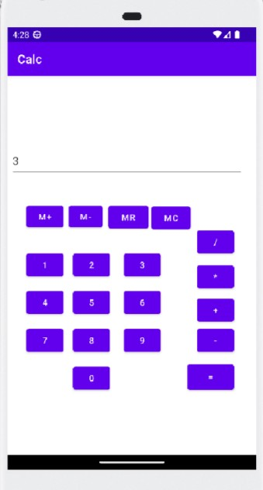

**Program 15**

**AIM: Develop an alert dialog for confirmation on exit.**

# Activity_main.xml

<?xml version="1.0" encoding="utf-8"?>

<androidx.constraintlayout.widget.ConstraintLayout

xmlns:android="[http://schemas.android.com/apk/res/](http://schemas.android.com/apk/res/android) [android](http://schemas.android.com/apk/res/android)" xmlns:app="[http://schemas.android.com/apk/res-](http://schemas.android.com/apk/res-auto) [auto](http://schemas.android.com/apk/res-auto)" xmlns:tools="[http://schemas.android.com/tools"](http://schemas.android.com/tools) android:layout_width="match_parent" android:layout_height="match_parent" tools:context=".MainActivity">

<Button android:id="@+id/alert_ btn" android:layout_width="1 77dp" android:layout_height=" 67dp" android:cursorVisible="tr ue" android:text="Delete" app:cornerRadius="15dp "

app:layout_constraintBottom_toBottomOf="parent" app:layout_constraintEnd_toEndOf="parent" app:layout_constraintStart_toStartOf="parent" app:layout_constraintTop_toTopOf="parent" />

</androidx.constraintlayout.widget.ConstraintLayout>

**MainActivity.java**

package com.example.delalert;

import androidx.appcompat.app.AlertDialog;

import androidx.appcompat.app.AppCompatActivity; import android.content.DialogInterface;

import android.os.Bundle; import android.view.View; import android.widget.Button; import com.example.delalert.R;

public class MainActivity extends AppCompatActivity { Button b1; @Override

protected void onCreate(Bundle savedInstanceState) { super.onCreate(savedInstanceState); setContentView(R.layout.activity_main);

b1 = (Button) findViewById(R.id.alert_btn); b1.setOnClickListener(new View.OnClickListener() { @Override public void onClick(View view) {

AlertDialog.Builder builder = new AlertDialog.Builder(MainActivity.this); builder.setMessage("Do you want to delete");

builder.setTitle("Alert!"); builder.setCancelable(false); builder.setPositiveButton("Yes", (DialogInterface.OnClickListener) (dialog, which) -> {

// When the user click yes button then app will close finish();

});

builder.setNegativeButton("No", (DialogInterface.OnClickListener) (dialog, which) -> {

// If user click no then dialog box is canceled. dialog.cancel();

}

});

}

}

# Output

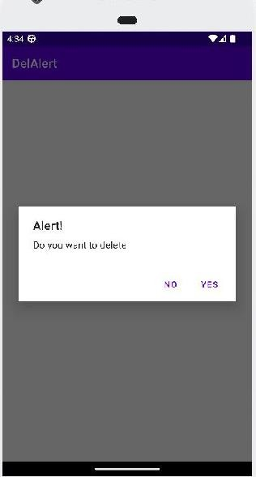

**Program 16**

**AIM:Develop a two tabbed window using Tabbed Activity and display proper messages when you switch between these tabs.**

# Activity_main.xml

<?xml version="1.0" encoding="utf-8"?>

<androidx.coordinatorlayout.widget.CoordinatorLayout xmlns:android=["htt](http://schemas.android.com/apk/res/android)p[://schemas.android.com/apk/res/android](http://schemas.android.com/apk/res/android)" xmlns:app="<http://schemas.android.com/apk/res-auto>" xmlns:tools="[http://schemas.android.com/tools"](http://schemas.android.com/tools) android:layout_width="match_parent" android:layout_height="match_parent" tools:context=".MainActivity">

<com.google.android.material.appbar.AppBarLayout android:layout_width="match_parent" android:layout_height="wrap_content" android:theme="@style/Theme.Tabact.AppBarOverlay">

<TextView android:id="@+id/title"

android:layout_width="wrap_content" android:layout_height="wrap_content" android:gravity="center" android:minHeight="?actionBarSize" android:padding="@dimen/appbar_padding" android:text="@string/app_name"

android:textAppearance="@style/TextAppearance.Widget.AppCompat.Toolbar.Title" />

<com.google.android.material.tabs.TabLayout android:id="@+id/tabs" android:layout_width="match_parent" android:layout_height="wrap_content" />

</com.google.android.material.appbar.AppBarLayout>

<androidx.viewpager.widget.ViewPager android:id="@+id/view_pager" android:layout_width="match_parent" android:layout_height="match_parent" app:layout_behavior="@string/appbar_scrolling_view_behavior" />

<com.google.android.material.floatingactionbutton.FloatingActionButton android:id="@+id/fab" android:layout_width="wrap_content"

android:layout_height="wrap_content" android:layout_gravity="bottom|end" android:layout_marginEnd="@dimen/fab_margin" android:layout_marginBottom="16dp" app:srcCompat="@android:drawable/ic_dialog_email" />

</androidx.coordinatorlayout.widget.CoordinatorLayout>

**Fragment_Main.xml**

<?xml version="1.0" encoding="utf-8"?>

<androidx.constraintlayout.widget.ConstraintLayout xmlns:android=["htt](http://schemas.android.com/apk/res/android)p[://schemas.android.com/apk/res/android](http://schemas.android.com/apk/res/android)" xmlns:app="<http://schemas.android.com/apk/res-auto>" xmlns:tools="[http://schemas.android.com/tools"](http://schemas.android.com/tools) android:id="@+id/constraintLayout"

android:layout_width="match_parent" android:layout_height="match_parent" tools:context=".ui.main.PlaceholderFragment">

<TextView android:id="@+id/section_label" android:layout_width="wrap_content" android:layout_height="wrap_content"

android:layout_marginTop="@dimen/activity_vertical_margin" app:layout_constraintBottom_toBottomOf="parent" app:layout_constraintEnd_toEndOf="parent" app:layout_constraintLeft_toLeftOf="parent" app:layout_constraintTop_toTopOf="@+id/constraintLayout" tools:layout_constraintLeft_creator="1" tools:layout_constraintTop_creator="1" />

</androidx.constraintlayout.widget.ConstraintLayout>

**MainActivity.java**

package com.example.tabb; import android.os.Bundle; import com.example.tabb.databinding.ActivityMainBinding;

import com.google.android.material.floatingactionbutton.FloatingActionButton; import com.google.android.material.snackbar.Snackbar;

import com.google.android.material.tabs.TabLayout; import androidx.viewpager.widget.ViewPager; import androidx.appcompat.app.AppCompatActivity; import android.view.Menu;

import android.view.MenuItem; import android.view.View; import com.example.tabb.ui.main.SectionsPagerAdapter; import

com.example.tabb.databinding.ActivityMainBinding; public class MainActivity extends AppCompatActivity {

private ActivityMainBinding binding; @Override

protected void onCreate(Bundle savedInstanceState) { super.onCreate(savedInstanceState); binding = ActivityMainBinding.inflate(getLayoutInflater()); setContentView(binding.getRoot());

SectionsPagerAdapter sectionsPagerAdapter = new SectionsPagerAdapter(this, getSupportFragmentManager());

ViewPager viewPager = binding.viewPager; viewPager.setAdapter(sectionsPagerAdapter); TabLayout tabs

= binding.tabs; tabs.setupWithViewPager(viewPager); FloatingActionButton fab = binding.fab; fab.setOnClickListener(new View.OnClickListener() {

@Override

public void onClick(View view) {

Snackbar.make(view, "Replace with your own action", Snackbar.LENGTH_LONG)

.setAction("Action", null).show();

}

});

}

}

# Output

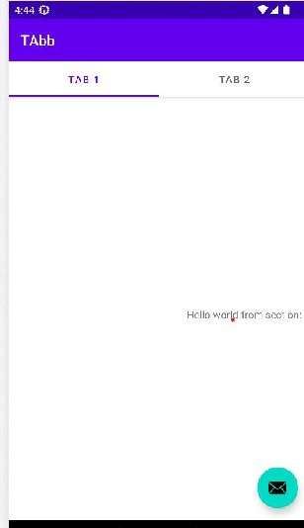

**Program 17**

**AIM: Create and apply style in your sample UI.**

# Activity_main.xml

<?xml version="1.0" encoding="utf-8"?>

<androidx.constraintlayout.widget.ConstraintLayout xmlns:android=["htt](http://schemas.android.com/apk/res/android)p[://schemas.android.com/apk/res/android](http://schemas.android.com/apk/res/android)" xmlns:app="<http://schemas.android.com/apk/res-auto>" xmlns:tools="[http://schemas.android.com/tools"](http://schemas.android.com/tools) android:layout_width="match_parent" android:layout_height="match_parent" tools:context=".MainActivity">

<TextView android:layout_width="212dp" android:layout_height="139dp" android:text="style And theme!!!!!!!!!!"

app:layout_constraintBottom_toBottomOf="parent" app:layout_constraintEnd_toEndOf="parent" app:layout_constraintStart_toStartOf="parent" app:layout_constraintTop_toTopOf="parent" style="@style/MyColor"/>

</androidx.constraintlayout.widget.ConstraintLayout>

**MainActivity.java**

package com.example.style; import

androidx.appcompat.app.AppCompatActivit y;import android.os.Bundle;

public class MainActivity extends AppCompatActivity {@Override protected void onCreate(Bundle

savedInstanceState) { super.onCreate(savedInstanceState); setContentView(R.layout.activity_main);

}

}

# STYLE.xml

<?xml version="1.0" encoding="utf-8"?>

<resources>

<style name="MyColor">

<item name="android:textSize">12pt</item>

<item name="android:textColor">#a83242</item>

</style>

<style name="AppTheme" parent="Theme.AppCompat">

<item name="backgroundColor">#000000</item>

</style> </resources>

# Output

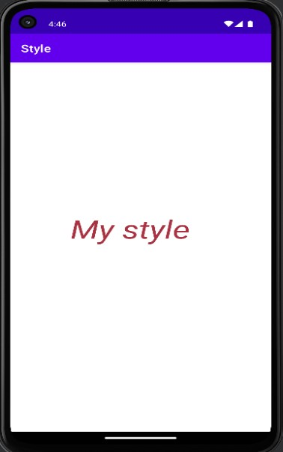

**Program 18**

**AIM: Apply a style as a theme (eg: dark theme) in your project.**

# Activity_main.xml

<?xml version="1.0" encoding="utf-8"?>

<androidx.constraintlayout.widget.ConstraintLayout xmlns:android="<http://schemas.android.com/apk/res/android>" xmlns:app="<http://schemas.android.com/apk/res-auto>" xmlns:tools="[http://schemas.android.com/tools"](http://schemas.android.com/tools) android:layout_width="match_parent" android:layout_height="match_parent" tools:context=".MainActivity">

<TextView android:layout_width="212dp" android:layout_height="139dp" android:text="style And theme!!!!!!!!!!"

app:layout_constraintBottom_toBottomOf="parent" app:layout_constraintEnd_toEndOf="parent" app:layout_constraintStart_toStartOf="parent" app:layout_constraintTop_toTopOf="parent" style="@style/MyColor"/>

</androidx.constraintlayout.widget.ConstraintLayout>

**MainActivity.java**

package com.example.style2;

import androidx.appcompat.app.AppCompatActivity; import android.os.Bundle; public class MainActivity extends AppCompatActivity { @Override

protected void onCreate(Bundle savedInstanceState) { super.onCreate(savedInstanceState); setContentView(R.layout.activity_main);

}

}

**AndroidManifest.xml**

<manifest xmlns:android="<http://schemas.android.com/apk/res/android>" xmlns:tools="[http://schemas.android.com/tools"](http://schemas.android.com/tools)>

<application android:allowBackup="true"

android:dataExtractionRules="@xml/data_extraction_rules" android:fullBackupContent="@xml/backup_rules" android:icon="@mipmap/ic_launcher" android:label="@string/app_name" android:supportsRtl="true" android:theme="@style/AppTheme"

tools:targetApi="31">

<activity android:name=".MainActivity" android:exported="true">

<intent-filter>

<action android:name="android.intent.action.MAIN" />

<category android:name="android.intent.category.LAUNCHER" />

</intent-filter>

</activity>

</application>

</manifest>

**Style.xml**

<?xml version="1.0" encoding="utf-8"?>

<resources>

<style name="MyColor">

<item name="android:textSize">12pt</item>

<item name="android:textColor">#a83242</item>

</style>

<style name="AppTheme" parent="Theme.AppCompat">

<item name="backgroundColor">#000000</item>

</style>

</resources>

# Output

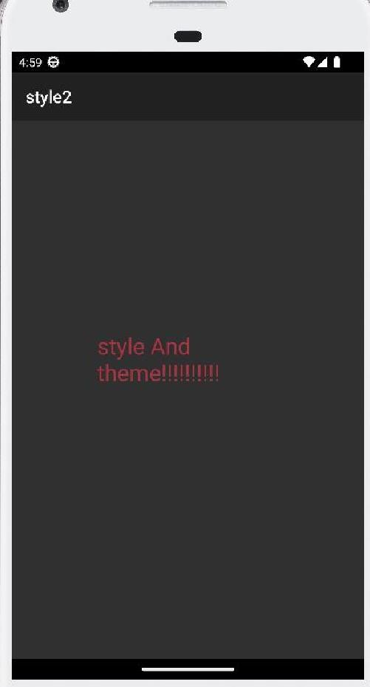

**Program 19**

**AIM: Develop an SQLite program for writing, reading, updating and deleting contacts details.**

# Activity_main.xml

<?xml version="1.0" encoding="utf-8"?>

<androidx.constraintlayout.widget.ConstraintLayout xmlns:android="<http://schemas.android.com/apk/res/android>"

xmlns:app="<http://schemas.android.com/apk/res-auto>" xmlns:tools="[http://schemas.android.com/tools"](http://schemas.android.com/tools) android:layout_width="match_parent" android:layout_height="match_parent" android:background="#95E636" tools:context=".MainActivity" tools:layout_editor_absoluteX="2dp" tools:layout_editor_absoluteY="2dp">

<Button android:id="@+id/insertBtn"

android:layout_width="wrap_content" android:layout_height="wrap_content" android:text="Insert" app:layout_constraintBottom_toBottomOf="parent" app:layout_constraintEnd_toEndOf="parent"

app:layout_constraintHorizontal_bias="0.182" app:layout_constraintStart_toStartOf="parent" app:layout_constraintTop_toTopOf="parent" app:layout_constraintVertical_bias="0.584" />

<Button android:id="@+id/updateBtn"

android:layout_width="wrap_content" android:layout_height="wrap_content" android:text="Update" app:layout_constraintBottom_toBottomOf="parent" app:layout_constraintEnd_toEndOf="parent" app:layout_constraintHorizontal_bias="0.801" app:layout_constraintStart_toStartOf="parent" app:layout_constraintTop_toTopOf="parent" app:layout_constraintVertical_bias="0.584" />

<Button android:id="@+id/showBtn"

android:layout_width="wrap_content" android:layout_height="wrap_content" android:text="show" app:layout_constraintBottom_toBottomOf="parent" app:layout_constraintEnd_toEndOf="parent" app:layout_constraintHorizontal_bias="0.789" app:layout_constraintStart_toStartOf="parent" app:layout_constraintTop_toTopOf="parent" app:layout_constraintVertical_bias="0.72" />

<Button android:id="@+id/btnDelete"

android:layout_width="wrap_content" android:layout_height="wrap_content" android:text="Delete" app:layout_constraintBottom_toBottomOf="parent" app:layout_constraintEnd_toEndOf="parent" app:layout_constraintHorizontal_bias="0.177" app:layout_constraintStart_toStartOf="parent" app:layout_constraintTop_toTopOf="parent" app:layout_constraintVertical_bias="0.72" />

<EditText android:id="@+id/txt1" android:layout_width="205dp" android:layout_height="50dp" android:ems="10" android:hint="Enter name"

android:inputType="textPersonName" android:textSize="20sp" app:layout_constraintBottom_toBottomOf="parent" app:layout_constraintEnd_toEndOf="parent" app:layout_constraintHorizontal_bias="0.839" app:layout_constraintStart_toStartOf="parent" app:layout_constraintTop_toTopOf="parent" app:layout_constraintVertical_bias="0.254" />

<EditText android:id="@+id/txt2" android:layout_width="204dp" android:layout_height="50dp" android:ems="10" android:hint="Enter Id"

android:inputType="textPersonName" app:layout_constraintBottom_toBottomOf="parent" app:layout_constraintEnd_toEndOf="parent" app:layout_constraintHorizontal_bias="0.835" app:layout_constraintStart_toStartOf="parent"

app:layout_constraintTop_toTopOf="parent" app:layout_constraintVertical_bias="0.406" />

<TextView android:id="@+id/textView" android:layout_width="78dp" android:layout_height="43dp" android:text="Name" android:textAlignment="center" android:textSize="20sp" android:textStyle="bold"

app:layout_constraintBottom_toBottomOf="parent" app:layout_constraintEnd_toEndOf="parent" app:layout_constraintHorizontal_bias="0.129" app:layout_constraintStart_toStartOf="parent" app:layout_constraintTop_toTopOf="parent" app:layout_constraintVertical_bias="0.261" />

<TextView android:id="@+id/textView2" android:layout_width="91dp" android:layout_height="42dp" android:text="ID" android:textAlignment="center" android:textSize="20sp" android:textStyle="bold"

app:layout_constraintBottom_toBottomOf="parent" app:layout_constraintEnd_toEndOf="parent" app:layout_constraintHorizontal_bias="0.134" app:layout_constraintStart_toStartOf="parent" app:layout_constraintTop_toTopOf="parent" app:layout_constraintVertical_bias="0.413" />

<TextView android:id="@+id/textView3"

android:layout_width="wrap_content" android:layout_height="wrap_content" android:text="Student Database" android:textAlignment="center" android:textColor="#D60606" android:textSize="25sp" android:textStyle="bold|italic" app:layout_constraintBottom_toBottomOf="parent" app:layout_constraintEnd_toEndOf="parent" app:layout_constraintStart_toStartOf="parent" app:layout_constraintTop_toTopOf="parent" app:layout_constraintVertical_bias="0.076" />

</androidx.constraintlayout.widget.ConstraintLayout>

**MainActivity.java**

package com.example.student;

import androidx.appcompat.app.AppCompatActivity; import android.annotation.SuppressLint; import android.content.ContentValues; import android.database.Cursor;

import android.database.sqlite.SQLiteDatabase; import android.os.Bundle;

import android.view.View; import android.widget.Button; import android.widget.EditText; import android.widget.Toast;

public class MainActivity extends AppCompatActivity { SQLiteDatabase db; @SuppressLint("WrongConstant")

@Override

protected void onCreate(Bundle savedInstanceState) { super.onCreate(savedInstanceState); setContentView(R.layout.activity_main);

Button insert=(Button)findViewById(R.id.insertBtn); Button show=(Button)findViewById(R.id.showBtn); Button update=(Button)findViewById(R.id.updateBtn); Button delete=(Button)findViewById(R.id.btnDelete); EditText name=(EditText) findViewById(R.id.txt1); EditText stdId=(EditText) findViewById(R.id.txt2);

try{

db=openOrCreateDatabase("StudentDB",SQLiteDatabase.CREATE_IF_NECESSARY,null); db.execSQL("Create Table temps(id integer,name text)");

} catch (Exception e) { e.printStackTrace();

}

// insert

insert.setOnClickListener(new View.OnClickListener() { @Override public void onClick(View view) {

ContentValues values = new ContentValues(); values.put("id",stdId.getText().toString()); values.put("name",name.getText().toString());

if((db.insert("temps",null,values))!=-1){

Toast.makeText(MainActivity.this, "Record successfully inserted!", 2000).show();

}else{

Toast.makeText(MainActivity.this, "Insertion Failed", 2000).show();

}

stdId.setText("");

name.setText("");

}

});

// update

update.setOnClickListener(new View.OnClickListener() { @Override public void onClick(View view) {

ContentValues values = new ContentValues(); values.put("name", name.getText().toString()); String whereClause = "id = ?";

String[] whereArgs = { stdId.getText().toString() };

int rowsUpdated = db.update("temps", values, whereClause, whereArgs); if (rowsUpdated > 0) { Toast.makeText(MainActivity.this, "Record successfully updated!", Toast.LENGTH_SHORT).show();

} else {

Toast.makeText(MainActivity.this, "Update Failed", Toast.LENGTH_SHORT).show();

}

stdId.setText("");

name.setText("");

}

});

//Delete

delete.setOnClickListener(new View.OnClickListener() { @Override public void onClick(View view) { String whereClause = "id = ?"; String[] whereArgs = { stdId.getText().toString() };

int rowsUpdated = db.delete("temps", whereClause, whereArgs); if (rowsUpdated > 0) { Toast.makeText(MainActivity.this, "Record successfully deleted!", Toast.LENGTH_SHORT).show();

} else {

Toast.makeText(MainActivity.this, "Delete Failed", Toast.LENGTH_SHORT).show();

}

stdId.setText("");

name.setText("");

}

});

// show

show.setOnClickListener(new View.OnClickListener() { @Override public void onClick(View view) {

Cursor c=db.rawQuery("SELECT * from temps",null); c.moveToFirst(); while (!c.isAfterLast()){

Toast.makeText(MainActivity.this, c.getString(0)+" "+c.getString(1), 1000).show(); c.moveToNext();

}

c.close();

}

});

}

}

# Output

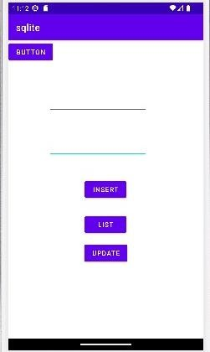

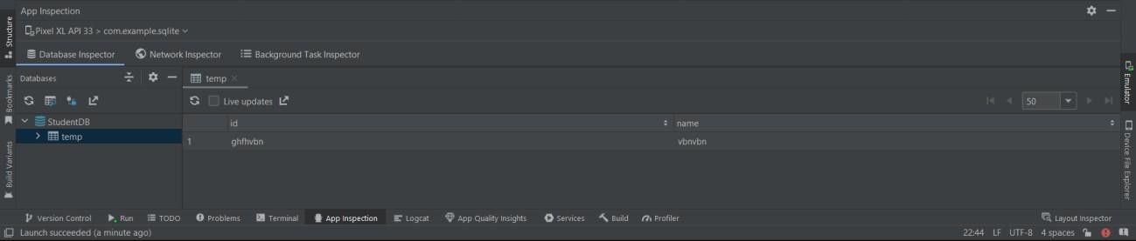

**Activity_main.xml**

**MICRO PROJECT**

<?xml version="1.0" encoding="utf-8"?>

<LinearLayout xmlns:android="<http://schemas.android.com/apk/res/android>" android:layout_width="match_parent" android:layout_height="match_parent"

android:orientation="vertical" android:padding="16dp">

<TextView android:layout_width="wrap_content" android:layout_height="wrap_content" android:text="Age" />

<EditText android:id="@+id/ageEditText" android:layout_width="match_parent"

android:layout_height="wrap_content" android:inputType="number" android:maxLength="2" />

<TextView android:layout_width="wrap_content" android:layout_height="wrap_content" android:text="Gender" />

<RadioGroup android:id="@+id/genderRadioGroup" android:layout_width="match_parent" android:layout_height="wrap_content" android:orientation="horizontal">

<RadioButton android:id="@+id/maleRadioButton"

android:layout_width="wrap_content" android:layout_height="wrap_content" android:text="Male" />

<RadioButton android:id="@+id/femaleRadioButton" android:layout_width="wrap_content" android:layout_height="wrap_content" android:text="Female" />

</RadioGroup>

<TextView android:layout_width="wrap_content" android:layout_height="wrap_content" android:text="Weight (kg)" />

<EditText android:id="@+id/weightEditText" android:layout_width="match_parent" android:layout_height="wrap_content" android:inputType="numberDecimal" android:maxLength="5" />

<TextView android:layout_width="wrap_content" android:layout_height="wrap_content" android:text="Height (cm)" />

<EditText android:id="@+id/heightEditText" android:layout_width="match_parent" android:layout_height="wrap_content" android:inputType="numberDecimal" android:maxLength="5" />

<TextView android:layout_width="wrap_content" android:layout_height="wrap_content" android:text="Activity Level" />

<Spinner android:id="@+id/activityLevelSpinner" android:layout_width="match_parent" android:layout_height="wrap_content" android:entries="@array/activity_levels" />

<Button android:id="@+id/calculateButton" android:layout_width="wrap_content" android:layout_height="wrap_content" android:text="Calculate" />

<TextView android:id="@+id/calorieTextView" android:layout_width="match_parent" android:layout_height="wrap_content" android:textSize="20sp" android:textStyle="bold" android:paddingTop="16dp" />

</LinearLayout>

# Activity_main.xml

package com.example.caloriecalc;

import androidx.appcompat.app.AppCompatActivity; import android.os.Bundle;

import android.os.Bundle; import android.view.View; import android.widget.Button; import android.widget.EditText;

import android.widget.RadioButton; import android.widget.RadioGroup; import android.widget.Spinner; import android.widget.TextView;

import androidx.appcompat.app.AppCompatActivity; public class MainActivity extends AppCompatActivity {

private EditText ageEditText;

private RadioGroup genderRadioGroup; private RadioButton maleRadioButton; private RadioButton femaleRadioButton; private EditText weightEditText;

private EditText heightEditText; private Spinner activityLevelSpinner; private Button calculateButton; private TextView calorieTextView; @Override

protected void onCreate(Bundle savedInstanceState) { super.onCreate(savedInstanceState); setContentView(R.layout.activity_main); ageEditText = findViewById(R.id.ageEditText);

genderRadioGroup = findViewById(R.id.genderRadioGroup); maleRadioButton = findViewById(R.id.maleRadioButton); femaleRadioButton = findViewById(R.id.femaleRadioButton); weightEditText = findViewById(R.id.weightEditText); heightEditText = findViewById(R.id.heightEditText);

activityLevelSpinner = findViewById(R.id.activityLevelSpinner); calculateButton = findViewById(R.id.calculateButton); calorieTextView = findViewById(R.id.calorieTextView); calculateButton.setOnClickListener(new View.OnClickListener() {

@Override

public void onClick(View v) { calculateCalorie();

}

});

}

private void calculateCalorie() {

int age = Integer.parseInt(ageEditText.getText().toString());

int weight = Integer.parseInt(weightEditText.getText().toString()); int height = Integer.parseInt(heightEditText.getText().toString());

double activityLevel = getActivityLevel(activityLevelSpinner.getSelectedItemPosition()); double bmr;

if (maleRadioButton.isChecked()) {

bmr = 88.362 + (13.397 * weight) + (4.799 * height) - (5.677 * age);

} else {

bmr = 447.593 + (9.247 * weight) + (3.098 * height) - (4.330 * age);

}

double calorie = bmr * activityLevel;

calorieTextView.setText("Your Daily Calorie Requirement is: " + calorie);

}

private double getActivityLevel(int position) { switch (position) {

case 0:

return 1.2;

case 1:

return 1.375;

case 2:

return 1.55;

case 3:

return 1.725;

case 4:

return 1.9; default:

return 1.2;

}

}

}

# Output

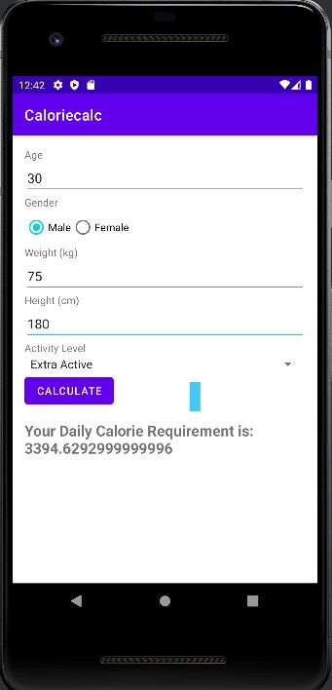

**NOTES:**

## Launching emulator, editing emulator settings, emulator shortcuts

Launching emulator:

We can run and test Android App in AVD of Emulator in Android Studio. This is basically the best way to test App in Android before uploading on Google Play. Below are the steps to run an Android App in AVD of Emulator:

**Step 1:** Firstly, open the AVD Manager directly by the AVD icon in the Toolbar.

**Step 2:** Your Virtual Devices list will be opened on your Computer screen. After that you Select that AVD on which you want to run your App.

**Step 3:** After that your AVD / Emulator will open up. It will take time to start depending on your system configuration and pixel resolution of AVD. Choose less pixel resolution for faster loading of AVD.

**Step 4:** After that you can run app directly as shown in figure below. Click on run icon.

**Step 5:** You can also run app go to the Menu bar and Click on Run > Run app. (Shift+F10) shortcut key to run app in AVD of Emulator in android studio.

**Step 6:** After that Device chooser will be opened on your computer screen. Choose a running device and Click OK.

**Step 7:** Your Android app run in AVD / Emulator in android studio.

Editing emulator settings

You can change properties by using the following guidelines:

* To change a Boolean property, click the check mark to the right of the Boolean property:

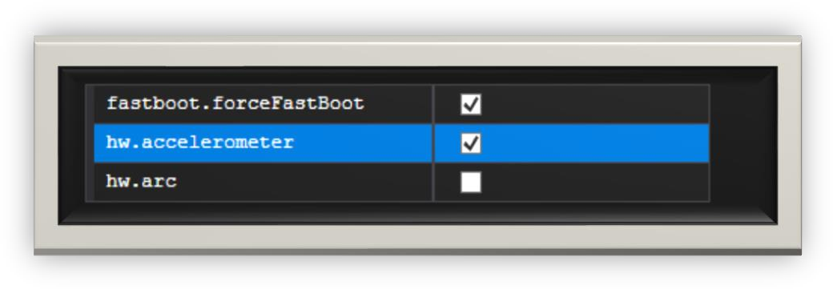

* To change an enum (enumerated) property, click the down-arrow to the right of the property and choose a new value.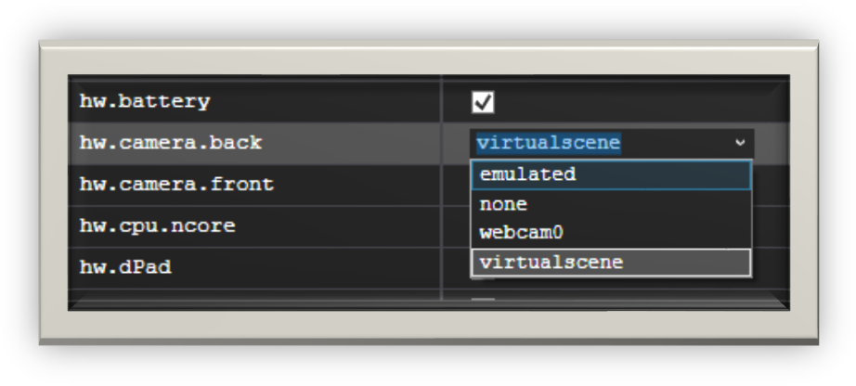

* To change a string or integer property, double-click the current string or integer setting in the value column and enter a new value.

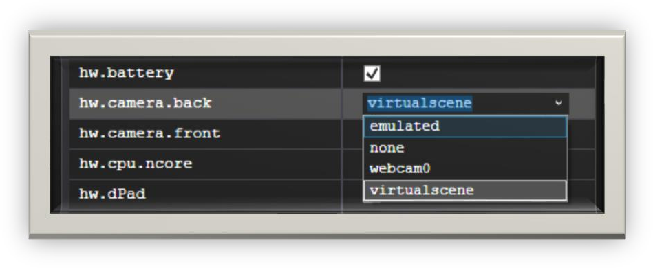

Emulator shortcuts

|  |  |
| --- | --- |
| **Action** | **Shortcut keys** |
| Home Button | Home key |
| Settings Button | F2 |
| Start Button | Shift + F2 |
| Back Button | Esc |
| Call or Dial Button | F3 |
| Hang Up or End Call Button | F4 |
| Search Button | F5 |
| Trackball mode | F6 |
| Power Button | F7 |
| Toggle cell network | F8 |
| Toggle code profiling | F9 |
| Camera Button | Ctrl + F3 |
| Volume Up | Ctrl + F5 |
| Volume Down | Ctrl + F6 |
| Switch layout orientation portrait or landscape backward | Ctrl + F11 |
| Switch layout orientation portrait or landscape forwards | Ctrl + F12 |
| Fullscreen mode | Alt + Enter |

## **Different Layouts in Android Studio**

1. **Android UI Layouts**

Android Layout is used to define the user interface that holds the UI controls or widgets that will appear on the screen of an android application or activity screen.

Each activity contains multiple user interface components and those components are the instances of the View and ViewGroup. All the elements in a layout are built using a hierarchy of View and ViewGroup objects.

A **View** is defined as the user interface which is used to create interactive UI components such as TextView, ImageView, EditText, RadioButton, etc., and is responsible for event handling and drawing. **ViewGroup** act as a base class for layouts and layouts parameters that hold other Views or ViewGroups and to define the layout properties. They are Generally Called layouts.

Types of Android Layout

* **Android Linear Layout**: LinearLayout is a ViewGroup subclass, used to provide child View elements one by one either in a particular direction either horizontally or vertically based on the orientation property.
* **Android Relative Layout**: RelativeLayout is a ViewGroup subclass, used to specify the position of child View elements relative to each other like (A to the right of B) or relative to the parent (fix to the top of the parent).
* **Android Constraint Layout**: ConstraintLayout is a ViewGroup subclass, used to specify the position of layout constraints for every child View relative to other views present. A ConstraintLayout is similar to a RelativeLayout, but having more power.
* **Android Frame Layout**: FrameLayout is a ViewGroup subclass, used to specify the position of View elements it contains on the top of each other to display only a single View inside the FrameLayout.
* **Android Table Layout**: TableLayout is a ViewGroup subclass, used to display the child View elements in rows and columns.
* **Android Web View**: WebView is a browser that is used to display the web pages in our activity layout.
* **Android ListView**: ListView is a ViewGroup, used to display scrollable lists of items in a single column.
* **Android Grid View**: GridView is a ViewGroup that is used to display a scrollable list of items in a grid view of rows and columns.

## Launching Emulator/Editing Emulator S

The **Android emulator** is an Android Virtual Device (AVD), which represents a specific Android device. We can use the Android emulator as a target device to execute and test our Android application on our PC. The Android emulator provides almost all the functionality of a real device.

## To start the Android Emulator and run an application in our project:

## In Android Studio, we need to create an Android Virtual Device (AVD) that the emulator can use to install and run your app. To create a new AVD:-

* 1. Open the AVD Manager by clicking Tools > AVD Manager.
  2. Click on Create Virtual Device, at the bottom of the AVD Manager dialog. Then Select Hardware page appears.
  3. Select a hardware profile and then click Next. If we don’t see the hardware profile we want, then we can create or import a hardware profile. The System Image page appears.
  4. Select the system image for the particular API level and click Next. This leads to open a Verify Configuration page.
  5. Change AVD properties if needed, and then click Finish.

In the toolbar, choose the AVD, which we want to run our app from the target device from the drop-down menu.

Click Run.

## Emulator Shortcuts

1. **Main Device Keys**

Keyboard Key Emulated Device Key Esc Back Button

F2 Left Softkey / Menu / Settings button or Page up

F3 Call/ dial Button

F4 Hang up / end call button

F5 Search Button

Home Home Button

Shift+f2 Right Softkey / Star button or Page down

## Other Device Keys

Keyboard Key Emulated Device Key Alt+Enter Toggle fullscreen mode

Ctrl+F11 Switch layout orientation portrait/landscape backwards or 7 on note

Ctrl+F12 Switch layout orientation portrait/landscape forwards or 9 on on note

Ctrl+F3 Camera Button or Ctrl+5 on note Ctrl+F5 Volume up or + on note

Ctrl+F6 Volume down or - on note

Del Enter trackball mode while key is pressed

F6 Toggle trackball mode

F7 Power Button

F8 Toggle cell network

F9 Toggle code profiling requires –trace startup option

*note: numeric keyboard with Num Lock off*