Bayes - Diabetes

Version 2024-05-15

## New names:  
## • `` -> `...1`

## CD4

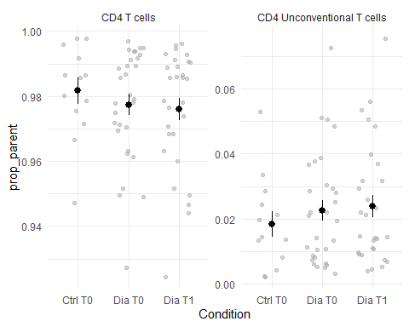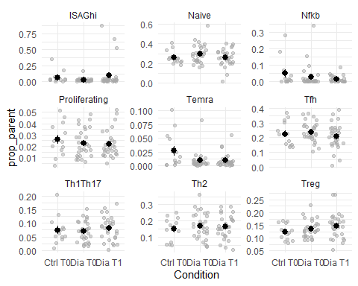

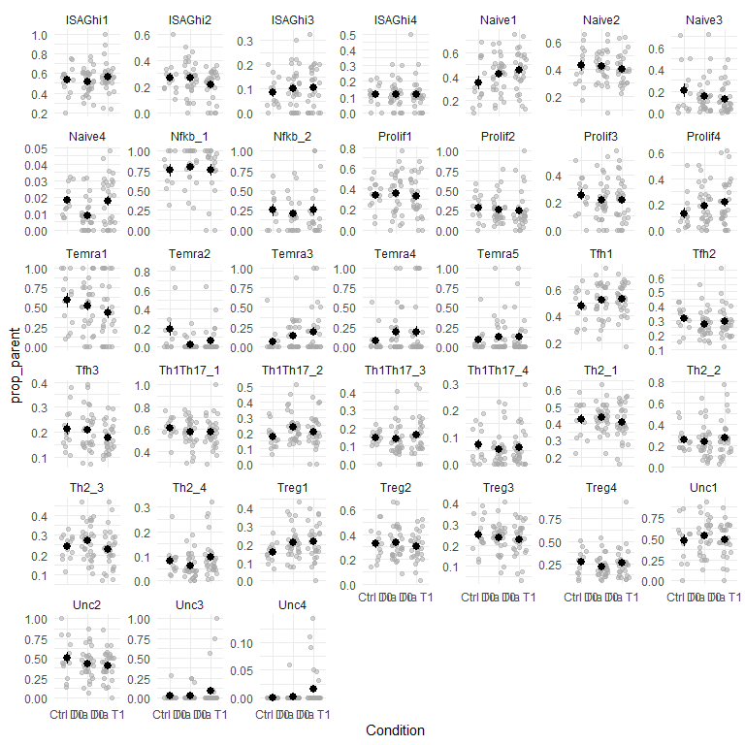

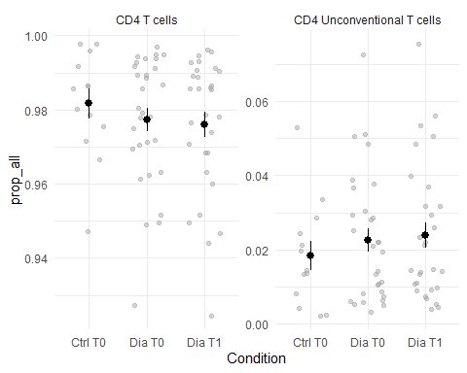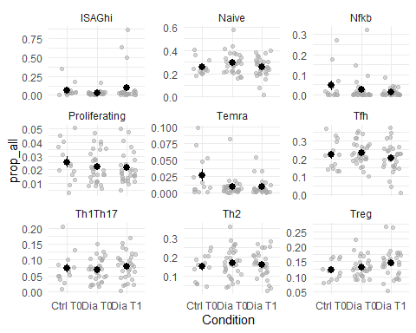

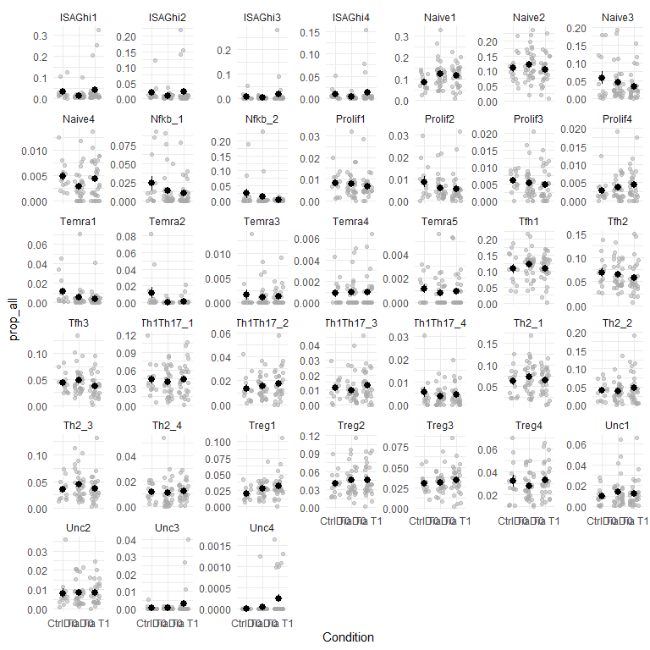

Samples with extreme proportions of ISAGhi:

| Pat. | Samp. | L2 | Cond. | Exp | n | % parent | % all |
| --- | --- | --- | --- | --- | --- | --- | --- |
| 108 | 368 | ISAGhi | Dia T0 | Exp18 | 233 | 16.7% | 16.6% |
| 106 | 365 | ISAGhi | Dia T1 | Exp18 | 537 | 52.5% | 50.0% |
| 105 | 363 | ISAGhi | Dia T1 | Exp18 | 702 | 67.0% | 63.5% |
| 216 | 370 | ISAGhi | Ctrl T0 | Exp18 | 445 | 35.8% | 35.1% |
| 130 | 454 | ISAGhi | Dia T1 | Exp20 | 543 | 87.3% | 86.3% |
| 210 | 457 | ISAGhi | Ctrl T0 | Exp20 | 95 | 18.3% | 17.9% |

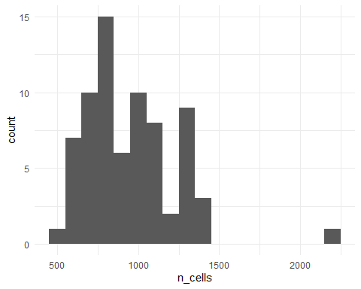

Distribution of cells per sample in the CD4 data

### Recalibrating the naive population

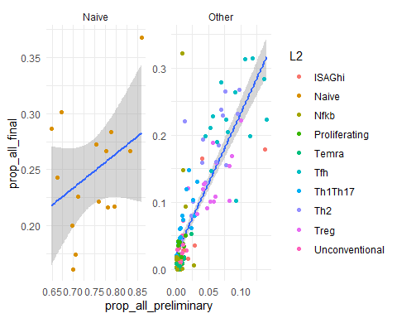

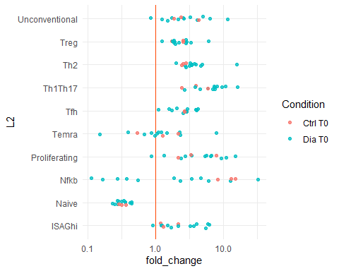

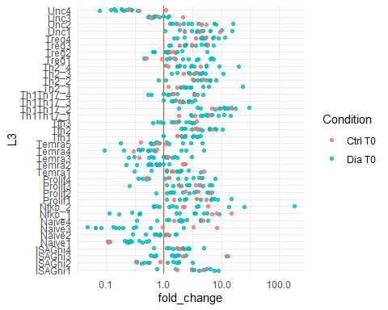

## Reading from cache df_all_43426f9fe750eda8d96f21e6c2ae34be.rds

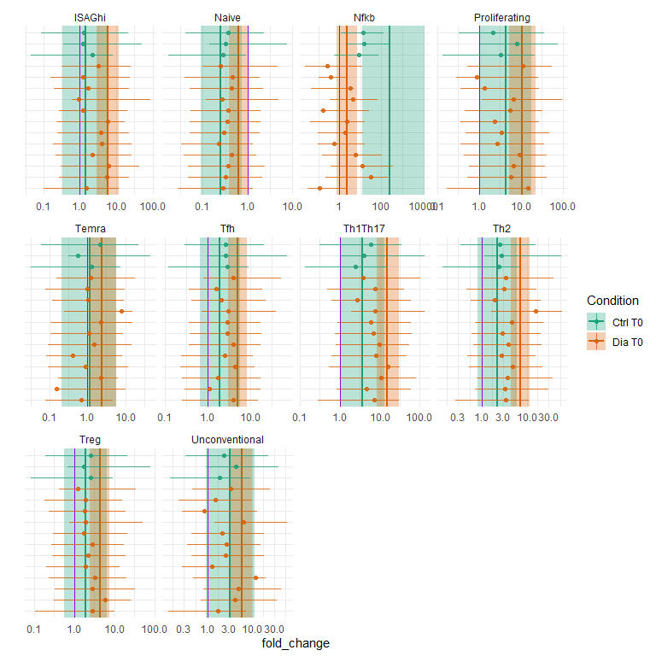

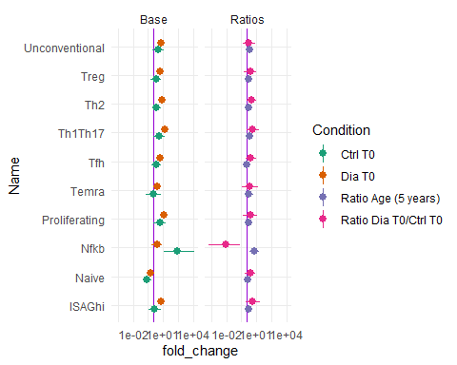

## Reading from cache df_all_de20c854c9c2d1e2279bf76ba02bd2a0.rds

## Reading from cache df_all_de20c854c9c2d1e2279bf76ba02bd2a0.rds

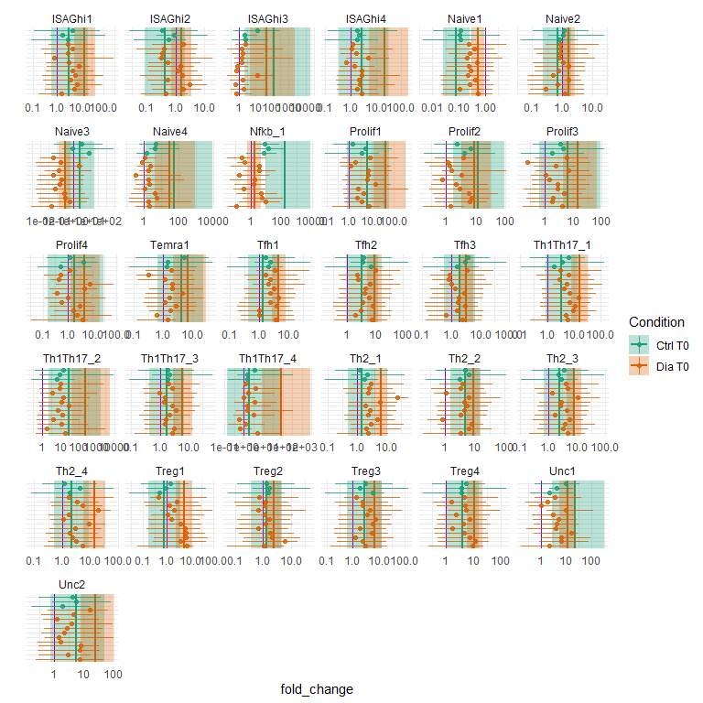

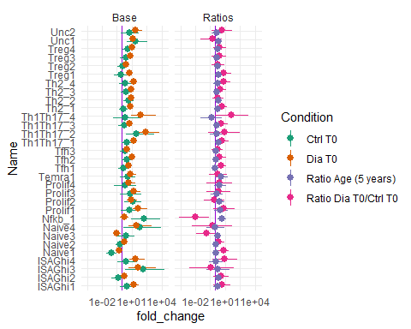

| Condition | Age |
| --- | --- |
| Dia T0 | 3.7 |
| Dia T0 | 1.4 |
| Dia T0 | 9.4 |
| Dia T0 | 11.0 |
| Dia T0 | 7.8 |
| Dia T0 | 16.5 |
| Ctrl T0 | 12.3 |
| Dia T0 | 14.1 |
| Dia T0 | 14.3 |
| Dia T0 | 15.8 |
| Ctrl T0 | 12.4 |
| Dia T0 | 7.6 |
| Dia T0 | 4.3 |
| Dia T0 | 5.9 |
| Ctrl T0 | 12.9 |
| Dia T1 | 9.9 |
| Dia T0 | 8.9 |
| Dia T1 | 5.6 |
| Dia T0 | 5.3 |
| Dia T1 | 6.3 |
| Dia T1 | 12.1 |
| Dia T0 | 4.6 |
| Ctrl T0 | 16.2 |
| Dia T0 | 11.1 |
| Dia T1 | 18.4 |
| Dia T0 | 17.4 |
| Ctrl T0 | 17.9 |
| Ctrl T0 | 3.8 |
| Dia T1 | 10.4 |
| Dia T1 | 17.2 |
| Dia T1 | 17.5 |
| Dia T0 | 16.2 |
| Ctrl T0 | 10.6 |
| Dia T1 | 3.1 |
| Ctrl T0 | 2.6 |
| Dia T1 | 4.2 |
| Dia T0 | 3.2 |
| Dia T1 | 8.8 |
| Dia T0 | 2.1 |
| Dia T1 | 2.4 |
| Ctrl T0 | 2.2 |
| Dia T1 | 4.7 |
| Dia T1 | 5.3 |
| Ctrl T0 | 2.4 |
| Dia T0 | 5.7 |
| Dia T1 | 6.7 |
| Dia T1 | 12.0 |
| Dia T1 | 8.6 |
| Ctrl T0 | 9.0 |
| Dia T1 | 10.2 |
| Dia T0 | 9.2 |
| Ctrl T0 | 4.0 |
| Dia T0 | 3.0 |
| Dia T0 | 10.9 |
| Dia T1 | 11.9 |
| Dia T1 | 6.9 |
| Dia T1 | 16.8 |
| Dia T1 | 15.1 |
| Ctrl T0 | 17.1 |
| Dia T1 | 15.3 |
| Dia T1 | 17.1 |
| Dia T0 | 16.1 |
| Dia T0 | 13.5 |
| Dia T1 | 14.5 |

## CD8

## New names:  
## • `` -> `...1`

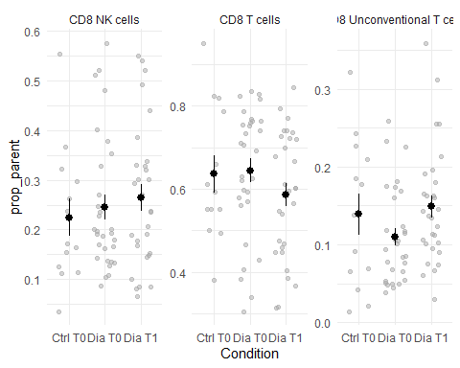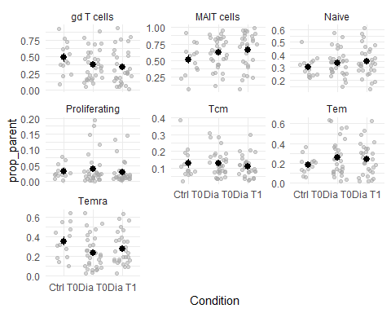

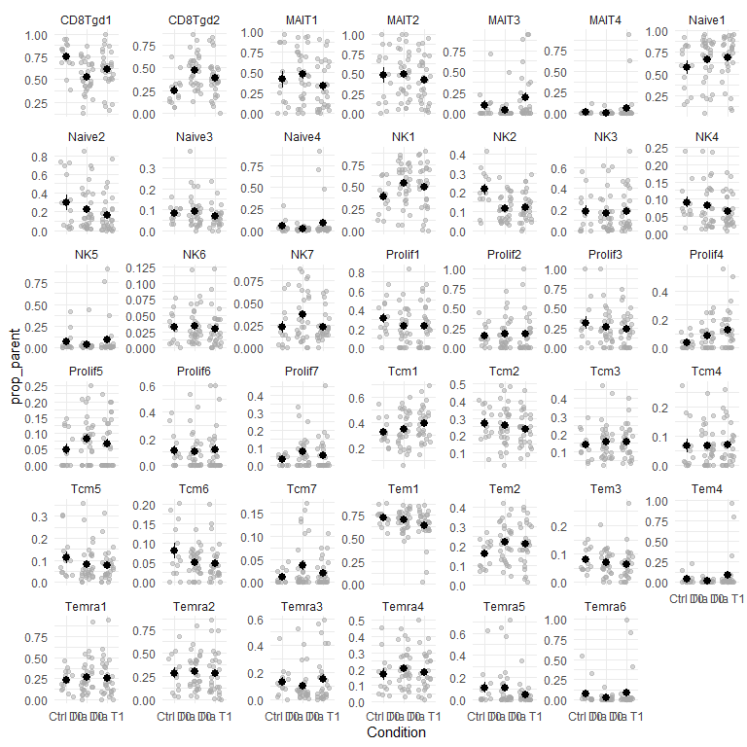

Samples with extreme proportion of MAIT4:

| Pat. | Samp. | L2 | L3 | Cond. | Exp | n | % parent | % all |
| --- | --- | --- | --- | --- | --- | --- | --- | --- |
| 105 | 353 | MAIT cells | MAIT4 | Dia T1 | Exp18 | 29 | 63% | 2% |
| 130 | 443 | MAIT cells | MAIT4 | Dia T1 | Exp20 | 275 | 95% | 32% |

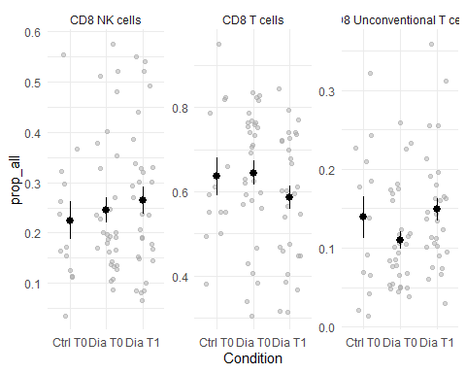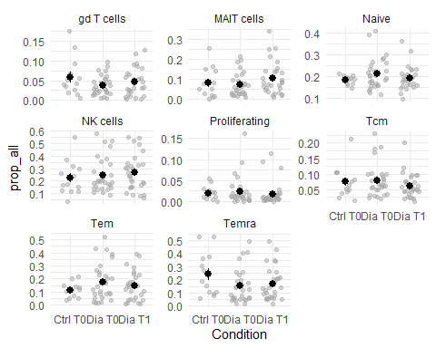

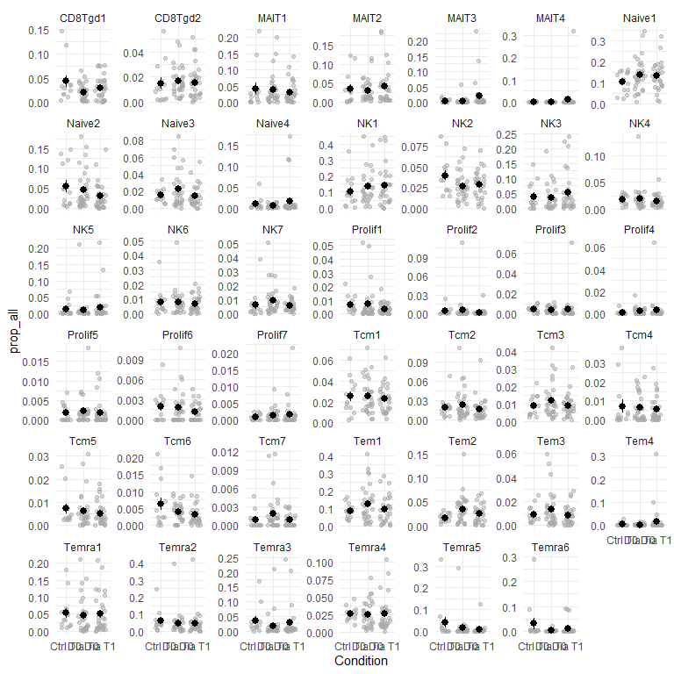

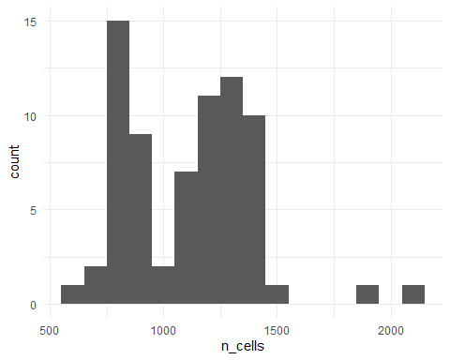

Distribution of cells per sample in the cd8 data

### Recalibrating the naive population

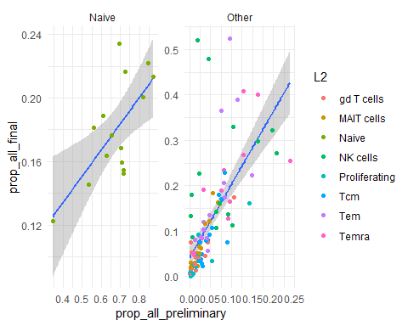

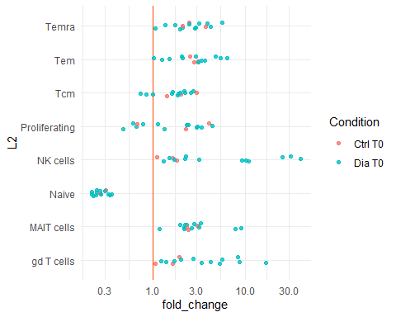

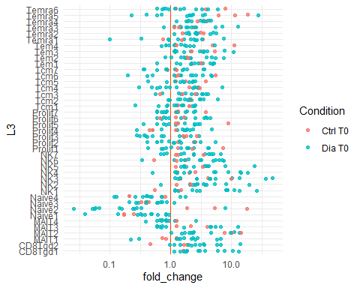

## Reading from cache df_all_f9c366828d16734b5eafb4a40290a584.rds

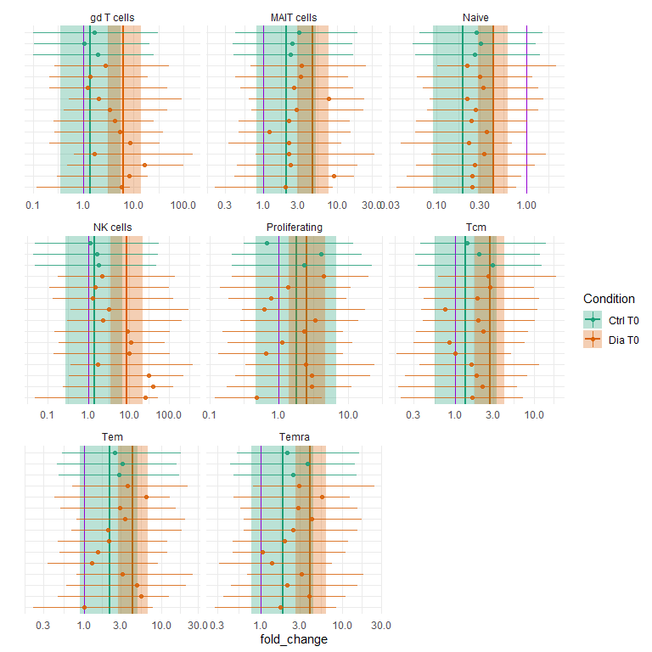

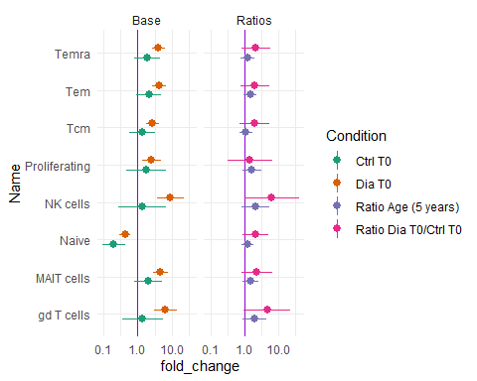

## Modelling

### CD4 - outliers removed

Those samples are claimed as outliers (proportion of the cells across the whole sample is 3 SD or more above the mean proportion across the given L3 population)

| Pat. | Samp. | L2 | L3 | Cond. | Exp | n | % parent | % all |
| --- | --- | --- | --- | --- | --- | --- | --- | --- |
| 106 | 365 | ISAGhi | ISAGhi1 | Dia T1 | Exp18 | 270 | 50.3% | 25.1% |
| 105 | 363 | ISAGhi | ISAGhi1 | Dia T1 | Exp18 | 360 | 51.3% | 32.5% |
| 130 | 454 | ISAGhi | ISAGhi1 | Dia T1 | Exp20 | 129 | 23.8% | 20.5% |
| 106 | 365 | ISAGhi | ISAGhi2 | Dia T1 | Exp18 | 165 | 30.7% | 15.3% |
| 105 | 363 | ISAGhi | ISAGhi2 | Dia T1 | Exp18 | 157 | 22.4% | 14.2% |
| 130 | 454 | ISAGhi | ISAGhi2 | Dia T1 | Exp20 | 139 | 25.6% | 22.1% |
| 130 | 454 | ISAGhi | ISAGhi3 | Dia T1 | Exp20 | 178 | 33% | 28% |
| 105 | 363 | ISAGhi | ISAGhi4 | Dia T1 | Exp18 | 86 | 12.3% | 7.8% |
| 130 | 454 | ISAGhi | ISAGhi4 | Dia T1 | Exp20 | 97 | 17.9% | 15.4% |
| 117 | 302 | Naive | Naive1 | Dia T0 | Exp16 | 266 | 57% | 33% |
| 105 | 362 | Naive | Naive3 | Dia T0 | Exp18 | 252 | 72% | 19% |
| 215 | 317 | Nfkb | Nfkb_1 | Ctrl T0 | Exp16 | 67 | 52.8% | 9.34% |
| 105 | 362 | Nfkb | Nfkb_1 | Dia T0 | Exp18 | 119 | 28.3% | 9.12% |
| 214 | 361 | Nfkb | Nfkb_1 | Ctrl T0 | Exp18 | 108 | 31.3% | 8.57% |
| 105 | 362 | Nfkb | Nfkb_2 | Dia T0 | Exp18 | 302 | 71.7% | 23.1% |
| 214 | 361 | Nfkb | Nfkb_2 | Ctrl T0 | Exp18 | 237 | 68.7% | 18.8% |
| 110 | 387 | Proliferating | Prolif1 | Dia T1 | Exp19 | 28 | 56% | 2.83% |
| 127 | 451 | Proliferating | Prolif1 | Dia T0 | Exp20 | 20 | 77% | 3.19% |
| 105 | 363 | Proliferating | Prolif2 | Dia T1 | Exp18 | 35 | 76% | 3.16% |
| 208 | 455 | Proliferating | Prolif2 | Ctrl T0 | Exp20 | 20 | 59% | 2.98% |
| 116 | 406 | Proliferating | Prolif3 | Dia T0 | Exp19 | 20 | 43% | 2% |
| 114 | 404 | Proliferating | Prolif4 | Dia T0 | Exp19 | 15 | 47% | 1.91% |
| 114 | 405 | Proliferating | Prolif4 | Dia T1 | Exp19 | 12 | 57% | 1.74% |
| 120 | 410 | Temra | Temra1 | Dia T1 | Exp19 | 35 | 76.1% | 4.14% |
| 120 | 409 | Temra | Temra1 | Dia T0 | Exp19 | 68 | 87.2% | 7.10% |
| 210 | 457 | Temra | Temra1 | Ctrl T0 | Exp20 | 24 | 85.7% | 4.52% |
| 213 | 326 | Temra | Temra2 | Ctrl T0 | Exp16 | 34 | 63% | 4.5% |
| 214 | 361 | Temra | Temra2 | Ctrl T0 | Exp18 | 104 | 84% | 8.3% |
| 215 | 317 | Temra | Temra3 | Ctrl T0 | Exp16 | 10 | 59% | 1.39% |
| 110 | 387 | Temra | Temra3 | Dia T1 | Exp19 | 9 | 27% | 0.91% |
| 122 | 433 | Temra | Temra4 | Dia T1 | Exp20 | 6 | 100% | 1% |
| 117 | 303 | Temra | Temra5 | Dia T1 | Exp16 | 4 | 80.0% | 0.540% |
| 109 | 385 | Temra | Temra5 | Dia T1 | Exp19 | 5 | 33.3% | 0.528% |
| 113 | 390 | Temra | Temra5 | Dia T0 | Exp19 | 6 | 31.6% | 0.568% |
| 101 | 342 | Tfh | Tfh3 | Dia T0 | Exp18 | 171 | 39% | 13% |
| 127 | 452 | Th1Th17 | Th1Th17_2 | Dia T1 | Exp20 | 37 | 43% | 6% |
| 122 | 433 | Th1Th17 | Th1Th17_3 | Dia T1 | Exp20 | 43 | 42.2% | 4.62% |
| 122 | 432 | Th1Th17 | Th1Th17_3 | Dia T0 | Exp20 | 38 | 40.4% | 3.95% |
| 123 | 321 | Th1Th17 | Th1Th17_4 | Dia T1 | Exp16 | 15 | 29% | 1.9% |
| 212 | 350 | Th1Th17 | Th1Th17_4 | Ctrl T0 | Exp18 | 37 | 15% | 3.0% |
| 125 | 434 | Th2 | Th2_1 | Dia T0 | Exp20 | 154 | 47% | 17% |
| 109 | 385 | Th2 | Th2_2 | Dia T1 | Exp19 | 181 | 77% | 19% |
| 104 | 349 | Th2 | Th2_3 | Dia T1 | Exp18 | 126 | 47% | 13% |
| 130 | 453 | Th2 | Th2_4 | Dia T0 | Exp20 | 33 | 19% | 5% |
| 108 | 369 | Treg | Treg1 | Dia T1 | Exp18 | 108 | 40% | 11% |
| 110 | 387 | Treg | Treg3 | Dia T1 | Exp19 | 85 | 33% | 9% |
| 114 | 404 | Unconventional | Unc1 | Dia T0 | Exp19 | 50 | 87.7% | 6.38% |
| 114 | 405 | Unconventional | Unc1 | Dia T1 | Exp19 | 45 | 86.5% | 6.54% |
| 205 | 297 | Unconventional | Unc2 | Ctrl T0 | Exp16 | 25 | 68% | 4% |
| 106 | 365 | Unconventional | Unc3 | Dia T1 | Exp18 | 29 | 56% | 2.7% |
| 105 | 363 | Unconventional | Unc3 | Dia T1 | Exp18 | 44 | 75% | 4.0% |
| 128 | 322 | Unconventional | Unc4 | Dia T0 | Exp16 | 1 | 5.9% | 0.1235% |
| 129 | 325 | Unconventional | Unc4 | Dia T1 | Exp16 | 1 | 9.1% | 0.1304% |
| 125 | 435 | Unconventional | Unc4 | Dia T1 | Exp20 | 1 | 11.1% | 0.1629% |

## Family: negbinomial   
## Links: mu = log; shape = log   
## Formula: n ~ offset(-log(sum_all/1000)) + isDia + isT1 + L3 + (0 + isDia + isT1 | L2) + (0 + isDia + isT1 | L3)   
## shape ~ L2 + (1 | L3)  
## Data: cd4_l3_for_model (Number of observations: 2672)   
## Draws: 4 chains, each with iter = 7000; warmup = 3500; thin = 1;  
## total post-warmup draws = 14000  
##   
## Group-Level Effects:   
## ~L2 (Number of levels: 10)   
## Estimate Est.Error l-95% CI u-95% CI Rhat Bulk_ESS Tail_ESS  
## sd(isDia) 0.28 0.15 0.03 0.62 1.00 1912 2467  
## sd(isT1) 0.13 0.10 0.01 0.38 1.00 3858 5574  
## cor(isDia,isT1) -0.17 0.54 -0.96 0.89 1.00 6728 8299  
##   
## ~L3 (Number of levels: 38)   
## Estimate Est.Error l-95% CI u-95% CI Rhat Bulk_ESS Tail_ESS  
## sd(isDia) 0.10 0.07 0.00 0.27 1.00 3688 5905  
## sd(isT1) 0.06 0.05 0.00 0.17 1.00 6936 7165  
## sd(shape_Intercept) 0.63 0.10 0.46 0.87 1.00 4425 7781  
## cor(isDia,isT1) -0.12 0.58 -0.97 0.93 1.00 10150 9701  
##   
## Population-Level Effects:   
## Estimate Est.Error l-95% CI u-95% CI Rhat Bulk_ESS  
## Intercept 3.31 0.20 2.92 3.71 1.00 1033  
## shape_Intercept -0.52 0.33 -1.16 0.13 1.00 2658  
## isDia -0.20 0.12 -0.44 0.04 1.00 4087  
## isT1 -0.13 0.07 -0.28 0.02 1.00 7985  
## L3ISAGhi2 -0.43 0.23 -0.88 0.03 1.00 4376  
## L3ISAGhi3 -1.15 0.27 -1.68 -0.63 1.00 5523  
## L3ISAGhi4 -0.99 0.25 -1.49 -0.49 1.00 4722  
## L3Naive1 1.45 0.26 0.93 1.94 1.00 1472  
## L3Naive2 1.34 0.25 0.85 1.82 1.00 1339  
## L3Naive3 0.18 0.27 -0.37 0.70 1.00 1604  
## L3Naive4 -1.78 0.28 -2.35 -1.24 1.00 1674  
## L3Nfkb_1 -0.42 0.38 -1.16 0.33 1.00 3441  
## L3Nfkb_2 -1.45 0.44 -2.28 -0.56 1.00 4117  
## L3Prolif1 -0.97 0.26 -1.49 -0.48 1.00 1768  
## L3Prolif2 -1.15 0.27 -1.68 -0.63 1.00 1965  
## L3Prolif3 -1.26 0.27 -1.80 -0.75 1.00 1912  
## L3Prolif4 -1.65 0.27 -2.19 -1.13 1.00 1882  
## L3Temra1 -1.32 0.29 -1.90 -0.75 1.00 2396  
## L3Temra2 -1.84 0.45 -2.68 -0.90 1.00 4549  
## L3Temra3 -2.93 0.35 -3.62 -2.24 1.00 3030  
## L3Temra4 -3.22 0.33 -3.87 -2.57 1.00 3023  
## L3Temra5 -3.17 0.33 -3.81 -2.51 1.00 2940  
## L3Tfh1 1.36 0.27 0.80 1.87 1.00 1539  
## L3Tfh2 1.11 0.26 0.59 1.61 1.00 1422  
## L3Tfh3 0.74 0.26 0.23 1.24 1.00 1460  
## L3Th1Th17_1 0.51 0.25 0.02 0.99 1.00 1428  
## L3Th1Th17_2 -0.54 0.26 -1.07 -0.04 1.00 1546  
## L3Th1Th17_3 -0.83 0.26 -1.36 -0.33 1.00 1532  
## L3Th1Th17_4 -1.77 0.28 -2.31 -1.23 1.00 1630  
## L3Th2_1 1.00 0.25 0.52 1.48 1.00 1348  
## L3Th2_2 0.48 0.26 -0.04 0.97 1.00 1420  
## L3Th2_3 0.44 0.25 -0.06 0.92 1.00 1385  
## L3Th2_4 -0.72 0.26 -1.23 -0.21 1.00 1508  
## L3Treg1 0.10 0.27 -0.44 0.61 1.00 1452  
## L3Treg2 0.52 0.25 0.03 1.01 1.00 1369  
## L3Treg3 0.22 0.25 -0.27 0.70 1.00 1320  
## L3Treg4 0.13 0.24 -0.35 0.60 1.00 1295  
## L3Unc1 -0.89 0.34 -1.55 -0.22 1.00 1532  
## L3Unc2 -1.37 0.32 -2.01 -0.75 1.00 1448  
## L3Unc3 -2.94 0.55 -3.98 -1.80 1.00 3278  
## L3Unc4 -5.91 0.54 -7.00 -4.89 1.00 3261  
## shape_L2Naive 0.85 0.47 -0.06 1.77 1.00 3242  
## shape_L2Nfkb -1.09 0.57 -2.21 0.06 1.00 4082  
## shape_L2Proliferating 0.49 0.47 -0.44 1.43 1.00 3190  
## shape_L2Temra -0.54 0.46 -1.44 0.37 1.00 3451  
## shape_L2Tfh 1.05 0.51 0.05 2.05 1.00 3478  
## shape_L2Th1Th17 0.82 0.47 -0.12 1.74 1.00 3328  
## shape_L2Th2 0.95 0.47 0.00 1.89 1.00 3276  
## shape_L2Treg 1.23 0.47 0.32 2.15 1.00 3361  
## shape_L2Unconventional -0.16 0.50 -1.15 0.83 1.00 3874  
## Tail_ESS  
## Intercept 2073  
## shape_Intercept 4723  
## isDia 5129  
## isT1 7545  
## L3ISAGhi2 7264  
## L3ISAGhi3 7938  
## L3ISAGhi4 7241  
## L3Naive1 2991  
## L3Naive2 3199  
## L3Naive3 3460  
## L3Naive4 3968  
## L3Nfkb_1 6239  
## L3Nfkb_2 8082  
## L3Prolif1 3890  
## L3Prolif2 4256  
## L3Prolif3 4133  
## L3Prolif4 3696  
## L3Temra1 5237  
## L3Temra2 7211  
## L3Temra3 6712  
## L3Temra4 6758  
## L3Temra5 5729  
## L3Tfh1 3304  
## L3Tfh2 3190  
## L3Tfh3 3305  
## L3Th1Th17_1 3238  
## L3Th1Th17_2 3800  
## L3Th1Th17_3 3563  
## L3Th1Th17_4 3875  
## L3Th2_1 3150  
## L3Th2_2 3473  
## L3Th2_3 3245  
## L3Th2_4 3548  
## L3Treg1 3540  
## L3Treg2 3225  
## L3Treg3 3152  
## L3Treg4 2944  
## L3Unc1 3852  
## L3Unc2 3472  
## L3Unc3 7645  
## L3Unc4 6147  
## shape_L2Naive 5646  
## shape_L2Nfkb 6152  
## shape_L2Proliferating 5460  
## shape_L2Temra 5100  
## shape_L2Tfh 5314  
## shape_L2Th1Th17 5399  
## shape_L2Th2 5255  
## shape_L2Treg 5545  
## shape_L2Unconventional 6003  
##   
## Draws were sampled using sample(hmc). For each parameter, Bulk_ESS  
## and Tail_ESS are effective sample size measures, and Rhat is the potential  
## scale reduction factor on split chains (at convergence, Rhat = 1).

List of highly influential observations (for the fit after removing outliers mentioned above, i.e. those are potentially still outliers):

### CD4 - full data

## Warning: There were 2 divergent transitions after warmup. Increasing  
## adapt_delta above 0.95 may help. See  
## http://mc-stan.org/misc/warnings.html#divergent-transitions-after-warmup

## Family: negbinomial   
## Links: mu = log; shape = log   
## Formula: n ~ offset(-log(sum_all/1000)) + isDia + isT1 + L3 + (0 + isDia + isT1 | L2) + (0 + isDia + isT1 | L3)   
## shape ~ L2 + (1 | L3)  
## Data: cd4_l3_for_model_alldata (Number of observations: 2736)   
## Draws: 4 chains, each with iter = 7000; warmup = 3500; thin = 1;  
## total post-warmup draws = 14000  
##   
## Group-Level Effects:   
## ~L2 (Number of levels: 10)   
## Estimate Est.Error l-95% CI u-95% CI Rhat Bulk_ESS Tail_ESS  
## sd(isDia) 0.28 0.15 0.03 0.63 1.00 1412 1679  
## sd(isT1) 0.47 0.18 0.21 0.92 1.00 4602 6746  
## cor(isDia,isT1) -0.47 0.41 -0.97 0.55 1.00 1832 2404  
##   
## ~L3 (Number of levels: 38)   
## Estimate Est.Error l-95% CI u-95% CI Rhat Bulk_ESS Tail_ESS  
## sd(isDia) 0.08 0.06 0.00 0.23 1.00 4575 6567  
## sd(isT1) 0.06 0.05 0.00 0.18 1.00 7432 6793  
## sd(shape_Intercept) 0.63 0.11 0.46 0.87 1.00 4605 8073  
## cor(isDia,isT1) -0.13 0.58 -0.97 0.93 1.00 11039 9350  
##   
## Population-Level Effects:   
## Estimate Est.Error l-95% CI u-95% CI Rhat Bulk_ESS  
## Intercept 3.51 0.24 3.07 3.99 1.01 749  
## shape_Intercept -0.68 0.33 -1.34 -0.01 1.00 2091  
## isDia -0.20 0.12 -0.46 0.04 1.00 4261  
## isT1 -0.11 0.17 -0.46 0.22 1.00 4856  
## L3ISAGhi2 -0.62 0.24 -1.10 -0.15 1.00 2970  
## L3ISAGhi3 -1.44 0.27 -1.96 -0.91 1.00 3817  
## L3ISAGhi4 -1.36 0.25 -1.85 -0.85 1.00 3170  
## L3Naive1 1.34 0.28 0.76 1.87 1.01 861  
## L3Naive2 1.28 0.28 0.73 1.80 1.01 857  
## L3Naive3 0.42 0.30 -0.18 1.00 1.01 1029  
## L3Naive4 -1.96 0.31 -2.58 -1.38 1.00 991  
## L3Nfkb_1 -0.55 0.43 -1.38 0.31 1.00 1464  
## L3Nfkb_2 -0.63 0.46 -1.53 0.28 1.00 2056  
## L3Prolif1 -1.18 0.28 -1.75 -0.65 1.00 1052  
## L3Prolif2 -1.36 0.29 -1.95 -0.81 1.00 1109  
## L3Prolif3 -1.47 0.29 -2.05 -0.91 1.00 1171  
## L3Prolif4 -1.86 0.29 -2.45 -1.31 1.00 1148  
## L3Temra1 -1.54 0.31 -2.16 -0.93 1.00 1395  
## L3Temra2 -2.05 0.48 -2.95 -1.04 1.00 2929  
## L3Temra3 -3.14 0.36 -3.84 -2.44 1.00 1781  
## L3Temra4 -3.43 0.35 -4.12 -2.75 1.00 1682  
## L3Temra5 -3.39 0.34 -4.08 -2.70 1.00 1569  
## L3Tfh1 1.47 0.28 0.90 1.99 1.01 969  
## L3Tfh2 0.99 0.28 0.43 1.52 1.00 993  
## L3Tfh3 0.59 0.28 0.03 1.12 1.01 964  
## L3Th1Th17_1 0.31 0.27 -0.25 0.81 1.01 946  
## L3Th1Th17_2 -0.72 0.28 -1.30 -0.21 1.01 979  
## L3Th1Th17_3 -1.02 0.28 -1.61 -0.50 1.00 1042  
## L3Th1Th17_4 -1.98 0.29 -2.58 -1.42 1.00 1100  
## L3Th2_1 0.81 0.27 0.27 1.32 1.01 930  
## L3Th2_2 0.32 0.29 -0.25 0.86 1.01 1022  
## L3Th2_3 0.24 0.28 -0.32 0.76 1.01 917  
## L3Th2_4 -0.93 0.29 -1.51 -0.39 1.01 990  
## L3Treg1 -0.08 0.28 -0.65 0.45 1.01 968  
## L3Treg2 0.34 0.28 -0.23 0.85 1.01 929  
## L3Treg3 0.02 0.27 -0.53 0.54 1.01 878  
## L3Treg4 -0.07 0.27 -0.61 0.44 1.01 891  
## L3Unc1 -1.04 0.36 -1.76 -0.39 1.01 1030  
## L3Unc2 -1.53 0.34 -2.22 -0.90 1.01 1057  
## L3Unc3 -3.12 0.56 -4.19 -1.99 1.00 2828  
## L3Unc4 -6.08 0.55 -7.21 -5.04 1.00 2523  
## shape_L2Naive 0.96 0.47 0.04 1.89 1.00 2631  
## shape_L2Nfkb -1.03 0.58 -2.20 0.08 1.00 4020  
## shape_L2Proliferating 0.67 0.47 -0.25 1.61 1.00 3174  
## shape_L2Temra -0.39 0.46 -1.31 0.50 1.00 2634  
## shape_L2Tfh 1.12 0.50 0.12 2.11 1.00 3391  
## shape_L2Th1Th17 0.99 0.46 0.06 1.91 1.00 2992  
## shape_L2Th2 1.10 0.47 0.18 2.03 1.00 3124  
## shape_L2Treg 1.39 0.46 0.47 2.29 1.00 2983  
## shape_L2Unconventional -0.00 0.50 -0.98 0.99 1.00 3093  
## Tail_ESS  
## Intercept 1451  
## shape_Intercept 4039  
## isDia 5419  
## isT1 6198  
## L3ISAGhi2 5019  
## L3ISAGhi3 7040  
## L3ISAGhi4 5774  
## L3Naive1 2094  
## L3Naive2 2039  
## L3Naive3 2303  
## L3Naive4 2544  
## L3Nfkb_1 3747  
## L3Nfkb_2 4418  
## L3Prolif1 2142  
## L3Prolif2 2162  
## L3Prolif3 2423  
## L3Prolif4 2261  
## L3Temra1 2519  
## L3Temra2 5672  
## L3Temra3 4336  
## L3Temra4 3276  
## L3Temra5 3163  
## L3Tfh1 1914  
## L3Tfh2 2440  
## L3Tfh3 2209  
## L3Th1Th17_1 2003  
## L3Th1Th17_2 1997  
## L3Th1Th17_3 2060  
## L3Th1Th17_4 2294  
## L3Th2_1 1765  
## L3Th2_2 1981  
## L3Th2_3 1835  
## L3Th2_4 2196  
## L3Treg1 2286  
## L3Treg2 1743  
## L3Treg3 1866  
## L3Treg4 1974  
## L3Unc1 2776  
## L3Unc2 2459  
## L3Unc3 5723  
## L3Unc4 5431  
## shape_L2Naive 4548  
## shape_L2Nfkb 6485  
## shape_L2Proliferating 6018  
## shape_L2Temra 5467  
## shape_L2Tfh 5390  
## shape_L2Th1Th17 5105  
## shape_L2Th2 5320  
## shape_L2Treg 5106  
## shape_L2Unconventional 5867  
##   
## Draws were sampled using sample(hmc). For each parameter, Bulk_ESS  
## and Tail_ESS are effective sample size measures, and Rhat is the potential  
## scale reduction factor on split chains (at convergence, Rhat = 1).

### CD4 - idaa1c

Using idaac to predict populations at time 0 to see potential differences predicting remission

## Family: negbinomial   
## Links: mu = log; shape = log   
## Formula: n ~ offset(-log(sum_all/1000)) + idaa1c + L3 + (0 + idaa1c | L2) + (0 + idaa1c | L3)   
## shape ~ L2 + (1 | L3)  
## Data: cd4_l3_for_model_idaa1c (Number of observations: 1102)   
## Draws: 4 chains, each with iter = 7000; warmup = 3500; thin = 1;  
## total post-warmup draws = 14000  
##   
## Group-Level Effects:   
## ~L2 (Number of levels: 10)   
## Estimate Est.Error l-95% CI u-95% CI Rhat Bulk_ESS Tail_ESS  
## sd(idaa1c) 0.10 0.06 0.01 0.23 1.00 3122 3808  
##   
## ~L3 (Number of levels: 38)   
## Estimate Est.Error l-95% CI u-95% CI Rhat Bulk_ESS Tail_ESS  
## sd(idaa1c) 0.03 0.02 0.00 0.08 1.00 7338 6436  
## sd(shape_Intercept) 0.44 0.11 0.26 0.67 1.00 4579 7540  
##   
## Population-Level Effects:   
## Estimate Est.Error l-95% CI u-95% CI Rhat Bulk_ESS  
## Intercept 2.81 0.19 2.45 3.22 1.01 879  
## shape_Intercept -0.01 0.27 -0.55 0.54 1.00 3072  
## idaa1c 0.02 0.05 -0.06 0.12 1.00 5907  
## L3ISAGhi2 -0.77 0.28 -1.32 -0.21 1.00 1657  
## L3ISAGhi3 -1.87 0.30 -2.46 -1.28 1.00 1876  
## L3ISAGhi4 -1.61 0.30 -2.20 -1.02 1.00 1953  
## L3Naive1 1.98 0.23 1.51 2.43 1.01 1191  
## L3Naive2 1.97 0.23 1.52 2.42 1.01 1140  
## L3Naive3 1.25 0.29 0.70 1.83 1.00 1810  
## L3Naive4 -1.62 0.30 -2.21 -1.03 1.00 1822  
## L3Nfkb_1 0.17 0.49 -0.71 1.21 1.00 4315  
## L3Nfkb_2 0.44 0.64 -0.69 1.85 1.00 5452  
## L3Prolif1 -0.79 0.27 -1.31 -0.27 1.00 1356  
## L3Prolif2 -0.97 0.28 -1.52 -0.43 1.00 1662  
## L3Prolif3 -1.15 0.28 -1.71 -0.60 1.00 1714  
## L3Prolif4 -1.52 0.27 -2.06 -0.98 1.00 1611  
## L3Temra1 -1.20 0.35 -1.86 -0.50 1.00 2497  
## L3Temra2 -3.51 0.61 -4.62 -2.22 1.00 5175  
## L3Temra3 -2.72 0.44 -3.55 -1.81 1.00 3600  
## L3Temra4 -3.01 0.41 -3.82 -2.20 1.00 3588  
## L3Temra5 -3.22 0.44 -4.05 -2.33 1.00 3733  
## L3Tfh1 1.98 0.22 1.54 2.41 1.01 1081  
## L3Tfh2 1.37 0.23 0.90 1.82 1.01 1193  
## L3Tfh3 1.14 0.24 0.67 1.60 1.01 1317  
## L3Th1Th17_1 0.82 0.24 0.36 1.28 1.01 1195  
## L3Th1Th17_2 -0.08 0.24 -0.56 0.37 1.01 1236  
## L3Th1Th17_3 -0.52 0.25 -1.01 -0.04 1.01 1274  
## L3Th1Th17_4 -1.68 0.27 -2.21 -1.15 1.00 1527  
## L3Th2_1 1.41 0.23 0.95 1.85 1.01 1204  
## L3Th2_2 0.84 0.25 0.34 1.32 1.00 1363  
## L3Th2_3 0.91 0.23 0.44 1.35 1.01 1141  
## L3Th2_4 -0.56 0.27 -1.09 -0.04 1.00 1475  
## L3Treg1 0.63 0.24 0.15 1.09 1.01 1317  
## L3Treg2 1.05 0.23 0.57 1.50 1.01 1219  
## L3Treg3 0.59 0.22 0.14 1.01 1.01 1067  
## L3Treg4 0.41 0.22 -0.04 0.83 1.01 1064  
## L3Unc1 -0.05 0.29 -0.61 0.51 1.00 1613  
## L3Unc2 -0.66 0.26 -1.17 -0.14 1.00 1345  
## L3Unc3 -4.55 0.51 -5.61 -3.61 1.00 4665  
## L3Unc4 -6.82 1.33 -10.09 -4.83 1.00 8071  
## shape_L2Naive 0.40 0.39 -0.36 1.17 1.00 4230  
## shape_L2Nfkb -1.89 0.47 -2.83 -0.96 1.00 4811  
## shape_L2Proliferating 0.19 0.39 -0.56 0.96 1.00 4330  
## shape_L2Temra -1.00 0.41 -1.83 -0.21 1.00 4475  
## shape_L2Tfh 0.85 0.40 0.05 1.64 1.00 3839  
## shape_L2Th1Th17 0.65 0.39 -0.14 1.41 1.00 4130  
## shape_L2Th2 0.60 0.38 -0.14 1.35 1.00 3957  
## shape_L2Treg 1.04 0.38 0.30 1.78 1.00 3594  
## shape_L2Unconventional 0.15 0.45 -0.73 1.08 1.00 4933  
## Tail_ESS  
## Intercept 1538  
## shape_Intercept 5355  
## idaa1c 5917  
## L3ISAGhi2 3406  
## L3ISAGhi3 4134  
## L3ISAGhi4 4627  
## L3Naive1 2719  
## L3Naive2 2221  
## L3Naive3 3659  
## L3Naive4 3816  
## L3Nfkb_1 6961  
## L3Nfkb_2 7312  
## L3Prolif1 3072  
## L3Prolif2 3022  
## L3Prolif3 3196  
## L3Prolif4 3881  
## L3Temra1 5002  
## L3Temra2 7368  
## L3Temra3 7025  
## L3Temra4 6197  
## L3Temra5 6583  
## L3Tfh1 2296  
## L3Tfh2 2612  
## L3Tfh3 2378  
## L3Th1Th17_1 2461  
## L3Th1Th17_2 2286  
## L3Th1Th17_3 2993  
## L3Th1Th17_4 3432  
## L3Th2_1 2204  
## L3Th2_2 3171  
## L3Th2_3 2011  
## L3Th2_4 3175  
## L3Treg1 2931  
## L3Treg2 2391  
## L3Treg3 2042  
## L3Treg4 2218  
## L3Unc1 3675  
## L3Unc2 3053  
## L3Unc3 7853  
## L3Unc4 6310  
## shape_L2Naive 6561  
## shape_L2Nfkb 6702  
## shape_L2Proliferating 6839  
## shape_L2Temra 7067  
## shape_L2Tfh 6336  
## shape_L2Th1Th17 6565  
## shape_L2Th2 5834  
## shape_L2Treg 6442  
## shape_L2Unconventional 7223  
##   
## Draws were sampled using sample(hmc). For each parameter, Bulk_ESS  
## and Tail_ESS are effective sample size measures, and Rhat is the potential  
## scale reduction factor on split chains (at convergence, Rhat = 1).

### CD8 - outliers removed

The following are claimed as outliers:

| Pat. | Samp. | L2 | L3 | Cond. | Exp | n | % parent | % all |
| --- | --- | --- | --- | --- | --- | --- | --- | --- |
| 215 | 307 | gd T cells | CD8Tgd1 | Ctrl T0 | Exp16 | 96 | 87.3% | 11.7% |
| 210 | 446 | gd T cells | CD8Tgd1 | Ctrl T0 | Exp20 | 119 | 83.8% | 14.7% |
| 202 | 402 | gd T cells | CD8Tgd2 | Ctrl T0 | Exp19 | 121 | 61% | 6% |
| 201 | 382 | MAIT cells | MAIT1 | Ctrl T0 | Exp19 | 241 | 87.0% | 22.0% |
| 125 | 424 | MAIT cells | MAIT1 | Dia T0 | Exp20 | 227 | 94.2% | 20.1% |
| 126 | 427 | MAIT cells | MAIT2 | Dia T1 | Exp20 | 240 | 72% | 18.18% |
| 127 | 441 | MAIT cells | MAIT2 | Dia T1 | Exp20 | 177 | 88% | 18.81% |
| 112 | 289 | MAIT cells | MAIT3 | Dia T1 | Exp16 | 75 | 94.94% | 13.4% |
| 108 | 359 | MAIT cells | MAIT3 | Dia T1 | Exp18 | 259 | 94.53% | 23.4% |
| 130 | 443 | MAIT cells | MAIT4 | Dia T1 | Exp20 | 275 | 95% | 32% |
| 209 | 445 | NK cells | NK2 | Ctrl T0 | Exp20 | 72 | 27% | 9% |
| 128 | 313 | NK cells | NK3 | Dia T1 | Exp16 | 187 | 43% | 22.5% |
| 108 | 359 | NK cells | NK3 | Dia T1 | Exp18 | 268 | 75% | 24.2% |
| 128 | 312 | NK cells | NK4 | Dia T0 | Exp16 | 121 | 24% | 14% |
| 108 | 358 | NK cells | NK5 | Dia T0 | Exp18 | 290 | 44% | 20.89% |
| 105 | 353 | NK cells | NK5 | Dia T1 | Exp18 | 257 | 76% | 13.45% |
| 130 | 443 | NK cells | NK5 | Dia T1 | Exp20 | 186 | 91% | 21.63% |
| 205 | 287 | NK cells | NK6 | Ctrl T0 | Exp16 | 29 | 6.4% | 3.5% |
| 125 | 424 | NK cells | NK6 | Dia T0 | Exp20 | 55 | 12.2% | 4.9% |
| 205 | 287 | NK cells | NK7 | Ctrl T0 | Exp16 | 32 | 7.0% | 3.9% |
| 128 | 312 | NK cells | NK7 | Dia T0 | Exp16 | 45 | 8.8% | 5.1% |
| 117 | 292 | Naive | Naive1 | Dia T0 | Exp16 | 301 | 86% | 35% |
| 105 | 352 | Naive | Naive2 | Dia T0 | Exp18 | 273 | 85% | 18% |
| 119 | 294 | Naive | Naive3 | Dia T0 | Exp16 | 57 | 23% | 6.9% |
| 106 | 354 | Naive | Naive3 | Dia T0 | Exp18 | 112 | 38% | 8.4% |
| 106 | 355 | Naive | Naive4 | Dia T1 | Exp18 | 128 | 48% | 11.74% |
| 105 | 353 | Naive | Naive4 | Dia T1 | Exp18 | 220 | 71% | 11.51% |
| 130 | 443 | Naive | Naive4 | Dia T1 | Exp20 | 147 | 92% | 17.09% |
| 125 | 424 | Proliferating | Prolif1 | Dia T0 | Exp20 | 56 | 84% | 4.96% |
| 127 | 440 | Proliferating | Prolif1 | Dia T0 | Exp20 | 46 | 57% | 5.24% |
| 110 | 376 | Proliferating | Prolif2 | Dia T0 | Exp19 | 136 | 71% | 11% |
| 106 | 355 | Proliferating | Prolif3 | Dia T1 | Exp18 | 77 | 74% | 7% |
| 105 | 353 | Proliferating | Prolif4 | Dia T1 | Exp18 | 123 | 56% | 6% |
| 105 | 353 | Proliferating | Prolif5 | Dia T1 | Exp18 | 23 | 10.5% | 1.20% |
| 110 | 376 | Proliferating | Prolif5 | Dia T0 | Exp19 | 22 | 11.5% | 1.84% |
| 107 | 356 | Proliferating | Prolif6 | Dia T0 | Exp18 | 15 | 44.1% | 1.07% |
| 216 | 360 | Proliferating | Prolif6 | Ctrl T0 | Exp18 | 11 | 39.3% | 0.83% |
| 105 | 353 | Proliferating | Prolif7 | Dia T1 | Exp18 | 41 | 19% | 2% |
| 126 | 426 | Tcm | Tcm1 | Dia T0 | Exp20 | 83 | 31% | 7% |
| 126 | 427 | Tcm | Tcm2 | Dia T1 | Exp20 | 123 | 46.2% | 9.3% |
| 126 | 426 | Tcm | Tcm2 | Dia T0 | Exp20 | 129 | 48.5% | 11.1% |
| 103 | 336 | Tcm | Tcm3 | Dia T0 | Exp18 | 58 | 23% | 4% |
| 204 | 428 | Tcm | Tcm4 | Ctrl T0 | Exp20 | 46 | 18% | 4% |
| 110 | 376 | Tcm | Tcm5 | Dia T0 | Exp19 | 32 | 36% | 2.68% |
| 111 | 378 | Tcm | Tcm5 | Dia T0 | Exp19 | 39 | 18% | 3.10% |
| 201 | 382 | Tcm | Tcm6 | Ctrl T0 | Exp19 | 23 | 20.2% | 2.10% |
| 202 | 402 | Tcm | Tcm6 | Ctrl T0 | Exp19 | 36 | 16.2% | 1.69% |
| 106 | 354 | Tcm | Tcm7 | Dia T0 | Exp18 | 15 | 13.89% | 1.129% |
| 118 | 397 | Tcm | Tcm7 | Dia T0 | Exp19 | 14 | 13.21% | 1.153% |
| 105 | 352 | Tem | Tem1 | Dia T0 | Exp18 | 622 | 78% | 41% |
| 109 | 374 | Tem | Tem2 | Dia T0 | Exp19 | 176 | 35% | 15% |
| 102 | 334 | Tem | Tem3 | Dia T0 | Exp18 | 74 | 12.11% | 5.16% |
| 105 | 352 | Tem | Tem3 | Dia T0 | Exp18 | 90 | 11.34% | 5.95% |
| 105 | 353 | Tem | Tem4 | Dia T1 | Exp18 | 590 | 80% | 31% |
| 120 | 399 | Temra | Temra1 | Dia T0 | Exp19 | 216 | 58% | 21% |
| 124 | 309 | Temra | Temra2 | Dia T1 | Exp16 | 343 | 85.5% | 41.9% |
| 124 | 310 | Temra | Temra2 | Dia T0 | Exp16 | 322 | 79.7% | 39.3% |
| 113 | 381 | Temra | Temra3 | Dia T1 | Exp19 | 234 | 58.6% | 20.45% |
| 110 | 377 | Temra | Temra3 | Dia T1 | Exp19 | 280 | 56.3% | 24.20% |
| 113 | 380 | Temra | Temra3 | Dia T0 | Exp19 | 266 | 52.8% | 21.14% |
| 125 | 425 | Temra | Temra4 | Dia T1 | Exp20 | 118 | 30% | 10% |
| 107 | 356 | Temra | Temra5 | Dia T0 | Exp18 | 410 | 71.6% | 29.2% |
| 214 | 351 | Temra | Temra5 | Ctrl T0 | Exp18 | 449 | 62.1% | 32.8% |
| 216 | 360 | Temra | Temra6 | Ctrl T0 | Exp18 | 382 | 54% | 29% |

## Family: negbinomial   
## Links: mu = log; shape = log   
## Formula: n ~ offset(-log(sum_all/1000)) + isDia + isT1 + L3 + (0 + isDia + isT1 | L2) + (0 + isDia + isT1 | L3)   
## shape ~ L2 + (1 | L3)  
## Data: cd8_l3_for_model (Number of observations: 2877)   
## Draws: 4 chains, each with iter = 7000; warmup = 3500; thin = 1;  
## total post-warmup draws = 14000  
##   
## Group-Level Effects:   
## ~L2 (Number of levels: 8)   
## Estimate Est.Error l-95% CI u-95% CI Rhat Bulk_ESS Tail_ESS  
## sd(isDia) 0.10 0.09 0.00 0.32 1.00 4649 6613  
## sd(isT1) 0.15 0.12 0.01 0.45 1.00 4805 6905  
## cor(isDia,isT1) -0.11 0.58 -0.97 0.93 1.00 6983 9014  
##   
## ~L3 (Number of levels: 41)   
## Estimate Est.Error l-95% CI u-95% CI Rhat Bulk_ESS Tail_ESS  
## sd(isDia) 0.21 0.10 0.02 0.42 1.01 1812 2608  
## sd(isT1) 0.45 0.11 0.24 0.67 1.00 3346 5373  
## sd(shape_Intercept) 0.58 0.08 0.43 0.76 1.00 4130 7191  
## cor(isDia,isT1) -0.63 0.37 -0.99 0.45 1.01 1052 1089  
##   
## Population-Level Effects:   
## Estimate Est.Error l-95% CI u-95% CI Rhat Bulk_ESS  
## Intercept 3.78 0.18 3.46 4.15 1.00 1467  
## shape_Intercept 0.15 0.43 -0.69 0.99 1.00 3470  
## isDia -0.22 0.09 -0.40 -0.05 1.00 7497  
## isT1 -0.01 0.11 -0.22 0.23 1.00 7550  
## L3CD8Tgd2 -0.45 0.22 -0.90 -0.02 1.00 2810  
## L3MAIT1 0.21 0.28 -0.33 0.74 1.00 3269  
## L3MAIT2 0.00 0.27 -0.55 0.51 1.00 2468  
## L3MAIT3 -1.69 0.39 -2.44 -0.92 1.00 4996  
## L3MAIT4 -3.54 0.47 -4.45 -2.60 1.00 5427  
## L3Naive1 1.34 0.22 0.88 1.77 1.00 2152  
## L3Naive2 0.38 0.26 -0.15 0.89 1.00 2598  
## L3Naive3 -0.42 0.27 -0.97 0.08 1.00 2165  
## L3Naive4 -1.22 0.30 -1.82 -0.63 1.00 3567  
## L3NK1 1.00 0.25 0.49 1.47 1.00 2557  
## L3NK2 0.06 0.21 -0.37 0.48 1.00 2418  
## L3NK3 0.26 0.28 -0.31 0.79 1.00 2915  
## L3NK4 -0.58 0.23 -1.05 -0.14 1.00 2055  
## L3NK5 -1.12 0.30 -1.72 -0.53 1.00 3268  
## L3NK6 -1.34 0.25 -1.86 -0.87 1.00 2258  
## L3NK7 -1.40 0.29 -1.99 -0.86 1.00 2075  
## L3Prolif1 -1.70 0.29 -2.27 -1.13 1.00 2592  
## L3Prolif2 -1.97 0.33 -2.62 -1.33 1.00 2601  
## L3Prolif3 -1.88 0.28 -2.43 -1.34 1.00 3231  
## L3Prolif4 -2.14 0.38 -2.91 -1.41 1.00 3951  
## L3Prolif5 -2.59 0.32 -3.22 -1.98 1.00 3321  
## L3Prolif6 -2.87 0.30 -3.45 -2.28 1.00 2941  
## L3Prolif7 -2.95 0.34 -3.62 -2.30 1.00 3849  
## L3Tcm1 -0.05 0.23 -0.51 0.38 1.00 2205  
## L3Tcm2 -0.29 0.25 -0.80 0.17 1.00 2199  
## L3Tcm3 -1.01 0.24 -1.51 -0.56 1.00 2068  
## L3Tcm4 -1.56 0.28 -2.14 -1.02 1.00 3203  
## L3Tcm5 -1.54 0.25 -2.03 -1.06 1.00 2538  
## L3Tcm6 -1.77 0.24 -2.25 -1.29 1.00 2837  
## L3Tcm7 -2.83 0.31 -3.46 -2.22 1.00 2863  
## L3Tem1 1.03 0.24 0.53 1.51 1.00 2409  
## L3Tem2 -0.07 0.29 -0.67 0.44 1.00 1977  
## L3Tem3 -0.81 0.28 -1.38 -0.28 1.00 2307  
## L3Tem4 -2.00 0.32 -2.65 -1.39 1.00 3782  
## L3Temra1 0.30 0.27 -0.26 0.82 1.00 2463  
## L3Temra2 0.08 0.24 -0.41 0.52 1.00 2088  
## L3Temra3 -0.44 0.25 -0.93 0.06 1.00 3080  
## L3Temra4 -0.11 0.24 -0.61 0.33 1.00 2325  
## L3Temra5 -1.27 0.30 -1.86 -0.67 1.00 3922  
## L3Temra6 -1.52 0.36 -2.24 -0.81 1.00 4279  
## shape_L2MAITcells -1.20 0.52 -2.25 -0.19 1.00 4139  
## shape_L2Naive -0.25 0.52 -1.29 0.79 1.00 3866  
## shape_L2NKcells -0.15 0.49 -1.12 0.81 1.00 3537  
## shape_L2Proliferating -1.00 0.49 -1.97 -0.04 1.00 3647  
## shape_L2Tcm -0.19 0.49 -1.16 0.77 1.00 3518  
## shape_L2Tem -0.44 0.53 -1.49 0.58 1.00 3888  
## shape_L2Temra -0.51 0.49 -1.49 0.46 1.00 3544  
## Tail_ESS  
## Intercept 2333  
## shape_Intercept 5385  
## isDia 7958  
## isT1 8517  
## L3CD8Tgd2 4878  
## L3MAIT1 5868  
## L3MAIT2 4269  
## L3MAIT3 7436  
## L3MAIT4 6790  
## L3Naive1 3674  
## L3Naive2 4864  
## L3Naive3 4753  
## L3Naive4 5696  
## L3NK1 4487  
## L3NK2 4330  
## L3NK3 4872  
## L3NK4 3423  
## L3NK5 5055  
## L3NK6 3822  
## L3NK7 3750  
## L3Prolif1 4806  
## L3Prolif2 5402  
## L3Prolif3 4649  
## L3Prolif4 5805  
## L3Prolif5 5419  
## L3Prolif6 4951  
## L3Prolif7 6289  
## L3Tcm1 3453  
## L3Tcm2 3848  
## L3Tcm3 4142  
## L3Tcm4 4816  
## L3Tcm5 4199  
## L3Tcm6 4476  
## L3Tcm7 5154  
## L3Tem1 4238  
## L3Tem2 3599  
## L3Tem3 4256  
## L3Tem4 4599  
## L3Temra1 4224  
## L3Temra2 3627  
## L3Temra3 4551  
## L3Temra4 3936  
## L3Temra5 6649  
## L3Temra6 7217  
## shape_L2MAITcells 6570  
## shape_L2Naive 6020  
## shape_L2NKcells 5678  
## shape_L2Proliferating 5561  
## shape_L2Tcm 5580  
## shape_L2Tem 6042  
## shape_L2Temra 5606  
##   
## Draws were sampled using sample(hmc). For each parameter, Bulk_ESS  
## and Tail_ESS are effective sample size measures, and Rhat is the potential  
## scale reduction factor on split chains (at convergence, Rhat = 1).

List of highly influential observation (with outliers removed, i.e. potential extra outliers)

### CD8 - full data

## Warning: There were 6 divergent transitions after warmup. Increasing  
## adapt_delta above 0.95 may help. See  
## http://mc-stan.org/misc/warnings.html#divergent-transitions-after-warmup

## Family: negbinomial   
## Links: mu = log; shape = log   
## Formula: n ~ offset(-log(sum_all/1000)) + isDia + isT1 + L3 + (0 + isDia + isT1 | L2) + (0 + isDia + isT1 | L3)   
## shape ~ L2 + (1 | L3)  
## Data: cd8_l3_for_model_alldata (Number of observations: 2952)   
## Draws: 4 chains, each with iter = 7000; warmup = 3500; thin = 1;  
## total post-warmup draws = 14000  
##   
## Group-Level Effects:   
## ~L2 (Number of levels: 8)   
## Estimate Est.Error l-95% CI u-95% CI Rhat Bulk_ESS Tail_ESS  
## sd(isDia) 0.20 0.15 0.01 0.56 1.00 4256 7616  
## sd(isT1) 0.20 0.17 0.01 0.62 1.00 5874 9002  
## cor(isDia,isT1) -0.03 0.57 -0.95 0.94 1.00 11813 10971  
##   
## ~L3 (Number of levels: 41)   
## Estimate Est.Error l-95% CI u-95% CI Rhat Bulk_ESS Tail_ESS  
## sd(isDia) 0.20 0.11 0.01 0.44 1.00 2769 6092  
## sd(isT1) 0.57 0.13 0.32 0.84 1.00 3462 6301  
## sd(shape_Intercept) 0.64 0.09 0.49 0.85 1.00 5890 8886  
## cor(isDia,isT1) -0.37 0.45 -0.96 0.73 1.00 1058 1501  
##   
## Population-Level Effects:   
## Estimate Est.Error l-95% CI u-95% CI Rhat Bulk_ESS  
## Intercept 3.80 0.19 3.44 4.20 1.00 2018  
## shape_Intercept 0.15 0.46 -0.75 1.08 1.00 4944  
## isDia -0.17 0.12 -0.41 0.06 1.00 9229  
## isT1 0.00 0.15 -0.27 0.30 1.00 10140  
## L3CD8Tgd2 -0.43 0.24 -0.93 0.04 1.00 4613  
## L3MAIT1 0.33 0.30 -0.27 0.93 1.00 4298  
## L3MAIT2 -0.01 0.30 -0.63 0.56 1.00 3713  
## L3MAIT3 -1.67 0.47 -2.59 -0.73 1.00 6087  
## L3MAIT4 -2.82 0.69 -4.17 -1.44 1.00 6689  
## L3Naive1 1.37 0.25 0.85 1.84 1.00 2776  
## L3Naive2 0.44 0.30 -0.15 1.02 1.00 3548  
## L3Naive3 -0.47 0.29 -1.07 0.08 1.00 3169  
## L3Naive4 -1.38 0.34 -2.04 -0.71 1.00 4115  
## L3NK1 1.33 0.29 0.72 1.88 1.00 2878  
## L3NK2 0.01 0.24 -0.47 0.48 1.00 3164  
## L3NK3 0.28 0.32 -0.38 0.89 1.00 3923  
## L3NK4 -0.63 0.25 -1.14 -0.16 1.00 2925  
## L3NK5 -0.74 0.35 -1.43 -0.07 1.00 4018  
## L3NK6 -1.42 0.28 -1.98 -0.90 1.00 3100  
## L3NK7 -1.47 0.32 -2.14 -0.89 1.00 2804  
## L3Prolif1 -1.70 0.31 -2.31 -1.10 1.00 3761  
## L3Prolif2 -1.93 0.35 -2.62 -1.25 1.00 3721  
## L3Prolif3 -1.95 0.31 -2.57 -1.36 1.00 4156  
## L3Prolif4 -2.40 0.43 -3.24 -1.56 1.00 4359  
## L3Prolif5 -2.67 0.35 -3.37 -1.99 1.00 4449  
## L3Prolif6 -2.88 0.32 -3.52 -2.25 1.00 3978  
## L3Prolif7 -3.12 0.38 -3.87 -2.37 1.00 4859  
## L3Tcm1 -0.08 0.25 -0.59 0.39 1.00 3076  
## L3Tcm2 -0.32 0.27 -0.86 0.19 1.00 3199  
## L3Tcm3 -1.05 0.27 -1.60 -0.54 1.00 2968  
## L3Tcm4 -1.61 0.31 -2.24 -1.01 1.00 4294  
## L3Tcm5 -1.55 0.27 -2.08 -1.03 1.00 3510  
## L3Tcm6 -1.75 0.27 -2.28 -1.23 1.00 3743  
## L3Tcm7 -2.82 0.34 -3.50 -2.17 1.00 3998  
## L3Tem1 1.25 0.30 0.65 1.82 1.00 3072  
## L3Tem2 -0.23 0.31 -0.87 0.36 1.00 2894  
## L3Tem3 -0.91 0.32 -1.55 -0.28 1.00 3423  
## L3Tem4 -1.58 0.53 -2.59 -0.54 1.00 4158  
## L3Temra1 0.58 0.29 -0.00 1.15 1.00 4209  
## L3Temra2 0.44 0.26 -0.07 0.95 1.00 3823  
## L3Temra3 -0.06 0.30 -0.65 0.54 1.00 4899  
## L3Temra4 -0.10 0.26 -0.64 0.40 1.00 3658  
## L3Temra5 -0.18 0.35 -0.85 0.52 1.00 4875  
## L3Temra6 -0.80 0.36 -1.49 -0.06 1.00 6395  
## shape_L2MAITcells -1.39 0.58 -2.55 -0.26 1.00 5417  
## shape_L2Naive -0.26 0.58 -1.40 0.86 1.00 5664  
## shape_L2NKcells -0.23 0.53 -1.28 0.81 1.00 5186  
## shape_L2Proliferating -0.99 0.53 -2.05 0.04 1.00 5082  
## shape_L2Tcm -0.21 0.53 -1.29 0.83 1.00 5200  
## shape_L2Tem -0.61 0.57 -1.75 0.51 1.00 5738  
## shape_L2Temra -0.76 0.54 -1.84 0.30 1.00 5336  
## Tail_ESS  
## Intercept 3278  
## shape_Intercept 7601  
## isDia 7688  
## isT1 8274  
## L3CD8Tgd2 5926  
## L3MAIT1 6507  
## L3MAIT2 6342  
## L3MAIT3 8756  
## L3MAIT4 9668  
## L3Naive1 4785  
## L3Naive2 5957  
## L3Naive3 5547  
## L3Naive4 7706  
## L3NK1 5135  
## L3NK2 5944  
## L3NK3 6049  
## L3NK4 5079  
## L3NK5 6607  
## L3NK6 5006  
## L3NK7 4623  
## L3Prolif1 6083  
## L3Prolif2 6637  
## L3Prolif3 7522  
## L3Prolif4 6813  
## L3Prolif5 6944  
## L3Prolif6 6434  
## L3Prolif7 7134  
## L3Tcm1 5196  
## L3Tcm2 5428  
## L3Tcm3 4750  
## L3Tcm4 6655  
## L3Tcm5 5325  
## L3Tcm6 6359  
## L3Tcm7 6815  
## L3Tem1 5071  
## L3Tem2 4886  
## L3Tem3 6067  
## L3Tem4 7833  
## L3Temra1 6599  
## L3Temra2 6326  
## L3Temra3 7564  
## L3Temra4 5362  
## L3Temra5 6886  
## L3Temra6 7663  
## shape_L2MAITcells 7975  
## shape_L2Naive 7947  
## shape_L2NKcells 7288  
## shape_L2Proliferating 7745  
## shape_L2Tcm 7355  
## shape_L2Tem 8657  
## shape_L2Temra 8123  
##   
## Draws were sampled using sample(hmc). For each parameter, Bulk_ESS  
## and Tail_ESS are effective sample size measures, and Rhat is the potential  
## scale reduction factor on split chains (at convergence, Rhat = 1).

### CD8 - idaa1c

Using idaac to predict populations at time 0 to see potential differences predicting remission

## Family: negbinomial   
## Links: mu = log; shape = log   
## Formula: n ~ offset(-log(sum_all/1000)) + idaa1c + L3 + (0 + idaa1c | L2) + (0 + idaa1c | L3)   
## shape ~ L2 + (1 | L3)  
## Data: cd8_l3_for_model_idaa1c (Number of observations: 1189)   
## Draws: 4 chains, each with iter = 7000; warmup = 3500; thin = 1;  
## total post-warmup draws = 14000  
##   
## Group-Level Effects:   
## ~L2 (Number of levels: 8)   
## Estimate Est.Error l-95% CI u-95% CI Rhat Bulk_ESS Tail_ESS  
## sd(idaa1c) 0.09 0.07 0.00 0.26 1.00 2741 5036  
##   
## ~L3 (Number of levels: 41)   
## Estimate Est.Error l-95% CI u-95% CI Rhat Bulk_ESS Tail_ESS  
## sd(idaa1c) 0.05 0.04 0.00 0.14 1.00 4587 5666  
## sd(shape_Intercept) 0.70 0.12 0.51 0.96 1.00 4643 7284  
##   
## Population-Level Effects:   
## Estimate Est.Error l-95% CI u-95% CI Rhat Bulk_ESS  
## Intercept 3.28 0.16 2.98 3.60 1.00 1623  
## shape_Intercept 0.48 0.54 -0.59 1.53 1.00 2843  
## idaa1c 0.02 0.05 -0.08 0.12 1.00 7740  
## L3CD8Tgd2 -0.20 0.22 -0.62 0.22 1.00 2759  
## L3MAIT1 0.56 0.28 0.02 1.13 1.00 4110  
## L3MAIT2 0.41 0.25 -0.07 0.89 1.00 3330  
## L3MAIT3 -1.74 0.59 -2.77 -0.44 1.00 8025  
## L3MAIT4 -3.96 0.90 -5.40 -1.93 1.00 7934  
## L3Naive1 1.87 0.20 1.47 2.26 1.00 2402  
## L3Naive2 0.99 0.28 0.46 1.54 1.00 4176  
## L3Naive3 0.13 0.26 -0.36 0.65 1.00 3679  
## L3Naive4 -1.64 0.23 -2.10 -1.19 1.00 3277  
## L3NK1 1.93 0.23 1.48 2.39 1.00 3141  
## L3NK2 0.13 0.20 -0.27 0.53 1.00 2504  
## L3NK3 0.73 0.31 0.14 1.37 1.00 4886  
## L3NK4 -0.21 0.23 -0.66 0.23 1.00 2869  
## L3NK5 -0.33 0.33 -0.96 0.33 1.00 4889  
## L3NK6 -0.94 0.24 -1.40 -0.46 1.00 3163  
## L3NK7 -0.74 0.27 -1.25 -0.20 1.00 3930  
## L3Prolif1 -1.20 0.33 -1.81 -0.52 1.00 5543  
## L3Prolif2 -1.13 0.39 -1.86 -0.30 1.00 7083  
## L3Prolif3 -1.89 0.28 -2.42 -1.33 1.00 4165  
## L3Prolif4 -2.26 0.33 -2.90 -1.59 1.00 5114  
## L3Prolif5 -2.18 0.32 -2.79 -1.53 1.00 4906  
## L3Prolif6 -2.45 0.34 -3.10 -1.74 1.00 5598  
## L3Prolif7 -3.04 0.29 -3.60 -2.46 1.00 4532  
## L3Tcm1 0.24 0.22 -0.19 0.66 1.00 2803  
## L3Tcm2 0.12 0.24 -0.35 0.59 1.00 3121  
## L3Tcm3 -0.59 0.23 -1.03 -0.13 1.00 2912  
## L3Tcm4 -1.17 0.29 -1.74 -0.59 1.00 4482  
## L3Tcm5 -1.19 0.26 -1.70 -0.68 1.00 3526  
## L3Tcm6 -1.72 0.23 -2.18 -1.25 1.00 3110  
## L3Tcm7 -2.21 0.33 -2.83 -1.53 1.00 4651  
## L3Tem1 1.96 0.26 1.45 2.46 1.00 3697  
## L3Tem2 0.59 0.24 0.11 1.07 1.00 3288  
## L3Tem3 -0.25 0.29 -0.80 0.35 1.00 4232  
## L3Tem4 -1.98 0.34 -2.64 -1.28 1.00 5769  
## L3Temra1 0.77 0.29 0.21 1.35 1.00 4068  
## L3Temra2 0.60 0.24 0.15 1.07 1.00 3230  
## L3Temra3 0.03 0.32 -0.57 0.68 1.00 5059  
## L3Temra4 0.12 0.22 -0.32 0.57 1.00 2960  
## L3Temra5 0.10 0.46 -0.73 1.06 1.00 7077  
## L3Temra6 -2.16 0.33 -2.79 -1.48 1.00 5240  
## shape_L2MAITcells -1.66 0.68 -3.02 -0.34 1.00 3492  
## shape_L2Naive -0.25 0.67 -1.53 1.11 1.00 3372  
## shape_L2NKcells -0.44 0.62 -1.65 0.77 1.00 2892  
## shape_L2Proliferating -0.98 0.61 -2.18 0.23 1.00 3098  
## shape_L2Tcm -0.38 0.61 -1.58 0.83 1.00 3242  
## shape_L2Tem -0.81 0.66 -2.11 0.50 1.00 3226  
## shape_L2Temra -0.94 0.62 -2.16 0.31 1.00 3081  
## Tail_ESS  
## Intercept 2257  
## shape_Intercept 4836  
## idaa1c 7029  
## L3CD8Tgd2 4123  
## L3MAIT1 6196  
## L3MAIT2 4889  
## L3MAIT3 8010  
## L3MAIT4 5862  
## L3Naive1 3880  
## L3Naive2 5571  
## L3Naive3 5585  
## L3Naive4 5194  
## L3NK1 4503  
## L3NK2 3610  
## L3NK3 6662  
## L3NK4 4643  
## L3NK5 7461  
## L3NK6 5208  
## L3NK7 5565  
## L3Prolif1 7882  
## L3Prolif2 9022  
## L3Prolif3 6940  
## L3Prolif4 8291  
## L3Prolif5 6941  
## L3Prolif6 7835  
## L3Prolif7 6516  
## L3Tcm1 4091  
## L3Tcm2 4775  
## L3Tcm3 4510  
## L3Tcm4 6869  
## L3Tcm5 4955  
## L3Tcm6 4553  
## L3Tcm7 6571  
## L3Tem1 6344  
## L3Tem2 5084  
## L3Tem3 5879  
## L3Tem4 7615  
## L3Temra1 6300  
## L3Temra2 5635  
## L3Temra3 7522  
## L3Temra4 4953  
## L3Temra5 7191  
## L3Temra6 7577  
## shape_L2MAITcells 6049  
## shape_L2Naive 5187  
## shape_L2NKcells 5006  
## shape_L2Proliferating 4384  
## shape_L2Tcm 4783  
## shape_L2Tem 5488  
## shape_L2Temra 5093  
##   
## Draws were sampled using sample(hmc). For each parameter, Bulk_ESS  
## and Tail_ESS are effective sample size measures, and Rhat is the potential  
## scale reduction factor on split chains (at convergence, Rhat = 1).

### Associations summary

In all cases, the isDia estimates show the difference (fold change in abundance) between healthy controls and diabetics at time 0 (fold change > 1 means higher abundance in diabetics). The isT1 estimates are the difference for diabetics between time 1 and and time 0 (fold change > 1 means higher abundance at time 1).

We look separately at L2 populations relative to total, L3 populations relative to parent population and then at the combined estimate - L3 populations relative to total.

Finally we look at the dataset with outliers removed (proportion relative to total is 3SD or more above others) and the full dataset without any removals.

