Recipe Cabinet
Project Presentation Document

Presenter | Martin Ragui
Affiliation | Zinuda coding school/Data Science
Date | 04 September 2026
Application | Desktop recipe management application

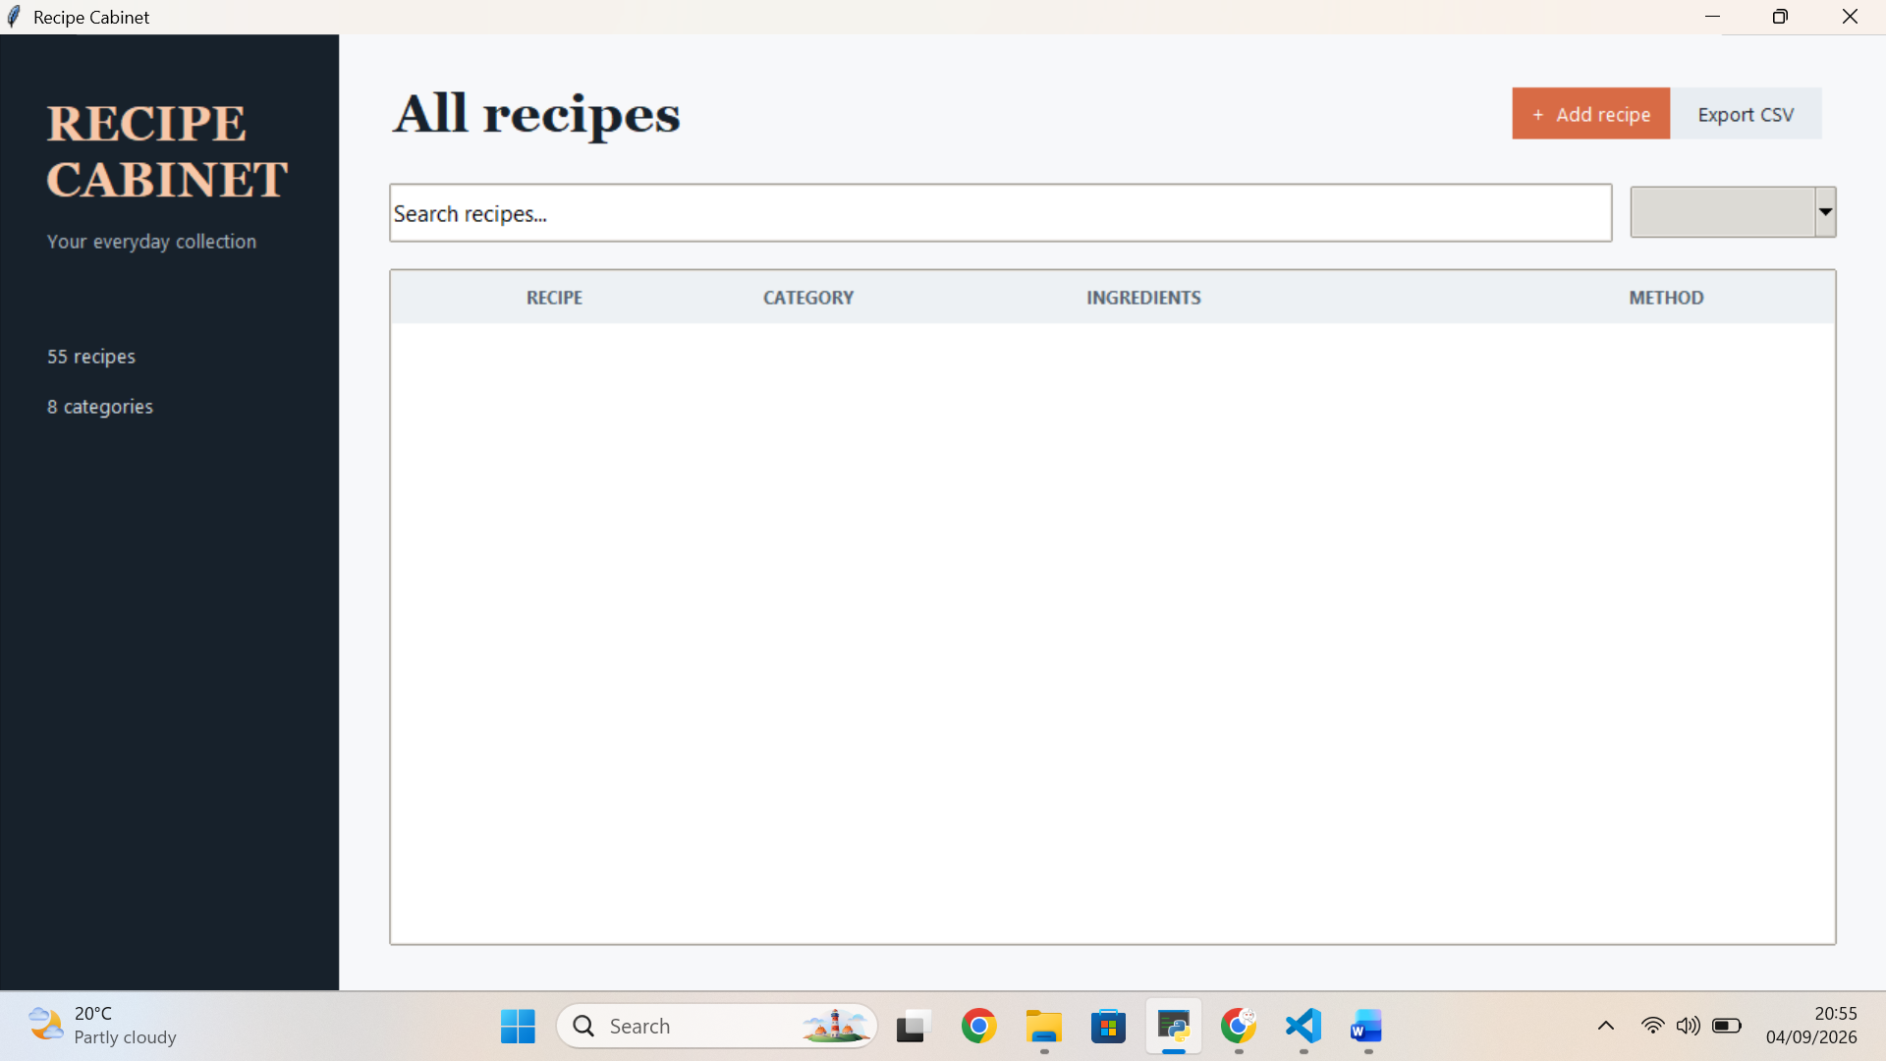

1. Introduction
Recipe Cabinet is a simple desktop application for storing, finding, and maintaining a personal collection of recipes. It replaces a text-based command-line workflow with a visual interface that makes common tasks faster to understand and use.
- The problem: recipe details can become difficult to organise when they are scattered across notes, files, or memory.
- The solution: one searchable collection with structured fields for recipe name, category, ingredients, and method.
- The value: users can retrieve a recipe quickly, keep information consistent, and update their collection without editing database files directly.

2. Project Overview
Recipe Cabinet is a CRUD recipe manager backed by SQLite. The current database contains 55 recipes across 8 categories, including cakes, cupcakes, cookies, bread, and pastries.
- Create recipes through a validated form.
- Read recipes in a sortable, scrollable table.
- Update existing recipes while retaining their database identity.
- Delete recipes with a confirmation step.
- Search across recipe details and filter by category.
- Export the complete collection as recipes.csv for portability and backup.

3. Target Audience
The primary audience is home bakers, cooking students, and anyone who wants a lightweight personal recipe catalogue without the complexity of a large online platform.
- Home cooks need quick access to ingredients and methods while preparing food.
- Students benefit from a clear example of a Python application using a database and graphical interface.
- Small household users need an offline tool that keeps their recipe data local.
- The application addresses these needs with simple navigation, readable fields, category filtering, and CSV export.

4. User Interface and User Experience
The interface is designed around a calm, practical workflow: browse the collection, search or filter it, select a recipe, and then add, edit, delete, or export data. A dark sidebar gives the application a strong visual identity while the light workspace keeps recipe information easy to scan.
- The main table exposes recipe name, category, ingredients, and method in one view.
- The selected recipe preview shows the method without requiring a separate page.
- The add and edit dialog uses a category dropdown to keep category values consistent.
- Validation prevents incomplete recipes from being saved.
- Confirmation dialogs reduce accidental deletion and feedback dialogs confirm exports.
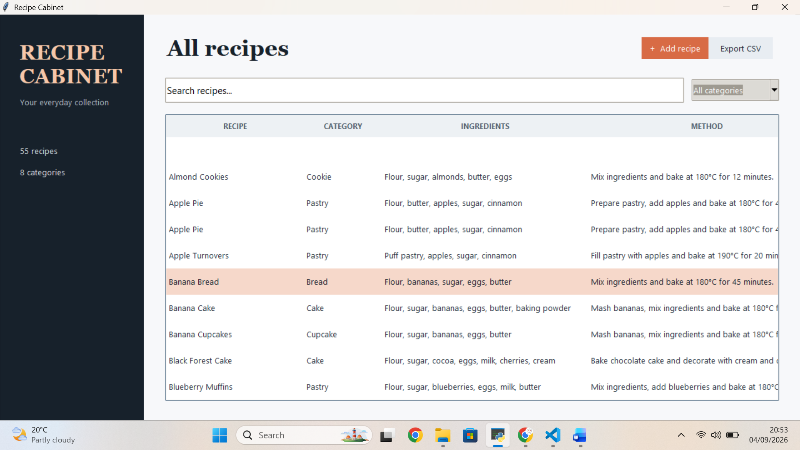

5. Core Features
The application focuses on the essential actions a recipe collection needs. Each feature has a direct user benefit and is connected to the same SQLite data source.
- Add recipe: captures a name, category, ingredients, and method in a guided form.
- View recipes: displays the collection in a table with a method column included in search results.
- Search and filter: finds matching text across recipe fields and narrows results by category.
- Edit recipe: updates all recipe details while preserving the selected record.
- Delete recipe: removes a selected record only after confirmation.
- Export CSV: creates recipes.csv with headers and all current database records.
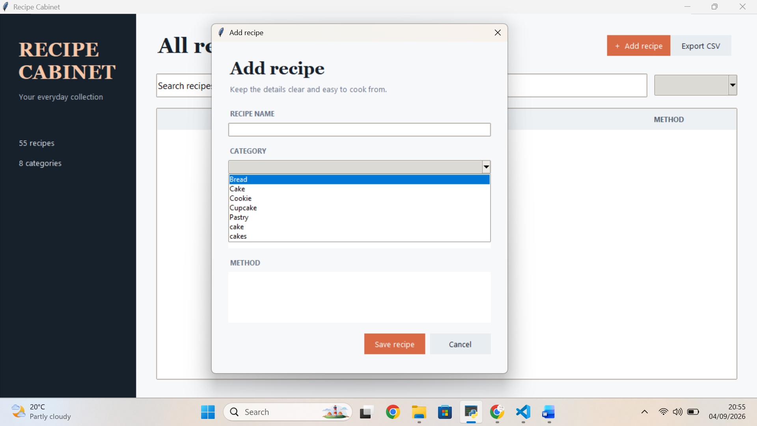

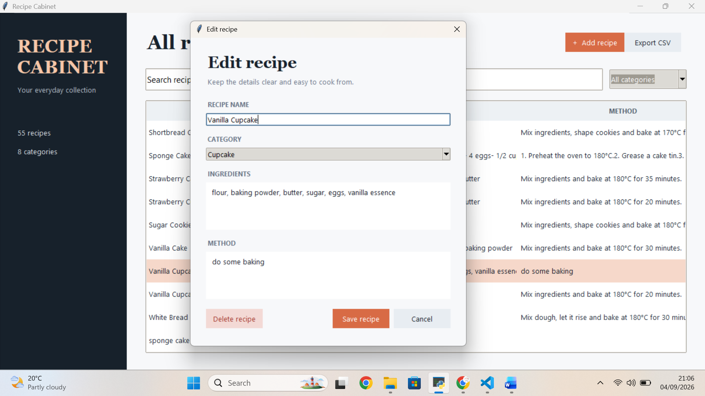

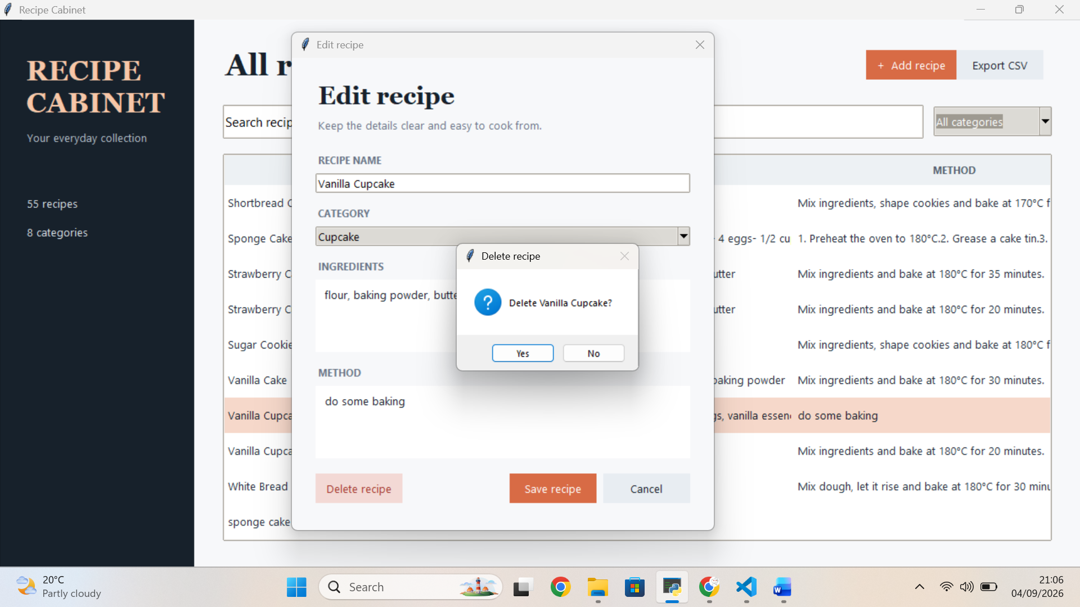

6. Technology Stack
The application uses a small, reliable Python stack chosen for portability and clarity.
- Python: application logic and event handling.
- Tkinter and ttk: desktop graphical user interface and themed widgets.
- SQLite3: local relational database with no separate server required.
- csv: standard-library export of recipe data to recipes.csv.
- python-docx: used to produce this project presentation document, not required to run the recipe app.
- The stack keeps setup simple, supports offline use, and makes the application suitable for a school project or personal utility.

7. Development Process
Development followed an incremental, feature-led approach. The application began with database creation and seed data, then moved through CRUD operations, the graphical interface, search and filtering, and CSV export.
- Milestone 1: create the recipes table and populate the initial recipe collection.
- Milestone 2: implement create, read, update, and delete database operations.
- Milestone 3: replace the command-line menu with the Tkinter interface.
- Milestone 4: improve usability with a method column, category dropdown, validation, and confirmation dialogs.
- Milestone 5: add full-database CSV export and verify the generated file.
- Key challenge: connecting a visual interface to existing database logic without losing data. The solution was to refresh the table from SQLite after each change.

8. Market Analysis and Competitor Landscape
Recipe Cabinet sits in the personal recipe-management space. Larger competitors often combine recipe discovery, social features, accounts, advertising, and meal planning. This application deliberately focuses on a smaller offline workflow.
- Potential alternatives include paper notebooks, spreadsheet files, note-taking apps, and full recipe websites or mobile apps.
- The differentiating factors are local data ownership, a simple desktop workflow, no account requirement, no advertising, and CSV portability.
- The opportunity is strongest for users who want a private personal catalogue rather than a social discovery platform.
- A future user study could compare time taken to find and update a recipe using Recipe Cabinet versus an unstructured notes file.

9. Marketing and Revenue Strategy
For the current educational and personal-use version, the most appropriate strategy is free distribution with a focus on usefulness, reliability, and ease of demonstration.
- Marketing: demonstrate the application through screenshots, a short walkthrough, classroom presentations, and a small project repository.
- User acquisition: target cooking students, home bakers, and people moving from paper or spreadsheet collections.
- Revenue option: keep the desktop core free and consider an optional paid cloud-sync or mobile companion service in a future version.
- Growth opportunity: partnerships with cooking schools, baking clubs, or independent recipe creators could provide focused user feedback.
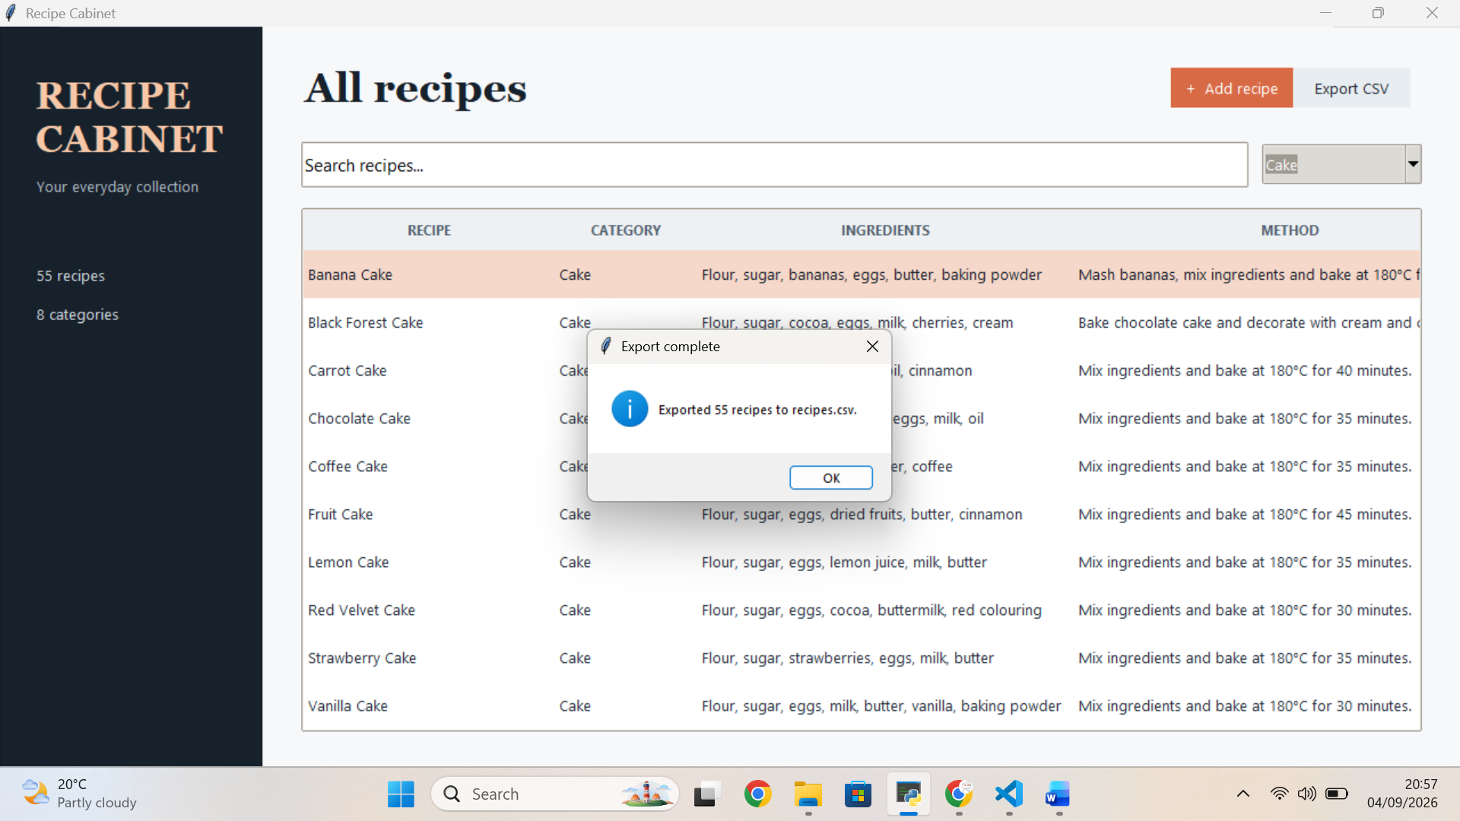

10. Roadmap and Future Enhancements
The current release provides a solid local recipe catalogue. Future work can extend it without changing the core database concept.
- Add recipe images and thumbnail previews.
- Support ingredients as structured lists with quantities and units.
- Add favourites, tags, ratings, and sorting controls.
- Provide import from CSV so an exported collection can be restored or migrated.
- Add print-friendly recipe cards and PDF export.
- Introduce optional encrypted backup or cloud synchronisation.
- Add automated tests for database operations, validation, search, and export.

11. Conclusion
Recipe Cabinet solves a focused problem with a clear, usable desktop application. It combines a modern Tkinter interface with SQLite storage and CSV export to make recipe data easy to manage and move.
- The application is simple enough for everyday use and clear enough to demonstrate core software-development concepts.
- The main benefits are faster retrieval, structured information, safe editing, local ownership, and portable export.
- The current design provides a practical base for richer recipe, backup, and sharing features.

12. Q&A
Thank you. Questions and discussion are welcome.
- How does the application store recipe data?
- Why was SQLite chosen instead of a hosted database?
- How does the category dropdown keep data consistent?
- What future feature would provide the greatest user benefit?

