Data Science from scratch

Contents

I. Fundamentals 2

1. Matrices & Linear Algebra Fundamentals 2

2. Hash Functions, Binary Trees 2

3. Relational Algebra and DB basics 3

4. Inner, Outer, Cross and Theta Join. 3

5. CAP Theorem 3

6. Sharding 4

7. OLAP 4

8. Multidimensional Data Model 5

9. ETL 6

10. JSON & XML 6

11. NoSQL 7

12. Regex (Regular Expressions) 8

13. Virtual Environments Setup (ISN’T COMPLETED) 8

II. Programming (Python and R) 9

1. Install Packages 9

2. Factor Analysis 9

3. Functions 10

4. Read Data. 11

5. Manipulate Data Frames 12

6. Subsetting Data Frames 13

III. Statistics (and how to calculate them in Python) 13

1. Descriptive Statistics 13

2. Histograms 15

3. Percentiles and Outliers 16

4. Probability Theory 16

5. Bayes Theorem 18

6. Random Variables 21

7. Probability Distribution Function 22

8. Cumulative Distribution Function 23

9. Central Limit Theorem 24

10. Continuous Distributions 24

11. Skewness 25

12. Monte Carlo Method 26

13. Hypothesis Testing 27

14. Normality Tests 29

15. Correlation Tests 30

16. Stationary Tests 32

17. Parametric Statistical Hypothesis Tests 33

18. Nonparametric Statistical Hypothesis Tests 33

19. Analysis of Variance (ANOVA) 34

Scale, Standardize, or Normalize 37

# Fundamentals

## Matrices & Linear Algebra Fundamentals

Linear algebra topics:

* Vectors
* Matrices
* Transpose of a matrix
* Inverse of a matrix
* Determinant of a matrix
* Trace of a matrix
* Covariance Matrix
* Dot product
* Eigenvalues
* Eigenvectors

## Hash Functions, Binary Trees

Hashing is a technique that is used to uniquely identify a specific object from a group of similar objects. Some examples of how hashing is used in our lives include:

* In universities, each student is assigned a unique roll number that can be used to retrieve information about them.
* Diagram

  Description automatically generatedIn libraries, each book is assigned a unique number that can be used to determine information about the book, such as its exact position in the library or the users it has been issued to etc.

In both these examples the students and books were hashed to a unique number.

With binary trees you can do a lot of operations like transversals, summations, construction, conversions, etc.

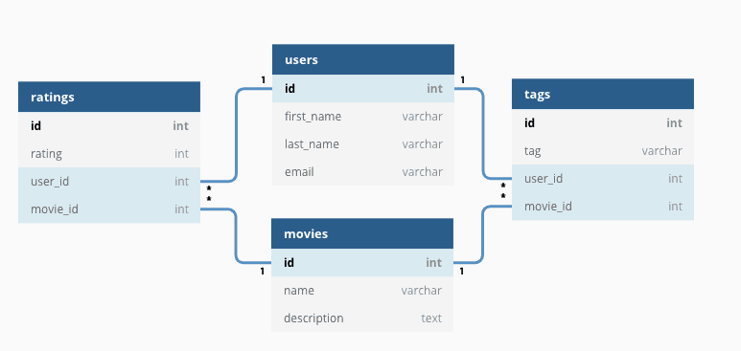

## Relational Algebra and DB basics

 Relational algebra query operations are performed recursively on a relation. The output of these operations is a new relation, which might be formed from one or more input relations.

The relational databases are tabular data that are interrelated.

## What is cross join SQL and When to use cross join SQL?Inner, Outer, Cross and Theta Join.

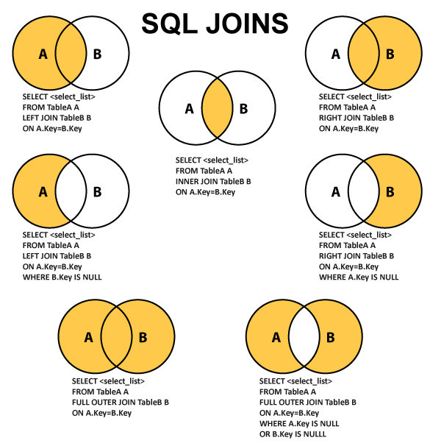

## CAP Theorem

* Consistency
* Availability
* Partition Tolerance

There’s a trade off between consistency and availability when the system has partitions. Partitioning is when the system can’t communicate each part with each other. If the system never has partitions, you can make the system consistent and available.

In real world you have degrees of consistency and degrees of availability and make trade offs between those two.

## Sharding

Sharding is when you have an enormous amount of data and you want to access them in the fastest way. This process is by fragmentating the data into small pieces and storing them in different servers to speed up the performance.

One way to access to every piece is by hierarchical sharding. Which means that you cut your piece into another small pieces and so on.

NoSQL uses sharding internally.

## OLAP

OLAP enables fast, flexible multidimensional data analysis for business intelligence (BI) and decision support applications.

OLAP (for online analytical processing) is software for performing multidimensional analysis at high speeds on large volumes of data from a data warehouse, data mart, or some other unified, centralized data store.

In theory, a cube can contain an infinite number of layers. (An OLAP cube representing more than three dimensions is sometimes called a hypercube.) And smaller cubes can exist within layers—for example, each store layer could contain cubes arranging sales by salesperson and product. In practice, data analysts will create OLAP cubes containing just the layers they need, for optimal analysis and performance.

**OLAP cubes enable four basic types of multidimensional data analysis:**

**Drill-down**

The drill-down operation converts less-detailed data into more-detailed data through one of two methods—moving down in the concept hierarchy or adding a new dimension to the cube. For example, if you view sales data for an organization’s calendar or fiscal quarter, you can drill-down to see sales for each month, **moving down in the concept hierarchy of the “time” dimension.**

**Roll up**

**Roll up is the opposite of the drill-down function**—it aggregates data on an OLAP cube by moving up in the concept hierarchy or by reducing the number of dimensions. For example, you could move up in the concept hierarchy of the “location” dimension by viewing each country's data, rather than each city.

**Slice and dice**

The slice operation **creates a sub-cube by selecting a single dimension from the main OLAP cube**. For example, you can perform a slice by highlighting all data for the organization's first fiscal or calendar quarter (time dimension).

The dice operation isolates a **sub-cube by selecting several dimensions within the main OLAP cube**. For example, you could perform a dice operation by highlighting all data by an organization’s calendar or fiscal quarters (time dimension) and within the U.S. and Canada (location dimension).

**Pivot**

**The pivot function rotates the current cube view to display a new representation of the data—enabling dynamic multidimensional views of data.** The OLAP pivot function is comparable to the pivot table feature in spreadsheet software, such as Microsoft Excel, but while pivot tables in Excel can be challenging, OLAP pivots are relatively easier to use (less expertise is required) and have a faster response time and query performance.

## Multidimensional Data Model

The multi-Dimensional Data Model is a method which is used for ordering data in the database along with good arrangement and assembling of the contents in the database.

The Multi-Dimensional Data Model allows customers to interrogate analytical questions associated with market or business trends, unlike relational databases which allow customers to access data in the form of queries. They allow users to rapidly receive answers to the requests which they made by creating and examining the data comparatively fast.

**OLAP (online analytical processing) and data warehousing uses multi-dimensional databases.** It is used to show multiple dimensions of the data to users.

It represents data in the form of data cubes. Data cubes allow to model and view the data from many dimensions and perspectives. It is defined by dimensions and facts and is represented by a fact table. Facts are numerical measures and fact tables contain measures of the related dimensional tables or names of the facts.

The following stages should be followed by every project for building a Multi-Dimensional Data Model:

**Stage 1: Assembling data from the client:** In first stage, a Multi-Dimensional Data Model collects correct data from the client. Mostly, software professionals provide simplicity to the client about the range of data which can be gained with the selected technology and collect the complete data in detail.

**Stage 2: Grouping different segments of the system:**In the second stage, the Multi-Dimensional Data Model recognizes and classifies all the data to the respective section they belong to and builds it problem-free to apply step by step.

**Stage 3: Noticing the different proportions:** In the third stage, it is the basis on which the design of the system is based. In this stage, the main factors are recognized according to the user’s point of view. These factors are also known as “Dimensions”.

**Stage 4: Preparing the actual-time factors and their respective qualities:** In the fourth stage, the factors which are recognized in the previous step are used further for identifying the related qualities. These qualities are also known as **“attributes”** in the database.

**Stage 5: Finding the actuality of factors which are listed previously and their qualities:**In the fifth stage,A Multi-Dimensional Data Model separates and differentiates the actuality from the factors which are collected by it. These play a significant role in the arrangement of a Multi-Dimensional Data Model.

Stage 6: Building the Schema to place the data, with respect to the information collected from the steps above: In the sixth stage, on the basis of the data, which was collected previously, a Schema is built. M

**Advantages of Multi-Dimensional Data Model**

* It is easy to maintain.
* Its performance is better than that of normal databases (e.g. relational databases).
* The representation of data is better than traditional databases. That is because the multi-dimensional databases are multi-viewed and carry different types of factors.
* It is workable on complex systems and applications, contrary to the simple one-dimensional database systems.
* The compatibility in this type of database is an upliftment for projects having lower bandwidth for maintenance staff.

**Disadvantages of Multi-Dimensional Data Model**

* The multi-dimensional Data Model is slightly complicated in nature, and it requires professionals to recognize and examine the data in the database.
* During the work of a Multi-Dimensional Data Model, when the system caches, there is a great effect on the working of the system.
* It is complicated in nature due to which the databases are generally dynamic in design.
* The path to achieving the end product is complicated most of the time.
* As the Multi-Dimensional Data Model has complicated systems, databases have many databases due to which the system is very insecure when there is a security break.

## ETL

ETL is a type of data integration that refers to the three steps (extract, transform, load) used to blend data from multiple sources. **It's often used to build a data warehouse**. During this process, data is taken (extracted) from a source system, converted (transformed) into a format that can be analyzed, and stored (loaded) into a data warehouse or other system. Extract, load, transform (ELT) is an alternate but related approach designed to push processing down to the database for improved performance.

## JSON & XML

JSON:

* Stands for **J**ava**S**cript **O**bject **N**otation
* Is a lightweight format for storing and transporting data
* Is often used when data is sent from a server to a web page
* Is "self-describing" and easy to understand

JSON example:

XML:

* stands for eXtensible Markup Language
* Is a markup language much like HTML
* Was designed to store and transport data
* Graphical user interface, text, application

  Description automatically generatedWas designed to be self-descriptive

XML Example: is displayed as 🡪

## NoSQL

NoSQL databases are purpose built for specific data models and have flexible schemas for building modern applications. NoSQL databases are widely recognized for their ease of development, functionality, and performance at scale. These types of databases are optimized specifically for applications that require large data volume, low latency, and flexible data models, which are achieved by relaxing some of the data consistency restrictions of other databases.

In a NoSQL database, a book record is usually stored as a JSON document. For each book, the item, ISBN, Book Title, Edition Number, Author Name, and AuthorID are stored as attributes in a single document. In this model, data is optimized for intuitive development and horizontal scalability.

NoSQL databases are a great fit for many modern applications such as mobile, web, and gaming that require flexible, scalable, high-performance, and highly functional databases to provide great user experiences.

* Flexibility: NoSQL databases generally provide flexible schemas that enable faster and more iterative development. The flexible data model makes **NoSQL databases ideal for semi-structured and unstructured data.**
* Scalability: NoSQL databases are generally designed to scale out by using distributed clusters of hardware instead of scaling up by adding expensive and robust servers. Some cloud providers handle these operations behind-the-scenes as a fully managed service.
* High-performance: NoSQL database are optimized for specific data models and access patterns that enable higher performance than trying to accomplish similar functionality with relational databases.
* Highly functional: NoSQL databases provide highly functional APIs and data types that are purpose built for each of their respective data models.

## Regex (Regular Expressions)

/d: digits /:D non-digits UPPERCASE [A-Z[ lowercase [a-z[ numbers [0-9[

Combinations

* Upper, lower and numbers = [a-zA-Z0-9[
* Upper and lower=[a-zA-Z[

Python example of regular expressions There’s a lot of regular expressions to study!!!!!!!!!!!!!!!!!!!!!!!!

## Virtual Environments Setup (ISN’T COMPLETED)

First thing you need to do is execute the [venv](https://docs.python.org/3/library/venv.html) module, which is part of the Python standard library.

The only thing left to do is to “activate” our environment by running the following scripts



# Programming (Python and R)

## Install Packages

To Install packages in Python you need to open de Windows Terminal or Windows PowerShell and write the followings command: pip install *package name or* py -m pip install *package name*

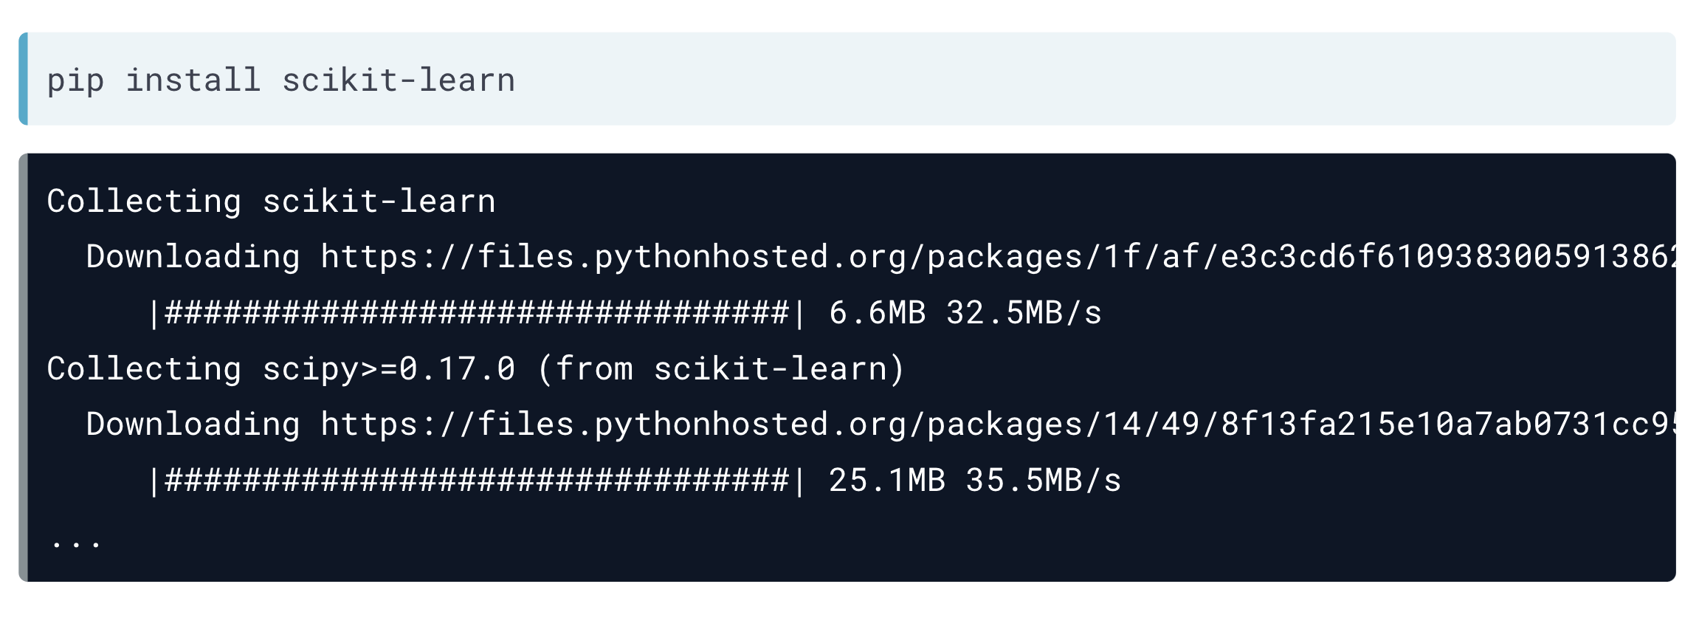

To use packages in Rstudio you must activate them in the Packages window

And if the packages aren’t in that window, you have to open Tools 🡪 Install Packages and write the package name

## Factor Analysis

Factor analysis is a technique that is used to reduce a large number of variables into fewer numbers of factors. This technique extracts maximum common variance from all variables and puts them into a common score. As an index of all variables, we can use this score for further analysis. Factor analysis is part of general linear model (GLM) and this method also assumes several assumptions**: there is linear relationship, there is no multicollinearity, it includes relevant variables into analysis, and there is true correlation between variables and factors.** Several methods are available, but principal component analysis (PCA) is used the most.

Assumptions:

**No outlier:** Assume that there are no outliers in data.

**Adequate sample size**: The case must be greater than the factor.

**No perfect multicollinearity:** Factor analysis is an interdependency technique. There should not be perfect multicollinearity between the variables.

**Homoscedasticity:** Since factor analysis is a linear function of measured variables, it does not require homoscedasticity between the variables.

**Linearity:** Factor analysis is also based on linearity assumption. Non-linear variables can also be used. After transfer, however, it changes into linear variable.

**Interval Data**: Interval data are assumed.

There are different types of methods used to extract the factor from the data set:

1. **Principal component analysis**: This is the most common method used by researchers. PCA starts extracting the maximum variance and puts them into the first factor. After that, it removes that variance explained by the first factors and then starts extracting maximum variance for the second factor. This process goes to the last factor.

2. **Common factor analysis**: The second most preferred method by researchers, it extracts the common variance and puts them into factors. This method does not include the unique variance of all variables. This method is used in SEM.

3. **Image factoring**: This method is based on correlation matrix. OLS Regression method is used to predict the factor in image factoring.

4. **Maximum likelihood method**: This method also works on correlation metric, but it uses maximum likelihood method to factor.

5. **Other methods of factor analysis**: Alfa factoring outweighs least squares. Weight square is another regression-based method which is used for factoring.

## Functions

An R function is created by using the keyword **function**. The basic syntax of an R function definition is as follows:

We can create user-defined functions in R. They are specific to what a user wants and once created they can be used like the built-in functions. Below is an example of how a function is created and used.

🡪

In Python functions work the same as in R, but have a different code

 🡪

If you do not know how many arguments that will be passed into your function, add a * before the parameter name in the function definition. In the following example the functions will print out the length of the list that will be created by iterating each value passed to the function

🡪 2

If you do not know how many keyword arguments that will be passed into your function, add two asterisk: ** before the parameter name in the function definition.

🡪 His last name is Refsnes

Also, If we call the function without argument, it uses the default value:

## Read Data.

In Python to read data for data science you’ll use the pandas package as pd and call each function for each data type.

Each function has its own arguments, but I’ll show you only the most used ones.

In Rstudio its much easier to read data. Just click the import dataset option and select your data type

And if you’re working with CSV files you need to call them following code: *read.csv(“data.csv”)*

## Manipulate Data Frames

In this chapter I’m going to introduce you to pandas functions to manipulate data frames in python

🡪

🡪

And now I’m going to show you some R code to manipulate data frames

This code shows us the data type for each column 🡪

Data types 🡪



## Subsetting Data Frames

In this chapter I will show you only how to slice your data in R

Now the code to subset data in Python

# Statistics (and how to calculate them in Python)

For this chapter we are going to work with the same dataset to perform all the statistics in python.

## Descriptive Statistics

The descriptive statistics are a group of different metrics that we can extract from a data set.

* Mean: Average value
* Median: Midpoint between the highest and the lowest values
* Rango: Span of values over which your data occurs
* Standard Deviation of the Mean (σ): On average, how much each measurement deviates from the mean
* Variance (): Is a measure of how spread out a data set is. It is calculated as the average squared deviation of each number from the mean of a data set

In just one line of code, we have the number of values, mean, standard deviation, minimum value, maximum value, the values positioned in 25%, 50% (median) and 75%. For each column.

A small standard deviation can be a goal in certain situations where the results are restricted, for example, in product manufacturing and quality control. A particular type of car part that has to be 2 centimeters in diameter to fit properly had better not have a very big standard deviation during the manufacturing process! A big standard deviation in this case would mean that lots of parts end up in the trash because they don’t fit right; either that, or the cars will have major problems down the road. So the more spread out the group of numbers are, the higher the standard deviation.

But in situations where you just observe and record data, **a large standard deviation isn’t necessarily a bad thing**; it just reflects a large amount of variation in the group that is being studied.

For example, if you look at salaries for everyone in a certain company, including everyone from the student intern to the CEO, the standard deviation may be very large. On the other hand, if you narrow the group down by looking only at the student interns, the standard deviation is smaller, because the individuals within this group have salaries that are similar and less variable. The second data set isn’t better, it’s just less variable.

Similar to the mean, **outliers affect the standard deviation** (after all, the formula for standard deviation includes the mean). Here’s an example: the salaries of the L.A. Lakers in the 2009–2010 season range from the highest, $23,034,375 (Kobe Bryant) down to $959,111 (Didier Ilunga-Mbenga and Josh Powell). Lots of variation, to be sure!

The standard deviation of the salaries for this team turns out to be $6,567,405; it’s almost as large as the average. However, as you may guess, if you remove Kobe Bryant’s salary from the data set, the standard deviation decreases because the remaining salaries are more concentrated around the mean. The standard deviation becomes $4,671,508

*The standard deviation has the same units of measure as the original data. If you’re talking about inches, the standard deviation will be in inches*.

Variance is the square of the standard deviation and is the last metric:

The more spread out the values are in a dataset, the higher the variance. Therefore, the variance gives more importance to outliers than the standard deviation.

## Histograms

All histograms have the same components but because they have different values they differ from each other’s shape.

* Range
  + How widely dispersed are the frequencies of each bin? Extremely large frequency ranges (particularly as a percentage) may indicate data that is fundamentally unreliable.
  + How wide are the bins themselves? Specifically, how broad are the intervals or how descriptive are the classes? Unusually large or small intervals, or unusually broad or narrow categories may indicate important observations about the data as a whole.
* Frequency Density
  + Frequency is measured by the area of the bar. What that means it that you can use a histogram with different interval or class widths to represent data with varying densities.
* Shape
  + The shape of a histogram can lead to valuable conclusions about the trend(s) of the data

As you can see in the code (🡪), we obtained the histogram for the CrimeRate and Education columns. The shape of the data isn’t a bell because they have some outliers.

We can say that the crime rates between 80 and 120 have more frequency than the others. And Education has more values between 12 and 13 .

Other types of histograms:

* Chart, histogram

  Description automatically generatedBell-shaped: A histogram with a prominent ‘mound’ in the center and similar tapering to the left and right. One indication of this shape is that the data is unimodal – meaning that the data has a single mode, identified by the ‘peak’ of the curve. **If the shape is symmetrical, then the mean, median, and mode are all the same value**. Note that a normally distributed data set creates a symmetric histogram that looks like a bell, leading to the common term for a normal distribution: a bell curve
* Right or Left Skewed: A skewed histogram has a peak that is left (or right) of center and a more gradual tapering to the other side of the graph. This is a unimodal data set, with the mode closer to the left (or right) of the graph and smaller than either the mean or the median. The mean of right-skewed data will be located to the right side of the graph and will be a greater value than either the median or the mode. This shape indicates that there are a number of data points, perhaps outliers, that are greater than the mode for the left skewed and lesser than the mode for the right

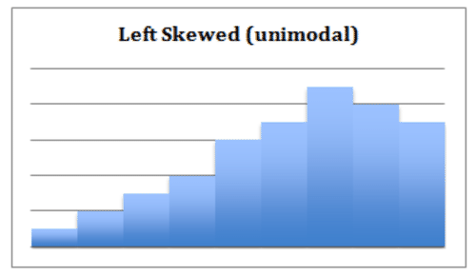

* Undefined Bimodal: This shape is not specifically defined, but we can note regardless that it is bimodal, having two separated classes or intervals equally representing the maximum frequency of the distribution.

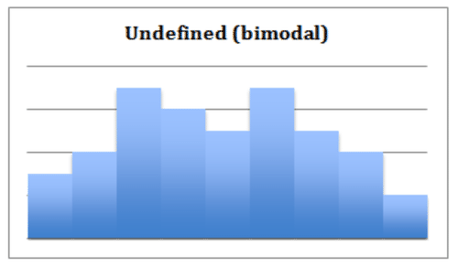

## Percentiles and Outliers

Percentiles is in everyday use, but there is no universal definition for it. The most common definition of a percentile is a number where a certain percentage of scores fall below that a number.

An outlier is an observation that lies an abnormal distance from other values in a random sample.

One way to visualize the percentiles rank and the outliers is by plotting a boxplot.

The box limits the 25th and 75th percentiles. The two lines outside the box limit the 10th and 90th percentile and the circles in red show the outliers.

## Probability Theory

The probability theory is a branch of mathematics concerned with the analysis of random phenomena. The outcome of a random event cannot be determined before it occurs, but it may be any one of several possible outcomes. The actual outcome is considered to be determined by chance. This theory has great importance for data science. One needs to possess a comprehensive understanding of the probability theory to be a well-performing data scientist. For instance, probability distributions play a key role in predictive analytics.

**Conditional Probability**

We defined the conditional probability as the probability of event A given that event B has occurred, is denoted as p(A|B).

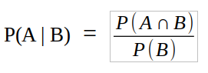*“Conditional probability is the likelihood of an event A to occur given that another event that has a relation with event A has already occurred.”*

The formula of the conditional probability:

P(A ∩ B) is the probability that both events A and B occur. P(B) is the probability that event B occurs. The conditional probability is typically not commutative which means that P(A | B) is not equal to P(B | A).

In the following example we see a probability space (Ω) which indicates all the probabilities add up to 1.

Conditional probability is a fundamental concept in probability theory and statistics. For instance, Bayesian statistics arises from an interpretation of the conditional probability.

A given condition might not have any effect on an event so the conditional and unconditional probabilities are equal (i.e. P( A | B) = P(A)). In such cases, the events **A and B are said to be independent.**

**Joint Probability**

Joint probability is the probability of two events occurring together. If two events are independent, the joint probability is calculated by multiplying the probabilities of each event.

**P(A ∩ B) = P(A) * P(B)** If we put that in the equation of the conditional probability:

Joint and conditional probability example:

The following table shows the number of female and male students enrolled in the sociology and music classes.

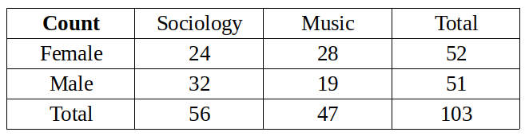

There are 103 students. We will first calculate the unconditional probabilities.

P(Female) = 52 / 103 = 0.505

P(Male) = 51 / 103 = 0.495

P(Music) = 47 / 103 = 0.456

P(Sociology) = 56 / 103 = 0.544

The joint probabilities can be calculated by dividing the number in a cell by the total number of students. For instance, the probability that a student is female and enrolled in the sociology class:

***~~P(Female ∩ Sociology) = (P(Female) * P(Sociology)) =24 / 103 = 0.233~~***

We can calculate the other joint probabilities similarly. The following table contains all the probabilities for these events.

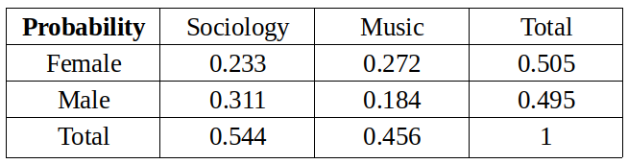

We will calculate the conditional probabilities now.

What is the probability that a student is female given that the student is enrolled in the music class?

P(Female | Music) = P(Female ∩ Music) / P(Music) = 0.272 / 0.456 = 0.596

What is the probability that a student is male given that the student is enrolled in the sociology class?

P(Male | Sociology) = P(Male ∩ Sociology) / P(Sociology) = 0.311 / 0.544 = 0.572

## Bayes Theorem

Principled way of calculating a conditional probability without the joint probability.

Specifically, one conditional probability can be calculated using the other conditional probability; for example:

*Firstly, in general, the result P(A|B) is referred to as the posterior probability and P(A) is referred to as the prior probability and sometimes P(B|A) is referred to as the likelihood and P(B) is referred to as the evidence.*

P(A|B) = P(B|A) * P(A) / P(B)

The reverse is also true; for example:

P(B|A) = P(A|B) * P(B) / P(A)

It is often the case that we do not have access to the denominator directly, e.g. P(B).

We can calculate it an alternative way; for example:

P(B) = P(B|A) * P(A) + P(B|not A) * P(not A)

This gives a formulation of Bayes Theorem that we can use that uses the alternate calculation of P(B), described below::

P(A|B) = P(B|A) * P(A) / (P(B|A) * P(A) + P(B|not A) * P(not A))

**Diagnostic Test Scenario**

Consider a human population that may or may not have cancer (Cancer is True or False) and a medical test that returns positive or negative for detecting cancer (Test is Positive or Negative), e.g. like a mammogram for detecting breast cancer.

Problem: If a randomly selected patient has the test and it comes back positive, what is the probability that the patient has cancer?

**Manual Calculation**

Medical diagnostic tests are not perfect; they have error.

Sometimes a patient will have cancer, but the test will not detect it. This capability of the test to detect cancer is referred to as the sensitivity, or the true positive rate.

In this case, we will contrive a sensitivity value for the test. The test is good, but not great, with a true positive rate or sensitivity of 85%. That is, of all the people who have cancer and are tested, 85% of them will get a positive result from the test.

P(Test=Positive | Cancer=True) = 0.85

Given this information, our intuition would suggest that there is an 85% probability that the patient has cancer.

Our intuitions of probability are wrong.

This type of error in interpreting probabilities is so common that it has its own name; it is referred to as the **base rate fallacy**.

It has this name because the error in estimating the probability of an event is caused by ignoring the base rate. That is, it **ignores the probability of a randomly selected person having cancer,** regardless of the results of a diagnostic test.

In this case, we can assume the probability of breast cancer is low and use a contrived base rate value of one person in 5,000, or (0.0002) 0.02%.

P(Cancer=True) = 0.02%.

We can correctly calculate the probability of a patient having cancer given a positive test result using Bayes Theorem.

Let’s map our scenario onto the equation:

**P(A|B) = P(B|A) * P(A) / P(B)**

**P(Cancer=True | Test=Positive) = P(Test=Positive|Cancer=True) * P(Cancer=True) / P(Test=Positive)**

We know the probability of the test being positive given that the patient has cancer is 85%, and we know the base rate or the prior probability of a given patient having cancer is 0.02%; we can plug these values in:

P(Cancer=True | Test=Positive) = 0.85 * 0.0002 / P(Test=Positive)

We don’t know P(Test=Positive), it’s not given directly.

Instead, we can estimate it using:

P(B) = P(B|A) * P(A) + P(B|not A) * P(not A)

P(Test=Positive) = P(Test=Positive|Cancer=True) * P(Cancer=True) + P(Test=Positive|Cancer=False) * P(Cancer=False)

Firstly, we can calculate P(Cancer=False) as the complement of P(Cancer=True), which we already know

P(Cancer=False) = 1 – P(Cancer=True)

= 1 – 0.0002

= 0.9998

We can plug in our known values as follows:

P(Test=Positive) = 0.85 * 0.0002 + P(Test=Positive|Cancer=False) * 0.9998

We still do not know the probability of a positive test result given no cancer.

This requires additional information.

Specifically, we need to know how good the test is at correctly identifying people that do not have cancer. That is, testing negative result (Test=Negative) when the patient does not have cancer (Cancer=False), called the true negative rate or the specificity.

We will use a contrived specificity value of 95%.

P(Test=Negative | Cancer=False) = 0.95

With this final piece of information, we can calculate the false positive or false alarm rate as the complement of the true negative rate.

P(Test=Positive|Cancer=False) = 1 – P(Test=Negative | Cancer=False)

= 1 – 0.95

= 0.05

We can plug this false alarm rate into our calculation of P(Test=Positive) as follows:

P(Test=Positive) = 0.85 * 0.0002 + 0.05 * 0.9998

P(Test=Positive) = 0.00017 + 0.04999

P(Test=Positive) = 0.05016

Excellent, so the probability of the test returning a positive result, regardless of whether the person has cancer or not is about 5%.

We now have enough information to calculate Bayes Theorem and estimate the probability of a randomly selected person having cancer if they get a positive test result.

P(Cancer=True | Test=Positive) = P(Test=Positive|Cancer=True) * P(Cancer=True) / P(Test=Positive)

P(Cancer=True | Test=Positive) = 0.85 * 0.0002 / 0.05016

P(Cancer=True | Test=Positive) = 0.00017 / 0.05016

**P(Cancer=True | Test=Positive) = 0.003389154704944**

The calculation suggests that if the patient is informed they have cancer with this test, then there is only 0.33% chance that they have cancer.

And we code all of this in a few lines of code, as it follows:

## Random Variables

A random variable, usually written X, is a variable whose possible values are numerical outcomes of a random phenomenon. There are two types of random variables, discrete and continuous.

**Discrete**

A discrete random variable is one which may take on only a countable number of distinct values such as 0,1,2,3,4,........ Discrete random variables are usually (but not necessarily) counts. If a random variable can take only a finite number of distinct values, then it must be discrete. Examples of discrete random variables include the number of children in a family, the Friday night attendance at a cinema, the number of patients in a doctor's surgery, the number of defective light bulbs in a box of ten.

The probability distribution of a discrete random variable is a list of probabilities associated with each of its possible values. It is also sometimes called the probability function or the probability mass function.

Suppose a random variable X may take k different values, with the probability that X = xi defined to be P(X = xi) = pi. The probabilities pi must satisfy the following:

* **0 < pi < 1 for each i**
* **p1 + p2 + ... + pk = 1.**

Example: Suppose a variable X can take the values 1, 2, 3, or 4.

The probabilities associated with each outcome are described by the following table:

Outcome 1 2 3 4

Probability 0.1 0.3 0.4 0.2

The probability that X is equal to 2 or 3 is the sum of the two probabilities: P(X = 2 or X = 3) = P(X = 2) + P(X = 3) = 0.3 + 0.4 = 0.7. Similarly, the probability that X is greater than 1 is equal to 1 - P(X = 1) = 1 - 0.1 = 0.9, by the complement rule.

This distribution may also be described by the probability histogram shown below:

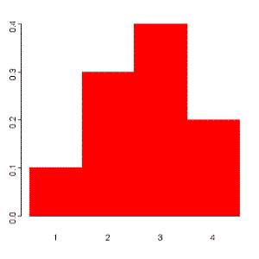

**Continuous**

A continuous random variable is one which takes an infinite number of possible values. Continuous random variables are usually measurements. Examples include height, weight, the amount of sugar in an orange, the time required to run a mile.

A continuous random variable is not defined at specific values. Instead, it is defined over an interval of values, and is represented by the area under a curve (in advanced mathematics, this is known as an integral). The probability of observing any single value is equal to 0, since the number of values which may be assumed by the random variable is infinite.

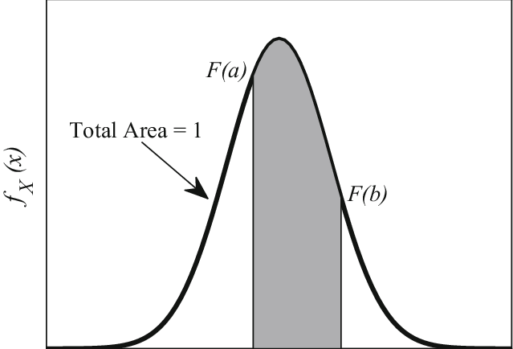Suppose a random variable X may take all values over an interval of real numbers. Then the probability that X is in the set of outcomes A, P(A), is defined to be the area above A and under a curve. The curve, which represents a function p(x), must satisfy the following:

1: The curve has no negative values (p(x) > 0 for all x)

2: The total area under the curve is equal to 1.

## Probability Distribution Function

A probability distribution can be described in various forms, such as by a probability density function or a cumulative distribution function. Probability density functions, or PDFs, are mathematical functions that usually apply to continuous and discrete values. Now that we have a basic idea of what a PDF is, how are they used in statistics? More importantly, how are they applied to Data Science, and what do they look like on paper?

PDFs are very commonly used in statistical analysis, and thus are quite commonly used for Data Science. Generally, PDFs are a necessary tool when studying data with applied science using statistics

The normal distribution, that is quite commonly used in machine-learning. Standard scaling of data is quite a popular way to normalize continuous values whose data has high variance. This PDF transforms continuous samples into standard deviations from the population’s mean.

Looking at a PDF, we see that it has a parabolic curve, where the center is where most of our data lies:

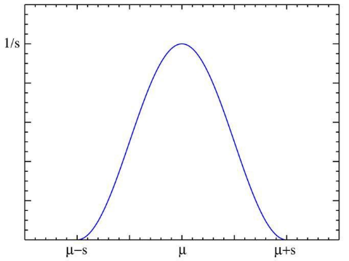

The normal distribution is a great example of a PDF. This is partially because it is very commonly used and familiar to most Scientists, but also partially because it has prominent applications across the entire spectrum of applied statistics. For many of the other distributions, the normal distribution acts as a base to be built upon for probability theory.

## Cumulative Distribution Function

All random variables (**discrete and continuous**) have a cumulative distribution function. It is a function giving the probability that the random variable X is less than or equal to x, for every value x. For a discrete random variable, the cumulative distribution function is found by summing up the probabilities

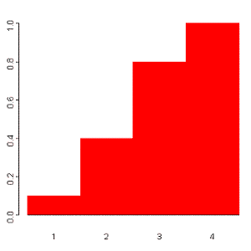The cumulative distribution function for the above probability distribution is calculated as follows:

The probability that X is less than or equal to 1 is 0.1,

the probability that X is less than or equal to 2 is 0.1+0.3 = 0.4,

the probability that X is less than or equal to 3 is 0.1+0.3+0.4 = 0.8, and

the probability that X is less than or equal to 4 is 0.1+0.3+0.4+0.2 = 1.

The probability histogram for the cumulative distribution of this random variable is shown to the right:

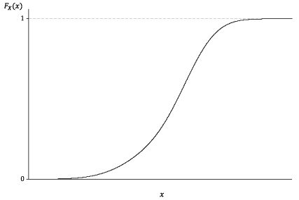

**Comparison between data and CDF**

Let’s work with the ‘Education’ column from our dataset and compare it with the probability density function and cumulative density function.

First, prepare the data and the normal theorical data

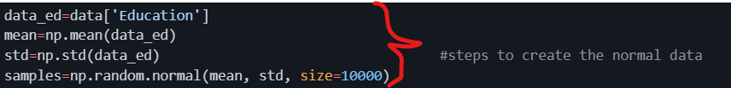

Second, define a function to compute the CDF for one-dimensional data

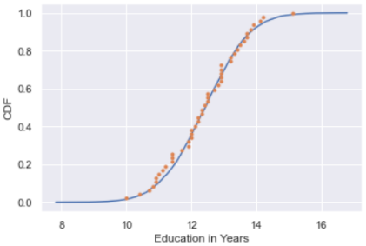And the last step is plot everything together to check normality thru cumulative density function

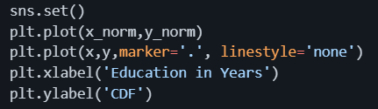

As we can see, our data has similar shape to the cumulative distribution function. Thanks to this we can say that the education column its nearly normally distributed.

## Central Limit Theorem

In probability theory, the central limit theorem (CLT) states that the distribution of a sample variable approximates a normal distribution (i.e., a “bell curve”) as the sample size becomes larger, assuming that all samples are identical in size, and regardless of the population's actual distribution shape.

Put another way, CLT is a statistical premise that, given a sufficiently large sample size from a population with a finite level of variance**, the mean of all sampled variables from the same population will be approximately equal to the mean of the whole population**. Furthermore, these samples approximate a normal distribution, with their variances being approximately equal to the variance of the population as the sample size gets larger, according to the law of large numbers.

## Continuous Distributions

1. Normal Distribution (or Gaussian Distribution)

* Gaussian distribution is a continuous probability distribution with symmetrical sides around its center.
* Its mean, median and mode are equal.
* 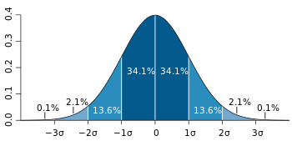Its shape looks like below with most of the data points clustered around the mean with asymptotic tails.

84% of the values drawn from normal distribution lie within 1𝜎

99.7% of the values drawn from normal distribution lie within 3𝜎

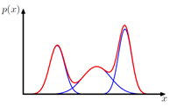

Simple Gaussian distribution fails to capture the following structure 🡪

1. Poisson Distribution

Poisson Distributions are commonly used to find the probability that an event might happen or not knowing how often it usually occurs. Additionally, Poisson Distributions can also be used to predict how many times an event might occur in a given time period.

Poisson Distributions are for example frequently used by insurance companies to conduct risk analysis (eg. predict the number of car crash accidents within a predefined time span) to decide car insurance pricing.

When working with Poisson Distributions, we can be confident of the average time between the occurrence of different events, but the precise moment an event might take place is randomly spaced in time.

The main characteristics which describe Poisson Processes are:

The events are independent of each other (if an event happens, this does not alter the probability that another event can take place).

* An event can take place any number of times (within the defined time period).
* Two events can’t take place simultaneously.
* The average rate between events occurrence is constant.

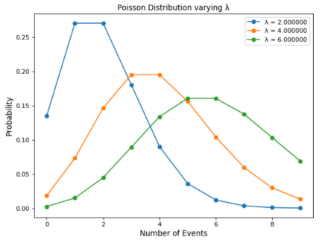Poisson Distribution can be modelled using the following formula, where lambda represents the expected number of events which can take place in a period. Sometimes called the event rate or rate parameter.

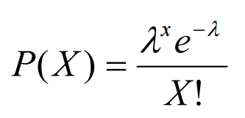

## Skewness

Skewness is the measure of the asymmetry of an ideally symmetric probability distribution and is given by the third standardized moment. If that sounds way too complex, don’t worry! Let me break it down for you.

In simple words, skewness is the measure of how much the probability distribution of a random variable deviates from the normal distribution. Now, you might be thinking – why am I talking about normal distribution here?

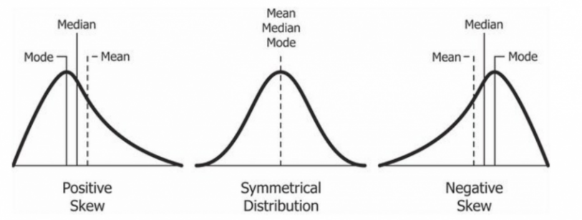Well, the normal distribution is the probability distribution without any skewness. You can look at the image below which shows symmetrical distribution that’s basically a normal distribution and you can see that it is symmetrical on both sides of the dashed line. Apart from this, there are two types of skewness:

* Positive Skewness
* Negative Skewness

Let’s take a look to the following distribution. It is the distribution of horsepower of cars:

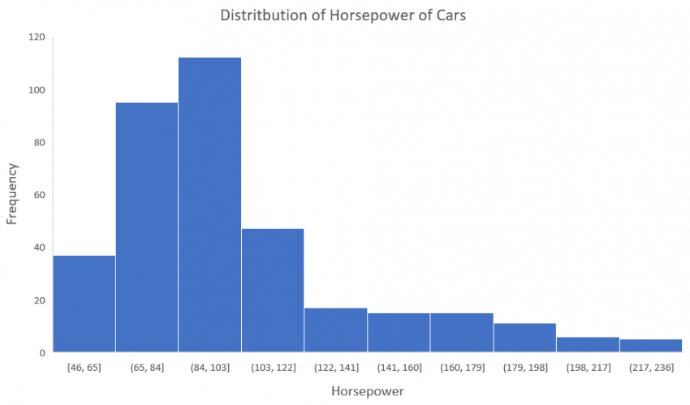You can clearly see that the above distribution is positively skewed. Now, let’s say you want to use this as a feature for the model which will predict the mpg (miles per gallon) of a car.

Since our data is positively skewed here, it means that it has a higher number of data points having low values, i.e., cars with less horsepower. So when we train our model on this data, it will perform better at predicting the mpg of cars with lower horsepower as compared to those with higher horsepower.

Also, skewness tells us about the direction of outliers. You can see that our distribution is positively skewed and most of the outliers are present on the right side of the distribution.

Note: The skewness does not tell us about the number of outliers. It only tells us the direction.

To statistically determine the skewness, we have the Pearson’s coefficient of skewness. This coefficient tells us the direction of the skewness (positive or negative) and we can obtain it in python as follows:

The direction of skewness is given by the sign.

* The coefficient compares the sample distribution with a normal distribution. The larger the value, the larger the distribution differs from a normal distribution.
* A value of zero means no skewness at all.
* A **large negative** value means the distribution is **negatively skewed**.
* A **large positive** value means the distribution is **positively skewed**.

## Monte Carlo Method

Monte Carlo simulation (also called the Monte Carlo Method or Monte Carlo sampling) is a way to account for risk in decision making and quantitative analysis. The method finds all possible outcomes of your decisions and assesses the impact of risk. The technique uses intensive statistical sampling methods that are so complex they are usually only performed with the aid of a computer.

The Monte Carlo method tells you:

* **All of the possible events that could or will happen,**
* **The probability of each possible outcome.**

The Monte Carlo simulation returns a quantified probability, which means that it gives you scenarios with numbers you can use. Let’s say your company wants to know if local bird life will be adversely affected by the construction of a new factory close to wetlands. A quantified probability would be “If we build the factory, there is a 30% chance the nesting bird population will be adversely affected.” This is more useful that a more general, qualified statement like “If we build the factory, the nesting bird population will be affected”.

Monte Carlo simulations are used in many areas of industry and science, including:

* Analyzing radiative heat transfer problems (Wang et.al),
* Estimating the transmission of particles through matter (Biersack & Haggmark),
* Calculating the probability of cost overruns in large projects (McCabe),
* Foreseeing where prices of securities are likely to move (Boyle et. al),
* Analyzing how a network or electric grid will perform in different scenarios. For example, Sortomme et. al ran simulations for how electric vehicle charging will affect the electric drig in the future.
* Assessing risk for credit or insurance (Gordy).
* Simulating proteins in biology (Earl et. al)

Accuracy

While a Monte Carlo simulation provides some good accuracy, it is unlikely to hit the “exact” mark for several reasons:

* Vast amounts of data are usually involved.
* There are usually several unknowns in the system.
* As it is probabilistic (i.e. randomness plays a role in predicting future events), there will always be a margin of error related to the results.

In fact, it can be quite easy to run a “bad” Monte Carlo simulation (Brandimarte, 2014). This can happen for a variety of reasons, including:

* Use of an incorrect model or an unrealistic probability distribution,
* The underlying risk factors aren’t complete (i.e. you haven’t specified them well enough),
* The choice of Monte Carlo (which uses a stochastic model) isn’t suited to your data,
* The random number generator chosen for the method isn’t good enough,
* Computer bugs, which you may not be aware of if your area of expertise is statistics (as opposed to programming)

## Hypothesis Testing

First, you might need to know what is an hypothesis, well, a hypothesis is an educated guess about something in the world around you. It should be testable, either by experiment or observation. For example:

* A new medicine you think might work.
* A way of teaching you think might be better.
* A possible location of new species.
* A fairer way to administer standardized tests.

It can really be anything at all as long as you can put it to the test.

If you are going to propose a hypothesis, it’s customary to write a statement. Your statement will look like this:

**“If I…(do this to an independent variable)….then (this will happen to the dependent variable).”**

For example:

* If I (decrease the amount of water given to herbs) then (the herbs will increase in size).
* If I (give patients counseling in addition to medication) then (their overall depression scale will decrease).

A good hypothesis statement should:

* Include an “if” and “then” statement (according to the University of California).
* Include both the independent and dependent variables.
* Be testable by experiment, survey or other scientifically sound technique.
* Be based on information in prior research (either yours or someone else’s).
* Have design criteria (for engineering or programming projects).

**What is Hypothesis Testing?**

Hypothesis testing in statistics is a way for you to test the results of a survey or experiment to see if you have meaningful results. You’re basically testing whether your results are valid by figuring out the odds that your results have happened by chance. If your results may have happened by chance, the experiment won’t be repeatable and so has little use.

Hypothesis testing can be one of the most confusing aspects for students, mostly because before you can even perform a test, you must know what your null hypothesis is. Often, those tricky word problems that you are faced with can be difficult to decipher. But it’s easier than you think; all you need to do is:

1. Figure out your null hypothesis,
2. State your null hypothesis,
3. Choose what kind of test you need to perform,
4. Either support or reject the null hypothesis.

What is the Null Hypothesis?

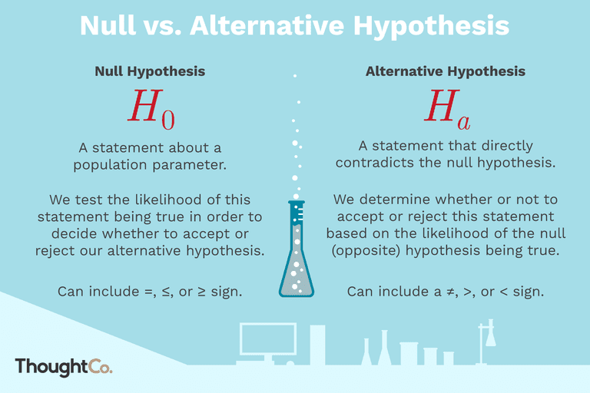If you trace back the history of science, the null hypothesis is always the accepted fact. Simple examples of null hypotheses that are generally accepted as being true are:

* DNA is shaped like a double helix.
* There are 8 planets in the solar system (excluding Pluto).
* Taking Vioxx can increase your risk of heart problems (a drug now taken off the market).

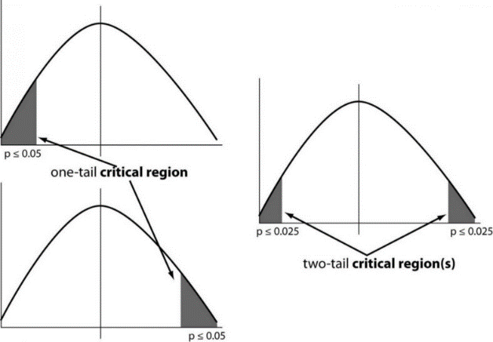The null hypothesis is the default claim, premise, value or parameter that is generally accepted. The alternative hypothesis is a research or investigative hypothesis that includes the claim to be tested which could hopefully replace the null hypothesis, in case it is proved to be true. The various tests below help to figure out to what extent information from the sample data can be extrapolated to the population from which it was drawn.

**One tailed test:** A test of a statistical hypothesis, where the region of rejection is on only one side of the sampling distribution, is called a one-tailed test.

Example: a college has ≥ 4000 student or data science ≤ 80% org adopted.

**Two-tailed test:** A two-tailed test is a statistical test in which the critical area of a distribution is two-sided and tests whether a sample is greater than or less than a certain range of values. If the sample being tested falls into either of the critical areas, the alternative hypothesis is accepted instead of the null hypothesis.

Example: a college != 4000 student or data science != 80% org adopted

P-Value

The P value, or calculated probability, is the probability of finding the observed, or more extreme, results when the null hypothesis (H 0) of a study question is true — the definition of ‘extreme’ depends on how the hypothesis is being tested.

If your P value is less than the chosen significance level, then you reject the null hypothesis i.e. accept that your sample gives reasonable evidence to support the alternative hypothesis. It does NOT imply a “meaningful” or “important” difference; that is for you to decide when considering the real-world relevance of your result.

## Normality Tests

This section lists statistical tests that you can use to check if your data has a Gaussian distribution.

* Shapiro-Wilk Test: **You use it when you want to tell if a random sample comes from a normal distribution or not.** The smaller the W value returned by the test, the more confident you can be that the sample is not normally distributed. This result can lead to the rejection of the null hypothesis you started with in the first place. You can also think about this in terms of a p-value: when it is less than or equal to a certain threshold (usually 0.05), then you can reject the null hypothesis.

* D’Agostino’s K^2 Test: It first computes the skewness and kurtosis to quantify how far the distribution is from Gaussian in terms of asymmetry and shape. It then calculates how far each of these values differs from the value expected with a Gaussian distribution and computes a single P value from the sum of these discrepancies. It is a versatile and powerful normality test, and is recommended.

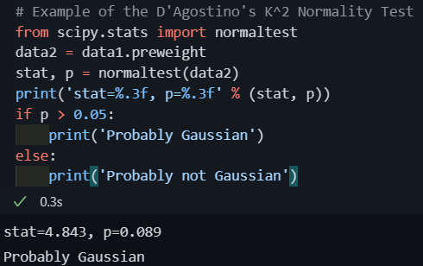

* Anderson-Darling Test: It computes the P value by comparing the cumulative distribution of your data set against the ideal cumulative distribution of a Gaussian distribution. It takes into account the discrepancies at all parts of the cumulative distribution curve

## Correlation Tests

Correlation is a bivariate analysis that measures the strength of association between two variables and the direction of the relationship. In terms of the strength of relationship, the value of the correlation coefficient varies between +1 and -1. A value of ± 1 indicates a perfect degree of association between the two variables. As the correlation coefficient value goes towards 0, the relationship between the two variables will be weaker. The direction of the relationship is indicated by the sign of the coefficient; a + sign indicates a positive relationship and a – sign indicates a negative relationship

* Pearson’s Correlation Coefficient: Pearson r correlation is the most widely used correlation statistic to measure the degree of the relationship between linearly related variables (Is there a relationship between temperature, measured in degrees Fahrenheit, and ice cream sales, measured by income?)
  + Observations in each sample are independent and identically distributed (iid).
  + Observations in each sample are normally distributed.
  + Observations in each sample have the same variance

* Spearman’s Rank Correlation: Spearman rank correlation is a non-parametric test that is used to measure the degree of association between two variables. The Spearman **rank correlation** test does not carry any assumptions about the distribution of the data and is the appropriate correlation analysis when the variables are measured on a scale that is at least ordinal. (Is there a statistically significant relationship between participants’ level of education (high school, bachelor’s, or graduate degree) and their starting salary?)
  + Observations in each sample are independent and identically distributed (iid).
  + Observations in each sample can be ranked.

* Kendall’s Rank Correlation: Kendall rank correlation is a non-parametric test that measures the strength of dependence between two variables. If we consider two samples, a and b, where each sample size is n, we know that the total number of pairings with a b is n(n-1)/2.
  + Observations in each sample are independent and identically distributed (iid).
  + Observations in each sample can be ranked.

* Chi-Squared Test: The test is applied when you have **two categorical variables** from a single population. It is used to determine **whether** **there is a significant association between the two variables**. his is useful when dealing with categorical variables, to see how likely it would be to observe your data’s distribution if those variables were independent. For instance, let’s say you want to know if being a man or a woman makes you more or less likely to be a smoker. If those two variables were independent, you could expect the same percentage of men and women among both smokers and non-smokers. Pearson’s chi-squared test will tell you how confident you can be that there is such a difference, or not

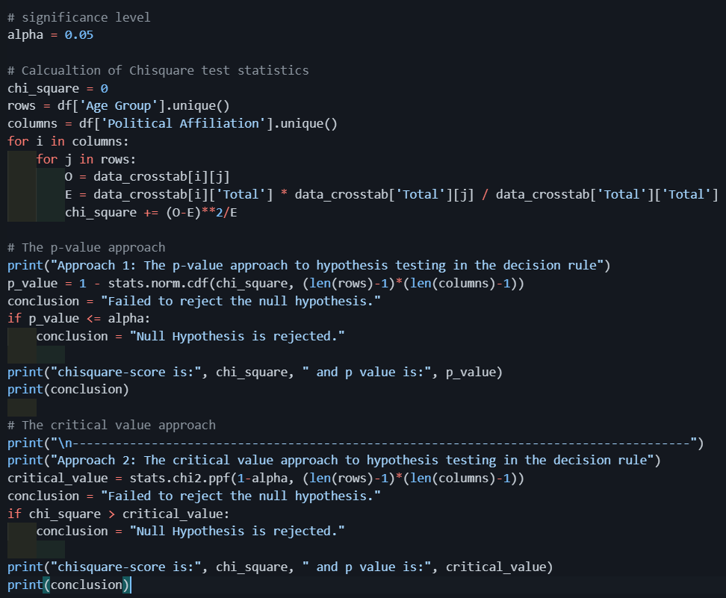

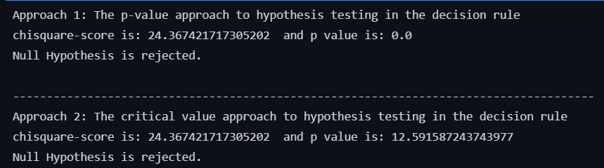

## Stationary Tests

Stationarity is an important concept in time series analysis because this means that the statistical properties of a time series (or rather the process generating it) do not change over time. Stationarity is important because many useful analytical tools and statistical tests and models rely on it. **Time series are stationary if they do not have trend or seasonal effects**

One way to detecting stationarity in time series data is using statistical tests developed to detect specific types of stationarity, namely those brought about by simple parametric models of the generating stochastic process

* Augmented Dickey-Fuller: Tests whether a time series has a unit root, e.g. has a trend or more generally is autoregressive.
  + Observations in are temporally ordered

* Kwiatkowski-Phillips-Schmidt-Shin: **Tests whether a time series is trend stationary or not.**
  + Observations in are temporally ordered

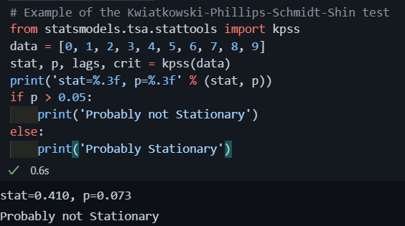

## Parametric Statistical Hypothesis Tests

* Parametric tests can provide trustworthy results with distributions that are skewed and nonnormal
* Parametric tests can provide trustworthy results when the groups have different amounts of variability
* Parametric tests have greater statistical power

* If the mean is a better measure and you have a sufficiently large sample size, a parametric test usually is the better, more powerful choice than the nonparametric

Types of tests:

* Student’s t-test: It is essentially, testing the significance of the difference of the mean values when the sample size is small (i.e, less than 30) and when the population standard deviation is not available.
  + Population distribution is normal, and
  + Samples are random and independent
  + The sample size is small.
  + Population standard deviation is not known.
  + A T-test can be a:
    - One Sample T-test: To compare a sample mean with that of the population mean.
    - Two-Sample T-test: To compare the means of two different samples.

* F-Test: It is a test for the null hypothesis that two normal populations have the same variance.
  + An F-test is regarded as a comparison of equality of sample variances.
  + F-statistic is simply a ratio of two variances.
  + By changing the variance in the ratio, F-test has become a very flexible test. It can then be used to:
    - Test the overall significance for a regression model.
    - To compare the fits of different models and
    - To test the equality of means.
  + Population distribution is normal, and samples are drawn randomly and independently.
* Analysis of Variance Test (ANOVA): Next chapter
* Repeated Measures ANOVA Test: Next chapter

## Nonparametric Statistical Hypothesis Tests

**Nonparametric tests assess the median which can be better for some study areas.** Nonparametric analyses provide an advantage because they assess the median rather than the mean. The mean is not always the better measure of central tendency for a sample. Even though you can perform a valid parametric analysis on skewed data, that doesn’t necessarily equate to being the better method.

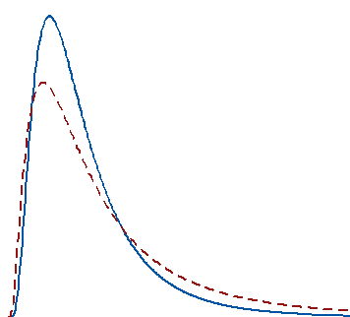Example: Salaries tend to be a right-skewed distribution. The majority of wages cluster around the median, which is the point where half are above, and half are below. However, there is a long tail that stretches into the higher salary ranges. This long tail pulls the mean far away from the central median value. The two distributions are typical for salary distributions.

In these distributions, if several very high-income individuals join the sample, the mean increases by a significant amount even though incomes for most people don’t change. They still cluster around the median.

In this situation, parametric and nonparametric test results can give you different results, and they both can be correct! For the two distributions, if you draw a large random sample from each population, the difference between the means is statistically significant. Despite this, the difference between the medians is not statistically significant. Here’s how this works.

For skewed distributions, changes in the tail affect the mean substantially. Parametric tests can detect this mean change. Conversely, the median is relatively unaffected, and a nonparametric analysis can legitimately indicate that the median has not changed significantly.

**You need to decide whether the mean or median is best for your study and which type of difference is more important to detect.**

**Nonparametric tests are valid when our sample size is small, and your data are potentially nonnormal.** Use a nonparametric test when your sample size isn’t large enough to satisfy the requirements in the table above and you’re not sure that your data follow the normal distribution. With small sample sizes, be aware that normality tests can have insufficient power to produce useful results.

This situation is difficult. Nonparametric analyses tend to have lower power at the outset, and a small sample size only exacerbates that problem.

**Nonparametric tests can analyze ordinal data, ranked data, and outliers**

**If the median is a better measure, consider a nonparametric test regardless of your sample size.**

Types of tests:

* Mann-Whitney U Test: This is also called the Mann-Whitney U test in statistics. This test becomes useful when you want to **look at the difference between two independent groups,** especially when the dependent variable is either ordinal or continuous, but not normally distributed.
  + Observations in each sample are independent and identically distributed (iid).
  + Observations in each sample can be ranked.

* Wilcoxon Signed-Rank Test:
  + Wilcoxon signed-rank test does not assume normality in the data, it can be used when this assumption has been violated and the use of the dependent t-test is inappropriate. It is used to compare two sets of scores that come from the same participants. This can occur when we wish to investigate any change in scores from one time point to another, or when individuals are subjected to more than one condition.
  + For example, you could use a Wilcoxon signed-rank test to understand whether there was a difference in smokers' daily cigarette consumption before and after a 6 week hypnotherapy programme (i.e., your dependent variable would be "daily cigarette consumption", and your two related groups would be the cigarette consumption values "before" and "after" the hypnotherapy programme).
  + Also use a Wilcoxon signed-rank test to understand whether there was a difference in reaction times under two different lighting conditions (i.e., your dependent variable would be "reaction time", measured in milliseconds, and your two related groups would be reaction times in a room using "blue light" versus "red light").
  + Observations in each sample are independent and identically distributed (iid).
  + Observations in each sample can be ranked.
  + Observations across each sample are paired.

* Kruskal-Wallis H Test:
  + This test is used for comparing two or more independent samples of equal or different sample sizes.

It extends the Mann-Whitney-U-Test which is used to comparing only two groups.

* + One-Way ANOVA is the parametric equivalent of this test. And that’s why it is also known as ‘One-Way ANOVA on ranks.
  + It uses ranks instead of actual data.
  + It does not assume the population to be normally distributed.
  + The test statistic used here is “H”.

* Friedman Test
  + The Friedman test is the non-parametric alternative to the one-way ANOVA with repeated measures. It is used to test for differences between groups when the dependent variable being measured is ordinal. It can also be used for continuous data that has violated the assumptions necessary to run the one-way ANOVA with repeated measures (e.g., data that has marked deviations from normality).
  + Observations in each sample are independent and identically distributed (iid).
  + Observations in each sample can be ranked.
  + Observations across each sample are paired.

## Analysis of Variance (ANOVA)

An ANOVA test is a way to find out if survey or experiment results are significant. In other words, they help you to figure out if you need to reject the null hypothesis or accept the alternate hypothesis.

**Basically, you’re testing groups to see if there’s a difference between them**. Examples of when you might want to test different groups:

* A group of psychiatric patients are trying three different therapies: counseling, medication and biofeedback. You want to see if one therapy is better than the others.
* A manufacturer has two different processes to make light bulbs. They want to know if one process is better than the other.
* Students from different colleges take the same exam. You want to see if one college outperforms the other.

There are two different types of independent variables to perform an ANOVA, which are:

* One-way has one independent variable (with 2 levels). For example: brand of cereal,
* Two-way has two independent variables (it can have multiple levels). For example: brand of cereal, calories.

Groups or levels are different groups within the same independent variable. In the above example, your levels for “brand of cereal” might be Lucky Charms, Raisin Bran, Cornflakes — a total of three levels. Your levels for “Calories” might be: sweetened, unsweetened — a total of two levels.

Let’s say you are studying if an alcoholic support group and individual counseling combined is the most effective treatment for lowering alcohol consumption. You might split the study participants into three groups or levels: Medication only, Medication and counseling, Counseling only. Your dependent variable would be the number of alcoholic beverages consumed per day.

*If your groups or levels have a hierarchical structure (each level has unique subgroups), then use a nested ANOVA for the analysis.*

**One Way ANOVA**

A one-way ANOVA is used to compare two means from two independent (unrelated) groups using the F-distribution. The null hypothesis for the test is that the two means are equal. Therefore, a significant result means that the two means are unequal.

Examples of when to use a one-way ANOVA

Situation 1: You have a group of individuals randomly split into smaller groups and completing different tasks. For example, you might be studying the effects of tea on weight loss and form three groups: green tea, black tea, and no tea.

Situation 2: Similar to situation 1, but in this case the individuals are split into groups based on an attribute they possess. For example, you might be studying leg strength of people according to weight. You could split participants into weight categories (obese, overweight and normal) and measure their leg strength on a weight machine.

Example in Python

For this new data we have a column named Diet which tells us the different types of diets assigned to a person. We have 3 different values 🡪

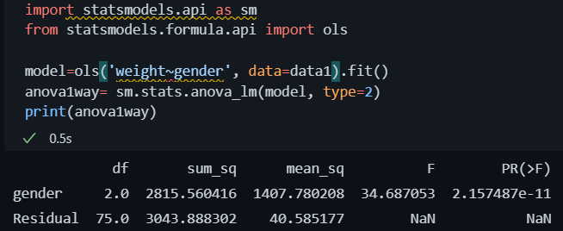Now let’s perform an ANOVA test comparing gender and pre weight 🡪

The p-value (2,16*e -11) for gender is much lower than the level of significance (0.05), therefore, we can say that there’s an association between the gender and the pre weight.

**Two Way ANOVA**

A Two-Way ANOVA is an extension of the One Way ANOVA. With a One Way, you have one independent variable affecting a dependent variable. With a Two-Way ANOVA, there are two independents. Use a two-way ANOVA when you have one measurement variable (i.e. a quantitative variable) and two nominal variables. In other words, **if your experiment has a quantitative outcome and you have two categorical explanatory variables**, a two-way ANOVA is appropriate.

For example, you might want to find out if there is an interaction between income and gender for anxiety level at job interviews. The anxiety level is the outcome, or the variable that can be measured. Gender and Income are the two categorical variables. These categorical variables are also the independent variables, which are called factors in a Two Way ANOVA.

Two-way example

For this example, we’ll use the same dataset as the one-way analysis.

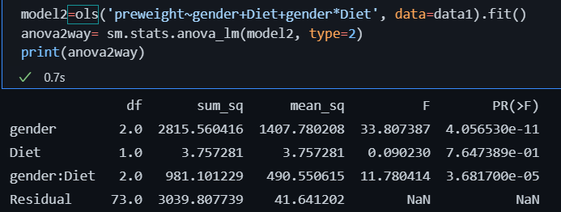As we can see the p-value for gender is much lowe than the level of significance but the p-value for Diet is higher. Therefore, there is no association between the pre weight and the diet but there are an association between pre weight and gender.

We have one last value which is the interaction between gender and Diet and their p value is lower than the level of significance. The interaction between them is statistically significant.

**MANOVA**

MANOVA is just an ANOVA with several dependent variables. It’s similar to many other tests and experiments in that it’s purpose is to find out if the response variable (i.e. your dependent variable) is changed by manipulating the independent variable. The test helps to answer many research questions, including:

Do changes to the independent variables have statistically significant effects on dependent variables?

What are the interactions among dependent variables?

What are the interactions among independent variables?

MANOVA Example

Suppose you wanted to find out if a difference in textbooks affected students’ scores in math and science. Improvements in math and science means that there are two dependent variables, so a MANOVA is appropriate.

An ANOVA will give you a single (univariate) f-value while a MANOVA will give you a multivariate F value. MANOVA tests the multiple dependent variables by creating new, artificial, dependent variables that maximize group differences. These new dependent variables are linear combinations of the measured dependent variables.

Interpreting the MANOVA results

If the multivariate F value indicates the test is statistically significant, this means that something is significant. In the above example, you would not know if math scores have improved, science scores have improved (or both). Once you have a significant result, you would then have to look at each individual component (the univariate F tests) to see which dependent variable(s) contributed to the statistically significant result.

Advantages

MANOVA enables you to test multiple dependent variables.

MANOVA can protect against Type I errors.

Disadvantages

MANOVA is many times more complicated than ANOVA, making it a challenge to see which independent variables are affecting dependent variables.

One degree of freedom is lost with the addition of each new variable.

The dependent variables should be uncorrelated as much as possible. If they are correlated, the loss in degrees of freedom means that there isn’t much advantages in including more than one dependent variable on the test.

**Nested ANOVA**

A nested ANOVA (also called a hierarchical ANOVA) is an extension of a simple ANOVA for experiments where each group is divided into two or more random subgroups. It tests to see if there is variation between groups, or within nested subgroups of the attribute variable. You should use nested ANOVA when you have:

* One measurement variable,
* Two or more nested nominal variables (factors).

Example

Let’s say you wanted to investigate the wage gap between men and women. You also think that height affects wages (which is true — see The Atlantic’s story on Why Tall People Make More) as does obesity (also true: see Forbes’ story The Price of Obesity). Your factors or levels (sex, height, weight) are nested within each other. For example, “weight” is not a standalone factor — it’s nested under male/female. The following image shows the hierarchical model:

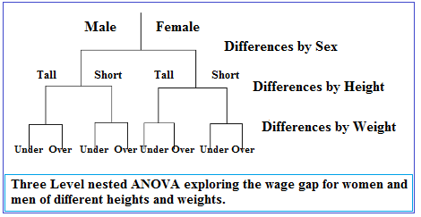

## Estimation

## Confidence intervals

## MLE

## Kernel Density Estimate

## Regressiom

## Covariance, Correlation and Pearson Coefficient

# Scale, Standardize, or Normalize

STATISTIC

There is a dataset where I analyze all the statistics below ()

A fondo:

Eigen values for data science