The box model:

Parts of a box:

Content box: The area where our content is displayed. To size it, we use some properties like inline-size, block-size or width and height.

Padding box: Padding sits around the content, we manage it using properties like padding and related properties.

Border box: Border wraps around the content and padding; size it using border and related properties.

Margin box: Margin its the outermost layer, wrapping the content, padding and border as white space between this box and the other boxes. Size it using margin and related properties.

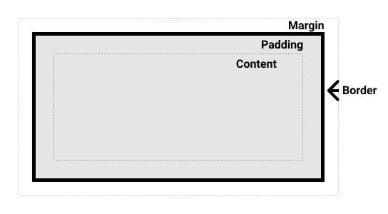
-

Standard CSS Box Model:

In the standard CSS box model, if you give a box an inline-size and a block-size (or width and height) atributtes, this defines the inline-size and block-size (width and height in horizontal languages) of the content box. Any padding and border is then added to those dimensions to get the total size taken up by the box.

If we asume that a box has the following CSS:

.box {
width: 350px;
height: 150px;
margin: 10px;
padding: 25px;
border: 5px solid black;
}

The actual space taken up by the box will be 410px wide (350 + 25 + 25 + 5 + 5) and 210px high (150 + 25 + 25 + 5 + 5).

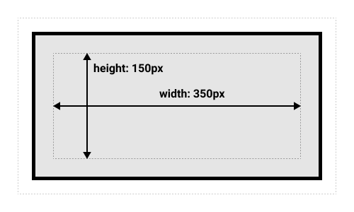

The alternative CSS box model:

In the alternative box model, any width is the width of the visible box on the page. The content area width is that width minus the width for the padding and border. No need to add up the border and padding to get the real size of the box.

To turn on alternative model for an element, set box-sizing: border-box on it:

.box {
box-sizing: border-box;
}

if we asume the box has the same CSS properties as above:

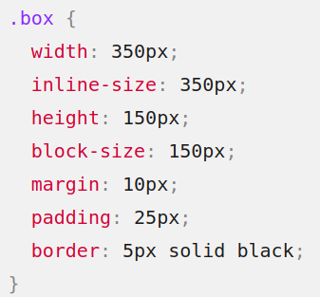

Now, the actual space taken up by the box will be 350px in the inline direction and 150 in the block direction:

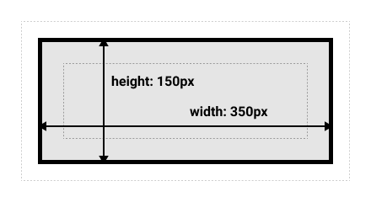

To use the alternative box model to all your elements (wich is a common choice among developers), set the box-sizing property on the <html> element and set all other elements to inherit that value:

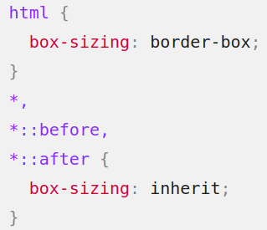

Margin, padding and borders:

Margin

Is an invisible space around your box. It pushes other elements away from the box. Margin can have positive and negative values. Setting a negative value on one side of your box can cause to overlap other things in the page. The margin is always added after the size of the visible box has been calculated.

We can control all margins of an element at once using the margin propery, or each side individually using the equivalent longhand properties:

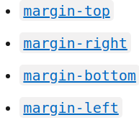
.

Margin collapsing:

- Two positive margins will combine to become one margin. Its size will be equal to the largest individual margin.
- Two negative margins will collapse and the smallest (furthest from zero) value will be used.
- If one margin its negative, his value will be substracted from the total.

Borders:

The border is drawn between the padding and the margin of a box. If you are using the standard box model, the size of the border is added to the width and height of the box. If you are using the alternative box model then the size of the border makes the content box smaller as it takes up some of the available width and height.

You can set the style, width and color of all four borders at once using the border property.

To set properties of each side individually, use:
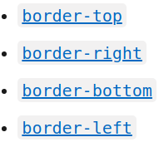

To set width, color and style of all sides, use:

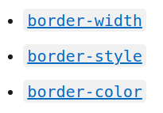
.

Padding:

The padding sits between the content and the border of an element and its used to push away the content from the border. You cannot have negative values. Any background applied to an element will display behind the padding.

The padding property controls the padding on all sides of an element. To control each side individually, use these longhand properties:

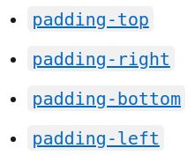
.

The box model and inline boxes:

All of the above fully applies to block boxes. Some of the properties can apply to inline boxes too.
In the example below, we have a <span> inside a paragraph. We have applied width, height, margin, border and padding to it. You can see that width and height are ignored. The vertical margin, padding and border are respected but don’t change the relationship of other content to our inline box. The padding and border overlap other words in the paragraph. The horizontal padding, margin and borders move other content away from the box.

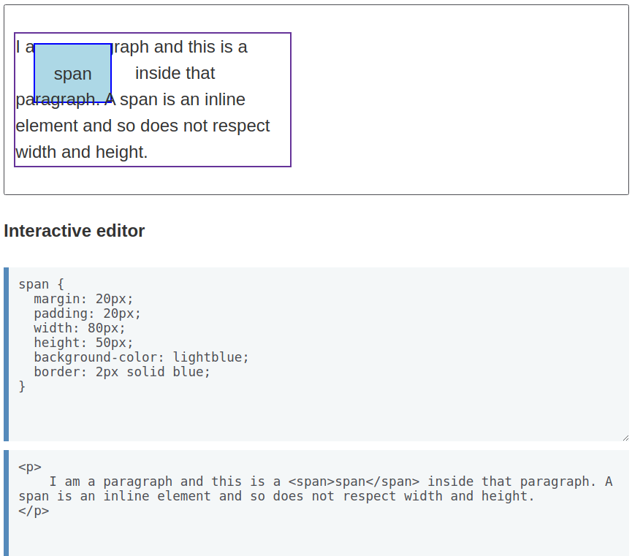
.

Using display: inline-block

display: inline-block is a special value of display, which provides a middle ground between inline and block. Use it if you don’t want an item to break into a new line, but want it to respect the width and height properties and avoid the overlapping seen before.

display: inline-block does a subset of the block things we already know about:

- width and height properties are respected.
- padding, margin and border will cause other elements to be pushed away from the box.

