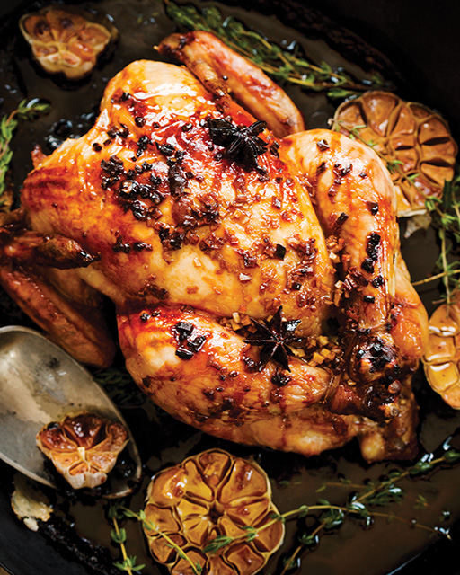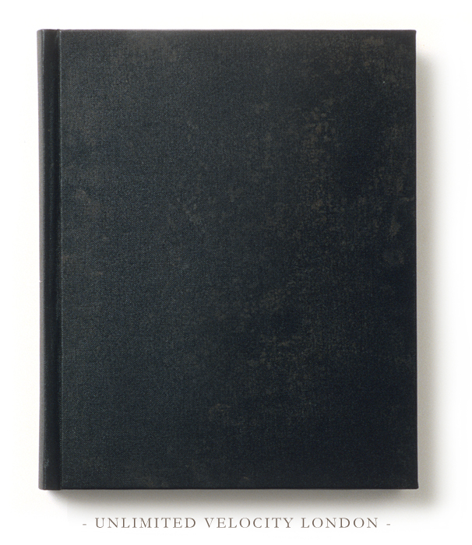

By: The Scouts

**Cooking through the Ages**

**Contents**

Hot apple cider 2

Honey roasted carrots 4

Roast potatoes 6

Roast Chicken with Orange Juice Glaze 8



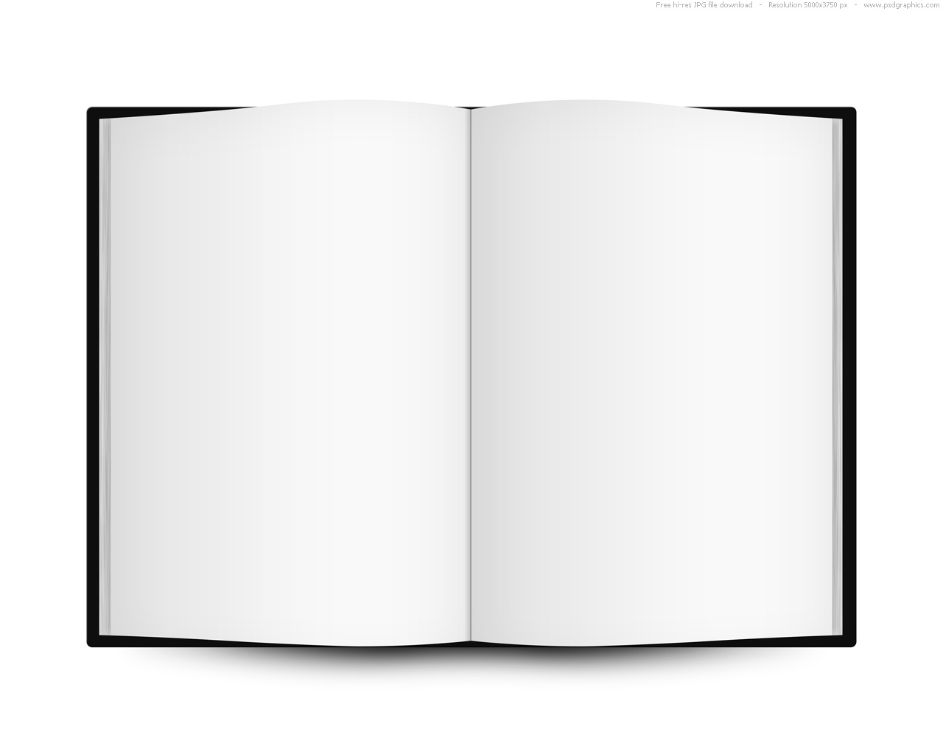

1

**Method**

**Place the cinnamon, cloves and apple cider into a saucepan and heat for 10 minutes on a low setting. Then remove the mixture from the heat and let everything infuse. Remove the cinnamon sticks and cloves and pour the mixture into a warmed glass.**

**Recipe for hot apple cider.**

**Ingredients**

**Apple cider**

**1 lemon**

**Ginger**

**2 cinnamon sticks**

**Sugar**

**2 cloves**

3

2



**Method**

**Heat oven to 170C and tip the carrots into a roasting tin and toss with 3 tbsp sunflower oil and some salt and pepper. Roast for 30 minutes. Drizzle 2 tbsp white wine vinegar and 2 tbsp clear honey over the carrots, toss well and return to the oven for a further 20 minutes.**

**Recipe for honey roasted carrots.**

**Ingredients**

**1kg small carrots, peeled**

**3tbsp sunflower oil**

**2 tbsp white wine vinegar**

**2 tbsp clear honey.**

5

4



**Recipe for roast potatoes.**

**Ingredients**

**5 tbsp duck fat**

**16 medium-sized potatoes (each about 176g)**

**8 garlic cloves**

**8 sprigs thyme**

**Sea salt.**

**Method**

**Heat oven to 170C and parboil the potatoes in salted water for 7-8 minutes then drain thoroughly. Put the duck fat into a roasting tin and heat in the oven for 5 minutes and add the drained, roughened potatoes to the tin of hot duck fat, then sprinkle over the garlic cloves, thyme and sea salt and mix until the potatoes are well coated in the fat. Return the tin to the oven and roast for 45-60 minutes or until golden and crunchy.**



7

6



**Method**

**This make take some time and is sure to feed the cat!**

**Recipe for Roast Chicken with Orange Juice Glaze**

**Ingredients**

8

