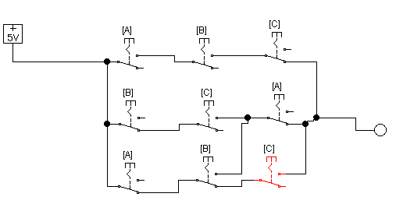

|  |  |  |  |
| --- | --- | --- | --- |
| A | B | C | Out |
| 0 | 0 | 0 | 0 |
| 0 | 0 | 1 | 1 |
| 0 | 1 | 0 | 1 |
| 0 | 1 | 1 | 1 |
| 1 | 0 | 0 | 0 |
| 1 | 0 | 1 | 0 |
| 1 | 1 | 0 | 1 |
| 1 | 1 | 1 | 0 |

/A/B C + /A B/C + /A B C + A B /C =

|  |  |  |  |  |
| --- | --- | --- | --- | --- |
|  | A | |  |  |
| B | 1 |  | 1 | 1 |
|  |  |  | 1 |  |
|  |  | C | |  |

C/A+B/C

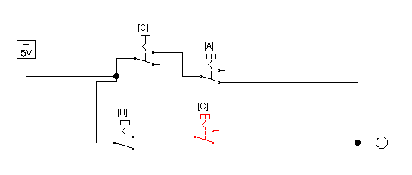

2.

/A/B C + /A B C + A /B C + /B C

C(A/B + /A B + A/B + /B)

C(/A + /B)