11. VAJA Prekodirnik BCD v 7- segmentni prikazovalnik

Realiziraj prekodirnik, ki prikaže BCD kodo na 7-segmentnem prikazovalniku.
Izpolni pravilnostno tabelo, za posamezno izhodno spremenljivko (segment) izpolni Veitchev diagram in zapiši minimalno obliko funkcije. Vezje realiziraj s programom EWB.

Kombinacije od 10 do 15 niso BCD koda in se ne bodo pojavile na vhodu prekodirnika, zato lahko za izhode pišemo poljubne vrednosti oziroma X.

PREKODIRNIK |  |  |  |  | BCD v 7-segmentni prikazovalnik
m | A | B | C | D | a | b | c | d | e | f | g
0 | 0 | 0 | 0 | 0 | 1 | 1 | 1 | 1 | 1 | 1 | 0
1 | 0 | 0 | 0 | 1 | 0 | 1 | 1 | 0 | 0 | 0 | 0
2 | 0 | 0 | 1 | 0 | 1 | 1 | 0 | 1 | 1 | 0 | 1
3 | 0 | 0 | 1 | 1 | 1 | 1 | 1 | 1 | 0 | 0 | 1
4 | 0 | 1 | 0 | 0 | 0 | 1 | 1 | 0 | 0 | 1 | 1
5 | 0 | 1 | 0 | 1 | 1 | 0 | 1 | 1 | 0 | 1 | 1
6 | 0 | 1 | 1 | 0 | 1 | 0 | 1 | 1 | 1 | 1 | 1
7 | 0 | 1 | 1 | 1 | 1 | 1 | 1 | 0 | 0 | 1 | 0
8 | 1 | 0 | 0 | 0 | 1 | 1 | 1 | 1 | 1 | 1 | 1
9 | 1 | 0 | 0 | 1 | 1 | 1 | 1 | 1 | 0 | 1 | 1
10 | 1 | 0 | 1 | 0 | X | x | x | x | x | x | x
11 | 1 | 0 | 1 | 1 | X | x | x | x | x | x | x
12 | 1 | 1 | 0 | 0 | X | x | x | x | x | x | x
13 | 1 | 1 | 0 | 1 | X | x | x | x | x | x | x
14 | 1 | 1 | 1 | 0 | X | x | x | x | x | x | x
15 | 1 | 1 | 1 | 1 | X | x | x | x | x | x | x

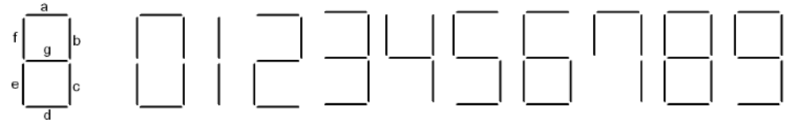

Rešitev za segment »a«

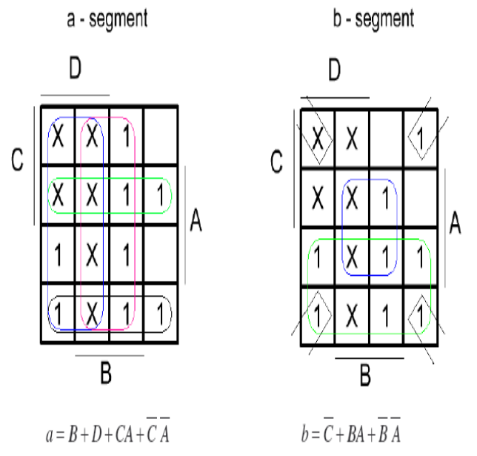  A  B  D  C | 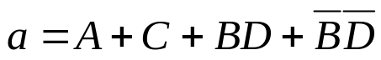

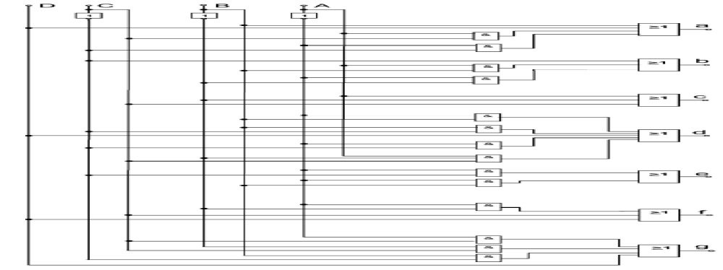
A
B
D
C

Segment B
 | A
B | x | x | 0 | 1
B | x | x | 1 | 0 | D
 | 1 | x | 1 | 1 | D
 | 1 | x | 1 | 1
 |  | C
b = A + /C/D + CD + /B
Segment C c = A + B + D + /C
 | A
B | x | x | 1 | 1
B | x | x | 1 | 1 | D
 | 1 | x | 1 | 1 | D
 | 1 | x | 0 | 1
 |  | C
Segment D d = A + C/D + /B C + B/CD + /B/C/D
 | A
B | x | x | 1 | 0
B | x | x | 0 | 1 | D
 | 1 | x | 1 | 0 | D
 | 1 | x | 1 | 1
 |  | C

Segment E e = AB + AC + /B/D + C/D
 | A
B | x | x | 1 | 0
B | x | x | 0 | 0 | D
 | 0 | x | 0 | 0 | D
 | 1 | x | 1 | 1
 |  | C
Segment F f = A + B +/C/D
 | A
B | x | x | 1 | 1
B | x | x | 1 | 1 | D
 | 1 | x | 0 | 0 | D
 | 1 | x | 0 | 1
 |  | C

Segment G g = A + C/B + B/C +B/D
 | A
B | x | x | 1 | 1
B | x | x | 0 | 1 | D
 | 1 | x | 1 | 0 | D
 | 1 | x | 1 | 0
 |  | C

