SAS | The Power To Know

Using SAS Visual Forecasting in Model Studio and SAS Studio

- Coding Tips and Performance Results  
  
Author: Franz Helmreich  
Date: 5. August 2019

Contents

1 Introduction 2

2 SAS-Drive & Model Studio Visual Forecasting 3

3 Transformation from Model Studio to SAS Studio 4

3.1 Directory Structure 4

3.2 Auto Forecasting (Auto_FC.sas) 5

3.3 Hierarchical Forecasting (Hierarchical_FC.sas) 6

3.4 Time Series Regression (TSR_FC.sas) 7

4 Implementation of a “User defined Model List” 8

4.1 User defined Auto Forecasting (User_Model_FC.sas) 9

5 Comparison of SAS9.4 HPF and SAS-Viya VF 10

5.1 Comparison of the short data set (SEG_SHORT_A) 12

5.2 Comparison of the long data set (SEG_LONG_A) 13

5.2.1 Using a user defined model list 13

5.2.2 Using auto forecasting methods 14

5.3 Conclusio 17

# 1 Introduction

This study tries to compare SAS Forecast Server functionality from SAS9.4 with Viya Visual Forecasting. The comparison is done on the experiences of the RHI forecasting project.

In order to transfer the actual project from Forecast Server to Viya some macros were developed to run the Viya forecasting functionality in SAS Studio. These macros are an extraction of SAS code from the online GUI Model Studio, are customized and parametrized to provide a kind of batch processing.

# SAS-Drive & Model Studio Visual Forecasting

Using SAS Viya V3.4 and Model Studio 8.4 a typical process flow looks like this:

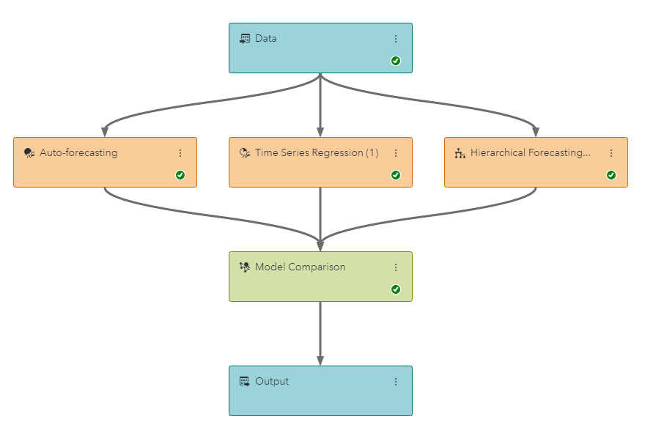

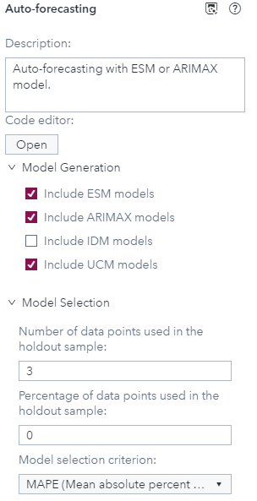 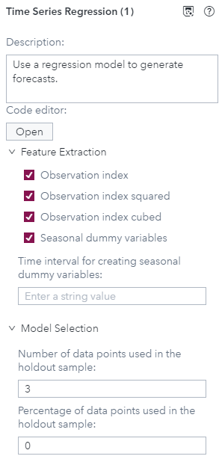 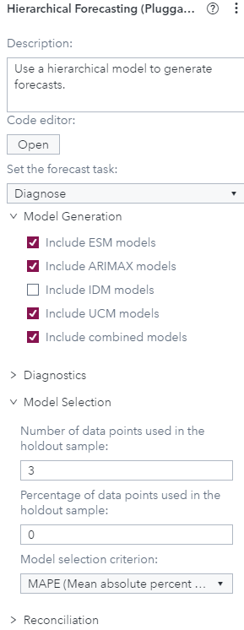

To automize this flow a parameterized SAS code is needed which can be started in SAS Studio.

# Transformation from Model Studio to SAS Studio

Taking the SAS code from Model Studio (View Code) I have developed three Macros:  
Auto_FC.sas, Hierachical_FC.sas and TSR_FC.sas are equivalent to the above workflow of Model Studio.

There is a requirement for an input and an output directory (Data_IN and Data_OUT). A time series has to be stored in Data_IN and then the results are stored in Data_OUT under the same name.

# Directory Structure

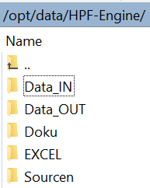 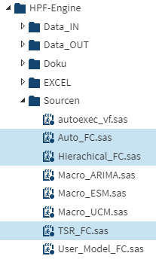

# Auto Forecasting (Auto_FC.sas)

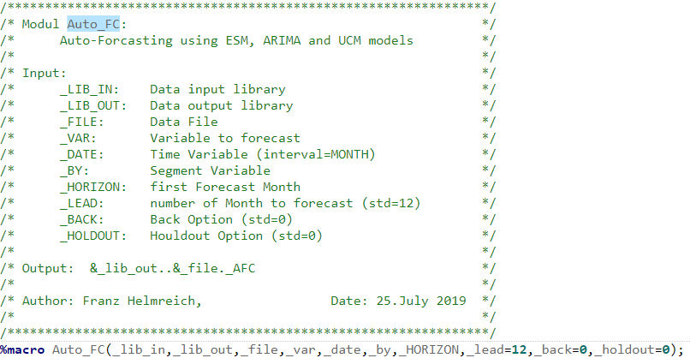

Output after running: %Auto_FC(Data_IN,Data_OUT,SEG_Long_A,A,date,FC_var,01JUL2019,

_lead=6,_holdout=3);

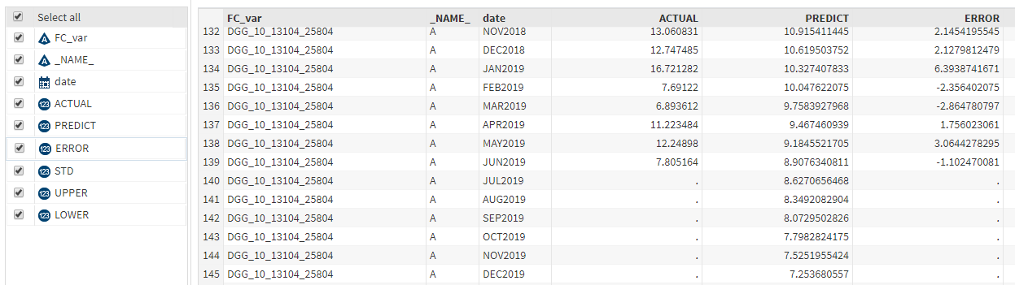

# Hierarchical Forecasting (Hierarchical_FC.sas)

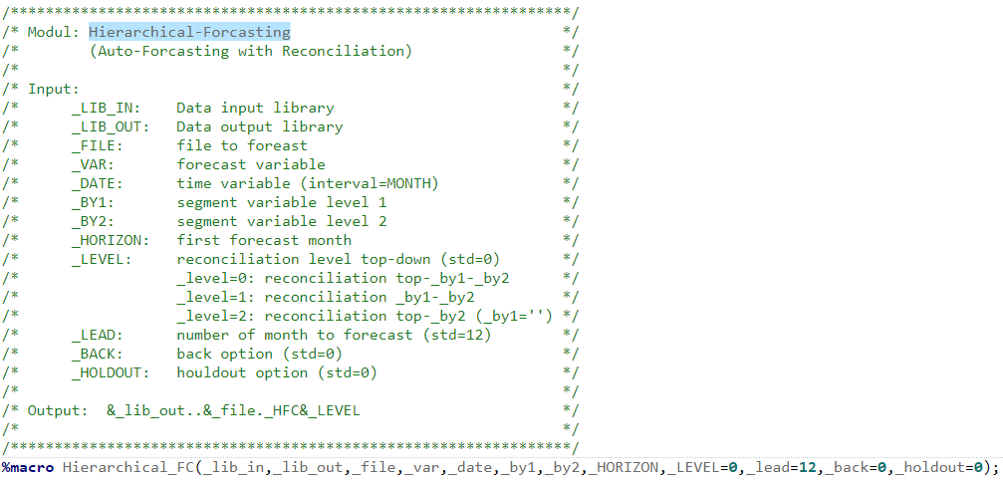

Output after running: %Hierarchical_FC(Data_IN,Data_OUT,SEG_Long_A,A,date,BU,FC_var,01JUL2019,

_level=0,_lead=6,_holdout=3);

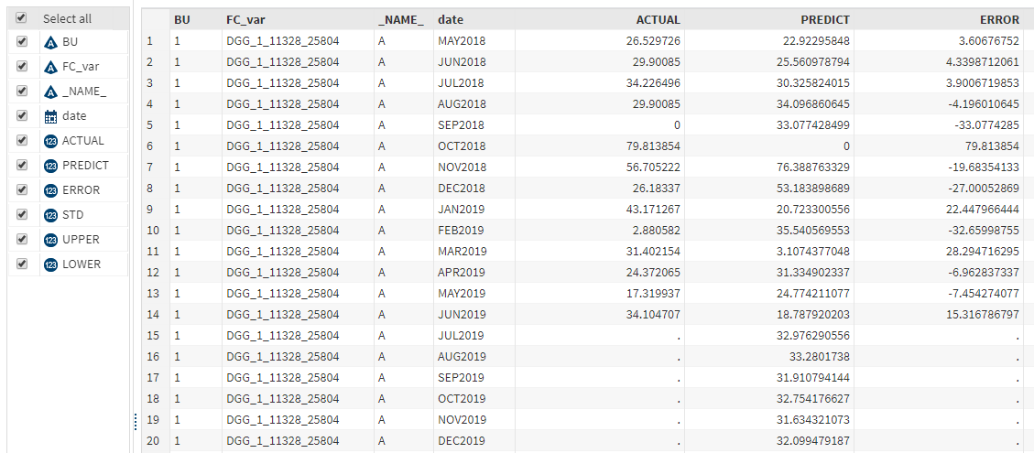

# Time Series Regression (TSR_FC.sas)

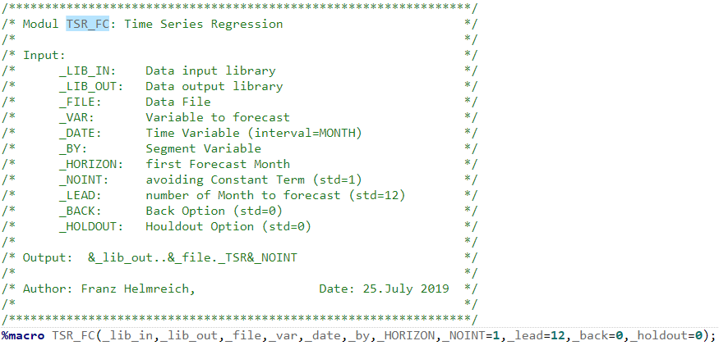

Output after running: %TSR_FC(Data_IN,Data_OUT,SEG_Long_A,A,date,FC_var,01JUL2019,

_lead=6,_holdout=3);

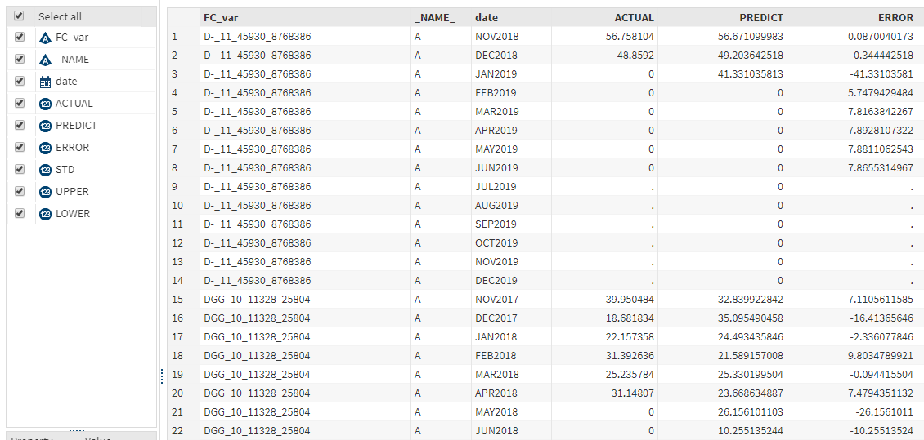

# Implementation of a “User defined Model List”

Model Studio offers some model selection groups like Seasonal or Non-Seasonal but does not cover a user defined model selection as it is available in Forecast Studio under SAS 9.4.

Starting with the general task “Modeling and Forecasting” in SAS-Studio, which provides a single model selection I developed the macro User_Model_FC.sas.

The user defined model list is an Excel file which has to be located in /opt/data/HPF-Engine/EXCEL and the name of this model list must be defined in the macro &_model_list.

E.g.: %let _model_list=Modelle_short;

|  |
| --- |
| Model |
| Simple |
| Seasonal |
| ARIMA_101_noint |
| ARIMA_000_noint |
| ARIMA_100_noint |
| ARIMA_001_noint |
| ARIMA_100 |
| ARIMA_001 |
| ARIMA_101 |
| ARIMA_000 |

Values in the model list:

**ESM models**: simple, linear, damptrend, seasonal, multseasonal, winters and addwinters

**ARIMA models**: ARIMA_pdq and ARIMA_pdq_NOINT

with p=AR-parameter, d=difference, q= MA-parameter

**UCM models**: UCM_il

with i=0/1 (irregular component) and l=0/1 (level component)

# User defined Auto Forecasting (User_Model_FC.sas)

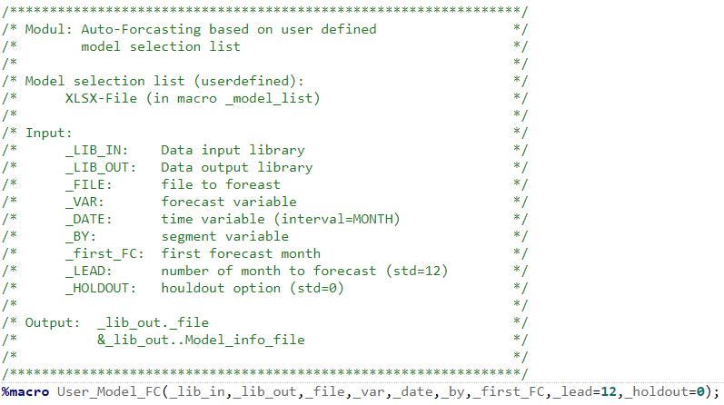

Output after running:

%let _model_list=Modelle_long;

%User_Model_FC(DATA_in,DATA_OUT,SEG_long_A,A,date,FC_var,01JUL2019,

_lead=6,_holdout=3);

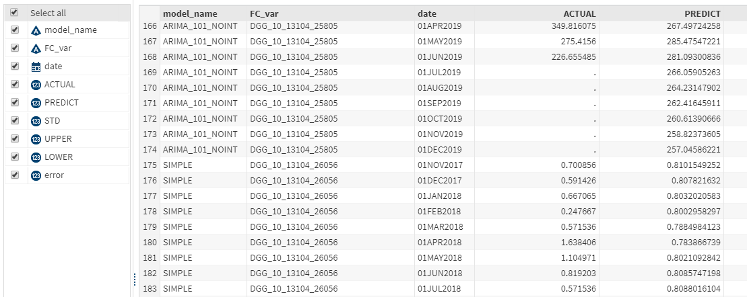

# Comparison of SAS9.4 HPF and SAS-Viya VF

The basis for this comparison are **two data sets** which belong to thecompany RHI-Magnesita, a global leader in refractories.

They are producing refractory products used in all the world’s high-temperature industrial processes. Without them, the steel, cement, lime, non-ferrous metals, glass, energy, environment and chemical industries couldn’t exist. The two data sets are just a subset of the 120.000 individual products.

**SEG_LONG_A:** 56.758 time series with a length between 8 and 20 months

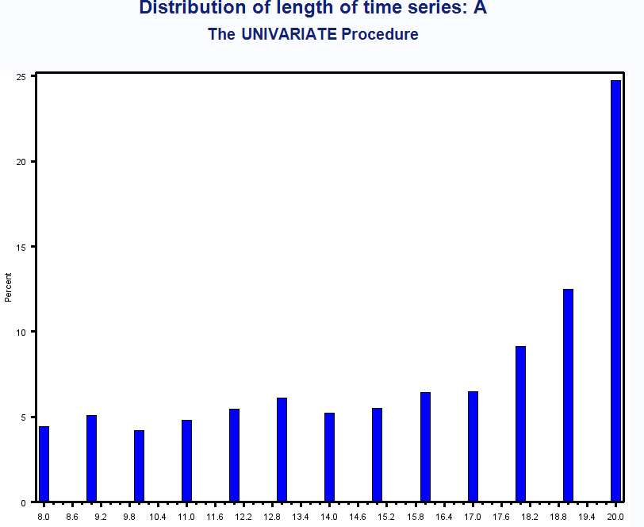

**SEG_SHORT_A:** 13.205 time series with a length between 3 and 7 months

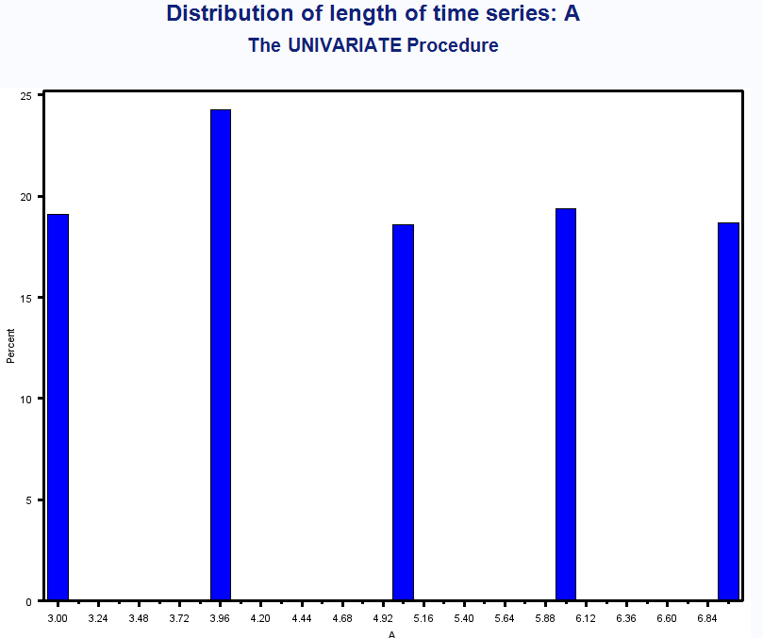

**IT-infrastructure**:

SAS9.4 Forecast Server is running on a laptop (8 core, 16 GB RAM)

SAS-Viya is running in the cloud on AWS (r4.4xlarge, 122 GB RAM)

The runtime between these two machines are not comparable and of course the Viya-Server was faster but also the laptop could finish the big file under 5 minutes.

The comparison will be done on the absolute error (ACTUAL-PREDICTED) with the sum of the last 3 month of the time series (holdout period!).

ERROR_HPF = error of Forecast Server (SAS9.4)

ERROR_VF = error of Visual Forecasting (Viya)

# Comparison of the short data set (SEG_SHORT_A)

Because of the short length of the time series a user defined model list with simple parameter settings was used:

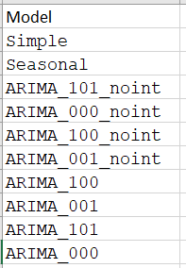 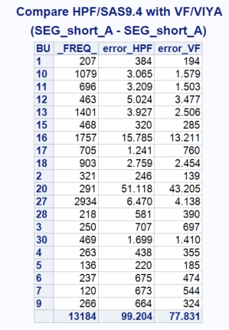

ERROR_HPF = error of Forecast Server (SAS9.4)

ERROR_VF = error of Visual Forecasting (Viya)

# Comparison of the long data set (SEG_LONG_A)

There are two scenarios for the comparison of the long time series data set.

# Using a user defined model list

The motivation of this user defined model list is to avoid all methods with a trend parameter.

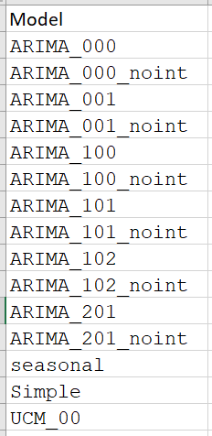 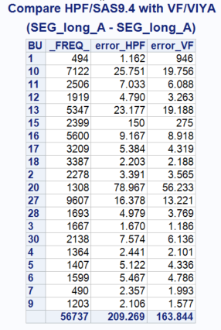

ERROR_HPF = error of Forecast Server (SAS9.4)

ERROR_VF = error of Visual Forecasting (Viya)

# Using auto forecasting methods

In this scenario the Forecast Server and Visual Forecasting on Viya uses all ESM, ARIMA and UCM models with a holdout sample of 3 month.

1. Compare Forecast Server with Visual Auto Forecasting

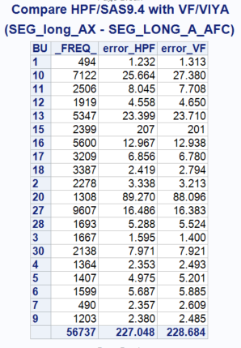

ERROR_HPF = error of Forecast Server (SAS9.4)

ERROR_VF = error of Visual Forecasting (Viya)

1. Compare Forecast Server with Visual Hierarchical Forecasting

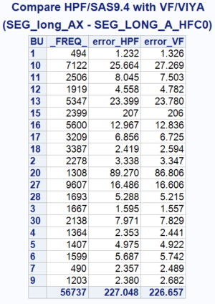

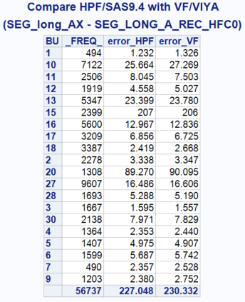 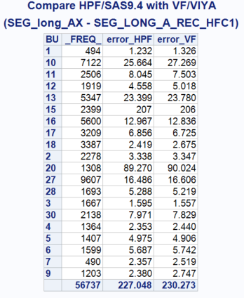

1. Compare Forecast Server with Visual Time Series Regression

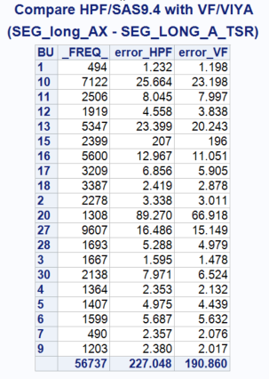

# Conclusio

|  |  |  |  |  |
| --- | --- | --- | --- | --- |
|  |  | SAS9.4 | **Viya** | Frequency |
| Short_A | User models (Modelle_short) | 99 204 | **77 831** | 13184 |
| Long_A | User models (Modelle_long) | 209 269 | **163 844** | 56737 |
| Long_A | Auto forecasting | 227 048 | **228 684** | 56737 |
| Long_A | Hierarchical FC no reconciliation | 227 048 | **226 657** | 56737 |
| Long_A | Hierarchical FC recon. level 0 | 227 048 | **230 332** | 56737 |
| Long_A | Hierarchical FC recon. level 1 | 227 048 | **230 273** | 56737 |
| Long_A | Time Series Regression | 227 048 | **190 860** | 56737 |

1. User defined model list working much better in Viya.
2. Time series Regression is also better then auto forecasting in SAS9.4 Forecast Server
3. There is no big difference between auto forecasting in SAS9.4 and Viya
4. Using hierarchical reconciliation in Viya does not improve results (can be caused by the special data structure of this time series).