Fishing in the English Channel: Trends in Fishing Effort, Ecosystem Impacts and Sustainability

A combined analysis using STECF AER, GFW and STECF FDI data (2008–2025)
Martin Pastoors
18 June 2026
Table of Contents

1. Summary
[To be written after finalisation of all chapters.]
Key points to address:
- Trends in total fishing effort in ICES 4.c/7.d/7.e (2008–present) from STECF AER data.
- Spatial patterns and concentration of effort from GFW data (2013–present).
- Position of the Vrolijk flyshoot fleet relative to total fleet activity.
- Stock status, MSC certification and current management concerns.
- Compliance with the 2024 gentlemen’s agreement.
- Evidence-based sustainability position and key messages.

2. Introduction

2.1 Background
The flyshoot (Danish seine) fishery has come under increasing public and media scrutiny in recent years, including critical coverage in the Netherlands (e.g. Follow the Money). At the same time, 2024 saw a new multilateral gentlemen’s agreement on flyshoot fishing in the eastern Channel, and the scallop fishery in the same area received MSC certification. This study brings together available quantitative data and scientific knowledge to provide an objective, evidence-based assessment of the sustainability position of the flyshoot fleet operating in the Channel.
This report was commissioned by Vrolijk and builds directly on the methodology developed in the earlier Flyshoot project, in which Global Fishing Watch (GFW) data and STECF data were used to analyse fleet-level fishing effort trends in the Channel.

2.2 Objectives
- To quantify trends in fishing effort and landings in the Channel (2008/2013–present) using official STECF statistics (AER), with spatial distribution characterised using GFW AIS data.
- To compile a scientifically grounded overview of the fisheries in the Channel, with particular focus on sustainability, ecosystem effects and the positioning of the flyshoot fishery.

2.3 Study area and scope
The study covers ICES divisions 27.4.c (southern North Sea), 27.7.d (eastern English Channel) and 27.7.e (western English Channel). The period of analysis is 2008–present for effort and landings trends (AER) and 2013–present for spatial analysis (GFW).

3. Material & Methods

3.1 Literature review approach
The literature review underpinning Sections 4.1 and 4.7 draws on four categories of sources:
Scientific literature was identified through targeted searches of Web of Science, Scopus and Google Scholar using the terms: English Channel fisheries, Channel demersal fisheries, flyshoot, Danish seine Channel, beam trawl North Sea Channel, scallop Pecten maximus Channel, seabed disturbance trawl, AIS fishing effort, and combinations thereof. Priority was given to peer-reviewed articles published since 2010, supplemented by earlier foundational studies where relevant (e.g. Eigaard et al. 2016; Depestele et al. 2016).
ICES working group reports were sourced from the ICES library (https://www.ices.dk), primarily:
- Working Group on Celtic Seas Ecoregion (WGCSE, ICES 2024a) — principal source for demersal stocks in the Channel (sole, plaice, whiting, sea bass, monkfish, megrim, mullet) and for the broader ecosystem and fisheries context of 27.7.d/e.
- Working Group on the Assessment of Demersal Stocks in the North Sea and Skagerrak (WGNSSK, ICES 2024c) — consulted for stocks with distributions spanning both 27.4.c and the Channel (e.g. plaice, dab, horse mackerel).
- Working Group on Widely Distributed Stocks (WGWIDE, ICES 2024e) — responsible for the assessment of mackerel (Scomber scombrus) and horse mackerel (Trachurus trachurus western stock), both of which are important flyshoot target species in the Channel.
- Working Group on Cephalopod Fisheries and Life History (WGCEPH, ICES 2024d) — consulted for cuttlefish (Sepia officinalis) and squid (Loligo spp., Illex spp.) in the Channel and North Sea. WGCEPH does not produce formal TAC advice but provides the best available science on stock status and drivers of variability.
- Working Group on Ecosystem Effects of Fishing Activities (WGECO) — for seabed disturbance and ecosystem-level assessments.
ICES advice sheets for the relevant stocks were also consulted directly.
Official statistics and national sources include the STECF AER (primary quantitative source for this report), Ifremer fleet and stock assessment reports, the UK Marine Management Organisation (MMO) annual sea fisheries statistics, and the Belgian ILVO annual fleet reports. Where possible, the most recent published edition was used.
Policy and grey literature includes EU regulation texts, the UK–EU Trade and Cooperation Agreement fisheries annex, the 2024 gentlemen’s agreement between VisNed, Rederscentrale and CNPMEM, and parliamentary reports on post-Brexit fisheries.
All quantitative claims made in the literature sections are cross-referenced with the AER and GFW results presented in Section 4, and discrepancies or gaps are noted where they arise.

3.2 STECF AER data (effort and landings trends)
The Annual Economic Report (AER) data were obtained from the STECF 25-07 data release (EU Fleet Economic and Transversal data, fleet segment level). The AER provides fishing effort (fishing days, sea days, kW-days, GT-days) and landed weight and value by fleet segment (country × fishing technique × vessel length class), disaggregated by ICES sub-region. Three separate tab-level datasets covering 2008–2012, 2013–2017 and 2018–2023 were concatenated to form a consistent time series.
Effort is expressed as fishing days. GBR is excluded from all AER analyses as no data are available for the UK in the STECF series following Brexit.

3.3 GFW data (spatial effort distribution and concentration)
Fishing activity data were retrieved via the Global Fishing Watch (GFW) API (gfwr v3.0) using the Events endpoint. Vessel metadata (flag state, gear type, gross tonnage) were obtained from the GFW vessel registry.
Days at sea are defined in this report as vessel-days: for each day, each vessel is assigned to the ICES division in which it spent the majority of its time, based on the spatial distribution of AIS positions recorded during that day. A day is counted as a fishing day if the AIS-derived speed and movement pattern during the majority of that day is classified as active fishing behaviour by the GFW algorithm. This definition differs from the administrative fishing day in the AER (which is based on logbook declarations) and from the simpler presence-day metric. The GFW data are used exclusively for spatial analysis — effort density maps, spatial hotspots, and effort concentration metrics. All computationally expensive spatial objects (KDE grids, gridded effort, concentration metrics) are stored in a dedicated cache file (cache_gfw_spatial.RData) to avoid recomputation on each knit.

3.4 STECF FDI data (reference only)
The STECF FDI dataset was obtained but is not used as a primary analysis source (see table below). The AER provides more complete and consistent country-level data for the same period.
Table 1. STECF FDI data quality issues and reason for exclusion.
FDI table | Key issue | Decision
Effort | Substantial confidentiality suppression in key strata | Not used
Landings | EU-aggregated only — no country breakdown | Not used
Catches | Country-level but with suppressed cells; partial AER overlap | Not used
Capacity | No division breakdown — national totals only | Not used

3.5 The 2024 Gentlemen’s Agreement
Brief description of the November 2024 multilateral agreement between VisNed (NL), Rederscentrale (BE) and CNPMEM (FR) governing flyshoot fishing in ICES 27.7.d, and its predecessor (April 2021). Key provisions: the 8-sea-day limit per 14-day period, technical gear specifications, and the monitoring obligation. Used as a reference framework for interpreting the fishing effort data in Chapter 4.

4. Results

4.1 Channel fisheries: background and context
This section provides an overview of the Channel fisheries based on the literature reviewed in Section 3.1. A detailed synthesis cross-referenced with the quantitative results of this report is provided in Section 4.8.

4.1.1 Geographic scope and management framework
The English Channel (ICES divisions 27.7.d and 27.7.e) is a semi-enclosed sea separating southern England from northern France, with the southern North Sea (27.4.c) forming a contiguous fishing area to the north-east. The Channel supports some of the most intensively exploited fishing grounds in Europe, with nationally important fisheries for France, the United Kingdom, Belgium and the Netherlands, and smaller but significant contributions from Germany (ICES, 2024a; STECF, 2024).
Fisheries management operates primarily through the EU Common Fisheries Policy (CFP) for EU member states, and through the UK–EU Trade and Cooperation Agreement (TCA, 2020) following Brexit. Quota shares, technical measures and access arrangements are reviewed annually through the Specialised Committee on Fisheries established under the TCA (European Commission, 2021; Seafish, 2022).

4.1.2 Principal fishing gears and target species
The Channel supports a highly diverse range of fishing gears. Bottom trawl and Danish seine (flyshoot) gears account for the largest share of demersal fishing effort, targeting mixed assemblages of flatfish, cephalopods, small pelagics and roundfish. The French fleet dominates total effort, contributing over 60% of total fishing days in the eastern Channel in most years (ICES, 2024a; Ifremer, 2023). The Dutch flyshoot fleet has expanded significantly since the early 2010s (Quirijns et al., 2020), a trend visible in the AER and GFW series presented in Sections 4.2 and 4.5. Belgian beam trawl effort has declined substantially since the mid-2000s (ILVO, 2022), consistent with the AER landings series in Section 4.3.
Scallop dredging is concentrated in the Baie de Seine (27.7.d) and western Channel (27.7.e), dominated by the French fleet with seasonal UK participation. MSC certification was granted for the Baie de Saint-Brieuc fishery (2022) and the Baie de Seine fishery (November 2024; MSC, 2024). Pot and trap fisheries for whelk, crab and lobster are important to UK coastal communities. Static net fisheries and small-scale handline fisheries are significant for both French and UK inshore fleets but are under-represented in the AER and GFW data due to vessel size and AIS reporting thresholds.

4.1.3 Stock status overview
A full species-by-species stock status table is provided in Section 4.8.3 (Table 2), based on the most recent ICES advice cycle (WGCSE 2024a, WGNSSK 2024c, WGWIDE 2024e, WGCEPH 2024d). Key points:
Sole stocks in 27.7.d and 27.7.e are assessed as having fishing mortality above F_{MSY} and biomass below B_{pa}, providing the biological explanation for the dramatic decline in flatfish landings visible in Figure 7 (Section 4.3.4). Plaice is in a somewhat better state. Sea bass remains under a recovery plan. Horse mackerel and mackerel are assessed by WGWIDE and are broadly within or close to safe biological limits. Cuttlefish and squid (WGCEPH) have no formal stock assessments or TACs; their management relies on technical measures. Scallops are managed through seasonal access windows and MSC conditions, with the Baie de Seine stock at record biomass levels (Ifremer, 2025) while the western Channel stock is showing signs of decline (MMO, 2023).

4.2 Effort trends — STECF AER

4.1.1 Total fishing days by year, country and gear category
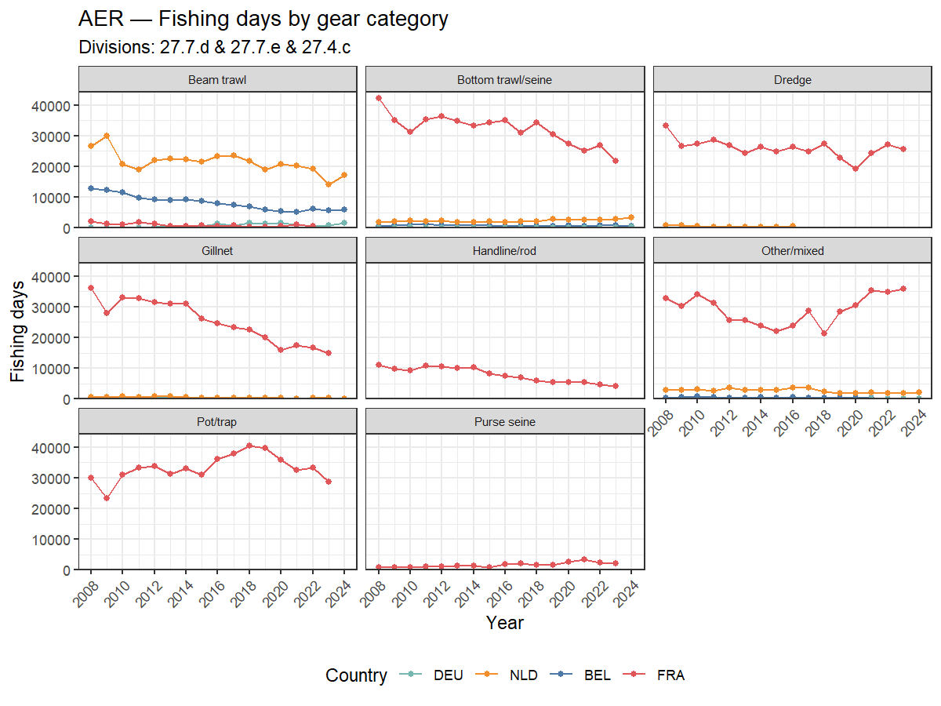
Figure 1. Total fishing days in ICES 4.c/7.d/7.e per year by country and gear category (AER, 2008–2023). Source: STECF 25-07. Note: GBR data may be absent or incomplete in the AER for post-Brexit years.

4.1.2 Capacity-weighted effort (GT-fishing days)
Capacity-weighted effort expresses each fishing day weighted by the vessel’s gross tonnage (GT), giving a measure of effective fleet capacity deployed. Where GT-fishing days are not reported, they are approximated from kW-fishing days using a fleet-average conversion factor (see Section 3.1). Imputed values are shown with open symbols.
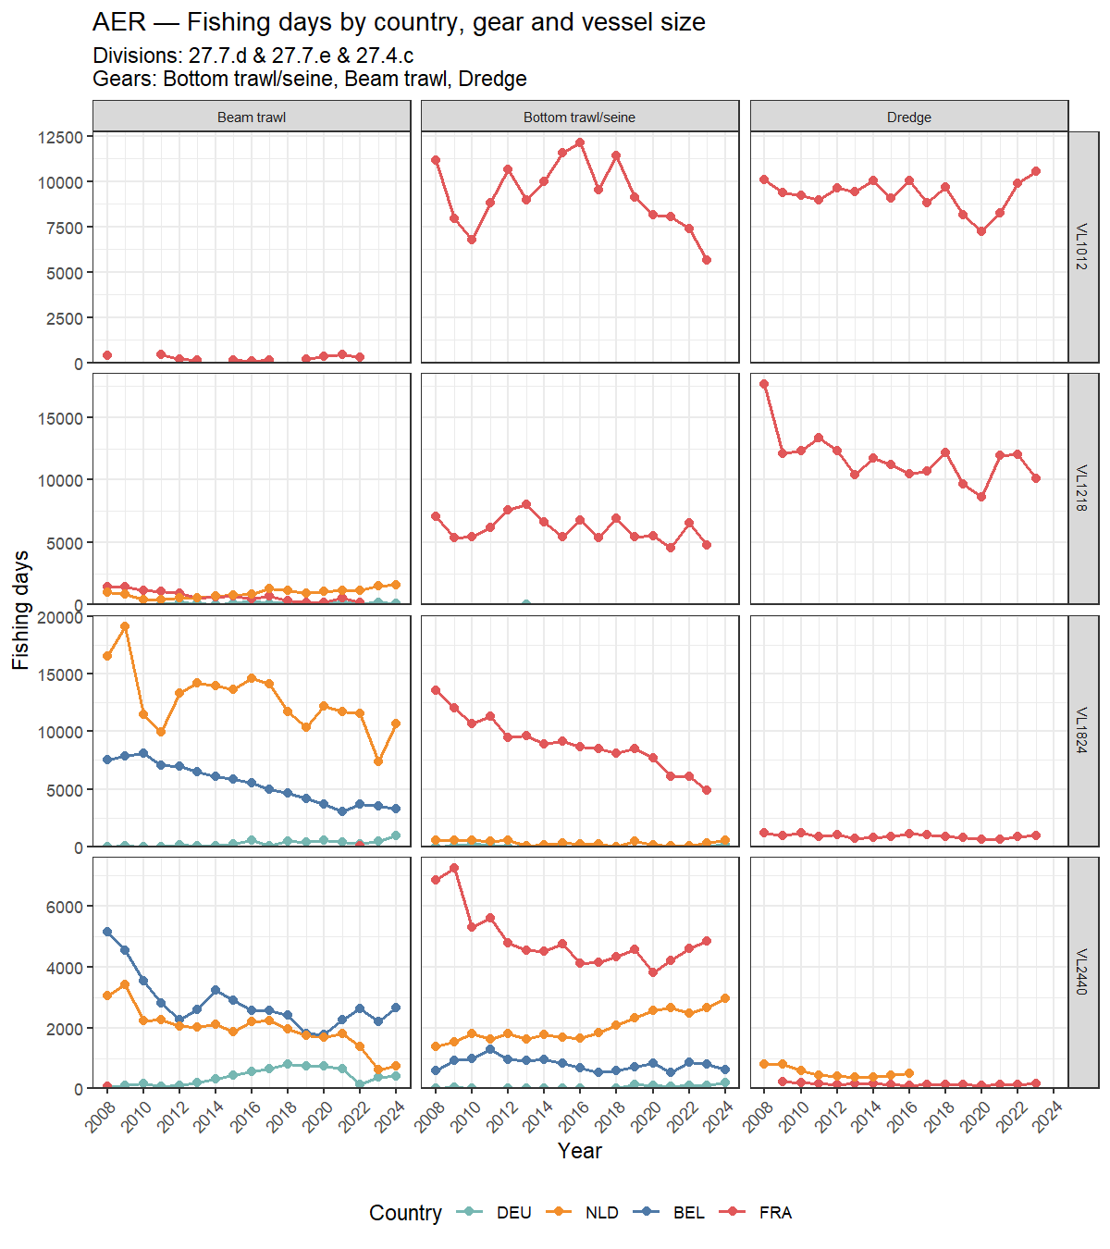
Figure 2. Fishing days by country, gear category and vessel length class (AER, 2008–2023). Only Bottom trawl/seine, Beam trawl and Dredge are shown; vessel length classes VL0010 and VL40XX are excluded. Y-axis is free per vessel length class row.

4.1.3 Seasonal patterns

4.2 Landings trends — STECF AER

4.2.1 Total landed weight by year, country and gear
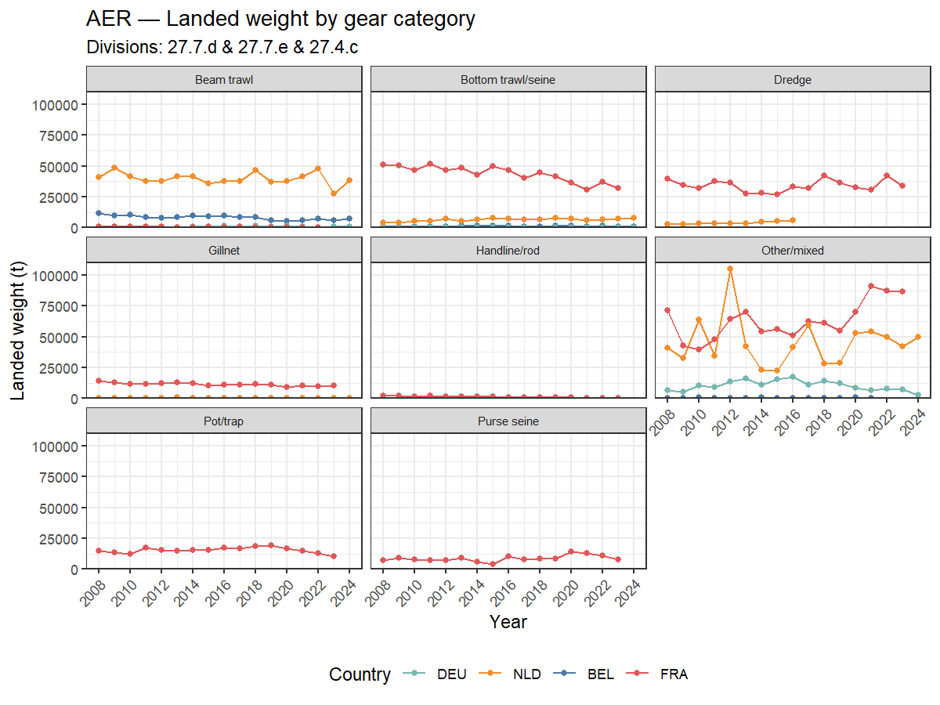
Figure 4. Landed weight (t) in ICES 4.c/7.d/7.e per year by country and gear category (AER, 2008–2023). Note: GBR data may be absent or incomplete for post-Brexit years.

4.2.2 Key species groups — landings by country
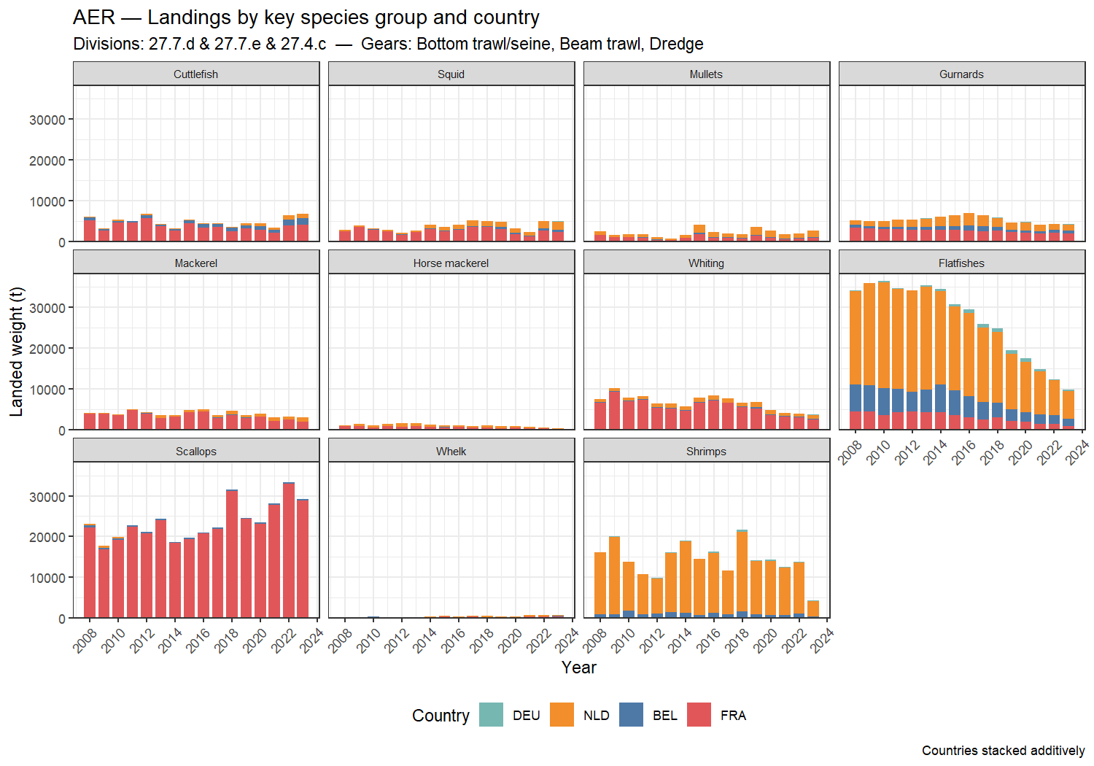
Figure 5. Landings by key species group and country for selected gears (AER, 2008–2023). Bars show stacked country contributions per year. Study area: ICES 4.c/7.d/7.e. Note: GBR data may be absent or incomplete in the AER for post-Brexit years.

4.2.3 Key species groups — landings by gear category
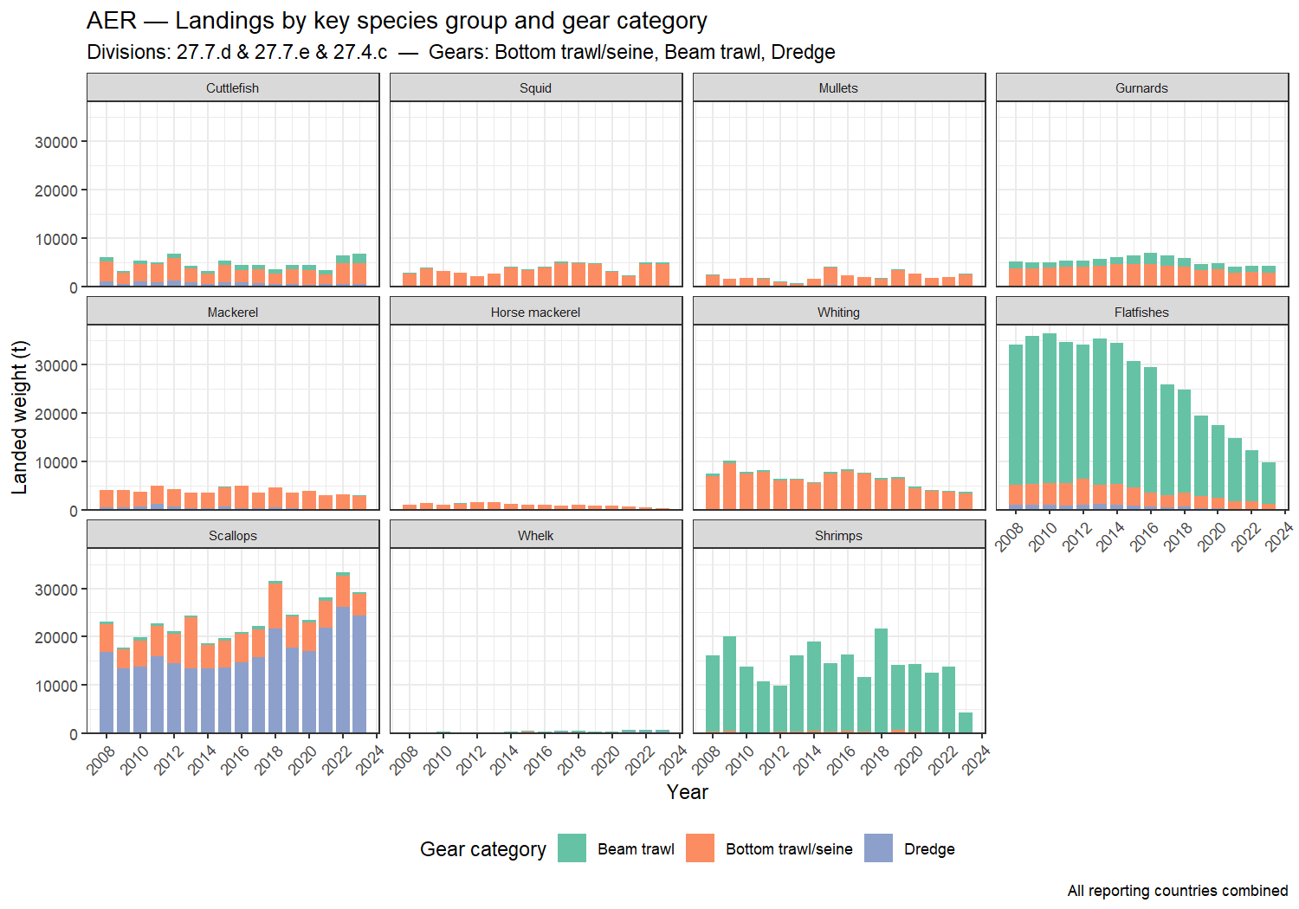
Figure 6. Landings by key species group and gear category in ICES 4.c/7.d/7.e (AER, 2008–2023). Only selected gears shown. Bars show stacked gear contributions per year across DEU, NLD, BEL, FRA and GBR combined.

4.2.4 Focal species × focal gears
The following figure focuses on the species and gear combinations most relevant to the flyshoot and associated fisheries: cuttlefish, squid, gurnards, mullets, flatfishes and scallops, caught by bottom trawl/seine, beam trawl, dredge, pot/trap and gillnet.
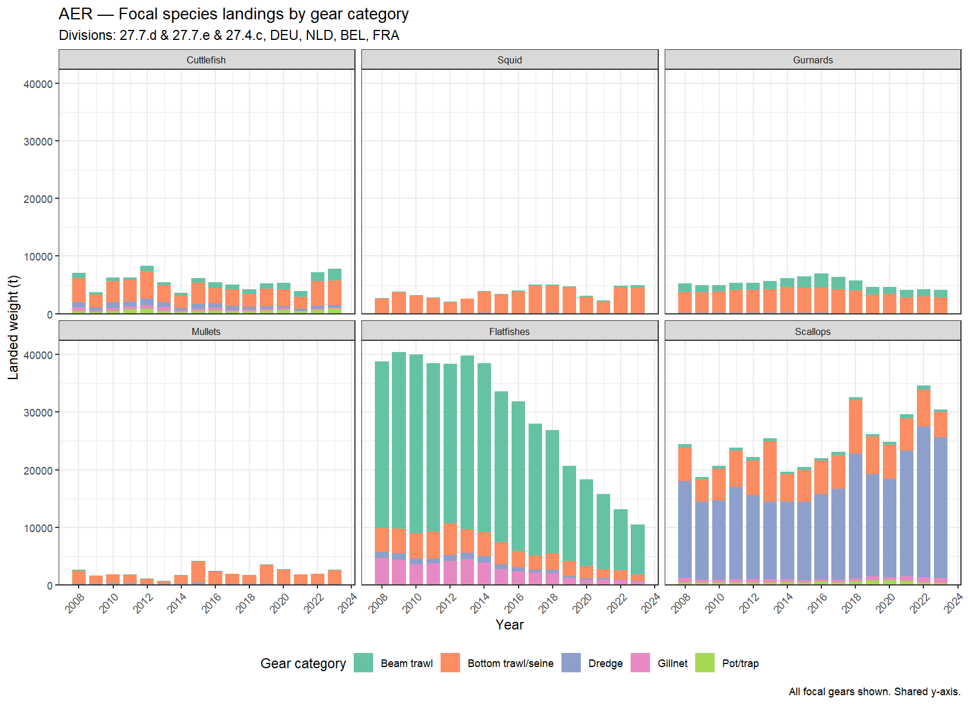
Figure 7. Landings of focal species by focal gear category in ICES 4.c/7.d/7.e (AER, 2008–2023). Each panel shows one species group; colours represent gear categories. Shared y-axis across all panels.
Figure 7 reveals several striking patterns in the landing trends for focal species groups in the Channel fisheries.
Flatfishes show by far the most dramatic trend in the dataset. Total landings declined from approximately 40,000 t/yr around 2008–2014 to around 10,000 t by 2023 — a roughly 75% reduction over 15 years. This decline is almost entirely driven by beam trawl landings (green), which dominated the flatfish catch throughout the period. Bottom trawl/seine contributes a smaller, relatively stable share. This trajectory mirrors the well-documented contraction of the Belgian and Dutch beam trawl fleets in the Channel under combined pressure from fuel costs, quota restrictions and declining sole and plaice stocks in 27.7.d/e (Depestele et al., 2016; ICES, 2024a; ILVO, 2022). The scale of the decline — visible here across the full fleet for the first time in a single figure — underscores the structural transformation of the Channel demersal fishery over this period.
Scallops show the opposite trend: large absolute tonnage (15,000–35,000 t/yr) with a clear upward trajectory since around 2016. The fishery is dominated by dredge gear (purple), with a secondary contribution from bottom trawl/seine (orange). The recent peak in 2022–2023 is consistent with the record 2024–2025 scallop season reported by Ifremer (2025). The growing importance of scallops relative to flatfishes is arguably the defining commercial shift in the Channel fishery over this period.
Cuttlefish landings are relatively stable at 5,000–8,000 t/yr, delivered almost entirely by bottom trawl/seine. Some interannual variability is evident, typical of cephalopod populations whose recruitment is sensitive to environmental conditions.
Squid follows a similar gear profile to cuttlefish (bottom trawl/seine dominated) but at lower tonnage (~2,000–5,000 t/yr), with a slight declining tendency since the mid-2010s.
Gurnards are caught predominantly by beam trawl with a secondary bottom trawl/seine component, at relatively stable landings of ~5,000 t/yr. Given the strong decline in beam trawl effort visible in Figure 1, the stability of gurnard landings may reflect increasing catch rates (CPUE) or a shift towards this low-value bycatch species as target species decline.
Mullets show very low tonnage throughout, delivered by bottom trawl/seine only, consistent with their coastal distribution and the predominance of gillnet fisheries for this species that are not captured in the AER at this level.
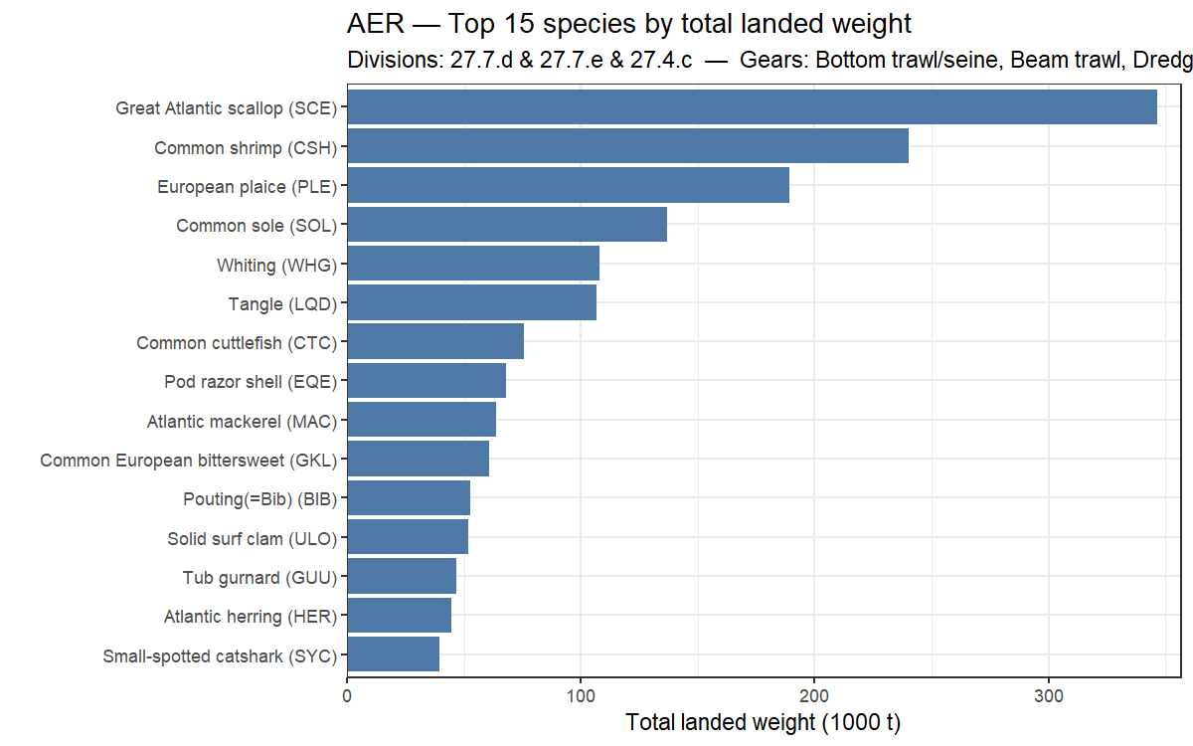
Figure 8. Top 15 species by total landed weight for selected gears in ICES 4.c/7.d/7.e across DEU, NLD, BEL, FRA and GBR (AER, 2008–2023).

4.3 Fleet composition by country and gear type — STECF AER

4.4 GFW effort — total fishing days and comparison with AER

4.4.1 Total GFW fishing days by year and flag state
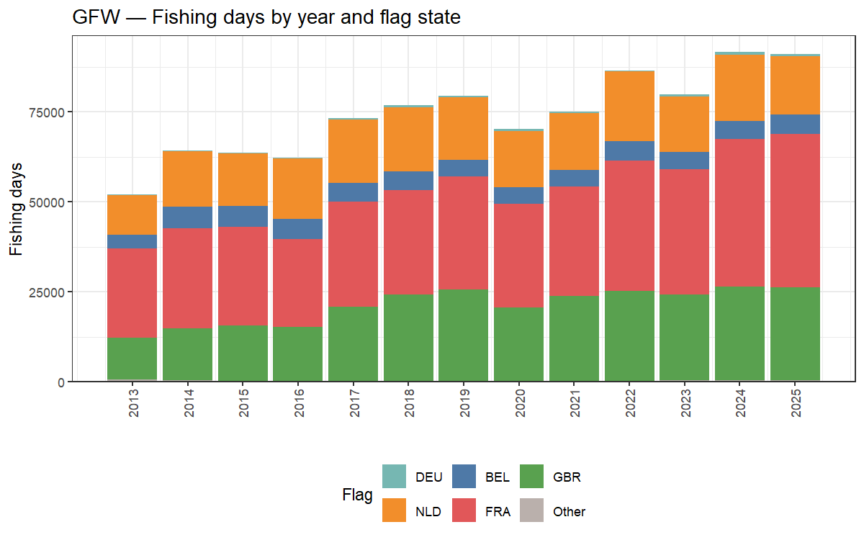
Figure 10. Total GFW fishing days per year by flag state (all divisions, 2013–2025).

4.4.2 AER vs GFW effort comparison
The two data sources measure effort differently — AER reports administrative fishing days declared by member states; GFW estimates fishing days from AIS vessel-tracking. The comparison below shows total fishing days over the overlapping period 2013–2023. Note that the AER series excludes GBR (post-Brexit data are not consistently included in the STECF AER) while the GFW series includes all five countries.
Several factors can explain systematic differences between the two series:
- Method for counting fishing days: AER records one fishing day as any day on which a vessel is registered as fishing by its flag state; GFW counts a vessel-day as active when AIS-derived speed and movement patterns are classified as fishing behaviour. The two methods can disagree for the same vessel on the same day.
- AIS coverage and adoption: AIS was gradually mandated across the EU fleet between 2008 and 2014. Early years of the GFW series therefore under-represent vessels that did not yet carry AIS transponders, leading to lower GFW effort estimates before ~2014.
- Small coastal vessels: Vessels below ~15 m LOA are not required to carry AIS in many jurisdictions. This segment is captured in the AER (via logbook reporting) but largely absent from GFW, causing a structural undercount in GFW relative to AER for gears dominated by small vessels (e.g. pot/trap, gillnet).
- Gear type assignment: GFW classifies gear from AIS movement patterns; misclassification can shift effort between gear categories when comparing with AER gear-specific totals.
- Spatial attribution: AER effort is attributed to the ICES division declared in the logbook; GFW effort is attributed to the GPS position of the fishing event. In boundary areas the two can differ.
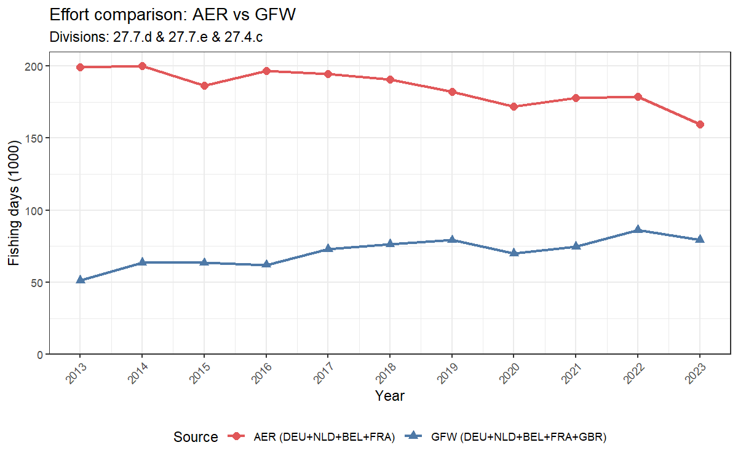
Figure 11. Comparison of total fishing days from AER (DEU+NLD+BEL+FRA) and GFW (DEU+NLD+BEL+FRA+GBR), 2013–2023. ICES 4.c/7.d/7.e. GBR is included in GFW but excluded from AER due to incomplete post-Brexit reporting in STECF.

4.5 GFW effort — spatial distribution

4.5.1 Spatial distribution of fishing events
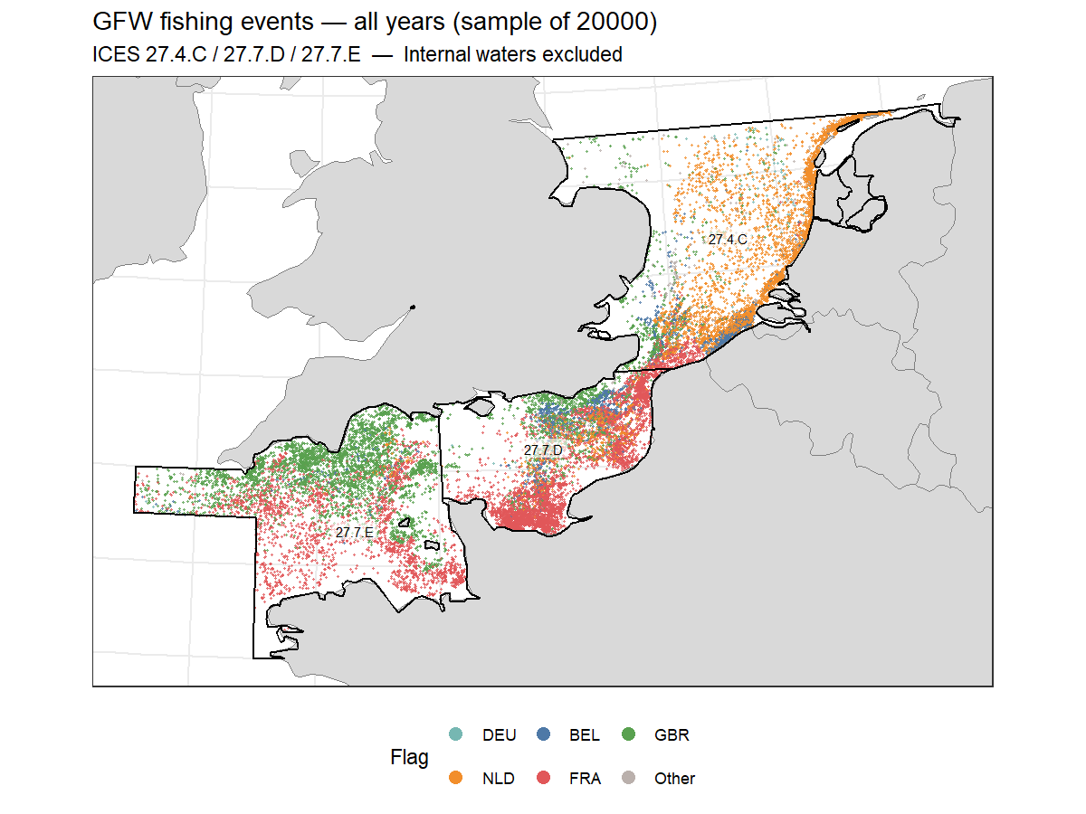
Figure 12. Spatial distribution of GFW fishing events (random sample of 20,000), all years combined, coloured by flag state. Country coastlines and ICES division boundaries shown.

4.5.2 Spatial distribution of fishing events by year
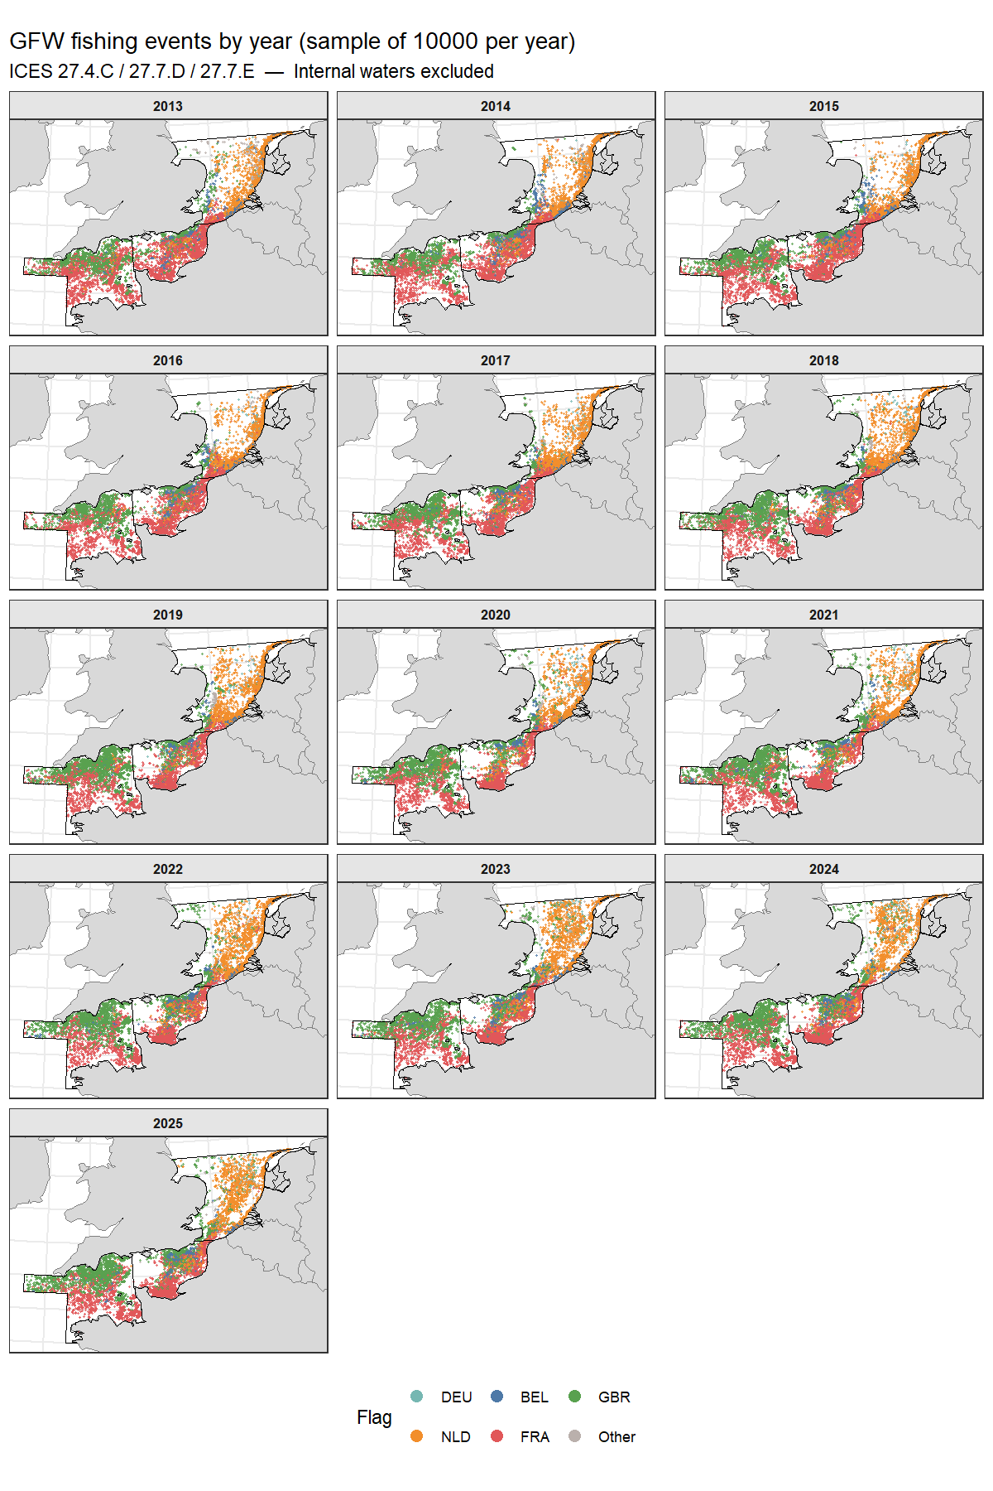
Figure 13. Spatial distribution of GFW fishing events by year (random sample of 10,000 per year), coloured by flag state. Country coastlines and ICES division boundaries shown.

4.5.3 Kernel density — all divisions
Kernel density estimation (KDE) converts the discrete set of fishing event locations into a continuous surface representing the spatial intensity of fishing effort. For each year, fishing event coordinates are projected into a metric coordinate system (UTM zone 30N) and a Gaussian kernel with bandwidth σ = 20 km is applied within the study area boundary (land excluded). The resulting density surface is normalised within each year to a 0–1 scale, where 1 represents the grid cell with the highest density and 0 the lowest. This within-year normalisation makes annual maps directly comparable in terms of spatial pattern, but means that absolute effort levels cannot be compared between years — a year with low total effort and a year with high total effort will both have cells reaching 1.0. For absolute effort comparisons, refer to Figures 10 and 11.
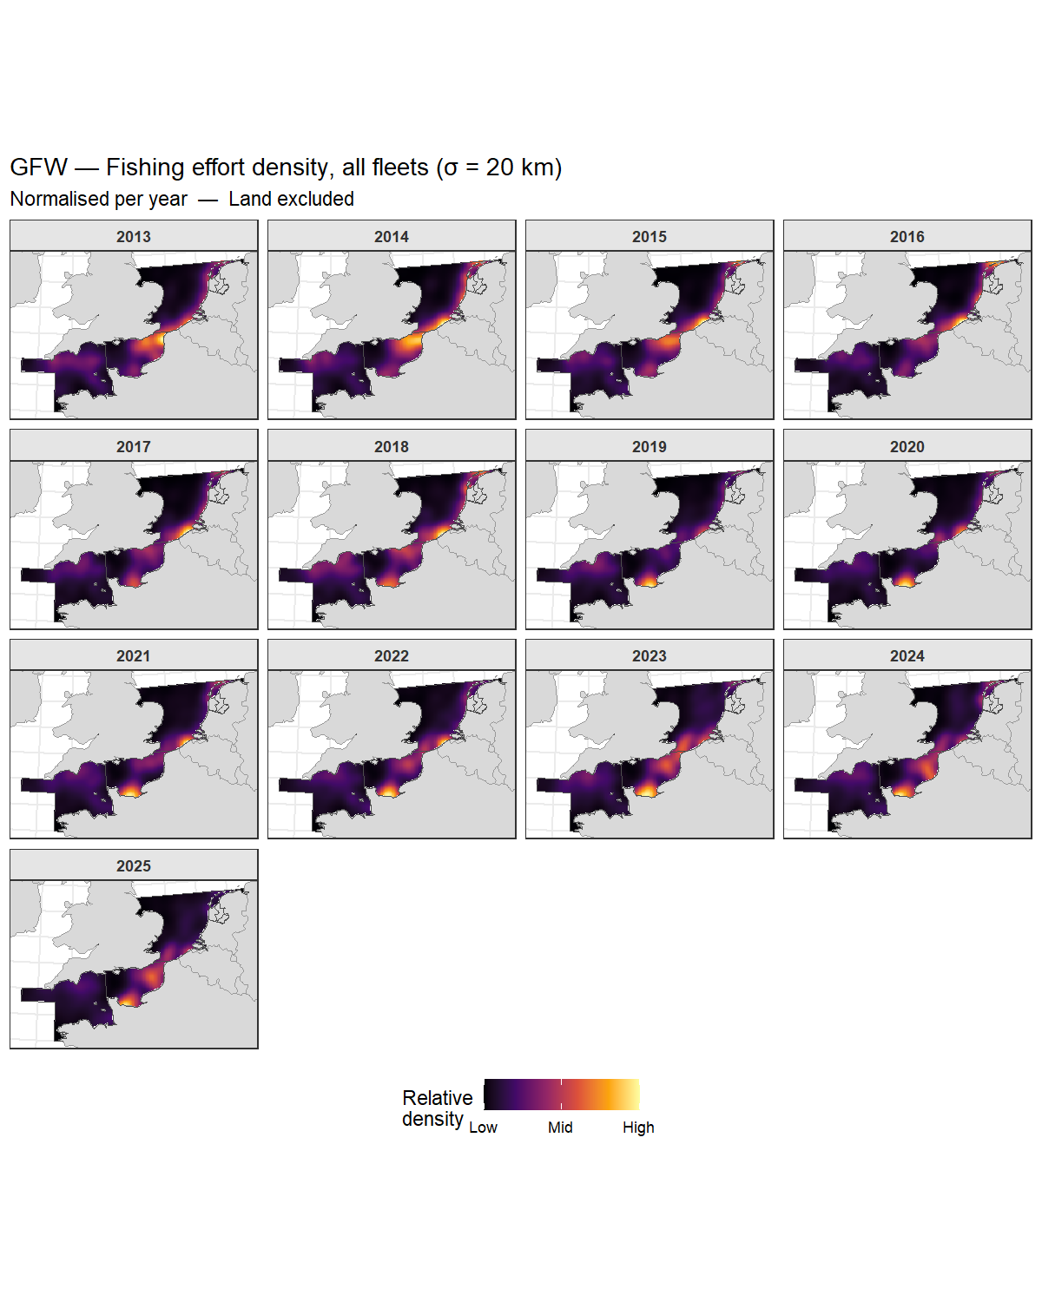
Figure 14. Kernel density of GFW fishing effort for all fleets combined, faceted by year. Bandwidth σ = 20 km. Density normalised within each year (0 = low, 1 = high).
Figure 14 shows the spatial distribution of fishing effort across the three study divisions (27.4.c, 27.7.d, 27.7.e) for all flag states combined. The broad pattern is consistent across years: effort is concentrated in the eastern Channel (27.7.d) and the southern North Sea (27.4.c), with lower but persistent effort in the western Channel (27.7.e). The area off the Pas de Calais and around the Baie de Seine emerges as the most persistently fished sub-area in 27.7.d. Effort in 27.4.c is concentrated along the southern fringe of the North Sea, consistent with the beam trawl and bottom trawl grounds historically fished by Dutch and Belgian vessels.

4.5.4 Kernel density — ICES 27.7.D
The 27.7.D panel uses a narrower bandwidth (σ = 10 km) to resolve finer-scale spatial structure within the eastern Channel. The same normalisation approach applies. The restricted study window (ICES 27.7.D only, land excluded) ensures the KDE is not influenced by effort in adjacent divisions.
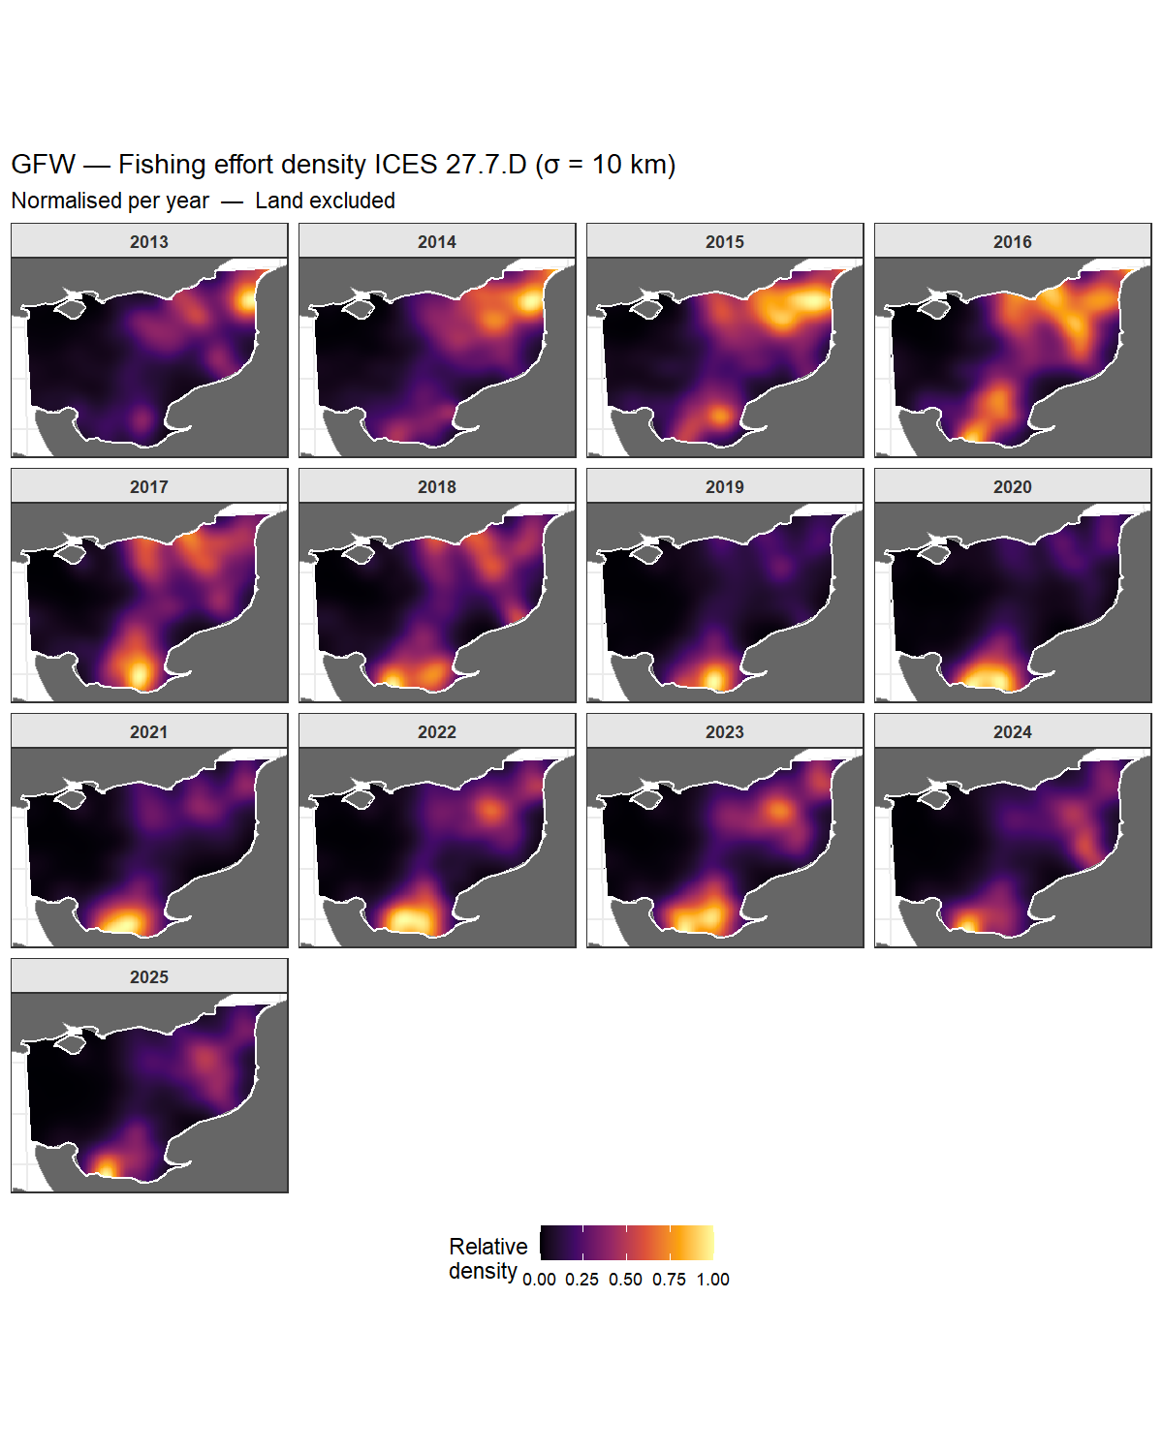
Figure 15. Kernel density of GFW fishing effort in ICES 27.7.D, faceted by year. Bandwidth σ = 10 km. Density normalised within each year.
Figure 15 reveals consistent hotspots in 27.7.D across the study period: the Baie de Seine and the area off Cap Gris-Nez/Calais in the north-east of the division are the most persistently fished zones. A secondary concentration is visible in the mid-Channel. The post-2021 period (post-Brexit) shows a subtle southward shift in the density peak, consistent with reduced access to UK waters in the northern half of 27.7.D and concentration of effort in French EEZ waters. This pattern is quantified further by the concentration metrics in Section 4.6.

4.6 GFW effort — spatial concentration (ICES 27.7.D)

4.6.1 Gini coefficient and top-10% cell share
Two complementary metrics are used to quantify the spatial concentration of fishing effort across the 5 km × 5 km grid cells covering ICES 27.7.D.
The Gini coefficient is a standard inequality measure borrowed from economics, adapted here to quantify the unevenness of effort across grid cells. It ranges from 0 to 1: a value of 0 means fishing effort is spread perfectly uniformly across all cells; a value of 1 means all effort is concentrated in a single cell. In practice, fishing effort is always somewhat concentrated — values above 0.7 indicate strong spatial concentration in a small number of areas, while values below 0.5 suggest a relatively dispersed fleet. A rising Gini over time indicates that the fleet is progressively concentrating in fewer locations.
The top-10% cell share is a more intuitive companion metric: it asks what percentage of the total annual fishing events falls within the 10% of grid cells that were most intensively fished that year. If effort were uniform, this would be exactly 10%. In practice values of 40–70% are common in concentrated fisheries, meaning that a small fraction of the available sea area absorbs the majority of fishing pressure. Together, the two metrics capture different aspects of spatial concentration: the Gini summarises the full distribution of effort, while the top-10% share focuses specifically on the most intensively exploited areas.
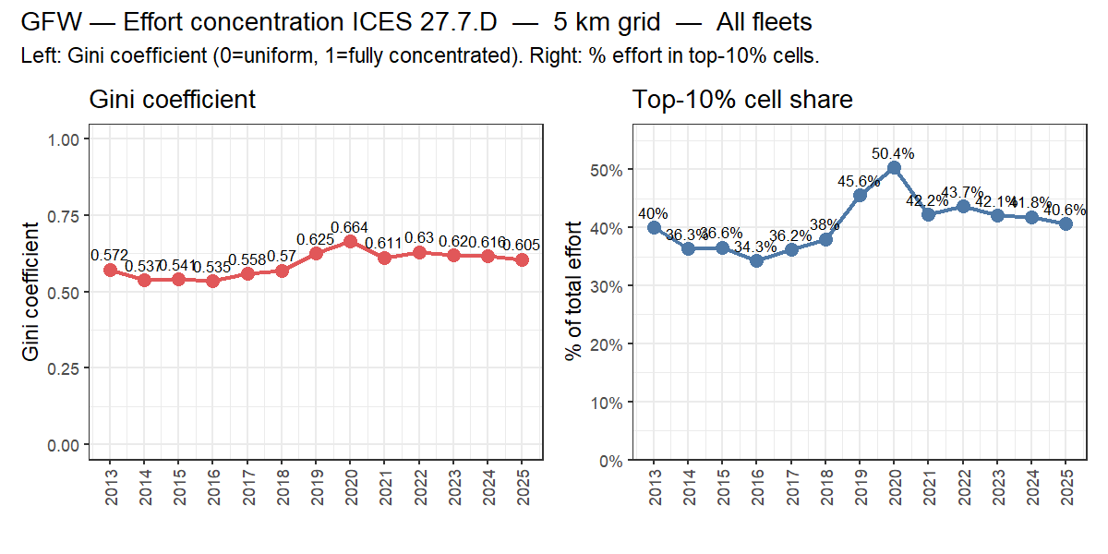
Figure 16. Spatial concentration of fishing effort in ICES 27.7.D: Gini coefficient (left) and percentage of total effort in the top-10% most-fished 5 km grid cells (right), 2013–2025. The Gini coefficient ranges from 0 (perfectly uniform effort) to 1 (all effort in one cell). The top-10% share shows what fraction of total annual events falls within the 10% of cells with highest effort.

4.7 Channel fisheries context: fleet composition and trends
This section places the quantitative results from Sections 4.1–4.6 in the broader context of the Channel fisheries literature. It draws on ICES WGCSE, STECF, Ifremer, MMO and peer-reviewed sources (see Section 3.5 for the literature selection approach).

4.7.1 Fleet composition and dominant gear types
The Channel (ICES 27.7.d/e) supports one of the most diverse and intensively fished areas in Europe. The French fleet dominates total effort in the eastern Channel, contributing over 60% of total AER fishing days in most years (ICES, 2024a; Ifremer, 2023), consistent with the AER results in Figure 1 which show France as the largest contributor across all gear categories. Bottom trawl/seine gears account for the largest share of demersal fishing effort, targeting mixed assemblages of flatfish, cephalopods and small pelagics. The Dutch flyshoot fleet expanded significantly through the 2010s (Quirijns et al., 2020), a trend visible in the AER and GFW series (Figures 1 and 10). Belgian beam trawl effort has declined substantially since the mid-2000s under pressure from fuel costs and quota restrictions (ILVO, 2022), consistent with the low and declining Belgian effort in beam trawl panels throughout the AER figures.
The scallop dredge fishery is concentrated in the Baie de Seine (27.7.d) and western Channel (27.7.e), dominated by the French fleet with seasonal UK participation. Scallop landings from the Baie de Seine reached a record ~48,000 t in 2024–2025 (Ifremer, 2025). MSC certification has been granted for the Baie de Saint-Brieuc fishery (2022) and the Baie de Seine fishery (November 2024), covering the majority of French Channel scallop production (MSC, 2024). The AER landings data (Figures 5–7) confirm scallops as one of the highest-tonnage species in the study area, dominated by the French dredge fleet.
Pot and trap fisheries targeting whelk (Buccinum undatum), crab and lobster are important to UK coastal communities, though the AER series shows limited representation of this segment at the fleet level. The whelk fishery in 27.7.d has grown markedly since the mid-2010s, driven by Asian export demand (MMO, 2023).

4.7.2 Historical effort trends and structural change
Total fishing effort in the Channel has declined substantially since the early 2000s, consistent with EU fleet capacity reduction programmes and quota restrictions under successive CFP reforms. The AER series (2008–2023) shows a general downward trend in fishing days for bottom trawl/seine and beam trawl across all major flag states (Figure 1), with the Dutch flyshoot fleet being an important exception showing growth through the 2010s before stabilising post-2020. This is consistent with Quirijns et al. (2020) and STECF (2024).
Post-Brexit disruption from 2021 onwards has reshaped fleet access in the eastern Channel. UK licensing restrictions have reduced French, Belgian and Dutch access to UK waters in 27.7.d/e, driving spatial redistribution towards French EEZ waters (Phillipson & Symes, 2018; House of Lords, 2022). This structural shift may contribute to the apparent changes in spatial effort patterns visible in the GFW KDE maps (Figures 14–15) around 2021–2022, with effort concentrating in the southern (French EEZ) portion of 27.7.d. The 2024 gentlemen’s agreement between VisNed, Rederscentrale and CNPMEM represents the most recent multilateral self-regulation initiative within this post-Brexit context.
The GFW spatial concentration metrics (Figure 16) quantify whether this redistribution has led to more or less concentrated effort patterns over time. A rising Gini coefficient or top-10% share after 2021 would be consistent with effort being pushed into a narrower range of spatial locations following access restrictions.

4.7.3 Stock status of key target species
Table 2 summarises the assessment and advice status for the principal commercial stocks in the study area. Stocks are grouped by the ICES working group responsible for their assessment. Note that several species caught in the Channel — particularly cephalopods — do not have formal ICES assessments or TAC-based management; these are indicated accordingly.
Species | Common name | Stock / area | ICES WG | Assessment type | F vs F_{MSY} | SSB vs B_{pa} | TAC | Notes
Solea solea | Common sole | 27.7.d | WGCSE | Analytical (XSA/SAM) | F > F_{MSY} | SSB < B_{pa} | Yes | Stock declining; below safe biological limits in recent years (ICES, 2024a)
Solea solea | Common sole | 27.7.e | WGCSE | Analytical | F > F_{MSY} | SSB < B_{pa} | Yes | Similar trajectory to 7.d; partial overlap with 7.d stock (ICES, 2024a)
Pleuronectes platessa | European plaice | 27.7.d/e | WGCSE | Analytical | F ≈ F_{MSY} | SSB > B_{pa} | Yes | Better status than sole; recovering trend since 2015 (ICES, 2024a)
Pleuronectes platessa | European plaice | 27.4.c | WGNSSK | Analytical (SAM) | F < F_{MSY} | SSB > B_{pa} | Yes | Part of larger North Sea plaice stock; in good status (ICES, 2024c)
Lepidorhombus spp. | Megrim | 27.7.d/e | WGCSE | Analytical | F > F_{MSY} | SSB variable | Yes | Mixed-species complex; overfished in recent assessments (ICES, 2024a)
Merlangius merlangus | Whiting | 27.7.d/e | WGCSE | Analytical | F > F_{MSY} | SSB < B_{pa} | Yes | Chronically overfished; bycatch in many demersal gears (ICES, 2024a)
Lophius spp. | Monkfish (anglerfish) | 27.7.b–k | WGCSE | Analytical | F ≈ F_{MSY} | SSB > B_{pa} | Yes | Relatively stable; two-species complex (L. piscatorius + L. budegassa) (ICES, 2024a)
Dicentrarchus labrax | European sea bass | 27.4.b/c, 27.7.a–h | WGCSE | Analytical | F recovering | SSB recovering | Yes | Under recovery plan since 2015; improving but still constrained (ICES, 2024a)
Trachurus trachurus | Atlantic horse mackerel | 27.7 (western stock) | WGWIDE | Analytical (XSA/SS3) | F < F_{MSY} | SSB > B_{pa} | Yes | Western stock; within safe biological limits; important flyshoot target (ICES, 2024e)
Scomber scombrus | Atlantic mackerel | NE Atlantic | WGWIDE | Analytical (SAM) | F > F_{MSY} | SSB declining | Yes | Disputed stock; quota conflict between EU, UK, Norway, Iceland (ICES, 2024e)
Pecten maximus | King scallop | 27.7.d Baie de Seine | Ifremer | Biomass survey | — | Recovering | Seasonal access | Record 2024–25 season; MSC certified Nov 2024 (Ifremer, 2025; MSC, 2024)
Pecten maximus | King scallop | 27.7.d Baie de Saint-Brieuc | Ifremer | Biomass survey | — | Stable | Seasonal access | MSC certified 2022 (MSC, 2024)
Pecten maximus | King scallop | 27.7.e western Channel | MMO/Cefas | Biomass survey | — | Declining | Seasonal access | UK MMO concerns; possible closures 2026–2027 (MMO, 2023)
Sepia officinalis | Common cuttlefish | 27.7.d/e, 27.4.c | WGCEPH | No formal assessment | — | — | None (technical measures) | High interannual variability; sensitive to temperature; no TAC (ICES, 2024d)
Loligo vulgaris | European squid | 27.7.d/e | WGCEPH | Biomass index only | — | — | None | Channel population; no formal stock assessment (ICES, 2024d)
Illex coindetii | Broadtail shortfin squid | 27.7 | WGCEPH | No formal assessment | — | — | None | Occasional significant catches; highly variable recruitment (ICES, 2024d)
Chelidonichthys spp. | Gurnards | Channel / NS | None | Not assessed | — | — | None | Bycatch species; no formal assessment or TAC
Buccinum undatum | Common whelk | 27.7.d/e | None | Not assessed | — | — | None | UK export fishery; managed locally; no ICES assessment
Mullus surmuletus | Striped red mullet | 27.7.d/e | WGCSE | Biomass index | — | — | None | Low TAC fishery; limited assessment capacity (ICES, 2024a)
Table 2. Principal commercial stocks in ICES 27.4.c/27.7.d/27.7.e: responsible ICES working group, assessment type, F/SSB status relative to reference points, TAC status and key notes. F_{MSY} = fishing mortality at maximum sustainable yield; B_{pa} = precautionary biomass reference point; WG = working group. Status characterisations based on most recent available ICES advice (2024 cycle). “—” indicates metric not formally estimated.
The table highlights several important points relevant to the Channel fisheries context:
Flatfish stocks under pressure. Both sole stocks (27.7.d and 27.7.e) are assessed as having fishing mortality above F_{MSY} and biomass below B_{pa}, confirming the biological basis for the dramatic decline in landings visible in Figure 7. The AER-derived flatfish landings series (predominantly beam trawl) is a direct consequence of both reduced fleet capacity and stock depletion. Plaice in 27.7.d/e is in a better state, with biomass above B_{pa}, consistent with the more modest landings decline for that species.
Cephalopods: unassessed but commercially critical. Neither cuttlefish (Sepia officinalis) nor squid (Loligo spp.) have formal ICES assessments or TACs. Management relies on technical measures (mesh sizes, seasonal closures). WGCEPH (ICES, 2024d) monitors population trends through survey indices and standardised CPUE, but the high interannual variability — driven by temperature-dependent recruitment and one-year life cycles — makes conventional stock assessment unreliable. The stable AER cuttlefish landings (Figure 7) are therefore not a signal of a stable stock, but rather of a stock whose annual productivity fluctuates widely around a longer-term mean.
Horse mackerel and mackerel: widely distributed, WGWIDE-assessed. Atlantic horse mackerel (Trachurus trachurus, western stock) and Atlantic mackerel (Scomber scombrus) are assessed by WGWIDE rather than WGCSE, reflecting their wide distribution across the North Atlantic rather than being confined to the Celtic Seas ecoregion. Horse mackerel is within safe biological limits and is an important flyshoot target in the Channel, contributing to the bottom trawl/seine landings visible in Figures 5 and 6 (ICES, 2024e). Mackerel is a more contentious case: the stock is considered to be fished above F_{MSY} and SSB is declining, with persistent quota disputes between the EU, UK, Norway and Iceland (ICES, 2024e). The Baie de Seine stock is at record biomass levels (Ifremer, 2025), but the western Channel stock assessed by MMO/Cefas is showing signs of decline, with closures under consideration. The contrast between the two sub-areas underlines the spatial heterogeneity of scallop productivity in the Channel.
No formal assessment for several bycatch species. Gurnards, whelk and mullets — all visible in the AER landings data — have no ICES stock assessments. Their sustainability cannot currently be evaluated through the standard ICES framework.

4.7.4 Ecosystem effects and sustainability
The seabed disturbance footprint of the Channel fisheries has been extensively studied. Eigaard et al. (2017) quantified the swept-area ratio across European shelf fisheries and identified the Channel as one of the most intensively bottom-trawled areas in European waters, with beam trawl having the highest physical impact per unit effort. Comparisons between gear types consistently show that Danish seine (flyshoot) has a substantially lower seabed disturbance footprint than comparable otter trawls or beam trawls, primarily because it does not drag heavy groundgear across the seabed in the same manner (Depestele et al., 2016; Hiddink et al., 2017). This relative advantage is a key component of the sustainability argument for the flyshoot fishery.
Bycatch and discards in the Channel mixed fisheries remain a management concern under the EU landing obligation (in force since 2019), though exemptions for high-survival species and de minimis provisions have reduced the practical scope of the obligation for many fleets (ICES WGCSE, 2024a). The flyshoot fishery is generally considered to have moderate bycatch rates compared to other demersal gears, though species composition of the bycatch varies considerably with area and season (Quirijns et al., 2020).

5. Discussion & Synthesis

5.1 Effort trends and fleet position
Integrative interpretation of AER effort trends (Section 4.2–4.3) and GFW spatial patterns (Sections 4.4–4.6), cross-referenced with the fleet composition literature (Section 4.7 and 4.1). How has effort in the Channel developed since 2008/2013? What is the position of the Vrolijk fleet within the total effort picture? What do the post-Brexit and 2024 agreement trends show?

5.2 Comparison of AER and GFW effort metrics
Where AER and GFW tell the same story vs. where they diverge (see Figure 11 and Section 4.4.2). Limitations of each source. Note on why FDI was not used for primary analysis (see Section 3.4).

5.3 Compliance with the 2024 gentlemen’s agreement
What does the available data show about compliance with sea-day limits and gear specifications? Contribution to the monitoring obligation under the 2024 agreement (Section 3.5).

5.4 Sustainability position
Synthesis drawing on the seabed disturbance literature (Section 4.7.4), stock status (Section 4.7.3) and the effort data (Sections 4.2–4.6). Evidence-based strengths (lower seabed disturbance than beam trawl, MSC-certified scallops, data transparency, compliance monitoring) and points requiring honest acknowledgement.

5.5 Responding to public criticism
How do the findings of this report relate to the critical media coverage of the flyshoot fishery (e.g. Follow the Money)? What is factually substantiated, what merits nuance, and what does the data not yet resolve?

6. Conclusions & Recommendations

6.1 Conclusions
[To be written after completion of analyses.]

6.2 Recommendations for sustainability communication
Recommendations for Vrolijk’s communication towards clients, media, policy-makers. Suggestions for ongoing monitoring consistent with the 2024 agreement obligations.

7. References
Depestele, J., Ivanović, A., Degrendele, K., Esmaeili, M., Polet, H., Roche, M., … & Zenone, A. (2016). Measuring and assessing the physical impact of beam trawling. ICES Journal of Marine Science, 73(Suppl 1), i15–i26. https://doi.org/10.1093/icesjms/fsv056
Eigaard, O. R., Bastardie, F., Hintzen, N. T., Buhl-Mortensen, L., Buhl-Mortensen, P., Catarino, R., … & Rijnsdorp, A. D. (2017). The footprint of bottom trawling in European waters: distribution, intensity, and seabed integrity. ICES Journal of Marine Science, 74(3), 847–865. https://doi.org/10.1093/icesjms/fsw194
European Commission (2021). Trade and Cooperation Agreement between the European Union and the United Kingdom — Fisheries provisions. Publications Office of the EU.
Hiddink, J. G., Jennings, S., Sciberras, M., Szostek, C. L., Hughes, K. M., Ellis, N., … & Kaiser, M. J. (2017). Global analysis of depletion and recovery of seabed biota after bottom trawling disturbance. Proceedings of the National Academy of Sciences, 114(31), 8301–8306. https://doi.org/10.1073/pnas.1618858114
House of Lords (2022). Post-Brexit fishing: the sea of opportunity that wasn’t. House of Lords Select Committee on the Environment and Climate Change, HL Paper 146.
ICES (2024a). Report of the Working Group on Celtic Seas Ecoregion (WGCSE). ICES Scientific Reports 6(52). https://doi.org/10.17895/ices.pub.26006529
ICES (2024b). ICES advice on fishing opportunities: Channel demersal stocks 2025. ICES Advice 2024. https://www.ices.dk/advice
ICES (2024c). Report of the Working Group on the Assessment of Demersal Stocks in the North Sea and Skagerrak (WGNSSK). ICES Scientific Reports 6(42). https://doi.org/10.17895/ices.pub.25653482
ICES (2024d). Report of the Working Group on Cephalopod Fisheries and Life History (WGCEPH). ICES Scientific Reports 6(44). https://doi.org/10.17895/ices.pub.25652743
ICES (2024e). Report of the Working Group on Widely Distributed Stocks (WGWIDE). ICES Scientific Reports 6(45). https://doi.org/10.17895/ices.pub.25654012
Ifremer (2023). Bilan des pêches en France — Résultats des campagnes scientifiques et de la flotte de pêche commerciale. Ifremer, Brest.
Ifremer (2025). Saison de pêche des coquilles Saint-Jacques en Manche — Bilan 2024–2025. Note de synthèse, Ifremer Halieutique Manche-Mer du Nord.
ILVO (2022). Vlaamse visserij in cijfers 2021. Instituut voor Landbouw-, Visserij- en Voedingsonderzoek (ILVO), Oostende.
Kroodsma, D. A., Mayorga, J., Hochberg, T., Miller, N. A., Boerder, K., Ferretti, F., … & Worm, B. (2018). Tracking the global footprint of fisheries. Science, 359(6378), 904–908. https://doi.org/10.1126/science.aao5646
MMO (2023). UK Sea Fisheries Statistics 2022. Marine Management Organisation, Newcastle upon Tyne. https://www.gov.uk/government/statistics/uk-sea-fisheries-statistics
MSC (2024). MSC certified fisheries — Scallop (Pecten maximus), English Channel. Marine Stewardship Council. https://www.msc.org/fisheries
Phillipson, J. & Symes, D. (2018). ‘A sea of troubles’: The Brexit crisis and the British fishing industry. Marine Policy, 90, 168–173. https://doi.org/10.1016/j.marpol.2017.12.016
Quirijns, F. J., Henstra, P., & van Marlen, B. (2020). Ontwikkeling van de Nederlandse vloot voor de flyshoot-visserij in het Kanaal en de Noordzee. Wageningen Marine Research rapport C059/20. https://doi.org/10.18174/520773
Seafish (2022). The UK fishing industry post-Brexit — Quota, access and economic impacts. Sea Fish Industry Authority, Edinburgh.
STECF (2024). STECF 25-07: EU Fleet Economic and Transversal data. Scientific, Technical and Economic Committee for Fisheries, European Commission. https://stecf.jrc.ec.europa.eu/

Annexes

Annex A — Data sources
Dataset | Source | Period | Role in this report
STECF AER | STECF 25-07 | 2008–2023 | Primary: effort trends, landings
GFW Events API | GFW API v3 (gfwr 3.0) | 2013–2025 | Spatial analysis only
GFW Vessel registry | GFW | 2013–2025 | Flag, gear type, GT
STECF FDI | STECF 2025 release | 2013–2024 | QA reference only
ICES FAO shapefiles | ICES/FAO | — | ICES division polygons

Annex B — Cache files
Cache files are stored in output/cache/ and are rebuilt automatically when source data are newer. Delete any file to force a full rebuild on the next knit.
File | Contents | Rebuilt when
cache_aer.RData | aer_effort_raw, aer_effort_summary, aer_effort_capacity_metric, aer_landings_raw, aer_landings_summary | AER Excel file is newer
cache_gfw.RData | fishing_days_study, events_classified_fr, vessel_meta, fao_sf_division, world | Any GFW pipeline .RData is newer
cache_gfw_spatial.RData | KDE grids, gridded effort, concentration metrics | cache_gfw.RData is newer
cache_fdi.RData | fdi_days, fdi_catches | FDI CSV outputs are newer

Annex C — Code section index
The table below maps each result in the report to the R code chunk or script section that generated it. All chunk names refer to channel_fisheries_combined_report.Rmd unless otherwise stated.
Figure / Table | Report section | Code chunk / script section | Source data
Figure 1 — Fishing days by gear | 4.2.1 | aer-effort-trend | aer_effort_summary (cache_aer)
Figure 2 — Fishing days by vessel size | 4.2.2 | aer-effort-gt | aer_effort_raw (cache_aer)
Figure 3 — Seasonal patterns | 4.2.3 | aer-effort-seasonal | aer_effort_summary (cache_aer)
Figure 4 — Landed weight by gear | 4.3.1 | aer-landings-total | aer_landings_summary (cache_aer)
Figure 5 — Landings by species and country | 4.3.2 | aer-landings-species-country | aer_landings_summary (cache_aer)
Figure 6 — Landings by species and gear | 4.3.3 | aer-landings-species-gear | aer_landings_summary (cache_aer)
Figure 7 — Focal species × focal gears | 4.3.4 | aer-landings-focal | aer_landings_summary (cache_aer)
Figure 8 — Top 15 species | 4.3.5 | aer-landings-top-species | aer_landings_summary (cache_aer)
Figure 10 — GFW days by flag state | 4.4.1 | gfw-plot-flag-total | fishing_days_study (cache_gfw)
Figure 11 — AER vs GFW comparison | 4.4.2 | aer-gfw-comparison | aer_effort_summary + fishing_days_study
Figure 12 — Spatial events, all years | 4.5.1 | gfw-plot-spatial-all | events_classified_fr, vessel_meta (cache_gfw)
Figure 13 — Spatial events by year | 4.5.2 | gfw-plot-spatial-by-year | events_classified_fr, vessel_meta (cache_gfw)
Figure 14 — KDE all divisions | 4.5.3 | gfw-plot-kde | kde_results (cache_gfw_spatial)
Figure 15 — KDE ICES 27.7.D | 4.5.4 | gfw-plot-kde-7d | kde_7d (cache_gfw_spatial)
Figure 16 — Gini and top-10% | 4.6.1 | gfw-plot-concentration | concentration_7d (cache_gfw_spatial)
Table 1 — FDI exclusion summary | 3.4 | fdi-note-table | Hard-coded
Table 2 — Stock status | 4.7.3 | Markdown table (no chunk) | ICES 2024a–e (literature)
KDE computation (kde_results, kde_7d): derived in the load-gfw-spatial chunk using spatstat::density.ppp() with bandwidth σ = 20 km (all divisions) and σ = 10 km (27.7.D). Inputs are fishing event coordinates from events_classified_fr, sampled to 10^{4} events per year.
Concentration metrics (concentration_7d): derived in load-gfw-spatial by aggregating events to a 5 km × 5 km grid covering ICES 27.7.D, then computing the Gini coefficient (ineq::Gini()) and top-10% cell share per year.
GFW pipeline scripts (not part of this Rmd — run separately to regenerate the raw .RData files in flyshootdir):
Script / Rmd | Purpose | Output file
GFW_effort_report.Rmd sections 1–3 | Vessel discovery and metadata | gfw_s3_vessel_meta.RData
GFW_effort_report.Rmd sections 4–6 | Event retrieval and zone classification | gfw_s6_zones.RData
GFW_effort_report.Rmd section 7 | Effort aggregation to vessel-days | gfw_s7_effort.RData
AER_channel_analysis.R | AER exploration and QA plots | (diagnostic output only)
FDI_channel_analysis.R | FDI loading, cleaning, QA | fdi_fishingdays_*.csv, fdi_catches_*.csv

Annex D — Supplementary figures
[Additional maps and charts not included in the main text.]

Session information
## R version 4.5.2 (2025-10-31 ucrt)
## Platform: x86_64-w64-mingw32/x64
## Running under: Windows 11 x64 (build 26200)
##
## Matrix products: default
## LAPACK version 3.12.1
##
## locale:
## [1] LC_COLLATE=English_Netherlands.utf8 LC_CTYPE=English_Netherlands.utf8
## [3] LC_MONETARY=English_Netherlands.utf8 LC_NUMERIC=C
## [5] LC_TIME=English_Netherlands.utf8
##
## time zone: Europe/Amsterdam
## tzcode source: internal
##
## attached base packages:
## [1] stats graphics grDevices utils datasets methods base
##
## other attached packages:
## [1] ineq_0.2-13 rnaturalearthdata_1.0.0 rnaturalearth_1.2.0
## [4] spatstat_3.6-0 spatstat.linnet_3.5-1 spatstat.model_3.7-1
## [7] rpart_4.1.27 spatstat.explore_3.8-1 nlme_3.1-169
## [10] spatstat.random_3.5-0 spatstat.geom_3.8-1 spatstat.univar_3.2-0
## [13] spatstat.data_3.1-9 sf_1.1-1 patchwork_1.3.2
## [16] janitor_2.2.1 readxl_1.5.0 lubridate_1.9.5
## [19] forcats_1.0.1 stringr_1.6.0 dplyr_1.2.1
## [22] purrr_1.2.2 readr_2.2.0 tidyr_1.3.2
## [25] tibble_3.3.1 ggplot2_4.0.3 tidyverse_2.0.0
##
## loaded via a namespace (and not attached):
## [1] gtable_0.3.6 xfun_0.57 spatstat.sparse_3.2-0
## [4] lattice_0.22-9 tzdb_0.5.0 vctrs_0.7.3
## [7] tools_4.5.2 spatstat.utils_3.2-3 generics_0.1.4
## [10] goftest_1.2-3 proxy_0.4-29 pkgconfig_2.0.3
## [13] Matrix_1.7-5 KernSmooth_2.23-26 RColorBrewer_1.1-3
## [16] S7_0.2.2 lifecycle_1.0.5 compiler_4.5.2
## [19] farver_2.1.2 deldir_2.0-4 snakecase_0.11.1
## [22] htmltools_0.5.9 class_7.3-23 yaml_2.3.12
## [25] pillar_1.11.1 classInt_0.4-11 abind_1.4-8
## [28] tidyselect_1.2.1 digest_0.6.39 stringi_1.8.7
## [31] labeling_0.4.3 splines_4.5.2 polyclip_1.10-7
## [34] fastmap_1.2.0 grid_4.5.2 cli_3.6.6
## [37] magrittr_2.0.5 utf8_1.2.6 e1071_1.7-17
## [40] tensor_1.5.1 withr_3.0.2 scales_1.4.0
## [43] timechange_0.4.0 rmarkdown_2.31 otel_0.2.0
## [46] cellranger_1.1.0 hms_1.1.4 evaluate_1.0.5
## [49] knitr_1.51 viridisLite_0.4.3 mgcv_1.9-4
## [52] rlang_1.2.0 Rcpp_1.1.1-1.1 glue_1.8.1
## [55] DBI_1.3.0 rstudioapi_0.18.0 R6_2.6.1
## [58] units_1.0-1

