GFW vs CV Electronic Logbook — Effort Comparison

Overlap in fishing effort metrics between CV logbooks and GFW AIS-based data for the same vessels
Martin Pastoors
18 June 2026
Table of Contents

1. Introduction
This report compares fishing effort derived from two independent data sources for the same set of vessels:
- GFW (Global Fishing Watch) — AIS-based effort derived from the Extract_GFW_effort_v7.R pipeline. Fishing events are identified using a machine-learning classifier applied to vessel speed and movement patterns. Each unique calendar date with at least one classified fishing event is counted as one fishing day.
- CV electronic logbook (elog) — haul-level trip records submitted by vessel operators. Each unique calendar date with at least one recorded haul within the study divisions is counted as one fishing day.
The effort metric used throughout is unique fishing days per vessel × year × ICES division. The study area covers ICES divisions 27.4.C, 27.7.D, 27.7.E and the time series spans 2013–2025.

2. Data and Methods

2.1 GFW effort data
GFW effort data are loaded from the Stage 7 pipeline output (gfw_s7_effort.RData). The object fishing_days_study contains pre-aggregated annual fishing days per vessel, ICES division, and quarter, with the following key fields:
Field | Description
ssvid | AIS vessel identifier (MMSI)
vessel_name | Vessel name as recorded in AIS transmissions
division | ICES division
year | Calendar year
fishing_days | Annual fishing days (GFW classifier)
GFW vessel names are mapped to the short CV vessel codes using the vessel_name_map defined in the settings block. Where no name match is found, vessel codes are recovered via MMSI lookup.

2.2 CV electronic logbook data
The CV elog is loaded from elog.RData. Required fields after loading are: vessel (short code), date (Date), and faozone (ICES division string, uppercased to fao_division).
Fishing days are derived using a majority-rule deduplication procedure:
- Count hauls per vessel × date × division combination.
- Where a date spans multiple divisions, retain only the division with the most hauls.
- Aggregate to unique dates per vessel × year × division.
This procedure avoids double-counting days that appear in two divisions in the logbook, and matches the aggregation approach used in the GFW pipeline.

2.3 Agreement classification
For the calendar heatmap analyses (Section 5), each fishing date is classified as one of three categories:
Colour | Category | Meaning
Green | Both | Date present in both GFW and CV logbook (agreement)
Red | CV only | Date in logbook but no GFW fishing event recorded
Blue | GFW only | Date in GFW but no corresponding logbook record
For the annual comparison (Section 4), agreement is defined as an absolute difference of ≤ 5 fishing days between sources.

3. Data loading

4. Annual fishing day comparison

4.1 Summary statistics
Overall comparison summary across all vessel-years.
Metric | Value
Vessel-years | 236.00
Mean GFW days | 47.20
Mean CV days | 33.80
Mean difference | 13.30
Median difference | 2.00
Mean ratio (GFW/CV) | 0.91
% agreement (±5 d) | 36.00
GFW higher | 90.00
CV higher | 61.00
Agreement | 85.00

Agreement statistics by vessel.
Vessel | Years | Mean GFW | Mean CV | Mean diff | Mean ratio | % agree
CC545762 | 38 | 47.6 | 0.0 | 47.6 | NaN | 26.3
CC622598 | 34 | 45.3 | 0.0 | 45.3 | NaN | 17.6
SCH135 | 30 | 54.9 | 52.0 | 2.9 | 1.06 | 63.3
SCH144 | 35 | 40.5 | 10.0 | 30.5 | 0.98 | 34.3
SCH65 | 38 | 43.3 | 61.1 | -17.8 | 0.85 | 34.2
SCH99 | 17 | 28.1 | 26.4 | 1.7 | 1.08 | 76.5
SL9 | 38 | 62.8 | 81.9 | -19.1 | 0.78 | 18.4
Z99 | 6 | 35.2 | 32.3 | 2.8 | 1.16 | 83.3

Agreement direction counts by ICES division.
Division | Agreement | CV higher | GFW higher
27.4.C | 25 | 23 | 34
27.7.D | 15 | 28 | 40
27.7.E | 45 | 10 | 16

4.2 Annual fishing days — all divisions combined
Figure 1 shows the total annual fishing days per vessel summed across divisions, comparing GFW and CV logbook records.
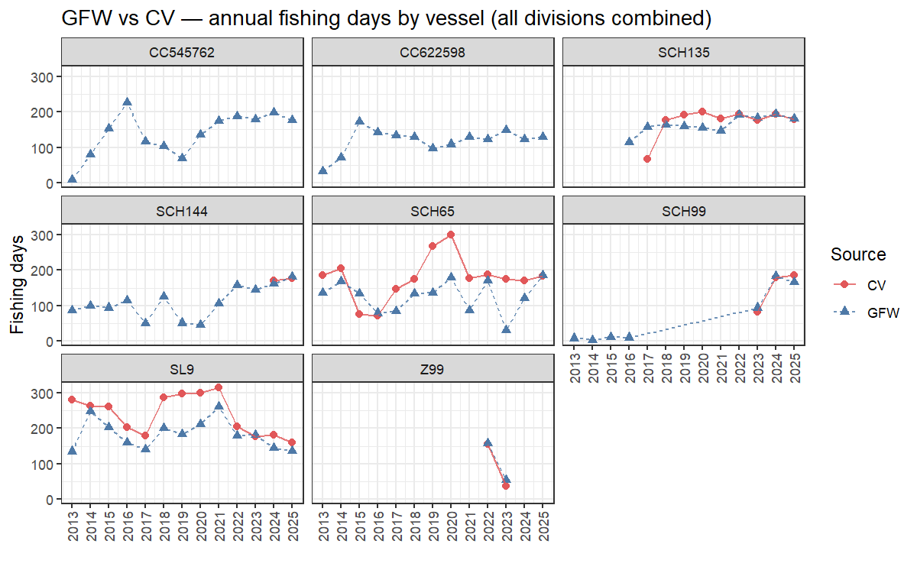
Figure 1. Annual fishing days per vessel (all divisions combined). Blue = GFW; red = CV logbook.

4.3 Annual fishing days — by vessel and ICES division
Figure 2 disaggregates the same comparison by ICES division.
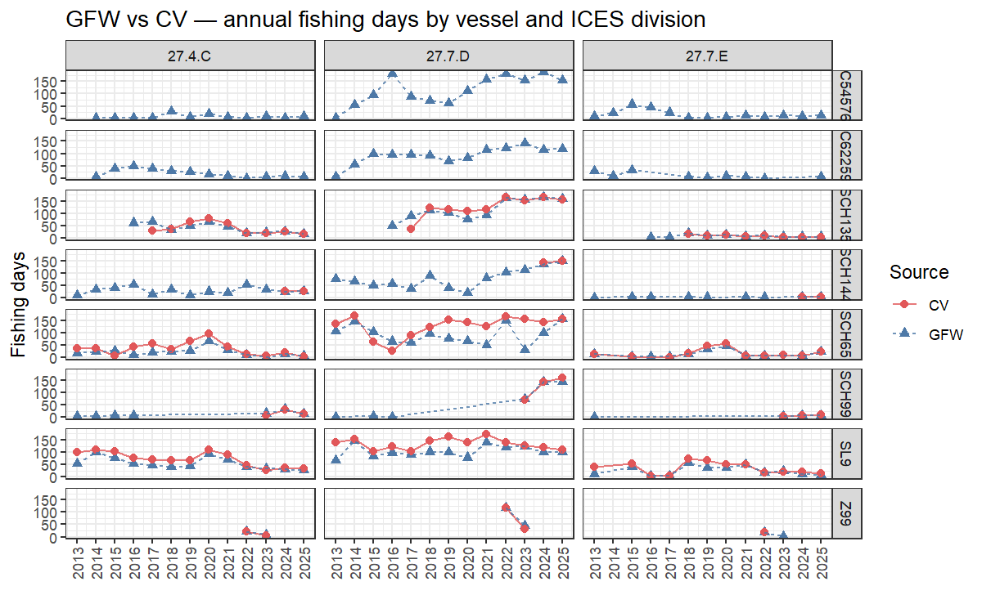
Figure 2. Annual fishing days per vessel and ICES division. Blue = GFW; red = CV logbook.

4.4 Scatter plot — GFW vs CV fishing days
Figure 3 shows a scatter plot of GFW against CV fishing days for all vessel-year-division combinations where both sources report non-zero days. Points above the 1:1 line indicate years where GFW reports more days than the logbook.
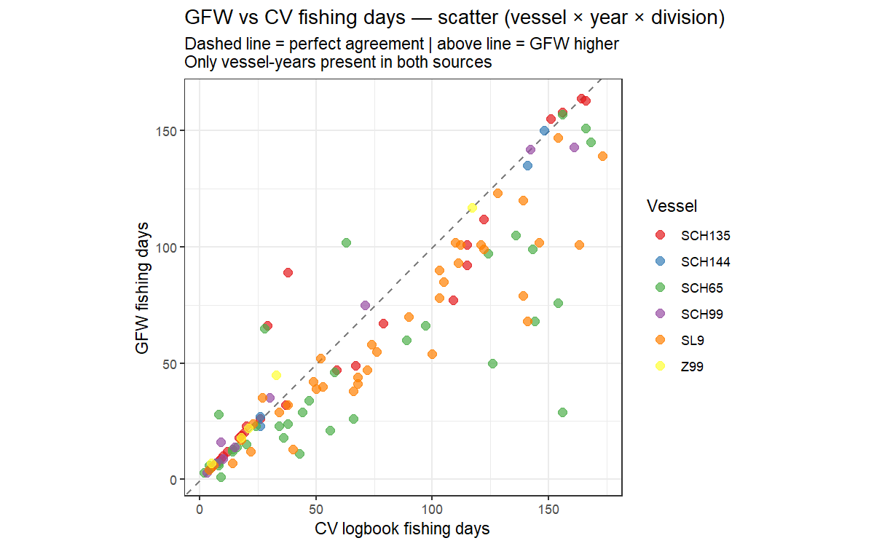
Figure 3. Scatter plot of GFW vs CV fishing days (vessel × year × division). Dashed line = 1:1. Only years present in both sources included.

5. Calendar heatmaps — daily overlap
The calendar heatmap analysis compares the two sources at the individual day level, showing which fishing dates are recorded by both sources, which appear only in the logbook, and which appear only in GFW.
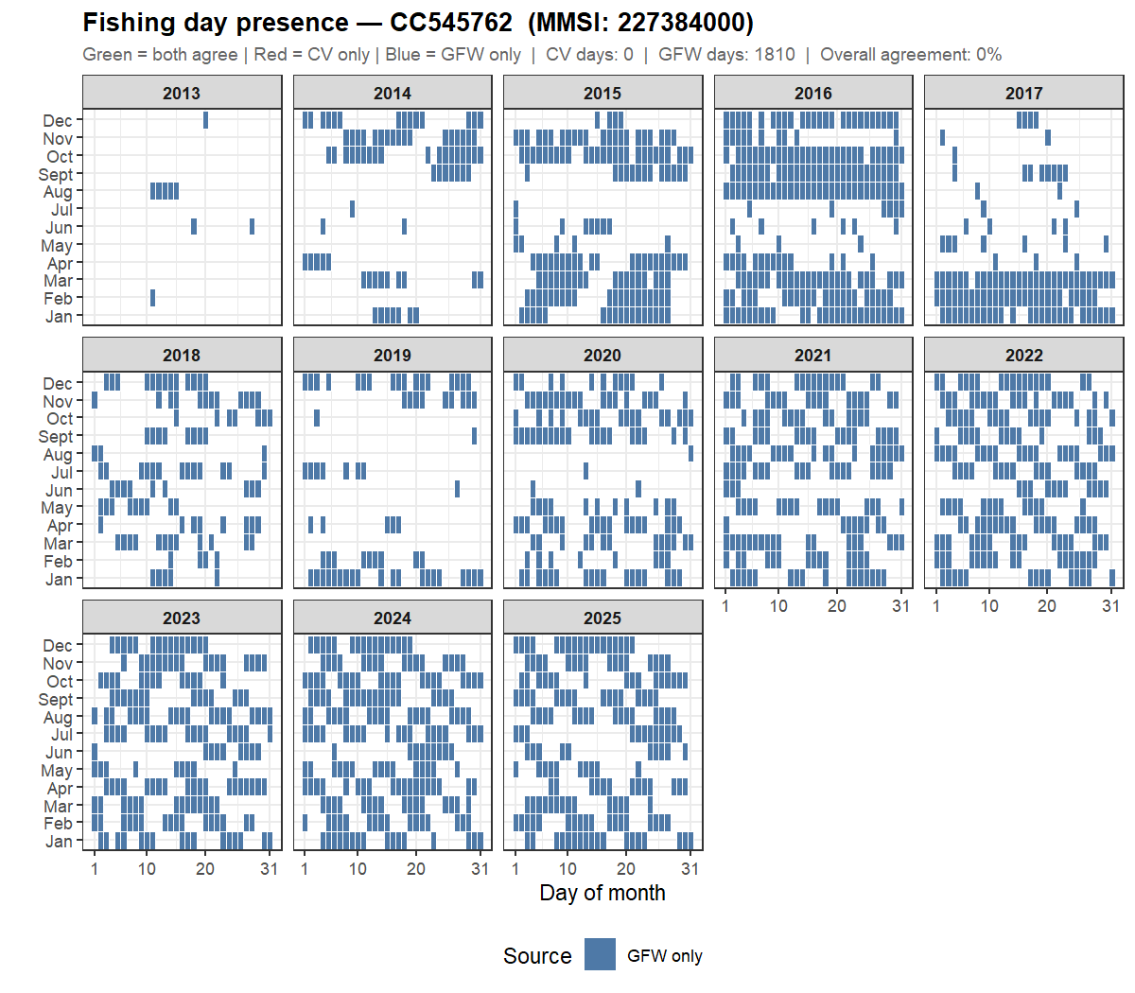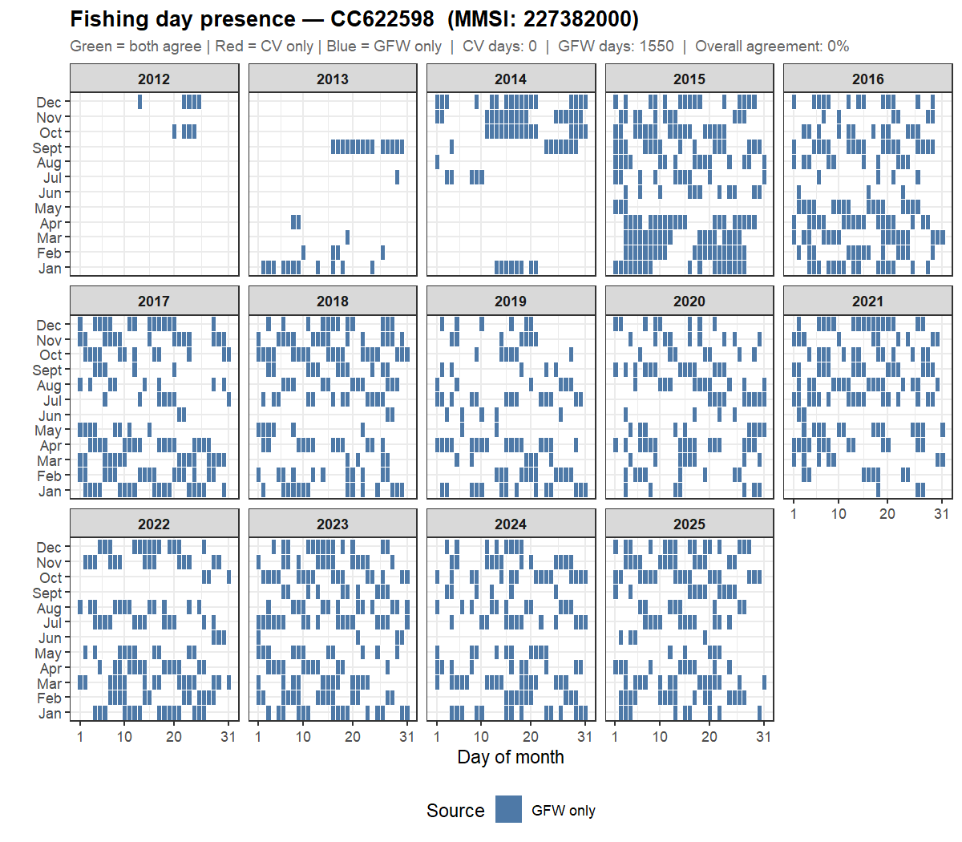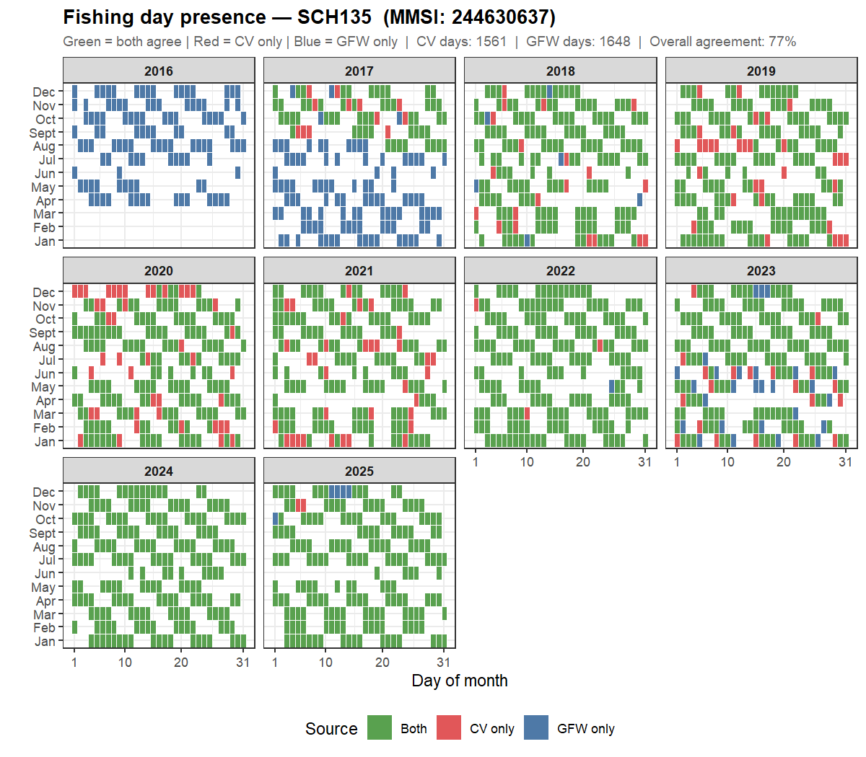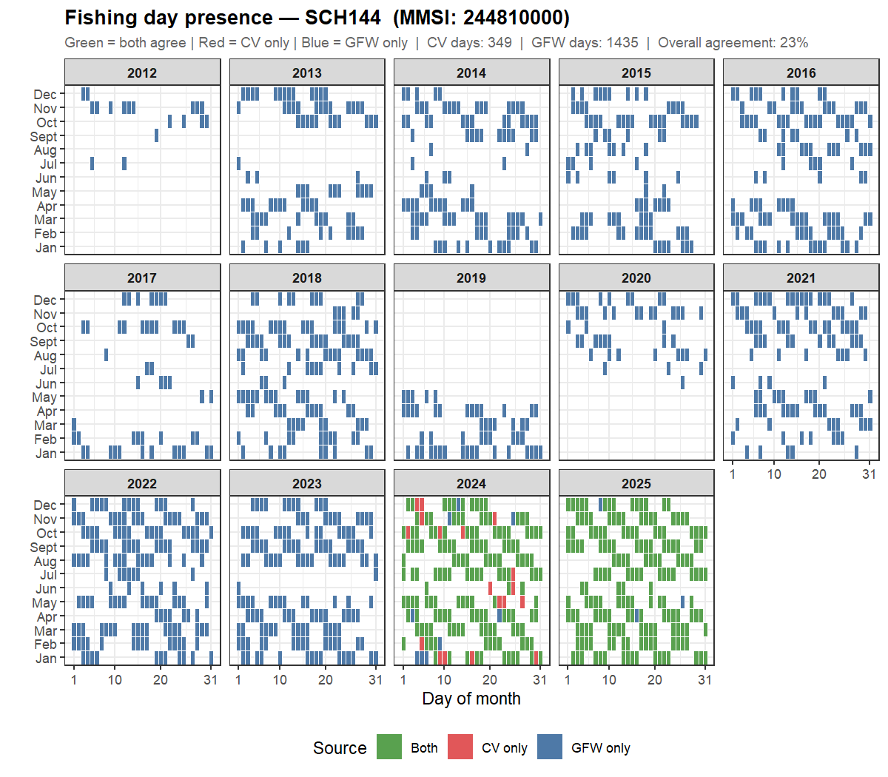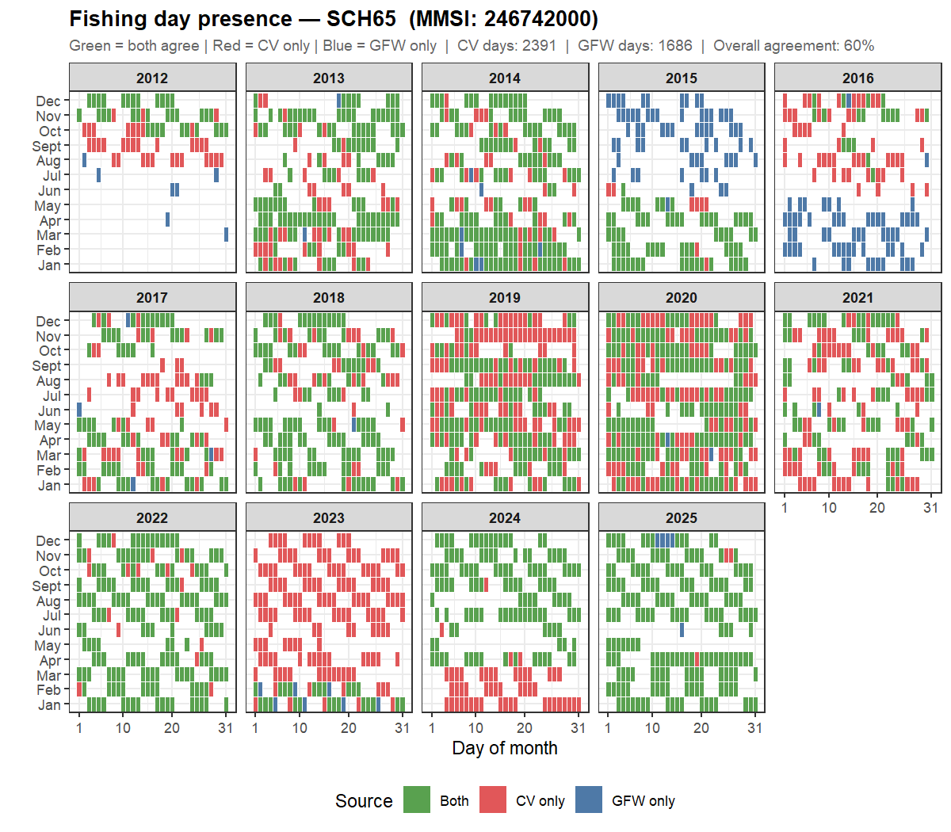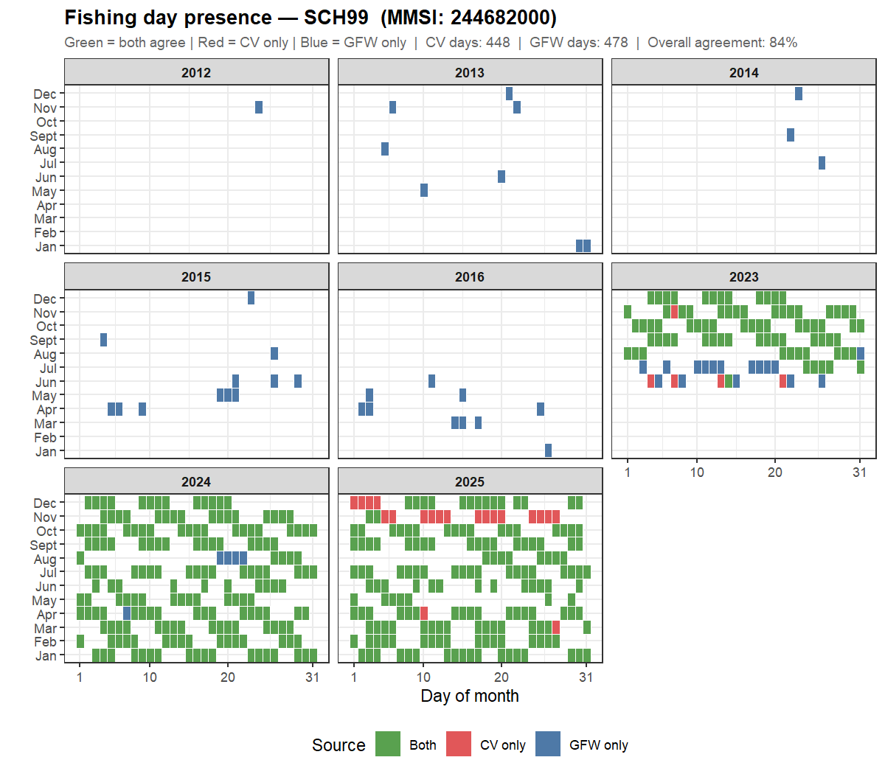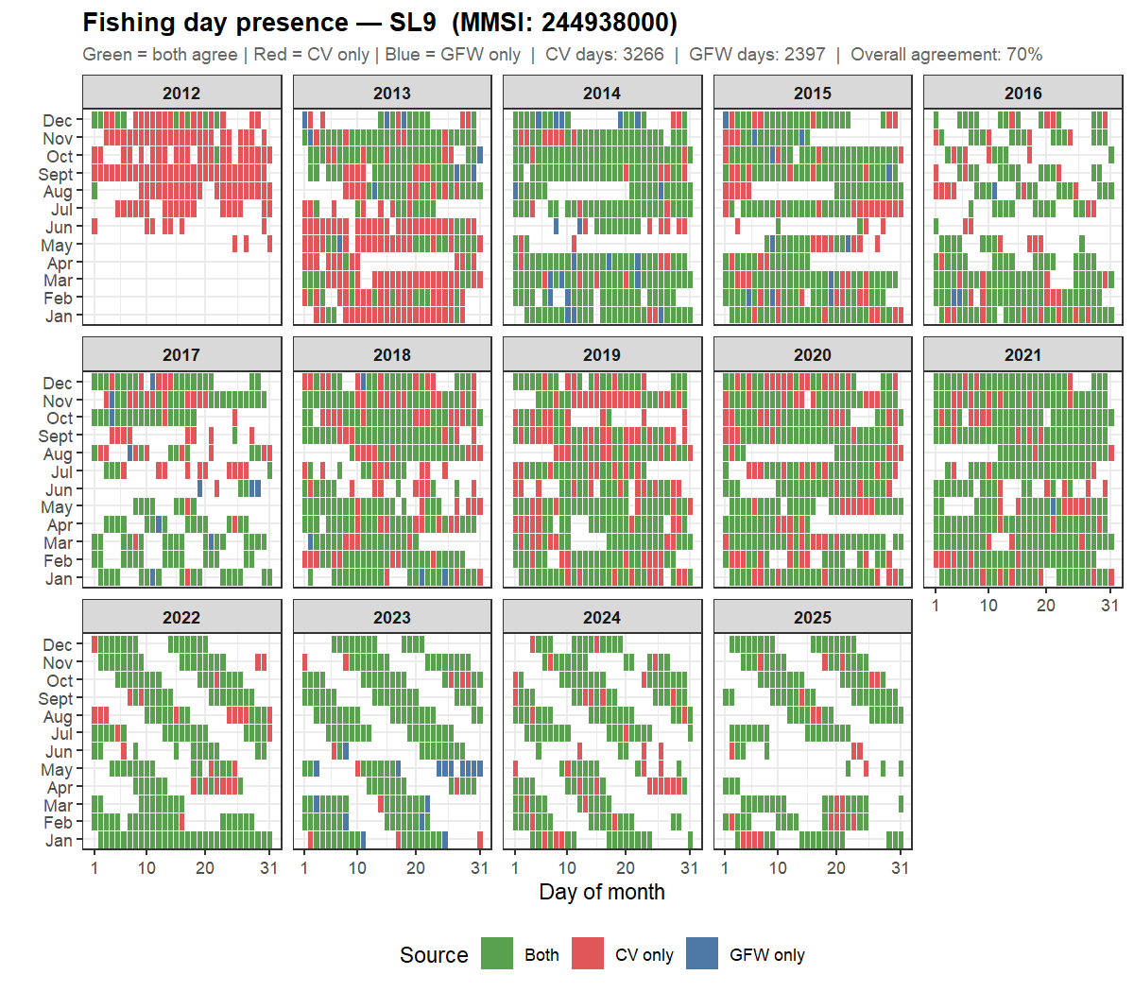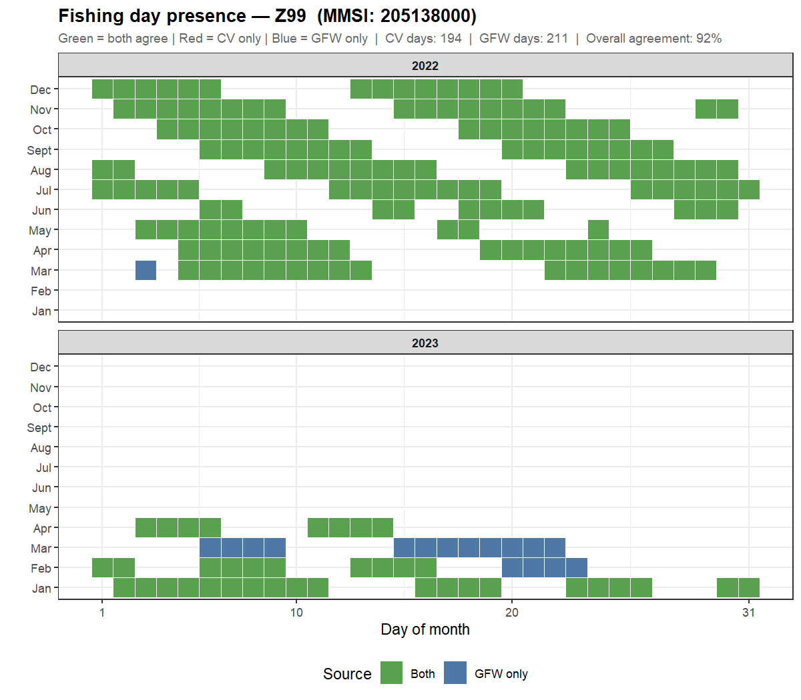

6. Discrepancy diagnostics
The diagnostics below focus on a subset of vessels and years where discrepancies are largest. Adjust focus_vessels and focus_years as needed.

6.1 CV duplicate records
CV haul record counts per vessel-date-division combination.
Vessel | Date-division combos | Combos with 1 record | Combos with 2+ records | Max records per day
SCH65 | 1015 | 4 | 1011 | 27
SL9 | 1198 | 16 | 1182 | 26

Dates recorded in multiple ICES divisions (focus vessels and years).
vessel | date | division
SCH65 | 2017-03-29 | 27.7.E
SCH65 | 2017-03-29 | 27.7.D
SCH65 | 2017-10-03 | 27.4.C
SCH65 | 2017-10-03 | 27.7.D
SCH65 | 2019-04-03 | 27.7.D
SCH65 | 2019-04-03 | 27.7.E
SCH65 | 2019-04-19 | 27.7.E
SCH65 | 2019-04-19 | 27.7.D
SCH65 | 2019-07-19 | 27.7.E
SCH65 | 2019-07-19 | 27.4.C
SL9 | 2018-01-26 | 27.7.D
SL9 | 2018-01-26 | 27.7.E
SL9 | 2018-03-03 | 27.7.D
SL9 | 2018-03-03 | 27.7.E
SL9 | 2018-06-27 | 27.4.B
SL9 | 2018-06-27 | 27.4.C
SL9 | 2018-10-19 | 27.4.C
SL9 | 2018-10-19 | 27.7.D
SL9 | 2018-10-31 | 27.4.C
SL9 | 2018-10-31 | 27.7.D
SL9 | 2018-11-01 | 27.4.C
SL9 | 2018-11-01 | 27.7.D
SL9 | 2018-11-03 | 27.4.C
SL9 | 2018-11-03 | 27.7.D
SL9 | 2018-12-03 | 27.4.C
SL9 | 2018-12-03 | 27.7.D
SL9 | 2019-02-25 | 27.7.E
SL9 | 2019-02-25 | 27.7.D
SL9 | 2019-03-20 | 27.7.D
SL9 | 2019-03-20 | 27.7.E
SL9 | 2019-03-24 | 27.7.D
SL9 | 2019-03-24 | 27.7.E

6.2 CV fishing days by division
CV fishing days inside and outside study divisions (focus vessels).
Vessel | Year | In study divs | Fishing days
SCH65 | 2017 | FALSE | 42
SCH65 | 2017 | TRUE | 149
SCH65 | 2018 | FALSE | 25
SCH65 | 2018 | TRUE | 174
SCH65 | 2019 | FALSE | 36
SCH65 | 2019 | TRUE | 270
SCH65 | 2020 | FALSE | 20
SCH65 | 2020 | TRUE | 299
SL9 | 2017 | FALSE | 44
SL9 | 2017 | TRUE | 179
SL9 | 2018 | FALSE | 30
SL9 | 2018 | TRUE | 295
SL9 | 2019 | FALSE | 33
SL9 | 2019 | TRUE | 300
SL9 | 2020 | FALSE | 17
SL9 | 2020 | TRUE | 300

6.3 GFW AIS gap check
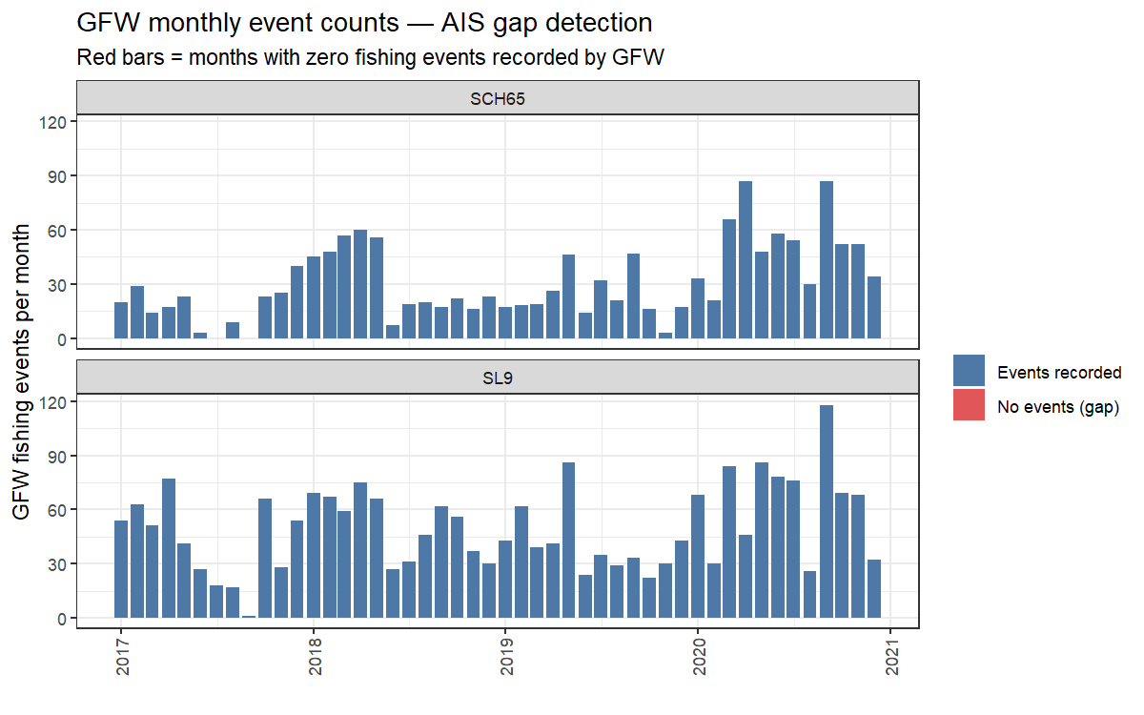
Figure 4. Monthly GFW fishing event counts for focus vessels. Red bars indicate months with no events recorded (potential AIS gaps).

6.4 Date-level comparison for a single vessel × year
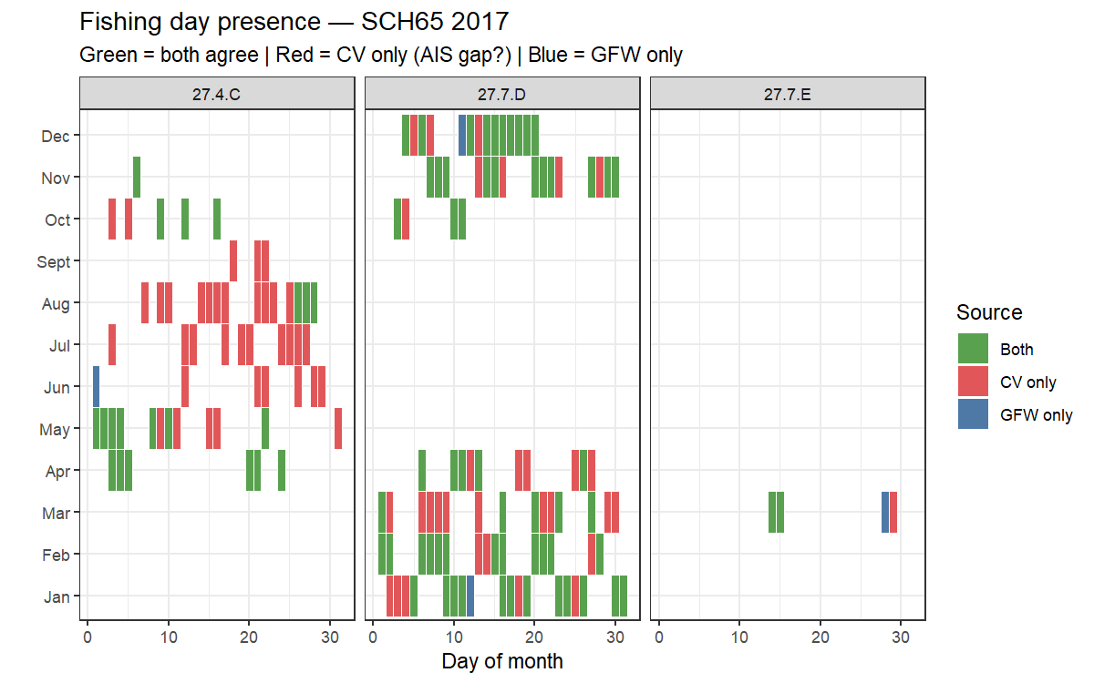
Figure 5. Calendar heatmap showing the date-level agreement between GFW and CV logbook for the focus vessel and year. Green = both; red = CV only; blue = GFW only.

7. Interpretation

7.1 What discrepancies may indicate
CV only (red cells) — possible causes:
- AIS transponder switched off or malfunctioning on that day.
- GFW classifier missed the fishing activity (e.g. slow steaming gear).
- Vessel fished in an area with poor satellite AIS coverage.
- Logbook records a day as fishing that GFW does not classify as such.
GFW only (blue cells) — possible causes:
- Fishing activity recorded by AIS but not submitted in the logbook.
- GFW classifier false positive (vessel steaming classified as fishing).
- Logbook records the trip under a different division or date.
- Vessel was active but the trip was not yet processed in the CV data.
Systematic patterns — for example, consistently red in a particular year or season — are more informative than isolated mismatches. A high proportion of green cells indicates good agreement between the two data sources.

7.2 Majority-rule deduplication
The CV fishing day count uses a majority-rule procedure to assign each vessel-date to a single ICES division (the one with the most hauls). This avoids inflating the CV day count when a vessel’s logbook records hauls in two divisions on the same day. The same logic underlies the GFW pipeline aggregation, making the two metrics directly comparable.

8. Saved outputs

Annex A — Data sources
Dataset | Source | Period | Role in this analysis
GFW effort (Stage 7) | GFW AIS pipeline | 2013–2025 | Fishing days per vessel × division × year
GFW events | GFW API / AIS pipeline | 2013–2025 | Day-level comparison and AIS gap diagnostics
CV electronic logbook | CV vessel operators | 2013–2025 | Independent effort metric from haul records
CV vessel info | CV fleet register | — | MMSI lookup, vessel metadata
Study area: ICES divisions 27.4.C, 27.7.D, 27.7.E.

Annex B — Technical notes
- Effort metric: unique fishing days per vessel × year × ICES division (one calendar date = one fishing day regardless of number of hauls or trips).
- Majority rule: where a vessel-date appears in multiple ICES divisions in the logbook, the division with the most hauls is retained. This prevents double-counting and matches the GFW aggregation approach.
- Agreement threshold: ±5 days absolute difference is used as the agreement criterion for annual comparisons (Section 4.1).
- Calendar heatmaps: based on date-only matching (not date × division), consistent with the approach used in the multi-year vessel PDF export.
- Source scripts: GFW_vs_CV_effort_comparison_v1.R (main analysis), Extract_GFW_effort_v7.R (GFW pipeline).

