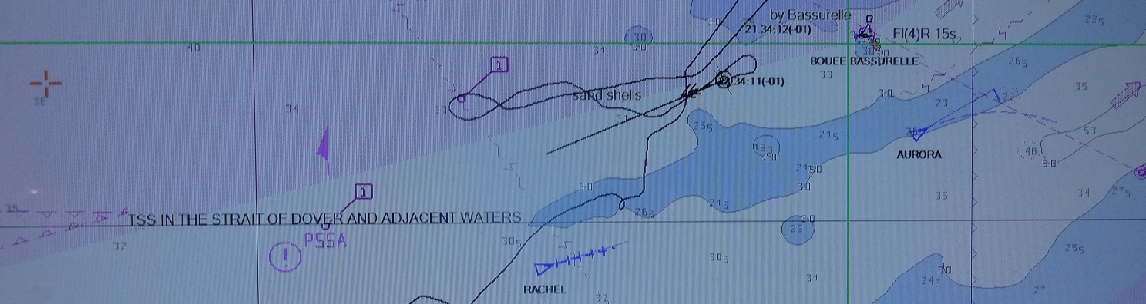

Fishing in the English Channel and southern North Sea
Trends in fishing effort, landings and spatial distribution of fleets in ICES divisions 27.7.d, 27.7.e and 27.4.c

Martin Pastoors

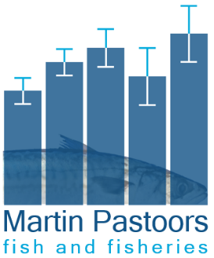
Date: 9 November 2026
Commission by: Cornelis Vrolijk BV
MPFF Report: 2026-03

Pastoors, M.A. (2026) Fishing in the English Channel and southern North Sea. Trends in fishing effort, landings and spatial distribution of fleets in ICES divisions 27.7.d, 27.7.e and 27.4.c. MPFF report 2026-03. Commissioned by Cornelis Vrolijk BV.

Version history
Version | Date | Changes
1.3 | 9 Nov 2026 | Restricted to ICES 27.7.d; new section on fleets, fisheries and spatial patterns
1.2.1 | 9 Nov 2026 | Full report on 7D, 7E and 4C again, without special focus on 7D
1.2 | 26 Oct 2026 | Added UK AER data up to 2020; restricted analyses to 7D and 7E.
1.1 | 5 Oct 2026 | Added UK landings data (MMO); added data explanations.
1.0 | 17 July 2026 | Added one more KDE figure; small editing
0.3 | 16 July 2026 | Added discussion sections after independent review; added interpretation of fishing effort
0.2 | 15 July 2026 | Added Kernel spatial analysis for 7D separately, added analysis of mixed/other gear
0.1 | 3 July 2026 | First complete version

