Fishing in the English Channel: Trends in Fishing Effort, Landings and Spatial distributions between countries and fleets

A combined analysis using STECF AER, MMO, GFW and STECF FDI data (2008–2025)
Martin Pastoors
05 October 2026
Table of Contents

Executive Summary
Background and aim. The English Channel and southern North Sea (ICES divisions 27.4.c, 27.7.d and 27.7.e) support some of the most intensively exploited fishing grounds in Europe, with important fisheries for France, the United King-dom, Belgium and the Netherlands. Over the past decade these fisheries have been shaped by three concurrent forces: declining fish stocks, post-Brexit access restructuring, and the rapid expansion of offshore wind farms in the southern North Sea. Against this background, this report was commissioned by Cornelis Vrolijk to provide an objective, evidence-based characterisation of fishing effort, landings and spatial distribution in the study area over the period 2008–2023 (AER), 2013–2023 (FDI) and 2013–2025 (GFW), with particular focus on the flyshoot segment in which the company operates.
Approach. Four complementary data sources were integrated: the STECF Annual Economic Report (AER, STECF 25-07), providing official fishing effort and landings by EU fleet segment; UK landings data from the Marine Management Organisation (MMO), covering UK and Channel Islands vessels, which are absent from the AER after Brexit; the STECF Fisheries Dependent Information database (FDI, STECF 25-10), used to disaggregate the AER bottom trawl/seine category into conventional otter trawl (OTB) and seine (SSC/SDN) gears; and Global Fishing Watch (GFW) AIS-derived fishing event data, used for spatial analysis of effort distribution and concentration.
Key findings. Total fishing effort in the study area declined by approximately 30% between 2008 and 2023, driven primarily by contraction of French otter trawl and Belgian and Dutch beam trawl fleets. France dominates the effort picture throughout, contributing around 80% of AER fishing days. The Dutch flyshoot fleet, while small in absolute terms, is the dominant seine fleet in the area, with approximately 70% of Dutch bottom trawl/seine days attributable to SSC/SDN gears. Landings are dominated by flatfishes, scallops and shrimps. Flatfish landings declined by more than 60% since 2008, consistent with poor stock status for Channel sole and plaice. Scallop landings increased markedly since 2016, supported by record biomass in the Baie de Seine.
Including the UK fleet. Over 2020–2023, UK and Channel Islands vessels accounted for around 19% of total landings in the study area, with the largest shares in 27.7.d and 27.7.e. UK landings are dominated by shellfish (whelk, scallops, cockles and crab), taken mainly by pots and traps and dredges, together with horse mackerel, flatfish and cuttlefish. EU-only (AER) figures therefore underestimate total landings in the study area by roughly 20%, and underrepresent shellfish and passive gears in particular. No UK effort data were available, so the effort trends in this report cover EU fleets only.
GFW spatial analysis reveals persistent fishing hotspots in the Pas de Calais and the Baie de Seine. Dutch effort in 27.4.C shows progressive spatial compression, likely linked to expanding wind farm footprints. Post-Brexit restructuring is visible from 2021 in the form of declining UK effort in 27.7.e and increasing spatial separation between national fleets. Spatial concentration in 27.7.D increased from a Gini coefficient of around 0.53–0.57 in 2013–2016 to 0.60–0.66 by 2019–2023, with a peak of 50% of total effort concentrated in the top-10% of grid cells in 2020, pointing to a structur-al shift rather than a temporary anomaly.
Conclusions. The fisheries in the Channel and Southern North Sea are undergoing a long-term structural contraction in effort, accompanied by declining landings of key flatfish species and progressive spatial concentration of the remaining fleet into a smaller number of heavily fished areas. The Dutch flyshoot fleet occupies a small but stable position within this system. The combination of AER, MMO, FDI and GFW data provides a robust multi-source baseline that can be used to contextualise the position of the Vrolijk fleet within the broader Channel fisheries, and to monitor future changes in fleet composition, spatial distribution and compliance with bilateral management arrangements.

Nederlandse samenvatting
Achtergrond en doel. Het Engelse Kanaal en de zuidelijke Noordzee (ICES divisies 27.4.c, 27.7.d en 27.7.e) behoren tot de meest intensief beviste wateren van Europa, met belangrijke visserijen voor Frankrijk, het Verenigd Koninkrijk, Bel-gië en Nederland. In het afgelopen decennium zijn deze visserijen beïnvloed door drie gelijktijdige ontwikkelingen: dalende visbestanden, herstructurering van de toegang na Brexit, en de snelle uitbreiding van offshore windparken in de zuidelijke Noordzee. In dit kader werd dit rapport in opdracht van Cornelis Vrolijk opgesteld, met als doel een ob-jectieve, op feiten gebaseerde beschrijving te geven van de visserij-inspanning, aanvoer en ruimtelijke verdeling in het studiegebied over de periode 2008–2023 (AER), 2013–2023 (FDI) en 2013–2025 (GFW), met bijzondere aandacht voor het flyshoot-segment.
Aanpak. Vier complementaire databronnen zijn gecombineerd: het STECF Jaarlijks Economisch Rapport (AER, STECF 25-07) voor officiële visserij-inspanning en aanvoer per EU-vlootsegment; aanvoergegevens van de Britse Marine Management Organisation (MMO) voor Britse vaartuigen en vaartuigen van de Kanaaleilanden, die na Brexit ontbreken in de AER; de STECF Fisheries Dependent Information-database (FDI, STECF 25-10) om de AER-categorie “bordenvisserij/zegen” te splitsen in conventionele bordenvisserij (OTB) en flyshoot (SSC/SDN); en Global Fishing Watch (GFW) AIS-gebaseerde visserijdata voor ruimtelijke analyse.
Belangrijkste bevindingen. De totale visserij-inspanning in het studiegebied daalde met circa 30% tussen 2008 en 2023, voornamelijk door inkrimping van de Franse bordenvisserij (OTB) en de Belgische en Nederlandse boomkorvis-serij. Frankrijk domineert het gehele inspanningspatroon en levert circa 80% van de AER-visdagen. De Nederlandse flyshoot-vloot is in absolute termen klein, maar is de dominante zegenvisserij in het gebied: circa 70% van de Neder-landse bordenvisserij/zegen-visdagen is toe te schrijven aan zegentuigen (SSC/SDN). De aanvoer wordt gedomineerd door platvis, sint-jakobsschelpen en garnalen. De aanvoer van platvis daalde met meer dan 60% ten opzichte van 2008, consistent met de slechte bestandsstatus van tong en schol in het Kanaal. De aanvoer van sint-jakobsschelpen nam sterk toe na 2016, gesteund door recordbiomassa in de Baie de Seine.
Britse vloot. In 2020–2023 was de Britse vloot (inclusief de Kanaaleilanden) goed voor circa 19% van de totale aanvoer in het studiegebied, met de grootste aandelen in 27.7.d en 27.7.e. De Britse aanvoer bestaat vooral uit schelpdieren en schaaldieren (wulken, sint-jakobsschelpen, kokkels en krab), gevangen met potten en fuiken en dreggen, aangevuld met horsmakreel, platvis en zeekat. Cijfers die alleen op de AER zijn gebaseerd onderschatten de totale aanvoer in het studiegebied daardoor met ongeveer 20%. Britse inspanningsgegevens waren niet beschikbaar; de inspanningstrends in dit rapport betreffen alleen EU-vloten.
De GFW-ruimtelijke analyse laat persistente visserijhotspots zien in het Nauw van Calais en de Baie de Seine. De Neder-landse inspanning in 27.4.C vertoont een progressieve ruimtelijke compressie, waarschijnlijk gerelateerd aan de uit-breiding van windparkgebieden. De gevolgen van Brexit zijn zichtbaar vanaf 2021: de Britse inspanning in 27.7.e neemt af en de nationale vloten vissen steeds meer in afzonderlijke gebieden. De ruimtelijke concentratie in 27.7.D nam toe van een Gini-coëfficiënt van 0,53–0,57 in 2013–2016 naar 0,60–0,66 in 2019–2023, met een piek waarbij 50% van de totale inspanning was geconcentreerd in 10% van de rastercellen in 2020. Dit lijkt een structurele verschuiving.
Conclusies. De visserij in het kanaal en de zuidelijke Noordzee ondergaat een langdurige structurele krimp in inspan-ning, gepaard met dalende aanvoer van belangrijke platvissoorten en toenemende ruimtelijke concentratie van de resterende vloot. De Nederlandse flyshoot-vloot neemt een kleine maar stabiele positie in binnen dit systeem. De combinatie van AER-, FDI- en GFW-data biedt een robuuste, meervoudige databasis die kan worden ingezet om de positie van de Vrolijk-vloot te contextualiseren binnen de bredere Channel-visserij, en om toekomstige veranderingen in vloot-samenstelling, ruimtelijke verdeling en naleving van bilaterale beheersafspraken te monitoren.

2. Introduction

2.1 Background
This study looks into the international fisheries developments in the English Channel and Southern North Sea in the past 15 years. Over this period there has been an increase in the fisheries for squid and cuttlefish in the Channel and more recently also in the Southern North Sea. This change in fishing patterns has come under increasing public and media scrutiny, including critical coverage in the Netherlands (e.g. Follow the Money). This study attempts to provide a thorough knowledge base on the Channel and Southern North Sea fisheries using data from different sources: 1) STECF Annual Economic Report (AER, STECF 25-03 & 25-07), 2) UK catch data 2020-2024 (MMO 2026), 3) STECF Fisheries Dependent Information (FDI; STECF, 2025b) and 3) Global Fishing Watch data (https://globalfishingwatch.org). The aim is to provide an objective, evidence-based assessment of the fisheries development in terms of effort and catches of fleets operating in the Channel and the available scientific literature on those fisheries.
The report was commissioned by Cornelis Vrolijk company (https://www.cornelisvrolijk.eu) and executed by Martin Pastoors Fish & Fisheries.

2.2 Objectives
- To quantify trends in fishing effort and landings in the Channel (2008/2013–present) using official STECF (AER) and MMO statistics, with spatial distribution characterised using GFW AIS data.
- To compile a scientifically grounded overview of the fisheries in the Channel, with particular focus on sustainability, ecosystem effects and the positioning of the flyshoot fishery.

2.3 Study area and scope
The study covers ICES divisions 27.4.c (southern North Sea), 27.7.d (eastern English Channel) and 27.7.e (western English Channel). The combination of 27.4c, 27.7.d and 27.7.e will be called “study area” in the report.
The period of analysis is 2008–2023 for EU effort and landings trends (AER; data for 2024 were not available for France and 2024 has therefore been left out), 2020–2024 for UK landings (MMO), and 2013–2025 for spatial analysis (GFW).

3. Material & Methods
This report combines four data sources, each covering a different period and providing different information. Figure 1 gives an overview: the AER provides the long-term series of EU effort and landings, the MMO data add the landings of the UK and Channel Islands fleets from 2020 onwards, the FDI data are used only to split the AER bottom trawl/seine category into otter trawl and seine, and the GFW data are used only for the spatial analysis. The sources are described in detail in Sections 3.2–3.5.
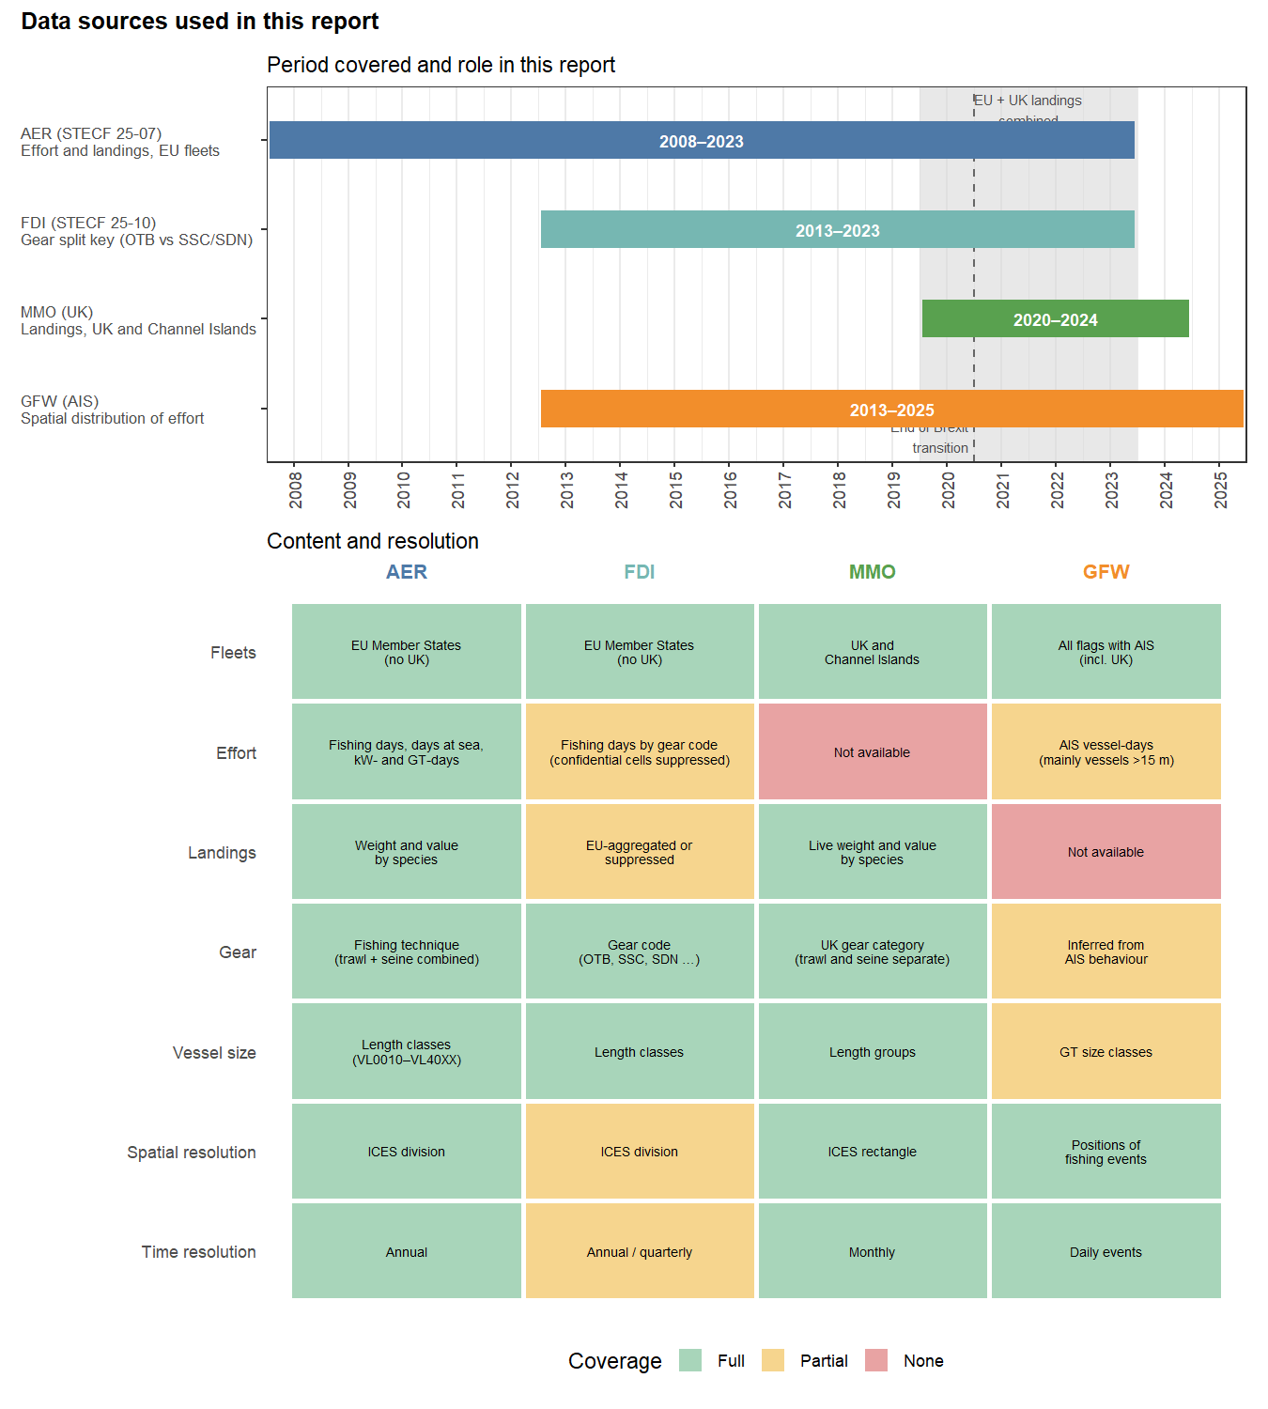
Figure 1: Overview of the data sources used in this report. Top: period covered by each source and its role in the analysis; the shaded band marks the years in which EU (AER) and UK (MMO) landings are combined. Bottom: content and resolution of each source (green = full, yellow = partial, red = not available).

3.1 STECF AER data (effort and landings trends)
The Annual Economic Report (AER) data were obtained from the STECF 25-07 data release (EU Fleet Economic and Transversal data, fleet segment level). The AER provides fishing effort (fishing days, sea days, kW-days, GT-days) and landed weight and value by fleet segment (country × fishing technique × vessel length class), disaggregated by FAO division.
The AER analyses in this report cover the period 2008–2023. The end year of 2023 reflects the absence of French effort and landings data for 2024 in the current STECF 25-07 release. The AER does not distinguish between bottom trawl and seine fisheries; they are reported as a combined category.
The AER does not contain data for the United Kingdom following its departure from the EU. UK landings were therefore obtained separately from the UK Marine Management Organisation (Section 3.3). No comparable UK effort data were available for this report.

3.1.1 Vessel length classes
The AER reports effort and landings by vessel length class (VLC), defined by overall length (LOA) in metres. Six standard classes are used throughout this report, as defined in the STECF fleet data collection framework:
Table 1: Vessel length classes (VLC) used in STECF AER data and throughout this report.
Code | Length range (m) | Typical vessel type
VL0010 | < 10 | Small inshore vessels (outboard/inboard motor)
VL1012 | 10–12 | Small coastal vessels
VL1218 | 12–18 | Medium coastal/demersal vessels
VL1824 | 18–24 | Medium offshore vessels, beam trawlers, flyshoot
VL2440 | 24–40 | Large demersal and pelagic trawlers
VL40XX | > 40 | Freezer trawlers
VL0010 and VL40XX are included in data tables but excluded from some effort figures where their small contribution makes them difficult to display alongside the dominant VL1218–VL2440 classes. All classes are included in the Annex D tables.

3.1.2 Species groups
Landings in the AER are reported at the individual species level using FAO 3-alpha species codes. For summary figures and tables, individual species are aggregated into ecologically and commercially meaningful species groups. The grouping was applied using FAO 3-alpha codes as the primary key (reliable and consistent across member states) with species name pattern matching as a fallback. Table Table 2 lists the species groups used and the main constituent species.
Table 2: Species groups used in landings analyses throughout this report, with principal constituent species.
Species group | Main species
Pelagic fish | Atlantic herring (HER)
Pelagic fish | Atlantic mackerel (MAC)
Pelagic fish | Horse mackerel (HOM/JAX)
Pelagic fish | European sardine/pilchard (PIL)
Pelagic fish | European sprat (SPR)
Seaweeds | Tangle/kelp/seaweeds nei (LQD, LAH, SWX and others)
Cuttlefish | Common cuttlefish (CTC) and other Sepia spp.
Squid | European squid/Loligo (LOL/LOG)
Squid | Other squids nei (SQZ, SQR, SQC and others)
Mullets | Grey/golden/red mullet (MUL, MUG, TFM)
Gurnards | Red/tub/grey gurnard (GUR, GUU, TUB)
Roundfish | Whiting (WHG)
Roundfish | Haddock (HAD)
Roundfish | Atlantic cod (COD)
Flatfishes | Common sole (SOL)
Flatfishes | European plaice (PLE)
Flatfishes | Turbot/brill (TUR/BLL)
Flatfishes | Megrim (MEG/LDB)
Flatfishes | Dab/flounder/other flatfishes (DAB, FLE, LEM, WIT and others)
Scallops | Great Atlantic scallop (SCE)
Scallops | Queen scallop (QSC)
Shrimps | Brown shrimp/Crangon (CRG/CSH)
Shrimps | Northern shrimp/Pandalus (PRA/PAN)
Shellfish & crustaceans | Whelk (WHE)
Shellfish & crustaceans | Edible/spider crab (CRE/SCR)
Shellfish & crustaceans | Other shellfish nei
Other demersal fish | European seabass (BSS)
Other demersal fish | Black seabream (BRB)
Other demersal fish | Rays & skates (RJC, RJH and others), smooth-hounds (SDV), other demersal

3.2 UK landings data (MMO)
UK landings were obtained from the dataset underlying the UK Sea Fisheries Statistics 2024 (MMO, 2025), covering landings by UK vessels into all ports and landings by non-UK vessels into UK ports for 2020–2024. The dataset reports monthly landings by vessel nationality, ICES division and statistical rectangle, port of landing, vessel length group, gear category and species, as live weight, landed weight and first-sale value (GBP).
Selection. Only vessels of UK nationality (England, Scotland, Wales and Northern Ireland) were retained, together with vessels from Jersey and Guernsey, which are reported separately as Channel Islands (CHI). Landings by non-UK vessels into UK ports were excluded, because these are already included in the AER data of the respective flag states. The data were restricted to ICES divisions 27.4.c, 27.7.d and 27.7.e.
Harmonisation with the AER. UK vessel length groups were mapped onto the AER vessel length classes (Table Table 1) using the lower bound of each length group. UK gear categories were mapped onto the AER gear categories as shown in Table Table 3. The original UK gear categories were retained in addition; unlike the AER, they distinguish demersal trawls from demersal seines. Species are coded with FAO 3-alpha codes in both sources, but some species are reported under different codes. Horse mackerel (HOM/JAX), cuttlefish (CTC/CTL), monkfish (ANF/MON/MNZ), squids (SQC/SQR/SQZ) and skates and rays (RJx/SKA) were therefore harmonised to a common code before species grouping (Section 3.2.2). Live weight was used throughout, consistent with the AER. Values were converted from GBP to EUR using annual average ECB exchange rates.
Limitations. The UK data cover landings only; no UK effort data were available, so UK vessels are absent from all effort figures. The UK series starts in 2020, so pre-Brexit UK landings cannot be compared with post-Brexit landings. Direct comparisons between EU and UK landings are restricted to 2020–2023, the years covered by both sources. Spatial attribution may differ slightly between sources: UK landings are attributed to the reported rectangle and division, while AER landings by sub-region are compiled by Member States from logbook and sales-note data.
Table 3: Mapping of UK (MMO) gear categories to the AER gear categories used in this report.
UK gear category (MMO) | AER gear category
Demersal trawls | Bottom trawl/seine
Demersal seine | Bottom trawl/seine
Beam trawl | Beam trawl
Dredge | Dredge
Drift and fixed nets | Gillnet
Handlines, Longlines | Handline/rod
Pots and traps | Pot/trap
Pelagic seine | Purse seine
Pelagic trawls, Other mobile/passive gears, Unknown | Other/mixed

3.3 STECF FDI data — limitations and use as gear-splitting key
The STECF Fisheries Dependent Information (FDI) dataset was obtained for the study area and period. Unfortunately the FDI Landings table is EU-aggregated (no country breakdown) and the Effort and Catches tables suffer from substantial confidentiality suppression in many strata. In addition, the spatial FDI tables were not available on the STECF website at the time of analysis. Therefore, the FDI data has not been used as the main source of the data for the report.
Despite these limitations, the FDI Effort table retains one piece of information not available in the AER data: gear code at the FAO level (e.g. OTB, OTT, SSC, SDN, PTB). The AER combines all of these into a single Bottom trawl/seine category, which conflates conventional otter trawl (OTB) with Danish/Scottish seine (SSC/SDN),two gears with very different fishing patterns and fleet compositions. The FDI gear-code information is therefore used to disaggregate the AER Bottom trawl/seine category, as described below.
Splitting approach. For each stratum (year, country, vessel length class, division), the share of each gear code within the Bottom trawl/seine total was computed from the FDI Effort table. This proportional split key was then applied to the corresponding AER fishing days, so that the total days in each stratum are conserved exactly. Shares in the FDI strata are rescaled to sum to 1 within each stratum, handling any within-stratum confidentiality suppression transparently.
Coverage and fallback rules. FDI data are used for 2013–2023 only. Post-2013 strata with no FDI coverage (primarily IRL, DNK, and some BEL and DEU strata where FDI reported zero or suppressed days) are assigned a pooled fallback split key derived from the FDI data aggregated across all available years and countries, stratified by vessel length class.
Limitations. Countries for which FDI coverage is sparse (IRL, DNK, DEU) receive a pooled fleet-average split that may not reflect their actual gear mix. Results for these countries should be interpreted with caution and are excluded from the figures showing the French and Dutch trends.

3.4 GFW data (spatial effort distribution and concentration)
Fishing activity data were retrieved via the Global Fishing Watch (GFW) API (gfwr v3.0) using the Events endpoint. Vessel metadata (country, gear type, gross tonnage) were obtained from the GFW vessel registry (https://globalfishingwatch.org, Kroodsma et al, 2018).
Recent publication have shown that the haul based effort from GFW may not be a reliable indicator for fishing effort for trawl based gears (Hintzen et al 2025). Therefore, we define GFW days at sea in this report as vessel-days: for each day, each vessel is assigned to the ICES division in which it spent the majority of its time, based on the spatial distribution of AIS positions recorded during that day. This definition is therefore a simple presence-day metric. The effort trends derived from GFW data were found to be very different from effort trends in AER (and FDI) data. An important limitation of the GFW data is that vessels below the AIS carriage requirement threshold (typically 15 m LOA, though requirements vary by country and fishing area) are systematically under-represented or absent. This means that gears dominated by small inshore vessels — gillnets, pots and traps, handlines — are structurally under-counted relative to larger trawl and seine vessels, which carry AIS as a mandatory requirement. Therefore, the GFW data are used exclusively used for the spatial analysis using effort density maps, spatial hotspots, and effort concentration metrics. The GFW spatial analysis covers the full period 2013–2025.

3.4.1 Kernel density estimation of spatial effort distribution
The spatial distribution of fishing effort was characterised using kernel density estimation (KDE), a standard non-parametric method for converting a set of discrete point locations into a smooth continuous surface representing effort intensity (Silverman, 1986). For each year, fishing event coordinates were projected into a metric coordinate system (UTM Zone 30N) and a Gaussian kernel with bandwidth σ = 20 km was applied across the full study area, and σ = 10 km for the focused analysis of ICES 27.7.D. The narrower bandwidth for 27.7.D resolves finer-scale spatial structure within the eastern Channel. Both bandwidths are fixed across years so that changes in the density surface reflect genuine shifts in fishing distribution rather than smoothing artefacts. Land is excluded from the estimation window. The resulting surface is normalised to a 0–1 scale within each year, making spatial patterns directly comparable across years regardless of differences in total effort; for absolute effort levels, the AER-based effort figures in Section 4.2 should be consulted alongside the KDE maps. KDE is widely used in fisheries spatial analysis to identify persistent hotspots, characterise seasonal grounds and detect shifts in fleet distribution over time (Gerritsen & Lordan, 2011; Kroodsma et al., 2018).

3.4.2 Spatial concentration metrics: Gini coefficient and top-10% cell share
Two complementary metrics were computed annually for ICES 27.7.D on a regular 5 km × 5 km grid to quantify how concentrated fishing effort is in space, rather than simply where it occurs. The Gini coefficient is a well-established inequality measure — originally from economics and widely applied in fisheries spatial analysis (Greenstreet et al., 2009; Eigaard et al., 2017) — that summarises the full distribution of effort across all grid cells on a scale from 0 (effort perfectly uniform across all cells) to 1 (all effort in a single cell). Values above approximately 0.7 indicate strong spatial concentration; a rising Gini over time signals progressive compression of effort into fewer areas, which may reflect displacement from previously accessible grounds, regulatory closures or increasing targeting efficiency. The top-10% cell share is a more intuitive companion metric: it expresses what percentage of total annual fishing events falls within the 10% of grid cells that were most intensively fished that year. If effort were uniform this would equal 10%; values of 40–70% are typical in concentrated demersal fisheries. Together the two metrics capture different aspects of concentration — the Gini reflects the shape of the full distribution while the top-10% share highlights the intensity of the most-fished areas — and tracking both annually allows changes in spatial footprint to be detected even when total effort remains stable.

3.5 Literature review approach
The literature review underpinning Section 4.5 draws on four categories of sources:
Scientific literature was identified through targeted searches of Web of Science, Scopus and Google Scholar using the terms: English Channel fisheries, Channel demersal fisheries, flyshoot, Danish seine Channel, beam trawl North Sea Channel, scallop Pecten maximus Channel, seabed disturbance trawl, AIS fishing effort, and combinations thereof. Priority was given to peer-reviewed articles published since 2010, supplemented by earlier foundational studies where relevant (e.g. Eigaard et al. 2016; Depestele et al. 2016).
ICES working group reports were sourced from the ICES library (https://www.ices.dk), primarily:
- Working Group on Celtic Seas Ecoregion (WGCSE, ICES 2025a) — principal source for demersal stocks in the Channel (sole, plaice, whiting, sea bass, monkfish, megrim, mullet) and for the broader ecosystem and fisheries context of 27.7.d/e.
- Working Group on the Assessment of Demersal Stocks in the North Sea and Skagerrak (WGNSSK, ICES 2024c) — consulted for stocks with distributions spanning both 27.4.c and the Channel (e.g. plaice, dab, horse mackerel).
- Working Group on Widely Distributed Stocks (WGWIDE, ICES 2024e) — responsible for the assessment of mackerel (Scomber scombrus) and horse mackerel (Trachurus trachurus western stock), both of which can be important bycatch species in the study area.
- Working Group on Cephalopod Fisheries and Life History (WGCEPH, ICES 2024d) — consulted for cuttlefish (Sepia officinalis) and squid (Loligo spp., Illex spp.) in the Channel and North Sea. WGCEPH does not produce formal TAC advice but provides the best available science on stock status and drivers of variability.
- Working Group on Ecosystem Effects of Fishing Activities (WGECO) — for seabed disturbance and ecosystem-level assessments.
ICES advice sheets for the relevant stocks were also consulted directly.
Official statistics and national sources include the STECF AER (primary quantitative source for this report), Ifremer fleet and stock assessment reports, the UK Marine Management Organisation (MMO) annual sea fisheries statistics, and the Belgian ILVO annual fleet reports. Where possible, the most recent published edition was used.
Policy and grey literature includes EU regulation texts, the UK–EU Trade and Cooperation Agreement fisheries annex, and parliamentary reports on post-Brexit fisheries.
All quantitative claims made in the literature sections are cross-referenced with the AER and GFW results presented in Section 4, and discrepancies or gaps are noted where they arise.

4. Results

4.1 Landings trends

4.1.1 AER landings by species during 2008-2023
The overall landings by species in the study area (27.4.c, 27.7.d and 27.7.e) during all of the years available in the AER data are shown in the figure below (left: all gears, right: bottom trawl/seine, beam trawl and dredge). Herring, scallops and tangle (seaweed) have the highest landings for all gears. For the selected demersal fisheries in the study area, scallops, shrimp and plaice have the highest landings overall.
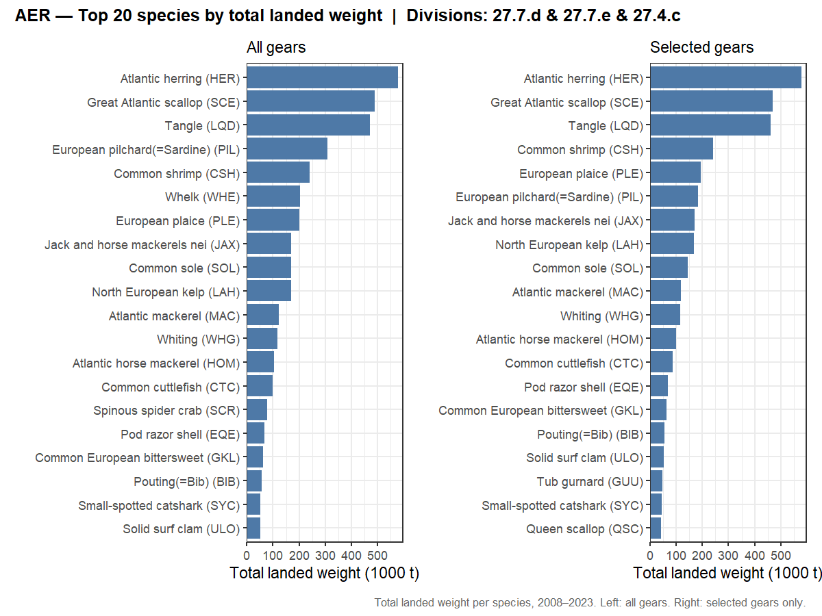
Figure 2: Top 20 species by total landed weight in ICES 4.c/7.d/7.e (2008–2023). Left: all gears combined; right: selected gears only (Bottom trawl/seine, Beam trawl, Dredge, Other/mixed). Source: STECF 25-07.
Tangle (LQD) is a seaweed species being harvested from the sea (Laminaria digitata). Common European bittersweet (GKL) is a shellfish species (Glycymeris glycymeris).

4.1.2 Total landed weight by year, country and gear
Total landings by gear and country are shown in the figure below. Highest landings are in the category Other/mixed which includes pelagic trawl (for e.g. herring). Beam trawl, bottom trawl/seine and dredge are the three gear types that generate somewhat comparable amounts of landings. Beam trawl is dominated by the Netherlands and bottom trawl/seine and dredge by France.
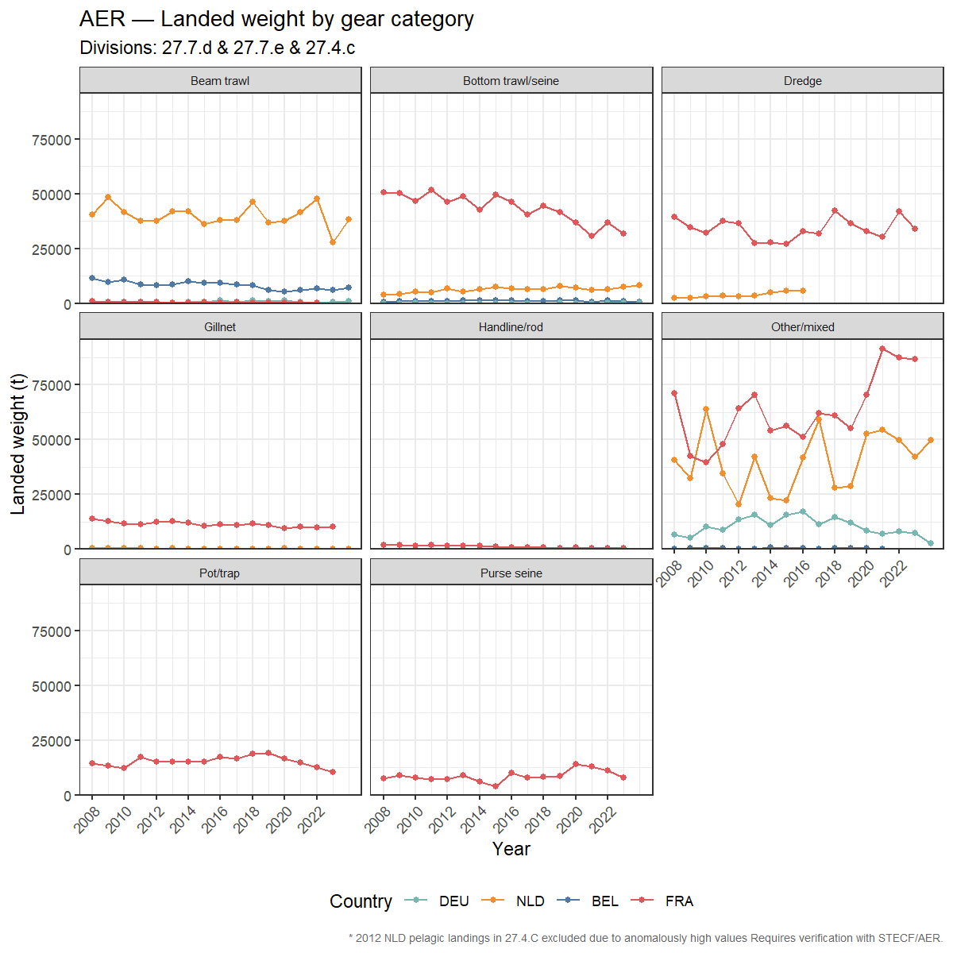
Figure 3: Landed weight (t) in ICES 4.c/7.d/7.e per year by country and gear category (AER, 2008–2023). Source: STECF 25-07.

4.1.3 Total landed weight for Other/mixed gear by year, country and species group
The Other/mixed gear category covers a highly diverse range of fishing techniques and target species that do not fit neatly into the main AER gear categories. The composition of this category differs markedly by country. French Other/mixed landings are dominated by seaweeds (tangle LQD and kelp LAH, harvested mechanically from the seabed) and pelagic fish (herring, mackerel, sardine and horse mackerel), together accounting for over 60% of French Other/mixed volume throughout the series. The increase in French Other/mixed landings since 2019 — visible in the preceding landings-by-gear figure — is driven largely by growing seaweed harvests rather than increasing pelagic or demersal fishing activity. Dutch Other/mixed landings are almost entirely pelagic fish, consistent with the Dutch pelagic trawl fleet (pair trawlers targeting herring, horse mackerel and mackerel in the Channel), though showing considerable interannual variability linked to stock availability and quota allocation. German Other/mixed landings are a modest but stable contribution, also predominantly pelagic. Belgian Other/mixed landings are negligible at this scale and have been omitted
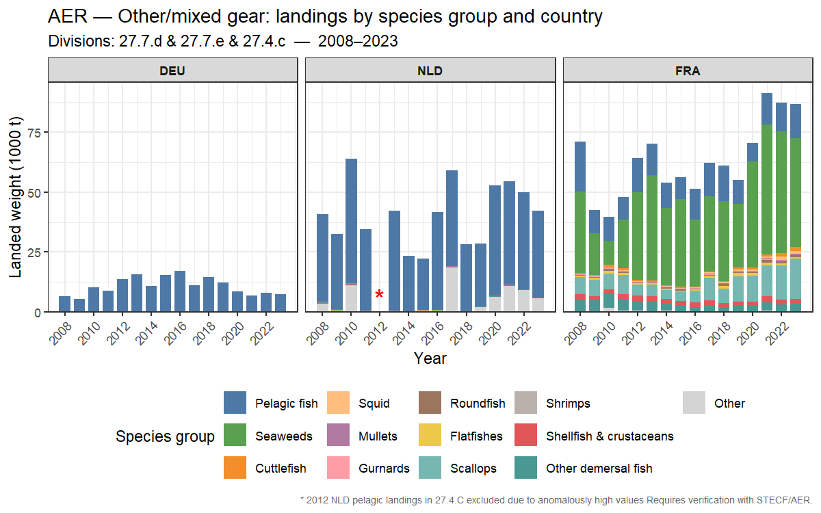
Figure 4: Landed weight (t) by species group and country for the Other/mixed gear category, ICES 4.c/7.d/7.e (AER, 2008–2023).

4.1.4 Key species groups — landings by country
Landings in the study area are dominated by flatfishes, scallops and shrimps in terms of volume, with flatfish landings showing a marked decline from around 40,000 t in 2008 to below 15,000 t by 2023, driven almost entirely by the Dutch (NLD) and Belgian (BEL) fleets. This is consistent with the contraction of beam trawl effort over this period. Scallop landings are dominated by France (FRA) and show an increasing trend since 2016, reaching record levels in 2022–2023. Shrimp landings are predominantly Dutch, in the Southern North Sea and relatively stable. Cephalopod landings (cuttlefish and squid) are France-dominated and show moderate interannual variability. Landings of mackerel, horse mackerel, whiting, mullets and gurnards are comparatively low across all countries.
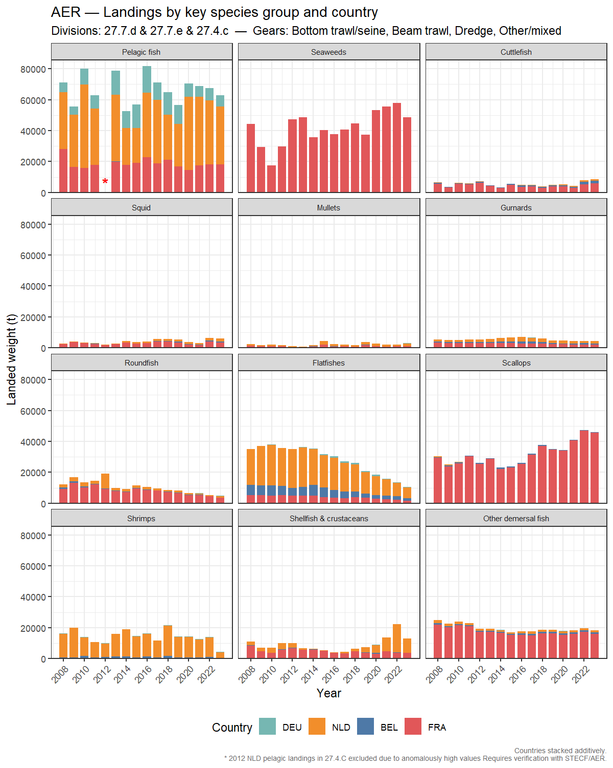
Figure 5: Landings by key species group and country for selected gears (Bottom trawl/seine, Beam trawl, Dredge, Other/mixed) in ICES 4.c/7.d/7.e (AER, 2008–2023).

4.1.5 Key species groups — landings by gear category
The gear breakdown confirms that flatfish landings are almost entirely taken by beam trawl, with a steep decline since 2008. Scallops are dominated by dredge. Cuttlefish, squid, gurnards and whiting are taken predominantly by bottom trawl/seine. Shrimps are exclusively beam trawl. Mullets, mackerel and horse mackerel show negligible landings across all gears.
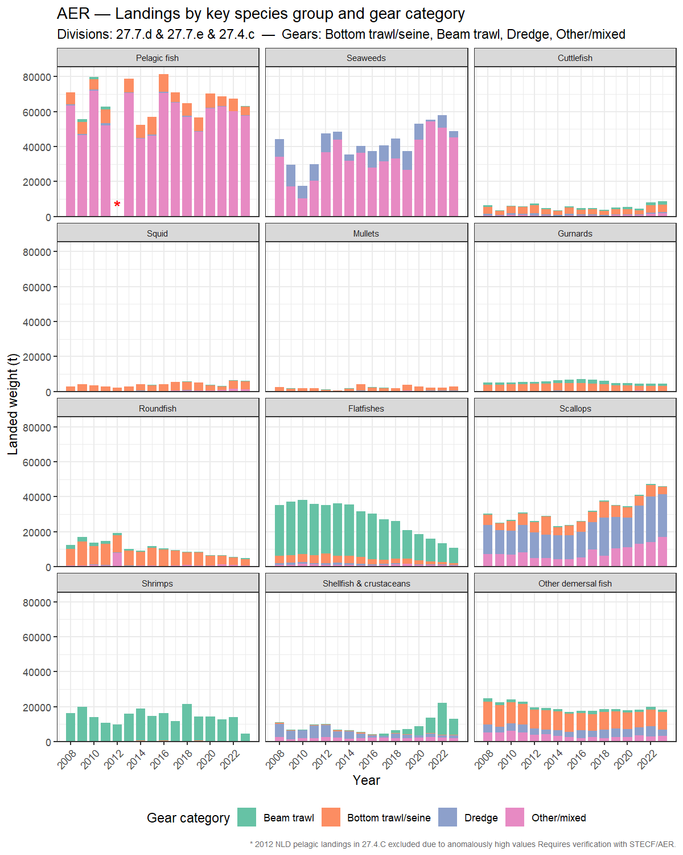
Figure 6: Landings by key species group and gear category for selected gears in ICES 4.c/7.d/7.e (AER, 2008–2023).

4.1.6 Including UK landings (2020–2023)
The figures in Sections 4.1.1–4.1.5 are based on the AER and therefore exclude the UK fleet. To complete the picture of landings in the study area, UK landings from the MMO (Section 3.3) were combined with the AER landings for 2020–2023, the years covered by both sources. Over this period, UK and Channel Islands vessels accounted for 19% of total landings in the study area (16% in 27.4.c, 20% in 27.7.d and 21% in 27.7.e).
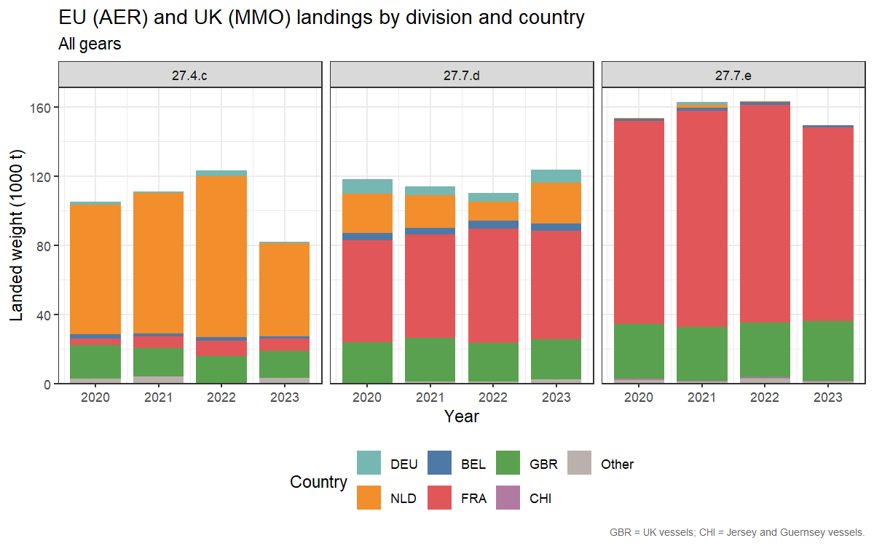
Figure 7: Landed weight (1000 t) by year, division and country, EU (AER) and UK (MMO) combined, all gears (2020–2023).
The species composition of the UK landings is dominated by shellfish (whelk, scallops, cockles and crab) together with horse mackerel, flatfish and cuttlefish. Including the UK therefore shifts the overall species composition of the study area towards shellfish and crustaceans.
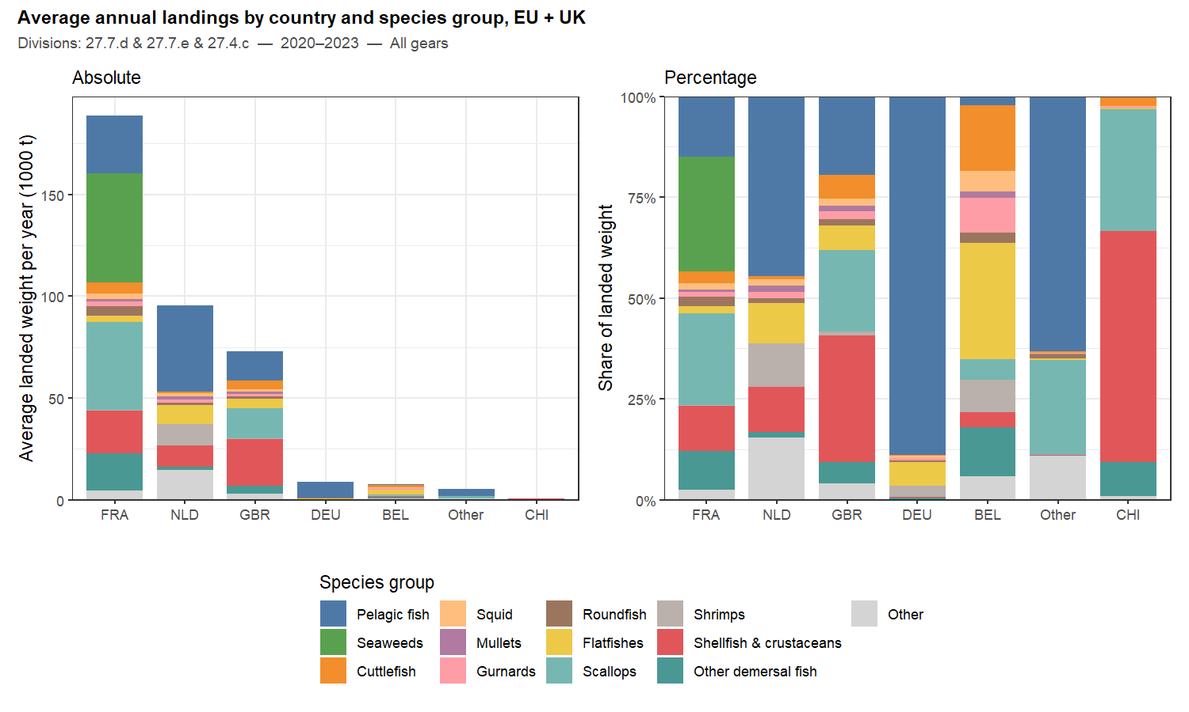
Figure 8: Average annual landed weight by country and species group, EU (AER) and UK (MMO) combined, all gears, ICES 4.c/7.d/7.e (2020–2023). Left: absolute (1000 t); right: percentage per country.
Unlike the AER, the UK data distinguish demersal trawls from demersal seines, so the gear composition of UK landings can be shown directly, without the FDI-based split of Section 4.2.6. The main gears are pots and traps and dredge in the whole study area, and pelagic trawl and demersal seine in 27.7.d and beam trawl in 27.7.e.
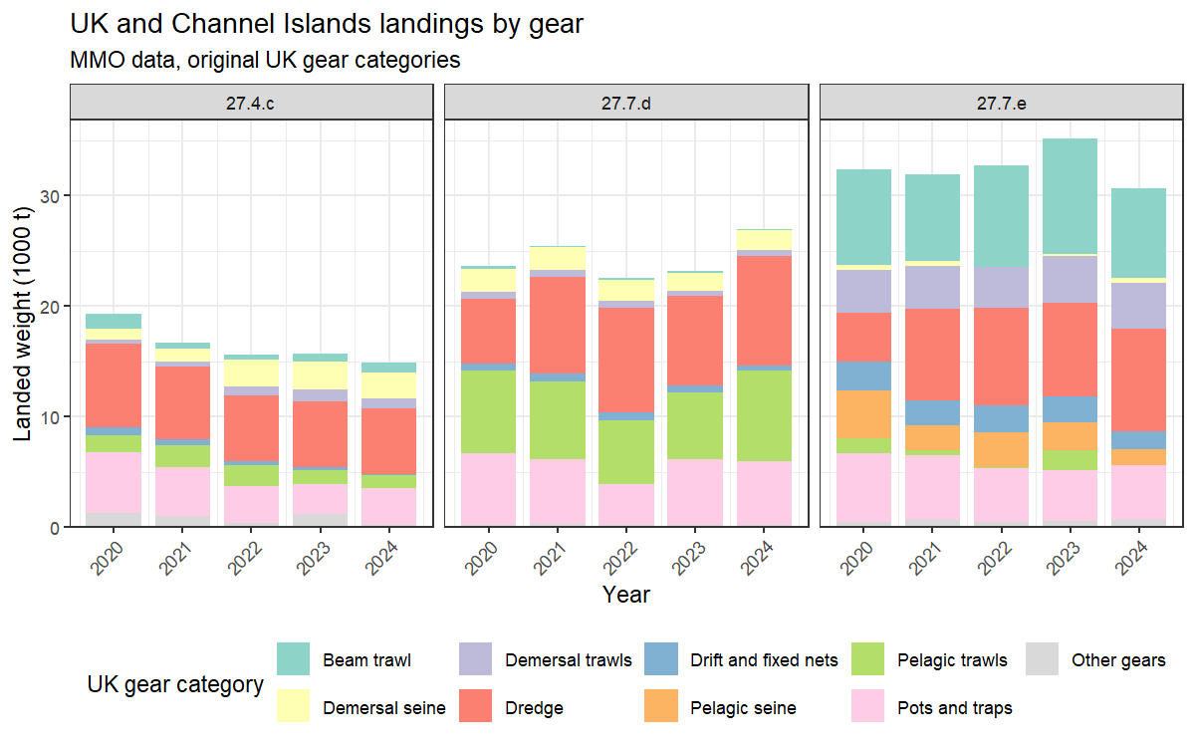
Figure 9: UK and Channel Islands landings (1000 t) by year, division and UK gear category (MMO, 2020–2024).

4.2 Effort trends (STECF AER)

4.2.1 Total fishing days by year and country (all gears)
Total fishing effort in the study area declined from around 235,000 days in 2008 to approximately 160,000 days in 2023, a reduction of roughly 30% over the period. France consistently dominates total effort, accounting for approximately 80% of fishing days throughout the series. The Netherlands is the second largest contributor, with effort relatively stable over the period. Belgian and German effort is small and declining. The overall downward trend is driven primarily by reductions in French effort, with a notable step-down around 2019–2020 that may partly reflect COVID-19 disruption as well as post-Brexit access restrictions in subsequent years.
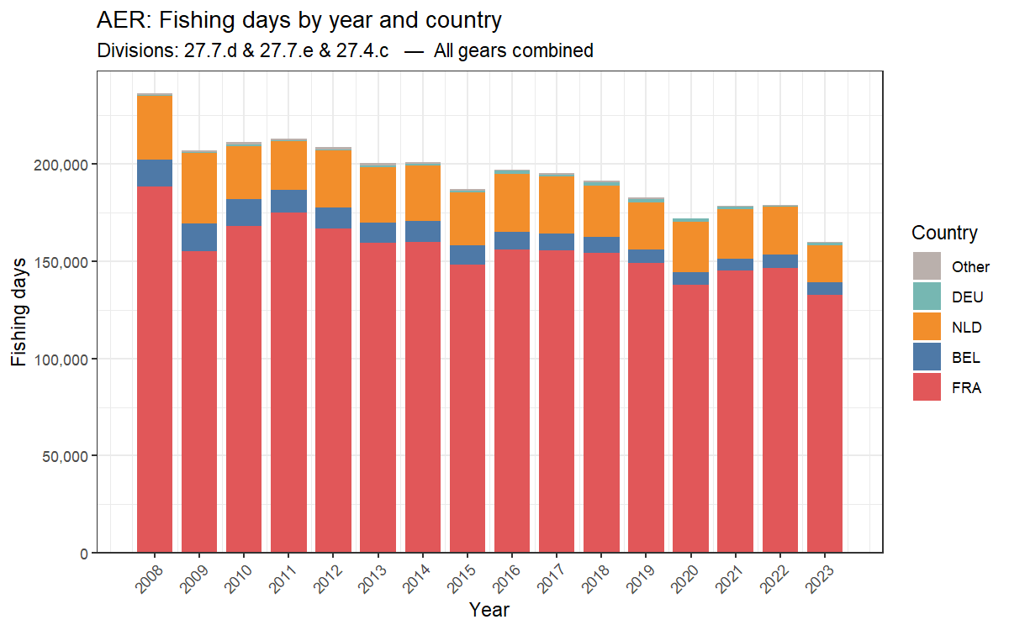
Figure 10: Total fishing days per year by country in ICES 4.c/7.d/7.e, all gears combined (AER, 2008–2023). Source: STECF 25-07.

4.2.2 Total fishing days by year, country and gear category
The breakdown of effort by gear category reveals that the dominant gears in the study area are bottom trawl/seine, dredge, gillnet and pot/trap, with the Other/mixed category contributing a substantial and growing share in 27.7.D (see Section 4.1.3 for further analysis of that category). Bottom trawl/seine effort is predominantly French throughout, with a gradual declining trend. Dredge effort is almost exclusively French, reflecting the scallop fleet operating in 27.7.D and 27.7.E. The Dutch fleet is most visible in beam trawl and, to a lesser extent, Other/mixed. Belgian effort appears primarily in beam trawl and shows the strongest decline of any national fleet over the period.
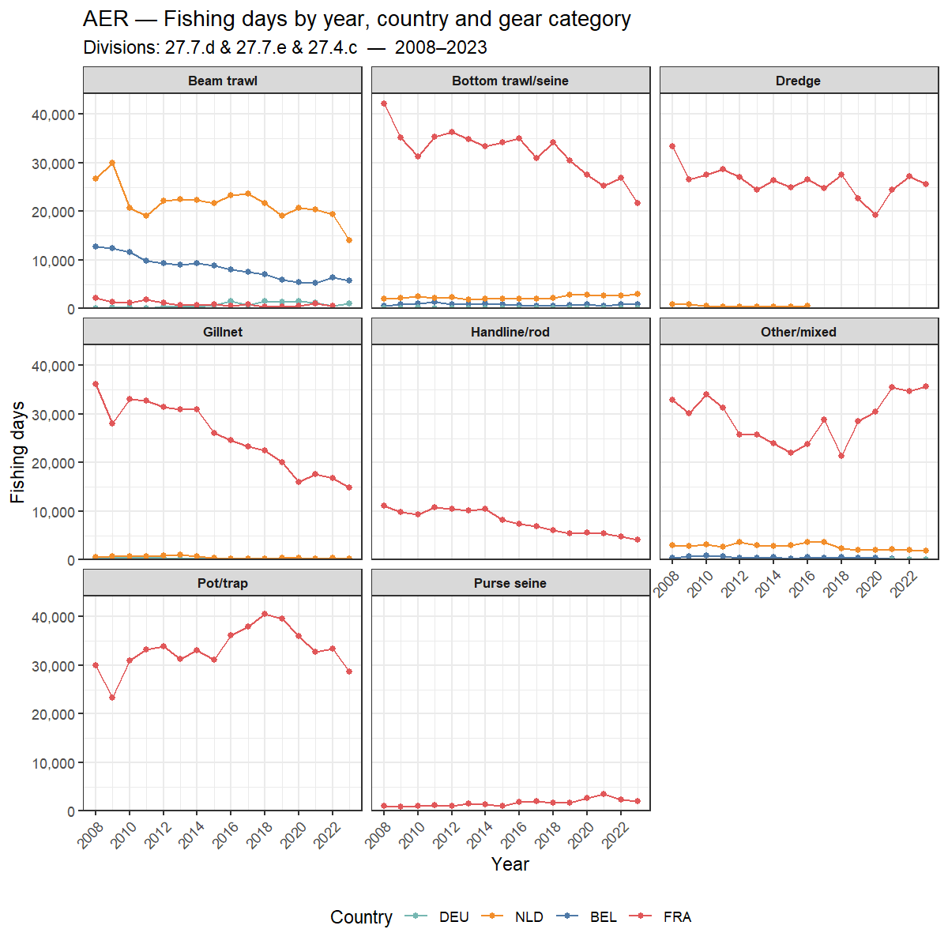
Figure 11: Total fishing days per year by country and gear category in ICES 4.c/7.d/7.e (AER, 2008–2023). Free y-axis per gear category.

4.2.3 Total fishing days by year, country and vessel length class
Fishing effort by vessel length class reveals distinct fleet structures by country. The French fleet (FRA) dominates across the smaller vessel size classes, with the largest absolute number of fishing days in the smaller vessel classes (VL0010–VL1218). This reflects the broad size distribution of the French demersal fleet. French effort shows a gradual declining trend across most size classes over the period. The Dutch fleet (NLD) is concentrated in the medium-to-large vessel classes (VL1824 and VL40XX), consistent with the flyshoot and beam trawl fleet composition, and shows relatively stable effort over time. Belgian effort (BEL) is most visible in the VL1824 class and shows a clear declining trend, consistent with the contraction of the Belgian beam trawl fleet documented in the landings data. German effort (DEU) is negligible across all size classes. Notably, the VL1824 class shows the most multi-country competition for effort, with French, Dutch and Belgian vessels all active in this size range.
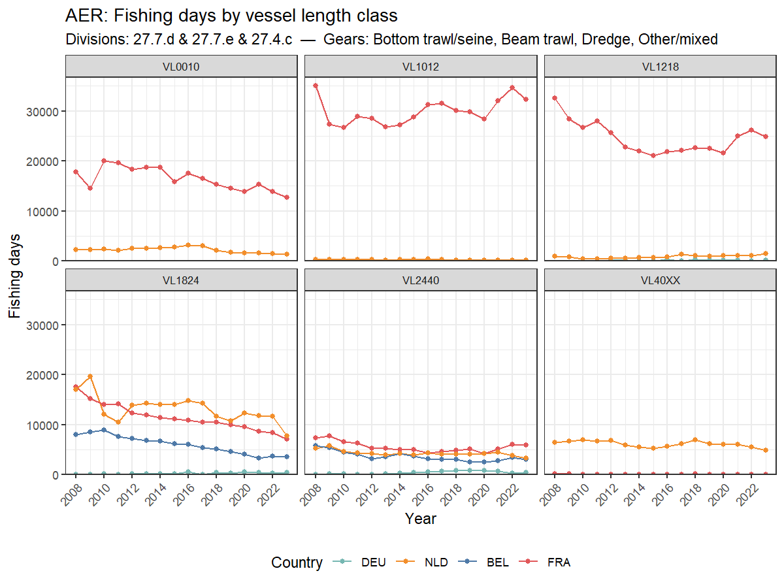
Figure 12: Total fishing days in ICES 4.c/7.d/7.e per year by country and vessel length class for selected gears (Bottom trawl/seine, Beam trawl, Dredge, Other/mixed) (AER, 2008–2023).

4.2.4 Total fishing days by year and vessel size class (selected gears)
Total effort for selected gears declined from around 120,000 days in 2008 to approximately 75,000 days in 2023. The decline is most pronounced in the medium vessel classes (VL1218 and VL1824), which together historically dominated total effort. Smaller vessels (VL0010–VL1012) show greater stability, while the largest vessels (VL2440–VL40XX) contribute relatively little throughout.
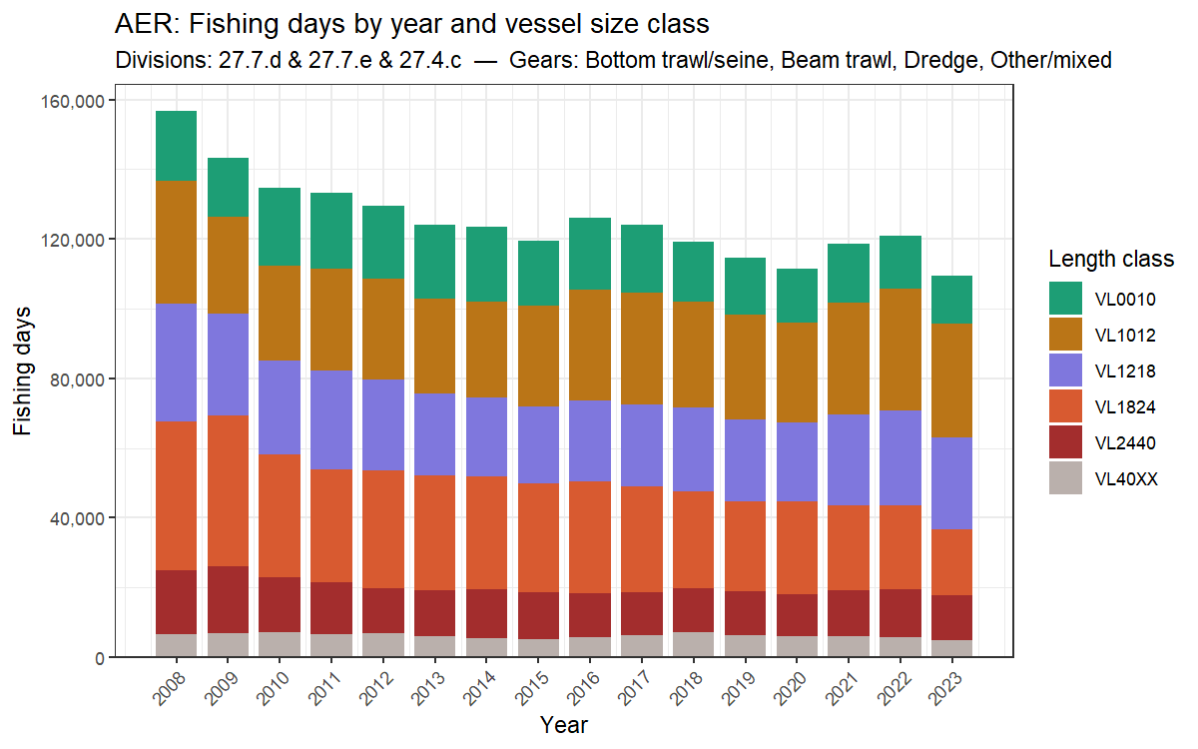
Figure 13: Total fishing days per year by vessel size class in ICES 4.c/7.d/7.e for selected gears (Bottom trawl/seine, Beam trawl, Dredge, Other/mixed) (AER, 2008–2023).

4.2.5 Fishing days by year, country, gear and vessel size
The figure below reveals clear fleet specialisation by gear and vessel size. French vessels dominate bottom trawl/seine effort across all size classes, with a modest declining trend. Dutch effort is concentrated in beam trawl (VL1824 and VL40XX) and shows the strongest decline over the period, consistent with the contraction of the Dutch beam trawl fleet. Belgian effort is similarly concentrated in beam trawl VL1824, also declining markedly. Dredge effort is almost exclusively French across small-to-medium vessel classes (VL1012–VL1218), and relatively stable.
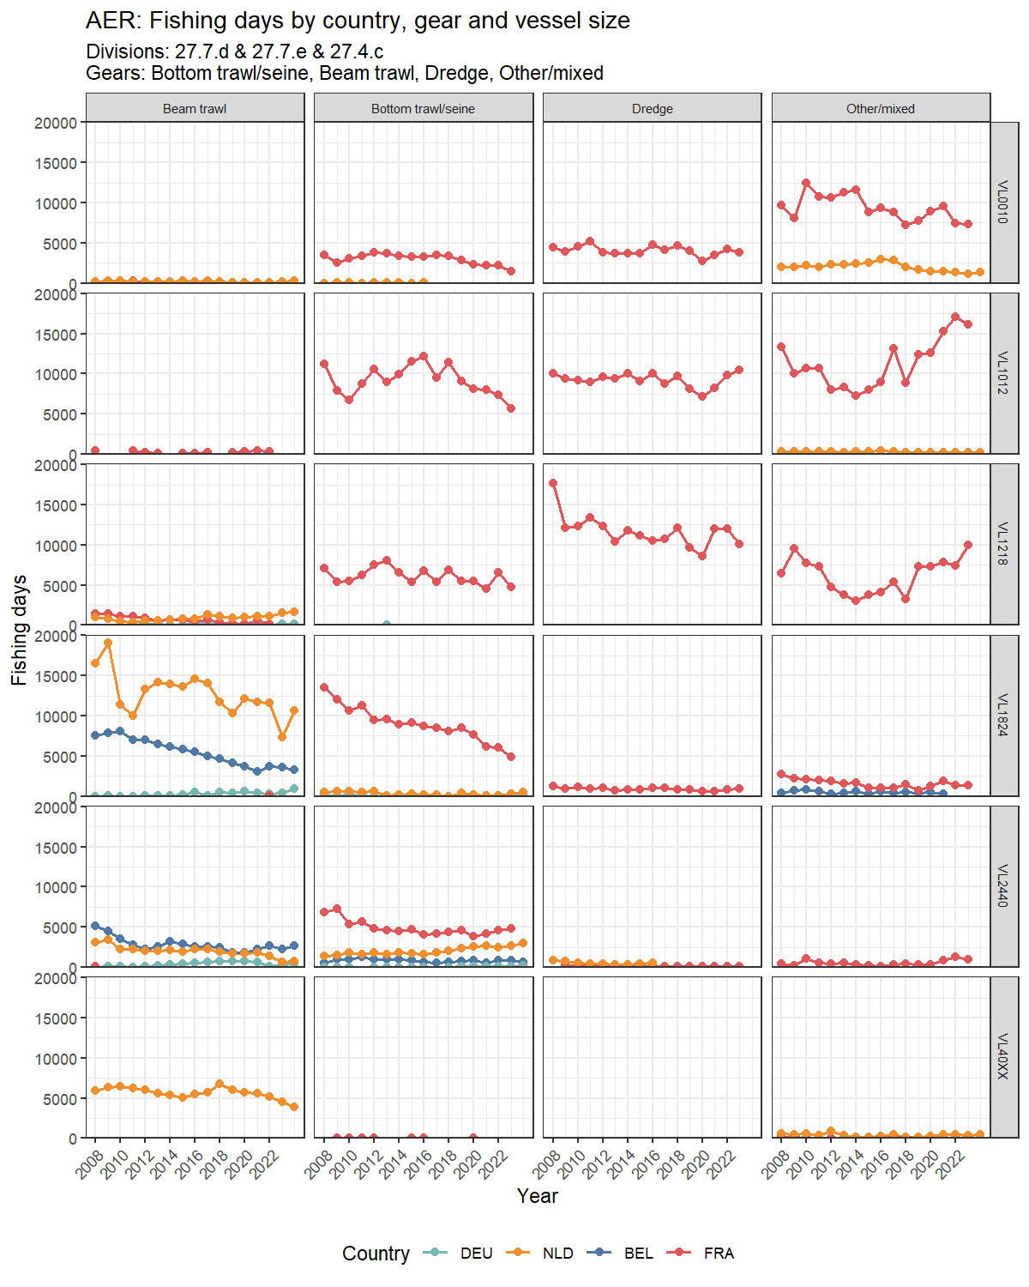
Figure 14: Fishing days by country, gear category and vessel length class for selected gears (AER, 2008–2023). Y-axis free per vessel length row.

4.2.6 Disaggregation of bottom trawl/seine into OTB and SSC/SDN (FDI-derived)
As described in Section 3.4, the AER Bottom trawl/seine category was disaggregated into conventional otter trawl (OTB/OTT/PTB) and seine (SSC/SDN) gears using proportional split keys derived from the STECF FDI Effort data. The left panel shows that the category is heavily dominated by conventional bottom trawl throughout 2013–2023, with overall fishing days declining by over 30% over the period. The right panel shows the gear-type share based on direct FDI splits only: conventional otter trawl (OTB/OTT/PTB) accounts for approximately 85–90% of days, with seine (SSC/SDN) contributing 10–15% and showing a modest upward trend in its share towards the end of the period. The picture varies strongly by country: France is almost exclusively OTB (~96%), while the Netherlands is predominantly seine (SSC/SDN, ~70%), reflecting the Dutch flyshoot fleet composition. Note that BEL and DEU received pooled fallback splits due to sparse FDI coverage and are therefore excluded from the percentage panel.
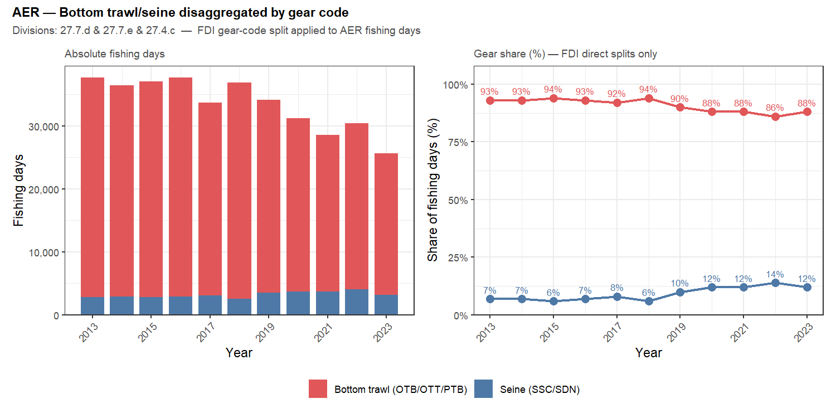
Figure 15: Bottom trawl/seine fishing days disaggregated into conventional otter trawl (OTB/OTT/PTB) and seine (SSC/SDN) using FDI gear-code proportions (AER + FDI, 2013–2023).
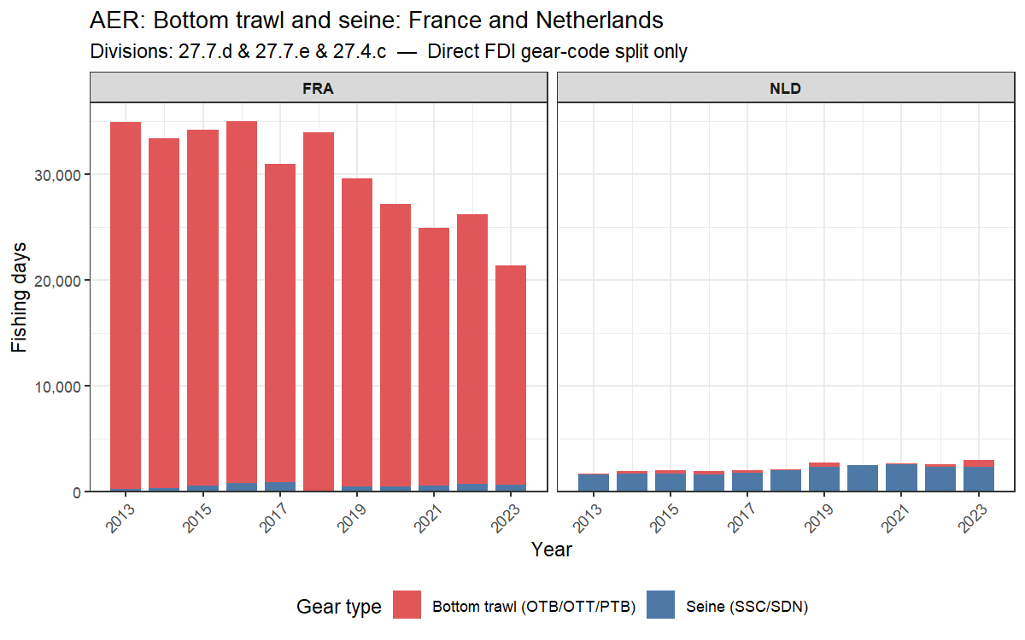
Figure 16: Bottom trawl/seine fishing days disaggregated by gear code for France and the Netherlands (AER + FDI, 2013–2023). Direct FDI gear-code splits only. Shared y-axis.

4.3 Global Fishing Watch (GFW) effort data and comparison with AER

4.3.1 Total GFW fishing days by year and country
GFW-derived fishing effort in the study area shows a clear increasing trend from around 53,000 days in 2013 to approximately 90,000 days in 2024–2025, contrasting with the declining trend seen in the AER data. Unlike the AER-based figures, the GFW series includes the United Kingdom (GBR), which accounts for approximately 25–30% of total effort in the area and is the second largest contributor after the Netherlands. The size class breakdown shows that effort is dominated by small vessels (S1 <100 GT), with a growing contribution from this class driving much of the overall increase. French and Dutch effort appears relatively stable in the GFW series, suggesting the overall increase may partly reflect improving AIS coverage over time rather than a genuine increase in fishing activity.
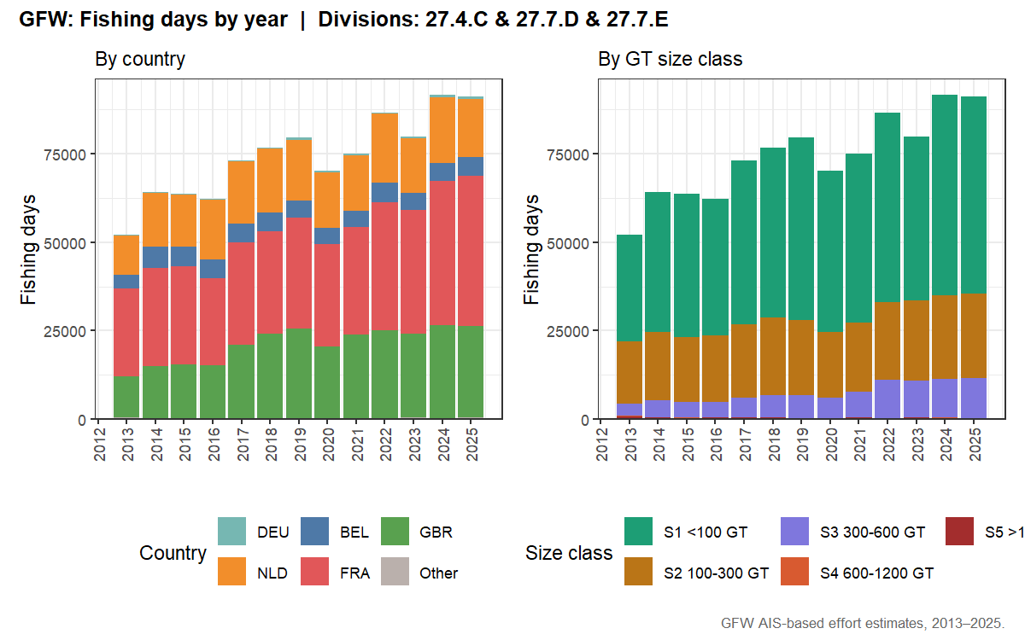
Figure 17: Total GFW fishing days per year by country and vessel size class (all divisions, 2008–2025).

4.3.2 AER vs GFW effort comparison
The two data sources measure effort differently: AER reports administrative fishing days declared by member states; GFW estimates fishing days from AIS vessel-tracking. The comparison below shows total fishing days over the overlapping period 2013–2023. Note that the AER series excludes GBR (post-Brexit data are not consistently included in the STECF AER) while the GFW series includes all five countries.
Several factors can explain systematic differences between the two series:
- Method for counting fishing days: AER records one fishing day as any day on which a vessel is registered as fishing by its country; GFW counts a vessel-day as active when AIS-derived speed and movement patterns are classified as fishing behaviour. The two methods can disagree for the same vessel on the same day.
- AIS coverage and adoption: AIS was gradually mandated across the EU fleet between 2008 and 2014. Early years of the GFW series therefore under-represent vessels that did not yet carry AIS transponders, leading to lower GFW effort estimates before ~2014.
- Small coastal vessels: Vessels below ~15 m LOA are not required to carry AIS in many jurisdictions. This segment is captured in the AER (via logbook reporting) but largely absent from GFW, causing a structural undercount in GFW relative to AER for gears dominated by small vessels (e.g. pot/trap, gillnet).
- Gear type assignment: GFW classifies gear from AIS movement patterns; misclassification can shift effort between gear categories when comparing with AER gear-specific totals.
- Spatial attribution: AER effort is attributed to the ICES division declared in the logbook; GFW effort is attributed to the GPS position of the fishing event. In boundary areas the two can differ.
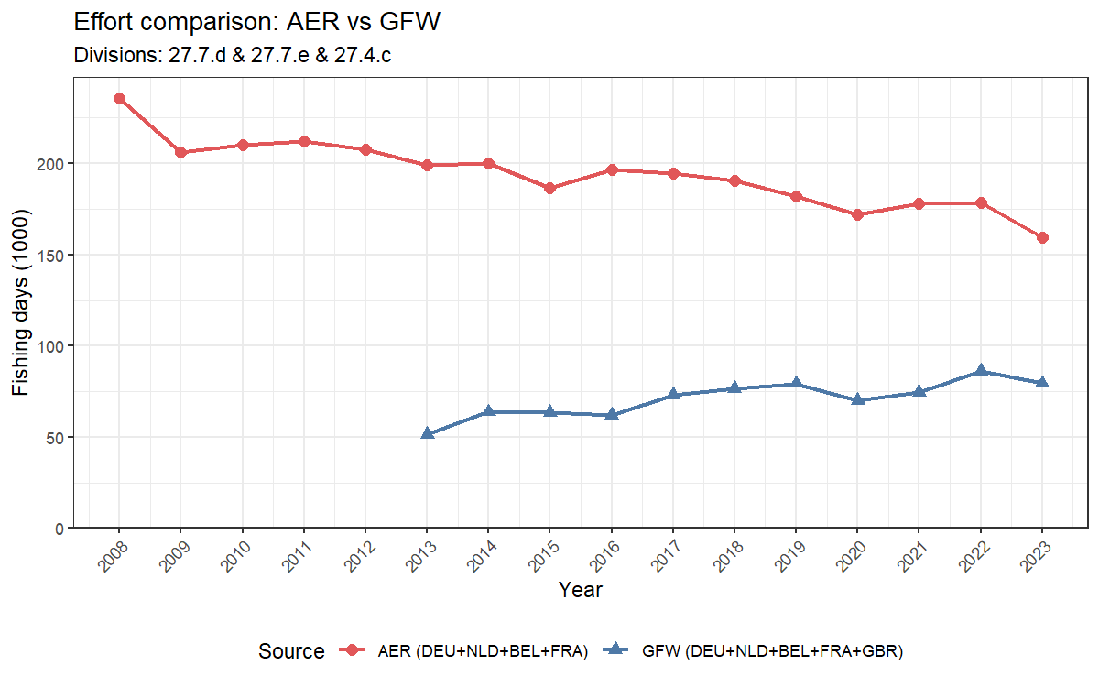
Figure 18: Comparison of total fishing days from AER (DEU+NLD+BEL+FRA) and GFW (DEU+NLD+BEL+FRA+GBR), 2008–2023. ICES 4.c/7.d/7.e.

4.3.3 Spatial distribution of GFW fishing events
The spatial distribution of GFW fishing events reveals clear national zoning patterns across the study area. Dutch (NLD) effort is heavily concentrated in the southern North Sea (27.4.C), particularly around and between the wind farm development zones. French (FRA) effort dominates the eastern and western Channel (27.7.D/E), spread broadly across the division. UK (GBR) effort is distributed throughout the Channel, with particular concentration in 27.7.E. The wind farm areas in 27.4.C appear to constrain fishing to the corridors between developments, potentially contributing to spatial concentration of effort in that division.
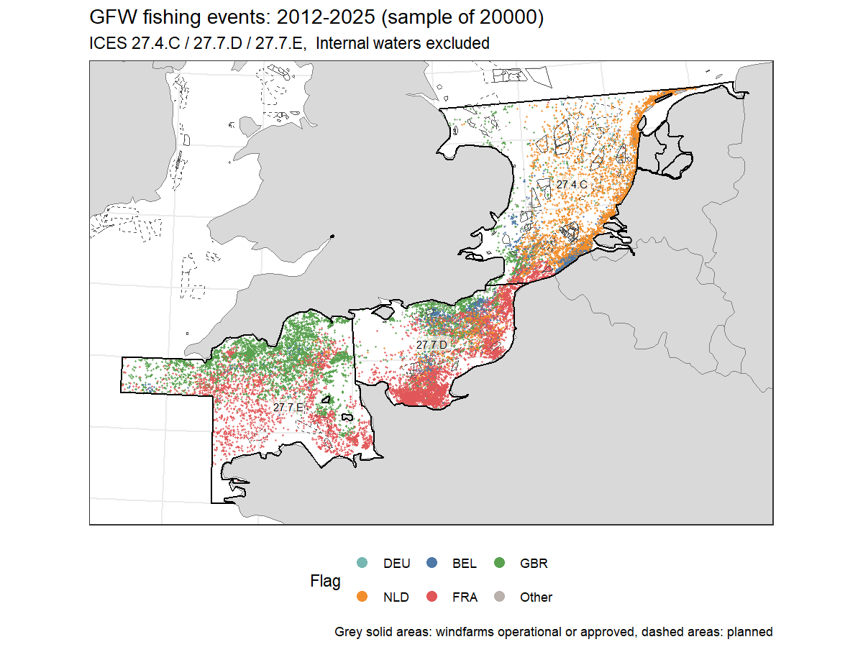
Figure 19: Spatial distribution of GFW fishing events (random sample of 20,000), all years combined, coloured by country. ICES 27.4.C/27.7.D/27.7.E.

4.3.4 Spatial distribution of fishing events by year
The annual maps reveal several notable patterns. Dutch (NLD) effort in 27.4.C shows progressive spatial compression over time, likely reflecting the expanding wind farm footprint pushing vessels into narrower corridors. French (FRA) effort in the Channel remains broadly stable in distribution throughout the series. UK (GBR) effort in 27.7.E appears to decline noticeably after 2020, consistent with post-Brexit fleet restructuring. From 2021 onwards, the spatial separation between national fleets becomes more pronounced, suggesting reduced overlap in fishing grounds following the EU-UK TCA access arrangements.
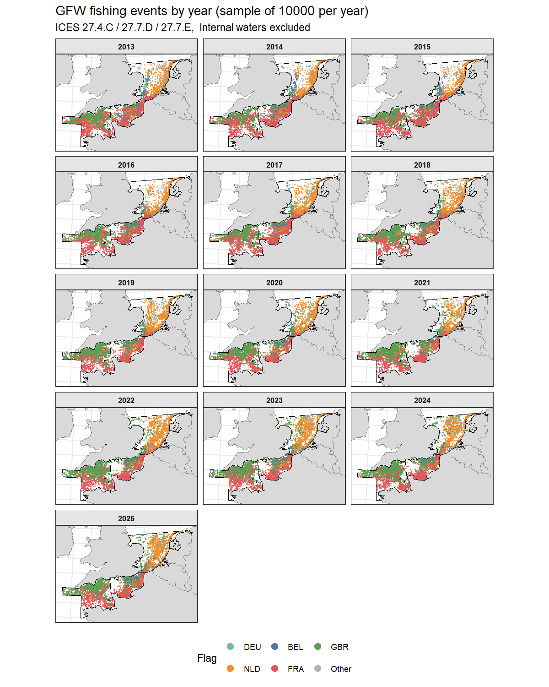
Figure 20: Spatial distribution of GFW fishing events by year (random sample of 10,000 per year), coloured by country. ICES 27.4.C/27.7.D/27.7.E.

4.3.5 Kernel density in the study area
Kernel density estimation (KDE) converts the discrete set of fishing event locations into a continuous surface representing the spatial intensity of fishing effort. For each year, fishing event coordinates are projected into a metric coordinate system (UTM zone 30N) and a Gaussian kernel with bandwidth σ = 20 km is applied within the study area boundary (land excluded). The resulting density surface is normalised within each year to a 0–1 scale, where 1 represents the grid cell with the highest density and 0 the lowest. This within-year normalisation makes annual maps directly comparable in terms of spatial pattern, but means that absolute effort levels cannot be compared between years, a year with low total effort and a year with high total effort will both have cells reaching 1.0. For absolute effort comparisons, refer to Figure 17 and Figure 18.
The KDE maps corroborate and sharpen the patterns visible in the point distribution maps above. The persistent high-density hotspot in the southern North Sea (27.4.C) along the Dutch and Belgian coasts is clearly visible throughout the series, with the peak density area appearing to shift and compress progressively eastward over time, consistent with the displacement effect of expanding wind farm developments. In the Channel, the eastern entrance to 27.7.D around the Pas de Calais consistently shows the highest effort density, reflecting the concentration of French bottom trawl activity in this area. A notable feature emerging from around 2021–2022 is the relative weakening of the 27.7.E density signal, particularly in the northern (UK) portion of the division, reinforcing the post-Brexit reduction in UK fleet activity suggested by the point maps. The KDE representation also makes clear that while the spatial footprint of fishing appears broadly stable across the series, the intensity within hotspot areas has increased relative to background effort levels — a pattern that will be quantified further by the concentration metrics in the following section.
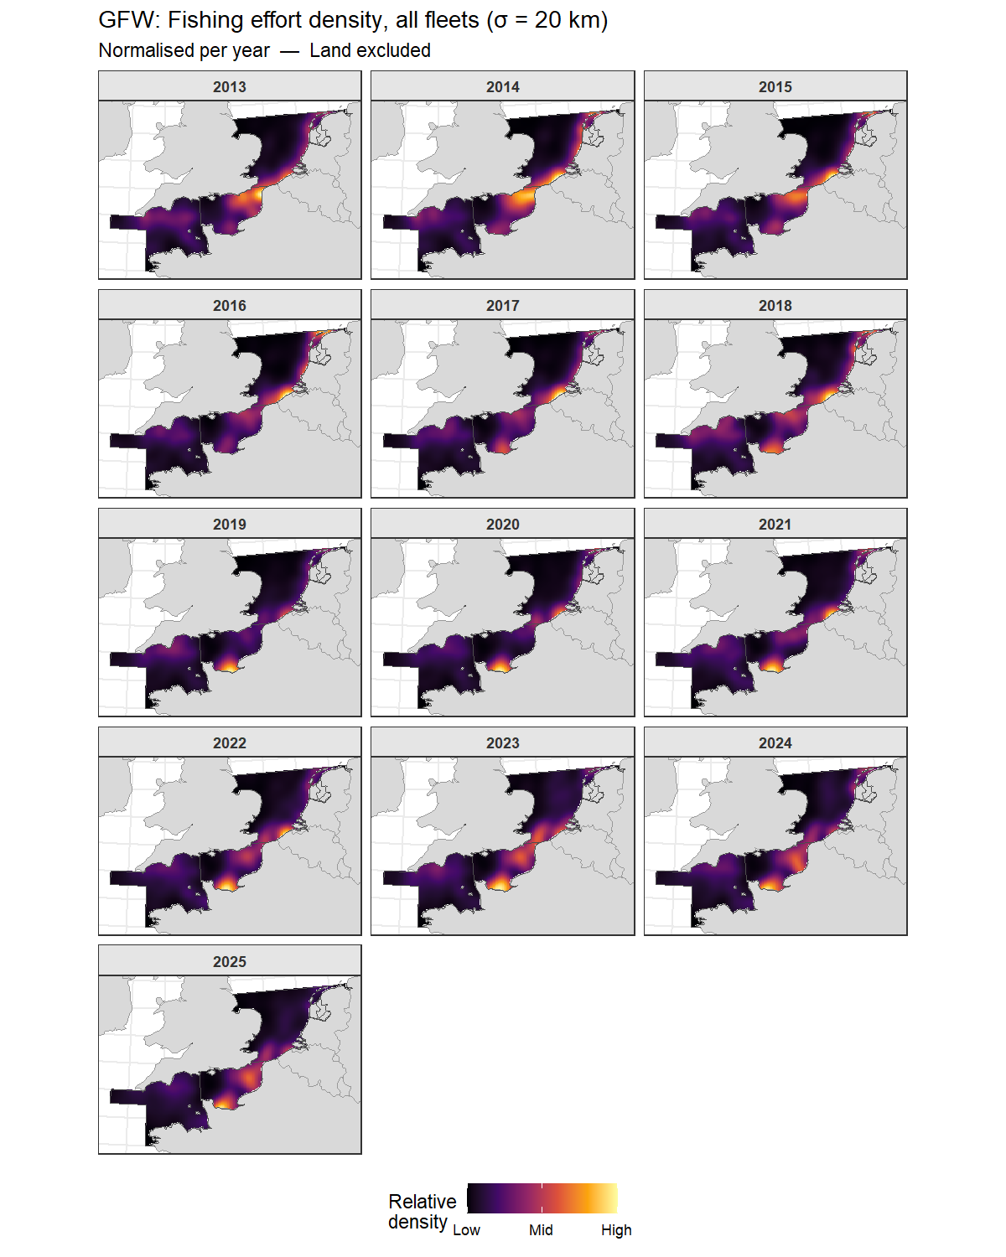
Figure 21: Kernel density of GFW fishing effort for all fleets combined, faceted by year. Bandwidth σ = 20 km. Density normalised within each year (0 = low, 1 = high).

4.3.6 Kernel density in ICES 27.7.D
The eastern Channel (ICES 27.7.D) is the division of primary interest for the flyshoot fishery and is examined in more detail using a finer kernel bandwidth of σ = 10 km, which resolves spatial structure at a scale more appropriate for within-division analysis. The estimation window is restricted to 27.7.D, with internal waters excluded, and the density surface is again normalised within each year to a 0–1 scale to allow direct comparison of spatial patterns across years independently of changes in total effort.
The 27.7.D KDE maps reveal a persistent concentration of effort in the eastern portion of the division, centred on the Pas de Calais and the Baie de Seine. This hotspot is visible throughout the series and reflects the sustained intensity of French OTB activity in these historically important grounds. Effort in the western portion of 27.7.D is consistently lower, with UK effort progressively weakening from around 2021, reinforcing the pattern identified in the full-area maps and the point distribution figures. The finer bandwidth makes the spatial sharpness of the hotspot clearer: rather than a broad gradient of effort, there is a pronounced peak in the east that becomes relatively more dominant over time, consistent with the increasing concentration metrics presented in the following section.
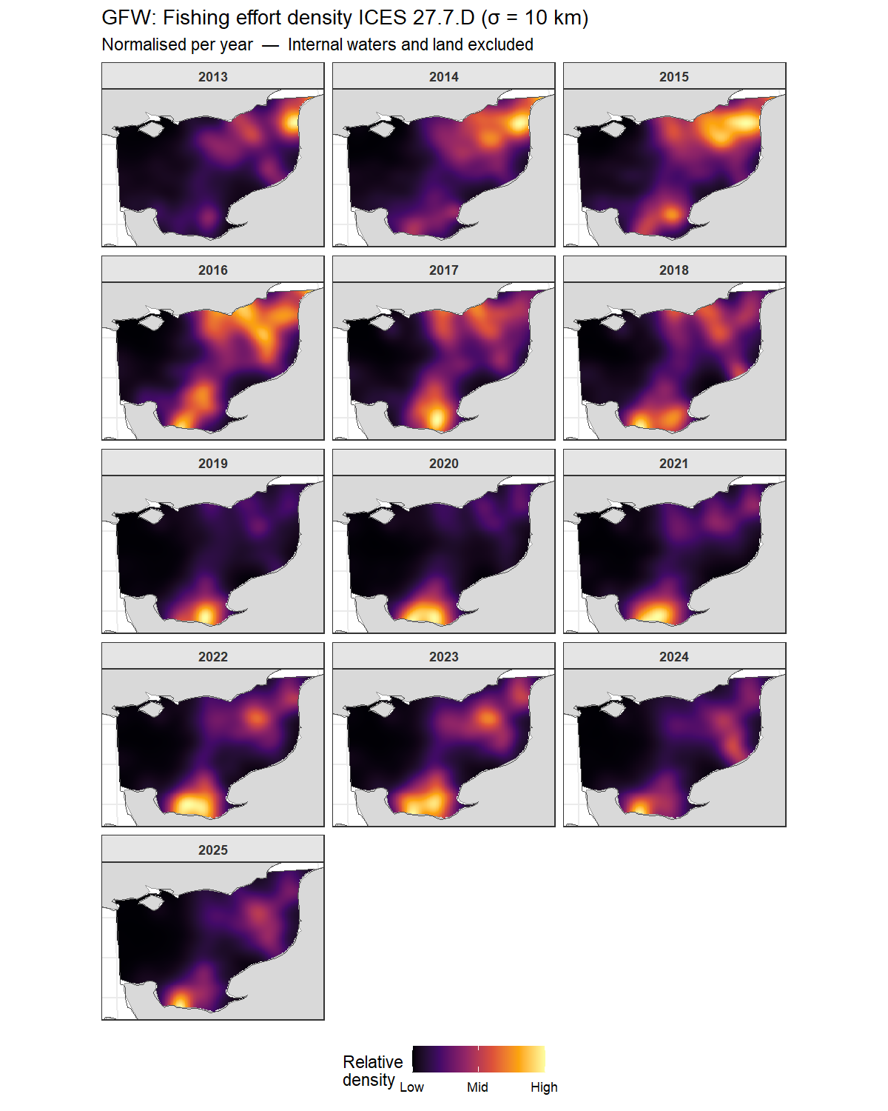
Figure 22: Kernel density of GFW fishing effort in ICES 27.7.D, all fleets combined, faceted by year. Bandwidth σ = 10 km. Density normalised within each year (0 = low, 1 = high). Internal waters excluded.

4.4 GFW effort spatial concentration in 27.7.D: Gini coefficient and top-10% cell share
Two complementary metrics are used to quantify the spatial concentration of fishing effort across the 5 km × 5 km grid cells covering ICES 27.7.D.
The Gini coefficient is a standard inequality measure borrowed from economics, adapted here to quantify the unevenness of effort across grid cells. It ranges from 0 to 1: a value of 0 means fishing effort is spread perfectly uniformly across all cells; a value of 1 means all effort is concentrated in a single cell. In practice, fishing effort is always somewhat concentrated. Values above 0.7 indicate strong spatial concentration in a small number of areas, while values below 0.5 suggest a relatively dispersed fleet. A rising Gini over time indicates that the fleet is progressively concentrating in fewer locations.
The top-10% cell share is a more intuitive companion metric: it asks what percentage of the total annual fishing events falls within the 10% of grid cells that were most intensively fished that year. If effort were uniform, this would be exactly 10%. In practice values of 40–70% are common in concentrated fisheries, meaning that a small fraction of the available sea area absorbs the majority of fishing pressure. Together, the two metrics capture different aspects of spatial concentration: the Gini summarises the full distribution of effort, while the top-10% share focuses specifically on the most intensively exploited areas.
Both metrics indicate a moderate but meaningful increase in spatial concentration of fishing effort in ICES 27.7.D over the study period. The Gini coefficient rose from 0.53–0.57 in 2013–2016 to 0.60–0.66 in 2019–2025, suggesting progressive compression of effort into a smaller number of grid cells. The top-10% cell share tells a similar story: the proportion of total effort in the most-fished 10% of cells increased from around 34–40% in the early period to a peak of 50% in 2020, before partially stabilising at 41–44% in recent years. Together these metrics quantify what the KDE maps suggested qualitatively — that while the broad spatial footprint of fishing in the eastern Channel has remained relatively stable, effort has become increasingly concentrated within already-intensively-fished areas. The peak in concentration around 2019–2020 coincides with a period of significant fleet restructuring driven by post-Brexit access uncertainty and the COVID19 pandemic. The partial relaxation of concentration since 2021 may reflect fleets settling into new access arrangements under the EU-UK TCA, though values remain consistently above the pre-2018 baseline, pointing to a structural rather than purely temporary shift in spatial behaviour.
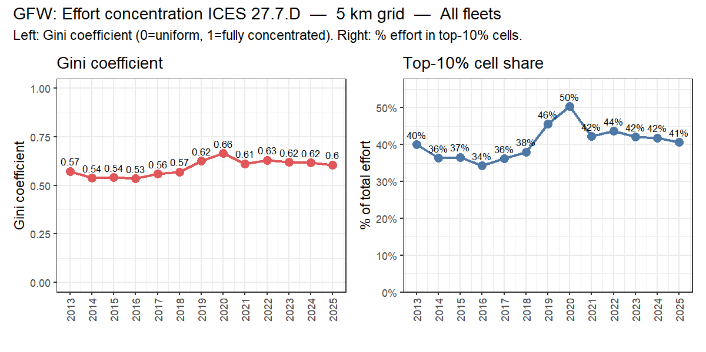
Figure 23: Spatial concentration of fishing effort in ICES 27.7.D: Gini coefficient (left) and percentage of total effort in the top-10% most-fished 5 km grid cells (right), 2008–2025.
The per-country KDE maps for ICES 27.7.D confirm that French effort dominates this division throughout all three periods, accounting for approximately 69–74% of GFW fishing days. The UK fleet contributes around 15–17%, with a modest decline in the most recent period (2022–2025) consistent with post-Brexit access restructuring. Belgian and Dutch effort in 27.7.D is substantially lower in absolute terms — around 6% and 5% respectively — meaning that on the shared colour scale used in the figure, these fleets appear dark not because of absence of fishing activity but because their effort density is an order of magnitude lower than the French fleet. The spatial patterns for the UK fleet show a broad distribution across the western portion of the division, while Dutch effort is more concentrated in the eastern Channel near the Pas de Calais, consistent with the flyshoot operational area documented in Brunel et al. (2025).
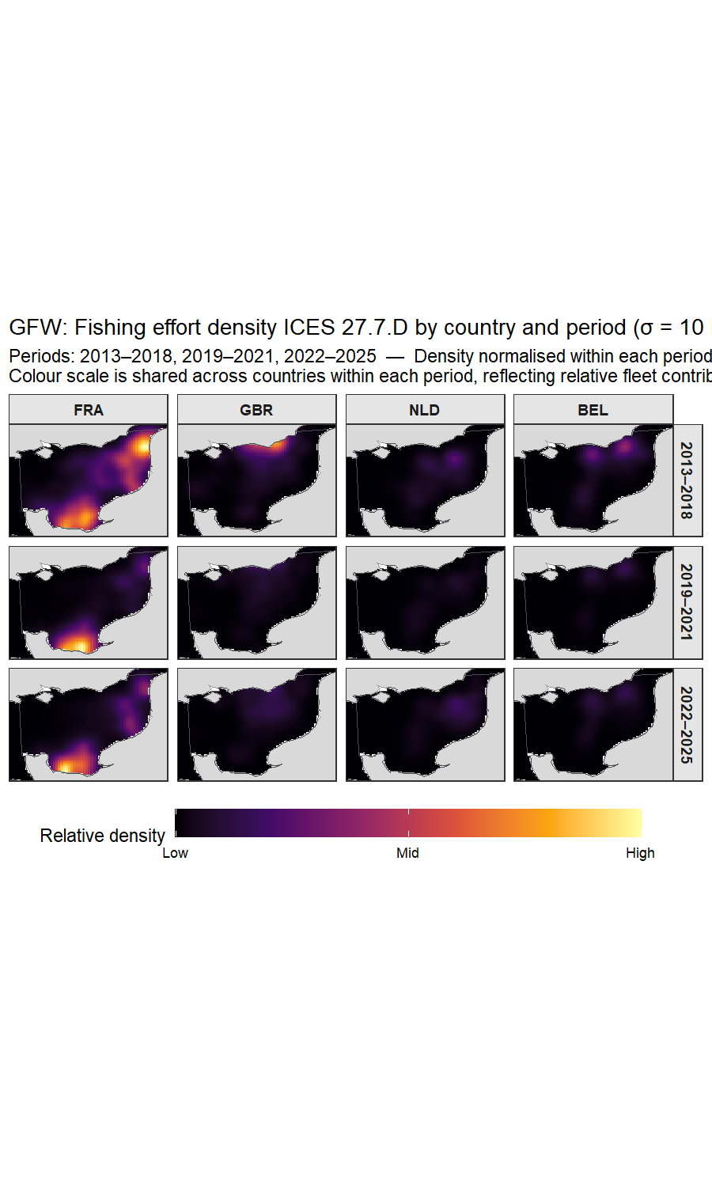
Figure 24: Kernel density of GFW fishing effort in ICES 27.7.D, by country, faceted by period. Bandwidth σ = 10 km. Density normalised within each period (0 = low, 1 = high). Internal waters excluded.

4.5 Channel fisheries context: literature review
This section places the quantitative results from Sections 4.1–4.4 in the broader context of the Channel fisheries literature. It draws on ICES WGCSE, STECF, Ifremer, MMO and peer-reviewed sources (see Section 3.5 for the literature selection approach).

4.5.1 Fleet composition and dominant gear types
The Channel (ICES 27.7.d/e) supports one of the most diverse and intensively fished areas in Europe. The French fleet dominates total effort in the eastern Channel, contributing over 60% of total AER fishing days in most years (ICES, 2025a; Ifremer, 2026), consistent with the AER results in Figure 11, which show France as the largest contributor across all gear categories.. Bottom trawl/seine gears account for the largest share of demersal fishing effort, targeting mixed assemblages of flatfish, cephalopods and small pelagics. The Dutch flyshoot fleet expanded through the 2010s (Quirijns et al., 2020), a trend visible in the AER and GFW series (Figure 16 and Figure 17). Belgian beam trawl effort has declined substantially since the mid-2000s under pressure from fuel costs and quota restrictions (ILVO, 2022), consistent with the low and declining Belgian effort in beam trawl panels throughout the AER figures.
The scallop dredge fishery is concentrated in the Baie de Seine (27.7.d) and western Channel (27.7.e), dominated by the French fleet with seasonal UK participation. Scallop landings from the Baie de Seine reached a record ~48,000 t in 2024–2025 (Ifremer, 2025). MSC certification has been granted for the Baie de Saint-Brieuc fishery (2022) and the Baie de Seine fishery (November 2024), covering the majority of French Channel scallop production (MSC, 2024). The AER landings data (Figure 2, Figures 5–6) confirm scallops as one of the highest-tonnage species in the study area, dominated by the French dredge fleet.
Pot and trap fisheries targeting whelk (Buccinum undatum), crab and lobster are the main UK gear in the study area (MMO 2026). The whelk fishery in 27.7.d has grown substantially since the mid-2010s, driven by Asian export demand (MMO, 2023).

4.5.2 Historical effort trends and structural change
Total fishing effort in the Channel has declined substantially since the early 2000s, consistent with EU fleet capacity reduction programmes and quota restrictions under successive CFP reforms. The AER series (2008–2023) shows a general downward trend in fishing days for bottom trawl/seine and beam trawl across all major countries (Figure 11), with the Dutch flyshoot fleet being an important exception showing growth through the 2010s before stabilising post-2020. This is consistent with Quirijns et al. (2020) and STECF (2024).
Post-Brexit disruption from 2021 onwards has reshaped fleet access in the eastern Channel. UK licensing restrictions have reduced French, Belgian and Dutch access to UK waters in 27.7.d/e, driving spatial redistribution towards French EEZ waters (Phillipson & Symes, 2018; House of Lords, 2022). This structural shift may contribute to the apparent changes in spatial effort patterns visible in the GFW KDE maps ((Figures 21–22) around 2021–2022, with effort concentrating in the southern (French EEZ) portion of 27.7.d. Post-Brexit bilateral agreements and access negotiations between the EU member states and the UK continue to shape fleet access patterns in the Channel.
The GFW spatial concentration metrics (Figure 23) quantify whether this redistribution has led to more or less concentrated effort patterns over time. An increase in Gini coefficient and top-10% share after 2021 is consistent with effort being pushed into a narrower range of spatial locations following access restrictions.

4.5.3 Stock status of key target species
Table 4 summarises the assessment and advice status for the principal commercial stocks in the study area. Stocks are grouped by the ICES working group responsible for their assessment. Note that several species caught in the Channel, particularly cephalopods, do not have formal ICES assessments or TAC-based management; these are indicated accordingly.
Table 4: Principal commercial stocks in ICES 27.4.c/27.7.d/27.7.e: responsible ICES working group, assessment type, F/SSB status relative to reference points, TAC status and key notes. F~MSY~ = fishing mortality at maximum sustainable yield; B~pa~ = precautionary biomass reference point; WG = working group. Status characterisations based on most recent available ICES advice (2025 cycle).
Species | Common name | Stock/area | ICES WG | Assessment type | F vs FMSY | SSB vs Bpa | TAC | Notes
Solea solea | Common sole | 27.7.e | WGCSE | Analytical | F < FMSY | SSB > Bpa | Yes | Stock well above MSY Btrigger (ICES, 2025a)
Solea solea | Common sole | 27.7.d | WGCSE | Analytical | F > FMSY | SSB < Bpa | Yes | Declining; below safe limits (ICES, 2025a)
Solea solea | Common sole | 27.4.c | WGNSSK | Analytical | F > FMSY | SSB < Bpa | Yes | Part of NS sole stock (ICES, 2025c)
Pleuronectes platessa | European plaice | 27.7.e | WGCSE | Biomass index only |  |  | Yes | Harvest rate declining (ICES, 2025a)
Pleuronectes platessa | European plaice | 27.7.d | WGCSE | Analytical | F > FMSY | SSB < Bpa | Yes | Stock below Blim (ICES, 2025a)
Pleuronectes platessa | European plaice | 27.4.c | WGNSSK | Analytical | F < FMSY | SSB > Bpa | Yes | Part of NS plaice stock that is well above Bpa (ICES, 2025c)
Lepidorhombus spp. | Megrim | 27.7.d/e | WGCSE | Analytical | F < FMSY | SSB > Bpa | Yes | Part of larger Bay of Biscay and Celtic Sea stock (ICES, 2025a)
Merlangius merlangus | Whiting | 27.7.e | WGCSE | Analytical | F > FMSY | SSB << Blim | Yes | Zero catch advice (ICES, 2025a)
Merlangius merlangus | Whiting | 27.7.d/27.4.c | WGNSSK | Analytical | F << FMSY | SSB >> Bpa | Yes | Part of North Sea stock (ICES, 2025a)
Lophius spp. | Monkfish | 27.7.d/e | WGCSE | Analytical | F < FMSY | SSB > Bpa | Yes | Part of larger stock area. Stock increasing (ICES, 2025a)
Dicentrarchus labrax | Sea bass | 27.4.c, 27.7.d/e | WGCSE | Analytical | F < Fmsy | SSB > Bpa | Yes | Part of larger stock. Stock is increasing (ICES, 2025a)
Trachurus trachurus | Horse mackerel | 27.4.c, 27.7.d | WGWIDE | Analytical | - | SSB << Blim | Yes | Part of larger North Sea stock. Zero catch advice (ICES, 2025e)
Trachurus trachurus | Horse mackerel | 27.7.e | WGWIDE | Analytical | F < Fmsy | SSB ~ Bpa | Yes | Part of larger Western stock (ICES, 2025e)
Scomber scombrus | Atlantic mackerel | NE Atlantic | WGWIDE | Analytical | F > FMSY | SSB ~ Blim | Yes | Disputed; quota conflict EU/UK/NO/IS (ICES, 2025e)
Pecten maximus | King scallop | 27.7.d Baie de Seine | Ifremer | Biomass survey | - | Recovering | No | Record 2025-25 season; MSC certified Nov 2025
Pecten maximus | King scallop | 27.7.e western | MMO/Cefas | Biomass survey | - | Declining | No | UK MMO concern; closures possible 2026-27
Sepia officinalis | Common cuttlefish | 27.7.d/e, 27.4.c | WGCEPH | Biomass survey | - | Increasing | No | High interannual variability (ICES, 2025d)
Loligo vulgaris | European squid | 27.7.d/e | WGCEPH | Biomass survey | - | Increasing | No | No formal assessment (ICES, 2025d)
Chelidonichthys spp. | Gurnards | Channel/NS | None | Not assessed | - | - | No | Bycatch species; no TAC
Buccinum undatum | Common whelk | 27.7.d/e | None | Not assessed | - | - | No | UK export fishery; no ICES assessment
Mullus surmuletus | Striped red mullet | 27.4.c, 27.7.d/e | WGNSSK | Biomass index | - | Increasing | No | Limited assessment capacity (ICES, 2025a)

4.5.4 Ecosystem effects and sustainability
The seabed disturbance footprint of the Channel fisheries has been extensively studied. Eigaard et al. (2017) quantified the swept-area ratio across European shelf fisheries and identified the Channel as one of the most intensively bottom-trawled areas in European waters, with beam trawl having the highest physical impact per unit effort. Comparisons between gear types consistently show that Danish seine (flyshoot) has a substantially lower seabed disturbance footprint than comparable otter trawls or beam trawls, primarily because it does not drag heavy groundgear across the seabed in the same manner (Depestele et al., 2016; Hiddink et al., 2017).
Bycatch and discards in the Channel mixed fisheries remain a management concern under the EU landing obligation (in force since 2019), though exemptions for high-survival species and de minimis provisions have reduced the practical scope of the obligation for many fleets (ICES WGCSE, 2025a). The flyshoot fishery is generally considered to have moderate bycatch rates compared to other demersal gears, though species composition of the bycatch varies considerably with area and season (Quirijns et al., 2020).

5. Discussion & Synthesis

5.1 Effort trends and fleet position
Total fishing effort in the Channel (ICES 27.4.c/27.7.d/27.7.e) has declined substantially over the 2008–2023 period covered by the AER series, with a reduction of approximately 30% across all gears and countries combined. This decline is consistent with the long-term trend of EU fleet capacity reduction under successive CFP reform cycles, and with the structural contraction of the Belgian and Dutch beam trawl segments visible in both landings and effort data. France dominates the total effort picture throughout, contributing around 80% of fishing days, and its otter trawl (OTB) fleet in the eastern Channel shows a steady but gradual decline over the period. Landings of key species have also declined: flatfish landings fell by over 60% since 2008, consistent with poor stock status for Channel sole and plaice, while scallop landings increased markedly since 2016. The FDI-based gear disaggregation, which is only available from 2013 onwards, shows that within the declining bottom trawl/seine category the gear composition has remained broadly stable over the 2013–2023 sub-period.
The Dutch flyshoot (SSC/SDN) fleet presents a contrasting trajectory: although small in absolute days relative to the French OTB fleet, it has been relatively stable and seine-dominated, with the FDI gear split confirming that roughly 70% of Dutch bottom trawl/seine days in the Channel are attributable to seine gears. This fleet segment is small in AER terms but disproportionately visible in the GFW spatial data because of the high AIS coverage on the larger vessel segments.
Post-Brexit restructuring from 2021 onwards has had a measurable effect on spatial distribution. The GFW annual maps show a progressive reduction in UK effort in 27.7.e and a sharpening of national spatial separation from 2021, consistent with altered access conditions under the Trade and Cooperation Agreement (European Commission, 2021). The Dutch fleet in 27.4.C shows spatial compression that could at least partly be attributable to the ongoing expansion of offshore wind farm development zones, which are progressively reducing the navigable fishing area available to trawling and seine vessels (Quirijns et al., 2020).

5.2 Contribution of the UK fleet
The MMO data show that the UK and Channel Islands fleets are a substantial user of the study area, accounting for around 19% of total landings over 2020–2023. Their fishery profile differs clearly from that of the EU fleets: UK landings are dominated by shellfish taken with pots and traps and dredges, whereas EU landings are dominated by pelagic fish, seaweeds, flatfish and scallops. An analysis based on the AER alone therefore not only underestimates total landings, but also gives a biased picture of the species and gear composition of the fisheries in the study area. The UK data also show substantial demersal seine (flyshot) landings in 27.7.d.
No UK effort data were available, so the relative fishing pressure of UK vessels cannot be expressed in fishing days. The GFW data suggest that UK vessels account for roughly 25–30% of AIS-derived fishing days, which is of the same order as their share of landings.

5.3 Comparison of AER and GFW effort metrics
The AER and GFW series measure effort using fundamentally different methodologies: administrative logbook declarations versus AIS-derived vessel-day estimates. Therefore, they are not directly comparable in absolute terms. The GFW series shows an increasing trend from 53,000 to 90,000 days over 2013–2025, while the AER shows a declining trend over 2013–2023. These opposing directions are reconciled by three structural factors: 1) improving AIS coverage over the early years of the GFW series inflates apparent growth; 2) GFW includes the UK effort (contributing ~25–30% of total days); and 3) GFW captures large vessels with high AIS compliance most accurately, while the AER captures the full administrative fleet including small inshore vessels below the AIS carriage threshold.
The most useful role of the GFW data in this report is therefore not as an independent cross-check of absolute effort levels, but as a source of spatial resolution unavailable from the AER. The within-division distribution of effort, the identification of national fishing grounds, and the detection of temporal shifts in spatial patterns can be based on GFW data. Used in this complementary way, the two sources are mutually reinforcing: the AER provides the authoritative time series of effort and landings by fleet segment, while GFW provides the spatial context that the AER cannot. The FDI was retained for the methodologically important role of gear-code disaggregation of the AER bottom trawl/seine category, but its quality limitations (confidentiality suppression, EU-aggregated landings) precluded its use as a primary effort or landings source (STECF, 2025b).

5.4 Compliance with management measures and bilateral agreements
Direct assessment of compliance with effort and gear management measures is beyond the scope of this report, which relies on aggregated AER and GFW data rather than vessel-level logbook or VMS records. However, the data presented allow some observations relevant to the monitoring context. The GFW spatial concentration metrics in 27.7.D show a step increase in Gini coefficient and top-10% cell share from 2018–2020 onwards, which coincides with the period of increasing negotiation pressure around Brexit access arrangements. This pattern is consistent with a progressive restriction of vessel access to previously used grounds, whether through formal licensing or informal avoidance. The partial reduction in concentration since 2022 may reflect stabilisation of access arrangements under the TCA, though concentration remains structurally elevated above pre-2018 levels.
The FDI gear split confirms that the Dutch fleet’s contribution to bottom trawl/seine effort in the Channel is predominantly seine (flyshoot), providing a quantitative baseline against which future changes in gear composition — for example in response to gear specifications in bilateral agreements — could be assessed. Across all fleets, conventional bottom trawl (OTB/OTT/PTB) accounts for approximately 57% of bottom trawl/seine fishing days, with seine (SSC/SDN) accounting for around 10%, reflecting the much larger scale of the French OTB fleet relative to the Dutch seine fleet. More granular vessel-level monitoring would be required to assess day-level compliance with any sea-day limits. The AER and GFW data presented here operate at fleet-segment and annual resolution and are best suited to detecting structural trends rather than real-time compliance monitoring.

6. Conclusions & Recommendations

6.1 Conclusions
This report has characterised fishing effort, landings and spatial distribution in the English Channel and southern North Sea (ICES 27.4.c/27.7.d/27.7.e) over the period 2008–2023 (AER), 2013–2023 (FDI), 2020–2024 (UK landings, MMO) and 2013–2025 (GFW), integrating four complementary data sources.
Total fishing effort has declined by approximately 30% since 2008, driven primarily by contraction of French otter trawl and Belgian and Dutch beam trawl effort. France dominates total effort throughout, contributing around 80% of AER fishing days. The Dutch flyshoot fleet, while small in absolute days, is the dominant seine fleet in the area and has remained relatively stable. he effort trends refer to EU fleets only, as no UK effort data were available.
Landings are dominated by flatfishes, scallops and shrimps; flatfish landings have declined markedly, consistent with the deteriorating stock status of Channel sole and plaice (ICES, 2025a; ICES, 2025b). Scallop landings show an increasing trend since 2016, supported by record biomass in the Baie de Seine (Varenne & Foucher, 2025). UK and Channel Islands vessels accounted for around 19% of total landings in the study area over 2020–2023, with a fishery profile centred on shellfish (whelk, scallops, cockles and crab) taken by pots and traps and dredges. Including the UK increases total landings by roughly a 20% relative to the AER and shifts the overall species composition towards shellfish and crustaceans.
GFW spatial analysis reveals persistent fishing hotspots in the Pas de Calais and Baie de Seine, with Dutch effort in 27.4.C showing progressive spatial compression likely linked to wind farm expansion. Post-Brexit spatial restructuring is visible from 2021, with declining UK effort in 27.7.e and increased spatial separation between national fleets. Spatial concentration in 27.7.D — as measured by the Gini coefficient and top-10% cell share — has increased from a pre-2018 baseline and remains elevated, pointing to a structural rather than temporary shift in spatial behaviour.
The FDI-based gear-code disaggregation shows that across all fleets, conventional bottom trawl (OTB/OTT/PTB) accounts for approximately 57% of bottom trawl/seine fishing days in the study area, with seine gears (SSC/SDN, predominantly Dutch) accounting for around 10%. The Dutch fleet is distinct in being predominantly seine-dominated (~70% of Dutch bottom trawl/seine days), while the French fleet is almost entirely OTB (~96%). This baseline characterisation provides the quantitative foundation against which future fleet developments and the effects of access agreements can be assessed.

6.2 Recommendations
- Obtain UK effort data. The most important gap in this analysis is the absence of UK fishing effort. UK effort data (fishing days, days at sea and kW-days by year, division, gear and vessel length, 2008–2025) should be requested from the MMO, so that the UK fleet can be included in the effort trends and the pre-Brexit period can be covered.
- Improve the gear split between otter trawl and seine. The FDI-based split is limited by confidentiality suppression. Unsuppressed FDI data, or national logbook data by gear code, should be requested from the relevant Member States (in particular France and the Netherlands) to make the split of the AER bottom trawl/seine category more robust.
- Update the series when new data become available. The AER series should be extended to 2024 once French data are published, and the UK series once the MMO publishes 2025 data.
- Verify data anomalies. The anomalous Dutch pelagic landings attributed to 27.4.c in 2012 should be verified with STECF and the national data provider.

7. References
Depestele, J., Ivanović, A., Degrendele, K., Esmaeili, M., Polet, H., Roche, M., … & Zenone, A. (2016). Measuring and assessing the physical impact of beam trawling. ICES Journal of Marine Science, 73(Suppl 1), i15–i26. https://doi.org/10.1093/icesjms/fsv056
Eigaard, O. R., Bastardie, F., Hintzen, N. T., Buhl-Mortensen, L., Buhl-Mortensen, P., Catarino, R., … & Rijnsdorp, A. D. (2017). The footprint of bottom trawling in European waters: distribution, intensity, and seabed integrity. ICES Journal of Marine Science, 74(3), 847–865. https://doi.org/10.1093/icesjms/fsw194
European Commission (2021). Trade and Cooperation Agreement between the European Union and the European Atomic Energy Community, of the one part, and the United Kingdom of Great Britain and Northern Ireland, of the other part. Official Journal of the European Union L 149, 30 April 2021, p. 10. https://eur-lex.europa.eu/legal-content/EN/TXT/?uri=CELEX:22021A0430(01)
Gerritsen, H. & Lordan, C. (2011). Integrating vessel monitoring systems (VMS) data with daily catch data from logbooks to explore the spatial distribution of catch and effort at high resolution. ICES Journal of Marine Science, 68(1), 245–252. https://doi.org/10.1093/icesjms/fsq137
Greenstreet, S. P. R., Fraser, H. M. & Piet, G. J. (2009). Using MPAs to address regional-scale ecological objectives in the North Sea: modelling the effects of fishing effort displacement. ICES Journal of Marine Science, 66(1), 90–100. https://doi.org/10.1093/icesjms/fsn172
Hiddink, J. G., Jennings, S., Sciberras, M., Szostek, C. L., Hughes, K. M., Ellis, N., … & Kaiser, M. J. (2017). Global analysis of depletion and recovery of seabed biota after bottom trawling disturbance. Proceedings of the National Academy of Sciences, 114(31), 8301–8306. https://doi.org/10.1073/pnas.1618858114
Hintzen, N. T., K. Brigden, H. J. Kaasstra, S. Mackinson, M. A. Pastoors and L. van de Pol (2025). Bias in Global Fishing Watch AIS data analyses results in overestimate of pelagic fishing impact. ICES Journal of Marine Science 82(3).
House of Lords Environment and Climate Change Committee (2022). Post-Brexit fishing: the sea of opportunity that wasn’t. 3rd Report of Session 2022–23, HL Paper 146. House of Lords. https://committees.parliament.uk/work/1483/post-brexit-fishing/
ICES (2024a). Report of the Working Group on Celtic Seas Ecoregion (WGCSE). ICES Scientific Reports. https://doi.org/10.17895/ices.pub.29401877
ICES (2025b). ICES Advice 2025. https://doi.org/10.17895/ices.pub.c.7488219.v86
ICES (2025c). Working Group on the Assessment of Demersal Stocks in the North Sea and Skagerrak (WGNSSK). ICES Scientific Reports. Report. https://doi.org/10.17895/ices.pub.29085995.v4
ICES (2025d). Working Group on Cephalopod Fisheries and Life History (WGCEPH; outputs from 2024 meeting). ICES Scientific Reports. Report. https://doi.org/10.17895/ices.pub.29390171.v2
ICES (2025e). Working Group on Widely Distributed Stocks (WGWIDE). ICES Scientific Reports. https://doi.org/10.17895/ices.pub.30233824.v3
Ifremer (2026). Bilan 2025 du statut des ressources halieutiques débarquées par la pêche française en 2024 – Hexagone et Outre-mer. Ifremer, Brest. https://archimer.ifremer.fr/doc/01012/112398/126792.pdf
Varenne, F. & Foucher, E. (2025). Rapport technique de fin de campagne COMOR 2025. Ref. RST RBE/HMMN/LRHPEB/25-02. Ifremer. https://doi.org/10.13155/108325
Departement Landbouw en Visserij (2022). Visserijrapport 2022 (VIRA). Vlaams Gewest, Brussel. https://landbouwcijfers.vlaanderen.be/visserij
Kroodsma, D. A., Mayorga, J., Hochberg, T., Miller, N. A., Boerder, K., Ferretti, F., … & Worm, B. (2018). Tracking the global footprint of fisheries. Science, 359(6378), 904–908. https://doi.org/10.1126/science.aao5646
MMO (2023). UK Sea Fisheries Statistics 2022. Marine Management Organisation, Newcastle upon Tyne. https://assets.publishing.service.gov.uk/media/662761cdd29479e036a7e504/UK_Sea_Fisheries_Statistics_2022_101123___.pdf
MMO (2025). UK Sea Fisheries Statistics 2020-2024. Marine Management Organisation, Newcastle upon Tyne. https://assets.publishing.service.gov.uk/media/692db462b3b9afff34e9630a/SFS24_UK_into_all_ports_non_uk_into_uk_ports_landings_2020_24.ods (accessed: 18/9/2026)
MSC (2024). MSC certified fisheries — Scallop (Pecten maximus), English Channel. Marine Stewardship Council. https://www.msc.org/fisheries
Phillipson, J. & Symes, D. (2018). ‘A sea of troubles’: The Brexit crisis and the British fishing industry. Marine Policy, 90, 168–173. https://doi.org/10.1016/j.marpol.2017.12.016
Quirijns, F. J., Henstra, P., & van Marlen, B. (2020). Ontwikkeling van de Nederlandse vloot voor de flyshoot-visserij in het Kanaal en de Noordzee. Wageningen Marine Research rapport C059/20. https://doi.org/10.18174/520773
Seafish (2022). The UK fishing industry post-Brexit — Quota, access and economic impacts. Sea Fish Industry Authority, Edinburgh.
Silverman, B. W. (1986). Density Estimation for Statistics and Data Analysis. Chapman and Hall, London.
STECF (2025a). STECF 25-07: EU Fleet Economic and Transversal data (AER). Scientific, Technical and Economic Committee for Fisheries, European Commission. https://stecf.jrc.ec.europa.eu/
STECF (2025b). STECF 25-10: Fisheries Dependent Information (FDI). Scientific, Technical and Economic Committee for Fisheries, European Commission. https://stecf.jrc.ec.europa.eu/

Annexes

Annex A — Data sources
Dataset | Source | Period | Role in this report
STECF AER | STECF 25-07 | 2008–2023 | Primary: effort trends, landings
UK landings (MMO) | UK Sea Fisheries Statistics 2024 | 2020–2024 | UK and Channel Islands landings (Section 4.1.6)
GFW Events API | GFW API v3 (gfwr 3.0) | 2013–2025 | Spatial analysis only
GFW Vessel registry | GFW | 2013–2025 | Flag, gear type, GT
STECF FDI | STECF 2025 release | 2013–2024 | QA reference only
ICES FAO shapefiles | ICES/FAO | — | ICES division polygons

Annex B — Cache files
Cache files are stored in output/cache/ and are rebuilt automatically when source data are newer. Delete any file to force a full rebuild on the next knit.
File | Contents | Rebuilt when
cache_aer.RData | aer_effort_raw, aer_effort_summary, aer_effort_capacity_metric, aer_landings_raw, aer_landings_summary | AER Excel file is newer
cache_uk.RData | uk_landings_raw, uk_landings_summary | UK Excel file is newer (delete manually after changing the UK mapping functions)
cache_gfw.RData | fishing_days_study, events_classified_fr, vessel_meta, fao_sf_division, world | Any GFW pipeline .RData is newer
cache_gfw_spatial.RData | KDE grids, gridded effort, concentration metrics | cache_gfw.RData is newer
cache_fdi.RData | fdi_days, fdi_catches | FDI CSV outputs are newer

Annex C — Code section index
The table below maps each result in the report to the R code chunk or script section that generated it. All chunk names refer to channel_fisheries_combined_report.Rmd unless otherwise stated.
Development of the R analysis code and report structure was supported in part by Claude (Anthropic, 2025), a large language model AI assistant. The AI assisted with data processing pipeline development, figure code, and drafting of text sections. All analytical decisions, interpretations and conclusions are the responsibility of the author.
Figure / Table | Report section | Code chunk / script section | Source data
Figure 1 — Fishing days by gear | 4.2.1 | aer-effort-trend | aer_effort_summary (cache_aer)
Figure 2 — Fishing days by vessel size | 4.2.2 | aer-effort-gt | aer_effort_raw (cache_aer)
Figure 3 — Seasonal patterns | 4.2.3 | aer-effort-seasonal | aer_effort_summary (cache_aer)
Figure 4 — Landed weight by gear | 4.3.1 | aer-landings-total | aer_landings_summary (cache_aer)
Figure 5 — Landings by species and country | 4.3.2 | aer-landings-species-country | aer_landings_summary (cache_aer)
Figure 6 — Landings by species and gear | 4.3.3 | aer-landings-species-gear | aer_landings_summary (cache_aer)
Figure 7 — Focal species × focal gears | 4.3.4 | aer-landings-focal | aer_landings_summary (cache_aer)
Figure 8 — Top 15 species | 4.3.5 | aer-landings-top-species | aer_landings_summary (cache_aer)
Figure 10 — GFW days by country | 4.4.1 | gfw-plot-flag-total | fishing_days_study (cache_gfw)
Figure 11 — AER vs GFW comparison | 4.4.2 | aer-gfw-comparison | aer_effort_summary + fishing_days_study
Figure 12 — Spatial events, all years | 4.5.1 | gfw-plot-spatial-all | events_classified_fr, vessel_meta (cache_gfw)
Figure 13 — Spatial events by year | 4.5.2 | gfw-plot-spatial-by-year | events_classified_fr, vessel_meta (cache_gfw)
Figure 14 — KDE all divisions | 4.5.3 | gfw-plot-kde | kde_results (cache_gfw_spatial)
Figure 15 — KDE ICES 27.7.D | 4.5.4 | gfw-plot-kde-7d | kde_7d (cache_gfw_spatial)
Figure 16 — Gini and top-10% | 4.6.1 | gfw-plot-concentration | concentration_7d (cache_gfw_spatial)
Table 1 — FDI exclusion summary | 3.4 | fdi-note-table | Hard-coded
Table 2 — Stock status | 4.7.3 | Markdown table (no chunk) | ICES 2025a–e (literature)
KDE computation (kde_results, kde_7d): derived in the load-gfw-spatial chunk using spatstat::density.ppp() with bandwidth σ = 20 km (all divisions) and σ = 10 km (27.7.D). Inputs are fishing event coordinates from events_classified_fr, sampled to 10^{4} events per year.
Concentration metrics (concentration_7d): derived in load-gfw-spatial by aggregating events to a 5 km × 5 km grid covering ICES 27.7.D, then computing the Gini coefficient (ineq::Gini()) and top-10% cell share per year.
GFW pipeline scripts (not part of this Rmd — run separately to regenerate the raw .RData files in flyshootdir):
Script / Rmd | Purpose | Output file
GFW_effort_report.Rmd sections 1–3 | Vessel discovery and metadata | gfw_s3_vessel_meta.RData
GFW_effort_report.Rmd sections 4–6 | Event retrieval and zone classification | gfw_s6_zones.RData
GFW_effort_report.Rmd section 7 | Effort aggregation to vessel-days | gfw_s7_effort.RData
AER_channel_analysis.R | AER exploration and QA plots | (diagnostic output only)
FDI_channel_analysis.R | FDI loading, cleaning, QA | fdi_fishingdays_*.csv, fdi_catches_*.csv

Annex D — Supplementary figures
The tables below summarise the key data extracted from the STECF AER and FDI datasets for the study area (ICES 27.4.c/27.7.d/27.7.e), covering the period 2008–2023. Values are rounded for presentation; totals may not sum exactly due to rounding. All weights in tonnes (live weight); effort in fishing days.

Table D1. Total landed weight (t) by country and year — all gears
Table 5: Total landed weight (t) by year and country, all gears, ICES 4.c/7.d/7.e (AER, 2008–2023).
Year | DEU | NLD | BEL | FRA | Other | Total
2008 | 6,721 | 88,306 | 12,210 | 200,446 | 11,433 | 319,116
2009 | 5,850 | 88,242 | 11,108 | 165,163 | 11,050 | 281,413
2010 | 10,847 | 114,344 | 12,291 | 152,322 | 53,513 | 343,317
2011 | 9,317 | 81,173 | 10,213 | 175,964 | 26,367 | 303,034
2012 | 14,057 | 152,949 | 9,525 | 184,174 | 6,800 | 367,505
2013 | 16,456 | 93,429 | 10,086 | 185,100 | 26,554 | 331,625
2014 | 11,684 | 76,723 | 12,163 | 159,889 | 5,664 | 266,123
2015 | 16,466 | 71,923 | 11,207 | 164,368 | 49,905 | 313,869
2016 | 18,632 | 92,337 | 11,230 | 170,936 | 32,721 | 325,856
2017 | 12,213 | 103,892 | 10,205 | 171,468 | 9,166 | 306,944
2018 | 16,119 | 81,280 | 9,609 | 188,030 | 8,926 | 303,964
2019 | 13,512 | 73,921 | 7,983 | 173,135 | 13,689 | 282,240
2020 | 10,020 | 98,226 | 7,681 | 180,994 | 4,823 | 301,744
2021 | 7,830 | 102,112 | 6,883 | 191,330 | 6,003 | 314,158
2022 | 8,493 | 104,379 | 8,326 | 201,035 | 3,822 | 326,055
2023 | 8,245 | 77,565 | 7,086 | 181,641 | 6,498 | 281,035
Total | 186,462 | 1,500,801 | 157,806 | 2,845,995 | 276,934 | 4,967,998

Table D2. Total landed weight (t) by country and year — selected gears
Selected gears: Bottom trawl/seine, Beam trawl, Dredge, Other/mixed.
Table 6: Total landed weight (t) by year and country, selected gears (Bottom trawl/seine, Beam trawl, Dredge, Other/mixed), ICES 4.c/7.d/7.e (AER, 2008–2023).
Year | DEU | NLD | BEL | FRA | Other | Total
2008 | 6,609 | 87,881 | 12,210 | 162,266 | 11,362 | 280,328
2009 | 5,658 | 87,702 | 11,108 | 128,091 | 11,046 | 243,605
2010 | 10,641 | 113,854 | 12,291 | 118,771 | 53,505 | 309,062
2011 | 9,146 | 80,822 | 10,213 | 137,903 | 26,366 | 264,450
2012 | 13,840 | 152,674 | 9,525 | 147,623 | 6,565 | 330,227
2013 | 16,316 | 92,769 | 10,086 | 146,857 | 26,544 | 292,572
2014 | 11,560 | 76,450 | 12,163 | 124,855 | 5,660 | 230,688
2015 | 16,384 | 71,753 | 11,207 | 133,205 | 49,897 | 282,446
2016 | 18,582 | 92,176 | 11,230 | 131,012 | 32,715 | 285,715
2017 | 12,161 | 103,664 | 10,205 | 135,048 | 9,163 | 270,241
2018 | 16,064 | 81,034 | 9,609 | 148,324 | 8,810 | 263,841
2019 | 13,452 | 73,675 | 7,983 | 133,378 | 13,687 | 242,175
2020 | 10,010 | 97,658 | 7,681 | 140,221 | 4,823 | 260,393
2021 | 7,826 | 101,972 | 6,883 | 152,972 | 6,003 | 275,656
2022 | 8,493 | 104,240 | 8,326 | 166,735 | 3,817 | 291,611
2023 | 8,243 | 77,463 | 7,086 | 152,509 | 6,496 | 251,797
Total | 184,985 | 1,495,787 | 157,806 | 2,259,770 | 276,459 | 4,374,807

Table D3. Total landed weight (t) by species group and year — selected gears
Selected gears: Bottom trawl/seine, Beam trawl, Dredge, Other/mixed. Species groups as defined in Section 3.
Table 7: Total landed weight (t) by year and species group, selected gears (Bottom trawl/seine, Beam trawl, Dredge, Other/mixed), ICES 4.c/7.d/7.e (AER, 2008–2023).
Year | Pelagic fish | Seaweeds | Cuttlefish | Squid | Mullets | Gurnards | Roundfish | Flatfishes | Scallops | Shrimps | Shellfish & crustaceans | Other demersal fish | Other | Total
2008 | 80,740 | 44,200 | 6,507 | 2,846 | 2,559 | 5,407 | 12,246 | 35,273 | 30,251 | 16,180 | 10,987 | 24,815 | 8,319 | 280,330
2009 | 65,701 | 29,379 | 3,525 | 4,099 | 1,750 | 5,120 | 16,870 | 37,316 | 25,113 | 20,015 | 6,930 | 22,730 | 5,058 | 243,606
2010 | 132,139 | 17,522 | 6,178 | 3,509 | 1,946 | 5,177 | 13,600 | 38,774 | 26,677 | 13,884 | 6,984 | 24,094 | 18,579 | 309,063
2011 | 83,458 | 29,736 | 5,785 | 2,960 | 1,917 | 5,501 | 14,636 | 36,092 | 30,797 | 10,823 | 9,922 | 22,927 | 9,898 | 264,452
2012 | 137,936 | 47,345 | 7,370 | 2,145 | 1,116 | 5,573 | 19,263 | 35,446 | 26,268 | 9,907 | 10,115 | 19,469 | 8,275 | 330,228
2013 | 98,015 | 48,425 | 4,719 | 2,772 | 635 | 5,784 | 10,008 | 36,956 | 29,625 | 16,148 | 6,812 | 19,198 | 13,475 | 292,572
2014 | 57,367 | 35,520 | 3,365 | 4,265 | 1,735 | 6,397 | 9,234 | 35,783 | 23,387 | 18,946 | 6,465 | 18,503 | 9,721 | 230,688
2015 | 100,733 | 40,210 | 5,747 | 3,647 | 4,299 | 6,671 | 11,723 | 31,818 | 24,188 | 14,574 | 5,579 | 17,113 | 16,144 | 282,446
2016 | 112,591 | 37,516 | 4,877 | 4,247 | 2,415 | 7,257 | 10,941 | 30,664 | 26,753 | 16,378 | 4,247 | 17,707 | 10,124 | 285,717
2017 | 77,316 | 40,711 | 5,252 | 5,638 | 2,031 | 6,653 | 9,554 | 26,982 | 32,598 | 11,774 | 4,453 | 17,551 | 29,729 | 270,242
2018 | 71,963 | 44,623 | 4,203 | 5,713 | 1,834 | 6,041 | 8,622 | 26,049 | 38,506 | 21,690 | 6,399 | 18,767 | 9,433 | 263,843
2019 | 66,839 | 37,398 | 5,491 | 5,285 | 3,869 | 4,894 | 8,353 | 20,977 | 35,910 | 14,243 | 7,337 | 18,730 | 12,850 | 242,176
2020 | 74,475 | 53,126 | 5,398 | 3,663 | 2,883 | 4,902 | 6,554 | 18,525 | 34,773 | 14,300 | 8,914 | 17,879 | 15,000 | 260,392
2021 | 73,335 | 55,399 | 4,249 | 3,178 | 2,131 | 4,510 | 6,454 | 15,958 | 42,179 | 12,566 | 13,573 | 18,376 | 23,750 | 275,658
2022 | 69,489 | 57,865 | 7,945 | 6,382 | 2,247 | 4,457 | 5,423 | 13,372 | 48,264 | 13,874 | 22,350 | 19,820 | 20,125 | 291,613
2023 | 65,552 | 48,751 | 8,675 | 6,128 | 2,957 | 4,370 | 4,935 | 10,588 | 48,603 | 4,435 | 13,045 | 18,321 | 15,436 | 251,796
Total | 1,367,649 | 667,726 | 89,286 | 66,477 | 36,324 | 88,714 | 168,416 | 450,573 | 523,892 | 229,737 | 144,112 | 316,000 | 225,916 | 4,374,822
Note: the “other” category consists mostly of sprat (SPR, bottom trawl/seine) and tangle (dredge), which would need further investigation of how these catches could be connected to those gears.

Table D4. Total fishing days by country and year — selected gears
Selected gears: Bottom trawl/seine, Beam trawl, Dredge, Other/mixed.
Table 8: Total fishing days by year and country, selected gears (Bottom trawl/seine, Beam trawl, Dredge, Other/mixed), ICES 4.c/7.d/7.e (AER, 2008–2023).
Year | DEU | NLD | BEL | FRA | Other | Total
2008 | 102 | 32,353 | 13,738 | 110,502 | 669 | 157,364
2009 | 237 | 35,678 | 14,022 | 93,254 | 584 | 143,775
2010 | 416 | 26,840 | 13,459 | 94,006 | 1,124 | 135,845
2011 | 184 | 24,272 | 11,782 | 97,032 | 968 | 134,238
2012 | 379 | 28,455 | 10,521 | 90,189 | 1,107 | 130,651
2013 | 450 | 27,670 | 10,381 | 85,657 | 1,456 | 125,614
2014 | 568 | 27,605 | 10,886 | 84,410 | 906 | 124,375
2015 | 730 | 27,056 | 9,877 | 81,877 | 775 | 120,315
2016 | 1,468 | 29,308 | 9,330 | 85,909 | 648 | 126,663
2017 | 865 | 29,328 | 8,479 | 85,407 | 779 | 124,858
2018 | 1,539 | 26,166 | 8,140 | 83,486 | 862 | 120,193
2019 | 1,431 | 23,872 | 7,135 | 82,077 | 800 | 115,315
2020 | 1,644 | 25,455 | 6,728 | 77,658 | 218 | 111,703
2021 | 1,314 | 25,131 | 6,144 | 86,146 | 482 | 119,217
2022 | 648 | 23,972 | 7,189 | 89,227 | 364 | 121,400
2023 | 1,127 | 18,850 | 6,591 | 83,020 | 617 | 110,205
Total | 13,102 | 432,011 | 154,402 | 1,409,857 | 12,359 | 2,021,731

Table D5. Total fishing days by vessel length class and year — selected gears
Selected gears: Bottom trawl/seine, Beam trawl, Dredge, Other/mixed. VL0010 and VL40XX included for completeness.
Table 9: Total fishing days by year and vessel length class, selected gears (Bottom trawl/seine, Beam trawl, Dredge, Other/mixed), ICES 4.c/7.d/7.e (AER, 2008–2023).
Year | VL0010 | VL1012 | VL1218 | VL1824 | VL2440 | VL40XX | Total
2008 | 20,079 | 35,312 | 33,917 | 42,897 | 18,500 | 6,659 | 157,364
2009 | 16,900 | 27,609 | 29,441 | 43,698 | 19,160 | 6,967 | 143,775
2010 | 22,521 | 26,987 | 27,405 | 35,563 | 16,029 | 7,340 | 135,845
2011 | 21,781 | 29,200 | 28,728 | 32,693 | 14,923 | 6,913 | 134,238
2012 | 20,941 | 28,815 | 26,851 | 34,046 | 12,983 | 7,014 | 130,650
2013 | 21,348 | 27,102 | 23,954 | 33,638 | 13,250 | 6,322 | 125,614
2014 | 21,389 | 27,542 | 23,018 | 32,796 | 13,925 | 5,704 | 124,374
2015 | 18,571 | 29,114 | 22,046 | 31,595 | 13,435 | 5,555 | 120,316
2016 | 20,705 | 31,696 | 23,162 | 32,387 | 12,723 | 5,988 | 126,661
2017 | 19,588 | 31,901 | 23,563 | 30,566 | 12,909 | 6,333 | 124,860
2018 | 17,410 | 30,251 | 24,053 | 28,045 | 13,319 | 7,115 | 120,193
2019 | 16,242 | 30,029 | 23,685 | 26,039 | 13,018 | 6,301 | 115,314
2020 | 15,478 | 28,522 | 22,827 | 26,704 | 12,085 | 6,086 | 111,702
2021 | 16,923 | 32,192 | 26,188 | 24,189 | 13,511 | 6,214 | 119,217
2022 | 15,378 | 34,864 | 27,364 | 24,029 | 14,057 | 5,709 | 121,401
2023 | 14,004 | 32,446 | 26,498 | 18,888 | 13,353 | 5,016 | 110,205
Total | 299,258 | 483,582 | 412,700 | 497,773 | 227,180 | 101,236 | 2,021,729

Table D6. FDI gear split: fishing days by country and gear code (bottom trawl/seine only)
Based on aer_split — the FDI-derived disaggregation of the AER Bottom trawl/seine category. Only direct FDI splits shown (pooled fallback rows excluded). Countries with fewer than 100 total split days excluded. See Section 3.4 for methodology.
Table 10: FDI gear-code split: fishing days by year and gear type for bottom trawl/seine (AER + FDI direct splits, 2008–2023). 'Other' = pooled fallback or unsplit strata.
Year | Bottom trawl (OTB/OTT/PTB) | Seine (SSC/SDN) | Total
2013 | 34,756 | 2,817 | 37,573
2014 | 33,217 | 2,545 | 35,762
2015 | 33,903 | 2,318 | 36,221
2016 | 34,449 | 2,517 | 36,966
2017 | 30,323 | 2,750 | 33,073
2018 | 33,944 | 2,082 | 36,026
2019 | 29,815 | 3,364 | 33,179
2020 | 27,116 | 3,583 | 30,699
2021 | 24,426 | 3,278 | 27,704
2022 | 25,744 | 4,031 | 29,775
2023 | 22,128 | 3,138 | 25,266
Total | 329,821 | 32,423 | 362,244

Table D7. Total fishing days by gear and year — focused gears with bottom trawl/seine split
Bottom trawl/seine disaggregated into bottom trawl (OTB/OTT/PTB) and seine (SSC/SDN) using FDI split key. Other focused gears shown as reported in AER.
Table 11: Total fishing days by year and gear, with bottom trawl/seine disaggregated using the FDI gear-code split from 2013 onwards. '--' indicates gear not separately reported for that year. ICES 4.c/7.d/7.e (AER + FDI, 2008–2023).
Year | Bottom trawl/seine (unsplit) | Bottom trawl (OTB/OTT/PTB) | Seine (SSC/SDN) | Beam trawl | Dredge | Other/mixed | Total
2008 | 44,871 | -- | -- | 41,559 | 34,161 | 36,773 | 157,364
2009 | 38,445 | -- | -- | 43,843 | 27,371 | 34,116 | 143,775
2010 | 35,374 | -- | -- | 33,710 | 28,064 | 38,697 | 135,845
2011 | 39,094 | -- | -- | 30,745 | 29,097 | 35,303 | 134,239
2012 | 39,760 | -- | -- | 32,964 | 27,447 | 30,480 | 130,651
2013 | -- | 34,847 | 2,820 | 32,724 | 24,936 | 29,932 | 125,259
2014 | -- | 33,533 | 2,889 | 32,851 | 26,965 | 27,884 | 124,122
2015 | -- | 34,216 | 2,838 | 31,930 | 25,470 | 25,694 | 120,148
2016 | -- | 34,706 | 2,940 | 33,383 | 27,171 | 28,345 | 126,545
2017 | -- | 30,555 | 3,081 | 32,774 | 24,989 | 32,970 | 124,369
2018 | -- | 34,331 | 2,572 | 30,634 | 27,766 | 24,338 | 119,641
2019 | -- | 30,609 | 3,513 | 26,720 | 23,061 | 31,083 | 114,986
2020 | -- | 27,469 | 3,710 | 28,146 | 19,422 | 32,875 | 111,622
2021 | -- | 24,854 | 3,670 | 27,856 | 24,867 | 37,950 | 119,197
2022 | -- | 26,344 | 4,052 | 26,693 | 27,467 | 36,810 | 121,366
2023 | -- | 22,458 | 3,155 | 20,821 | 26,089 | 37,575 | 110,098
Total | 197,544 | 333,922 | 35,240 | 507,353 | 424,343 | 520,825 | 2,019,227

Session information
## R version 4.5.2 (2025-10-31 ucrt)
## Platform: x86_64-w64-mingw32/x64
## Running under: Windows 11 x64 (build 26200)
##
## Matrix products: default
## LAPACK version 3.12.1
##
## locale:
## [1] LC_COLLATE=English_Netherlands.utf8 LC_CTYPE=English_Netherlands.utf8
## [3] LC_MONETARY=English_Netherlands.utf8 LC_NUMERIC=C
## [5] LC_TIME=English_Netherlands.utf8
##
## time zone: Europe/Amsterdam
## tzcode source: internal
##
## attached base packages:
## [1] stats graphics grDevices utils datasets methods base
##
## other attached packages:
## [1] ineq_0.2-13 rnaturalearthdata_1.0.0 rnaturalearth_1.2.0
## [4] spatstat_3.6-0 spatstat.linnet_3.5-1 spatstat.model_3.7-1
## [7] rpart_4.1.27 spatstat.explore_3.8-1 nlme_3.1-169
## [10] spatstat.random_3.5-0 spatstat.geom_3.8-1 spatstat.univar_3.2-0
## [13] spatstat.data_3.1-9 sf_1.1-1 flextable_0.9.11
## [16] captioner_2.2.3 patchwork_1.3.2 janitor_2.2.1
## [19] readxl_1.5.0 lubridate_1.9.5 forcats_1.0.1
## [22] stringr_1.6.0 dplyr_1.2.1 purrr_1.2.2
## [25] readr_2.2.0 tidyr_1.3.2 tibble_3.3.1
## [28] ggplot2_4.0.3 tidyverse_2.0.0
##
## loaded via a namespace (and not attached):
## [1] tidyselect_1.2.1 viridisLite_0.4.3 farver_2.1.2
## [4] S7_0.2.2 fastmap_1.2.0 fontquiver_0.2.1
## [7] digest_0.6.39 timechange_0.4.0 lifecycle_1.0.5
## [10] magrittr_2.0.5 compiler_4.5.2 rlang_1.3.0
## [13] tools_4.5.2 yaml_2.3.12 data.table_1.18.4
## [16] knitr_1.51 labeling_0.4.3 askpass_1.2.1
## [19] classInt_0.4-11 xml2_1.5.2 RColorBrewer_1.1-3
## [22] abind_1.4-8 KernSmooth_2.23-26 withr_3.0.2
## [25] grid_4.5.2 polyclip_1.10-7 gdtools_0.5.1
## [28] e1071_1.7-17 scales_1.4.0 spatstat.utils_3.2-3
## [31] cli_3.6.6 rmarkdown_2.31 ragg_1.5.2
## [34] generics_0.1.4 otel_0.2.0 rstudioapi_0.18.0
## [37] tzdb_0.5.0 DBI_1.3.0 proxy_0.4-29
## [40] splines_4.5.2 cellranger_1.1.0 vctrs_0.7.3
## [43] Matrix_1.7-5 fontBitstreamVera_0.1.1 hms_1.1.4
## [46] tensor_1.5.1 systemfonts_1.3.2 units_1.0-1
## [49] goftest_1.2-3 glue_1.8.1 stringi_1.8.7
## [52] gtable_0.3.6 deldir_2.0-4 pillar_1.11.1
## [55] htmltools_0.5.9 openssl_2.4.1 R6_2.6.1
## [58] textshaping_1.0.5 evaluate_1.0.5 lattice_0.22-9
## [61] snakecase_0.11.1 fontLiberation_0.1.0 class_7.3-23
## [64] Rcpp_1.1.1-1.1 zip_2.3.3 uuid_1.2-2
## [67] spatstat.sparse_3.2-0 mgcv_1.9-4 officer_0.7.5
## [70] xfun_0.57 pkgconfig_2.0.3

