Contents

Executive summary
This paragraph is in the template’s Normal style. Headings below are numbered by the template; this heading uses the unnumbered style “Hheading 1”.
Total landings in the example data were 580,500 t. Inline numbers like this one are calculated when the report is knitted.

Introduction

Background
Section references are filled in by Word: the methods are described in Section , and the results in Section .

Objectives
- First objective, as a bullet list.
- Second objective.

Material & Methods
Figure shows the example landings, and Table gives the same numbers as a table.

Results

Landings
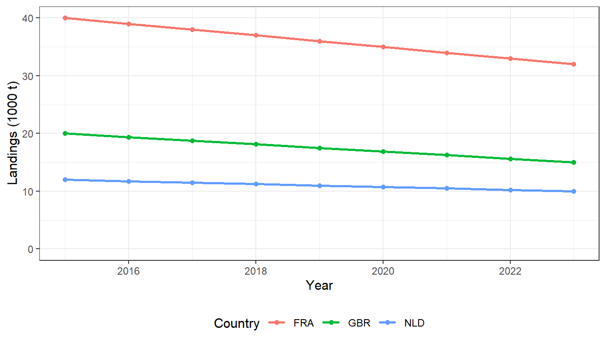
Figure : Landings (t) per year by country (example data).
Table : Landings (t) per year by country (example data).
year | FRA | NLD | GBR
2015 | 40,000 | 12,000 | 20,000
2016 | 39,000 | 11,750 | 19,375
2017 | 38,000 | 11,500 | 18,750
2018 | 37,000 | 11,250 | 18,125
2019 | 36,000 | 11,000 | 17,500
2020 | 35,000 | 10,750 | 16,875
2021 | 34,000 | 10,500 | 16,250
2022 | 33,000 | 10,250 | 15,625
2023 | 32,000 | 10,000 | 15,000

A third-level heading
Text under a third-level heading.

A landscape page
Wide tables or figures can be placed on a landscape page like this one.
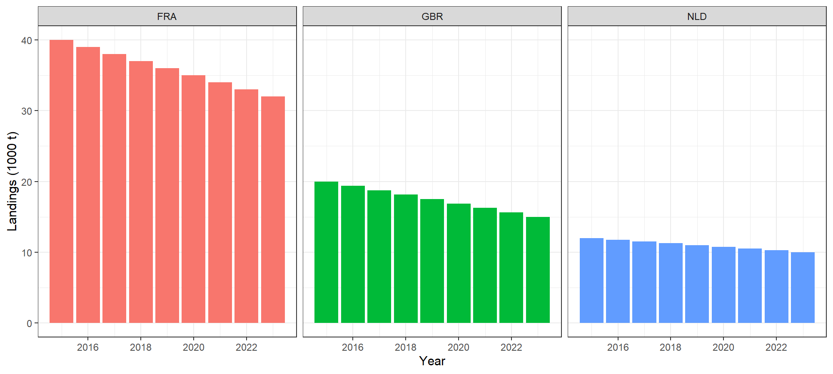
Figure : The same figure on a landscape page.

References
Pastoors, M.A. (2026). Example reference in the template’s Reference style.

