Spatial distribution of mackerel catches
By: Martin Pastoors
Version: 24/03/2025

Introduction

Methods

Results
Simple feature collection with 14 features and 3 fields
Geometry type: GEOMETRY
Dimension: XY
Bounding box: xmin: -8 ymin: 49 xmax: 8 ymax: 55.5
Geodetic CRS: WGS 84
# A tibble: 14 × 4
# Groups: year [14]
year species weight geometry
<dbl> <chr> <dbl> <GEOMETRY [°]>
1 2012 MAC 172845. MULTIPOLYGON (((3 54, 4 54, 4 54.5, 3 54.5, 2 54.5, 1 …
2 2013 MAC 231267. MULTIPOLYGON (((3 54, 4 54, 4 54.5, 3 54.5, 2 54.5, 2 …
3 2014 MAC 349813 MULTIPOLYGON (((3 54, 4 54, 4 54.5, 3 54.5, 2 54.5, 2 …
4 2015 MAC 317895 MULTIPOLYGON (((3 53.5, 4 53.5, 4 54, 4 54.5, 3 54.5, …
5 2016 MAC 299485 MULTIPOLYGON (((-2 50.5, -3 50.5, -3 50, -2 50, -2 50.…
6 2017 MAC 317248 MULTIPOLYGON (((1 54.5, 0 54.5, 0 54, 1 54, 1 54.5)), …
7 2018 MAC 494133 MULTIPOLYGON (((-2 50, -2 50.5, -3 50.5, -4 50.5, -4 5…
8 2019 MAC 299648 MULTIPOLYGON (((1 54, 2 54, 2 53.5, 3 53.5, 4 53.5, 4 …
9 2020 MAC 288357 MULTIPOLYGON (((-2 50, -1 50, -1 49.5, 0 49.5, 1 49.5,…
10 2021 MAC 410883 POLYGON ((0 50, 1 50, 2 50, 2 50.5, 2 51, 3 51, 3 51.5…
11 2022 MAC 394174. MULTIPOLYGON (((3 53.5, 3 53, 2 53, 2 52.5, 2 52, 2 51…
12 2023 MAC 359802. MULTIPOLYGON (((3 53.5, 4 53.5, 4 54, 5 54, 5 54.5, 4 …
13 2024 MAC 239485 MULTIPOLYGON (((0 50, 1 50, 2 50, 2 50.5, 2 51, 3 51, …
14 2025 MAC 32372 MULTIPOLYGON (((1 50, 1 49.5, 2 49.5, 2 50, 2 50.5, 2 …
Table 1: Overview of mackerel records 2023 and 2024

Overview of mackerel landings per rect and per month
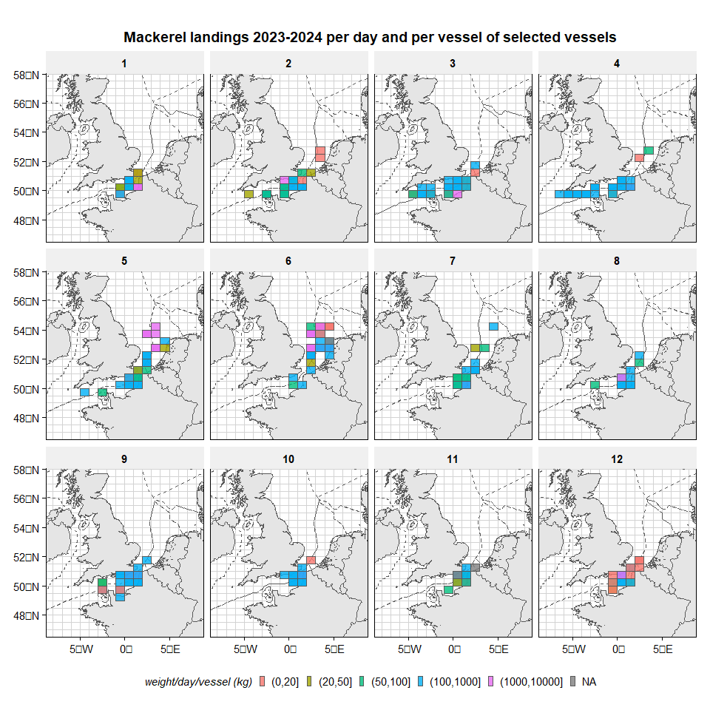
Figure 1: Landings (kg) of participating vessels in ‘open’ parts of the EEZs (black), MPAs (red) and offshore wind areas (blue).

