WQ 2024 analysis on spatial distributions and indicators
By: Martin Pastoors and Hans van Oostenbrugge
Version: 24/01/2025


Introduction
The spatial distribution of the Dutch bottomtrawl fleet is increasingly influenced by developments at sea that make traditional fishing areas less accessible or inaccessible to fishing vessels or that affect the presence or catchability of the most important target species. The most important developments are offshore wind development (and associated pipelines on or in the seabed) and protected areas.
The participating vessels have previously been equipped with tools to collect real-time information on catches and fishing positions. This made it possible to estimate catch compositions per haul and thereby creating detailed spatial maps of the importance of different fishing areas to the fishery. In future, this information will be linked to the research program operated by Wageningen Social and Economic Research (WSER) in which the effects of wind farms are mapped.
The aim of this paper is to show the content of the data and the potential added value to the existing information from current VMS-analyses.

Methods
We collected highly detailed information on landings and fishing positions from participating vessels for the years 2023 and 2024. The information is disaggregated by individual fish-crates. This made it possible to estimate catch compositions per haul and thereby creating detailed spatial maps of the importance of different fishing areas to the fishery.
Information on spatial plans on the North Sea (Netherlands and neighbouring countries) was derived from different sources, including Informatiehuis Marien (https://viewer.openearth.nl/ihm-viewer) and Compendium Greater North Sea (https://viewer.openearth.nl/compendium-greater-north-sea/).
In this first study we focused on the catch composition per haul in the bottom trawl fishery in the southern North Sea both in space and time. Participating skippers have contributed their data for this analysis and have been involved in the analysis of the data. This type of data may be used in future to supply the WSER project on the effects of offshore wind farms.

Results
Overview of sampling based on individual weight measurements The dataset obtained is the combination of the data from the position of the vessel and the electronic scale on board of the vessel. This scale is used to weigh the retained catches onboard the vessel, before they are stored. Numerous vessels have installed this equipment onboard as a measure to enhance fish quality throughout the processing chain.
The dataset consists of information from 2 years from participating vessels (KW14, KW45, KW145, SL42, UK64) and includes 196 trips in which over 15,000 hauls were made (Table 1). Based on the information from the electronic scales a total of 40 species were landed in this period. More than 50% of the retained catches consisted of plaice and sole, but also a wide variety of other species were caught in this fishery (Table 2). From the retained catches the volume is known, and the the value has been calculated using the average price per species and week.
year nspecies ntrips nhauls nobs weight revenue
------- ---------- -------- -------- -------- --------- -----------
2023 41 79 5,306 13,379 339,991 2,322,427
2024 42 117 10,348 16,874 650,201 5,327,614
(all) 83 196 15,654 30,253 990,192 7,650,041
Table 1: Overview of catch records 2023 and 2024

Catches by species (kg)
species englishname 2023 2024 total
--------- ------------------------- --------- --------- ---------
PLE European plaice 136,659 200,989 337,648
SOL Common sole 44,119 106,080 150,199
SQR European squid 50,555 22,830 73,386
NEP Norway lobster 33,779 31,481 65,260
TUR Turbot 15,669 31,684 47,353
GUU Tub gurnard 18,074 22,599 40,673
DAB Common dab 6,072 17,297 23,368
RJH Blonde ray 4,833 15,979 20,812
RJC Thornback ray 3,590 12,149 15,739
FLE European flounder 1,782 13,298 15,080
BLL Brill 3,418 8,943 12,361
HAD Haddock 2,629 7,590 10,219
MAC Atlantic mackerel 4,245 1,949 6,194
SBR Blackspot seabream 3,413 1,786 5,199
COD Atlantic cod 1,514 2,133 3,648
LEM Lemon sole 1,663 1,936 3,599
CTC Common cuttlefish 1,397 1,995 3,393
WHG Whiting 489 2,049 2,538
LBE European lobster 1,844 171 2,015
GUG Grey gurnard 1,031 976 2,007
CRE Edible crab 620 1,241 1,861
MUR Surmullet 1,333 193 1,526
MON Angler(=Monk) 370 1,077 1,446
HOM Atlantic horse mackerel 914 378 1,292
HKE European hake 404 668 1,073
BSS European seabass 789 271 1,061
WEG Greater weever 289 721 1,010
BIB Pouting(=Bib) 546 295 841
WIT Witch flounder 338 237 575
RJM Spotted ray 402 68 470
SYC Small-spotted catshark 372 0 372
DGS Picked dogfish 171 38 209
SMD Smooth-hound 209 0 209
CAA Atlantic wolffish 122 62 184
HAL Atlantic halibut 30 108 137
GUR Red gurnard 41 7 48
SCE Great Atlantic scallop 10 30 40
LIN Ling 27 8 35
JOD John dory 13 17 29
COE European conger 26 1 28
MEG Megrim 0 10 10
POK Saithe(=Pollock) 0 0 0
Table 2: Sampled catch by species in 2023 and 2024

Map of different areas in the North Sea
Figure 1 shows the patial distribution of the natura 2000 areas and offshore wind areas (OWF) locations as they are included in the analyses for this report. This will provide an example for the application of the newly achieved detailed dataset on landings. The map shows both existing and planned nature and OWF areas which cover a substantial proportion of the North Sea and the historic fishing grounds of the North Sea fishers.
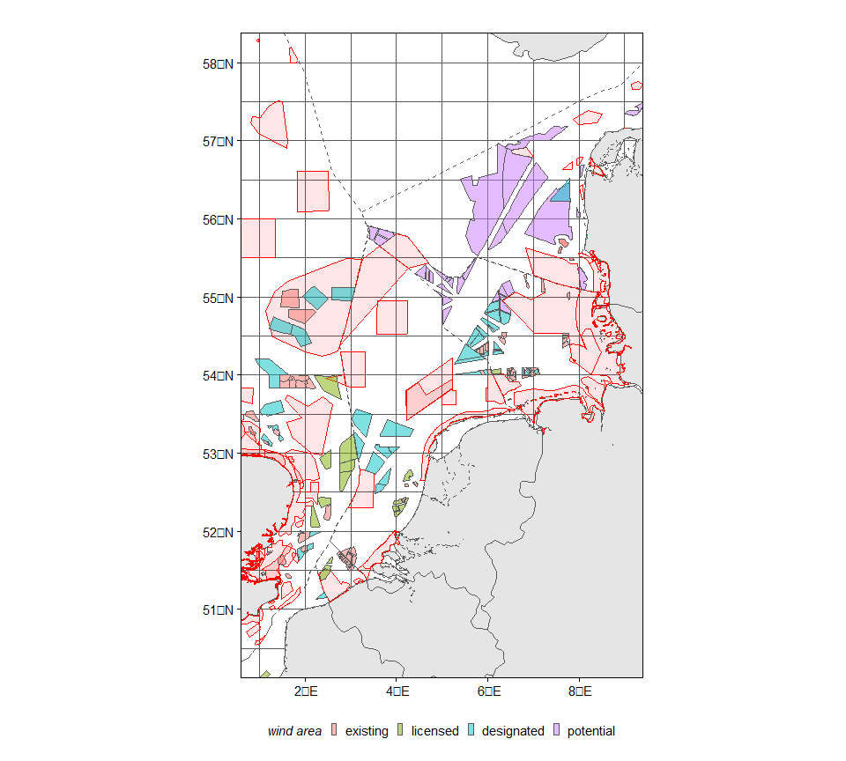
Figure 1: Base map with EEZs (dotted lines) and MPAs (red areas) and offshore wind areas with different status.

Overview of landings per haul (black) and in designated windareas (blue) and MPAs (red) during 2023 and 2024. Grey points are GPS positions.
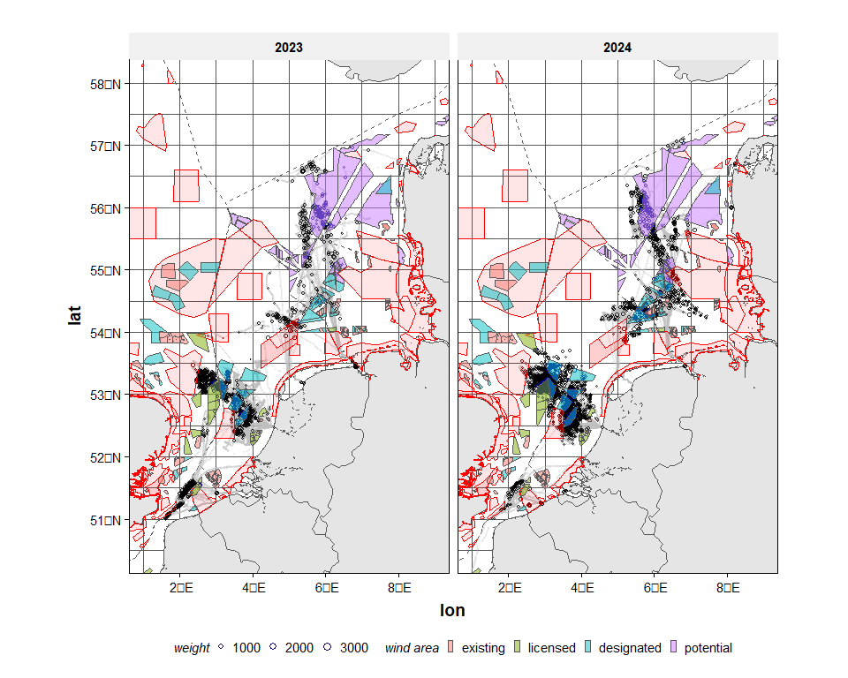
Figure 2: Landings (kg) of participating vessels in ‘open’ parts of the EEZs (black), MPAs (red) and offshore wind areas (blue).
Figure 2 shows the overall distribution of the retained catches in the fishing area, both in the open area and within the borders of the designated OWFs and N2000 areas. The plots show that the catches are obtained in a limited area and that the overlap between fishing areas and closed areas is partial. Moreover, the fishing patterns vary over the two years with more catches from the eastern channel in 2023 and an eastward shift in landings in the DK waters in 2024. The map also shows a high concentration of locations north of the Frisian Front in 2024 with seemingly lower landings than in 2023.

Quarterly patterns in landings are shown below.
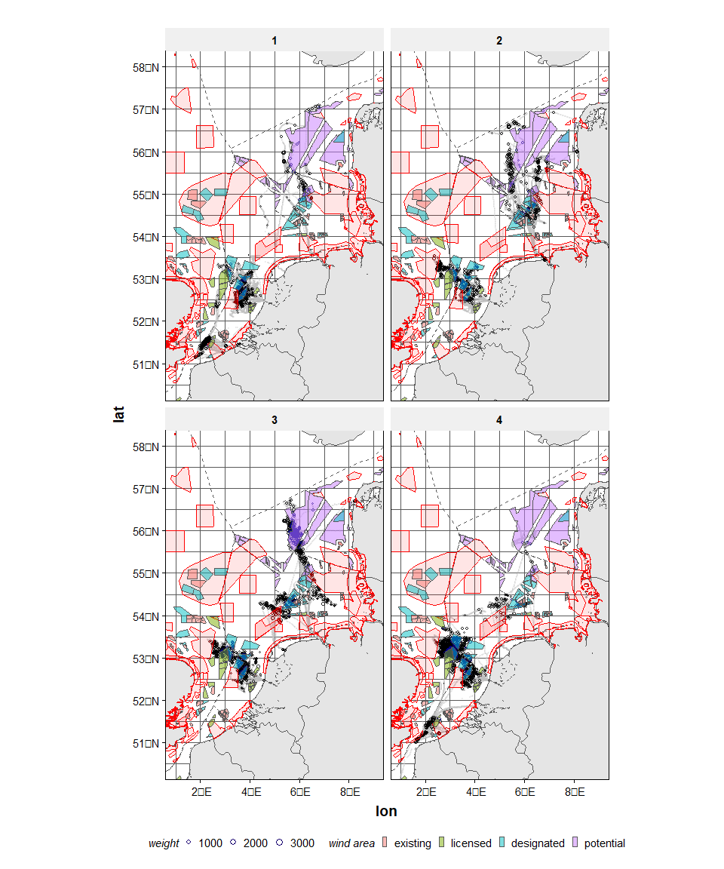
Figure 3: Landings (kg) of participating vessels by quarter in ‘open’ parts of the EEZs (black), MPAs (red) and offshore wind areas (blue).
As a result of the overlap of the MPAs, and designated OWF, a considerable part of the landings (table 3) and revenue (table 4) is obtained from fishing activities in these areas. Approximately 32% of the landings and revenues of these vessels originates from planned OWF and 4-5% originates from MPAs. It is also evident that the UK fishing grounds are important to these vessels as around 27% of the landings and revenue are obtained in UK waters.
country open wind mpa total
--------- --------- --------- -------- ---------
BEL 20,376 1,085 7,300 28,760
DEU 51,863 22,960 5,801 80,624
DNK 82,791 55,098 2,048 139,937
GBR 162,429 83,344 2,449 248,221
NLD 256,700 128,149 23,710 408,559
all 574,159 290,636 41,307 906,102
country open wind mpa all
--------- ------- ------- ------ --------
BEL 2.2% 0.1% 0.8% 3.2%
DEU 5.7% 2.5% 0.6% 8.9%
DNK 9.1% 6.1% 0.2% 15.4%
GBR 17.9% 9.2% 0.3% 27.4%
NLD 28.3% 14.1% 2.6% 45.1%
all 63.4% 32.1% 4.6% 100.0%
Table 3: Total landings by zone in 2023 and 2024 (kg). Open refers to the part of the EEZ that is not covered by either MPAs of offshore wind areas
country open wind mpa total
--------- ----------- ----------- --------- -----------
BEL 131,294 5,643 50,016 186,953
DEU 426,577 155,947 36,273 618,798
DNK 396,912 298,158 8,698 703,768
GBR 1,281,581 648,133 18,602 1,948,316
NLD 2,324,394 1,183,270 197,553 3,705,217
all 4,560,758 2,291,151 311,142 7,163,051
country open wind mpa all
--------- ------- ------- ------ --------
BEL 1.8% 0.1% 0.7% 2.6%
DEU 6.0% 2.2% 0.5% 8.6%
DNK 5.5% 4.2% 0.1% 9.8%
GBR 17.9% 9.0% 0.3% 27.2%
NLD 32.4% 16.5% 2.8% 51.7%
all 63.7% 32.0% 4.3% 100.0%
Table 4: Total revenue by zone in 2023 and 2024 (Euro). Open refers to the part of the EEZ that is not covered by either MPAs of offshore wind areas

Zoomed-in view of the area around the Brown Bank
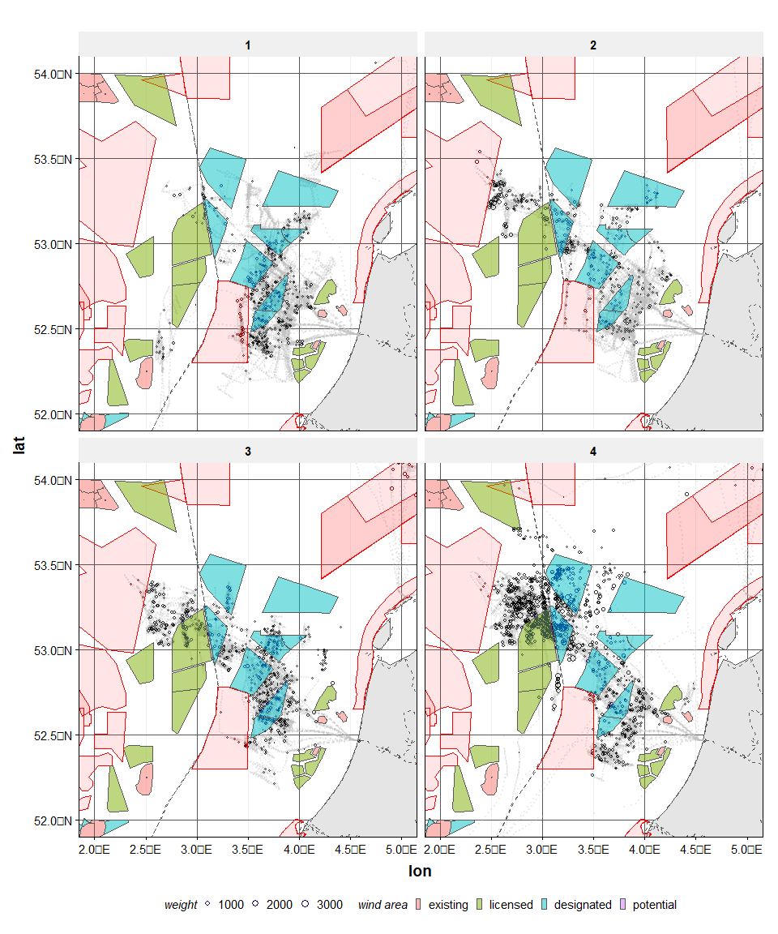
Figure 4: Landings (kg) of participating vessels in ‘open’ parts of the EEZs (black), MPAs (red) and designated wind areas (blue). Zoomed in to the area around the Brown Bank
The distribution maps from the brown bank show a shift in the retained catches from the open UK waters in 2023 to the designated OFL locations and the Dutch part of the southern North Sea in 2024. It can also be noted that the retained catches from the large N2000 area (brown bank) are taken from a relatively small strip in the area, which is exploited in both years, whereas the landings from other areas seem to be much more dynamic. Moreover, this information shows the in some areas the fishers are always fishing in the same direction and location, whereas in other areas the trawling locations (grey areas of VMS positions) are much more spread out.

Zoomed-in view of the German Bight
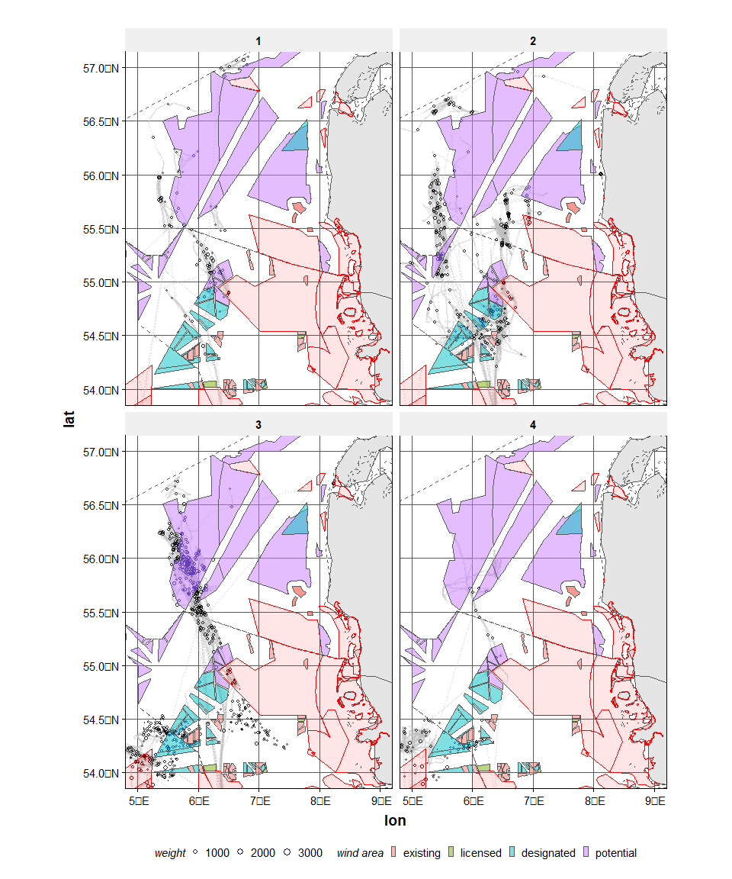
Figure 5: Landings (kg) of participating vessels in ‘open’ parts of the EEZs (black), MPAs (red) and designated wind areas (blue). Zoomed in to the German Bight
The plots of the northern part of the North Sea show the shift in fishing area of these vessels to more eastward fishing grounds. It also shows that fishing takes place in a north south direction and the retained catches are registered at the end of the haul (see patterns in the most eastern fishing location in DK waters in 2024).
The overviews also show exploratory trips to the North part of the DK waters. In 2023 these locations were apparently productive enough to spend more time in this area, whereas in 2024 the vessel just went there once and did not come back. This information on (apparent low) fishing success in specific hauls in relatively unfished areas is of large importance for the development of knowledge on fishing behavior and fishing patterns.
The current spatial information on fisheries is estimated from total retained catches, and these are distributed evenly over the VMS fishing locations (Deetman et al., 2024). This means that the retained catches per fishing track are assumed equal. Table 5 shows that for the vessels included in this first analyses there is considerable variation in retained catches among the hauls within a trip. For the three species analysed the average standard deviation was around 47% of the average retained landings weight. This means that on average, the retained landings in each haul were 47% higher or lower than the average landings of all hauls in the trip. Between the trips there is also large variation: in some trips the retained catches for all hauls are almost identical (low variance between hauls) whereas for other trips the variance between hauls is much higher (in some instance even higher than the average retained catches of the trip). This means that the added value of these detailed data is considerable.
species meanrelstdev minrelstdev maxrelstdev lower025relstdev upper975relstdev
--------- -------------- ------------- ------------- ------------------ ------------------
PLE 0.47 0.02 0.92 0.08 0.83
SOL 0.45 0 0.9 0.23 0.79
SQR 0.46 0.01 1.22 0.01 0.82
Table 5: Descriptive statistics of the variation (standard deviation) of plaice, sole and squid in retained catches among hauls within a trip, for the two-year period and all participating vessels

Discussion
The highly detailed information on catch per haul that is visualized in this report is based on a limited number of vessels that have coupled their scales with their GPS systems. This can be considered as a first step in the digitalization of the bottom trawl fleet, where additional information may in future be expected from coupling fuel sensors and specific fishing equipment sensors (e.g. Marelec pull sensor). The currently available information could already be compared to the type of information that is available from the coupling of VMS and logbook data. This comparison has not been carried out at this stage but is expected to be carried out in the near future.
Given that the results are based on a limited number of vessels, the results cannot be considered representative of any part of the Dutch bottom trawl fleet. Currently, we are only able to show the potential of using such data, not yet in a practical application for the spatial use of different areas by different fleet segments. This potential lays in the higher accuracy of the estimation of the retained landings in specific locations. As for now all spatial analyses are based on the assumption that the retained landing per haul is equal within a trip. For the estimation of the retained catches and their value for large areas this approach is useful as it concerns the total of large amounts of hauls and the uncertainty in the estimate of the total landings from the area is lowered by the high amount of data points (hauls) in the area. However, the method causes bias in small areas with either very low or very high retained catches as these are compensated by lower/higher catches in other hauls in the same trip. The current data includes the detail to distinguish the low resolution spatial and temporal patterns which will make analyses of fishing behavior more meaningful and the estimates of the value of specific areas much more precise.
In order to match the given location in the dataset to the location at which the fish were really caught some extra comparative analyses should be done, but these data provide a big step forward in spatial analyses of fishing behavior.

References
Deetman, B., M. Robert, M. Kraan and K. G. Hamon (2024). Waarde (zoek)gebieden wind op zee voor de visserij. Inzicht in de sociaal-economische waarde van gebieden, die geïdentificeerd zijn in de Partiële Herziening van het Programma Noordzee 2022-2027, voor de Nederlandse visserij. Wageningen, Wageningen Economic Research. Rapport 2024-033: 84

