# TBB sole fishery CPUE analysis

M.A. Pastoors

Date: 27/02/2024

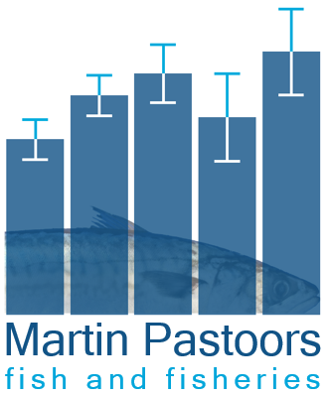

**Executive summary**

**Introduction**

**Map of TBB effort, sole catch and sole catch/day by ICES rectangle and year**

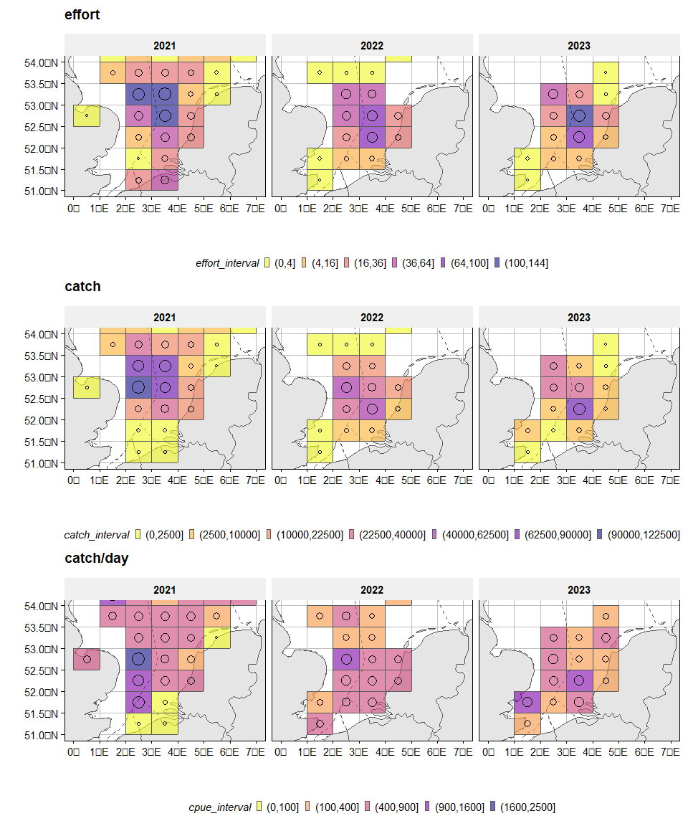

*Figure 1: TBB effort, sole catch and sole catch/day by ICES rectangle and year*

**Map of AUGUST TBB effort, sole catch and sole catch/day by ICES rectangle and year**

CPUE plot overlaid with the survey biomass per haul

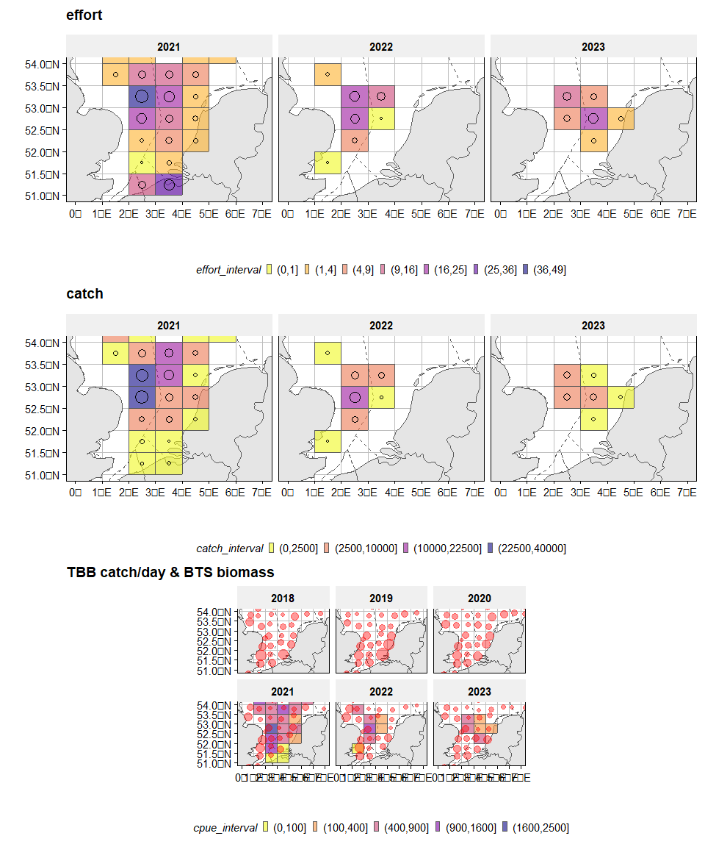

*Figure 2: August TBB effort, sole catch and sole catch/day by ICES rectangle and year*

**AUGUST TBB sole catch/day against BTS sole biomass for each ICES rectangle**

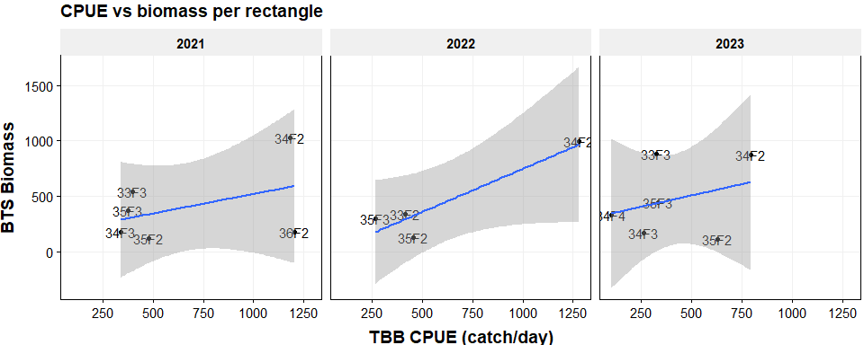

*Figure 3: TBB sole catch/day vs BTS sole biomass*

# ANNEX (annual details by vessel)

**Map of total beamtrawl effort by vessel, by ICES rectangle and year**

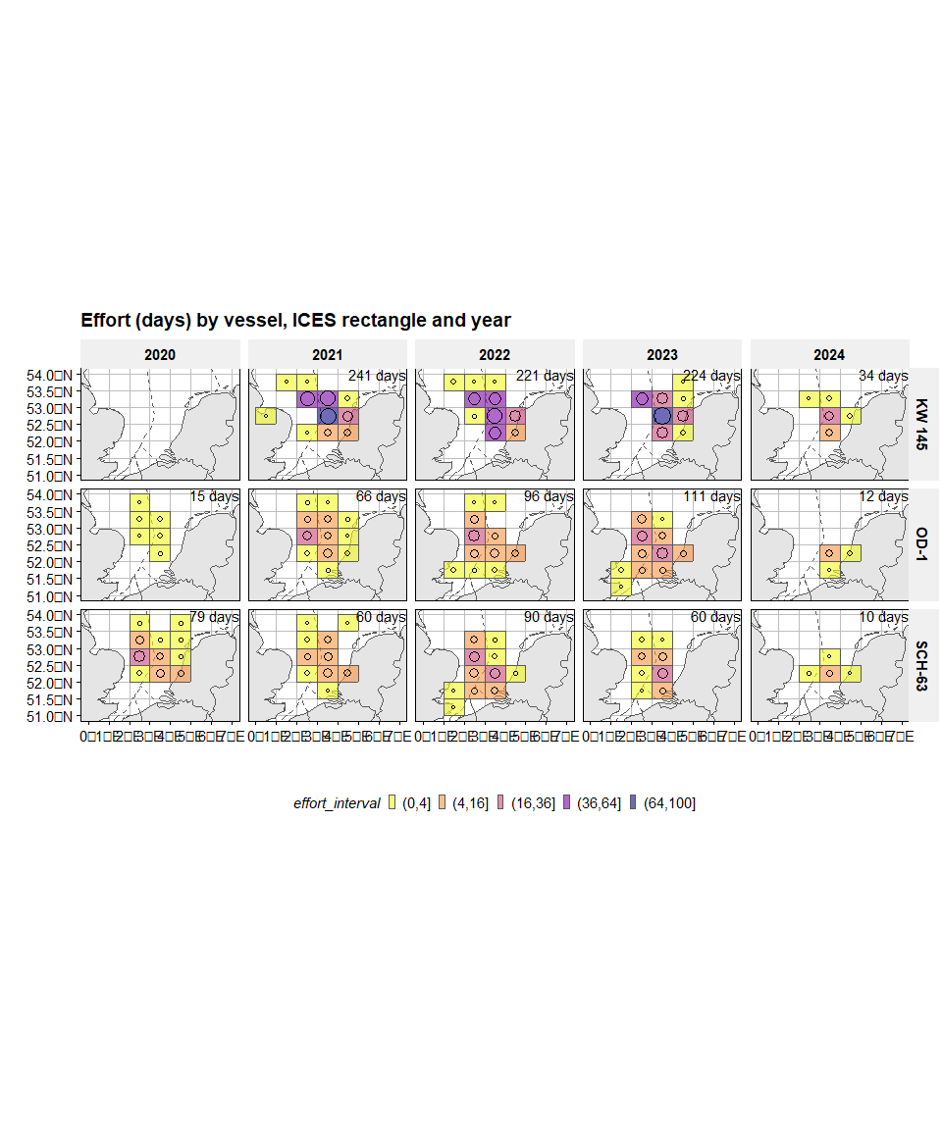

*Figure 4: Effort (days) by vessel, ICES rectangle and year*

**Map of beamtrawl sole catch by vessel, by ICES rectangle and year**

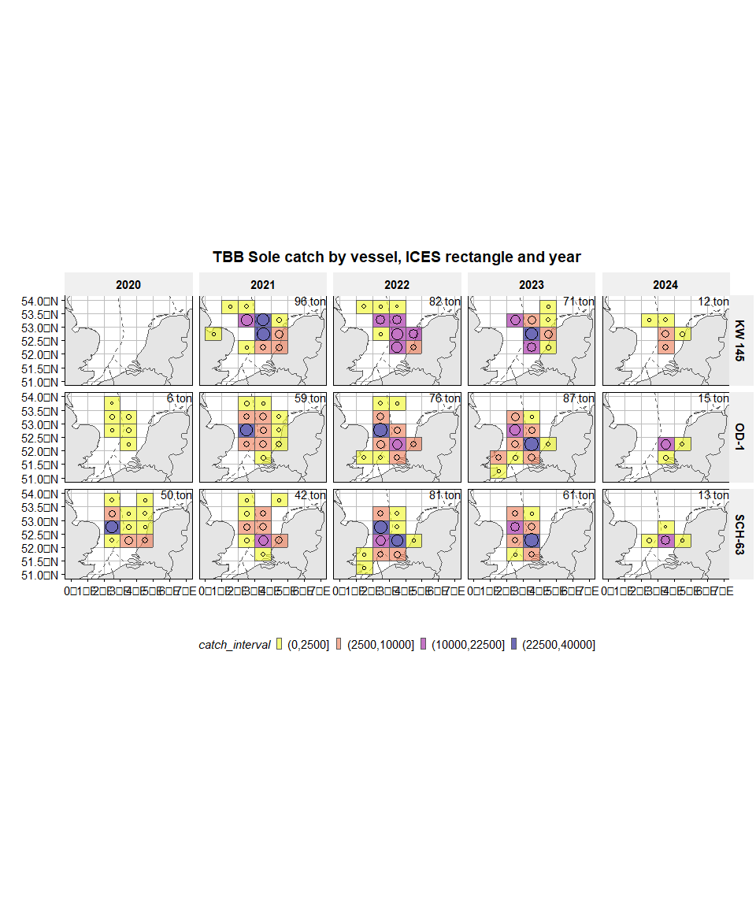

*Figure 5: TBB Sole catch by vessel, ICES rectangle and year*

**Map of beamtrawl sole CPUE (catch/day) by vessel, by ICES rectangle and year**

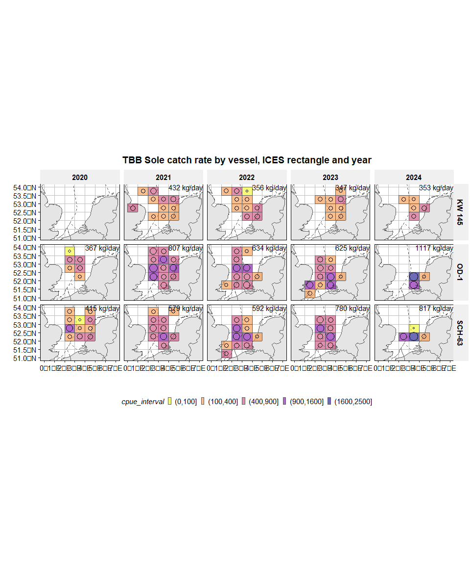

*Figure 6: TBB Sole catch rate by vessel, ICES rectangle and year*

# ANNEX (AUGUST details by vessel)

**Map of AUGUST total beamtrawl effort by vessel, by ICES rectangle and year**

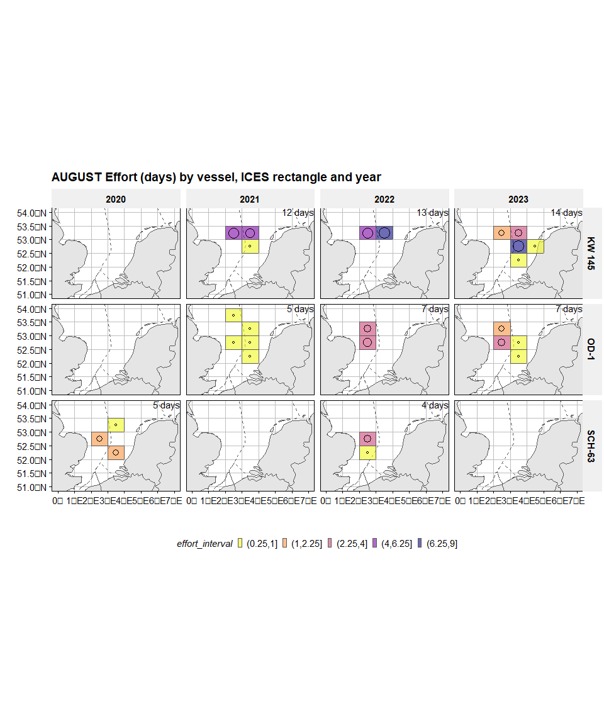

*Figure 7: AUGUST Effort (days) by vessel, ICES rectangle and year*

**Map of AUGUST beamtrawl sole catch by vessel, by ICES rectangle and year**

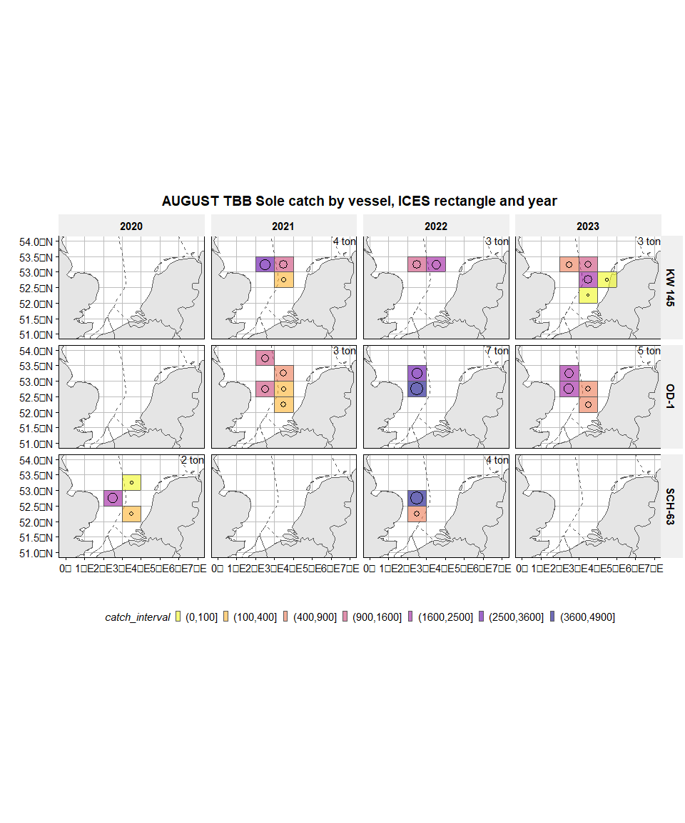

*Figure 8: AUGUST TBB Sole catch by vessel, ICES rectangle and year*

**Map of AUGUST beamtrawl sole CPUE (catch/day) by vessel, by ICES rectangle and year**

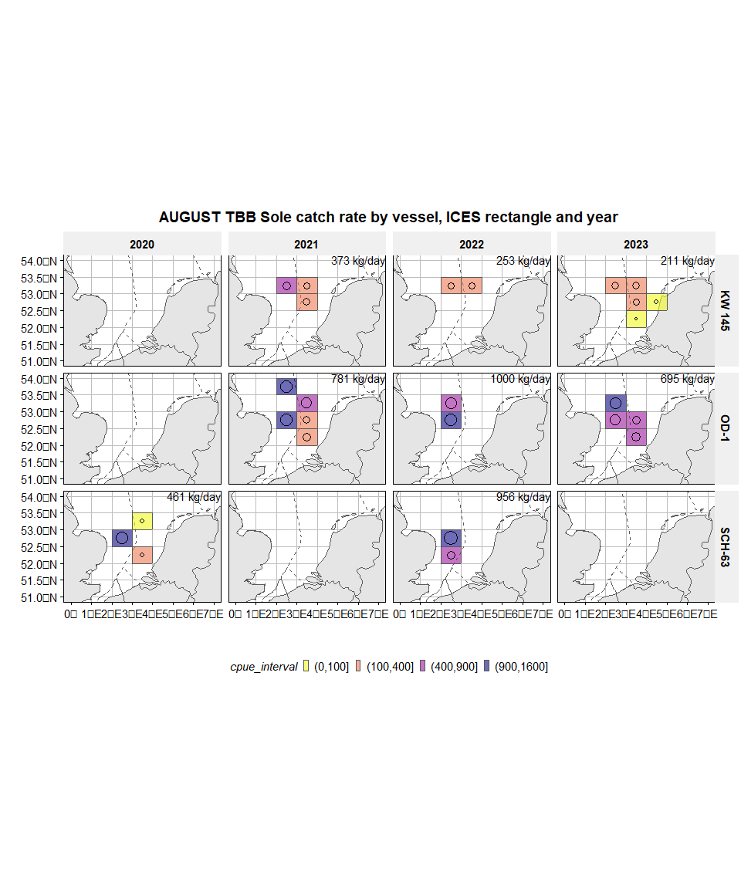

*Figure 9: AUGUST TBB Sole catch rate by vessel, ICES rectangle and year*