# Vessel tripreport SL9, trip 2023437, 2023438, 2023439, 2023441

### Trip start: 19/07/2023, end: 26/07/2023

Report generated: 31/07/2023

&nbsp; &nbsp; &nbsp; &nbsp;   
------------- ------------ ---------------- ------------ ------------  
vessel SL9 SL9 SL9 SL9   
trip 2023437 2023438 2023439 2023441   
nhauls 19 32 20 7   
startdate 2023-07-19 2023-07-21 2023-07-24 2023-07-26   
enddate 2023-07-20 2023-07-23 2023-07-25 2023-07-26   
weeks 29 29, 30 30 30   
months 7 7 7 7   
divisions 27.7.d 27.7.d; 27.4.c 27.7.d 27.7.d   
rects 29F1 29F1; 31F2 30F1; 29F1 29F1   
ndays 2 3 2 1   
haulsperday 9.50000 10.66667 10.00000 7.00000

trip elog elog per trek   
--------- ------ ---------------  
2023437 5984 5911   
2023438 5764 5675   
2023439 7860 7816   
2023441 1710 1352

trip vangst MAC CTC MUR WEG MGC HOM RJC GUU GUR PLE OTHER TOTAL   
--------- ---------------- ------ ------ ------ ----- ----- ----- ----- ----- ----- ----- ------- -------  
2023437 aanvoer (elog) 3835 1520 179 178 82 55 54 42 . . 39 5984   
2023438 aanvoer (elog) 990 2420 1177 312 70 170 356 148 . . 121 5764   
2023439 aanvoer (elog) 4420 2680 218 156 27 203 . 140 7 . 9 7860   
2023441 aanvoer (elog) 320 1060 145 100 14 21 . 27 . 14 9 1710

trip vangst MAC CTC WEG MUR MUL HOM RJC GUU GUR PLE OTHER TOTAL   
--------- ------------------------- ------ ------ ----- ------ ----- ----- ----- ----- ----- ----- ------- -------  
2023437 aanvoer (elog per trek) 3823 1465 176 176 83 55 54 41 . . 39 5911   
2023438 aanvoer (elog per trek) 1003 2347 306 1167 71 171 347 145 . . 118 5675   
2023439 aanvoer (elog per trek) 4386 2681 154 217 28 198 . 135 7 . 10 7816   
2023441 aanvoer (elog per trek) 114 991 46 111 14 22 . 27 . 14 12 1352

*Table 1: Samenvatting van de reis*

**Aanvoer per soort (elog)**

species 2023437_gewicht 2023437_perc 2023438_gewicht 2023438_perc 2023439_gewicht 2023439_perc 2023441_gewicht 2023441_perc soorten  
--------- ----------------- -------------- ----------------- -------------- ----------------- -------------- ----------------- -------------- ---------  
 BIB 0 0% 0 0% 1 0% 0 0% bib  
 BLL 1 0% 1 0% 0 0% 0 0% bll  
 BRB 1 0% 16 0% 0 0% 0 0% brb  
 BSS 3 0% 0 0% 0 0% 0 0% bss  
 CTC 1520 25% 2420 42% 2680 34% 1060 62% ctc  
 DAB 9 0% 2 0% 2 0% 0 0% dab  
 FLE 0 0% 4 0% 1 0% 0 0% fle  
 GUR 0 0% 44 1% 7 0% 6 0% gur  
 GUU 42 1% 148 3% 140 2% 27 2% guu  
 HOM 55 1% 170 3% 203 3% 21 1% hom  
 JOD 1 0% 0 0% 0 0% 0 0% jod  
 LEM 0 0% 1 0% 0 0% 0 0% lem  
 MAC 3835 64% 990 17% 4420 56% 320 19% mac  
 MGC 82 1% 70 1% 27 0% 14 1% mgc  
 MUR 179 3% 1177 20% 218 3% 145 8% mur  
 PLE 20 0% 22 0% 0 0% 14 1% ple  
 RJC 54 1% 356 6% 0 0% 0 0% rjc  
 RJH 0 0% 20 0% 0 0% 0 0% rjh  
 SCE 2 0% 0 0% 0 0% 0 0% sce  
 SQR 0 0% 8 0% 3 0% 1 0% sqr  
 TUR 1 0% 2 0% 0 0% 0 0% tur  
 WEG 178 3% 312 5% 156 2% 100 6% weg  
 WHG 1 0% 1 0% 2 0% 2 0% whg  
 (all) 5984 100% 5764 100% 7860 100% 1710 100% (all)

*Table 2: Vangst per soort (kg)*

**Aanvoer per soort en dag (elog)**

species 19/07 20/07 21/07 22/07 23/07 24/07 25/07 26/07 (all)  
--------- ------- ------- ------- ------- ------- ------- ------- ------- -------  
 bib 0 0 0 0 0 0 1 0 1  
 bll 0 1 0 0 1 0 0 0 2  
 brb 0 1 0 0 16 0 0 0 17  
 bss 0 3 0 0 0 0 0 0 3  
 ctc 840 680 740 20 1660 1340 1340 1060 7680  
 dab 0 9 0 0 2 0 2 0 13  
 fle 0 0 0 0 4 0 1 0 5  
 gur 0 0 0 0 44 0 7 6 57  
 guu 0 42 20 60 68 60 80 27 357  
 hom 20 35 0 160 10 20 183 21 449  
 jod 0 1 0 0 0 0 0 0 1  
 lem 0 0 0 0 1 0 0 0 1  
 mac 920 2915 760 120 110 3380 1040 320 9565  
 mgc 20 62 40 0 30 20 7 14 193  
 mur 60 119 105 885 187 150 68 145 1719  
 ple 0 20 0 0 22 0 0 14 56  
 rjc 20 34 80 0 276 0 0 0 410  
 rjh 0 0 0 0 20 0 0 0 20  
 sce 0 2 0 0 0 0 0 0 2  
 sqr 0 0 0 0 8 0 3 1 12  
 tur 0 1 0 0 2 0 0 0 3  
 weg 100 78 160 0 152 100 56 100 746  
 whg 0 1 0 0 1 0 2 2 6  
 (all) 1980 4004 1905 1245 2614 5070 2790 1710 21318

*Table 3: Vangst per soort (kg) per dag*

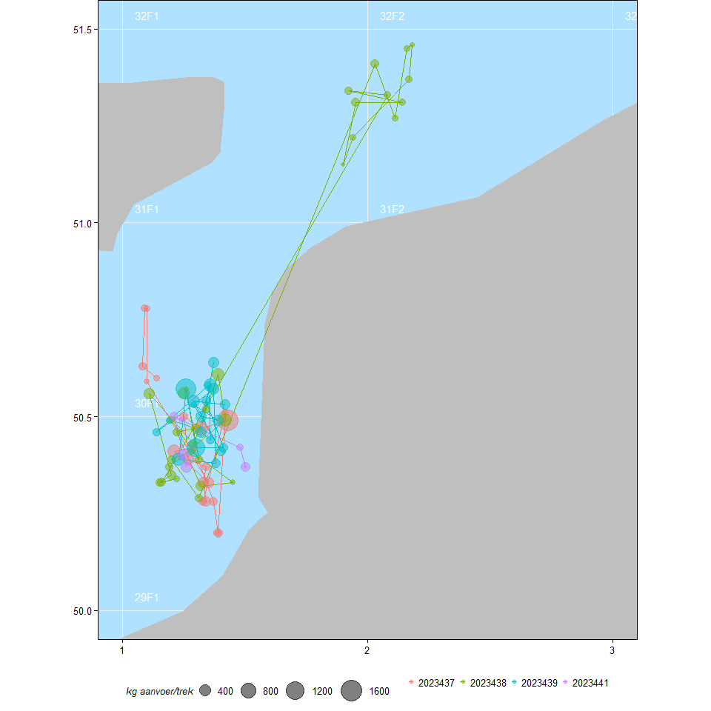

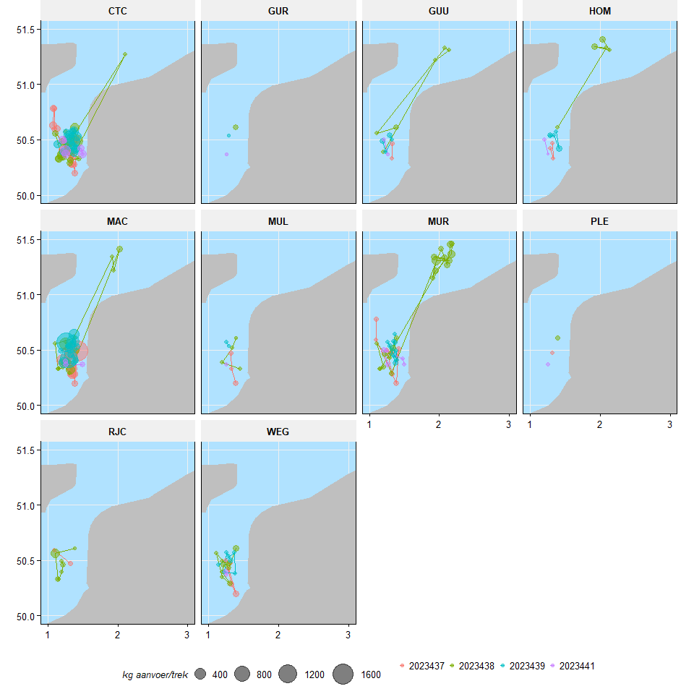

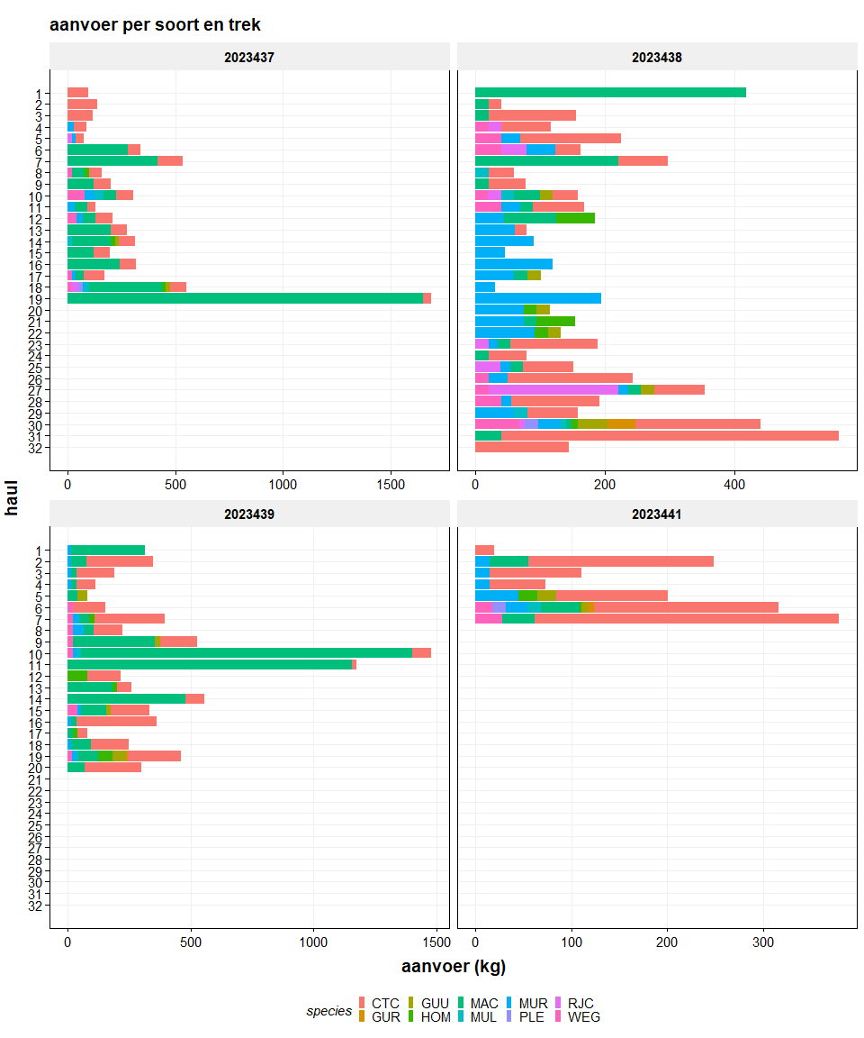

*Figure 3: Totale vangst per trek en soort (10 soorten met hoogste vangst)*