# Herring 6a survey report 2017

## Overview of catch, sampling and biological information

Martin Pastoors

Date: 19/10/2017 16:39:23

### Introduction

### Data handling

### Results

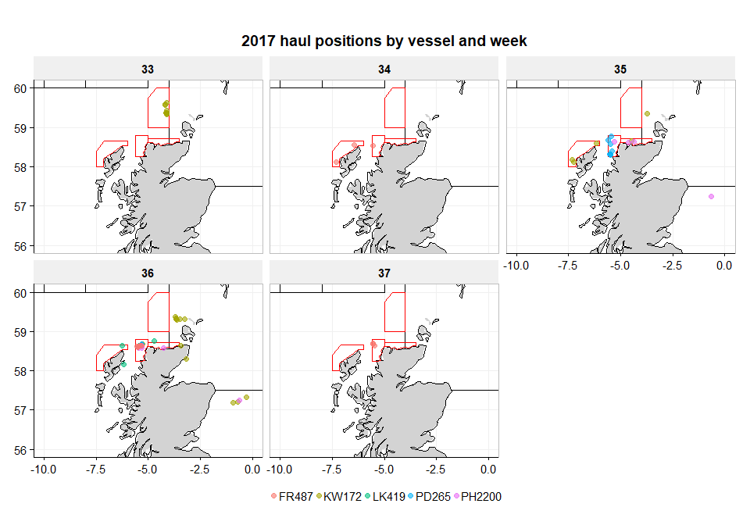

*Figure 1:*

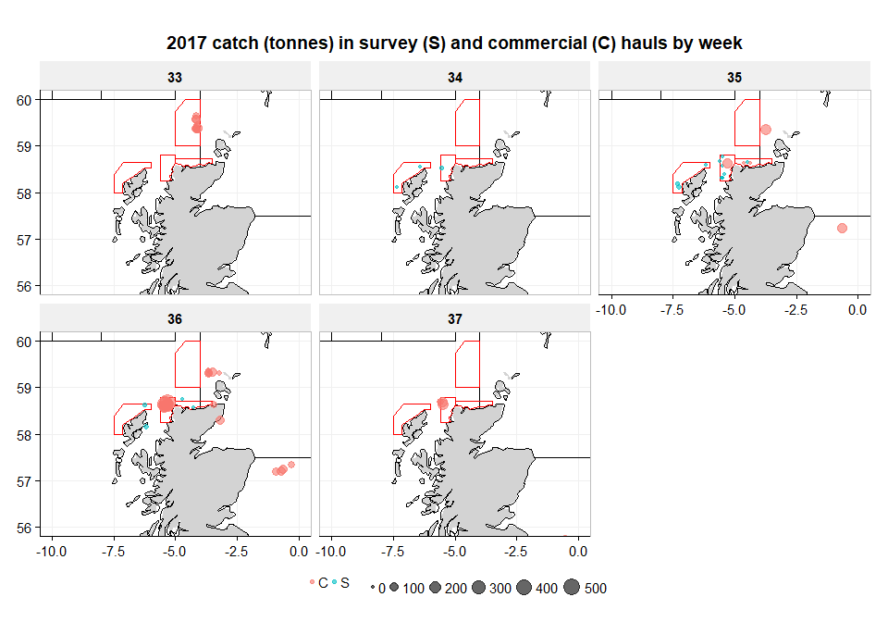

*Figure 2:*

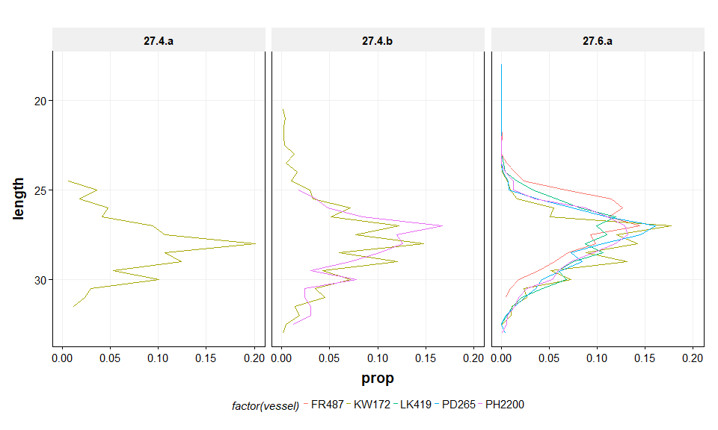

*Figure 3:*

