*Working document for WKWHMRP 2021*

Martin Pastoors, 04/10/2022

**Abstract**

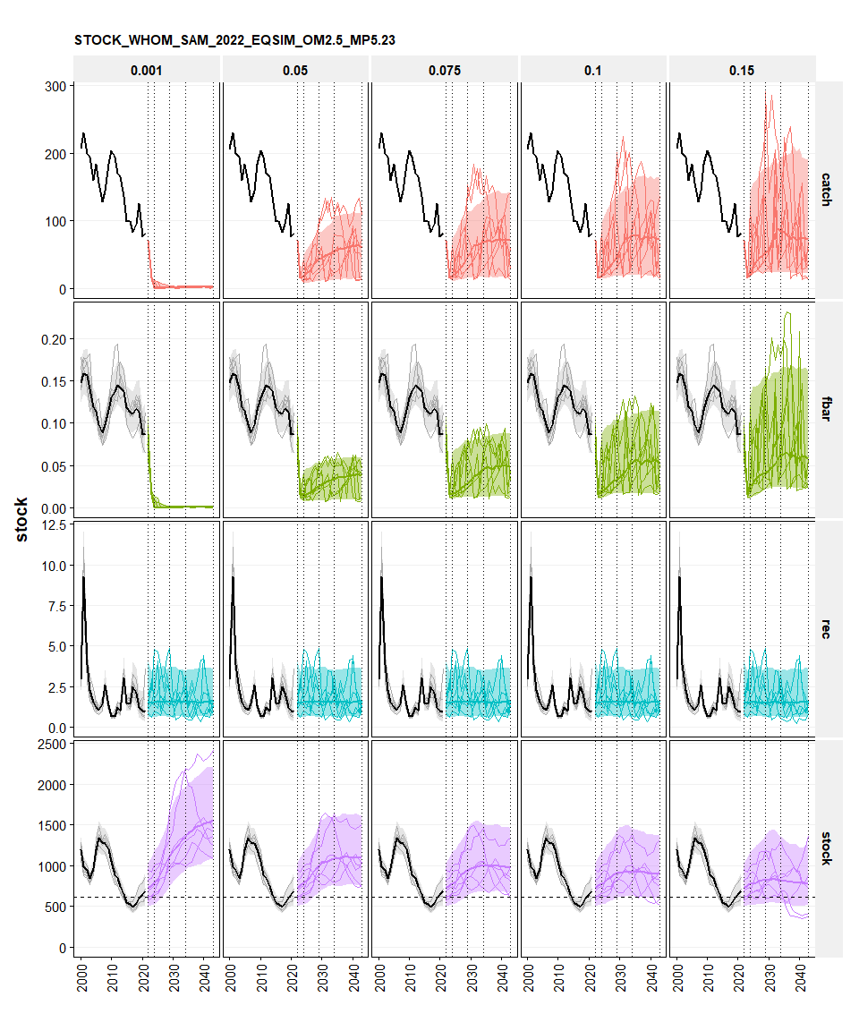 *fig x Simulation summary 2022 assessment, SS3, EqSim. MP5.23 double breakpoint F with 20% IAV constraint above Btrigger.*

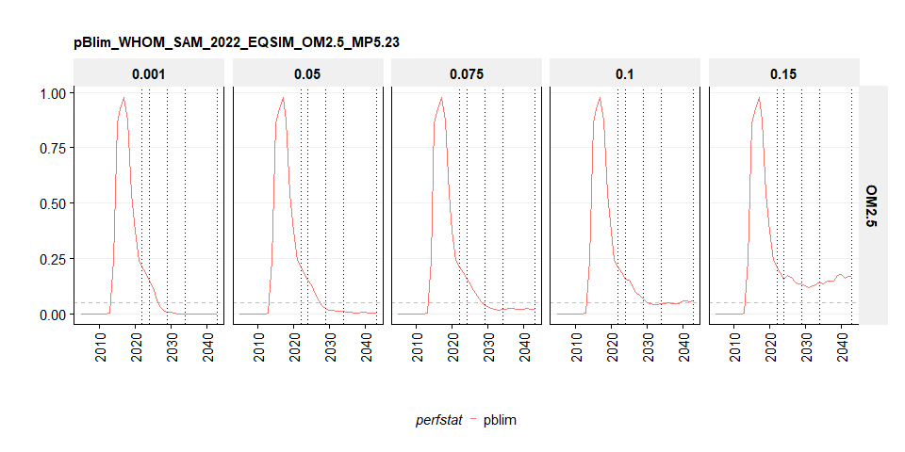

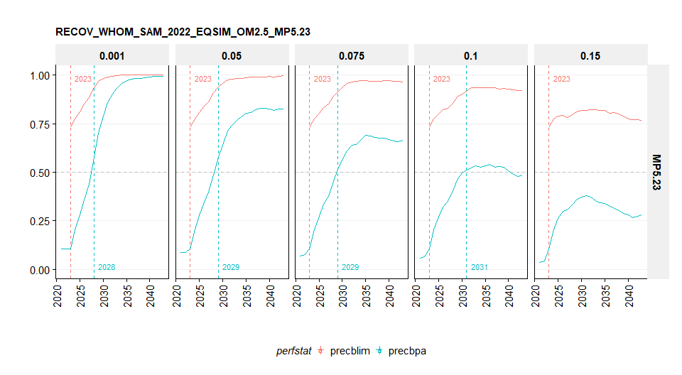

perfstat ftgt 2023 2024 2025 2026 2027 2028 2029 2030 (all)  
---------- ------- -------- -------- -------- -------- -------- -------- -------- -------- ---------  
 catch 0.001 15,513 1,030 715 811 899 990 1,108 1,202 22,267  
 catch 0.05 15,513 18,616 22,339 26,806 32,168 38,601 44,159 45,473 243,674  
 catch 0.075 15,513 18,616 22,339 26,806 32,168 38,601 46,322 55,586 255,950  
 catch 0.1 15,513 18,616 22,339 28,846 33,853 39,892 46,322 55,586 260,965  
 catch 0.15 15,513 21,335 30,521 39,912 44,268 48,248 52,366 56,592 308,754

perfstat ftgt 2023 2024 2025 2026 2027 2028 2029 2030  
---------- ------- --------- --------- --------- --------- --------- ----------- ----------- -----------  
 stock 0.001 752,802 788,241 825,677 895,723 982,930 1,053,134 1,120,786 1,175,604  
 stock 0.05 752,802 782,687 806,401 856,160 911,161 954,367 996,633 1,024,219  
 stock 0.075 752,802 781,284 798,439 839,529 882,298 915,358 945,548 963,502  
 stock 0.1 752,802 780,387 788,714 827,068 854,838 884,158 905,610 911,668  
 stock 0.15 752,802 777,649 775,151 791,660 811,250 817,484 824,056 824,452

perfstat ftgt 2023 2024 2025 2026 2027 2028 2029 2030  
---------- ------- ------- ------- ------- ------- ------- ------- ------- -------  
 fbar 0.001 0.015 0.001 0.001 0.001 0.001 0.001 0.001 0.001  
 fbar 0.05 0.015 0.015 0.016 0.018 0.021 0.023 0.026 0.027  
 fbar 0.075 0.015 0.017 0.018 0.02 0.023 0.027 0.029 0.033  
 fbar 0.1 0.015 0.019 0.021 0.025 0.028 0.032 0.033 0.036  
 fbar 0.15 0.015 0.025 0.03 0.035 0.039 0.041 0.042 0.045

perfstat ftgt 2023 2024 2025 2026 2027 2028 2029 2030  
---------- ------- ------ ------ ------ ------ ------ ------ ------ ------  
 pblim 0.001 0.19 0.15 0.12 0.06 0.03 0.02 0.01 0.01  
 pblim 0.05 0.19 0.15 0.13 0.09 0.06 0.04 0.02 0.02  
 pblim 0.075 0.19 0.16 0.14 0.1 0.08 0.06 0.04 0.03  
 pblim 0.1 0.19 0.16 0.15 0.12 0.1 0.09 0.07 0.05  
 pblim 0.15 0.19 0.16 0.17 0.16 0.15 0.14 0.14 0.13

perfstat ftgt 2023 2024 2025 2026 2027 2028 2029 2030  
---------- ------- ------ ------ ------ ------ ------ ------ ------ ------  
 pbpa 0.001 0.72 0.64 0.56 0.42 0.3 0.21 0.14 0.1  
 pbpa 0.05 0.72 0.64 0.6 0.5 0.4 0.34 0.26 0.23  
 pbpa 0.075 0.72 0.65 0.6 0.53 0.45 0.4 0.35 0.31  
 pbpa 0.1 0.72 0.65 0.62 0.56 0.5 0.46 0.43 0.41  
 pbpa 0.15 0.72 0.66 0.65 0.61 0.58 0.56 0.54 0.54