*Working document for WKWHMRP 2021*

Martin Pastoors, 10/10/2022

**Abstract**

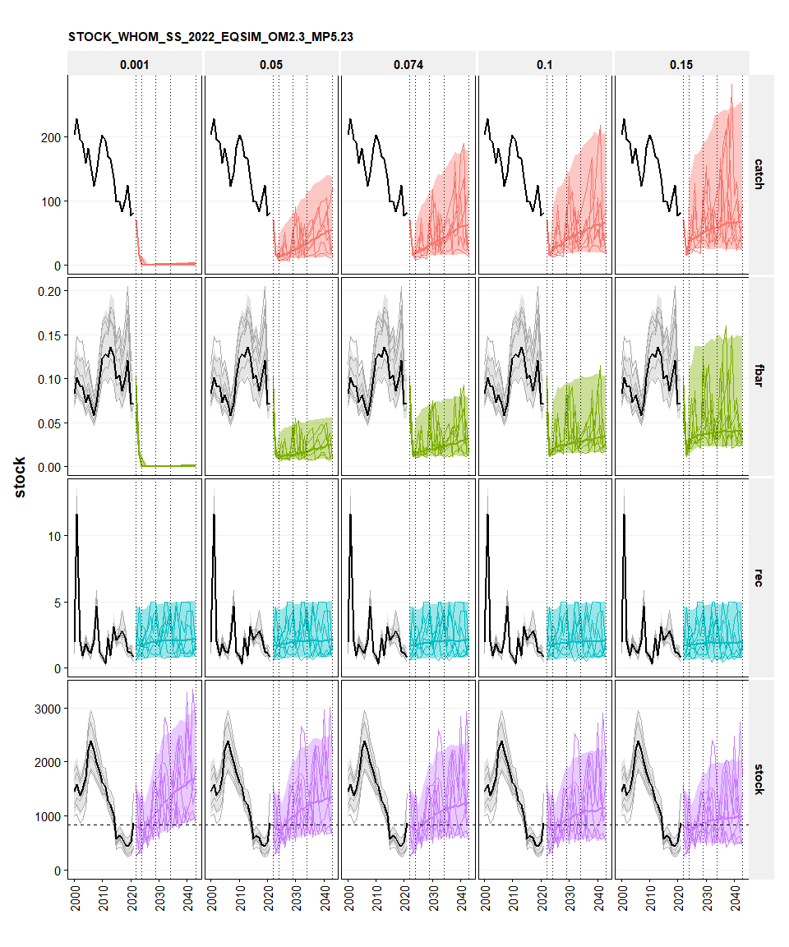 *fig x Simulation summary 2022 assessment, SS3, EqSim. MP5.23 double breakpoint F with 20% IAV constraint above Btrigger.*

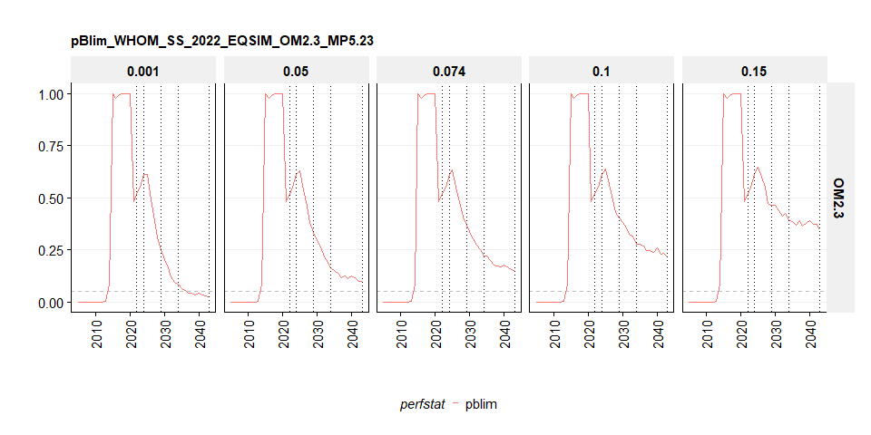

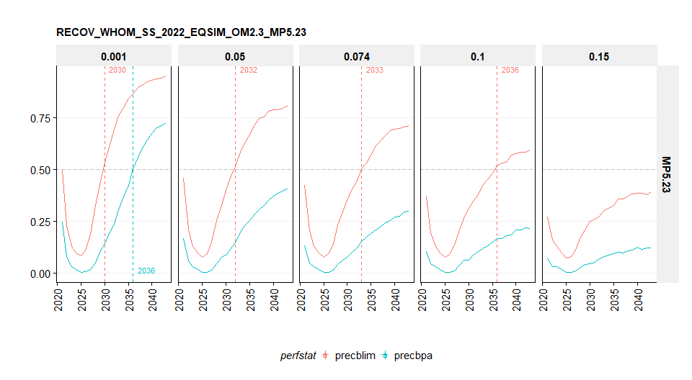

perfstat ftgt 2023 2024 2025 2026 2027 2028 2029 2030 (all)  
---------- ------- -------- -------- -------- -------- -------- -------- -------- -------- ---------  
 catch 0.001 15,513 314 300 340 396 454 514 606 18,438  
 catch 0.05 15,513 15,579 14,616 16,238 17,963 19,874 22,098 24,619 146,500  
 catch 0.074 15,513 18,616 21,414 23,604 25,757 27,879 30,872 34,020 197,676  
 catch 0.1 15,513 23,645 27,055 29,832 32,600 35,219 39,215 42,001 245,080  
 catch 0.15 15,513 35,275 39,240 42,891 45,397 47,229 50,829 52,910 329,284

perfstat ftgt 2023 2024 2025 2026 2027 2028 2029 2030  
---------- ------- --------- --------- --------- --------- --------- --------- ----------- -----------  
 stock 0.001 766,439 729,282 756,995 838,384 901,481 988,568 1,060,370 1,106,722  
 stock 0.05 766,439 729,282 748,454 816,326 862,345 939,065 989,182 1,002,652  
 stock 0.074 766,439 729,282 744,061 804,644 848,741 913,330 956,795 962,007  
 stock 0.1 766,439 729,282 738,672 795,847 830,756 891,312 920,103 925,538  
 stock 0.15 766,439 729,282 732,089 775,400 799,353 851,866 863,754 866,966

perfstat ftgt 2023 2024 2025 2026 2027 2028 2029 2030  
---------- ------- ------- ------- ------- ------- ------- ------- ------- -------  
 fbar 0.001 0.013 0 0 0 0 0 0 0  
 fbar 0.05 0.013 0.012 0.011 0.012 0.013 0.013 0.014 0.014  
 fbar 0.074 0.013 0.016 0.016 0.017 0.018 0.019 0.019 0.02  
 fbar 0.1 0.013 0.02 0.022 0.023 0.024 0.024 0.025 0.026  
 fbar 0.15 0.013 0.03 0.032 0.034 0.035 0.035 0.036 0.037

perfstat ftgt 2023 2024 2025 2026 2027 2028 2029 2030  
---------- ------- ------ ------ ------ ------ ------ ------ ------ ------  
 pblim 0.001 0.55 0.61 0.61 0.49 0.42 0.31 0.25 0.2  
 pblim 0.05 0.55 0.61 0.63 0.54 0.46 0.38 0.34 0.3  
 pblim 0.074 0.55 0.61 0.64 0.55 0.48 0.41 0.37 0.34  
 pblim 0.1 0.55 0.61 0.64 0.56 0.51 0.43 0.4 0.38  
 pblim 0.15 0.55 0.61 0.65 0.6 0.55 0.47 0.46 0.47

perfstat ftgt 2023 2024 2025 2026 2027 2028 2029 2030  
---------- ------- ------ ------ ------ ------ ------ ------ ------ ------  
 pbpa 0.001 0.8 0.86 0.92 0.86 0.76 0.65 0.6 0.55  
 pbpa 0.05 0.8 0.86 0.92 0.87 0.78 0.7 0.67 0.64  
 pbpa 0.074 0.8 0.86 0.92 0.88 0.79 0.72 0.69 0.67  
 pbpa 0.1 0.8 0.86 0.92 0.88 0.8 0.74 0.71 0.69  
 pbpa 0.15 0.8 0.86 0.93 0.89 0.83 0.77 0.75 0.75