**Overview of ICES advice**

*June 2018 advice round*

Martin Pastoors, 08/07/2018

# Introduction

In this document an overview is presented of the ICES assessment and advice for the most recent number of years for the stocks that are relevant to the PFA and Dutch fisheries in general.

# Material and methods

The overviews are based on two databases that have been developed as part of a more comprehensive research effort into the role of fisheries advice in European decision-making: one database containing the history of stock assessments and one database containing the history of scientific advice and management decisions.

# Assessment and advice overviews

## North Sea herring

Herring in Sub-area IV, Divisions VIId & IIIa (autumn-spawners)

**History of stock assessments**

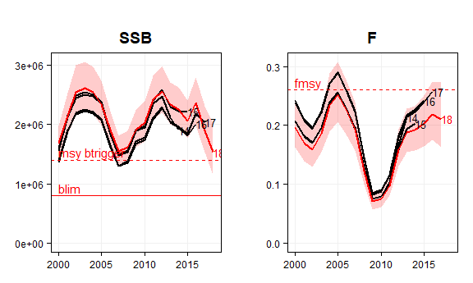

Most recent assessment in red (with 95% conf. intervals). Earlier assessments is black.

**Advice and management overview**

year advicebasis fadvmax advicemax tac catch  
------ -------------------------- --------- ----------- ----- -------  
 2015 2008 Management plan 0.25 430 445 482  
 2016 2014 Management strategy 0.23 518 518 560  
 2017 2014 Management strategy 0.27 426 482 492  
 2018 2014 Management strategy 0.26 491 601   
 2019 MSY approach 0.22 291

year advice_c tac_c catch_c advicetype tactype catchtype  
------ ---------- ------- --------- ------------ ---------- -----------  
 2015 landings catch icescatch  
 2016 20 16 16 landings catch icescatch  
 2017 -18 -7 -12 landings catch icescatch  
 2018 15 25 landings catch   
 2019 -41 landings landings

**Comments**

Assessment benchmarked in 2018. New natural mortality estimates lead to higher SSB and lower F. New method to standardize natural mortality estimates (no more scaling revision in future?). Revision of reference points. Weak 2014 year class leads to substantially lower advice, which was already foreseen in 2017. [her.27.3a47d.pdf](http://www.ices.dk/sites/pub/Publication%20Reports/Advice/2018/2018/her.27.3a47d.pdf)

## Western Baltic Spring Spawning herring

Herring in Sub-divisions 22-24 and Division IIIa (spring-spawners)

**History of stock assessments**

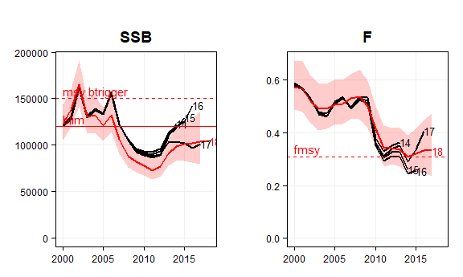

Most recent assessment in red (with 95% conf. intervals). Earlier assessments is black.

**Advice and management overview**

year advicebasis fadvmax advicemax tac catch  
------ ---------------------------- --------- ----------- ----- -------  
 2015 MSY approach (FMSY = 0.28) 0.28 44 50 37  
 2016 MSY approach (FMSY = 0.32) 0.32 53 51 51  
 2017 MSY approach (FMSY = 0.32) 0.32 57 51 46  
 2018 MSY approach (F = 0.295) 0.3 35 48   
 2019 MSY approach (F=0) 0 0

year advice_c tac_c catch_c advicetype tactype catchtype  
------ ---------- ------- --------- ------------ ---------- -----------  
 2015 landings catch icescatch  
 2016 18 2 38 landings catch icescatch  
 2017 8 -1 -9 landings catch icescatch  
 2018 -39 -5 landings catch   
 2019 -100 landings landings

**Comments**

Assessment benchmarked in 2018. Revision of reference points. Redefinition of Blim from 90 kT to 120 kT which leads to stock having been below Blim for a number of years already. No possibility of rebuilding stock to Blim within one year (which is the unwritten new ICES rule), and therefore a zero catch advice. An additional analysis will be undertaken (by MP) to evaluate alternative options for the zero catch advice. [her.27.20-24.pdf](http://www.ices.dk/sites/pub/Publication%20Reports/Advice/2018/2018/her.27.20-24.pdf)

## Baltic Sea herring

Herring in Sub-divisions 25 to 29 and 32 excluding Gulf of Riga

**History of stock assessments**

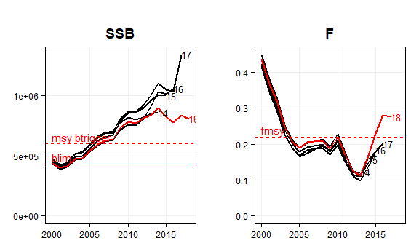

Most recent assessment in red (with 95% conf. intervals). Earlier assessments is black.

**Advice and management overview**

year advicebasis fadvmax advicemax tac catch  
------ -------------------------------- --------- ----------- ----- -------  
 2015 MSY approach 0.26 193 186 174  
 2016 MSY approach 0.22 201 207 192  
 2017 MSY approach 0.22 216 221 203  
 2018 MAP target F ranges: Flower to 332 259   
 2019 MAP target F ranges: Flower to 0.22 193

year advice_c tac_c catch_c advicetype tactype catchtype  
------ ---------- ------- --------- ------------ ---------- -----------  
 2015 landings catch icescatch  
 2016 4 11 10 landings catch icescatch  
 2017 7 7 6 landings catch icescatch  
 2018 53 17 landings catch   
 2019 -42 landings landings

**Comments**

Substantially lower estimate of SSB and higher estimate of fishing mortality in the most recent assessment is probably due to the variability in the survey index. The 2014 year class is estimated to be strong.  
[her.27.25-2932.pdf](http://www.ices.dk/sites/pub/Publication%20Reports/Advice/2018/2018/her.27.25-2932.pdf)

## Herring in 6a and 7bc

Herring (Clupea harengus) in Divisions VIa and VIIb,c (West of Scotland, West of Ireland)

**History of stock assessments**

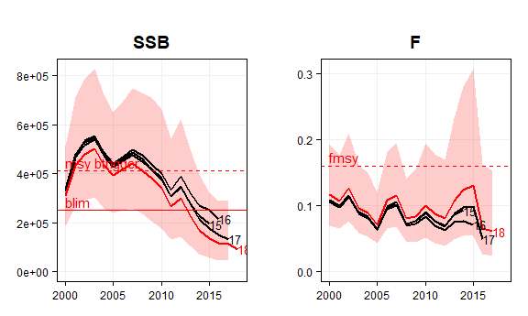

Most recent assessment in red (with 95% conf. intervals). Earlier assessments is black.

**Advice and management overview**

year advicebasis fadvmax advicemax tac catch  
------ -------------- --------- ----------- ----- -------  
 2016 MSY approach 0 0 6 7  
 2017 MSY approach 0 6 6  
 2018 MSY approach 0 6   
 2019 MSY approach 0.04 0

year advice_c tac_c catch_c advicetype tactype catchtype  
------ ---------- ------- --------- ------------ ---------- -----------  
 2016 landings catch icescatch  
 2017 0 -7 landings catch icescatch  
 2018 0 landings catch   
 2019 landings landings

**Comments**

The advice for a zero TAC is the same as in the previous years. Unfortunately ICES has not presented advice on the proposed rebuilding plan that has been developed by the PELAC and that has been submitted for review to ICES and that had been evaluated by the herring working group in March 2018. In previous years the monitoring TAC for herring in 6a and 7bc had been suggested by ICES as a means to maintain the knowledge base for this herring stock. The monitoring TAC is still mentioned under issues relevant for the advice. [her.27.6a7bc.pdf](http://www.ices.dk/sites/pub/Publication%20Reports/Advice/2018/2018/her.27.6a7bc.pdf)

## Herring in the Irish Sea

Herring (Clupea harengus) in Division 7.a North of 52°30’N (Irish Sea)

**History of stock assessments**

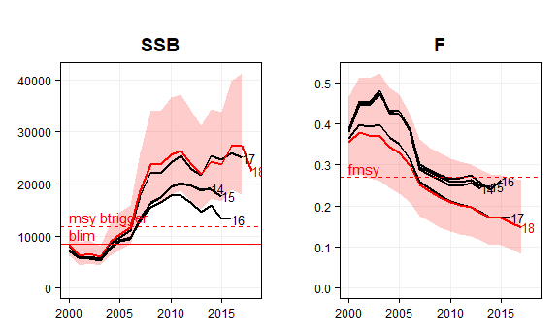

Most recent assessment in red (with 95% conf. intervals). Earlier assessments is black.

**Advice and management overview**

year advicebasis fadvmax advicemax tac catch  
------ -------------- --------- ----------- ----- -------  
 2015 MSY approach 0.26 5 5 5  
 2016 MSY approach 0.26 5 5 4  
 2017 MSY approach 0.26 4 4 4  
 2018 MSY approach 0.27 7 7   
 2019 MSY approach 0.27 7

year advice_c tac_c catch_c advicetype tactype catchtype  
------ ---------- ------- --------- ------------ ---------- -----------  
 2015 landings catch icescatch  
 2016 -6 -6 -12 landings catch icescatch  
 2017 -10 -10 -9 landings catch icescatch  
 2018 70 70 landings catch   
 2019 -2 landings landings

**Comments**

Stock was benchmarked in 2017. SSB is well above MSY Btrigger and fishing mortality well below Fmsy. Potential mixing of herring in the Irish Sea and the Celtic Sea. [her.27.nirs.pdf](http://www.ices.dk/sites/pub/Publication%20Reports/Advice/2018/2018/her.27.nirs.pdf)

## Herring in the Celtic Sea

Celtic Sea and Division VIIj herring

**History of stock assessments**

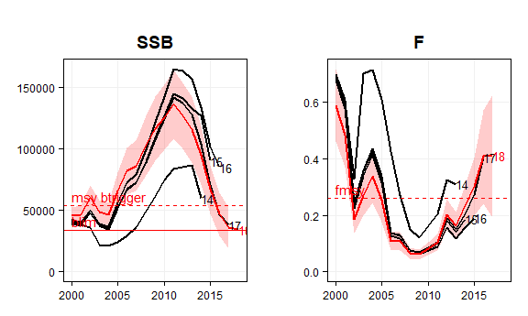

Most recent assessment in red (with 95% conf. intervals). Earlier assessments is black.

**Advice and management overview**

year advicebasis fadvmax advicemax tac catch  
------ -------------- --------- ----------- ----- -------  
 2015 MSY approach 0.36 15 16 18  
 2016 MSY approach 0.26 17 15 16  
 2017 MSY approach 0.26 16 14 11  
 2018 MSY approach 0.18 5 10   
 2019 MSY approach 0.16 5

year advice_c tac_c catch_c advicetype tactype catchtype  
------ ---------- ------- --------- ------------ ---------- -----------  
 2015 landings catch icescatch  
 2016 14 -2 -8 landings catch icescatch  
 2017 -6 -6 -34 landings catch icescatch  
 2018 -66 -30 landings catch   
 2019 -13 landings landings

**Comments**

Stock went through interbenchmark in 2018 however perception of the stock trends is very similar to last year. Evaluations conducted in 2018 showed that the agreed management strategy is no longer precautionary. Therefore the advice is according to the MSY approach. [her.27.irls.pdf](http://www.ices.dk/sites/pub/Publication%20Reports/Advice/2018/2018/her.27.irls.pdf)

## Sprat in the North Sea

Sprat in the North Sea (Sub-area IV)

**History of stock assessments**

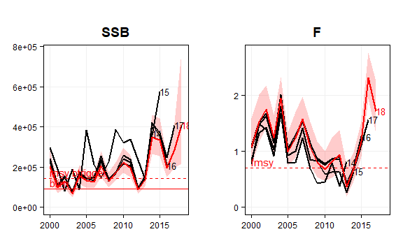

Most recent assessment in red (with 95% conf. intervals). Earlier assessments is black.

**Advice and management overview**

year advicebasis fadvmax advicemax tac catch  
------ -------------------------------- --------- ----------- ----- -------  
 2015 MSY approach (wanted catch) 1.2 227 350 290  
 2016 MSY approach, Fcap (wanted cat 0.7 506 245   
 2017 MSY approach, Fcap (catch) 0.7 126 176   
 2018 MSY approach, Fcap (catch) 170   
 2019 MSY approach, Fcap (catch) 0.7 178

year advice_c tac_c catch_c advicetype tactype catchtype  
------ ---------- ------- --------- ------------ ---------- -----------  
 2015 landings catch icescatch  
 2016 123 -30 landings catch   
 2017 -75 -28 landings catch   
 2018 36 landings landings   
 2019 4 landings landings

**Comments**

The change in recruitment level between this year’s assessment and the previous years is caused by a recent update of natural mortality of sprat in the first six months of their life. The 2018 assessment also revised the 2017 SSB downwards. The assessment has a tendency to overestimate above-average recruitments. [spr.27.4.pdf](http://www.ices.dk/sites/pub/Publication%20Reports/Advice/2018/2018/spr.27.4.pdf)

## Sprat in the Baltic Sea

Sprat in Sub-divisions 22 to 32

**History of stock assessments**

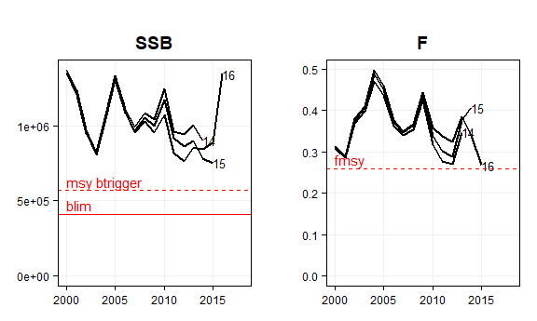

Most recent assessment in red (with 95% conf. intervals). Earlier assessments is black.

**Advice and management overview**

year advicebasis fadvmax advicemax tac catch  
------ -------------------------------- --------- ----------- ----- -------  
 2015 MSY approach 0.29 222 240 247  
 2016 MSY approach** 0.26 205 243 246  
 2017 MSY approach (F = 0.26) 314 304 286  
 2018 MAP target F ranges: Flower to 292 305   
 2019 MAP target F ranges: Flower to 0.26 301

year advice_c tac_c catch_c advicetype tactype catchtype  
------ ---------- ------- --------- ------------ ---------- -----------  
 2015 landings catch icescatch  
 2016 -8 1 0 landings catch icescatch  
 2017 53 25 16 landings catch icescatch  
 2018 -7 0 landings catch   
 2019 3 landings landings

**Comments**

Advice according to the Baltic Multiannual Plan (MAP). [spr.27.22-32.pdf](http://www.ices.dk/sites/pub/Publication%20Reports/Advice/2018/2018/spr.27.22-32.pdf)

## Greater argentine in 5b and 6a

Greater silver smelt (Argentina silus) in Divisions Vb and VIa (Faroes grounds, West of Scotland)

**History of stock assessments**

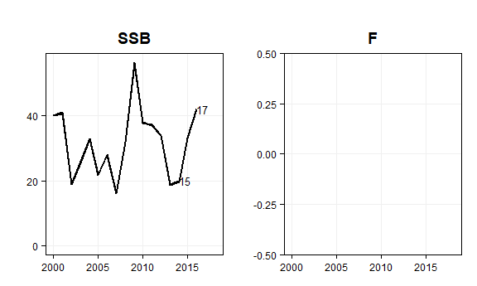

Last assessment was in 2017. Biennial assessment based on survey trends

**Advice and management overview**

year advicebasis fadvmax advicemax tac catch  
------ -------------------------------- --------- ----------- ----- -------  
 2016 Precautionary approach includi 10 17 16  
 2017 Biennial 10 15   
 2018 Precautionary approach 12   
 2019 Precautionary approach (same v 12

year advice_c tac_c catch_c advicetype tactype catchtype  
------ ---------- ------- --------- ------------ ---------- --------------  
 2016 landings catch iceslandings  
 2017 0 -11 landings catch   
 2018 20 landings landings   
 2019 0 landings landings

**Comments**

Latest advice was from 2017, applicable for two years. Next advice foreseen in 2019. [aru.27.5b6a.pdf](http://ices.dk/sites/pub/Publication%20Reports/Advice/2017/2017/aru.27.5b6a.pdf)

## Northern Hake

Hake - Northern stock (IIIa, IV, VI, VII, VIIIa,b)

**History of stock assessments**

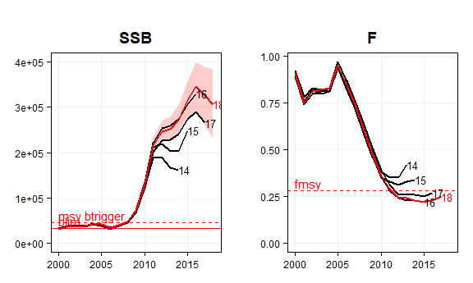

Most recent assessment in red (with 95% conf. intervals). Earlier assessments is black.

**Advice and management overview**

year advicebasis fadvmax advicemax tac catch  
------ -------------- --------- ----------- ----- -------  
 2015 MSY approach 0.27 78 91 106  
 2016 MSY approach 0.27 110 109 119  
 2017 MSY approach 124 120 112  
 2018 MSY approach 115 112   
 2019 MSY approach 0.28 142

year advice_c tac_c catch_c advicetype tactype catchtype  
------ ---------- ------- --------- ------------ ---------- -----------  
 2015 landings catch icescatch  
 2016 40 20 12 catch catch icescatch  
 2017 13 10 -6 catch catch icescatch  
 2018 -7 -7 catch catch   
 2019 23 catch landings

**Comments**

Stock size is well above MSY Btrigger and fishing mortality is below Fmsy. In the past, there has been a tendency to underestimate SSB and overestimate F but this is not the case in the most recent years. [hke.27.3a46-8abd.pdf](http://ices.dk/sites/pub/Publication%20Reports/Advice/2018/2018/hke.27.3a46-8abd.pdf)

## North Sea cod

Cod in Sub-area IV, Divison VIId & Division IIIa (Skagerrak)

**History of stock assessments**

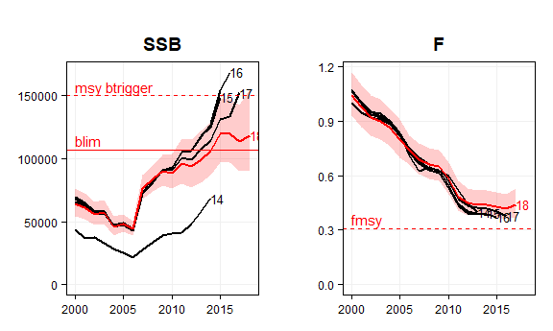

Most recent assessment in red (with 95% conf. intervals). Earlier assessments is black.

**Advice and management overview**

year advicebasis fadvmax advicemax tac catch  
------ -------------------------------- --------- ----------- ----- -------  
 2015 Management plan long-term phas 0.22 27 35 50  
 2016 MSY approach 0.33 40 40 51  
 2017 MSY approach 0.33 47 47 41  
 2018 MSY approach 0.31 60 43   
 2019 MSY approach 0.24 28

year advice_c tac_c catch_c advicetype tactype catchtype  
------ ---------- ------- --------- ------------ ---------- -----------  
 2015 landings catch icescatch  
 2016 51 15 2 landings catch icescatch  
 2017 17 16 -19 catch catch icescatch  
 2018 26 -8 catch catch   
 2019 -53 catch landings

**Comments**

The 2018 assessment gave substantially lower estimates of SSB and higher estimates of fishing mortality in recent years. According to the advice document, this is (partially) caused by a lower than expected survey index for the strong 2013 and 2016 year classes in IBTS quarter 1 survey and the IBTS quarter 3 survey. The 2017 SSB is 32% lower compared to the estimate that was presented last year. This also leads to a substantially lower advice for 2019 compared to the advice for 2018. [cod.27.47d20.pdf](http://ices.dk/sites/pub/Publication%20Reports/Advice/2018/2018/cod.27.47d20.pdf)

## North Sea plaice

Plaice (Pleuronectes platessa) in Subarea IV (North Sea) and Division IIIa (Skagerrak)

**History of stock assessments**

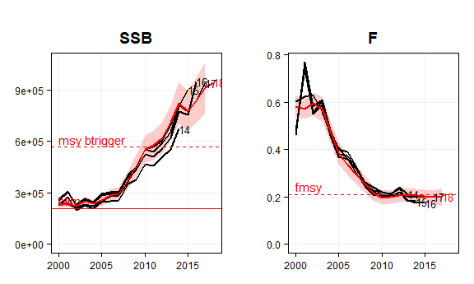

Most recent assessment in red (with 95% conf. intervals). Earlier assessments is black.

**Advice and management overview**

year advicebasis fadvmax advicemax tac catch  
------ -------------------------------- --------- ----------- ----- -------  
 2015 Apply second stage of the mana 0.28 128 128 124  
 2016 Apply second stage of the mana 0.3 216 143 123  
 2017 MSY approach 0.19 158 148 103  
 2018 MSY approach 0.21 134 128   
 2019 MSY approach 0.21 139

year advice_c tac_c catch_c advicetype tactype catchtype  
------ ---------- ------- --------- ------------ ---------- -----------  
 2015 landings catch icescatch  
 2016 69 12 -1 catch catch icescatch  
 2017 -27 3 -16 catch catch icescatch  
 2018 -15 -13 catch catch   
 2019 4 catch landings

**Comments**

Stock size is well above MSY Btrigger (and close to 1 million tonnes) and fishing mortality is around Fmsy. An EU multiannual management plan (MAP) has been proposed for this stock (EU, 2016). This plan is not adopted by Norway, thus, not used as the basis of the advice for this shared stock. The advice is based on the MSY approach. [ple.27.420.pdf](http://ices.dk/sites/pub/Publication%20Reports/Advice/2018/2018/ple.27.420.pdf)

## North Sea sole

Sole in Sub-area IV (North Sea)

**History of stock assessments**

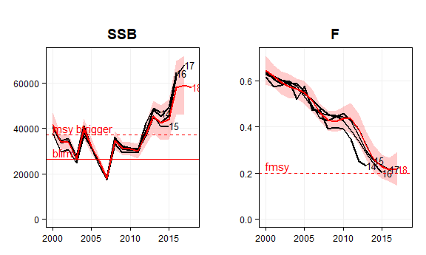

Most recent assessment in red (with 95% conf. intervals). Earlier assessments is black.

**Advice and management overview**

year advicebasis fadvmax advicemax tac catch  
------ -------------------------------- --------- ----------- ----- -------  
 2015 November update: Apply second 0.22 11 12 15  
 2016 Apply second stage of the mana 0.2 13 13 15  
 2017 Apply second stage of the mana 0.17 15 16 14  
 2018 Apply second stage of the mana 16 16   
 2019 MAP* F ranges: Flower to Fuppe 0.2 13

year advice_c tac_c catch_c advicetype tactype catchtype  
------ ---------- ------- --------- ------------ ---------- -----------  
 2015 landings catch icescatch  
 2016 12 12 5 catch catch icescatch  
 2017 20 21 -11 catch catch icescatch  
 2018 3 -2 catch catch   
 2019 -19 catch landings

**Comments**

Stock size above MSY Btrigger, fishing mortality around Fmsy. Advice according to the EU multiannual plan (MAP) for the North Sea. [sol.27.4.pdf](http://www.ices.dk/sites/pub/Publication%20Reports/Advice/2018/2018/sol.27.4.pdf)

## Atlantic Seabass

Sea bass (Dicentrarchus labrax) in Divisions IVb and c, VIIa, and VIId–h (Central and South North Sea, Irish Sea, English Channel, Bristol Channel, Celtic Sea)

**History of stock assessments**

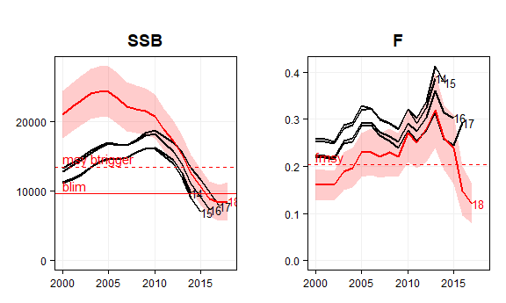

Most recent assessment in red (with 95% conf. intervals). Earlier assessments is black.

**Advice and management overview**

year advicebasis fadvmax advicemax tac catch  
------ ------------------------ --------- ----------- ----- -------  
 2015 MSY approach 1 2  
 2016 MSY approach 0.13 1 1  
 2017 Precautionary approach 0.14 0 1  
 2018 MSY approach 1   
 2019 MSY approach 0.14 2

year advice_c tac_c catch_c advicetype tactype catchtype  
------ ---------- ------- --------- ------------ ---------- -----------  
 2015 landings landings icescatch  
 2016 -53 -29 landings landings icescatch  
 2017 -100 -23 landings landings icescatch  
 2018 Inf landings landings   
 2019 103 landings landings

**Comments**

ICES has reissued the advice for 2018 and issued an advice for 2019. ICES was requested by the EU to provide updated advice on fishing opportunities for 2018 because a benchmark of the assessment had been conducted in early 2018. The 2018 benchmark has not changed the perception of the current SSB (B below Blim). However, given the current low fishing mortality and the above-average recruitment in 2013 and 2014, SSB in 2019 and 2020 is predicted to be above Blim, allowing for some catches in 2018 and 2019. [bss.27.4bc7ad-h.pdf](http://ices.dk/sites/pub/Publication%20Reports/Advice/2018/2018/bss.27.4bc7ad-h.pdf)

# More information

Please refer to the [ICES website](http://www.ices.dk/community/advisory-process/Pages/Latest-advice.aspx) for an overview of all advice documents.