**Analysis of advice changes in a number of key pelagic stocks**

Martin Pastoors, 10/01/2019

**Introduction**

In this document an overview is presented of the ICES advice for a number of key pelagic stocks relevant to the Pelagic Advisory Council (her-347d, her-noss, her-3a22, hom-west, mac-nea, whb-comb). The analysis is based on ICES advice database (Pastoors et al, in prep.) and the ICES stock assessment graph database ( [ICES SAG](www.http://ices.dk/marine-data/tools/Pages/stock-assessment-graphs.aspx)). The document outlines changes in reference points, changes in advice and a comparison between stock size assumed as the basis for the forecast and the most recent estimates of stock size from the 2018 assessments.

**Changes in F reference points**

Fpa (blue) and Fmsy (green) reference points points as estimated in the different assessment years. Note that for a number of years it was no longer deemed necessary to provide Fpa estimates, and they were consequently removed from the advice documents. In the more recent years, Fpa values have been added again on the request of ICES clients.

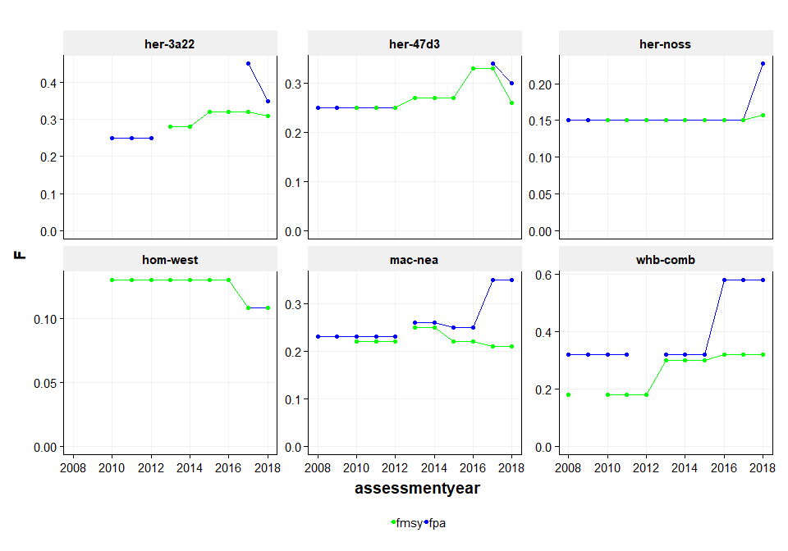

**Changes in biomass points**

Blim (red) and MSY Btrigger (green) reference points points as estimated in the different assessment years.

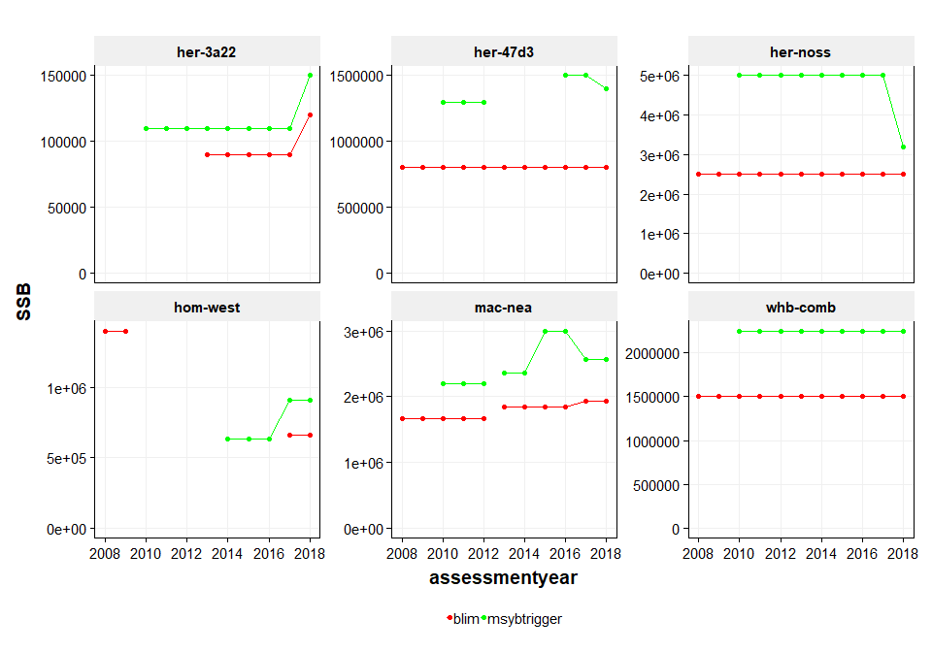

**Changes in advice**

Recommended catches (in fact: max of advised landings) presented for each of the different TAC years. The red dots and line refer to the most recent published advice, the blue dots refer to replaced advices, due to errors or revisions in the stock assessments.

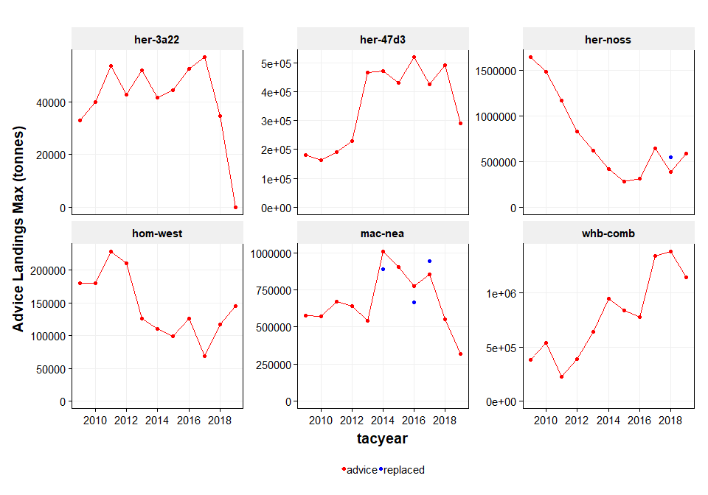

**Comparing perceived stock sizes with most recent estimates**

Comparison of the most recent estimates of stock size from the 2018 assessments (black line) with the SSB values assumed as part of the forecasts in each of the subsequent years. The red dots refer to the most recent published advice, the blue dots refer to replaced advices, due to errors or revisions in the stock assessments.

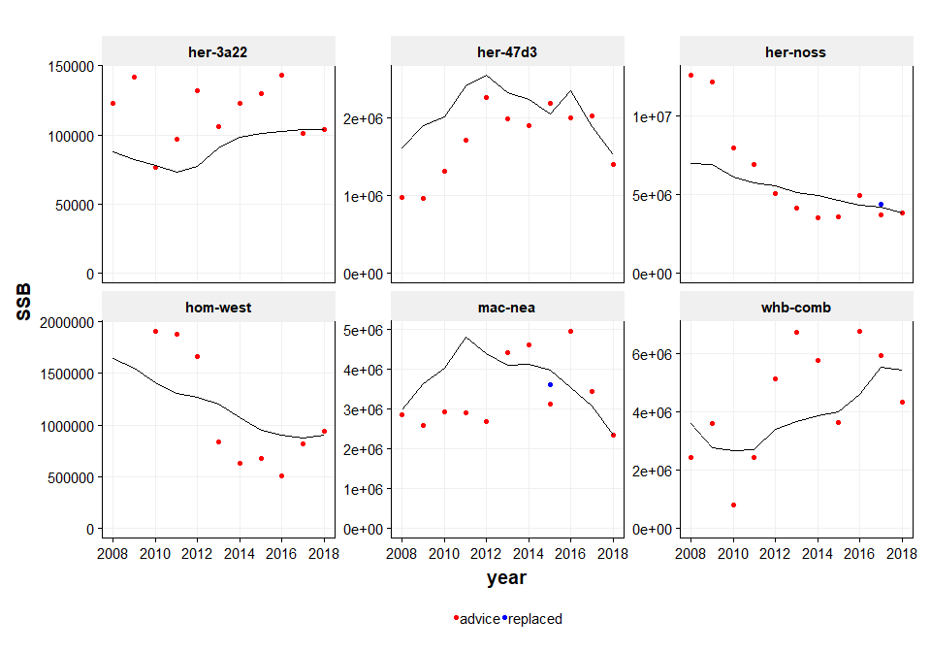

**References**

Pastoors, M.A. et al (*in prep*) Documenting the past of scientific advice: the ICES advice database.

**Advice tables**

The tables below are the summaries of advice for the stocks mentioned in this paper. Most of the columns are self-explanatory. However, the columns ‘purpose’ and ‘advice’ have a specific meaning: purpose refers to the purpose of the advice, either used for advice (purpose is ‘advice’ and advice is TRUE) or the advice has been replaced or withdrawn (purpose is ‘replaced’ and advice is FALSE). The column SSB_STF refers to the SSB as estimated in the short term forecasts in the diferent years. All quantities are in tonnes, except for fishing mortality which is in 1/year.

stock assessyear purpose fpa fmsy blim msybtrig ssb_stf tacyear fadv advlandings  
---------- ------------ ---------- ------ ------ --------- ---------- ---------- --------- ------ -------------  
 her-3a22 2008 advice . . . NA 123000 2009 0.25 32800  
 her-3a22 2009 advice . . . NA 142000 2010 0.25 39800  
 her-3a22 2010 advice 0.25 . . 110000 76200 2011 0.38 53600  
 her-3a22 2011 advice 0.25 . . 110000 97000 2012 0.25 42700  
 her-3a22 2012 advice 0.25 . . 110000 132000 2013 0.25 51900  
 her-3a22 2013 advice . 0.28 90000 110000 106000 2014 0.3 41602  
 her-3a22 2014 advice . 0.28 90000 110000 123000 2015 0.28 44439  
 her-3a22 2015 advice . 0.32 90000 110000 130000 2016 0.32 52547  
 her-3a22 2016 advice . 0.32 90000 110000 143000 2017 0.32 56802  
 her-3a22 2017 advice 0.45 0.32 90000 110000 101000 2018 0.3 34618  
 her-3a22 2018 advice 0.35 0.31 120000 150000 104000 2019 0 0  
 her-47d3 2008 advice 0.25 . 8e+05 NA 978000 2009 0.16 180000  
 her-47d3 2009 advice 0.25 . 8e+05 NA 971000 2010 0.15 164000  
 her-47d3 2010 advice 0.25 0.25 8e+05 1300000 1317000 2011 0.12 190000  
 her-47d3 2011 advice 0.25 0.25 8e+05 1300000 1714000 2012 0.12 230000  
 her-47d3 2012 advice 0.25 0.25 8e+05 1300000 2271000 2013 0.22 466000  
 her-47d3 2013 advice . 0.27 8e+05 NA 1996000 2014 0.25 470000  
 her-47d3 2014 advice . 0.27 8e+05 NA 1903000 2015 0.25 430000  
 her-47d3 2015 advice . 0.27 8e+05 NA 2194000 2016 0.23 518242  
 her-47d3 2016 advice . 0.33 8e+05 1500000 2008000 2017 0.27 426000  
 her-47d3 2017 advice 0.34 0.33 8e+05 1500000 2034000 2018 0.26 491355  
 her-47d3 2018 advice 0.3 0.26 8e+05 1400000 1404000 2019 0.22 291040  
 her-noss 2008 advice 0.15 . 2500000 NA 12600000 2009 0.12 1643000  
 her-noss 2009 advice 0.15 . 2500000 NA 12200000 2010 0.12 1483000  
 her-noss 2010 advice 0.15 0.15 2500000 5000000 7990000 2011 0.12 1170000  
 her-noss 2011 advice 0.15 0.15 2500000 5000000 6900000 2012 0.12 833000  
 her-noss 2012 advice 0.15 0.15 2500000 5000000 5080000 2013 0.12 619000  
 her-noss 2013 advice 0.15 0.15 2500000 5000000 4123000 2014 0.1 418000  
 her-noss 2014 advice 0.15 0.15 2500000 5000000 3502000 2015 0.08 283000  
 her-noss 2015 advice 0.15 0.15 2500000 5000000 3586000 2016 0.08 317000  
 her-noss 2016 advice 0.15 0.15 2500000 5000000 4974000 2017 0.12 646075  
 her-noss 2017 replaced 0.15 0.15 2500000 5000000 4364000 2018 0.11 546472  
 her-noss 2017 advice 0.15 0.15 2500000 5000000 3691000 2018 0.09 384197  
 her-noss 2018 advice 0.23 0.16 2500000 3184000 3859000 2019 0.14 588562  
 hom-west 2008 advice . . 1400000 NA . 2009 . 180000  
 hom-west 2009 advice . . 1400000 NA . 2010 . 180000  
 hom-west 2010 advice . 0.13 . NA 1910000 2011 0.13 229000  
 hom-west 2011 advice . 0.13 . NA 1880000 2012 0.13 211000  
 hom-west 2012 advice . 0.13 . NA 1660000 2013 0.13 126000  
 hom-west 2013 advice . 0.13 . NA 836000 2014 0.13 110546  
 hom-west 2014 advice . 0.13 . 635000 635000 2015 0.12 99304  
 hom-west 2015 advice . 0.13 . 635000 675000 2016 0.13 126000  
 hom-west 2016 advice . 0.13 . 635000 512000 2017 0.11 69186  
 hom-west 2017 advice 0.11 0.11 661900 911600 818000 2018 0.1 117070  
 hom-west 2018 advice 0.11 0.11 661900 911600 941821 2019 0.11 145237  
 mac-nea 2008 advice 0.23 . 1670000 NA 2845000 2009 0.2 578000  
 mac-nea 2009 advice 0.23 . 1670000 NA 2591000 2010 0.22 572000  
 mac-nea 2010 advice 0.23 0.22 1670000 2200000 2930000 2011 0.22 672000  
 mac-nea 2011 advice 0.23 0.22 1670000 2200000 2908000 2012 0.22 639000  
 mac-nea 2012 advice 0.23 0.22 1670000 2200000 2677000 2013 0.22 542000  
 mac-nea 2013 replaced . . . NA . 2014 . 889886  
 mac-nea 2013 advice 0.26 0.25 1840000 2360000 4408000 2014 0.22 1011000  
 mac-nea 2014 advice 0.26 0.25 1840000 2360000 4605000 2015 0.22 906000  
 mac-nea 2015 replaced 0.25 0.22 1840000 3000000 3620000 2016 0.22 667385  
 mac-nea 2015 advice 0.25 0.22 1840000 3000000 3131000 2016 0.22 773840  
 mac-nea 2016 replaced 0.25 0.22 1840000 3000000 4957000 2017 0.22 944302  
 mac-nea 2016 advice 0.25 0.22 1840000 3000000 4958000 2017 0.22 857000  
 mac-nea 2017 advice 0.35 0.21 1940000 2570000 3444000 2018 0.21 550948  
 mac-nea 2018 advice 0.35 0.21 1940000 2570000 2354000 2019 0.17 318403  
 whb-comb 2008 advice 0.32 0.18 1500000 NA 2424000 2009 0.16 384000  
 whb-comb 2009 advice 0.32 . 1500000 NA 3586000 2010 0.18 540000  
 whb-comb 2010 advice 0.32 0.18 1500000 2250000 796000 2011 0.32 223000  
 whb-comb 2011 advice 0.32 0.18 1500000 2250000 2422000 2012 0.18 391000  
 whb-comb 2012 advice . 0.18 1500000 2250000 5130000 2013 0.18 643000  
 whb-comb 2013 advice 0.32 0.3 1500000 2250000 6715000 2014 0.18 948950  
 whb-comb 2014 advice 0.32 0.3 1500000 2250000 5738000 2015 0.18 839886  
 whb-comb 2015 advice 0.32 0.3 1500000 2250000 3618000 2016 0.3 776000  
 whb-comb 2016 advice 0.58 0.32 1500000 2250000 6766000 2017 0.32 1342330  
 whb-comb 2017 advice 0.58 0.32 1500000 2250000 5907000 2018 0.32 1387872  
 whb-comb 2018 advice 0.58 0.32 1500000 2250000 4327000 2019 0.32 1143629